The George Parks Highway Scenic Byway

Corridor Partnership Plan

Draft 2—3/14/2008

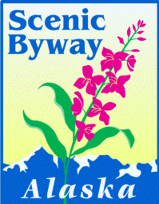

This project was funded by the Alaska Department of Transportation & Public Facilities and a National Scenic Byways Grant from the Federal Highway Administration.

This publication was released by the Alaska Department of Transportation and Public Facilities, produced at a cost of $ (insert cost) per copy to benefit the George Parks Highway State Scenic Byway, and printed in Anchorage Alaska. The views expressed herein are those of the George Parks Highway Scenic Byway Stakeholders and do not necessarily reflect the view of ADOT&PF.

TABLE OF CONTENTS

- Introduction

- Byway Background

- Planning Process and Public Involvement

- Intrinsic Quality Assessment

- Transportation and Safety

- Tourism and Marketing

- Interpretation

- Vision, Goals, and Objectives

9. Implementation

- Conclusion

- Acknowledgements

Appendix: Parks Highway Scenic Byway Resource Inventory

Figures:
Figure 1. The George Parks Highway Scenic Byway
Figure 2. Parks Highway Scenic Byway Natural Resources
Figure 3. Parks Highway Scenic Byway Recreation Resources
Figure 4. Parks Highway Scenic Byway Scenic Resources
Figure 5. Parks Highway Scenic Byway Cultural Resources

Tables:
Table 1. 2006 Parks Highway Scenic Byway Traffic Volumes
Table 2. 2005 Parks Highway Scenic Byway Accident Data

1. INTRODUCTION

The Parks Highway

“Have you been on the Parks yet?” If queried by visitors for advice on local hotspots, residents will typically ask travelers this question. A milestone journey, no trip to Alaska is considered complete without a voyage on the George Parks Highway. This route, commonly referred to as the Parks Highway, runs 323 miles from the Glenn Highway in the Matanuska Valley to Fairbanks in the Alaska Interior. Completed in 1971, this highway is one of the most important roads in Alaska for commerce and recreation. The Parks Highway and a short section of the Glenn Highway link the state’s two largest cities, Anchorage and Fairbanks, with spectacular natural surroundings and unparalleled recreation opportunities. The Parks winds through the kind of scenery that typifies Alaska and captures the imagination of people from all over the world: the continent’s highest peaks and largest glaciers, alpine tundra, taiga forests, wild rivers, and vast expanses inhabited only by wildlife. The Parks Highway was named in honor of George Alexander Parks, governor of the Territory of Alaska from 1925 to 1933. However, the aptness of the name was recognized when it was chosen.

Segmenting the Parks Highway

Mileposts on the Parks Highway do not begin with zero. Instead, they begin with milepost 35, reflecting the distance from Anchorage. The route can be organized into three distinct segments:

- the highway start at the Glenn Highway junction in the Matanuska Valley to the Chulitna River Bridge (milepost 35-132);
- the Chulitna River Bridge to Healy (milepost 132-248); and
- Healy to Fairbanks (milepost 248-362).

As of 2007, the 116-mile middle segment of highway, from milepost 132-248, was the only section designated as an Alaska State Scenic Byway and thus is the primary focus of this Corridor Partnership Plan. This segment, the George Parks Highway Scenic Byway, will be referred to as the Parks Byway in this plan. There is local interest in extending the state byway designation both north and south to encompass the entire route. However, since highway segments not designated under state byway programs are ineligible for state and federal byway grant funding, the beginning and end segments of the Parks Highway were omitted from this planning effort. This Corridor Partnership Plan should be updated in the future to include additional highway segments if the current designation is extended.

The Parks Byway

If one byway could epitomize all that is Alaska, that byway would be the Parks Byway. Passing through Denali country, dominated by the lofty, snow-covered peaks of the Alaska Range, active glaciers, rolling tundra, boggy muskegs, and spruce forests laced by rivers, the Parks Byway is, according to some residents, the best drive in Alaska. It winds through the heart of the last frontier, coming within fifty miles of Mt. McKinley, the highest peak in North America and the defining feature of Alaska’s terrain. Mt. McKinley soars far above the smaller peaks surrounding it. The mountain, called Denali—‘The High One’—by neighboring Athabaskan Indians, duplicates polar conditions; snow cloaks its summit year-round and radiating glaciers flow down its windswept slopes. According to one Alaska Native tradition, the origin of man began near ‘The High One’, with the raven as creator. On lowlands below the banner mountain roams the largest mammals in the northern hemisphere: caribou, bear, moose, wolf, and Dall’s sheep. In summer, the animals blend into the folds of the landscape, moss-floored forest, and distant tundra moors. As migratory bands, as packs and family groups, or as solitaries, they forage the slopes and stream courses of Denali country.

The views of beautiful, snowcapped Mt. McKinley and wildlife encounters are not all an excursion on this byway offers. The Parks Byway provides adventurers and sightseers excellent opportunities in the state to explore Alaska firsthand. Adventure-seekers can explore the Alaskan wilderness at the region’s two largest protected areas, Denali National Park and Preserve and Denali State Park. At these parks, travelers can partake in almost limitless outdoor recreation activities during every season. Travelers can also whitewater raft down the roaring Nenana River, pause to observe the Alaska Veterans Memorial near Byers Lake, stop in Healy to learn more about the largest coal mining operation in Alaska, and have a home-cooked meal while learning about early adventurers and homesteaders at the historic Mary’s McKinley View Lodge.

The Parks Byway crosses two boroughs—the Matanuska-Susitna and Denali—and passes through the communities of Cantwell and McKinley Park. The small community of Trapper Creek is approximately 17 miles south of the byway but serves as the corridor’s southern gateway, while Healy provides a similar function on the byway’s northern boundary. These rural communities, rich in frontier ethos and infused with pioneer history, provide visitors with the best opportunities in the state to experience the Alaskan way of life, discernible by modern-day trappers, explorers, mountaineers, miners, and homesteaders. Perhaps nowhere else on earth is there still a breed of daring, rugged individualists to match the people who call Denali country home.

A journey down the Parks Byway, with its views of Mt. McKinley, surrounding state and national parklands, large mammals, outdoor recreation opportunities, frontier culture, and pioneer history, perfectly captures the spirit, grandeur, wildness, and abundance that Alaska brings to mind.

The George Parks Highway Scenic Byway Corridor Partnership Plan

The Parks Byway is deserving of All-American Road status due to its exceptional intrinsic qualities, especially its world-class natural and recreation resources. The Parks Highway Scenic Byway Corridor Partnership Plan meets the requirements of the National Scenic Byways Program for this designation. This plan will help local byway leaders plan for the long-term economic future of the region. This plan is not a regulatory document. It does not address land use regulations, nor does it seek to limit landowner rights. Rather, funding obtained for the byway will be used to improve the local economy by providing better services for visitors and residents. This plan provides a blueprint for marketing, interpretive, and infrastructure investments in order to bolster economic development in the region while improving the experience of traveling on the Parks Byway. This plan documents the uniqueness of the route, the resources it contains, and highlights the pride that local residents have in their area. Elected officials, landowners, and business owners support the byway concept, evidenced by this collaborative planning effort.
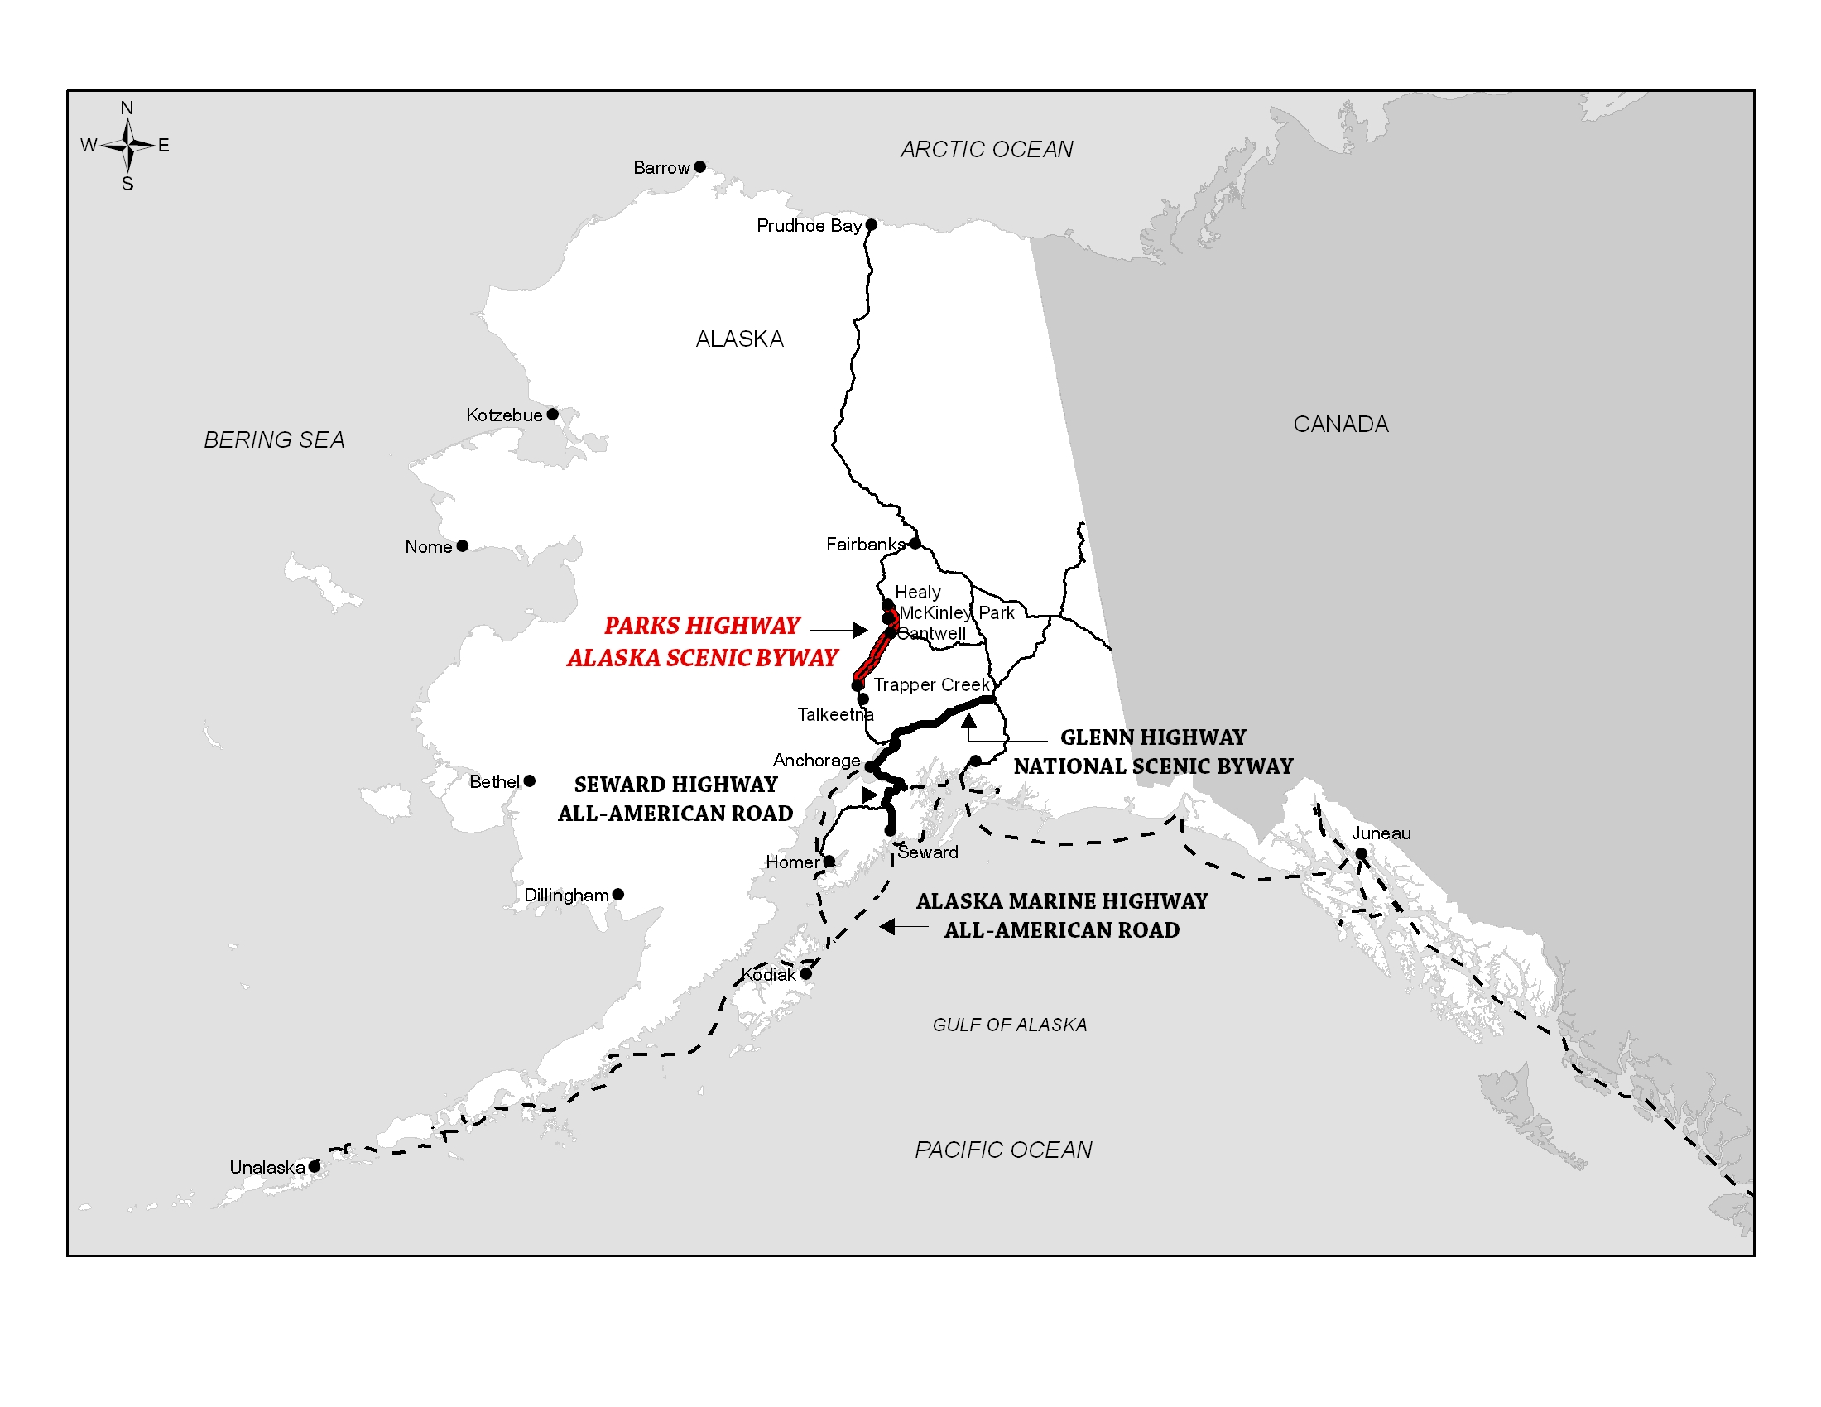

Figure 1. The George Parks Highway Scenic Byway

2. BYWAY BACKGROUND

National Scenic Byways Program

The U.S. Congress created the National Scenic Byways Program in 1991. Under this program, the U.S. Secretary of Transportation recognizes certain outstanding roads as National Scenic Byways or All-American Roads. Designation as a National Scenic Byway indicates that the route possesses distinctive recreation, historic, natural, or other qualities that are unique to the region. Designation as an All-American Road, the higher designation of the two, indicates that the route has not only regional, but also national significance.

Participation in the National Scenic Byways Program is voluntary and involves recognition, not regulation. It promotes tourism and economic development in byway communities and educates the traveling public about the local environment, history, and culture. One of the key benefits of national byway recognition is the added economic opportunities provided to communities along the designated route. Promotion of the byway through national and international marketing conducted by the program can generate economic growth and increase community recognition. Other potential benefits include eligibility for federal grant funds for infrastructure improvements, development and implementation of marketing and interpretive plans, and access to resources to help byway organizations manage and market the byway corridor.

Alaska Scenic Byways Program

In 1993, the State of Alaska established a scenic byways program to recognize and celebrate the state’s most scenic travel corridors. Administered by the Alaska Department of Transportation and Public Facilities (ADOT&PF), this program also recognizes routes that provide access to the state’s significant natural, recreation, cultural, and historic resources.

A grassroots citizen’s group initiates an Alaska state byway designation at the local level. Once state designation is granted, the route becomes eligible for grant funding to develop a Corridor Partnership Plan. Once the plan is completed, the byway is eligible to receive National Scenic Byway grant funding to implement qualified projects identified in the Corridor Partnership Plan. The corridor also becomes eligible to apply for national byway designation under the National Scenic Byways Program if there is broad local support.

The Corridor Partnership Plan

A Corridor Partnership Plan is required for state scenic byways seeking byway implementation grants or designation as a National Scenic Byway or All-American Road. Its purpose is to assess the key resources along the route and identify methods to maintain, enhance, and promote those resources over time. It describes how byway stakeholders will assume responsibility for the long-term management and promotion of the byway's resources.

Besides increasing funding possibilities, preparation of a Corridor Partnership Plan has many other benefits. The process creates opportunities for multiple communities along the byway to work together to accomplish common goals. It supports a realization of community visions, tourism promotions, stewardship efforts, and projects such as visitor facilities and wayside improvements.

Achieving National Byway Status

National designation requires submittal of an application that must include a Corridor Partnership Plan that meets the Federal Highway Administration (FHWA) requirements and demonstrates that the byway possesses one or more intrinsic qualities that are significant on a multi-state or national level. The FHWA solicits nominations every 3-5 years. Nominations are reviewed and approved by the ADOT&PF before they are submitted to the FHWA for national review. At the national level, a selection committee comprised of tourism, highway, and other professionals from around the nation convene to identify which nominated corridors are deserving of the National Scenic Byway or All-American Road award. The committee’s recommendations are forwarded to the U.S. Secretary of Transportation for a final decision. Non-monetary benefits are available to National Scenic Byways in the form of training and marketing through the FHWA and other entities.

3. PLANNING PROCESS AND PUBLIC INVOLVEMENT

This planning process brought communities, businesses, Alaska native corporations, non-profit organizations, landowners, and tourism and natural resource interests together across three boroughs to identify a common vision and goals for the byway. Public involvement was the driving process for completing this plan. Prior to the start of this project, a Public Involvement Plan (PIP) was crafted, the purpose of which was to describe public involvement and communication goals. The PIP enabled stakeholders to receive background and technical information on the project in order to provide meaningful input.

The public process began with informing local governments in the Matanuska-Susitna, Denali, and North Star boroughs of the project inception. These organizations helped to coordinate public meetings in Healy, Cantwell, Trapper Creek, and McKinley Park. The public meetings were widely advertised in local newspapers and community online forums. Public meeting announcements were also posted in local post offices and other community bulletin boards. Attendance in these small towns was considered high, with thirty-two stakeholders attending the meeting in Healy, eight in Cantwell, twenty in Trapper Creek, and four in McKinley Park. Presentations on the project were also given at the Matanuska-Susitna State Parks Advisory Board and the Alaska Campground Owners’ Association.

Public meeting attendees had an opportunity to hear about the state and national byways programs and to understand the process involved in the preparation of a Corridor Partnership Plan. At each meeting, information was collected on what attendees valued most about the byway, potential interpretive stories to share with the public, ways in which the visitor’s experience could be enhanced, and areas in need of upgrades. In general, meeting attendees were supportive of the project and felt that developing a Corridor Partnership Plan for the Parks Byway would be useful to the communities along the corridor. The primary concern heard during the outreach effort related to the challenges associated with maintenance of current and future facilities. At the conclusion of each public meeting, attendees were given the opportunity to provide further guidance on the plan by volunteering to serve on the Parks Byway Corridor Partnership. Subsequent Parks Byway Corridor Partnership meetings were held to create the plan’s goals, objectives, and implementation strategies, and to verify the corridor inventory produced by the consulting team. Prior to the completion of the plan, another round of public meetings were held in Healy, Cantwell, and Trapper Creek to give the public a chance to review the final plan before it went to print.

This Corridor Partnership Plan is an integration of numerous local and regional planning documents, especially past plans’ goals, recommendations, and projects as they relate to the corridor. Planning documents were consulted from the Matanuska-Susitna and Denali boroughs, the National Park Service, the Alaska Department of Natural Resources, the Alaska Department of Transportation and Public Facilities, and others (Appendix A).

The Parks Byway Community Partnership

The Parks Byway Community Partnership was formed in the spring of 2007, choosing to maintain an informal structure. Composed of almost twenty stakeholders with varied interests from communities in both the Mat-Su and Denali boroughs, this grassroots group has been dedicated, productive, and committed to the byway’s development. The biggest challenge the Partnership encountered was the difficulty in maintaining continuity in one plan for a byway that stretches over one hundred miles and involves multiple communities. Four meetings were held in Healy, Cantwell, Byers Creek, and Denali National Park to create a byway vision statement and this corridor plan’s goals, objectives, and potential actions. These meetings were well attended, with an average of thirteen members present at each gathering. Through cooperative planning and continued sustainable development, the Parks Byway Community Partnership is dedicated to maintaining and enhancing the intrinsic qualities of the Parks Byway by providing travelers with a safe, comfortable, and educational adventure.

4. INTRINSIC QUALITY ASSESSMENT

Introduction

The Alaska and National Scenic Byways Program identifies six intrinsic qualities that serve to capture the spirit of adventure and sense of magic found on American roads: natural, recreation, scenery, history, culture, and archeology. A corridor resource inventory of these qualities can be found in Appendix B. In the case of the Parks Byway, while all six qualities recognized by the National Scenic Byways Program are exemplified, it is especially the natural and recreation resources that are world-class (Figs. 2 & 3). This byway offers views of Mt. McKinley, the tallest mountain in North America, and passes through a protected subarctic ecosystem the size of Massachusetts that contains the largest inland glaciers in Alaska, one of North America’s lowest mountain passes, and fossils of national significance. Travelers come from all over the globe to sample the byway’s recreation opportunities. Adventurers and athletes come to participate in world-class mountaineering activities, others traverse the byway to view the five largest mammals in the northern hemisphere, hike in the colorful tundra, take a sled dog ride, snowmobile in a winter wonderland, or view the northern lights.

Scenic opportunities and historic and cultural experiences also abound as exceptional secondary intrinsic qualities (Figs. 4 & 5). A statewide survey that looked at intrinsic qualities of Alaska’s byways supports these claims; it was found that Alaskans believed the Parks Byway exhibited not just one or two, but a diversity of interrelated intrinsic qualities.1 This chapter reviews these qualities and outlines the national significance of this byway.

Natural Qualities

Natural Quality applies to those features in the visual environment that are in a relatively undisturbed state. These features predate the arrival of human populations and may include geological formations, fossils, landform, water bodies, vegetation, and wildlife. There may be evidence of human activity, but the natural features reveal minimal disturbances (FHWA Policy 5.18.95).

Tallest Mountain in North America. The Alaska Range, one of the greatest mountain uplifts on the continent, dominates the landscape of this region. Looming above other mountains in the range is Mt. McKinley, North America’s highest peak, with its summit at 20,320 feet. This beautiful ice and snow-encrusted giant is the largest granitic body in the world. Piercing the central plain of Alaska at latitude 63º N, Mt. McKinley is unique among the mountains of the world in that it is the highest point near the Arctic Circle. No other mountain in the world even comes close to its height at this high latitude. Denali is so massive that it creates its own weather systems. This results in extreme weather patterns; in few mountain locales of the world does the weather change so precipitously and dramatically. Mt. McKinley’s height, combined with its subarctic location, makes it one of the coldest mountains on earth, if not the coldest. Even in June, nighttime temperatures on its upper slopes may reach -40 degrees F. For all these reasons, Alaska’s “High One” has earned a reputation as the ultimate challenge in North American mountaineering.

Vast Protected Area. The Parks Byway provides visitors with superb opportunities to experience a complete subarctic ecosystem in settings relatively undisturbed by humans, while offering a phenomenon surprisingly rare in Alaska: road-accessible wilderness. Immense tracks of undisturbed public land surround the Parks Byway. The byway lies on the eastern edge of Denali National Park and Preserve, one of the largest national parks in the United States. Comprised of over six million acres, two million acres of the park have been in protected status since 1917, which makes the park the largest continuously protected area in the world. The United Nations Man and Biosphere Program designated the park an International Biosphere Reserve in order to recognize internationally the exceptional health and integrity of this colossal ecological system. Wild and untouched, this park is considered by some as one of the world's last great frontiers for wilderness adventure. The byway also travels though Denali State Park (325,240 acres) and it’s associated State Recreation Areas (1,470 areas), an integral part of this spectacular region. Together, these neighboring parks create a Massachusetts-sized protected area that enables an array of flora and fauna to co-exist in an unspoiled natural environment.

Largest Inland Glaciers in Alaska. Alpine glaciers flow from the heights of Mt. McKinley and its companion peaks. These glaciers, from 14 to 38 miles long and up to 4 miles wide, are some of the largest in North America and the largest inland glaciers in Alaska. Easily viewed from the byway, they flow from the high peaks and melt into the broad Chulitna Valley, giving the Chulitna River the milky waters and braided channels typical of a glacial stream. Glacier topography is characteristic of this region; the Parks Byway guides visitors over ground moraines, through drumlin fields, and snakes around kettle lakes, eskers, and outwash plains.

One of North America’s Lowest Mountain Passes. Although unforested Broad Pass is one of the lowest-elevated passes along the North American mountain system, expansive views provide travelers a top-of-the world feeling. Just south of Cantwell, Broad Pass is one of the most beautiful areas on the byway, with its broad alpine valleys and mountain peaks on either side. Loons, swans, and other waterfowl claim this low pass as home base. Caribou are temporary residents during migration season. In fall, when blueberry leaves are gold and bearberry leaves are scarlet, this area is a compelling stop. This long, wide basin affords panoramic views of Mt. McKinley and the imposing 30-mile spine of Curry and Kesugi ridges in the Talkeetna Range. Uniquely situated on the divide between the Cook Inlet and Yukon River watersheds, Broad Pass is also noteworthy in that it separates the Chulitna and Nenana river basins and divides the Susitna and Yukon watersheds.

Critical Fossils Finds. The Denali region is emerging as a site of important fossils, including footprints credited with being the first evidence of prehistoric wading birds. Other fossil tracks at Denali National Park and Preserve are the first evidence of dinosaurs found in Interior Alaska. These tracks shed light into the roaming habits of prehistoric creatures and support the theory that dinosaurs migrated to Alaska from Asia across the Bering Land Bridge. Visitors can view samples of fossil tracks and more at Denali’s Murie Science and Learning Center.

Natural Quality Challenges and Opportunities

One of the things that makes the Parks Byway such an extraordinary scenic and pleasurable drive is that there is very little development. The byway’s natural qualities and the fact that it winds through the backcountry of Alaska augment and enhance its other intrinsic qualities. As such, sustainable development and preservation of the natural qualities that make this corridor so remarkable is of high importance.

The majority of undeveloped lands surrounding the Parks Byway fall under protection of the National Park Service and the Alaska Department of Natural Resources, agencies that actively manage these lands in the public’s best interests. Other land managers include the Matanuska-Susitna and Denali boroughs, the Bureau of Land Management, Ahtna Incorporated, CIRI, and private landowners. There may be a need to gain support for voluntary development guidelines to ensure that natural resources are not compromised during future development.

Recreational Qualities

Recreational Quality involves outdoor recreational activities directly associated with and dependent upon natural and cultural elements of the corridor’s landscape. The recreational activities provide opportunities for active and passive recreational experiences. They include, but are not limited to, downhill skiing, rafting, boating, fishing, and hiking. Driving the road itself may qualify as a pleasurable recreational experience. The recreational activities may be seasonal, but the quality and importance of the recreational activities as seasonal operations must be well recognized (FHWA Policy 5.18.95).

World-Class Mountaineering. This region sports once in a lifetime mountaineering opportunities, considered by some to be the best in the world. Mt. McKinley is part of the world renowned “Seven Summits Challenge” to climb the highest peak on each of the seven continents. This soaring goliath, the tallest in North America at 20320 feet, has captured the imagination of mountaineers from all over the world, men and women with sparkling eyes and sun-crinkled faces. Typically about 1,300 people a year attempt to climb Mt. McKinley, with roughly half reaching the summit. Other peaks in the Alaska Range, such as Mt. Foraker and Mt. Hunter, also draw experienced mountaineers and technical climbers.

Wildlife Watching and Alaska’s ‘Big Five’. The Parks Byway provides access to trails and waterways that lead to opportunities to experience maybe the best chance to view some of the largest northern mammals in the world. Here, many travelers are able to fulfill a life-long goal of viewing Alaska’s “big five” in their natural habitat. From vehicles, Parks Byway visitors can see caribou resting on a snow patch, moose browsing in stands of willow, Dall’s sheep high on the hillsides, wolves trotting across the tundra, or bears feeding on ripening blueberries. Bird life in the region is also especially rich. The area houses thousands of lakes that provide diverse avian habitat, which attracts more than 130 bird species from all over the world.

Limitless Multi-Use Outdoor Recreation Opportunities. The Parks Byway’s extensive natural landscape supplies almost limitless outdoor recreation opportunities for local residents as well as visitors from all over the world. Those traveling on the byway can participate in an abundance of outdoor activities depending on the season. In winter, travelers can choose from aurora viewing, snowmobiling, showshoeing, dog mushing, cross-country and backcountry skiing, winter camping, warming up in public-use cabins, and ice-fishing. In spring, summer, and fall, warm-weather recreation opportunities abound, including hiking, camping, kayaking, biking, hunting, fishing, flightseeing, river rafting, wildlife viewing, glacier trekking, backpacking, fall-color viewing, berry picking, and more. Some of these recreation opportunities are highlighted in the following pages.

Unparalleled Hiking. This byway offers some of the best hiking and backpacking in the nation. In the summer months, there are over 12 hours of daylight available to enjoy the exceptional views of Mt. McKinley, the highest mountain in North America, and the entire southern arc of the Alaska Range. Denali National Park and Preserve is predominately a trail-free park, nationally rare in this aspect, and offers outstanding route-finding backpacking opportunities across the tundra, spectacular vistas, encounters with wildlife, and the experience of traveling the land much as the first explorers did. It’s
neighbor Denali State Park has over 40 miles of trails for hikers who prefer established routes. The Kesugi Ridge trail system in the state park is becoming one of the most popular backpacking routes in the state. Kesugi Ridge is a long, narrow spur of geography paralleling the Alaska Range across the Chulita River basin that offers extraordinary vistas rugged mountains bordered by the largest inland glaciers in Alaska. In clear weather, the ridge offers the most spectacular views of Mt. McKinley in the entire area.

Dog Mushing—the Alaska State Sport. This is an Alaska adventure vacation of a lifetime for some Parks Byway visitors. While whizzing by beautiful scenery behind barking and exuberant dogs, visitors are treated to a high-speed excursion across the frozen tundra. Many local mushers, including those at Denali National Park and Preserve, offer tours of their dog kennels, along with a variety of different dog sled rides. There are also professional outfitters along the byway that offer canine excursions. Trails along and around the byway provide mushers with a flat, smooth surface; the wind and cold temperatures of winter make for a memorable ride.

World-Class Snowmobiling. In terms of accessibility and vistas, the area around Cantwell, especially treeless Broad Pass, offers nationally significant cross-country snowmobiling conditions. While on one of the lowest-elevated mountain passes in the nation, snowmobilers can take in panoramic views of beautiful Broad Pass, including the largest mountain in North America, during a day trip from the transportation hubs of either Anchorage or Fairbanks. In the winter, Cantwell becomes a fantasyland for snowmobilers. During this time of year, pullouts along the Parks Byway near Cantwell are often full of empty snowmobile trailers, their owners off playing in the deep snow on the wide-open tundra. Once the snow falls, these pullouts become great jumping-off points for more remote destinations made accessible by the snow pack. Cantwell is also a popular staging area for snowmobiling on the unmaintained Denali Highway. Denali National Park and Preserve permits the use of snowmobiling in some areas.

Accessible Aurora Viewing. During the dark winter months, between September and March, when the nights are long and the sky dark, the Parks Byway is the most accessible place in Alaska to experience a remarkable phenomenon. Winter visitors are treated to the Northern Lights, or Aurora Borealis, shimmering ribbons of color that flirt and dance their way across the dark night sky in varying degrees of intensity and form. Because this byway is situated far away from city lights, which can hinder Aurora viewing, Northern Light shows are spectacular. Travelers can simply pull over, face north, and lean back to get an experience of a lifetime. One Alaska Native legend affirms that the northern lights are spirits playing ball in the sky with a walrus skull. Another legend calls them the flaming torches carried by departed souls guiding travelers to the afterlife.

Guided Excursions. Numerous outfitting and tour companies offer a variety of excursions within the region, from flightseeing trips over Mt. McKinley to white water rafting down the Nenana River, to dog mushing on frozen rivers. Snowmobile and aurora viewing tours are growing steadily in popularity, as are flightseeing and glacier landing trips. About 40 companies advertise air tours of the region. Many tour companies are located in nearby Talkeetna, but some operate out of Cantwell, McKinley Park, and Healy.

Recreational Quality Challenges and Opportunities

Since most recreation facilities are on public lands, the greatest threat to the recreation resources of the Parks Byway is marginal funding provided to state and federal parks given the ever-growing demand for recreation access. Throughout the byway, the problems of rising visitation and insufficient resources to maintain year-round restrooms and other basic services are echoed all around.

Local partnerships and working relationships between public and private entities can be one way to overcome management and funding issues. Additional funding to maintain public facilities may be acquired by working with other state and national byways and organizing businesses and local governments under the byway umbrella. The American Recreation Coalition is one example of this type of partnership between public and private organizations.

The proposed South Denali Visitor Center Complex in Denali State Park would enhance recreation opportunities in the area by providing year-round activities for both motorized and non-motorized users.2 Short trails and boardwalks are planned to guide visitors through the tundra to viewing areas. Less improved long-distance trails would carry adventurous travelers up to the Curry Lookout and down to the Susitna River. The extensive trail system would link to the Denali Princess Wilderness Lodge, the Byers Lake Campground, and the Kesugi Ridge trail system. This visitor complex will be a destination in itself and have sufficient activities and amenities for a visitor to spend days experiencing the region.

Scenic Qualities

Scenic Quality is the heightened visual experience derived from the view of natural and manmade elements of the visual environment of the scenic byway corridor. The characteristics of the landscape are strikingly distinct and offer a pleasing and most memorable visual experience. All elements of the landscape—landform, water, vegetation, and manmade development—contribute to the quality of the corridor’s visual environment. Everything present is in harmony and shares in the intrinsic qualities (FHWA Policy 5.18.95).

Voted One of Alaska’s Most Scenic Byways. Rated one of the top ten scenic highway segments in Alaska in a statewide survey, 3 the Parks Byway shares with travelers some of the state’s most memorable scenery (Fig. 3). Traveling north on the highway from Anchorage, at mile 132, the start of the byway, the landscape noticeably changes, becoming more intricate and interesting. Here, visitors can catch their fist glimpse of Mt. McKinley, peaking above the dense forest. As the road begins to curve through rolling, undeveloped topography, expansive views materialize in all directions of unique and diverse landform features—the continent’s highest peaks, active glaciers, churning rivers, muskeg bogs, and rich boreal forests. Leaving a lasting impression on visitors include jaw-dropping views of Mt. McKinley and the Alaska Range, the imposing spines of Curry and Kesugi ridges, the picturesque eroded cliffs above the East Fork Chulitna River, the steep-walled gorges of Hurricane Gulch and the Nenana Canyon, and the panoramic vastness of Broad Pass.

A Kaleidoscope of Color. Seasonal changes bring scenic variety; in fall, the tundra converts into a kaleidoscope of color. Each fall, visitors, residents, and professional photographers make the pilgrimage up the Parks Byway to bask in the brilliant fall colors of the tundra: scarlet blueberry shrubs, sunflower-yellow willows, and pumpkin-orange shrub birch. In winter, vivid hues from Aurora dance in the sky overhead. Nationally recognized under the Clean Air Act Amendment, Denali National Park and Preserve is a designated Class I Airshed. The exceptional air quality in the region and the lack of city lights provide conditions for outstanding daytime views and excellent night sky visibility in fall, winter, and spring.

Scenic Quality Challenges and Opportunities

The scenic qualities of the Parks Byway are magnificent. The virtually untouched, open landscape makes driving the byway a pleasure. Care should be taken to insure that these scenic qualities are not compromised. Preparation of a “Denali Recreation Region Study” by the Alaska Department of Natural Resources was a recommendation listed in the Denali State Park Management Plan. This study will suggest ways to maintain the visual resources along the byway while allowing for responsible development that blends with the natural landscape to enhance tourism and recreation.

Currently, there are disturbed area species such as balsam poplar that have grown up to block views at many viewpoints. Frequent clearing of overgrown brush in established viewing areas that interfere with viewsheds would improve the scenic viewing experience on the byway. Additional brush clearing in Denali State Park, particularly at the Veteran’s Memorial, and along other areas of the highway would also serve to enhance scenic viewing opportunities along the corridor.

Historic Qualities

Historic Quality encompasses legacies of the past distinctly associated with physical elements of the landscape, whether natural or manmade, that are of such historic significance that they educate the viewer and stir an appreciation for the past. The historic elements reflect the actions of people and may include buildings, settlement patterns, and other examples of human activity. Historic features can be inventoried, mapped, and interpreted. They possess integrity of location, design, setting, material, workmanship, feeling, and association (FHWA Policy 5.18.95).

First Peoples. Some of Alaska’s richest and most interesting history can be found in stories associated with the Parks Byway, from some of the country’s oldest archaeological sites to a rich history of stalwart adventurers. People have traveled through and inhabited this area for nearly 10,000 years; over 100 archaeological sites confirm the use of the area by Native Alaskans for trade and subsistence.4 The first people to enter this region were hunters, recently migrated from Asia over the Bering Land Bridge.5 They entered a world dominated by the brute physical facts of massive landforms, ice, roiling glacial rivers, and a climate usually frigid and only occasionally warm. The Dena’ina Athabaskan, who once lived on the area’s rich resources, traditionally occupied the Susitna River basin and hills along the southern flank of the Alaska Range.

Early Explorers. Non-native people first explored Interior Alaska following the territory’s purchase from Russia in 1867. Many of the place names along the Parks Byway are derived from this period’s explorers and military men, such as Lt. John C. Cantwell and Captain Michael J. Healy. The first Caucasian explorer to rave about the beauty and wildlife of the alpine country was geographer Alfred Brooks, on a U.S. Geological Survey expedition that traversed the Alaska Range in 1902. On this journey, he wrote:

“…the broad lowland of the Susitna Valley lay spread before us, the dark greens of its spruce forest contrasting with the light greens of the open marshes and the bright gleam of small lakes and winding water courses. Beyond rose a range of highlands, and then, forming the sky-line, snow-covered Alaskan mountains.”6

His accounts of a possible route up Mt. McKinley enticed the legendary Judge Wickersham to lead the first accent of the peak in 1903. “Glare ice” and a “spur as sharp as a house roof rapidly rising to where it was nearly perpendicular,” as well as constant snow slides forced a retreat. Wickersham launched a heroic chapter in mountaineering, peopled by literate adventurers whose exploration and climbing accounts still captivate readers today. Of the Wickersham Wall that later carried his name, he wrote:

“Immense masses of snow and ice high on the mountainside broke loose with the report of a cannon. With rapidly accelerating speed they shot down the ice encrusted slope, gathering momentum every second…& finally striking the glacier with the roar of a hundred great guns.”7

The Race Up Mt. McKinley. In 1903, Dr. Frederick Cook and five partners completed the first circumnavigation of the mountain. Cook and his party made a determined attempt to climb the scantly charted Mt. McKinley, but were checkmated at 11,300 feet by steepness, scarce provisions, and weather. In 1906, Cook returned to Alaska and successfully explored the southern approaches of the mountain. Running short of time, the expedition turned back, only on a last-minute impulse, Cook set back out with his assistant horse packer, Edward Barrill. In a two-week round-trip dash, Cook claimed to have made the summit by gaining the East Buttress (an arduous feat today and virtually impossible in Cook’s day). Newspapers around the country blazoned the headline: McKinley is Conquered! Three years later Barrill published an affidavit stating that he and Cook never got higher than ten thousand feet.8 C.E. Rusk, leader of the 1910 Portland Oregon Mazama Mountaineering Club expedition, in his report debunking Captain Cook’s claim that he was the first person to reach the summit of Mount McKinley wrote:

“…as we gazed upon the forbidding crags of the great mountain from far up the Ruth Glacier…we realized how utterly impossible and absurd was the story of this man who, carrying a single pack, claims to have started from the Tokositna on the eighth of September, and to have stood on the highest point of McKinley on the sixteenth of the month. The man does not live who can perform such a feat. Let us draw the mantle of charily around him and believe, if we can, that there is a thread of insanity running through the woof of his brilliant mind…If he is mentally imbalanced, he is entitled to the pity of mankind. If he is not, there is no corner of the earth where he can hide from his past.”9

In 1910, four Alaskan sourdough miners decided to carry a fourteen-foot spruce flagpole up to the summit of Mt. McKinley, just to prove that they could do it. It all started with an Alaskan old-timer’s barroom boast. At Bill McPhee’s old saloon, Tom Lloyd, a Kantishna miner, stated he knew for a fact that McKinley could be climbed. McPhee said that the fifty-year-old Lloyd was too old and too fat to make the climb. For two cents, Lloyd claimed he would do it himself, just to prove it could be done. McPhee countered with an offer of $500, and Lloyd accepted the challenge. “If anyone is able to reach the summit of the mountain,” Lloyd said, “surely Alaskans can.” With no special alpine gear—not even ropes—Lloyd and his team of miners and mushers became the first to summit the North Peak, which at 19,470 feet is just slightly lower than the 20,320-foot South Peak.10

The first complete ascent of Mt. McKinley was co-led in 1913 by Hudson Stuck, Alaska’s Episcopal Archdeacon, and Sourdough Harry Karstens, who would become the first Superintendent of Denali National Park and Preserve. Native Alaskan Walter Harper and theology student Robert Tatum completed the team. Their arduous journey up the mountain took over two months and include temperament and style clashes, a tent fire, digestive problems, and oxygen deficiency. However, they made it to the top. Of the view from the summit, Stuck wrote:

“It is difficult to describe at all the scene which the top of the mountain presented, and impossible to describe it adequately. One was not occupied with the thought of description but wholly possessed with the breadth and glory of it, with its sheer, amazing immensity and scope. Only once, perhaps, in a lifetime is such vision granted…”11

Creation of Denali National Park. Around this time, naturalist Charles Sheldon was introduced to the Denali area. His efforts for preservation of Denali’s wilderness and wildlife culminated in the original establishment of Mt. McKinley National Park and Preserve in 1917 (later renamed Denali National Park and Preserve in 1980). After Congress passed a bill to create the park in 1917, Sheldon was delegated to personally deliver the act to President Wilson. Harry Karstens said of Sheldon:

“He was continually talking of the beauties of the country and of the variety of the game and wouldn’t it make an ideal park and game preserve…He came in the following July hunting for the Biological Survey and stayed a year, during that time…we had located the limits of the caribou run. We would talk over the possible boundaries of a park and preserve which we laid out practically the same as the present park boundaries.”12
The Curry Hotel. The same year Denali was made a national park, the Alaska Railroad built Deadhorse Roadhouse atop Curry Ridge, known at the time as Deadhorse Hill. It was named after a bear scared a team of horses off a steep cliff. Nellie Neal Lawing, known as Alaska Nellie, ran the roadhouse. Nellie’s crowning glory appears to have been in July of 1923 when she had the honor of serving President Warren G. Harding and then Secretary of State Herbert Hoover a grand breakfast of Alaska sourdough hot cakes.13 The name Deadhorse was changed to Curry upon opening of a new luxurious hotel complete with a swimming pool and tennis courts. The Curry Hotel operated until the 1950s. It was destroyed by fire in 1958. Little can be seen where it once stood and nature has reclaimed most of the old settlement as well.
Best Bush Pilot in Alaska. It was in 1955 that legendary bush pilot Don Sheldon met the head of the surveying team from the Boston Museum of Science, Bradford Washburn. Don had just recently installed only the second set of retractable skis ever built to one of his SuperCubs, and this intrigued Washburn, because their survey work would require landing on the upper glaciers of Mt. McKinley and its neighboring peaks. The relationship between Sheldon and Washburn would continue for the next 15 years and Sheldon would become one of the world's most proficient pilots at landing on glaciers. Washburn would become famous for his cartographic masterpieces of the McKinley Massif; his wife Barbara would become the first woman to summit the mountain. Over the years, Sheldon distinguished himself for his uncanny skills at flying his bush planes and the stories of his lifesaving flights are too numerous to list here. Many trapped mountain climbers, hikers, or survivors of downed aircraft released a sigh of relief when they heard the sputter of Sheldon's bush plane overhead. Just when everyone said no one could get through, that's when Don Sheldon would appear in his Piper SuperCub.14
The First Parks Highway Advocate. Alaska legend Mary Carey came to the Denali region as a widow in the early 1960s and promptly homesteaded 100 miles from the nearest road in what is now Denali State Park. She constantly advocated the building of the Parks Highway. When she petitioned then-governor Bill Egan to build a highway from Anchorage to Fairbanks, which would pass through the area she thought had the prettiest view of Mt. McKinley, he famously replied that, “Alaska already has two roads, how many do you want in one state?”15 When the Parks Highway was finally built by her homestead in 1973 she built a lodge at mile 134, which her family still operates to this day, and then proceeded to write 16 books, including “Alaska, Not for a Woman” and one of the first books written about the Parks Highway, “An Auto Trip to Alaska’s Shangri-La.”

Historic Quality Challenges and Opportunities

The byway’s historic stories can be preserved and enhanced through consultation and planning with byway communities and the appropriate agencies. Developing an interpretive plan would promote the area’s history, highlight historic events along the corridor, and aid in development of interpretive media.

An inventory and preservation plan could be developed for the historic structures along the byway corridor, such as early homesteading houses and roadhouses, which could be used to apply for funding to restore and renovate important historic structures along the route and to list these special places on national and/or state historic registers.

Cultural Qualities

Cultural Quality is evidence and expressions of the customs or traditions of a distinct group of people. Cultural features include, but are not limited to, crafts, music, dance, rituals, festivals, speech, food, special events, vernacular, architecture, etc. The cultural qualities of the corridor could highlight one or more significant communities and/or ethnic traditions (FHWA Policy 5.18.95).

Unique Frontier Culture. The Parks Byway provides travelers with the opportunity to experience a unique frontier culture, discernible by modern-day trappers, explorers, mountaineers, miners, and homesteaders. The communities of the Parks Byway are rich in this shared culture born of the quintessential Alaskan theme of undeveloped wilderness and characterized by self-sustainability and traditional values. Roadhouses in these communities and along the byway, including Mary’s McKinley View Lodge, Byers Creek Lodge, the Cantwell Lodge, and the Totem Inn, provide a feeling of stepping back in time. Some of these roadhouses have offered travelers meals and lodging since before the road was constructed in 1971. The following is a brief summary of how the communities of Cantwell and Healy contribute to this corridor’s unique cultural atmosphere.

Cantwell, which includes the federally recognized Native Village of Cantwell, originated as a flag stop on the Alaska Railroad for prospectors. Prior to World War II, the Cantwell Section House was composed almost entirely of Indian women. One of the stories now legendary is about “Cantwell” Alice Norton, and her all-woman crew of gandy dancers, laborers who drove spikes into rails to hold them in place. The rhythm of their sledgehammers, swung to a regular beat, earned them their nickname. It is said that Cantwell Alice and her female crew kept the best-maintained line on the entire railroad. It is also said that Cantwell Alice could out-drink, out-cuss, and out-gamble any railroader in the area.15

Alaska Natives make up roughly 35% of Cantwell’s population today. The community retains strong Native traditions, with subsistence values remaining an integral part of the lifestyle. Wild food harvests are a primary example of these values and are crucial for maintaining important cultural traditions. Residents of the Denali Borough, particularly the federally qualified subsistence users of Cantwell, harvest about 260,000 pounds of wild foods per year. Over the entire borough, annual wild food harvests average 139 pounds per person.16

Healy is a quaint mining and railroad town that has evolved into a diverse community with year-round visitor services. This town offers an alternative starting point to the main entrance of Denali Park. The Healy River Coal Company, now known as the Usibelli Coal Mine, Inc., first commercially mined here in 1919. The hills near Healy produce about 1.5 million short tons of coal each year, which is exported as far away as South Korea.17 Healy coal continues to be a major contributor to the area’s economy and the rest of the state; in 1981, coal mining was heralded as the second largest export business in Alaska. Usibelli Coal Mine, Inc. was named the 2007 Governor’s Exporter of the Year and is listed in Alaska Business Monthly as one of the top 49 Alaska Businesses. There are approximately 100 employees at the mine, about a third of them are second or third generation Usibelli employees. Just outside Healy are the mining settlements of Suntrana and Usibelli. Just north of Healy is the Stampede Road, which leads to the Stampede Trail, an original gold mining trail.

Multi-Community Cultural Carnival. The regional Winterfest Celebration in the Denali Borough showcases the season responsible for the corridor’s frontier lifestyle with a wide range of activities that provide opportunities to safely enjoy winter and sample the amenities the area has to offer. This annual festival connects the region’s culture with recreation opportunities through a variety of activities for all ages and skill levels, including dog sled rides, cross-country skiing, snow sculpting, snow bowling, dog fur spinning, avalanche safety, snow shelter building, history presentations, snowshoe walks, winter bicycling, track finding, and storytelling. Denali National Park and Preserve sponsors the Winterfest Celebration, but includes all Denali Borough communities in the festivities.

Cultural Quality Challenges and Opportunities

There are relatively untapped opportunities for cultural history interpretation, particularly about Alaska Natives and pioneer culture. An interpretive plan could serve to highlight the uniqueness of byway communities through recommendations to share local stories in informational, educational, and interpretive media. Interpreting heritage activities that highlight local traditions would serve to communicate with visitors the self-sufficiency and ingenuity of area residents. An interpretive plan would serve to capture these cultural themes and stories and recommend the best way to share cultural qualities with byway travelers.

The byway Partnership supports efforts by the Matanuska-Susitna and the Denali boroughs to develop town centers within byway communities. Realization of this goal should help to support the need for local availability of services and products that encourage year-round economic activity, while preserving local cultural distinctiveness.

Archaeological Qualities

Archaeological Quality involves those characteristics of the scenic byways corridor that are physical evidence of historic or prehistoric human life or activities that are visible and capable of being inventoried and interpreted. The scenic byway corridor’s archaeological interest, as identified through ruins, artifacts, structural remains, and other physical evidence have scientific significance that educate the viewer and stir an appreciation for the past (FHWA Policy 5.18.95).

This intrinsic quality will not be significantly marketed due to the sensitivity of archaeological sites along the corridor. Known resources include sites associated with Athabascan groups and major prehistoric sites such as the Teklanika Archaeological District, a property listed on the National Register of Historic Places. Joining efforts with area archeologists would ensure that protection of these sensitive resources remains unchanged.

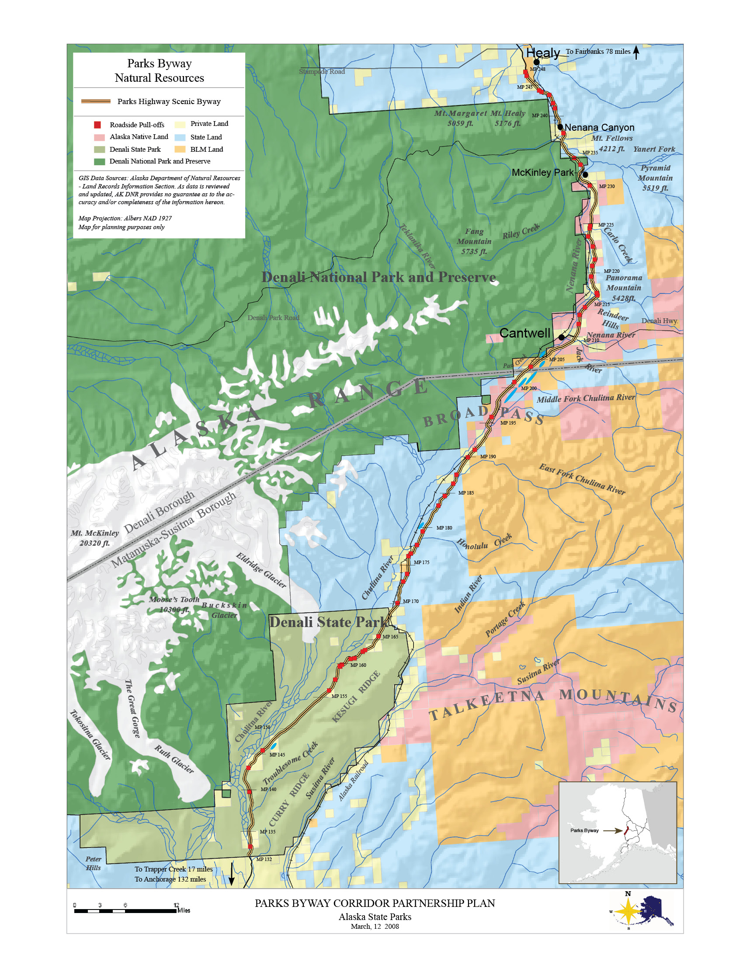

Figure 2. Parks Highway Scenic Byway Natural Resources
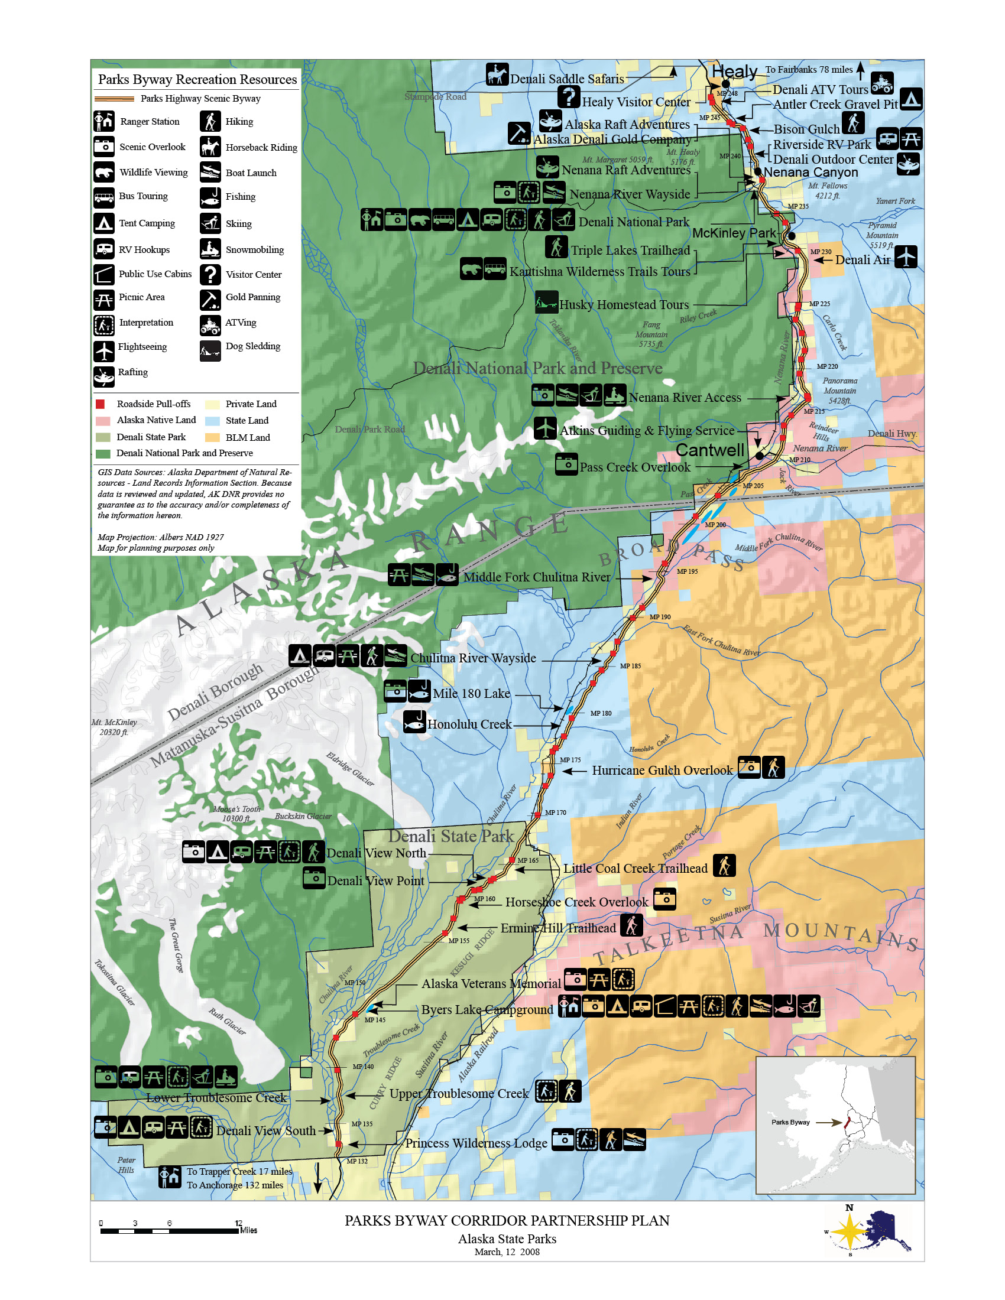

Figure 3. Parks Highway Scenic Byway Recreation Resources

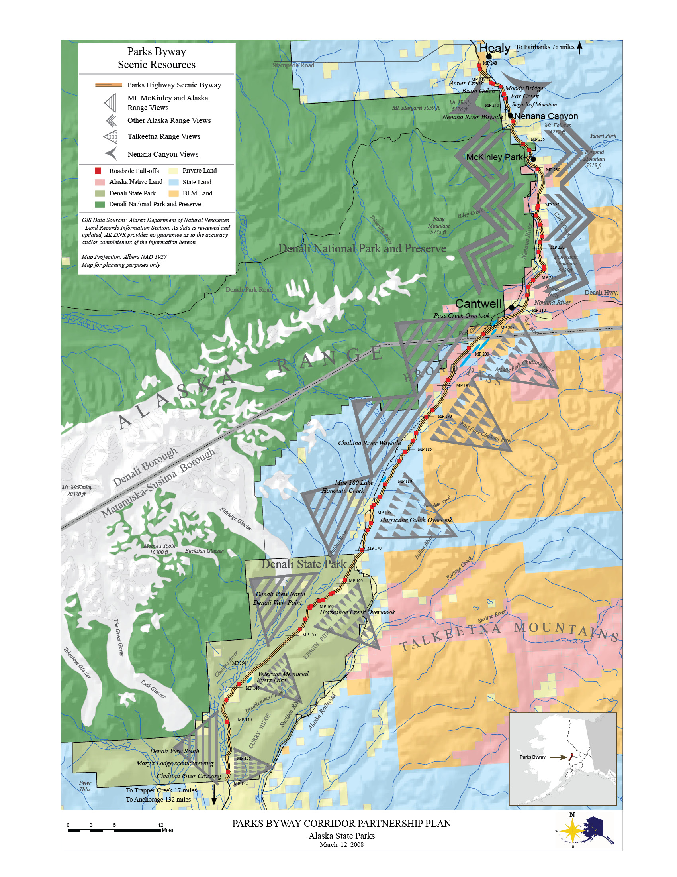

Figure 4. Parks Highway Scenic Byway Scenic Resources

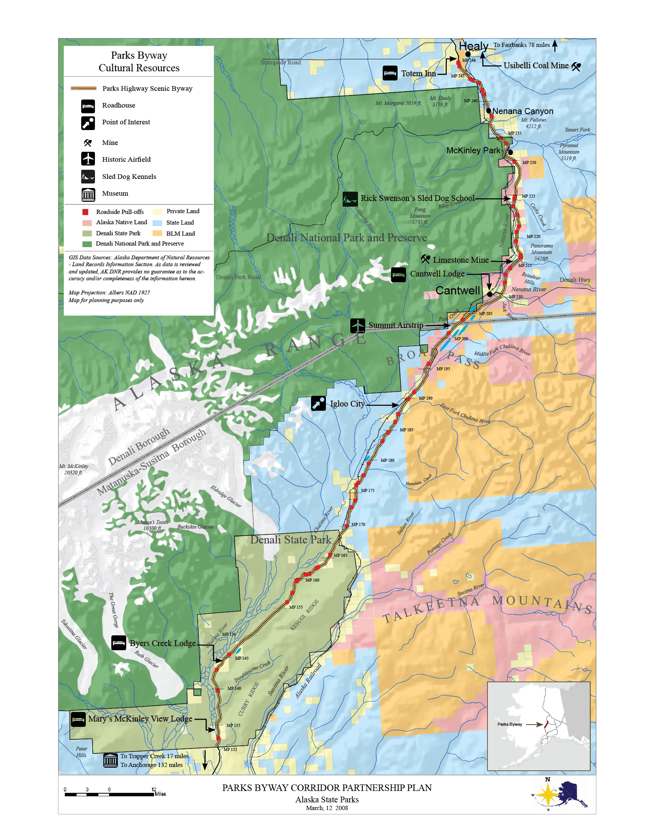

Figure 5. Parks Highway Scenic Byway Cultural Resources
5. TRANSPORTATION AND SAFETY

Introduction

This chapter presents an overview of the transportation system in the Denali region and how the Parks Byway fits into this system. Topics required by the National Scenic Byways Program that could influence the visitor’s experience are addressed here: traffic conditions and signs, commercial traffic, outdoor advertising, air and rail service, bus and shuttle service, and bicycle and pedestrian travel. Transportation system recommendations from the Alaska Department of Transportation and Public Facilities (ADOT&PF) 2006 Parks Highway Visioning Document are provided at the end of this chapter.

Transportation System Overview

The Parks Byway is the backbone of the transportation system through central Alaska. It is a vital link connecting numerous communities in Southcentral Alaska to the northern regions of the state and is paramount for community connections and commerce on both statewide and regional levels. This link serves this region as the main trunk for a network of connector roads, city streets, destination recreation areas, local traffic, commercial establishments, and through passenger and freight traffic.1 For many rural communities, the byway is their lifeblood. Serving as the main street for most of the communities it passes through, the byway enables local residents to get to work, school, visit friends, and recreate. Others employ the route for private and commercial through traffic to Fairbanks, Anchorage, and destinations in, between, or beyond. There are no alternate routes through this region.

Most of the byway is a two-lane road with varying paved shoulders. There are segments of byway that have divided controlled access with frontage roads. Mileposts along the Parks Byway do not begin with zero. Instead, they begin with milepost 35, continuing the milepost numbering of the Glenn Highway where the two highways intersect near Palmer. Thus, mileposts along the Parks Highway reflect the distance from Anchorage, which is not actually on the Parks Highway.

One concern in this corridor relates to summer traffic flow and the mix of recreation and residential traffic. On any given weekend or holiday during the summer, recreation traffic increases sharply due to people traveling to destinations such as key trailheads or fish streams. Tourism traffic is evident in the large number of recreation vehicles, pedestrians crossing the street, and fast-moving tour buses. Land adjacent to the byway provides for many functions during all seasons, including pullouts, recreation access, bike trails, public and commercial establishment parking, raft launches, trailheads, and camping.

Traffic Volumes

Average daily traffic ranges are quite low on the byway—from between 1210 and 2312 vehicles per day (Table 1). This data is from 2006, the most recently compiled year. Traffic volumes in 2006 are up slightly from 2004, although it’s interesting to note that volumes dropped at an average of over 600 vehicles per day at the entrance to Denali National Park and Preserve.

In general, traffic volumes along the corridor decrease from the Wasilla area north to the entrance of Denali National Park and Preserve, where volumes then begin to increase north to the Fairbanks area. The Parks Byway has high seasonal variations in traffic volumes in the rural and high recreation use areas along the corridor. In 2000, increases of over 100% were recorded during summer in some areas.

Table 1: 2004-2006 Parks Highway Scenic Byway Traffic Volumes
Milepost | Feature | Average Daily Volumes
 |  | 2004 | 2006
132.7 | Chulitna River bridge | 989 | 1210
146 | Byers Lake Campground entrance | 1102 | 1203
185 | East Fork Chulitna River | 1380 | 1390
209.9 | Jct. with Denali Hwy | 1912 | 2312
237.3 | Jct. with Denali Park road | 2862 | 2225
249 | Jct. with Healy spur road | 1979 | 2166
Source: ADOT&PF Alaska Highway Data section of ADOT&PF website.

Safety and Accident Record

The Scenic Byway segment of the Parks Highway is a safe road and safety will only improve as planned upgrades are completed in problem areas. Accident data collected in 2005, the most recently compiled year, show 85 accidents for the year (Table 2). The overwhelming majority of these accidents resulted in property damage or minor injuries. Recent highway projects along the Parks Byway have improved general road conditions and safety, with priorities given mainly to reduction of at-grade railroad crossings, traffic control, and pedestrian access. However, there is still a need for passing, turning, and climbing lanes on some portions of the byway.2

Winter driving conditions can be challenging and account for a small percentage traffic accidents each year. Although ADOT&PF maintains the byway year-round, in the winter, snow, wind, and cold require extra preparation on the part of the traveler. Certain grades and alignments require caution during winter, especially the hills of Honolulu Creek and the East Fork of the Chulitna River. Before embarking, travelers can access a current ADOT&PF road report by phone or online.

Moose and other wildlife on the roadway cause a small number of traffic accidents annually. It is ADOT&PF policy to clear vegetation in the right-of-way to allow drivers to see wildlife before the animals reach the roadway and to install warning signs in the most concentrated wildlife crossing areas.

Table 2: 2005 Parks Highway Scenic Byway Accident Data (Milepost 232-248)
Accident Severity | Number of Accidents
Fatal | 2
Major Injury | 10
Minor Injury | 22
Property Damage | 51
Total Accidents | 85
Source: ADOT&PF, 2005 Accident Report

Signage and Outdoor Advertising

Private and commercial signage along the byway is minimal and adequate; what does exist is not intrusive or inappropriate. Private signs clustered within communities leave large tracks along the byway without signage. Signage requirements come under the jurisdiction of ADOT&PF and the Matanuska-Susitna and Denali boroughs.

Mile markers and Alaska Scenic Byway signs dot the byway. The Alaska Scenic Byway signs may be confusing to some visitors; most signs show only an image of a blooming fireweed and do not actually indicate through text that the traveler is on a state byway. The ADOT&PF has plans to install lettered byway signs approximately every 15 miles on the Parks Byway in 2008 and 2009.

Signs between the boroughs show a lack of continuity. Signs in the Denali Borough mark roadside parking and scenic viewpoints, while those in the Matanuska-Susitna Borough do not. Sign consistency between both boroughs would present the byway as a unified, continuous route. Overall, signage is satisfactory but minor improvements could be made. For example, additional signage is needed to better direct visitors to recreation areas and trailheads.

In 1998, Alaska voters passed one of the most restrictive outdoor advertising laws in the country by a 72 percent majority. As a result, billboards and outdoor, off-premise advertising are prohibited in the state. The local boroughs and the ADOT&PF Right-of-Way Section enforce outdoor advertising within the byway corridor. Given the existing laws, outdoor advertising should not be a significant issue along the Parks Byway.

Commercial Traffic

The Parks Byway is a critical link in Alaska’s commercial trucking network, serving a large volume of daily truck movements between Anchorage and Fairbanks. It is also a direct route to the economically vital oil fields of the North Slope region from Anchorage. The fundamental traffic conflict is that of speed. Generally, commercial traffic prefers higher speeds and tourist traffic prefers a more leisurely speed to allow for unexpected stops and viewing. As such, the Parks Byway must continue to be oriented toward handling all forms of ground transportation, including both commercial and through traffic, while still supporting the safe and efficient flow of localized traffic in key areas.

Air Service

The Parks Byway provides access to numerous public airfields, many of which are capable for expansion and future development. Tour companies operating out of offices based at these airfields offer visitors sightseeing and glacier landing tours. Countless lakes provide wilderness access for floatplanes.

Alaska Railroad State Scenic Byway

The Alaska Railroad, the main line of which parallels the entire length of the Parks Highway, provides both passenger and freight service. Flag stops along the route provide wilderness access and allow Parks Byway travelers to hop aboard at various locations to experience another method of transportation. The Alaska Railroad also offers custom trips in the region. The Denali Star Train runs between Anchorage and Fairbanks with stops at Talkeetna, Curry, and Denali National Park and Preserve.

Bus and Shuttle Travel

A variety of bus and shuttle services transport visitors in and around Denali National Park and Preserve. Two narrated bus tours are provided for park visitors, the Tundra Wilderness Tour and the Natural History Tour. In addition to tour buses, there is also a variety of transportation options for visitors moving around the park frontcountry and to and from communities along the Parks Byway. Courtesy vans and busses operated by local businesses transport visitors from their establishments along the byway to and around the park. This particular service is being refined in order to provide a more valuable alternative for adventure-seeking visitors lodging in hotels along the corridor. All bus services offered within the national park, including the Savage River Shuttle, the Dog Sled Demonstration Shuttle, and the Riley Creek Loop Shuttle, are concession-operated. A consolidated shuttle bus/transit system serving Parks Byway communities and managed as a partnership between the National Park Service, the business community, and potentially local government is in the initial planning stages.3

Bicycle and Pedestrian Travel

Paved shoulders, six feet or more in width, extend the length of the byway and provide good accommodation for bicyclists. Shoulders on some bridges along the byway are narrower than the highway shoulders, but still provide adequate accommodation for pedestrians and bicyclists. In developed areas such as the Nenana Canyon commercial area, ADOT&PF has constructed separated paths and separated trails as part of improvement projects.4

2006 Parks Highway Visioning Document

The ADOT&PF recently completed a regional transportation study intended to describe a future vision for the Parks Highway. This study serves as the conceptual basis for a more detailed future planning effort. Most of the large-scale improvements suggested in the document will require additional federal funding and direction from the Alaska Department of Administration and the Alaska State Legislature. Based on 2030 traffic projections, the visioning document included the following future recommendations along the Parks Byway.

Trapper Creek – Broad Pass. There is a need for passing lanes in this area. It is likely that an upgraded, two-lane section outfitted with passing and climbing lanes with select, short, four-lane sections will be adequate to address 2030 traffic needs. There is a significant conflict between slow-moving and turning traffic viewing Mt. McKinley and faster moving through traffic. Frontage roads may be required from the Chulitna River to Byers Creek.

Cantwell – Carlo Creek. There is a need for passing lanes and climbing lanes in this region. It is possible that an upgraded, two-lane section outfitted with passing and climbing lanes with an interchange, a short four-lane section, and frontage roads in Cantwell may be adequate if traffic volumes warrant and funding is available.

Carlo Creek – McKinley Park. There is a need for passing lanes and climbing lanes on this section of byway. Also needed are turning lanes to accommodate the numerous driveways in McKinley Park. A continuous frontage road system extending the full length of this section of the byway is the ultimate vision. This frontage road system would ideally connect to the byway at several interchanges or unsignalized, at-grade intersections. Further investigations will determine if an upgraded, two-lane section with the frontage road system will be necessary in 2030 if traffic volumes warrant and funding is available.

McKinley Park – Nenana Canyon. The heart of this section is Nenana Canyon, or the Nenana Canyon Commercial District, a high volume, 1-mile segment just north of the entrance to Denali National Park. A safety project was recently completed north of the canyon. Several bypass options or some type of cut-and-clover design have been discussed as a long-term solution to handle through traffic in this area.

The entrance to Denali National Park needs turning lanes and other safety improvements. North of the Nenana Canyon area is a rural section with the need for passing lanes. Based on currently available volume projections, an improved two-lane section may be adequate through 2030.

Nenana Canyon – Healy. There is a need for passing and climbing lanes on this section of the byway. It is possible that an upgraded two-lane section outfitted with passing and climbing lanes and the interchange at the road to Anderson will be adequate if traffic volumes warrant and funding is available.

Transportation System Challenges and Opportunities

At present, there is sufficient capacity to accommodate travelers along the byway. Plans of the ADOT&PF and other entities will accommodate additional capacity, and increase the comfort and safety of travelers by improving signage and access to the byway’s attractions. One challenge that the Parks Byway faces with regard to transportation is funding for improvements. Without additional federal and state funding beyond the current levels, the Partnership and partner agencies may not be able to implement some of the suggestions in this document.

In addition to funding road improvements, funding for maintenance of byway facilities such as restrooms and snowy pullouts is another factor influencing the Parks Byway transportation system. Many restrooms are closed during the winter months because extreme cold makes pumping public restrooms impossible and funding for insulated or heated tanks is not available. During winter, travelers must be strategic about their restroom stops. Trapper Creek, Cantwell, and Healy have businesses with restroom facilities. Similarly, several byway pullouts lack litter receptacles. Some travelers will hold their trash until they reach a community but many byway pullouts accumulate litter during the busy summer season. Local residents will at times take responsibility for keeping these pullouts litter-free; however, this is not a maintainable situation.

The proposed South Denali Visitor Center in Denali State Park will go a long way in improving availability of visitor facilities and services at the southern end of the byway. This visitor complex will be open year-round, which will take off some pressure to maintain additional restrooms on the byway. A similar facility at the north end of the byway would be desirable in the future.
6. TOURISM AND MARKETING

Introduction

This chapter presents an overview of the tourism environment and how the Parks Byway fits into this environment. One of the primary goals of this plan is to enhance the economic vitality of local communities along the byway through a more developed tourism strategy. Most of the communities along the byway rely on the economic benefits derived from tourism and recreation travel-related activities. As such, strengthening the local tourism economy can represent an important part of the byway communities’ economic development strategy. Given that tourist numbers in Alaska are climbing, numerous opportunities exist for Parks Byway communities to capture additional tourist markets through expansion of marketing and promotional activities.

The Tourism Environment

Tourism is a major contributor to Alaska’s economy, second in revenue only to oil production, and the state’s largest renewable industry.1 Overall, travel and tourism’s economic impact stands out at more than 1.6 billion annually, representing 5.6% of Alaska’s gross state product.2 According to the Alaska Tourism Satellite Account, on average, each pleasure visitor to Alaska spends $2,430.3

Figure 2: Alaska Summer Visitor Volume
Sources: 2001-2004 data from Alaska Visitor Arrivals study (conducted by Northern Economics, Inc.);
2005 data based on 2006 visitor/resident ratios obtained fro AVSP V (conducted by McDowell Group, Inc.).

The number of summer visitors to Alaska has increased since 2001 (Fig. 2). Cruise travel fueled most of this growth in the last decade.4 The cruise ship industry does not limit visitors to water-based excursions. Rather, the tours they market to Alaskan visitors include “Land Only” and “Cruise Tours” (a combination of cruise and land travel) that combine a wide variety of experiences, destinations, and modes of travel, made available through regional hubs and partnerships with others in the travel industry. Princess Tours represents a major tourism interest on the byway, with two wilderness lodges on the route holding over 600 rooms each. Princess Tours brings over 100,000 people to the region annually, with a goal of increasing this number to 125,000 visitors per year. Holland America and Cook Inlet Region, Inc. are planning additional guest facilities in upcoming years that together will offer an additional 800 rooms.

Tourist travel on the Parks Byway is largely centered on the major tourist attraction of Denali National Park and Preserve, which attracted 415,935 visitors in 2006. Tourism in Denali is intensely seasonal, concentrated in a burst of visitation between May and September. During the summer months, seasonal, non-resident workers triple the Denali Borough’s population. The communities along the Parks Byway provide extensive services to park visitors, including accommodations, guide and charter services, and restaurants. The national park continues to provide the Denali Borough with a large source of revenue. A bed tax collected by hotels at the park's entrance supplies almost $2 million, 86% of the Borough's revenues, the money that helps pay for public services such as schools and road maintenance. 5

One option for expanding capacity, and potentially the benefits of tourism, is to increase tourism beyond the months of June through August. Options include strengthening the shoulder season to extend beyond May and September, and establishing new avenues for winter activities such as skiing, snowmobiling, dog sledding, and northern lights viewing. The open, snow-covered tundra makes an exceptional playground for winter recreation. Cantwell is taking advantage of this resource, marketing itself as an attraction for winter recreation pursuits like snowmobiling. Denali State Park already offers great winter access for skiing, snowmobiling, snowshoeing, dog sledding, northern lights viewing, and winter camping. The proposed South Denali Visitor Center will offer even more winter activities including winter environmental education, cultural workshops, groomed Nordic ski trails, and public use cabins and huts. Reaching out to travelers by expanding promotional activities and through partnerships with established visitor industries, such as the cruise ship and railroad industries, will encourage additional byway travelers, who will stay longer, enjoy their trip more, and keep coming back.

Tourism and Marketing Challenges and Opportunities

Interpretive and travel publications and electronic media will represent the crux of the marketing strategy for the Parks Byway. Developing and implementing a byway marketing plan is essential to realizing the byway’s tourism and economic development potential. This marketing plan will look at past travel trends and future projections, identify both national and international target markets, identify multi-lingual needs, and help position the Parks Byway as a world-class drive. The plan would also recommend which marketing tools would be most appropriate to reach each of the target markets. The Denali and Matanuska-Susitna boroughs each have a Chamber of Commerce and Alaska State Parks and the National Park Service operate visitor centers on the byway. The Parks Byway Community Partnership will use the resources of these and other organizations to promote and publicize the byway both locally and nationally.

One challenge influencing the tourist market is the availability of housing for seasonal employees. In the summer season, the Denali Borough experiences a shortage of accommodations for seasonal residents. Growth of the tourist market in these communities could see a parallel growth in seasonal residents. A similar challenge concerns the capacity of existing recreational facilities and visitor accommodations, many of which may be at carrying capacity. A regional assessment of existing and projected seasonal housing, recreational facilities, and visitor accommodation needs may prove valuable.

The Parks Byway is fortunate to have many active players interested in its success. Strategic alliances with local chambers of commerce, visitor bureaus in Fairbanks and Anchorage, the Alaska Travel Industry Association, the Alaska Wilderness Recreation and Tourism Association, other byway organizations, and state and federal agencies would allow available byway funds to be used with a singular, organized purpose. Coordination with other planning efforts for public facilities affecting the byway, such as the proposed South Denali Visitor Center, would ensure a consistent message and provide an integrated, regional marketing strategy.
7. INTERPRETATION

Introduction

This chapter highlights existing Parks Byway interpretive media and messages, and suggests additional messages that would improve the visitor experience. This chapter also looks at the byway’s ability to direct travelers to byway opportunities, thus enhancing the visitor experience while at the same time supporting local businesses.

Existing Experience

Existing interpretation along the Parks Byway corridor is limited and only represents a fraction of the byway’s interpretive potential. The following is a summary of interpretive sites on this segment on the Parks Byway, as they existed at the onset of the planning process. This section provides a baseline by which to justify the plan’s interpretive suggestions.

Mt. McKinley Princess Lodge. Denali State Park interpreters provide multiple interpretive programs at the lodge seven days a week. Topics range from wildlife to geologic processes of the Alaska Range. The lodge also hosts daily talks from guest service staff on topics such as the history of Alaska, the Iditarod, and the 1964 Good Friday earthquake. All talks and presentations are open to the public.

Mary’s McKinley View Lodge. This privately owned historic lodge was homesteaded in the early 1960s by the Late Mary Cary, regionally proclaimed historian, author, adventurer, and pioneer. The lodge provides interpretive offerings and sells local arts and crafts.

Denali View South Wayside. This Denali State Park wayside showcases scenic viewpoints, a short interpretive trail, viewing scopes, and interpretive panels on natural history topics such as Mt. McKinley’s mountaineering history and Alaska Range weather. In summer, State Park volunteers give informal oral presentations.

Lower Troublesome Creek. A double-sided kiosk provides limited interpretation on Denali State Park bears, hiking, plants, and moose.

Upper Troublesome Creek. A double-sided kiosk provides limited interpretation on Denali State Park bears, scenic viewing, and safety concerns.

Byers Lake Campground. This Denali State Park visitor facility has a number of kiosks and bulletin boards containing interpretive and informational displays. Topics currently explored include the history of the area, birds, safety information, bears, Mt. McKinley, glaciers, and winter activities.

Alaska Veterans Memorial. This popular Denali State Park picnic spot includes a number of interpretive displays on World War II and natural and cultural history topics. The Alaska Veterans Memorial consists of interpretive sculptures and an alcove with a semi-circle of five 20-foot-tall concrete panels, one for each branch of service. A non-profit friends group manages a summer-operated visitor center, staffed by volunteers who give informal oral presentations.

Denali View North Campground. This Denali State Park facility features camping and picnic sites. This site offers visitors spotting scopes, a nature trail, and interpretive kiosks with panels on topics such as Mt. McKinley’s mountaineering history, bears, Leave No Trace Techniques, and scenic viewing of the Alaska Range. State Park volunteers give informal oral presentations in summer.

Little Coal Creek Trailhead. A kiosk provides limited interpretation on bears, moose, plants, and safety concerns.

Denali National Park and Preserve. This national park provides numerous interpretive and educational facilities both onsite and offsite to visitors, families, schoolchildren, and other audiences. These resources include the Denali Center for Resources - Science and Learning, the Murie Science and Learning Center, the Denali Visitor Center, the Eielsen Visitor Center, the Denali Bookstore, the Wilderness Access Center, the Backcountry Information Center, and entrance area interpretive trails. The park also sponsors natural history tours, campfire interpretive programs, guided and self-guided hikes, and sled dog demonstrations.

Nenana River Bridge Wayside. A pedestrian path begins here at milepost 238 on the west side of the byway that leads south to the Denali Park entrance. An interpretive kiosk provides information on natural and cultural history topics.

Existing and Potential Interpretive Themes

The subsequent interpretive themes are those ideas, concepts, and stories central to the nature of the Parks Byway. These themes are essential to visitor understanding and appreciation, and although they do not include everything that may be interpreted, they do address those ideas that are critical to understanding and appreciating the Parks Byway’s significance.

Byway interpretive themes should be unified and consistent across the corridor’s parks, visitor centers, and interpretive sites. The Denali National Park and Preserve interpretive team works with a number of major interpretive themes, all of which also relate to the Parks Byway.1 Interpretive messages along the byway could incorporate some of these tested themes and theme statements:

Intact Natural Ecosystems. This healthy, functioning ecosystem provides the opportunity to discover the connective force of nature and experience our natural heritage.

Wildlife and Wildlife Habitat. The size and ecological integrity of the area preserves a home of unequaled quality for populations of large northern mammals, birds, and other wildlife.

Mountain Massif and Geologic Processes. Towering above this northern landscape, Mt. McKinley and the Alaska Range embody a power and beauty that captivates human imagination, and inspires exploration and protection of the region’s landscapes, wildlife, and wilderness.

Wilderness Values and Wilderness Recreation. The region’s wilderness character and the values it embodies provide unparalleled opportunities for people to experience wild America.

People and the Land. People have interacted with this landscape through time, allowing its attributes to shape their character, lives, and values as they seek to define their relationship with the natural world.

Dynamic Change. On a scale that diminishes the human lifespan, cycles and forces tremendous in scope influence the region’s landscapes and its inhabitants.

There is also the potential to branch out in other directions, to tell additional stories about the corridor and the broader topics of connections and the Alaskan way of life. Potential themes might include:

Denali Country Gateway. The Parks Byway serves as the primary gateway to the spectacular Denali region of Alaska.

Frontier Culture and Pioneer History. The communities of the Parks Byway are rich in a shared frontier culture discernible by past and present trappers, miners, explorers, mountaineers, and homesteaders and characterized by self-sustainability and traditional values.

Recreation in Alaska. From extreme winter sports to berry picking to leisurely wildlife viewing, recreation in Alaska is multi-faceted and in a class all its own. What many people may call recreation is a way of life and a means of survival to rural Alaskans living along the byway.

Outside Connections. This remote region holds interesting state, national, and global connections. From international adventurers to World War II activities, this region links to the rest of the world in surprising ways.

Interpretation Challenges and Opportunities

Developing and implementing an interpretive plan for the Parks Byway would promote stewardship, enhance visitor connections to the byway’s unique landscapes and cultures, update existing interpretation, and tie together the different resources and sites along the byway. An interpretive plan would also serve to guide development of interpretive media in a meaningful, consistent way. It is recommended that the byway organization work with the Alaska Scenic Byways Program to design interpretive signage and other media consistent with state standards.

An on-board and on-route information system linked to interpretation would accomplish several objectives for the byway: to orient travelers, to provide travelers with information on byway opportunities, and to encourage visitors to frequent local businesses and attractions. Information panels and bulletin boards should have a uniform appearance similar in style to interpretive panels in order to link byway interpretation with visitor information and orientation.

8. VISION, GOALS, AND OBJECTIVES

This chapter represents what the Parks Byway Community Partnership envisions for the future of the Parks Byway and documents what the byway organization would like to accomplish specifically with this Corridor Partnership Plan. Throughout a series of meetings over the course of this project, the Partnership created the following vision statement and goals and objectives, which were designed to be easy to understand and straightforward to implement

Vision Statement

Take a journey on the Parks Byway into the wilds of Alaska. Experience breathtaking views clear to the horizon of majestic mountains, including Denali (Mt. McKinley), North America’s highest peak. The Parks Highway Scenic Byway takes you from the birch and spruce forests of the Upper Susitna River Basin through the Alaska Range’s wide-open alpine tundra. It passes steeply carved hillsides, broad open plains, glacier fed rivers, and clear water streams—a landscape carved over time by snow and ice and other natural forces.

Through cooperative planning and continued sustainable development, the Parks Byway Community Partnership is dedicated to maintaining the scenic qualities of the byway corridor and to honoring the spirit of the last frontier by providing travelers with a safe, comfortable, and educational adventure for all who visit to enjoy. The Parks Byway Community Partnership further enhances communities and places of interest along the corridor, promotes tourism, supports the local culture, and adds to the economic base of the region.

The Parks Highway Scenic Byway, a place where people value their connection to the land for recreation, self-sufficiency, and continuing cultural traditions; a land where the independent, frontier spirit of the people is reflected in the uniqueness of their rural communities.

Goals and Objectives

Goal 1: Develop a sustainable Parks Byway Community Partnership to provide for the long-term viability of the Scenic Byway.

Objective A: Pursue and attain status as an All-American Road.

Objective B: Formalize the Partnership organizational structure for administrative, financial, and operational purposes.

Objective C: Strengthen and promote the Partnership through increased public and stakeholder participation in planning and implementation efforts.

Objective D: Develop methods to regularly communicate with the public and byway stakeholders on ongoing and future Partnership efforts.

Goal 2: Protect and enhance the intrinsic qualities of the byway through cooperative planning, education, and partnerships.

Objective A: Collaborate with private and public entities and agencies to protect and improve scenic viewing opportunities along the byway.

Objective B: Work with stakeholders and landowners to encourage protection of natural resources along the byway and in gateway communities.

Objective C: Promote and support respectful development that offers visitors and Alaskans opportunities to experience the byway’s natural, cultural, and recreational resources.

Objective D: Preserve and enhance the byway’s historical, cultural, and archaeological resources through consultation and planning with byway communities and appropriate agencies.

Goal 3: Develop and implement an interpretive plan to promote stewardship and connections to the byway’s unique landscapes and cultures.

Objective A: Use the interpretive plan to develop consistent and complimentary informational and educational materials.

Goal 4: Develop and implement a marketing plan that enlightens visitors to opportunities along the byway and in neighboring gateway communities.

Objective A: Create a multi-season marketing plan that will promote year-round use and enjoyment of the byway by Alaskans, national, and international travelers.

Objective B: Highlight the uniqueness of the byway communities by recording and including local stories in informational, educational, and interpretive materials.

Goal 5: Support enhancing traveler services and facilities along the byway to provide a safe and enjoyable travelling experience for all users.

Objective A: Support development of a transportation service that enables both visitors and residents to travel safely and efficiently within and between communities.

Objective B: Support a multi-modal approach to the visitor experience that connects areas of the byway via rail, trails, river, and road.

Objective C: Engage with stakeholders and byway communities to inventory and plan for meeting travelers’ basic needs in all seasons. Promote respectful and sustainable development that complements the local character.

Objective D: Work with user groups, community members, and the appropriate agencies to identify and accommodate the needs of non-vehicular byway traffic. Develop a plan for year-round, multi-use trails along the byway and in gateway communities that allows for a safe and enjoyable journey.

Objective E: Support the acquisition of private and public funding to improve and maintain byway facilities and services.

9. IMPLEMENTATION

This chapter outlines implementation responsibilities to ensure that this plan’s vision, goals, and objectives are carried out. This plan is a representation of the Parks Byway Community Partnership’s vision for the Parks Byway. As such, the Partnership will play a pivotal role in overseeing implementation activities, which will require cooperation from the ADOT&PF, the Matanuska-Susitna Borough, the Denali Borough, the National Park Service, Alaska State Parks, Native organizations, Chambers of Commerce, and other agency and individual representatives as appropriate.

Parks Byway Community Partnership Responsibilities

The Parks Byway Community Partnership will act as the administrative entity to implement this plan. To ensure viability of the byway, the structure and organizational framework of the Partnership will be left in place or improved once national All-American Road designation is received. The Partnership will coordinate with the ADOT&PF to maintain the intrinsic qualities of the byway, prioritize byway enhancements for grant applications, oversee grant application processes, identify significant issues over time, seek private and public funds to implement the goals and strategies identified in this plan and if needed, establish special sub-committees. It is important to note that the Partnership can only make recommendations and suggestions—it has no authority to mandate public or private policy. As such, the Parks Byway Community Partnership will be the guiding light for the success of the Parks Byway as a nationally designated All-American Road.

Ongoing Public Participation.

The public will continue to have input in the byway decision-making process. All Parks Byway Community Partnership meetings will be publically advertised and open to the public. Outreach to new members will be encouraged. Reaching out to new partners that share the byway’s vision will ensure the vitality and longevity of the Parks Byway Community Partnership. Similarly, assuring that the implementation team is composed of stakeholders with varied interests will guarantee the likelihood of the plan’s implementation.

9. CONCLUSION

There is no doubt that the Parks Byway is a world treasure that is unlike any other byway in the nation. Were else can you see the tallest mountain in North America and the five largest mammals in the Northern Hemisphere? Where else can you have your pick of unique outdoor recreational activities—from adventure sports like whitewater rafting and glacier hiking to more relaxed activities like aurora watching and berry picking? Where else can you sit spellbound, while listening to the bravery and courage of early adventurers? The Parks Byway’s 116 miles of wild and scenic views, multi-use outdoor recreation opportunities, and unique frontier culture and pioneer history place it among the greatest driving experiences in the United States. The Parks Byway provides tremendous opportunities for Alaskan residents and international and other visitors to experience the spirit, grandeur, wildness, and abundance that is Alaska.

This Corridor Partnership Plan represents a strategy that acknowledges this world-class resource, while recognizing that a coordinated implementation strategy between partners is essential for the preservation and enhancement of the corridor’s resources. Change is coming to the region. As the South Denali area appears to be on the brink of a period of rapid growth, these efforts will help to maintain current facilities, plan new ones accordingly, improve visitor experience and safety, and preserve the area’s natural and cultural character.

The intrinsic qualities of the Parks Byway make traversing it an experience to treasure. It is the hope of the individuals who have cooperated in this plan that this cooperative effort maintains the unique character of this exceptional byway.

10. ACKNOWLEDGMENTS

Preparation of this Corridor Partnership Plan included the input of many individuals and groups as well as the residents of the communities along the Parks Byway.

Parks Byway Corridor Partnership

Armeda Bulard, Cantwell Lodge, Denali Borough Assembly
Becky Buxton, Princess Tours
Beverly Grenz, Denali Outpost Bed and Breakfast
Cass Ray, McKinley Park Resident
Chuck and Judy Saylor, Healy Residents
Dan Valentine, Denali State Park Ranger
David Talerico, Mayor, Denali Borough
Dominic Canale, Doyan Aramark
Eileen McGurk, Cantwell RV Park and Campground
Elwood Lynn, Assistant Superintendent of Operations, Denali National Park
Emerson Krueger, Planner, Matanuska-Susitna Borough
Gordon and Rachel Carlson, CLI Construction
Howard Carbon, Alaska Nature Guides, Mat-Su State Park Citizens Advisory Board
Ingrid Nixon, Chief of Interpretation, Denali National Park
Julia Potter, Denali Citizens Council, Healy Chamber of Commerce
Miriam Valentine, Park Planner, Denali National Park
Neal Laugman, Healy Chamber of Commerce, McKinley Media Corps
Rodney Norwood Marsh, Mat-Su Commission for Historic Preservation
Sharlene Berg, CIRI
Steve Jones, Denali Borough Planning Commissioner
Vernon Carlson, Denali Borough School Board
Wayne Biessel, Superintendent, Denali State Park

Further Support Given By:

Aneta Synan, ADOT&PF, State Scenic Byways Coordinator
Dave Sanches, ADOT&PF, Area Planner, Northern Region
Mary Jane Sutliff, ADOT&PF, Area Planner, Matanuska-Susitna Borough

Prepared for the Alaska Department of Transportation and Public Facilities By:

The Department of National Resources, Alaska State Parks, Interpretation and Education:
Penny Bauder, Planner, CPP Project Manager
Bill Kiger, Natural Resource/Interpretive Manager
Meg Anderson, Publications Specialist

APPENDIX: PARKS HIGHWAY SCENIC BYWAY CORRIDOR RESOURCE INVENTORY

Parks Highway Scenic Byway Corridor Resource Inventory

E = Existing P=Planned O=Opportunity NB=Northbound SB=Southbound B=Both sides **open year-round (most resources are closed in winter)
NAT = Natural qualities; REC = Recreation opportunity; SV = Scenic viewing; CULT = Cultural site; HIST = Historic site;
MP | Resource |  | Intrinsic Quality |  |  | Side of Hwy. |  |  |  |  |  | Rec. Water Access | Restrooms |  | Parking |  | Interpretive Sites |  | Picnic Areas |  | Scenic Viewing |  | Trailhead |  |  | Camping | Comments
131.8 | Scenic Byway signs |  |  |  |  | B |  |  |  |  |  |  |  |  |  |  |  |  |  |  |  |  |  |  |  |  | Signs need to be labeled 'start byway' NB and 'end byway' SB
Note: Road changes quality here; good views of Mt. McKinley
132.3 | Denali State Park boundary |  |  |  |  |  |  |  |  |  |  |  |  |  |  |  |  |  |  |  |  |  |  |  |  |  | Southern park boundary; signed
132.7 | Chulitna River Bridge |  | REC; SV |  |  |  |  |  |  |  |  |  |  |  |  |  |  |  |  |  |  |  |  |  |  |  | Fishing for salmon, rainbows, and grayling
133 | Gravel pull-off |  | REC |  |  | SB |  |  |  |  |  |  |  |  | E |  |  |  |  |  |  |  |  |  |  |  | Short walk leads down to Chulitna River
134.5 | Mary's McKinley View Lodge |  | CULT; SV; HIST |  |  | SB |  |  |  |  |  |  | E |  | E |  | E |  |  |  | E |  |  |  |  |  | Historic lodge; Mary is an area legend; great views
134.6 | Proposed S. Denali Visitor Center |  | REC; NAT; SV |  |  | NB |  |  |  |  |  | P | P |  | P |  | P |  | P |  | P |  | P |  |  | P | Proposed road to South Denali Visitor Center; VC will bring many more opportunities to experience the corridor’s resources
134.7 | Denali View South |  | REC; NAT; SV |  |  | SB |  |  |  |  |  |  | E |  | E |  | E |  | E |  | E |  | E |  |  | E | Paved campsites; picnic area; great views of Alaska Range; short interpretive trail to overlook
137.3 | Lower Troublesome Creek |  | REC; NAT |  |  | SB |  |  |  |  |  |  | E  O |  | E |  | E |  | E |  |  |  | E |  |  | E | Double-ended pull-off; campsites; trail to river; fishing; winter access; need for year-round restroom
MP | Resource |  | Intrinsic Quality |  |  | Side of Hwy. |  |  |  |  |  | Rec. Water Access | Restrooms |  | Parking |  | Interpretive Sites |  | Picnic Areas |  | Scenic Viewing |  | Trailhead |  |  | Camping | Comments
137.7 | Upper Troublesome Creek |  | REC; NAT |  |  | NB |  |  |  |  |  |  | E |  | E |  | E |  |  |  |  |  | E |  |  |  | 15 mile hike to Byer's Lake campground; interp opportunities
140 | Paved pull-off |  |  |  |  | SB |  |  |  |  |  |  |  |  | E |  |  |  |  |  |  |  |  |  |  |  | Small area; distance marker SB: Wasilla 98 miles, Anch. 140 miles
Note: Great views of the Alaska Range to the west; potential SV and interpretation opportunity
143 | Gravel pull-off |  |  |  |  | SB |  |  |  |  |  |  |  |  | E
144 | Byers Creek Lodge ** |  | CULT; REC |  |  |  |  |  |  | E |  |  | E |  | E |  |  |  |  |  | E |  |  |  |  |  | Last lodge before Cantwell; unsigned
145.7 | Paved pull-off |  |  |  |  | SB |  |  |  |  |  |  |  |  | E |  |  |  |  |  |  |  |  |  |  |  | Small pull-off
146 | Byers Lake Campground |  | NAT; REC; SV |  |  | NB |  |  |  | E |  |  | E |  | E |  | E  O |  | E |  | E |  | E |  |  | E | 74 campsites; public use cabins; fishing; boating; wildlife viewing outdated interpretive panels need replacing; State Park access
147 | Alaska Veterans Memorial |  | REC; HIST |  |  | NB |  |  |  |  |  |  | E |  | E |  | E |  | E |  | E |  | E |  |  |  | Summer seasonal vistor center; winter trail to Byers Lake
156.3 | Gravel pull-offs |  | SV |  |  | B |  |  |  |  |  |  |  |  | E |  |  |  |  |  |  |  |  |  |  |  | Vacant buildings on NB side; good views of Kesugi Ridge
156.5 | Ermine Hill Trailhead |  | NAT; REC |  |  | NB |  |  |  |  |  |  |  |  | E |  |  |  |  |  |  |  | E |  |  |  | State Park access; information needed on trail specifics
157.7 | Paved pull-off |  |  |  |  | SB |  |  |  |  |  |  |  |  | E
159.5 | Gravel pull-off |  | SV; NAT |  |  | NB |  |  |  |  |  |  |  |  | E |  |  |  |  |  | O |  |  |  |  |  | Good views of Kesugi Ridge
159.5 | Paved pull-off |  |  |  |  | SB |  |  |  |  |  |  |  |  | E |  |  |  |  |  |  |  |  |  |  |  | Double-ended pull-off
MP | Resource |  | Intrinsic Quality |  |  | Side of Hwy. |  |  |  | Rec. Water Access |  |  | Restrooms |  | Parking |  | Interpretive Sites |  | Picnic Areas |  | Scenic Viewing |  | Trailhead |  |  | Camping | Comments
159.8 | Gravel pull-off |  |  |  |  | SB |  |  |  |  |  |  |  |  | E |  |  |  |  |  |  |  |  |  |  |  | Undeveloped pull-off
159.9 | Horseshoe Creek Scenic Overlook |  | REC; SV |  |  | NB |  |  |  | E |  |  |  |  | E |  |  |  | O |  | E |  |  |  |  |  | Small parking area by creek; picnic opportunity; wildlife viewing
161.1 | Gravel pull-off |  |  |  |  | NB |  |  |  |  |  |  |  |  | E |  |  |  |  |  |  |  |  |  |  |  | Large pull-off
161.5 | Gravel pit |  |  |  |  | NB |  |  |  |  |  |  |  |  | E
162.4 | Denali View Point |  | NAT; SV |  |  | SB |  |  |  |  |  |  |  |  | E |  |  |  |  |  | E  O |  |  |  |  |  | Scenic viewing of the Alaska Range; brush clearing needed to improve views
162.7 | Denali View North Campground |  | REC; SV; NAT; REC |  |  | SB |  |  |  |  |  |  | E |  | E |  | E |  | E |  | E |  | E |  |  | E | 20 campsites; native plant walk; spotting scopes; views of AK Range; interpretation
162.8 | Gravel pull-off |  |  |  |  | NB |  |  |  |  |  |  |  |  | E |  |  |  |  |  |  |  |  |  |  |  | Paved shoulder parking
163.1 | Paved pull-off |  |  |  |  | SB |  |  |  |  |  |  |  |  | E |  |  |  |  |  |  |  |  |  |  |  | Large, double-ended pull-off
163.9 | Little Coal Creek Trailhead |  | NAT; REC |  |  | NB |  |  |  |  |  |  | E |  | E |  | O |  |  |  |  |  | E |  |  |  | State Park access; north end of park trail system
ROAD CONDITIONS MILE 132-163: 2 LANE PAVED; SHOULDERS 7-8 FEET WIDE; BRIDGES HAVE ADEQUATE SHOULDERS
165.5 | Paved pull-offs |  | REC |  |  | B |  |  |  |  |  |  |  |  | E |  |  |  |  |  |  |  |  |  |  |  | Creek; good berry picking
168 | Denali State Park boundary |  |  |  |  | B |  |  |  |  |  |  |  |  |  |  |  |  |  |  |  |  |  |  |  |  | Northern park boundary; entering sign SB; no leaving sign NB
Note: Winding hilly road northbound, foliage obscures sight line
170 | Paved pull-off |  | SV; NAT |  |  | SB |  |  |  |  |  |  |  |  | E |  |  |  |  |  | E |  |  |  |  |  | Large pull-off; scenic viewpoint; expansive views of AK Range
173 | Paved pull-off |  | SV; NAT |  |  | SB |  |  |  |  |  |  |  |  | E |  |  |  |  |  | E |  |  |  |  |  | Scenic viewpoint; good views of AK Range; small footpath to west
MP | Resource |  | Intrinsic Quality |  |  | Side of Hwy. |  |  |  | Rec. Water Access |  |  | Restrooms |  | Parking |  | Interpretive Sites |  | Picnic Areas |  | Scenic Viewing |  | Trailhead |  |  | Camping | Comments
173.9 | Paved pull-off |  |  |  |  | SB |  |  |  |  |  |  |  |  | E |  |  |  |  |  |  |  |  |  |  |  | Just south of bridge and a short walk to the gulch
174.1 | Hurricane Gulch Bridge pull-off |  | NAT; REC; SV; HIST |  |  | SB |  |  |  |  |  |  |  |  | E |  | O |  | O |  | E |  | O |  |  |  | Great veiw of natural gorge; unmarked trail off parking lot; needs expansion, walkway across bridge and interpretation; unsigned
176 | Paved pull-off |  |  |  |  | NB |  |  |  |  |  |  |  |  | E
Note: road begins to curve as byway descends long grade northbound to Honolulu Creek
176.5 | Paved pull-off |  | NAT; SV |  |  | SB |  |  |  |  |  |  |  |  | E |  |  |  |  |  | E |  |  |  |  |  | Narrow, doubled-ended turnout; Talkeetna mountains viewing
177.8 | Paved pull-off |  |  |  |  | NB |  |  |  |  |  |  |  |  | E |  |  |  |  |  |  |  |  |  |  |  | Small, paved parking area
178.1 | Honolulu Creek |  | NAT; REC |  |  | B |  |  |  | E |  |  |  |  | E |  | O |  |  |  |  |  |  |  |  |  | Access to creek to w. at north end of bridge; fishing; limited parking; geologic interpretive opportunities
179.5 | Paved pull-off |  | NAT; REC; SV |  |  | SB |  |  |  | E |  |  |  |  | E |  |  |  |  |  |  |  |  |  |  |  | Turnout by Mile 180 Lake; great bird habitat; footpath to lake
180 | Mile 180 Lake |  | NAT; REC; SV |  |  | SB |  |  |  | E |  |  |  |  | E |  | O |  |  |  |  |  |  |  |  |  | Double pull-off; fishing; limited parking; improvements could include increased parking & interp.
183.2 | Paved pull-off |  | NAT; SV |  |  | SB |  |  |  |  |  |  |  |  | E |  |  |  |  |  | E |  |  |  |  |  | Double-ended pull-off; views of AK Range and the Talkeetnas
184.5 | Paved pull-off |  |  |  |  | SB |  |  |  |  |  |  |  |  | E
185 | Bridge over the E. Chulitna River |  |  |  |  |  |  |  |  |  |  |  |  |  | E |  |  |  |  |  |  |  |  |  |  |  | Parking at south end of bridge; large gravel lot
185.6 | Chulitna River wayside |  | REC; NAT; SV |  |  | NB |  |  |  | E |  |  | E |  | E |  | O |  | E |  |  |  | E |  |  | E | 0.5 mile paved loop; overnight parking; campground host Potential trail to eroded bluffs and geologic interpretation
MP | Resource |  | Intrinsic Quality |  |  | Side of Hwy. |  |  |  | Rec. Water Access |  |  | Restrooms |  | Parking |  | Interpretive Sites |  | Picnic Areas |  | Scenic Viewing |  | Trailhead |  |  | Camping | Comments
186.3 | Paved pull-off |  | NAT; SV |  |  | SB |  |  |  |  |  |  |  |  | E |  |  |  |  |  | E |  |  |  |  |  | Small pull-off; view of eroded bluffs
Note: winding upgrade northbound
187.5 | Paved pull-offs |  |  | SV |  | B |  |  |  |  |  |  |  |  | E |  |  |  |  |  | E |  |  |  |  |  | Signed; double-ended pull-off on SB; small pull-off on NB
188.7 | Igloo |  |  | CULT |  | NB |  |  |  |  |  |  |  |  | E |  |  |  |  |  |  |  |  |  |  |  | Status unknown
190 | Gravel pullout |  |  |  |  | SB |  |  |  |  |  |  |  |  | E |  |  |  |  |  |  |  |  |  |  |  | double-ended; state scenic byway signs on both sides of road
191.1 | Paved pull-off |  |  | REC |  | SB |  |  |  |  |  |  |  |  | E |  |  |  |  |  |  |  |  |  |  |  | Large area; snow machine parking in winter
194.5 | Middle Fork Chulitna River Bridge |  |  | REC |  | SB |  |  |  | E |  |  |  |  | E |  |  |  |  |  |  |  | E |  |  |  | Gravel access to river at south end of bridge; good fishing
Note: Winding roads RR crossing
195 | Broad Pass |  |  | NAT; SV |  |  |  |  |  |  |  |  |  |  | E |  |  |  |  |  | E |  |  |  |  |  | One of the lowest passes in N. America; caribou & swan viewing
195.9 | Paved pull-off |  |  | NAT; SV |  | NB |  |  |  |  |  |  |  |  | E |  | O |  |  |  | E |  |  |  |  |  | Dramatic views; signed pull-off; interpretive opportunities
200.9 | Paved pull-off |  |  | NAT; SV |  | NB |  |  |  |  |  |  |  |  | E |  | O |  |  |  | E |  |  |  |  |  | Unsigned; large area; great views; interpretive opportunities
201.3 | Summit airstrip |  |  | HIST; SV |  | NB |  |  |  |  |  |  |  |  |  |  | O |  |  |  |  |  |  |  |  |  | WWII history; Mustang fighter base; summit airstrip
202.1 | Borough boundaries |  |  |  |  | B |  |  |  |  |  |  | O |  | O |  | O |  | O |  | O |  |  |  |  |  | Boundary of Mat-Su and Denali boroughs; Opportunity to provide information on both boroughs
203.5 | Paved pull-off |  |  | NAT; SV |  | NB |  |  |  |  |  |  |  |  | E |  |  |  |  |  |  |  |  |  |  |  | Dramatic views; large area
208 | Pass Creek Bridge |  |  | REC; SV |  | SB |  |  |  |  |  |  |  |  | E |  | O |  |  |  | E |  | O |  |  |  | Small viewpoint at S. end of bridge; caribou; berry picking; blank interpretive sign; potential trails to falls & Eldridge Glacier
MP | Resource |  |  | Intrinsic Quality |  | Side of Hwy. |  |  |  | Rec. Water Access |  |  | Restrooms |  | Parking |  | Interpretive Sites |  | Picnic Areas |  | Scenic Viewing |  | Trailhead |  |  | Camping | Comments
209 | Denali Hwy. distance marker |  |  |  |  | NB |  |  |  |  |  |  |  |  |  |  |  |  |  |  |  |  |  |  |  |  | "1 mile" to Denali Highway. sign
209.4 | Welcome to Cantwell sign |  |  |  |  | NB
209.4 | Jack River Bridge |  |  | NAT; REC; SV |  |  |  |  |  |  |  |  |  |  |  |  | O |  |  |  |  |  |  |  |  |  | Dramatic views; drumlins; interpretive opportunities
209.9 | Denali Highway ** |  |  | REC; SV; CULT; HIST |  | NB |  |  |  |  |  |  |  |  | E |  | O |  |  |  |  |  |  |  |  |  | Interpretive opportunities on northeast corner; Backwoods Lodge just off junction; byway loop
210 | Cantwell ** |  |  | CULT; HIST |  | SB |  |  |  |  |  |  | E |  | E |  | E |  | E |  | E |  |  |  |  | E | Town is 2 miles west of Parks Hwy; all amenities
210 | Cantwell Lodge ** |  |  | CULT; HIST |  | SB |  |  |  |  |  |  | E |  | E |  |  |  |  |  |  |  |  |  |  |  | Historic lodge and saloon; just off the Denali Hwy.
211.5 | Paved pull-off |  |  |  |  | SB |  |  |  |  |  |  |  |  | E |  |  |  |  |  |  |  |  |  |  |  | Signed, double-ended pull-off
212.7 | Gravel pull-off |  |  |  |  | SB |  |  |  |  |  |  |  |  | E |  |  |  |  |  |  |  |  |  |  |  | Small area
Note: Highway parallels Nenana River; views of slide area - NAT and SV qualities
213.8 | Paved pull-off |  |  |  |  |  | SB |  |  |  |  |  |  |  | E |  |  |  |  |  |  |  |  |  |  |  | Signed, double-ended pull-off; white spruce and fireweed
215 | Limestone Mine view |  |  | CULT; HIST |  |  | NB |  |  |  |  |  |  |  |  |  | O |  |  |  |  |  |  |  |  |  | Only limestone mine in AK; supplied Healy coal project; potential interpretive opportunity, but would need to install wayside
215.5 | Nenana River access |  |  | NAT; REC; SV |  |  | SB |  |  | O |  |  |  |  | E |  | O |  |  |  | E |  |  |  |  |  | Rd. leads 0.4 mile to river; jet boat tours; used by truckers
ROAD CONDITIONS MILE 163-216: 2 LANE; PAVED SHOULDERS 6-8 FEET WIDE
216 | Gravel pull-off |  |  |  |  |  |  | SB |  |  |  |  |  |  |  |  |  |  |  |  |  |  |  |  |  |  | Small area
MP | Resource |  |  | Intrinsic Quality |  |  |  | Side of Hwy. |  |  | Rec. Water Access |  | Restrooms |  | Parking |  | Interpretive Sites |  | Picnic Areas |  | Scenic Viewing |  | Trailhead |  | Camping |  | Comments
216.5 | Paved pull-off |  |  | NAT; SV |  |  |  | NB |  |  |  |  |  |  | E |  |  |  |  |  | E O |  |  |  |  |  | Signed; expansive views of Nenana River, Panorama Mountain and wilderness area; needs brush clearing
218.5 | Paved pull-off |  |  | NAT; SV |  |  |  | SB |  |  |  |  |  |  | E |  |  |  |  |  |  |  | O |  |  |  | Signed; great views of Nenana River and wilderness area; potential path to river
219.1 | Scenic Byway sign |  |  |  |  |  |  | NB
219.3 | Scenic Byway sign |  |  |  |  |  |  | SB
219.7 | Paved pull-off |  |  |  |  |  |  | SB |  |  |  |  |  |  | E |  |  |  |  |  |  |  |  |  |  |  | Double-ended paved pull-off
220.5 | Paved pull-off |  |  | NAT; SV |  |  |  | SB |  |  |  |  |  |  | E |  | O |  |  |  | E |  |  |  |  |  | Very large area - ends at 220.7; great views of AK Range and wilderness; potential to develop wayside here with interpretation
222.2 | Paved pull-off |  |  | SV |  |  |  | SB |  |  |  |  |  |  | E |  |  |  |  |  | O |  |  |  |  |  | Signed; scenic viewpoint opportunity
223.5 | Gravel pull-off |  |  |  |  |  |  | NB |  |  |  |  |  |  | E |  |  |  |  |  |  |  |  |  |  |  | Very small area
224 | Carlo Creek |  |  |  |  |  |  |  |  |  |  |  |  |  |  |  |  |  |  |  |  |  |  |  |  |  | Visitor services here - food, lodging
224.5 | Gravel pit |  |  |  |  |  |  | SB |  |  |  |  |  |  |  |  |  |  |  |  |  |  |  |  |  |  | DOT gravel pit area
224.8 | Gravel pull-off |  |  | SV |  |  |  | SB |  |  |  |  |  |  | E |  |  |  |  |  | E |  |  |  |  |  | No overnight camping sign; good views to the south
Note: Interesting views of Fang Mountain and erosion pillars to the west around milepost 226 - NAT and SV qualities
229.7 |  | Paved pull-off |  |  | SV |  |  |  | SB |  |  |  |  |  |  | E |  |  |  |  |  | E |  |  |  |  | Signed, double-ended paved pull-off
MP |  | Resource |  |  | Intrinsic Quality |  |  |  | Side of Hwy. |  |  | Rec. Water Access |  | Restrooms |  | Parking |  | Interpretive Sites |  | Picnic Areas |  | Scenic Viewing |  | Trailhead | Camping |  | Comments
231.4 |  | Triple Lakes Trailhead |  |  | NAT; REC |  |  |  | SB |  |  |  |  |  |  | E |  |  |  |  |  |  |  | E |  |  | Trail ends at Denali Park depot; parking needs to be expanded
231.5 |  | Gravel pull-off |  |  |  |  |  |  | NB |  |  |  |  |  |  | E |  |  |  |  |  |  |  |  |  |  | Small area
233.1 |  | Gravel pull-off |  |  | NAT: SV |  |  |  | NB |  |  |  |  |  |  | E |  |  |  |  |  | E |  |  |  |  | No overnight camping sign
234.2 |  | Paved pull-off |  |  | NAT; SV; REC |  |  |  | NB |  |  |  |  |  |  | E |  | O |  |  |  | E |  | O |  |  | Double-ended area; views of Mt. Fellows, Pyramid Peak; potential wayside with trailhead and restroom
ROAD CONDITIONS MILE 216-237: 2 LANE; PAVED SHOULDERS 7-8 FEET WIDE; AT LEAST TWO BRIDGES HAVE NARROW SHOULDERS
237.3 |  | Denali National Park |  |  | NAT; REC; CULT; SV |  |  |  | SB |  |  |  |  | E |  | E |  | E |  | E |  | E |  | E | E |  | NPS Visitor Center; sled dogs; dump station; campground; Murie Science and Learning Center; ANHA bookstore; trailheads
237.7 |  | Paved pull-off |  |  |  |  |  |  | SB |  |  |  |  |  |  | E |  |  |  |  |  |  |  |  |  |  | NPS sign; placement is confusing to visitors--looks like entrance
238 |  | Nenana River Bridge wayside |  |  | NAT; REC; SV |  |  |  | SB |  |  | E |  | E |  | E |  | E |  |  |  | E |  |  |  |  | Third crossing; helicopter tours and rafting to E.; pedestrian bridge on SB side of road; wayside interpretive exhibits
238-243 |  | Nenena River Canyon |  |  | REC; NAT; SV |  |  |  |  |  |  | E |  | E |  | E |  | E |  | E |  | E |  | E |  |  | Commercial area offering diverse visitor services, all amenities, many different recreation opportunities; Dall's sheep viewing
240.3 |  | Hornet Creek Bridge |  |  | SV |  |  |  |  |  |  |  |  |  |  | E |  |  |  |  |  |  |  |  |  |  | Double-ended parking
241.1 |  | Gravel pull-off |  |  | NAT; REC; SV |  |  |  | SB |  |  |  |  |  |  | E |  | O |  |  |  | E |  |  |  |  | Walking access to Fox Creek; geologic and AK Railroad interpretive opportunities
241.2 |  | Fox Creek Bridge
241.6 |  | Gravel pull-off |  |  | SV |  |  |  | SB |  |  |  |  |  |  | E |  | O |  |  |  |  |  |  |  |  | Large area; views of Nenena River; interpretive opportunities
MP |  | Resource |  |  | Intrinsic Quality |  |  |  | Side of Hwy. |  |  | Rec. Water Access |  | Restrooms |  | Parking |  | Interpretive Sites |  | Picnic Areas |  | Scenic Viewing |  | Trailhead | Camping |  | Comments
242.3 |  | Dragonfly Creek Bridge |  |  |  |  |  |  | SB |  |  |  |  |  |  | E |  | O |  |  |  | E |  |  |  |  | Unsigned; parking lot south of bridge; interpretive opportunities
242.7 |  | Paved pull-off |  |  | SV |  |  |  | SB |  |  |  |  |  |  | E |  | O |  |  |  |  |  | E |  |  | Double-ended turnout; interpretive opportunities (bridge history)
243 |  | Moody Bridge (also known as Windy Bridge) |  |  | NAT; HIST; SV |  |  |  |  |  |  |  |  |  |  |  |  |  |  |  |  |  |  |  |  |  | Fourth Nenana crossing spanning Windy Canyon; Dall's sheep viewing
243.8 |  | Bison Gulch Bridge |  |  | REC |  |  |  | NB |  |  |  |  |  |  | E |  |  |  |  |  |  |  | E |  |  | Small paved parking area at N. end of bridge; unofficial trailhead going up Mt. Healy on SB side of road
243.9 |  | Gravel pull-off |  |  | REC; SV |  |  |  | NB |  |  |  |  |  |  | E |  |  |  |  |  |  |  |  |  |  | Narrow road leading up to flat area; used by ATVers
244 |  | Gravel pull-off |  |  | SV |  |  |  | NB |  |  |  |  |  |  | E |  |  |  |  |  |  |  | O |  |  | Large area with abrupt edge; coal mining and geologic interpretive opportunities
244.4 |  | Antler Creek |  |  |  |  |  |  |  |  |  |  |  |  |  |  |  |  |  |  |  |  |  |  |  |  | Creek access to W. at south end of bridge
245 |  | Antler Creek gravel pit |  |  | REC; SV |  |  |  | NB |  |  |  |  |  |  | E |  | O |  |  |  | O |  |  | O |  | Interpretive potential; unofficial camping area; good scenic views
246.3 |  | Gravel pull-off |  |  |  |  |  |  | NB |  |  |  |  |  |  | E |  |  |  |  |  |  |  |  |  |  | Small area
246.9 |  | Paved pull-off |  |  | SV |  |  |  | NB |  |  |  |  |  |  | E |  |  |  |  |  |  |  |  |  |  | Unsigned; view of Mt. Healy
247.9 |  | Scenic Byway end sign |  |  |  |  |  |  | NB
248 |  | Healy ** |  |  |  |  |  |  | NB |  |  | E |  | E |  | E |  | E |  | E |  | E |  | E | E |  | Commercial area offering all visitor services
248.3 |  | Scenic Byway sign |  |  |  |  |  |  | SB |  |  |  |  |  |  |  |  |  |  |  |  |  |  |  |  |  | This is the only sign that actually says 'scenic byway AK'
248.7 |  | Totem Inn ** |  |  | CULT; HIST |  |  |  | NB |  |  |  |  | E |  | E |  |  |  |  |  |  |  |  |  |  | Historic lodge

? Federal Highway Administration National Scenic Byways Program. (1999). Byway Beginnings: Understanding, Inventorying, and Evaluating a Byway’s Intrinsic Qualities. Washington D.C.: Whiteman & Taintor with the National Park Service Rivers, Trails, and Conservation Assistance Program.
? Federal Highway Administration National Scenic Byways Program. Community Guide to Planning & Managing a Scenic Byway. Washington D.C.: R.D. Mingo & Associates.
1 1 Brown, G. (2002). Alaska Scenic Byways Statewide Study. Anchorage, AK: Alaska Pacific University.
2 2 National Park Service. (2006). Final South Denali Implementation Plan and Environmental Impact Statement.
3 3 Brown, G. (2002). Alaska Scenic Byways Statewide Study. Anchorage, AK: Alaska Pacific University.
4 4 Kari, J. and J.A. Fall. (2003). Shem Pete’s Alaska: The Territory of the Upper Cook Inlet Dena’ina. Fairbanks, AK: University of Alaska Press.
5 5 Brown, W.E. (1993). Denali, Symbol of the Alaskan Wild. Virginia Beach, VA: The Donning Company.
6 6 Brown, W.E. (1993). Denali, Symbol of the Alaskan Wild. Virginia Beach, VA: The Donning Company.
7 7 Sherwonit, B. (2000). Denali, a Literary Anthology. Seattle, WA: The Mountaineering Books.
8 8 Washburn, B. and P. Cherici. (2001). The Dishonorable Dr. Cook. Seattle, WA: The Mountaineers Books.
9 9 Dunn, R. (2001). The Shameless Diary of an Explorer. New York, NY: Random House, Inc.
1 10 Cole, T. (1985). The Sourdough Expedition. Anchorage, AK: Alaska Northwest Publishing Company.
1 11 Sherwonit, B. (2000). Denali, a Literary Anthology. Seattle, WA: The Mountaineering Books.
1 12 Walker, T. (2005). Kantishna: Mushers, Miners, Mountaineers. Missoula, MT: Pictorial Histories Publishing Company
1 13 Marsh, K.L. (2002). A River Between Us: The Upper Susitna River Valley. Trapper Creek, AK: Trapper Creek Museum Sluice Box Productions.
1 14 Greiner, J. (1974). Wager with the Wind. The Don Sheldon Story. Chicago, IL: Rand McNally & Company.
1 15 Carey, M. (1975). Alaska—Not for a Woman. Austin, TX: Eakin Press.
1 15 Carey, M. (1989). An Auto Trip to Alaska’s Shangri-La. Tex-Alaska Press.
1 16 State of Alaska, Department of Commerce and Economic Development. Denali Borough Economic Overview: <http://www.dced.state.ak.us/dca/AEIS/Denali/General/Denali_General_Narrative.htm> (20 November 2007).
1 17 Denali Borough. (2005). Proceedings of the Denali Summit: Envisioning the Future of the Denali Borough Communities. Healy, AK.
1 1 State of Alaska, Department of Transportation and Public Facilities. (2006). Parks Highway Visioning Document (AKSAS Project Number 74833). Anchorage, AK: CH2MHill.
2 2 Denali Borough. (2007). Comprehensive Plan, Draft May 10, 2007.
3 3 Denali National Park and Preserve. (2006). Needs Assessment & Feasibility Study for a Community Transportation System (Task Order Number T2000041414). Anchorage, AK: HDR Alaska.
4 4 State of Alaska, Department of Transportation and Public Facilities. (2006). Parks Highway Visioning Document (AKSAS Project Number 74833). Anchorage, AK: CH2MHill.
1 1 State of Alaska, Department of Commerce and Economic Development. (2006). The Net Return to the State of Alaska from Timber, Tourism, Minerals, and Commercial Fisheries. Report prepared for the Senate Labor & Commerce Committee.
2 2 Alaska Travel Industry Association. (2006). Alaska’s Visitor Industry 2006 Report.
3 3 State of Alaska, Department of Commerce and Economic Development. (2004). The Alaska Tourism Satellite Account: a Comprehensive Analysis of the Economic Contribution of Travel & Tourism. Philadelphia, PA: Global Insight.
4 4 State of Alaska, Department of Commerce and Economic Development. (2006). Alaska Visitor Statistics Program, Alaska Visitor Volume and Profile, Summer 2006. Juneau, AK: McDowell Group.
5 5 State of Alaska, Department of Labor and Workforce Development. (2001). Alaska Economic Trends: The Denali Borough 21 (9).
1 1 National Park Service. (2006). Denali Education Plan: A Long Range Vision for Education and Interpretation, Draft Dec. 19, 2006.

