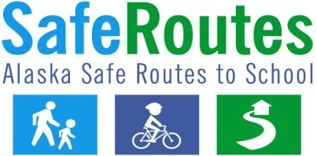

Winter Safety Tips:
1. Walkers and bicyclists should always wear reflective clothing, bright colors, and personal reflectors.
2. If walking/biking at night, be sure to use a headlamp or flashlight.
3. Bicyclists in Alaska are required by to use a headlight and a taillight at night.
4. When road and sidewalk conditions are icy, be sure to wear shoes with good traction. Wear ice traction cleats to prevent slipping, if necessary.
5. Only cross at designated crosswalks.
6. Icy roads may prevent motorists from stopping or slowing down for pedestrians. Before stepping into the street to cross, be sure all cars have stopped completely.
7. Never assume a motorist can see you. Make eye contact with motorists before crossing the street.
8. If a sidewalk is not present, walk against traffic. This allows you to make eye contact with motorists.
9. Always ride with the flow of traffic (on the right).
10. Never walk or ride with earphones. Snow can muffle the sound of approaching cars.
11. Stay warm with scarves and hats but be careful not to block your vision. This type of clothing could easily impair your vision, making it difficult to see icy conditions, which could lead to a fall.

