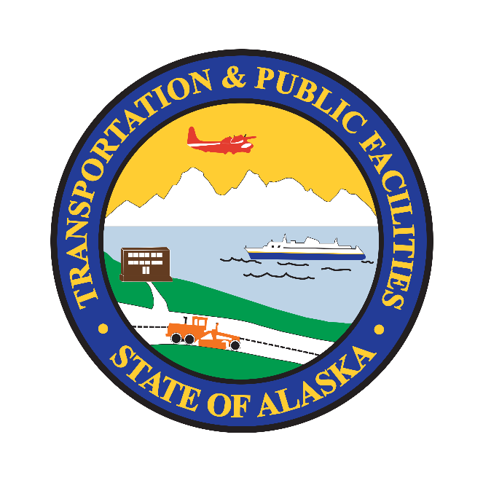

Alaska Department of Transportation & Public Facilities (Alaska DOT&PF)

Civil Rights Office & Alaska Community Transit
Disadvantaged Business Enterprise (DBE) Monitoring of Subrecipients & Compliance Plan

August 2025

Overview: All FTA Subrecipients through Alaska DOT&PF, Alaska Community Transit and Civil Rights Office are required under CFR 49 CFR 26 to include Disadvantaged Business Enterprises (DBEs) the maximum opportunity to complete for and perform contracts and subcontracts while utilizing FTA Funds.

All FTA subrecipients under the Alaska DOT&PF Alaska Community Transit, as mandated by 49 CFR Part 26 are obligated to incorporate Disadvantaged Business Enterprises (DBEs) in their procurement processes. The primary objective is to afford DBEs the utmost opportunity to actively compete for and engage in contracts and subcontracts funded by the Federal Transit Administration (FTA) within Alaska.

This regulatory framework is designed to promote diversity and inclusivity in the allocation of FTA funds, ensuring that businesses classified as DBEs have a fair chance to participate in the transportation-related projects. Subrecipients are expected to integrate measures that facilitate the involvement of DBEs in various stages of project development, procurement, and execution.

The inclusion of DBEs in contracting and subcontracting activities not only aligns with federal regulations but also contributes to fostering economic growth, job creation, and a more equitable distribution of opportunities within the Alaskan community. By adhering to these requirements, subrecipients play a vital role in advancing the overarching goals of promoting fair competition and reducing barriers for disadvantaged businesses in the transportation sector.

It is imperative for all stakeholders involved in FTA-funded projects to demonstrate a commitment to the principles outlined in the federal DBE regulations, recognizing the significance of diversity and the value that DBEs bring to the overall success and sustainability of community transit initiatives in Alaska.

Alaska DOT&PF Civil Rights Office has developed a DBE Monitoring Program Plan to provide a detailed framework for ensuring subrecipient compliance with DBE program requirements. This plan outlines procedures for ongoing monitoring, including the implementation of a formal monitoring schedule and the use of a comprehensive checklist to review key elements of subrecipient DBE programs.

The plan also specifies how Alaska DOT&PF Civil Rights Office identifies and addresses subrecipient deficiencies and instances of noncompliance, ensuring corrective actions are implemented effectively. To enhance program transparency and accountability, these monitoring procedures are integrated into the updated DBE Program document.

Monitoring Schedule
In-person Site Visits: Every five years, Alaska Community Transit will conduct in-person site visits to each FTA subrecipient. These visits will:
- Verify compliance with DBE program requirements.
- Address deficiencies identified during prior reviews (if any).
- Ensure subrecipients are meeting the obligations set forth in the federal DBE regulations.
During the DBE portion of these site visits, a representative from the Alaska DOT&PF Civil Rights Office will participate to provide expertise and ensure consistency with compliance standards.

Quarterly Virtual Reviews: To ensure ongoing oversight, the Alaska DOT&PF Civil Rights Office will offer quarterly virtual reviews to be conducted. These sessions will focus on:
- Monitoring compliance with DBE requirements between site visits.
- Offering guidance to subrecipients to address concerns proactively.
- Reviewing updates on DBE participation and progress on corrective actions.

Monitoring Procedures and Documentation
Standardized Questions for DBE Compliance: A comprehensive set of standardized questions will guide all monitoring activities. These questions include:
- Is there evidence of DBE participation in procurement activities?
- Are procurement records and contracts compliant with DBE requirements?
- What outreach efforts have been conducted to engage DBEs?
- Are there documented good faith efforts to involve DBEs?

Document Requests: Before any monitoring activity, subrecipients will be required to provide the following:
- DBE plans and policy documents.
- Procurement records showing DBE participation.
- Documentation of outreach efforts and good faith attempts to include DBEs.
- Records of corrective actions addressing previous deficiencies. (Previous reviews and any deficiencies identified)

Deficiency Resolution Process
Alaska DOT&PF Civil Rights Office has developed a structured process for addressing deficiencies identified during monitoring activities:

Notification of Deficiency: Alaska Community Transit will issue a formal notice in conjunction with Alaska DOT&PF Civil Rights Office to subrecipients of FTA Sections 5311, 5310 and 5311(f), detailing the deficiency, the specific DBE program requirement in question, and a timeline for resolution.

Corrective Action Plan (CAP):
- FTA subrecipients must submit a CAP within 60 days, outlining steps to resolve the deficiency.
- FTA subrecipients are responsible for submitting the CAP to the Alaska DOT&PF Civil Rights Office.
- If an extension is needed, a formal request must be submitted for approval, including a proposed timeline for CAP completion.

Escalation of Noncompliance: Persistent noncompliance may result in:
- Withholding of funds.
- Reporting the issue to the FTA.

Compliance Discussions at Monthly Meetings:
During monthly Transit Agency Meetings, a designated agenda item will focus on DBE compliance. These discussions will provide an opportunity to:
- Share reminders and updates on DBE program requirements as outlined in the federal DBE regulations.
- Identify and discuss opportunities for additional training and technical assistance to support subrecipients in achieving compliance and enhancing their understanding of DBE program obligations.

This plan strengthens Alaska DOT&PF Civil Rights Office oversight of FTA subrecipients by establishing a clear framework for monitoring, reporting, and addressing deficiencies. By adhering to the federal DBE regulations and integrating these enhanced procedures, it reaffirms its commitment to fostering a competitive, inclusive, and equitable environment for DBEs within the Alaskan transportation sector.

DBE Monitoring of Subrecipients & Compliance Questions

Overview: All FTA Subrecipients are expected to integrate measures that facilitate the involvement of DBEs in various stages of project development, procurement, and execution. The inclusion of DBEs in contracting and subcontracting activities not only aligns with federal regulations but also contributes to fostering economic growth, job creation, and a more equitable distribution of opportunities within the Alaskan community. By adhering to these requirements, subrecipients play a vital role in advancing the overarching goals of promoting fair competition and reducing barriers for disadvantaged businesses in the transportation sector.

It is imperative for all stakeholders involved in FTA-funded projects to demonstrate a commitment to the principles outlined in 49 CFR Part 26, recognizing the significance of diversity and the value that DBEs bring to the overall success and sustainability of community transit initiatives in Alaska.

Semi-Annual DBE Uniform Reporting
Review Question(s) & Authority | Agency Response(s) | Reviewer Comment(s)
Authority: 49 CFR Part 26.11(a)

Since the last review, has the subrecipient submitted Semi-Annual DBE Uniform Report (October 1 – March 31) to the Alaska DOT&PF on time (total of three)?
Authority: 49 CFR Part 26.11(a)

Since the last review, has the subrecipient submitted Semi-Annual DBE Uniform Report (April 1 – September 30) to the Alaska DOT&PF on time (total of three)?
Do the reports accurately reflect the subrecipient's contracting with or utilization of DBE firms?
What are the procedures used to ensure that Semi-Annual DBE Uniform Reports are completed, accurate, and submitted to Alaska DOT&PF, on-time, and include all requested information/forms?
Procurement Process
Review Question(s) & Authority | Agency Response(s) | Reviewer Comment(s)
Authority: 2 CFR Part 200.332, 49 CFR Part 26.37

What procedures does the agency have to ensure DBEs are included in the procurement process (purchasing goods, services, contracting etc.)?

Please provide documentation of procurement process and sections dedicated to DBE procurement.
What efforts has the subrecipient made to ensure DBE firms and small businesses have maximum opportunities to compete for and perform contracts financed, fully or partially, with FTA funds?

Examples include advertising in newspapers that serve minority communities, advertising on social media, maintaining a list of minority vendors, and contacting other agencies for potential DBE contractors and connecting them to the Civil Rights Office DBE Certification website.
Are the following lists maintained?
- Vendor/bidder list
- List of purchases/contracts within the 6-month period covered by the report
- A list of all firms contacted, and good faith effort forms)
(Note: Agencies need to track all contracting opportunities, regardless of whether they were awarded to DBEs, for inclusion in the semi-annual report.)
Prompt Payment Compliance
Review Question(s) & Authority | Agency Response(s) | Reviewer Comment(s)
Authority: 49 CFR Part 26.29

Does the agency have a prompt payment policy and mechanism in place to ensure that DBEs receive prompt payment on FTA-funded projects?

Provide documentation
Commercially Useful Function (CUF) Form
Review Question(s) & Authority | Agency Response(s) | Reviewer Comment(s)
Authority: 49 CFR 26.55

Does the agency have documentation to show that it monitors contractors to ensure DBEs are serving a commercially useful function (CUF)?

If yes, were CUF review forms completed and submitted to Alaska DOT&PF annually?
Transit Vehicle Manufacturer (TVM) Reporting
Review Question(s) & Authority | Agency Response(s) | Reviewer Comment(s)
Authority: 49 CFR Part 26.49(a)(4)

Has the subrecipient purchased any transit vehicles within the past five years, excluding unmodified mass-produced vans or unmodified pop-up vans, that have been altered for paratransit purposes?
If yes, have the vehicles been purchased from an approved Transit Vehicle Manufacturer (TVM) list?

All vehicles purchased with FTA funding must be reported to the Civil Rights Office within 15 days of purchase. TVM log: https://dot.alaska.gov/cvlrts/docs/FTA-Subrecipient-Instructions-for-Reporting-TVMs-012724.pdf
DBE Goal & Subrecipient Participation
Review Question(s) & Authority | Agency Response(s) | Reviewer Comment(s)
Authority: 49 CFR 26.45(g)(2)

Did the subrecipient attend or provide feedback during the most recent public participation meeting for the FTA DBE Goal Methodology?

The Alaska DOT&PF, as a recipient of FTA funding, is required to submit a DBE Goal Methodology every three years. This methodology outlines the process used by Alaska DOT&PF to determine its DBE goal. This Goal Methodology has been developed following the criteria set forth in 49 CFR Part 26.45 and is based on demonstrable evidence of the availability of DBE firms that are ready, willing, and able to work on FTA-assisted contracts relative to all businesses that are capable of performing such work.
Alaska Unified Certification Program (AUCP)
Review Question(s) & Authority | Agency Response(s) | Reviewer Comment(s)
Authority: 49 CFR Part 26.81(Subpart E)

What has been the subrecipient's involvement in the Alaska Unified Certification Program (AUCP)? Is the recipient listed on the AUCP member website?

Subrecipient are encouraged to participate in the Alaska Unified Certification Program (AUCP). As recipients of USDOT funds, the undersigned organizations have agreed to take part in the AUCP, which handles all DBE certification decisions on behalf of all USDOT recipients within Alaska. The AUCP aims to provide "one-stop shopping" for applicants, ensuring that a firm only needs to apply once for DBE certification, which will then be honored by all federal recipients in the state.

AUCP Website: dot.alaska.gov/cvlrts/aucpmemb.shtml
DBE Complaints & Procedure
Review Question(s) & Authority | Agency Response(s) | Reviewer Comment(s)
Authority: 49 CFR Part 26.25

Who within the agency is responsible for ensuring that DBEs are not discriminated against in the award and administration of FTA-funded contracts and subcontracts? What is the complaint procedure?
Did the recipient receive any complaints involving DBE firms?

If yes: Describe the complaint and how it was resolved. Were they forwarded to Alaska DOT&PF, Civil Rights Office?

