Hi all,

I have heard that some of you guys are having problems with the Excel sheets.

Here are some tips to get by the program:

- You will not get anywhere if you are trying to run OCX file.  Run (double click) Excel File.

Use this file to follow the instruction if the program doesn’t work

Not this one

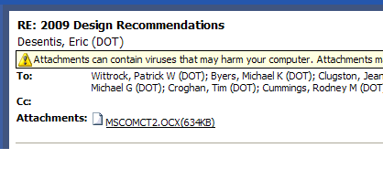

- Make sure to enable the macro function

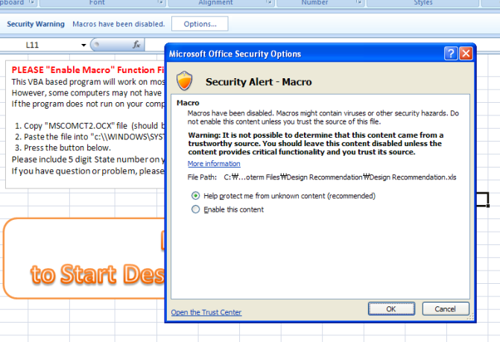

- If you don’t see all the sheet tabs, unhide the tabs by right clicking the tabs

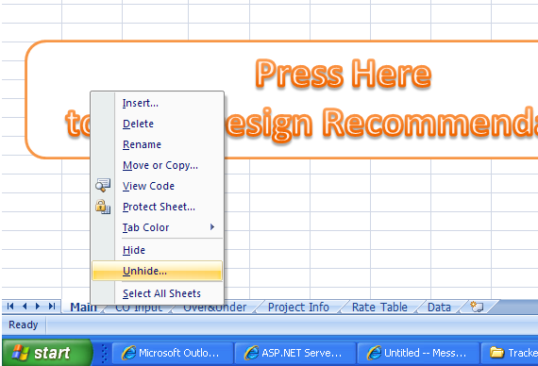

If you are still having problem with the file please contact Chong Kim at 244-8521 or 269-0452.