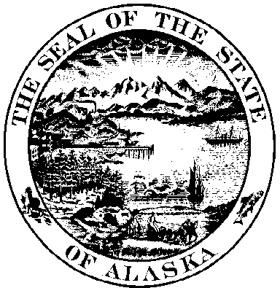
Land Survey Monument Record Rev. Apr 2003

1) Land Corner Restoration

Land Corner Establishment

Other: ______________________________________________________

2) Description of corner evidence found or a concise statement of the method used to re-establish the corner:

3) Description of monument and accessories established to perpetuate the location of the
monument.

4) A sketch showing the relative location of monument and reference points or a sketch showing the monuments used and the measurements made to determine the position of the monument being established. (Use additional sheets if necessary)

Date of field work _________________________

Page 1 of 2

Surveyor’s Certificate and Stamp

5) I, _____________________, registration no. ________
do hereby certify that I was in responsible charge of the
surveying work described in this record and that to the
best of my knowledge the information presented herein
is true and correct. Date_________________

Corner Description

6) Corner _________________________, ______________________________Subdivision

Section _____________, Township _________________, Range __________________,

Meridian, Alaska. Recorders No: ,

Recording District ___________________________, Date Filed__________________.

If unsurveyed, include protracted section number.

7) = Location of Monument

1”=1 Mile

Index Ref. No. __________--___________
(See Alaska Land Survey Monument Master Index)


8) Return to:

State of Alaska, Dept of Transportation
ROW/Surveys
Attn: Right-of-Way Engineering Supervisor
PO Box 196900
Anchorage, Alaska 99519

Page 2 of 2

