

MEMORANDUM STATE OF ALASKA
Department of Transportation and Public Facilities
Division of Statewide Design and Engineering Services
Right of Way Engineering - Survey Section

To: | All DOT Survey Consultants | Date:  AKSAS: | February 1, 2006  N/A
From: | Bob Keiner  Survey Technician  Survey Section  Central Region | Tel No:  Subject: | 269-0556  Pre-Code How-To

This memo explains the correct usage of Pre-Codes that are to be used when locating monuments in the field. Using this coding system will sort the points according to the proper layering standards, insert the proper symbols on the correct layers, and will strip the Pre-Code out of the full descriptor, so as to not create clutter in the drawing. The procedure is very straight-forward, and there are no additional software or hardware requirements other than what is included with Autodesk Land Desktop software.

In order to use the Pre-Codes, you must first establish the Pre-Codes in the Description Key Manager. These codes can be added to the typical description key that is used for all jobs, or made into a completely new key that can stand alone. Below is an example of the Description Key with just the Pre-Codes:

Code | Format | Point Layer | Symbol Block Name | Symbol Layer
FCS* | $+ | EPPH | esspgcont | ESPH
GPS* | $+ | EPPH | essgpscont | ESPH
PCL* | $+ | EPRC | esspclmon | ESRC
PGM* | $+ | EPRGOV | essblmmon | ESRGOV
PMC* | $+ | EPRP | essscor | ESRP
PPM* | $+ | EPRP | esspmon | ESRP
SCL* | $+ | EPRC | esssclmon | ESRC
SCP* | $+ | EPPH | esstrav2 | ESPH
STS* | $+ | EPPH | esstrav | ESPH
TBM* | $+ | EPPV | essptbm | ESPV
VBM* | $+ | EPPV | esspbm | ESPV

The only thing different about these description keys is the format “$+” that will strip the first word out of the Full Description. In doing so, the points will be layered correctly, and have symbols inserted while also removing the Pre-Code from the Full Description.

We have found that this method of coding greatly reduces the requirement of having such exacting descriptions. In the past there were lengthy lists of possibilities when trying to establish a description key for monumentation, based on keywords found in the descriptions, as well as the positions of the words within the description. Now that can be accomplished by using a simple 3 letter code at the beginning of the description.

Below is an example of a Fieldbook Legend sheet that is pasted into the front cover of DOT fieldbooks for easy reference:

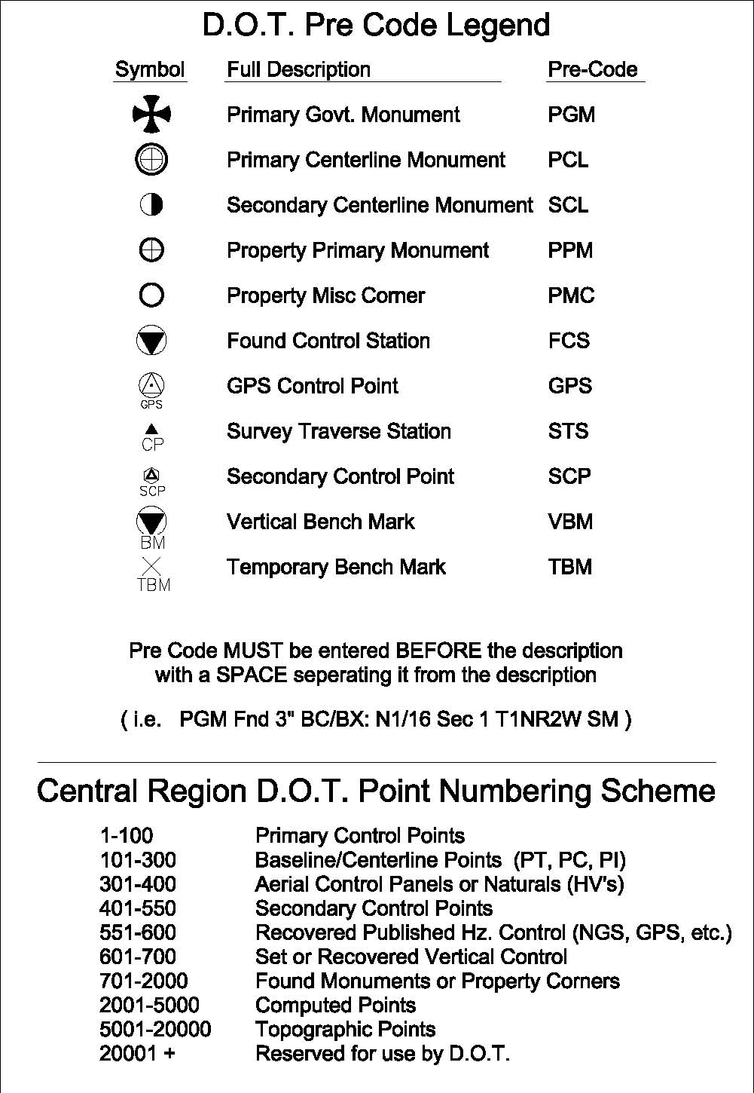

Each category of Pre-Codes gives examples of what types of monuments are associated with each code and examples of how each monument should be described. This information in the description must be clearly marked on the cap and not input from the plat. Follow the use of upper and lower case as shown in the examples. In the majority of cases the information to the left of the colon is standard. Attention must be paid to Set or Fd. The information in the brackets will be used to identify who or what agency set the recovered monument. “Who” will be identified by an LS number (i.e. 7222-S or in those rare cases with an E) or company name. When describing square corners attention will be paid to the punctuation as it is shown in the examples. Township and Range is an important part of the description and will be included. When describing subdivision corners include all information that you feel is pertinent. Condition of the monument need not be included in the description since this information is recorded in the field notes. Full subdivision names should be used, however do not include Sub or Subd as part of the descriptor. Lot and block can be shortened as shown in the examples. This is only a small sampling of the possible choices, and not all circumstances are identical, so use your best judgment. Be prepared to make edits as directed.

The pre-code used shall be determined by the type of monument that is found, and not necessarily what the monument is meant to represent. For example, a rebar inside a monument case would still receive a pre-code of PMC, since the rebar is a secondary monument. Also, a GLO/BLM monument in a case in the centerline of the road would still be called PGM.

Primary Government Monument PGM
Only BLM/GLO corners shall be given this code. If the corner was set by anyone other than BLM/GLO, then use another Pre-Code. Use only one asterisk at the start of Township/Range.

PGM Fd BC[BLM]: C1/4 S36 *T17N R4W
PGM Fd BC[GLO]: S19|S20/S30|S29 *T18N R1W

Primary Centerline Monument PCL
Primary monuments set or found in cases. If the monument is a BLM/GLO corner, use that Pre-Code instead.

PCL Set BC/Bx[DOT]: PC 10+75.04
PCL Fd BC/Bx[DOT]: Glenn Highway PT 1653+45.90 Ahd/1653+43.17 Bk

Secondary Centerline Monument SCL
Secondary centerline monuments set.

SCL Set Rbr/AC[DOT]: PC 1723+29.50

Property Primary Monument PPM
Primary Monuments other than BLM/GLO monuments. This would include an Aluminum monument set at a section corner, if a private surveyor set the monument.

PPM Fd BC[232-S]: Ref Mon (30' South) S8/S17 *T17N R1E
PPM Fd AM[6925-S]: SW 1/16 S8 *T17N R1E
PPM Fd BC[617-S]: ASLS 83-91 C5/PT ROW

Property Misc Corner PMC
Any property corner other than a primary. This covers all secondary monuments dealing with property location Pre-Code. Concrete ROW monuments are also included.

PMC Fd Rbr: NE L9 Blk3 Colonial Park
PMC Fd Rbr: S Tr C ROW / Sec Line Inx
PMC Fd Rbr: ROW PC L1 Blk3 Colonial Park
PMC Fd Conc ROW Mon: KGB PT 911+45.5 100’ Lt
PMC Fd Brg Tree Tag: RP to ¼ S8|S9 *T17N R1W
PMC Fd Rbr/AC[5368-S]: NW L2 Blk6 Wandering Acres

Found Control Station FCS
Published NGS, USG&GS, USLM, etc, control stations.

FCS Fd BC/ROD[NGS]: Station BIG LAKE GPS 1986
FCS Fd BC[NGS]: Station PURIN 1949

GPS Control Station GPS
GPS control points.

GPS Fd BD/ROD: AKDOT GPS-44 1989
GPS Set Rbr/AC: OGH 5.7 AZ

Survey Traverse Station STS
Survey points set or used by DOT for control. (Typically a rebar and plastic cap.) If DOT is the agency that set the point this does not need to be included in the descriptor. If the point being used was set by someone else include this information. This category does not include secondary points, such as nails and spikes.

STS Fd Rbr[USKH]: TS OG-1
STS Fd RR Spike: Inx Pal-Was/Glenn
STS Set PK Nail: OGA-22
STS Set Rbr/PC: TS-7R

Secondary Control Point SCP
Secondary control points set or used by DOT for control. (Nails, spikes, etc.) If DOT is the agency that set the point this does not need to be included in the descriptor. If the point being used was set by someone else include this information.

SCP Set Spike: TS-484
SCP Set Mag Nail: TS-487

Vertical Bench Mark VBM
Vertical bench marks. (Does not include TBM’s.)

VBM Fd BC[GAAB]: GAAB –113 BC in Pipe at Inx. Hillside and O’Malley

Temporary Bench Mark TBM
Temporary bench marks.

TBM Set RR Spike: TBM Hyer 12” Birch Inx. Hyer Rd/Palmer Wasilla Highway

If there are any doubts as to the proper Pre-Code to use, please ask! These codes control final layering and symbology that will be delivered in drawings to other sections in the building. If something is coded incorrectly in the field, then it will be delivered as such.

If there are any questions, comments, suggestions, or concerns, please discuss the issue with Bob Keiner, Mike Spangler. or Michael Miller.

