Table of Contents

Introduction iii
Course Goal, Themes, and Outcomes iii
Student Requirements v
Prerequisites v
Course Organization v
Overall Course Agenda vi
Module 1: Introductions and Course Overview 1-1
Module 2: Purpose of Specifications 2-1
Lesson 2.1 Specifications as a Contract Document 2-4
Lesson 2.2: Specification Types 2-41
Lesson 2.3: Formatting Specifications 2-44
Module 3: Writing and Interpreting Specifications 3-1
Lesson 3.1: Introduction to Writing Style and Plain Language 3-5
Lesson 3.2: Voice and Mood in Specifications 3-16
Lesson 3.3: The Five Cs of Specification Writing 3-32
Module 4: Method or End-result Specifications 4-1
Module 5: Conclusion and End-of-Course Activities 5-1
Participant Appendices PA-1
Appendix A: Spearin Doctrine Explanation PA-3
Appendix B: Sample Style Guide Table of Contents PA-5
Appendix C: Commonly Used Phrases PA-9
Appendix D: Specification Writer’s Checklist PA-11
Appendix E: Example Method Specification for a Concrete Sidewalk PA-21
Appendix F: Sample Rewritten PA-23
Appendix G: Sample Method Specification PA-25
Appendix H: Sample End-result Specification PA-27
Appendix I: Sample Quality Assurance Specification PA-31
Appendix K: Example End-result Specification for a Concrete Sidewalk PA-41
Appendix L: Answers to Activities PA-45
Appendix M: Glossary of Terms PA-67


National Highway Institute (NHI) has been designated as an Accredited Provider by the International Association for Continuing Education and Training (IACET).
NHI is accredited by IACET to offer 1.2 CEUs for this program (NHI-134001 Principles and Applications of Highway Construction Specifications)

Introduction
NHI 134001 is a two-day training course designed to provide those who write and use construction specifications with the tools to recognize and apply the principles of correct, consistent, clear, complete, and concise highway construction specifications. The course reflects current best practices and requirements for writing highway construction specifications.
This course has been in existence since the early 1990s. It has been changed and improved significantly with each revision. In this most recent version, there are several notable changes.
- A complete rewrite of the course to incorporate student-centered content and interactivity
- The elimination of the resource manual, which has now been incorporated into the instructor guide and participant workbook
- The addition of significant content related to the assignment of risk
- The development of a more robust link to a project’s Quality Assurance Plan
- A significant reduction in the time spent on the rules of grammar
- A significant reduction in the time spent on the historical perspective regarding specifications

Course Goal, Themes, and Outcomes

Course Goal
At the end of this course, participants will be able to recognize and apply the principles of writing correct, consistent, clear, complete, and concise highway construction specifications.

Course Themes
Throughout the course, the content and instruction emphasize how to write quality specifications. The intention is to guide participants toward writing specifications that are accurately interpreted, thus minimizing confusion and disputes.
This course contains other themes, including the effect of writing style upon the interpretation of specifications, the function of specifications as a contract document, and the assignment of risk to each party.

Course Outcomes
Upon completion of the course, participants will be able to do the following:
- Compare the functions of standard and supplemental specifications with the functions of special provisions.
- Explain how the “order of precedence” affects writing specifications and preparing plans.
- Explain the purposes of a specification.
- Describe the purpose of the general provisions.
- Explain how specifications are used to assign risk and affect the behavior of different parties, within a given scenario.
- Compare method and end-result specifications.
- Explain each element of the AASHTO five-part format.
- Explain how a consistent writing style can affect the interpretation of specifications.
- Explain the potential benefits of writing in the active voice.
- Rewrite passive voice sentences into the active voice.
- Evaluate specifications to determine the need for imperative or indicative mood.
- State the five Cs used in specification writing.
- Identify potential ambiguities in the wording, given a sample specification.
- Identify the potential benefits of each of the five Cs.
- Write a new specification using the five Cs and the agency’s preferred format.
- Complete a checklist of the information needed before writing or revising a specification.
- Apply the five Cs and the agency’s preferred format to revise the specification, given a sample specification.
- Write a new specification to a given set of criteria using the five Cs and the agency’s preferred format, given a sample specification.
- Relate the type of specification to the allocation of risk.
- Write an end-result specification to replace a method specification, given an excerpt from a method specification.

Student Requirements
The agency should advise all participants to bring a copy of their specification manual to class.
If participants plan to use an e-spec instead of a specification book, they should download it to a device before arriving because Internet access might not be available in the training room.

Prerequisites
There are no prerequisites for this course; however, students should be able to read and write English. Proficiency in English grammar will greatly assist the student in successfully completing this course.

Course Organization
The course consists of five modules listed as follows:
- Introductions and Course Overview
- Purpose of Specifications
  - Module 2 addresses the purpose of specifications and how specifications function as a contract document.
- Writing and Interpreting Specifications
  - Module 3 addresses how to prepare for the writing process, how to affect the interpretation of specifications through writing style, and how to implement an appropriate writing style.
- Method or End-result Specifications
  - Module 4 addresses the different types of specifications, comparisons of their advantages and disadvantages, and approaches to converting a method specification to an end-result specification.
- Conclusion and End-of-Course Activities

Overall Course Agenda

Day 1
Time | Module Number and Lesson Title
8:30 a.m. Start | Module 1: Introductions and Course Overview
 | Module 2: Lesson 2.1: Specifications as a Contract Document
 | Break (15 minutes)
 | Module 2: Lesson 2.1: Specifications as a Contract Document
 | Module 2: Lesson 2.2: Specification Types
 | Module 2: Lesson 2.3: Formatting Specifications
12:15 – 1:15 p.m. | Lunch (60 minutes)
 | Module 3: Lesson 3.1: Introduction to Writing Style and Plain Language
 | Module 3: Lesson 3.2: Voice and Mood in Specifications
 | Break (15 minutes)
 | Module 3: Lesson 3.2: Voice and Mood in Specifications
4:30 p.m. Finish | Module 3: Lesson 3.3: The Five Cs of Specification Writing

Day 2
Time | Module Number and Lesson Title
8:30 a.m. Start | Module 3: Lesson 3.3: The Five Cs of Specification Writing
 | Break (15 minutes)
 | Module 3: Lesson 3.3: The Five Cs of Specification Writing
 | Module 4: Method or End-result Specifications
12:30 – 1:30 p.m. | Lunch (60 minutes)
 | Module 4: Method or End-result Specifications
 | Break (15 minutes)
4:30 p.m. Finish | Module 5: Conclusion and End-of-Course Activities (including exam and course evaluation)

This page is intentionally blank.

Module 1: Introductions and Course Overview

This page is intentionally blank.
Slide 1-1

Welcome to Principles and Applications of Highway Construction Specifications.

Slide 1-2

Module 1 introduces the presenter, the participants, and provides a brief course overview.
Learning Outcomes
Module 1 supports all of the learning outcomes.

Slide 1-3
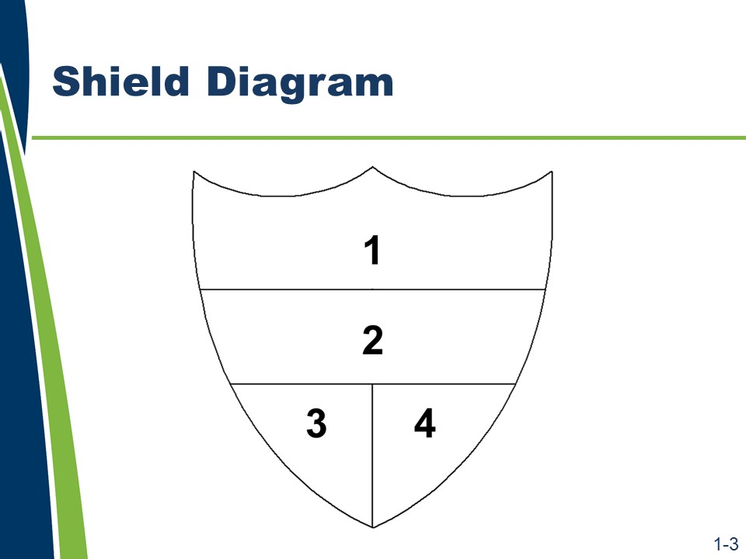
Key Message
Many factors affect how highway construction specifications are written and interpreted. By the end of this course, participants will be able to recognize and apply the principles of writing complete, correct, clear, concise, and consistent highway construction specifications.
Activity
- Form small groups of no more than five.
- Select a spokesperson for the group.
- Introduce yourselves to each other.
- Move to one of the identified work areas around the room.
- Re-create the shield diagram (as large as possible) on a sheet of flip chart paper.
- Discuss the four items, achieve consensus, and record your responses in the corresponding panels (positions) on the shield as shown on the slide.
- Post the shield so that everyone in the room can view it.
Shield Panels (positions)
  - Identify one critical skill in specification writing that all members of your team want to improve.
  - Identify a common household chore and write a brief (must fit legibly within the space provided) portion of a specification for that chore.
  - Draw a symbol or illustration of the greatest challenge faced in writing a specification.
  - Record the names and respective years of experience with specifications (either following specifications or writing specifications) for each member of the group. Total and post the collective years of experience for the entire group.

Slides 1-4 to 1-9 (Not shown because the content is included below.)
Learning Outcomes
This course addresses these learning outcomes.
- Compare the functions of standard and supplemental specifications with the functions of special provisions.
- Explain how the “order of precedence” affects writing specifications and preparing plans.
- Explain the purposes of a specification.
- Describe the purpose of the general provisions.
- Explain how specifications are used to assign risk and affect the behavior of different parties, within a given scenario.
- Compare method and end-result specifications.
- Explain each element of the AASHTO five-part format.
- Explain how a consistent writing style can affect the interpretation of specifications.
- Explain the potential benefits of writing in the active voice.
- Rewrite passive voice sentences into the active voice.
- Evaluate specifications to determine the need for imperative or indicative mood.
- State the five Cs used in specification writing.
- Identify potential ambiguities in the wording, given a sample specification.
- Identify the potential benefits of each of the five Cs.
- Write a new specification using the five Cs and the agency’s preferred format.
- Complete a checklist of the information needed before writing or revising a specification.
- Apply the five Cs and the agency’s preferred format to revise the specification, given a sample specification.
- Write a new specification to a given set of criteria using the five Cs and the agency’s preferred format, given a sample specification.
- Relate the type of specification to the allocation of risk.
- Write an end-result specification to replace a method specification, given an excerpt from a method specification.
This page is intentionally blank.

Module 2: Purpose of Specifications

This page is intentionally blank.
Slide 2-1

Module 2 addresses the purpose of specifications.
- Definitions of important terms
- Establishment of specifications as part of an agency’s contract
- Order of precedence of the many documents that make up the contract
- Purpose of specifications
- Content of specifications
- Types of specifications
- Format of specifications

Slides 2-2 to 2-4
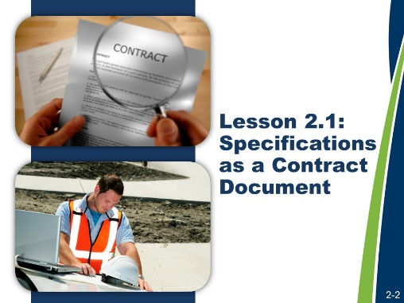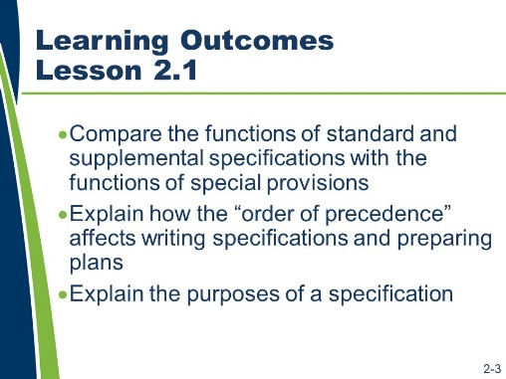
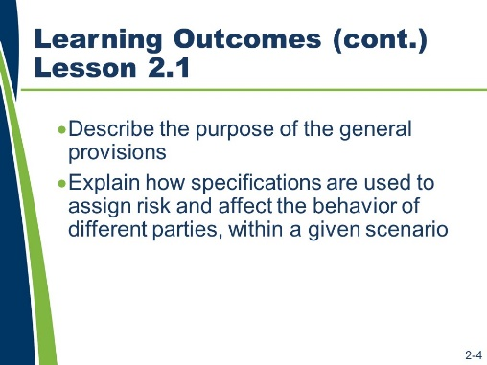

Lesson 2.1 Specifications as a Contract Document
Lesson 2.1 addresses the purposes of specifications.
Learning Outcomes
This lesson supports these learning outcomes.
- Compare the functions of standard and supplemental specifications with the functions of special provisions.
- Explain how the “order of precedence” affects writing specifications and preparing plans.
- Explain the purposes of a specification.
- Describe the purpose of the general provisions.
- Explain how specifications are used to assign risk and affect the behavior of different parties, within a given scenario.

Resources
- Agency’s specification manual(s).
- American Association of State Highway and Transportation Officials. Guide Specifications for Highway Construction. Ninth Edition, 2008.
- Transportation Research Board of the National Academies. Transportation Research Circular E-C173: Glossary of Transportation Construction Quality Assurance Terms. Sixth Edition, 2013.
- United States Department of Transportation, Federal Highway Administration. Development and Review of Specifications. Technical Advisory, OPI – HIAM-20. Washington, DC, March 24, 2010.
- United States Department of Transportation, Federal Highway Administration, National Highway Institute. Transportation Construction Quality Assurance Course 134064A. Publication No. 08-067.
- United States Department of Transportation, Federal Highway Administration.
- Transportation Construction Quality Assurance Reference Manual, 2012.
- United States National Archives and Records Administration. Code of Federal Regulations. 23 CFR 637: Construction Inspection and Approval, 2011.

Slides 2-5 and 2-6
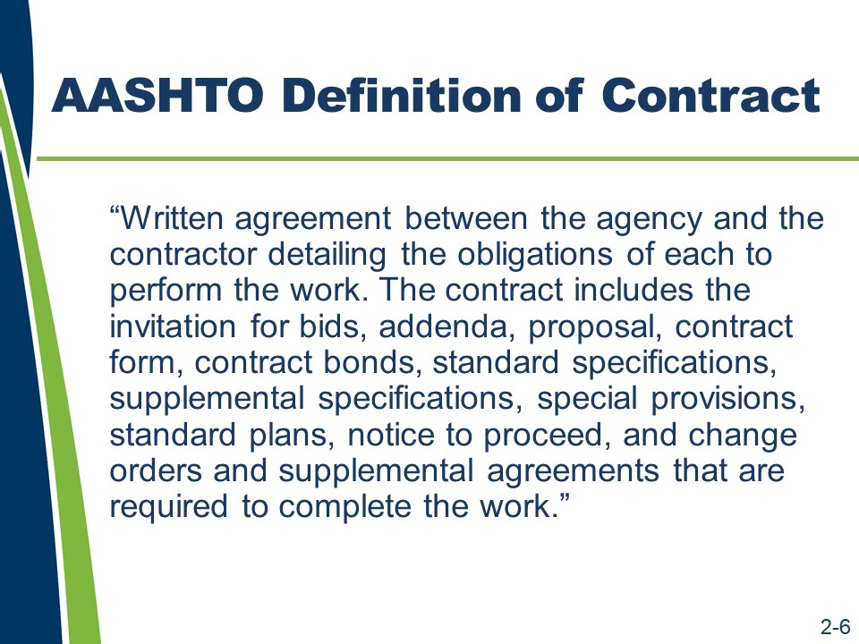
(Slide 2-5 is not shown because it contains the answer to the question below.)
Definition of Contract and Specification
The foundation of highway construction is the contract. Specifications are a part of the contract.
The contract defines specifications and other related terms. It is important for specification writers to understand these definitions.
What is the basic definition of a contract?

Slides 2-7 and 2-8 (Not shown because they contain answers to the questions below.)
Definition of Contract and Specification (continued)
What documents are considered part of your agency’s contract? (Be sure to write answers below as these answers are individual to your agency and are not provided for you in this workbook.)
In some agencies, the names of the documents included in the contract are different from the AASHTO list. Additionally, some agencies may or may not include each of the documents included by AASHTO as part of their contract. They may also include other documents not listed.

Definition of Contract and Specification (continued)
What is a typical definition of specification?
What is your agency’s definition of specification?

Slides 2-9 to 2-11
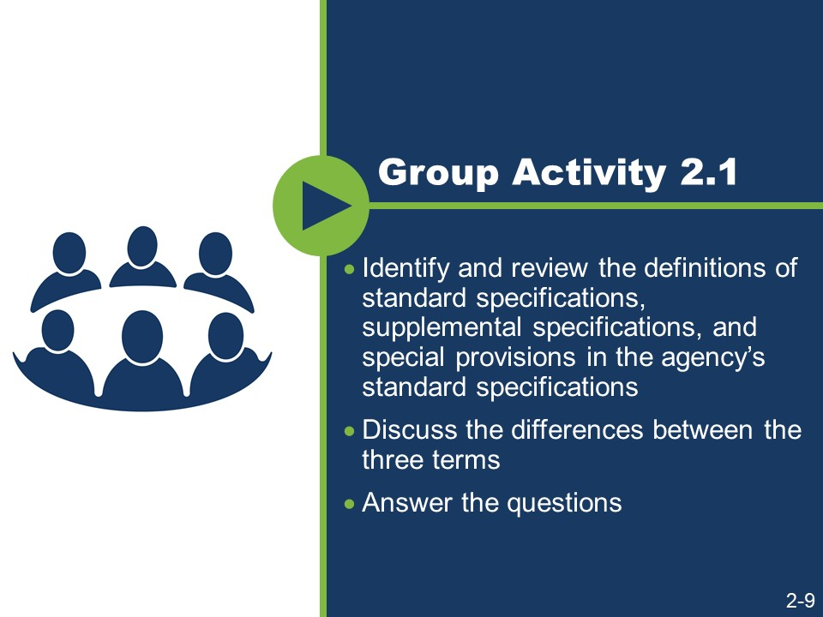
(Slides 2-10 – 2-11 are not shown because they contain answers to the activity.)
Activity
- Work in a small group.
- Identify and review the definitions of standard specifications, supplemental specifications, and special provisions in the agency’s standard specifications.
- Discuss the differences between the three terms.
- Answer the questions.
- What is the definition of standard specifications?
- What is the definition of supplemental specifications?
- What is the difference between standard specification and supplemental specifications?

Activity (continued)
- What is the definition of special provisions?
- What is the difference between special provisions and standard and supplemental specifications?

Slide 2-12
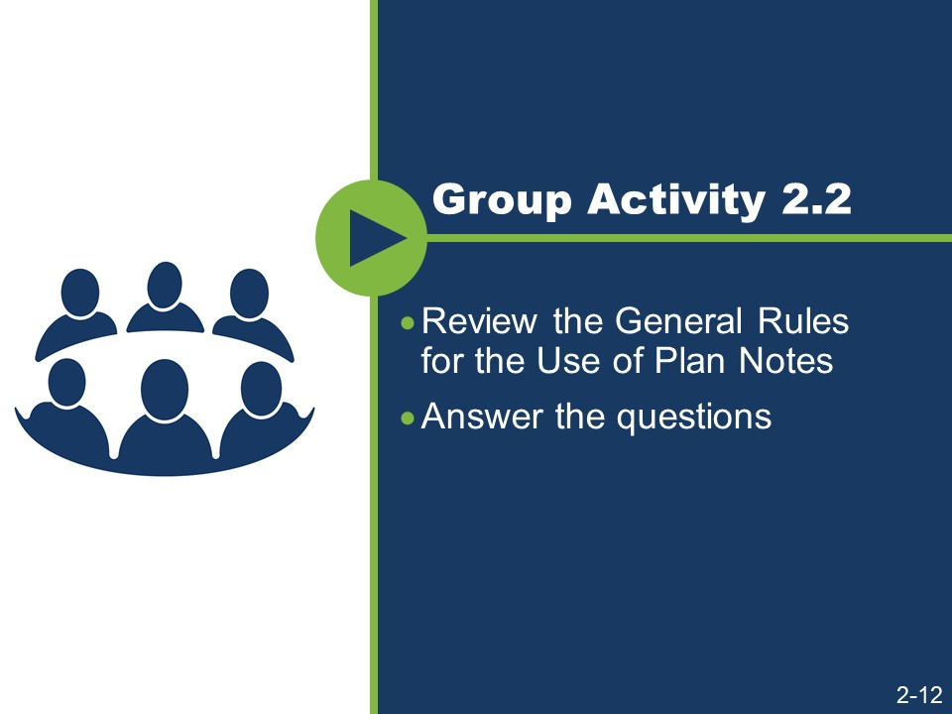
Activity (continued)
- Work in a small group.
- Review the General Rules for the Use of Plan Notes.
- Answer the questions.

General Rules for the Use of Plan Notes
(Excerpted from the FHWA Technical Advisory)
- Do not include information in both the specifications and the plans.
- Use plan notes when necessary to communicate and clarify information on the plans where the information cannot be highlighted advantageously in a specification.
- If the instructions apply to only one particular item, plan notes may be appropriate.
- Permitting agencies may also require the inclusion of certain notes on the plans.
- Plan notes should not function as a specification, so they should not be used to revise the specifications. Revisions to the specifications should instead be handled through a supplemental specification or a special provision.
- Because plan notes are a way to circumvent the specification review and approval process, their overuse can have serious consequences.

Activity (continued)
- Does your agency have a policy governing the use of plan notes?
- Can you describe that policy?
- How does your agency policy compare and contrast with the general rules?

Slide 2-13
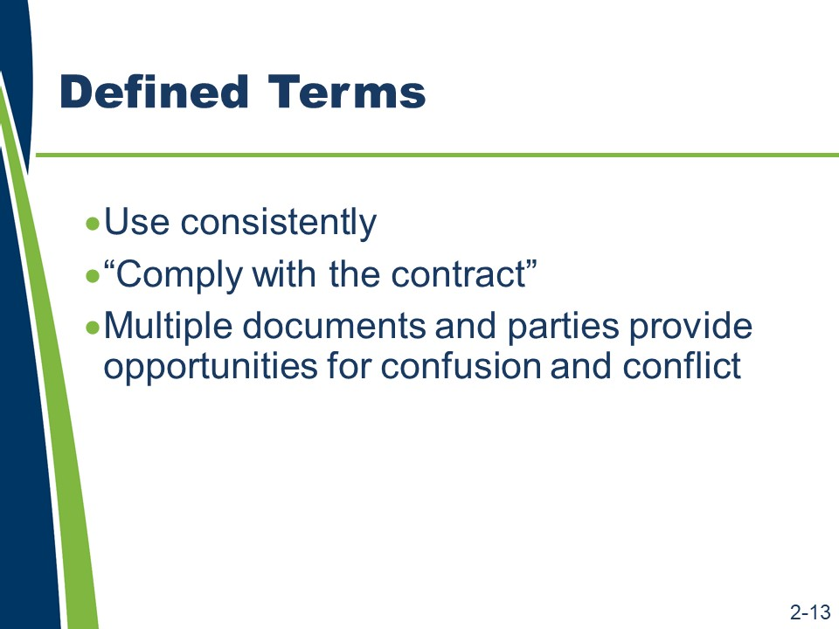
Defined Terms
Defined terms need to be used consistently. Understanding the contents of and definitions within the contract documents is necessary to writing specifications that are properly coordinated with the other contract documents. This consistent approach will help guide a specification user to the information he or she seeks.
Using defined terms can also allow specifications to be written more efficiently and concisely. For example, if the plans and specifications are both defined as being part of the contract, then it is no longer necessary to require the contractor to “comply with the requirements of the plans and specifications.” Instead, fewer words can be used by simply saying that the contractor is required to “comply with the contract.”
With the many contract documents that the agency must coordinate during the planning and design phases and that the contractor must navigate during the bidding and construction phases, there are many opportunities for confusion and potential conflict. The contract is written to address this potential for conflict.

Slide 2-14

Order of Precedence
An order of precedence clause is one mechanism to ensure that conflicts between the various contract documents do not compromise the quality of the project. This clause is often found in the “Control of Work” section of the General Provisions.
There are many opportunities for confusion and potential conflict within the contract documents that the agency uses during the planning and design phases and the contractor navigates during the bidding and construction phases.
If not addressed, the potential conflicts can lead to disputes and claims; therefore, it is important to address these potential conflicts in the contract documents.
A tool that is used in the contract to address potential conflicts is an order of precedence clause. The order of precedence clause establishes a hierarchy of authority for the documents in the contract.
In general, the order of the precedence clause establishes a hierarchy of documents using the following guidelines:
- Project-specific information usually governs or takes precedence over the more generic information.
- Written specifications govern over drawings.
For example, if a requirement in the standard specifications conflicts with a requirement in the plans, the requirement in the plans would take precedence over the standard specifications because the plans are more specific to the project. However, standard specifications would take precedence over standard plans because written specifications typically govern over drawings.

Slide 2-15
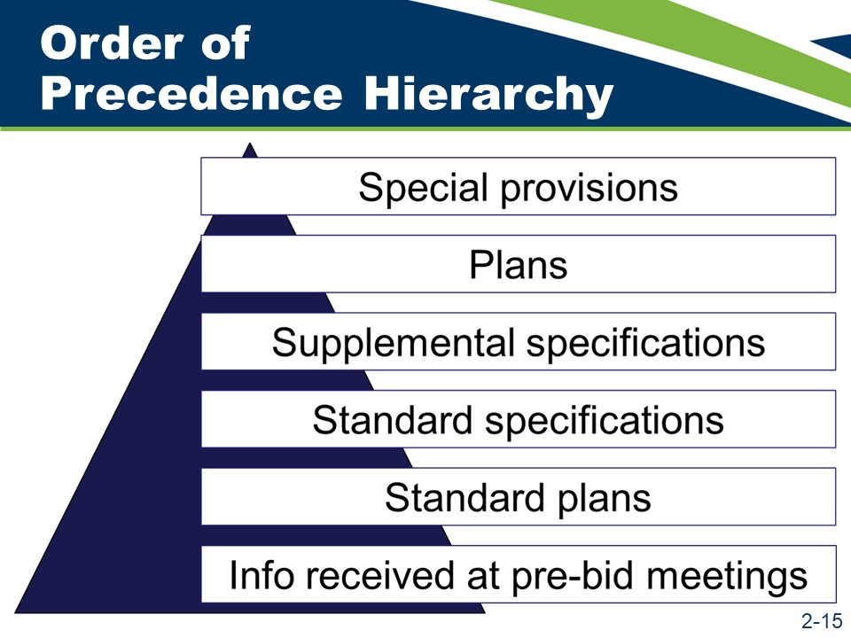
Order of Precedence (continued)
The hierarchy of documents in the order of precedence clause in the AASHTO Guide Specifications is as follows:
- Information received at the pre-bid meetings is at the bottom of the pyramid because all other items in the contract documents take precedence over it.
- The standard plans govern over the information received at the pre-bid meetings but not over the other contract documents.
- The standard specifications take precedence over the standard plans.
- The supplemental specifications prevail over the standard specifications.
- The plans outweigh the supplemental specifications.
- The special provisions govern over all the other contract documents.

Activity
- Review the agency’s order of precedence clause.
- Complete the blank order of precedence pyramid.


Slide 2-16
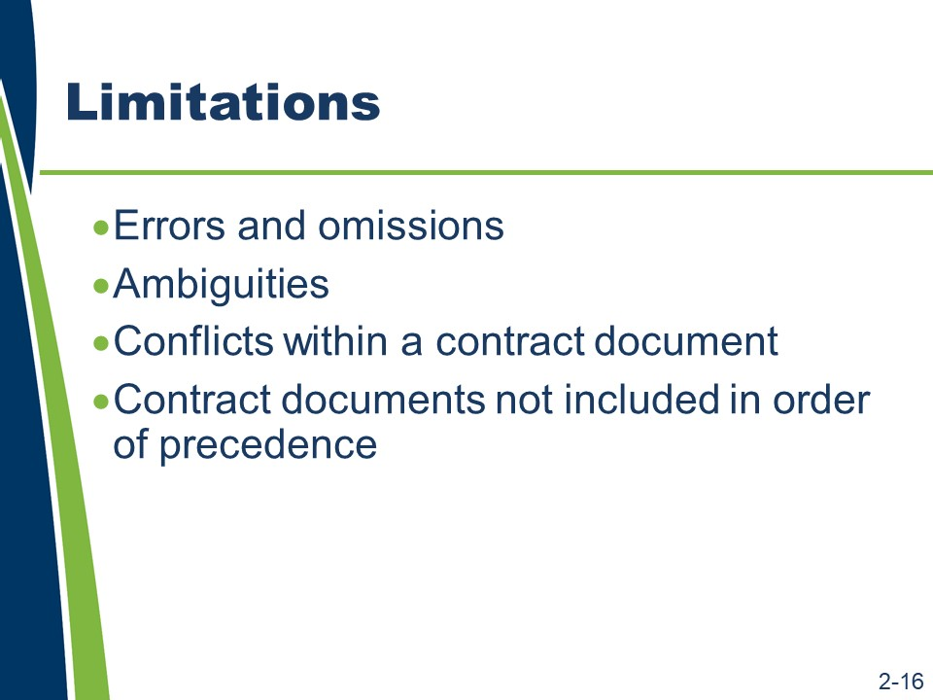
Limitations of Order of Precedence
The order of precedence clause has its limitations.

Errors and omissions
If the wrong special provision or detail sheet is included in the contract, will the order of precedence clause address this problem?
What if a plan sheet or special provision is missing from the contract?

Limitations of Order of Precedence (continued)

Ambiguities
Does the order of precedence clause address ambiguities?

Conflicts within a contract document
Does the order of precedence clause address conflicts within a particular document (for example, within a special provision)?

Contract documents not included in the order of precedence
If a document is not listed (for example, if the contract form, addenda, contract bonds, or change orders are not listed), does the order of precedence clause address conflicts with these documents?

Slide 2-17
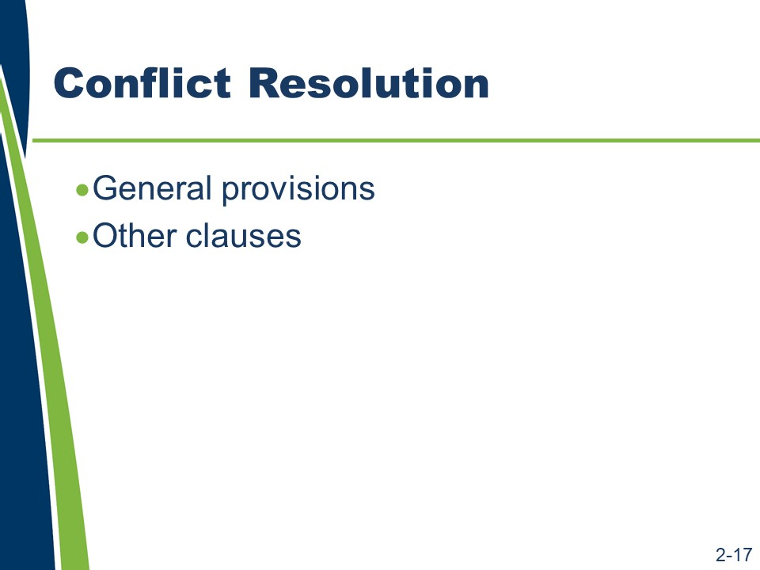
Conflict Resolution
It is important to know the location of the clause, its purpose, and its application. Knowing where the clause exists and how to use it prevents the disputes and claims that it is designed to avoid. However, this clause should not be overused or used as a crutch.
What mechanism do we have to rely on when a problem with the specifications cannot be resolved by the order of precedence clause?

Slide 2-18 (Not shown because it contains the answer to the activity.)
Purposes of Specification
What are the purposes of specifications?

Slides 2-19 to 2-21
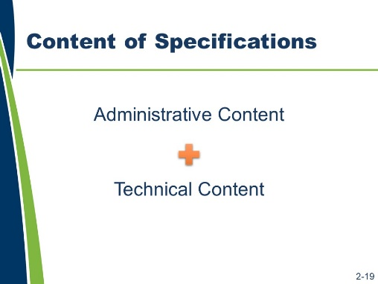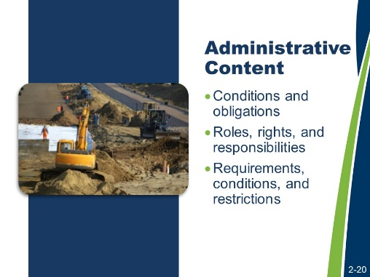
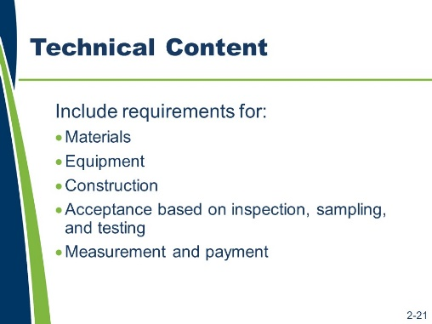
Content of Specifications
Specifications are composed of two kinds of content – administrative and technical. Administrative content includes the following:
- The conditions and obligations that control the behaviors of the parties to the contract.
- The roles, rights, and responsibilities of the parties to the contract.
- The administrative requirements, conditions, and restrictions that affect how the work is performed and the contract is administered.
Technical content focuses on the technical elements of the work and defines the quality of the end product. That includes requirements for the following.
- Materials
- Equipment
- Construction
- Acceptance based on inspection, sampling, and testing
- Measurement and payment

Content of Specifications (continued)
What are examples of administrative content in the agency’s standard specifications?
What are examples of technical content in the agency’s standard specifications?

Slides 2-22 and 2-23
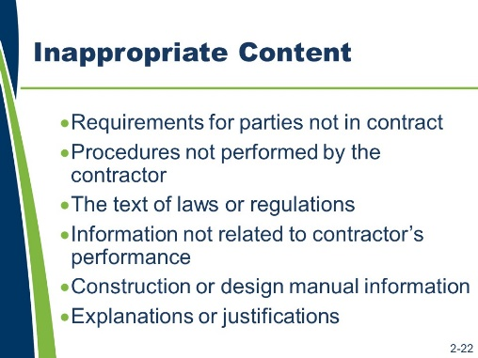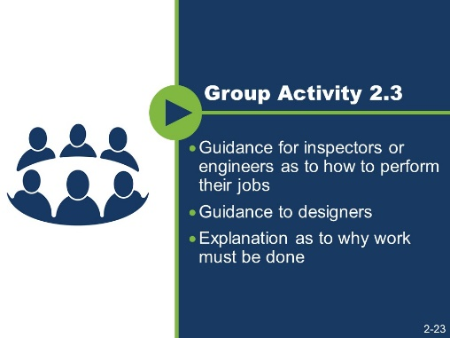
Inappropriate Content
While administrative and technical content belong in specifications, other content is not appropriate for inclusion in a specification.
Content that should not be in a specification includes:
- Requirements applicable to parties that are not part of the contract.
- Testing, sampling, and inspection procedures not being performed by the contractor.
- The text of laws or regulations (unless the law or regulation requires that the text be included in the contract).
- Information that that does not relate to the contractor’s performance of the work.
- Information that should be included in a construction or design manual.
- Explanations or justifications of requirements.
Activity
- Identify if the content belongs in a specification.

- Guidance for inspectors or engineers as to how to perform their jobs
- Guidance to designers
- Explanation as to why work must be done

Slides 2-24 to 2-26
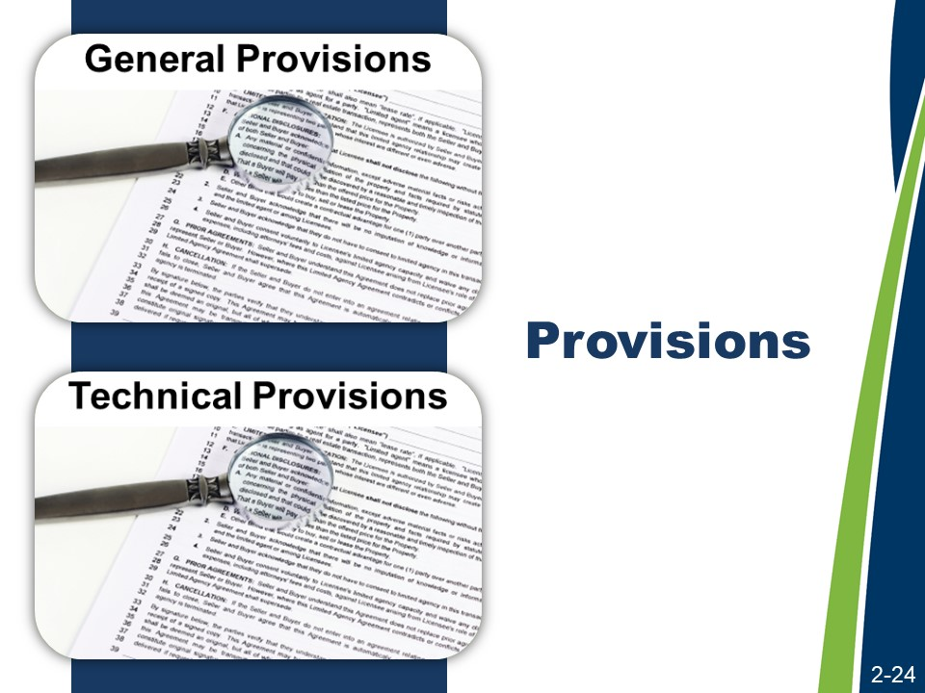
(Slides 2-25 and 2-26 are not shown because they contain answers to the activity.)
Provisions
The general provisions consist primarily of administrative content. The technical provisions generally contain technical content.
General provisions reduce the need for repetition in the technical provisions.
The general provisions are typically found in Section 100. (Section 100 might also be known as Section 1, Division 1, Division 100, or Part 1.) The technical provisions are generally found in Sections 200 to 800. Agencies may use numbering systems different from the numbering systems presented here.
The general provisions are like umbrella provisions in that they apply to every type of work (each contract item). There is no need to refer to or repeat the requirements covered by the general provisions in the technical provisions, unless a general provision is being modified by a technical provision for use in a unique situation.
What types of provisions exist in the general provisions?
What types of provisions exist in the technical provisions?

Slide 2-27
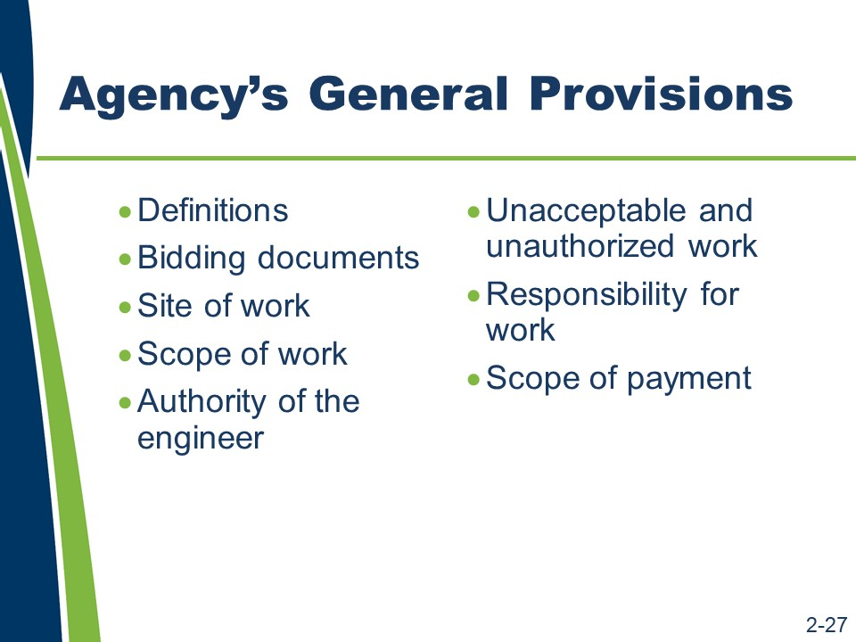
Agency’s General Provisions
The agency’s general provisions typically provide seventy to one hundred pages of requirements; however, the following are particularly important to the writing of specifications.
- Details on definitions
- Bidding documents
- Site of work
- Scope of work
- Authority of the engineer
- Unacceptable and unauthorized work
- Responsibility for the work
- Scope of payment

Slide 2-28
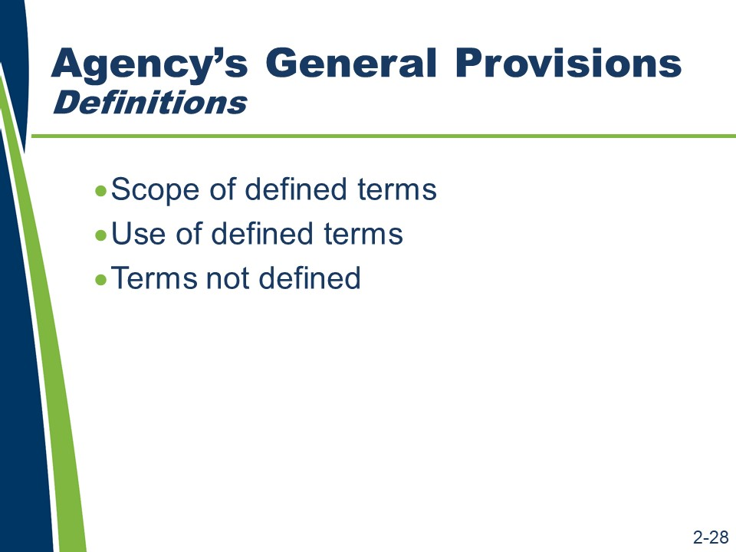
Agency’s General Provisions (continued)
- Definitions
  - Scope of defined terms. These definitions affect how the terms are used not only in the standard specifications but also in all of the contract documents.
  - Use of defined terms. It is important and contractually significant to consistently use and interpret defined terms. If these terms are not used consistently, then the value of the defined term itself is diminished. It can also result in the creation of conflicts and ambiguities.
  - Terms not defined. For words not defined in this section, the commonly used definition applies. Defined terms that are specific to an item of work may be defined in their respective material or construction section.

Slide 2-29
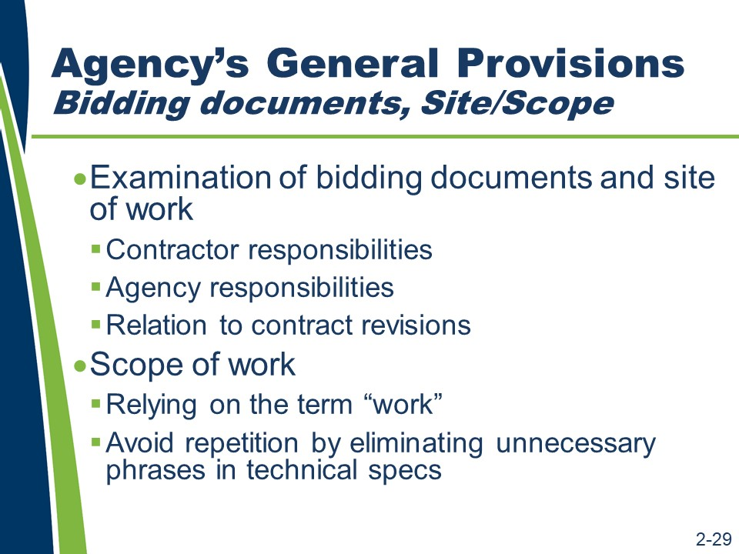
Agency’s General allocates risk by specifying the assumed completeness of the contractor’s knowledge of the bidding documents and the site of work.
- Agency responsibilities. This provision obligates the agency to provide bidding documents for a project that is buildable as represented. The accuracy of the bidding document and the contract equates to the agency’s responsibility for additional costs that result if the contract documents, when followed by the contractor, do not yield the intended product. This is referred to as the Spearin Doctrine.
- Relation to contract revisions. This provision addresses the contract parties’ knowledge of their respective obligations as represented in the bidding documents. It is one of the considerations when evaluating the need for a contract revision on the project.
- Scope of work
  - Relying on the term “work.” The term “work” is often defined as “all work.” The common agency definition of work includes everything associated with completing the task. Using the term “work” means that technical specifications do not have to state, for example, that the contractor must provide materials or mobilize equipment. These requirements are covered by using the term “work.”
  - Avoid repetition by eliminating unnecessary phrases in technical specs.
This section tells the contractor to perform the work in accordance with the contract. It is unnecessary to state elsewhere in the specifications that work must be performed “in accordance with the contract” because this section states, “All work must be performed in accordance with the contract.”

Slide 2-30
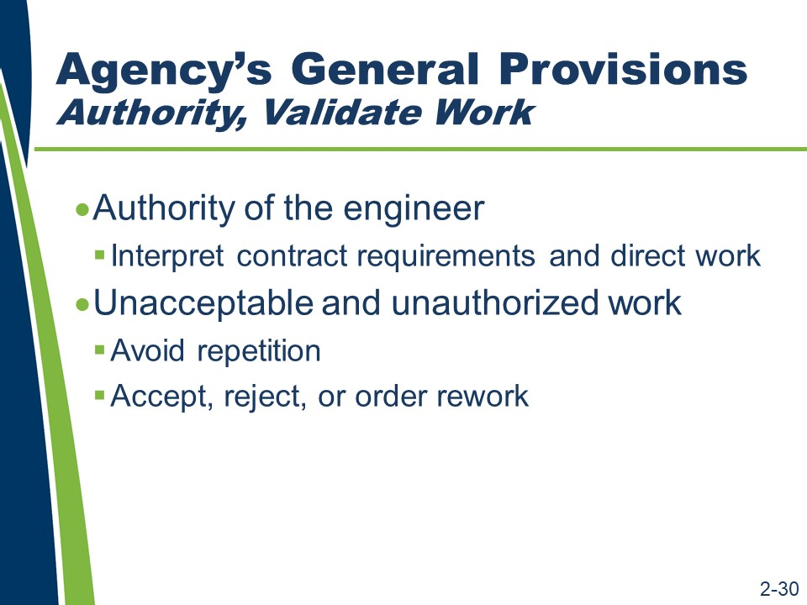
Agency’s General Provisions (continued)
- Authority of the engineer
  - Interpret the contract documents and direct work. The engineer has authority to interpret the contract documents and make acceptance decisions via this section. It is not necessary to repeat elsewhere in the specifications that work is to be performed “as directed by the engineer” or other similar statements because this authority is stated in the general provisions. Remembering this will help eliminate repetition in technical specifications.
- Unacceptable and unauthorized work
  - Avoid repetition. Based on this section, it is not necessary to repeat that the agency will not pay for unacceptable (or “rejected”) or unauthorized work in the specific technical sections.
  - Accept, reject, or order rework. The technical section only needs to state how the specific work will be identified as unacceptable or unauthorized and how the contractor is to correct or remove and replace that work.

Slide 2-31
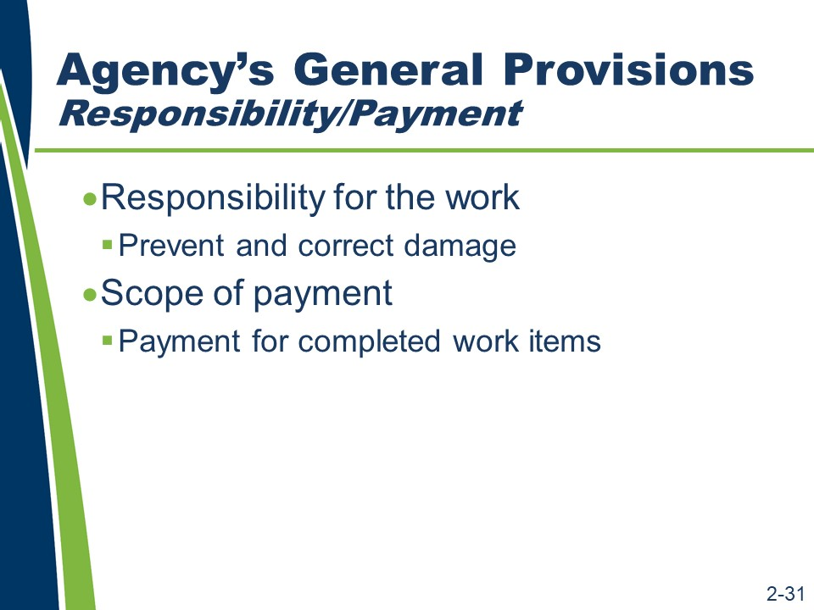
Agency’s General Provisions (continued)
- Responsibility for the work
  - Prevent and correct damage. This provision requires the contractor to prevent and correct any damage to the work prior to final acceptance by the agency.
Avoid repetition by not repeating similar obligations in the technical provisions. Technical specifications that modify this requirement for “interim completion” or “opening to public traffic” can be used effectively.
- Scope of payment
  - Payment for completed work items. It is unnecessary to repeat that the payment for each contract item at the unit price is full compensation for all costs necessary to perform the work represented by the contract item. This is covered in the scope of payment provision of the general provisions.

Slide 2-32
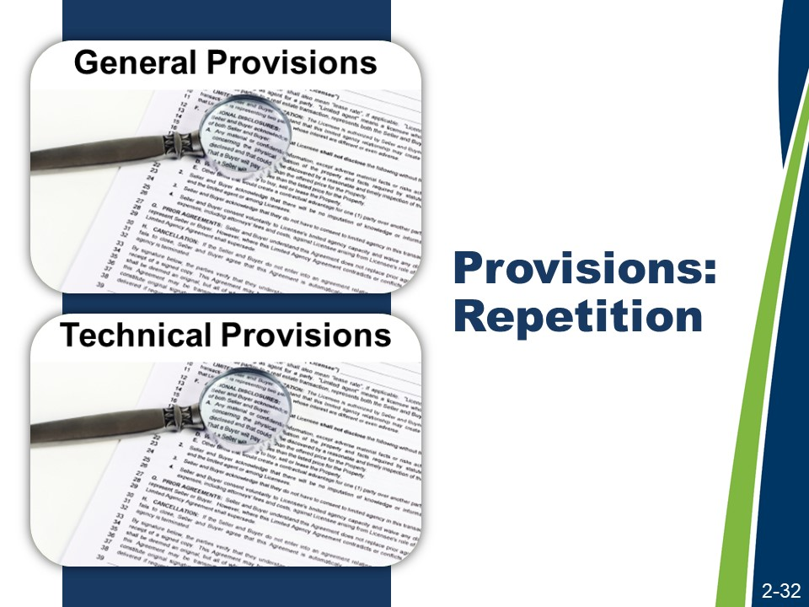
Provisions
The general provisions are necessary to properly write technical provisions. The general provisions set the broad framework within which the technical provisions are interpreted.
What is stated in the general provisions does not need to be repeated in the technical provisions, because what is established in the general provisions applies to all technical provisions.
If a general provision requirement is repeated or improperly applied in the language of a technical provision, a number of problems may occur.
- Repetition may set a precedent that these general provisions need to be repeated in a technical provision for it to apply to that provision.
- Repetition provides an opportunity for the general provisions to be applied improperly; that is, the general provision is now in two locations and has to be maintained in two locations.
When preparing to write technical provisions, specification writers should review the general provisions carefully and use this knowledge to avoid repetition.
It is important to develop an ability to critique the specifications, to read between the lines. Thinking like the specification users and understanding how the users will interpret the specifications will make you a better specification writer.

Slides 2-33 to 2-36
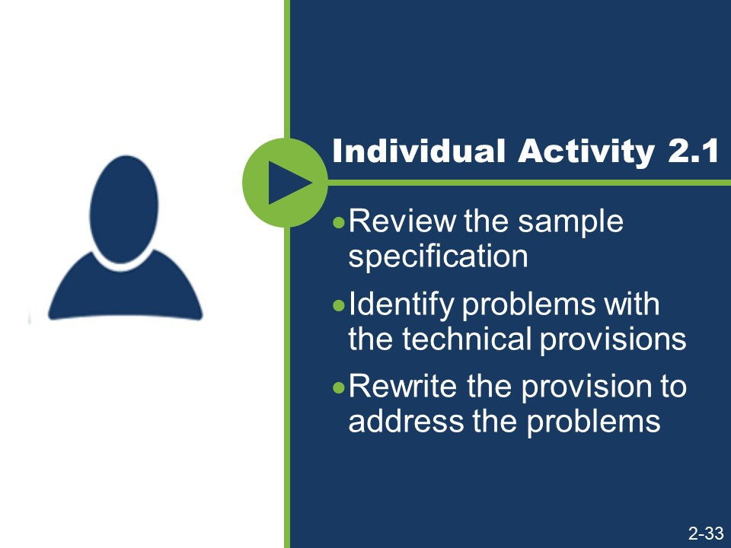
(Slides 2-34 – 2-36 are not shown because they contain answers to the activity.)
Activity
- Review the sample specification and identify problems with the technical provisions.
- Rewrite the provision to address the problems.

Sample 1
“This item consists of furnishing and installing an actuated controller and associated equipment according to these specifications and at the locations shown on the plans or as directed.”

Sample 2
“Before cleaning with pressurized water, remove all debris from bridge sidewalks, bridge decks, curb tops, beam flanges, gusset plates, abutment bridge seats, pier tops, truss joints, deck drain systems, and other locations where debris has accumulated and as directed by the engineer.”

Slide 2-37
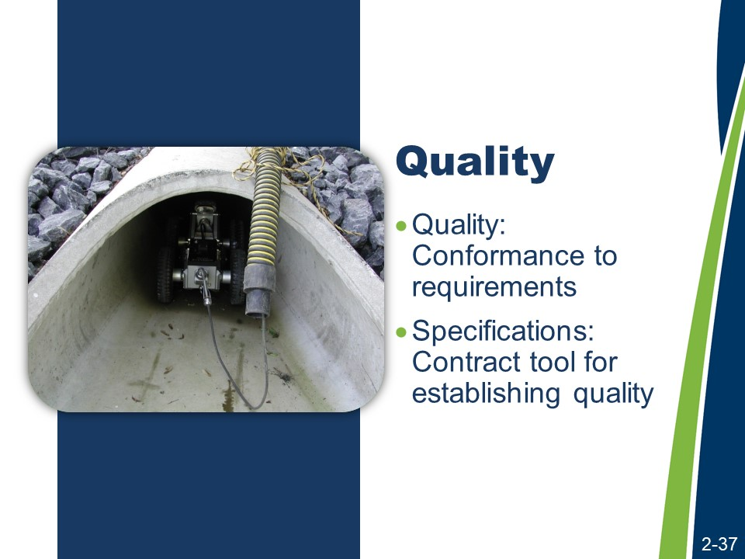
Quality
An important aspect of the administrative and technical content of specifications relates to quality and how it is to be assured. Quality is addressed in both the general and technical provisions of the agency’s specifications. Quality in highway construction is highly dependent on the strength and clarity of the specifications.
The Transportation Research Board defines quality as the degree to which a product or service:
- Is excellent.
- Satisfies the needs of a specific customer.
- Conforms with a given requirement.
A simpler definition, presented in NHI’s Transportation Quality Assurance Course, is that quality is the “conformance to requirements.” Specifications are the contract tool used to establish the degree of conformity necessary for acceptance; therefore, specifications are the key tool for establishing quality.
Consider the systems that need to be in place to ensure that the contractor provides a project to the desired level of quality, that is, in conformance with the requirements.

Slide 2-38 (Not shown because the graphic is included below.)
Quality (continued)
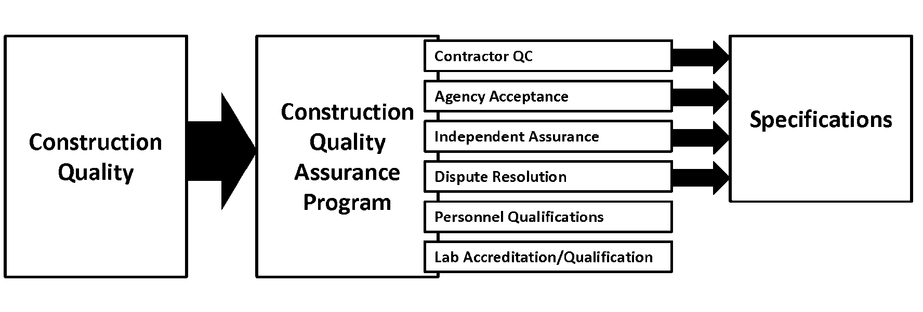
First, the quality of the construction is defined. Then, a quality assurance program is developed. By implementing the components of the quality assurance program, the contractor is guided toward the quality goals and it helps to ensure that the project is constructed to the defined quality.

Slide 2-39
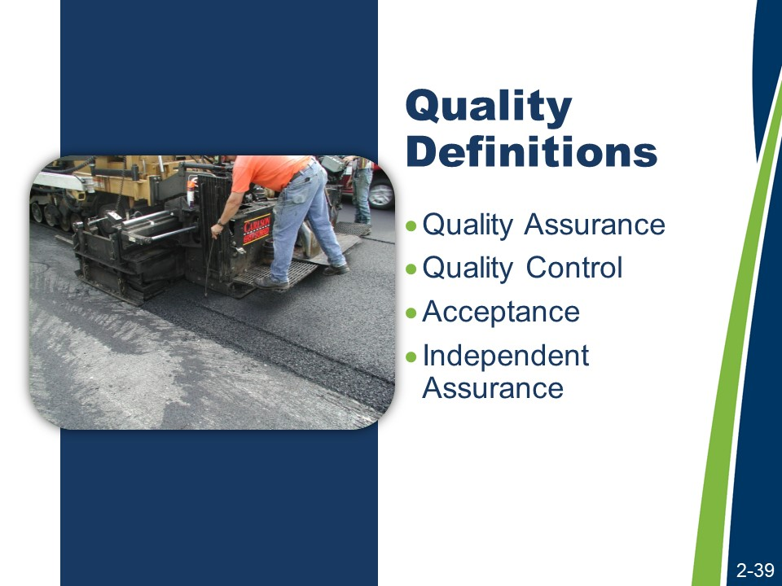
Quality Definitions
There are four key terms applicable to a discussion of quality.
- Quality Assurance. AASHTO defines quality assurance (QA) as (1) all of those planned and systematic actions necessary to provide confidence that a product or facility will perform satisfactorily in service or (2) making sure the quality of a product is what it should be.
- Quality Control. FHWA’s Transportation Construction Quality Assurance Reference Manual defines quality control (QC) as the system used by a contractor party to monitor, assess, and adjust their production or placement process to ensure that the final product will meet the specified level of quality.
- Acceptance. NHI Course 134064A Transportation Quality Assurance Publication No. 08-067 defines acceptance as all factors used by the agency (e.g., sampling, testing, and inspection) to evaluate the degree of compliance with contract requirements and to determine the corresponding value for a given product.
- Independent Assurance. 23 CFR 637 Construction Inspection and Approval defines independent assurance as activities that are an unbiased and an independent evaluation of all the sampling and testing procedures used in the acceptance program.

Quality Definitions (continued)
Does your agency have its own quality assurance program?
If you do, does your agency use the same terms as FHWA’s Quality Assurance program or different terms?
If different from the FHWA’s terms, what terms does your agency use and how are they defined?
Ultimately, this course is about writing specifications, not quality. NHI Course 134064A Transportation Quality Assurance delivers a much more complete exploration of quality. However, the risk that the specification will not yield a product of sufficient quality is an important consideration when drafting specifications. Risk is the next focus of this course.

Slide 2-40
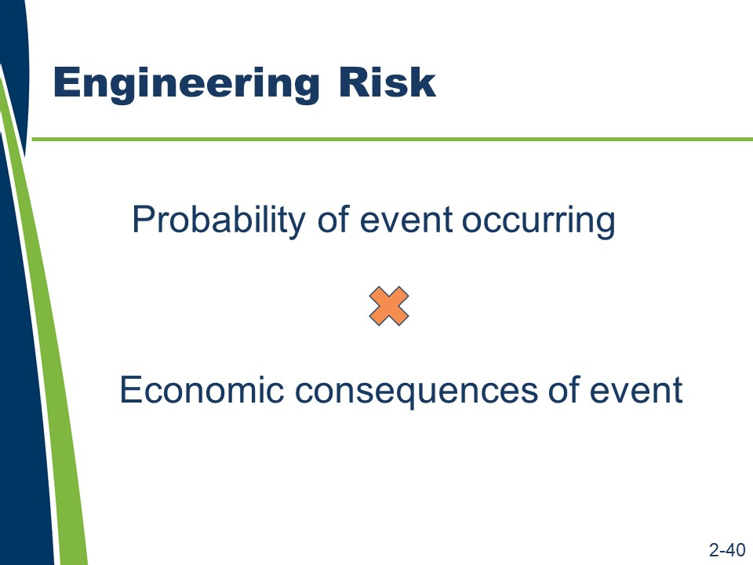
Risk
Prudent risk sharing must be considered within the specifications. When writing specifications, specification writers should consider both implicit and explicit risk allocation.
Since the agency and the contractor are the only two parties to the contract, then all of the risks associated with the project are owned or shared by them in some way.
Specifications are the vehicle through which risks associated with the execution of the project are assigned to either the agency or the contractor.
Though risk can be explicitly assigned, it can also be implicit. For example, the risk associated with discovering a differing site condition is explicitly shifted to the agency when the agency’s contract contains a differing site conditions clause. If the contract is silent with regard to differing site conditions, however, the risk of discovery still exists, and that risk is borne by the agency or the contractor depending on the nature of the conditions that are encountered and applicable legal precedent.
Note that using the specifications to increase the contractor’s risk can result in higher costs to the agency. The contractor must address increased risk by increasing its contingency or by declining to bid on a risky project, reducing the field of bidders, reducing competition, and potentially resulting in higher prices for the work.
Being able to identify how risk is allocated in a specification requires an understanding of the following.
- What can go wrong on a project and why?
- What are the chances of something going wrong?
- What are the potential costs or other consequences of something going wrong?

Risk (continued)
How do you define risk?
What are some of the potential risks on a highway construction project?
The perception of risk can also affect the behavior of the parties to the contract.
Specification writers should consider what behavior to encourage before beginning to write a specification.
For example, one agency was considering whether to reimburse erosion control as a lump sum. In this agency’s experience, when the agency paid for erosion control as a lump sum, as opposed to individual erosion control bid items or force account items, the contractor behaved in a more responsible manner when planning the work and kept the clearing and grubbing to a minimum; only exposing those areas being actively worked. This behavior happened especially if the contractor was also the responsible party for the environmental permit.
The agency had observed similar behavior when traffic control was paid as a lump sum. The contractor tended to apply additional effort in planning its and its subcontractors’ work based on traffic control and work zone needs to minimize their costs and take advantage of multiple work operations within the same work zone.
It is the agency’s observation that when erosion control and traffic control are performed using estimated quantities and unit prices, the contractor has no incentive to minimize the costs to the agency. Instead, the contractor may behave in a manner to maximize profit by maximizing quantities.

Slides 2-41 to 2-44
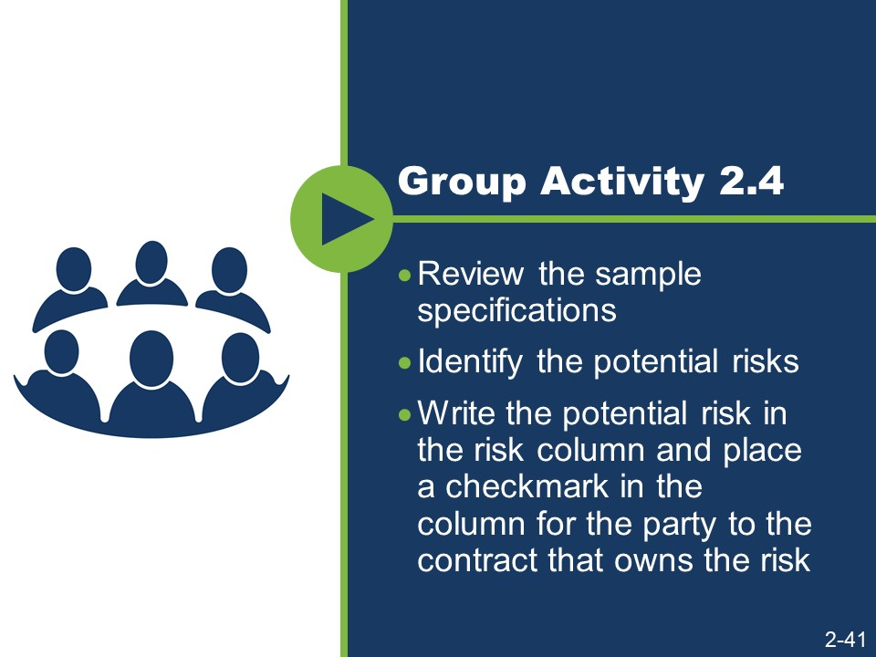
(Slides 2-42 to 2-44 are not shown because they contain answers to the activity.)
Activity
- Work in a small group.
- Review the sample specifications.
- Identify the potential risks.
- Write the potential risk in the risk column and place a checkmark in the column for the party to the contract that owns the risk.

Sample 1
“Remove and dispose of residue from the grooving operations as directed by the engineer to minimize dust and to prevent debris from entering drainage systems.”

Sample 2
“Using methods approved by the engineer, clean dirt and debris from the pavement surface and paved shoulders before placing HMA. Remove loose material from joints and cracks using compressed air. If the engineer determines the compressed air system will not remove deleterious material, remove loose material by a hand or mechanical method, as approved by the engineer. The agency will pay for removal of material by hand or mechanical methods in accordance with subsection 501.04.E.”

Sample 3
“The surface areas of asphalt and concrete pavement that are to receive markings shall be cleaned with a high-pressure air blast to remove loose material prior to placement of the epoxy pavement marking. Should any pavement become dirty, from tracked mud or for other reasons, as determined by the engineer, it shall be cleaned prior to the placement of the epoxy pavement marking.”

Activity (continued)
Sample | Risk  (There may be more than one risk for each sample.) | Contractor (√) | Agency (√)
1
2
3

Slide 2-45
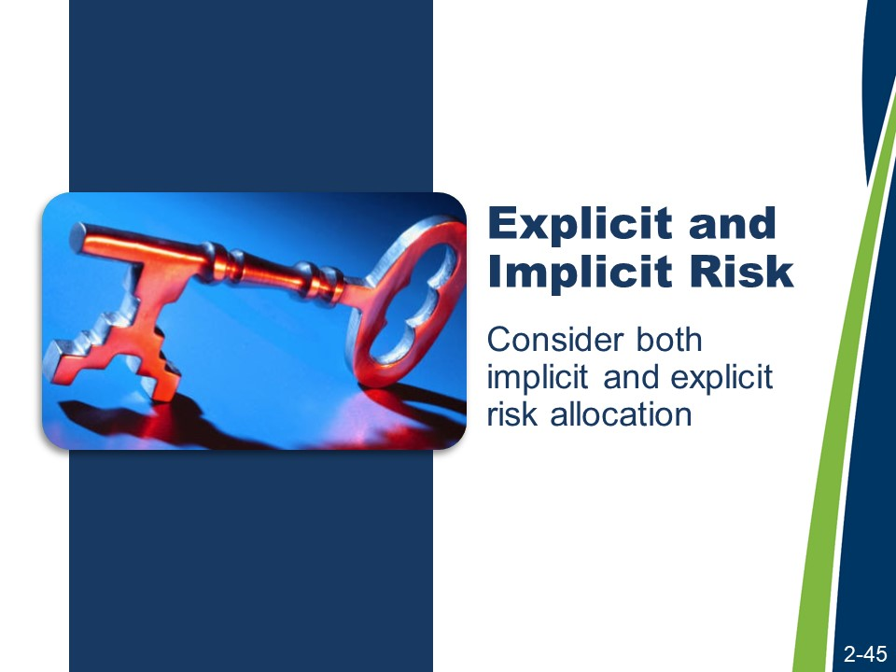
Both implicit and explicit risk allocation must be considered when writing specifications.
Explicit and Implicit Risk
In order to discern the difference between implicit and explicit risk allocation, consider the samples from the previous activity.
- In Sample 1, the risk of the engineer’s direction is implicit. The engineer has the authority to give directions to the contractor; however, the agency may have to pay for those directions as changes to the scope of work or as corrective work if the direction does not produce a quality product.
- In Sample 2, the risk of the compressed air method is explicit, as the provisions define how the agency will pay for additional work if the compressed air method does not work. The risk the agency bears is explicit.
- In Sample 3, the risk of the compressed air method is implicit, since it is the specified method for removing loose material. If it does not accomplish this objective, then the direction to use another method would be a change for which the agency would be responsible. However, the risk that the surface might become dirty and need to be cleaned is explicitly assigned to the contractor. This risk is complicated by the fact that it is the engineer that determines when the pavement is sufficiently dirty to require cleaning before application of the epoxy pavement marking.

Slides 2-46 and 2-47
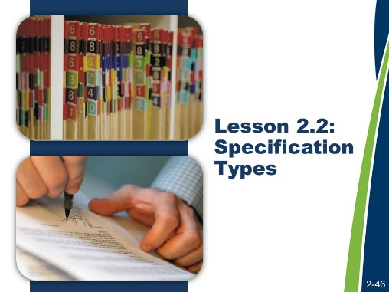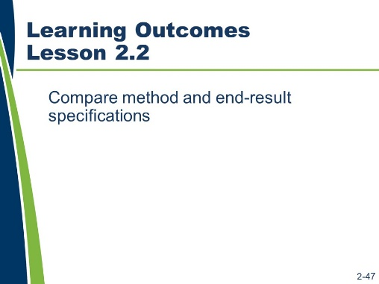

Lesson 2.2: Specification Types
Lesson 2.1 addressed the purpose of specifications, ending with a discussion of risk allocation. In Lesson 2.2, the discussion of risk allocation is expanded with the focus shifting from specific specification language to types of specifications.
Learning Outcomes
This lesson supports this learning outcome.
- Compare method and end-result specifications.
Resources
- NHI course Alternative Contracting (Course Number 134058).
- United States Department of Transportation, Federal Highway Administration. Development and Review of Specifications. Technical Advisory, OPI – HIAM-20. Washington, DC, March 24, 2010.

Slide 2-48
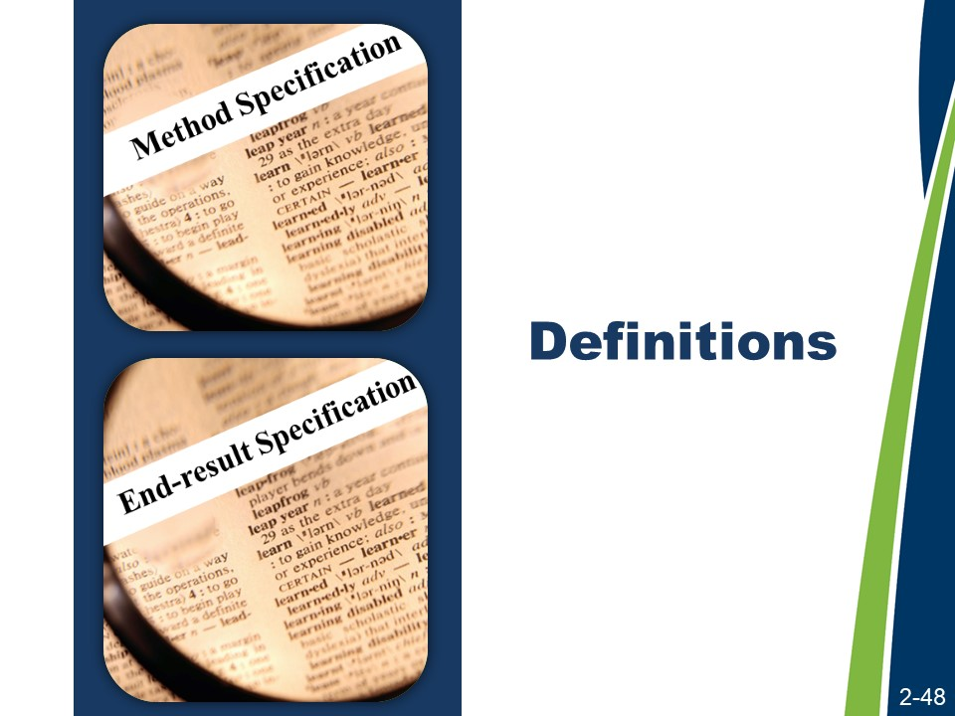
Method and End-Result Definitions
Method specifications and end-result specifications are distinct types of specifications and represent two different approaches to specifying. The Federal Highway Administration (FHWA) has approved definitions for method and end-result specifications.
As detailed in Transportation Circular E-C173 in guidance from the Federal Highway Administration (FHWA), the definitions for method and end-result specifications include:
- Method Specifications. Specifications that require the contractor to use specified materials in definite proportions and specific types of equipment and methods to place the material. Typically, method specifications are based on materials and methods that have historically produced satisfactory results; however, they do not allow for contractor innovation. If the agency writes a method specification, the agency directs the method of construction.
In method specifications, the agency bears the risk of whether or not the method will perform as intended. The contractor only has to be capable of performing the work using the specified method.
- End-result Specifications. Specifications that describe how the finished product should perform over time.
In end-result specifications, the contractor bears more of the risk because the contractor must choose a method that will meet the acceptance criteria.

Slide 2-49 (Not shown because the graphic is included below.)
Method and End-Result Definitions (continued)
There are several approaches to specifying an end result.
- End-result
- Quality assurance
- Performance-related
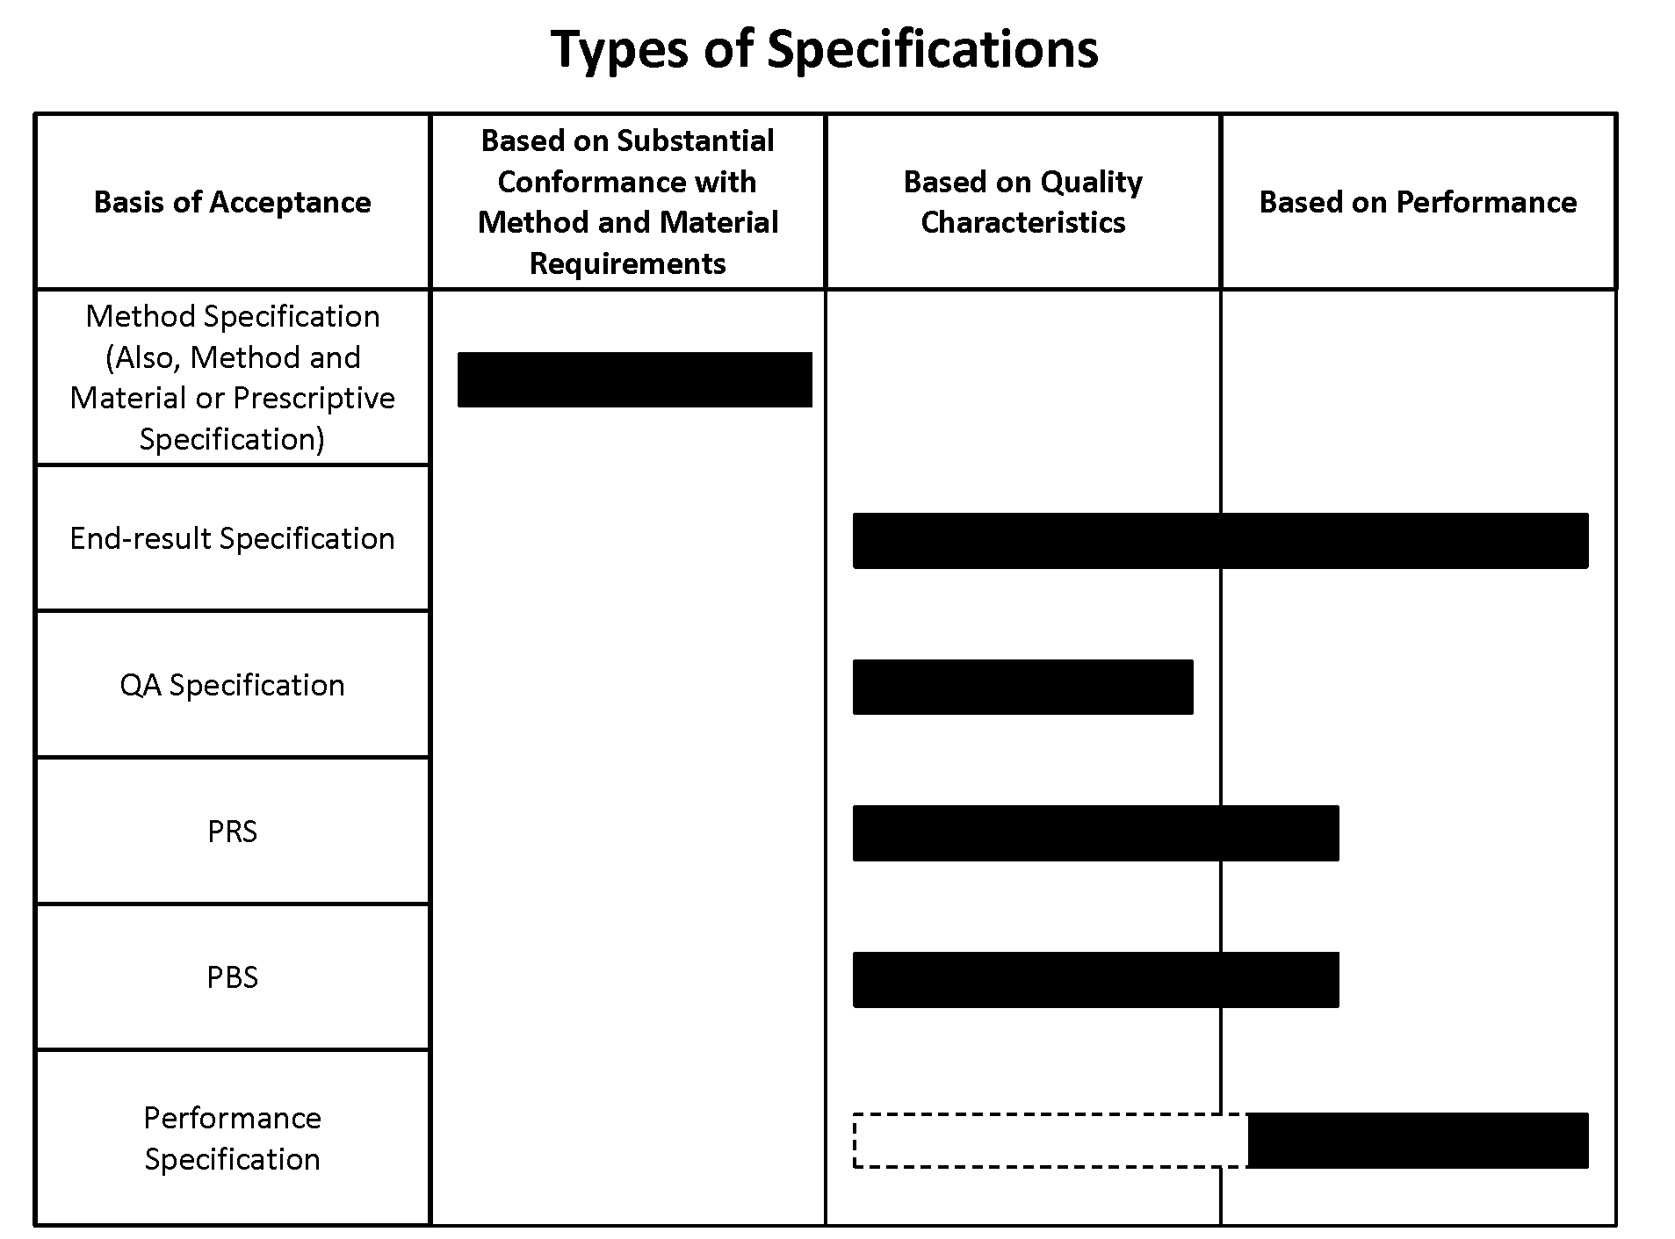
- Performance-based

For further training opportunities on the topic of delivery methods and alternative contracting options, consider attending the NHI course Alternative Contracting (Course Number 134058).

Slides 2-50 and 2-51
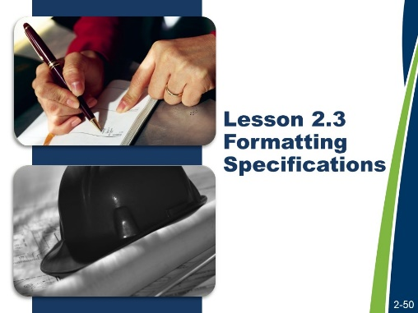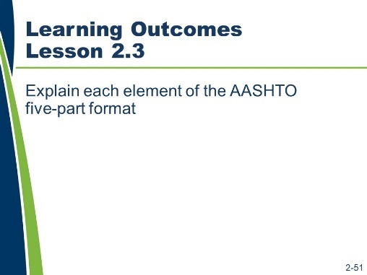

Lesson 2.3: Formatting Specifications
Lesson 2.1 addressed the purpose of specifications, ending with a discussion of risk allocation. In Lesson 2.2, the discussion of risk allocation was expanded with the focus shifting from specific specification language to types of specifications. This lesson addresses the formatting of specifications.
Learning Outcome
This lesson supports this learning outcome.
- Explain each element of the AASHTO five-part format.
Resources
- American Association of State Highway and Transportation Officials. Guide Specifications for Highway Construction. Ninth Edition, 2008.
- United States Department of Transportation, Federal Highway Administration. Development and Review of Specifications. Technical Advisory, OPI – HIAM-20. Washington, DC, March 24, 2010.

Slide 2-52
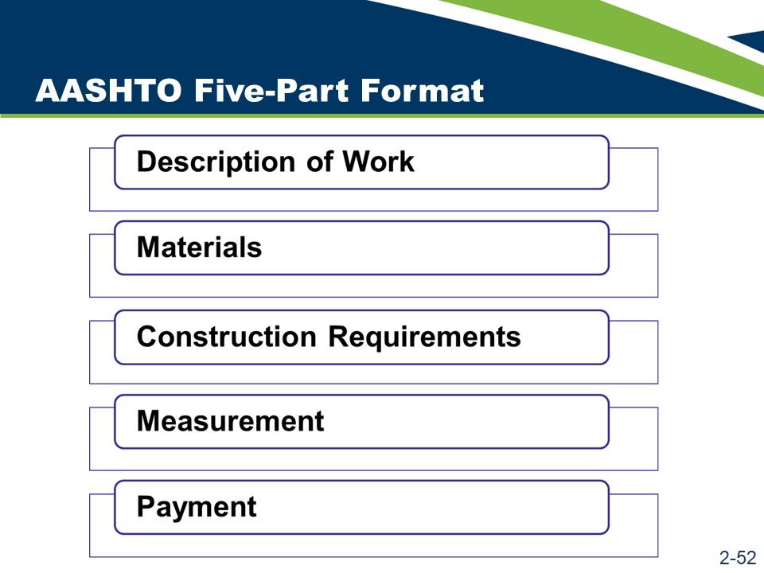
AASHTO Five-Part Format
Agency specifications should be organized using the AASHTO five-part format. In addition to creating uniformity across the highway construction industry nationally, using the five-part format helps specification writers ensure that the specifications contain all the necessary components.
The AASHTO five-part format includes:
- Description of Work.
- Materials.
- Construction Requirements.
- Measurement.
- Payment.
Each part has an important and unique function within the overall specification.

AASHTO Five-Part Format (continued)
Some technical specification sections may not contain material requirements (e.g., clearing and grubbing). To maintain a consistent heading structure throughout the technical specifications, do not omit the “Materials” subsection heading. Label the subsection heading as vacant or blank.
Some older specifications may not follow the AASHTO five-part format and may not contain all necessary components; therefore, specification writers should avoid developing new specifications simply by “cutting and pasting” from older specifications. Instead, the specification writer should break down the older specification into its essential elements and then begin developing the new specification from these essential elements, organizing the completed specification into the AASHTO five-part format.
The following is a description of the contents of each part of the AASHTO five-part format.
- Description of Work. This specification section is sometimes titled “Scope of Work” or “Work Included,” as often seen in architectural or building specifications. AASHTO has adopted the title “Description of Work” for highway specifications.
- Materials. This part of a specification identifies the materials required to complete the work. This section of a specification stipulates detailed material requirements or provides cross-references to detailed material specifications in another division or book.
- Construction Requirements. This part fully describes requirements to construct and accept the work. It also describes the measurable quality of the work.
- Measurement. The “Measurement” part specifies what, when, and how to measure for payment.
- Payment. The “Payment” part should define all of the pay items needed to complete the work.
This format serves as an organizational structure, an outline for the specification, and a checklist ensuring that all essential information is included in the specification.

Slide 2-53
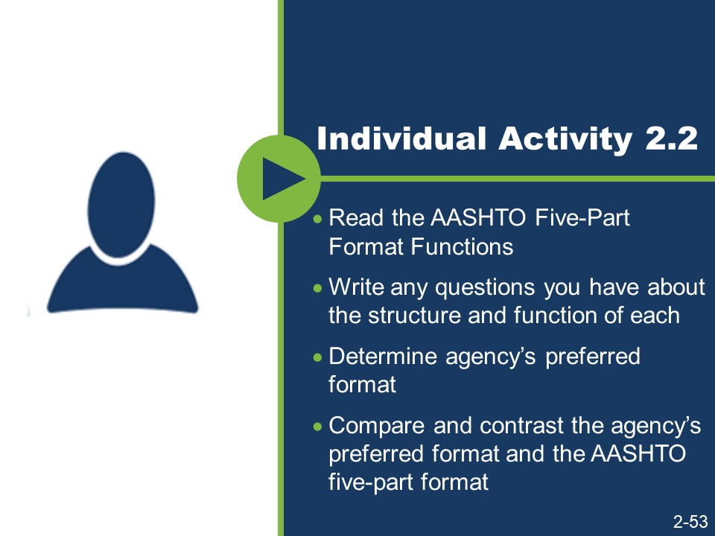
Activity
- Read the AASHTO Five-Part Format Functions.
- Write any questions you have about the structure and function of each part.
- Determine the agency’s preferred format found in the technical provisions in the agency’s standard specifications.
- Compare and contrast the agency’s preferred format and the AASHTO five-part format.
- If the agency’s preferred format differs from the AASHTO five-part format, how are the AASHTO five-part format functions addressed?

AASHTO Five-Part Format Functions
Part Title | This part should…
Description of Work | - Provide a short, concise statement of the work required.  - Define the related plans or specifications that clarify the work.  - State the relationships to other work items that are necessary to perform this work.  - Avoid phrases such as “in accordance with these specifications and as shown on the plans or directed by the engineer.” This point is covered in the general provisions and should not be repeated.  - Avoid including methods of construction, construction details, and procedures for measurement and payment.  - Avoid duplicating or elaborating on information already on the plans.
Materials | - Cross-reference applicable agency standard material specifications.  - Cross-reference applicable nationally recognized material specifications (e.g., AASHTO or American Society for Testing and Materials (ASTM)) if the agency’s specifications do not apply to or do not fully describe the required material.  - Establish detailed specifications of the properties of each material and the methods of testing each material. This is critical if reference specifications are unavailable or if a given material is common to many work items located in the agency’s Materials division.
Construction Requirements | - Complement the plans. Information overlap or duplication may lead to a difference in instructions and disagreements as to which is the proper document to follow.  - Identify and describe the equipment to be used to perform the work for method specifications.  - Provide the detailed sequence of construction operations, or if using performance standards, describe the required end product.  - Specify the type and frequency of tests required during construction and the final testing results necessary for acceptance.  - Identify the minimum quality control activities if quality control testing and measurement are the responsibility of the contractor.  - Specify the quality assurance methods that the agency will use.

Part Title | This part should…
Measurement | - Specify the components of the interim or completed work to measure for payment.  - Include the units of measurement used for each bid item.  - Specify exactly how to determine the quantity, including what measurement to take, and where or when to take the measurement. For example, measurements can be taken in place, before disturbing the material that is to be excavated, as originally provided, as finally provided, in the vehicles hauling the material, and others. Specify all modifying measurement factors (e.g., disturbed or undisturbed material, temperature, waste, and spillage).  - Avoid specifying what work will be at the contractor’s expense.  - The following is not recommended language: “Contractor shall perform corrective work at contractor’s expense.” This language is not recommended for two reasons. First, the general provisions already make clear the contractor’s obligation with regard to corrective work. Second, the specification should not be concerned with how the contractor pays for the corrective work. Rather, the specification should make clear that the corrective work is to be performed at “no additional cost to the agency.”
Payment | - Identify all work incidental to the payment. It should not repeat the full compensation language. For example, “This payment constitutes full compensation for all labor, materials, equipment, and other resources necessary to complete the work as required by the contract.” The general provisions already state that this is true of payment for all contract items.  - Ensure that the bid item reflects a discrete unit of work that includes the labor, materials, equipment, and other costs related to the work.

Slides 2-54 and 2-55
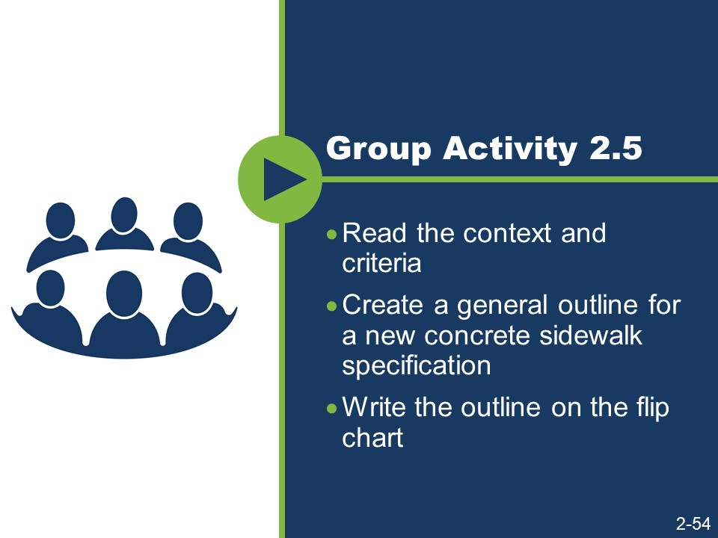
(Slide 2-55 is not shown because it contains answers to the activity.)
Activity
- Work in a small group.
- Read the context and criteria.
- Create a general outline for a new concrete sidewalk specification.
- Write the outline on the flip chart.

Activity (continued)

Context
The agency intends to award a contract for the reconstruction of eight blocks of a State Highway through an urban corridor and within a city’s limits. Included in the scope of this contract will be the construction of a concrete sidewalk adjacent to new, concrete curb and gutter to be reconstructed as part of the same contract. The contract will also include the reconstruction of the adjacent State Highway asphalt pavement. The concrete sidewalk will be constructed for the length of the project on both sides of the highway. The contractor constructing the sidewalk will be required to comply with this specification when performing the sidewalk construction work. The location and dimensions of the sidewalk and a profile of the sidewalk and bedding course are shown in the plans for the project.

Criteria
The equipment needed to construct a concrete sidewalk includes an excavator, hand tools, and a hand-driven compactor to excavate for and compact the bed course and set the forms. The contractor will also need to provide all necessary forms and hand tools for placing, consolidating, finishing, jointing, and texturing the concrete.
The material needed to construct the sidewalk includes bed course materials, concrete meeting the specified compressive strength, reinforcing steel, and joint filler similar to that specified in other subsections of the agency’s standard specifications.
- For the bed course, consider specifying a class of aggregate subbase that allows ease of placement and minimal compactive effort.
- For concrete, consider specifying a standard concrete mix that produces the minimum acceptable compressive strength considering the intended use of the sidewalk.
- For reinforcing steel, consider specifying a standard type used in the region or within the jurisdiction where the sidewalk is being placed.
- For the joint filler and curing agent, consider specifying types similar to those required by your agency for concrete pavements.

Slide 2-56
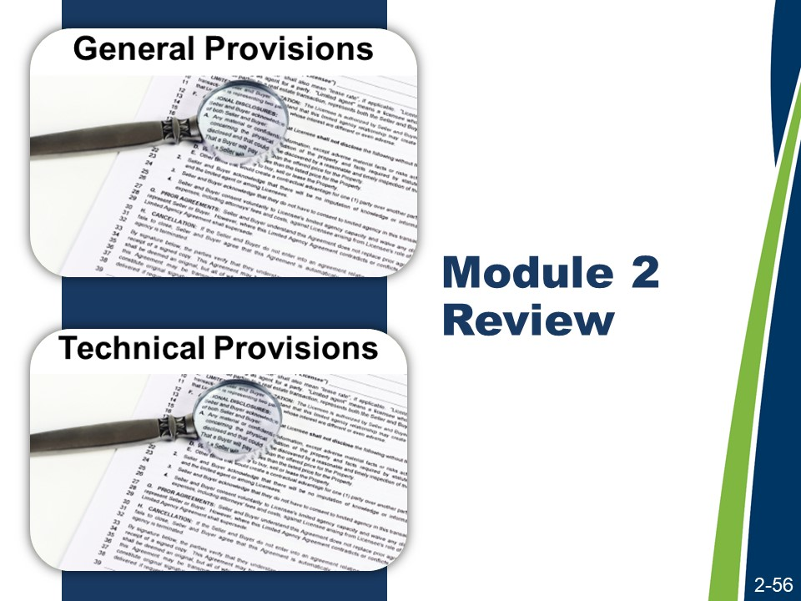
Module 2 Review
This concludes the content for Module 2.
Activity
- Work with a nearby partner.
- Review the key learning points and objectives from Module 2.
- Answer the questions.
- Many agencies define change orders, contract modifications, or supplemental agreements (or other agency terms for contract revisions) as being part of the contract. If these documents were included in the agency’s order of precedence clause, where would they be placed in the pyramid?

Module 2 Review (continued)
- During discussion of the effect of specifications on a contractor’s behavior, it was observed that specifying erosion control or traffic maintenance as lump sum items encouraged desirable contractor behaviors, such as better planning to minimize lane closures. Using lump sum items appeared to reduce the risk to the agency related to the cost of these items However, an important consideration, when contemplating making erosion control a lump sum item, is whether the contractor or the owner holds the environmental permit. What contractor behaviors would be a concern if erosion control was specified as a lump sum item, but the agency held the environmental permit?
- There are many different organizational structures that might be used for highway construction specifications other than the AASHTO five-part format. For example, the Construction Specifications Institute publishes a specification format that is widely used in private industry. Benefits of using the AASHTO five- part format are that it serves as a reliable outline for technical specifications and a convenient reminder to specification writers regarding the necessary content of highway specifications. What other benefits come from agencies using the AASHTO five-part format?

Module 2 Review (continued)
The following are the key learning points in Lesson 2.1.
- The definitions of contract and specifications.
- The identification of the parts of the contract.
- The definitions of important highway specification related terms.
- The order of precedence.
- The purpose of specifications.
- The definition of general and technical provisions.
- The definition of administrative and technical content
- Risk.
The following is the key learning point in Lesson 2.2.
- The two main types of specifications (method and end-result).
The following are the key learning points in Lesson 2.3.
- The five-part format helps specification writers ensure that the specifications contain all the necessary components.
The following are the learning outcomes for Module 2.
- Compare the functions of standard and supplemental specifications with the functions of special provisions.
- Explain how the “order of precedence” affects writing specifications and preparing plans.
- Explain the purposes of a specification.
- Describe the purpose of the general provisions.
- Explain how specifications are used to assign risk and affect the behavior of different parties, within a given scenario.
- Compare method and end-result specifications.
- Explain each element of the AASHTO five-part format.

Module 3: Writing and Interpreting Specifications

This page is intentionally blank.
Slide 3-1
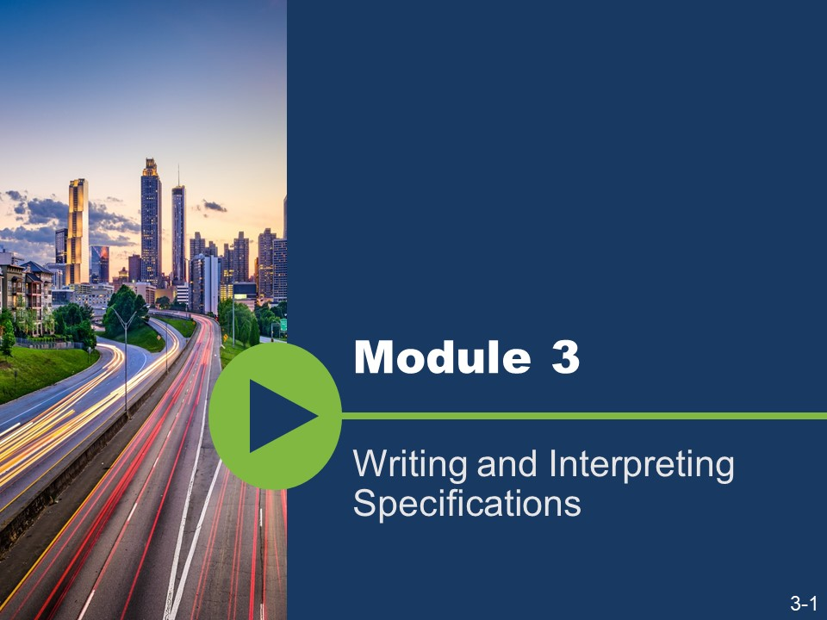
Module 3 addresses writing and interpreting specifications.

Slides 3-2 and 3-3
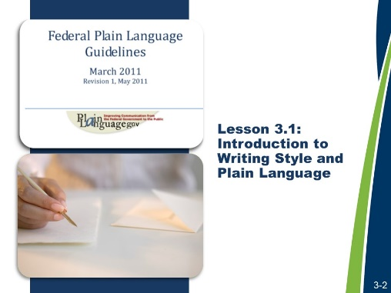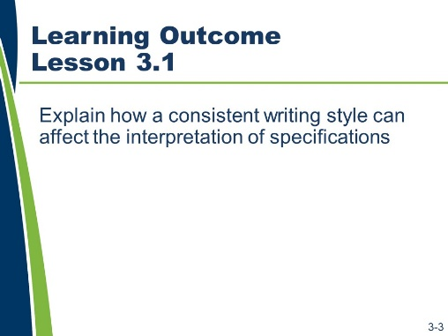

Lesson 3.1: Introduction to Writing Style and Plain Language
Lesson 3.1 explains the use of writing style and its effect on the audience’s interpretation. Resources available to specification writers to help them write better specifications will also be identified.
Learning Outcomes
This lesson supports these learning outcomes.
- Explain how a consistent writing style can affect the interpretation of specifications.
Resources
- Federal Plain Language Guidelines, May 2011. http://www.plainlanguage.gov/.
- Agency’s specification manual(s).
- United States Department of Transportation, Federal Highway Administration. Development and Review of Specifications. Technical Advisory, OPI – HIAM-20. Washington, DC, March 24, 2010.

Slides 3-4 and 3-5
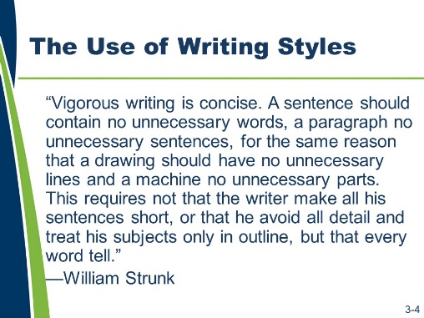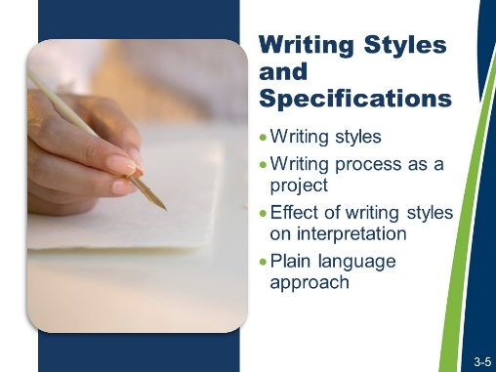
The Use of Writing Styles
Vigorous writing is concise. A sentence should contain no unnecessary words, a paragraph no unnecessary sentences, for the same reason that a drawing should have no unnecessary lines and a machine no unnecessary parts. This requires not that the writer make all of his sentences short, or that he avoid all detail, and treat his subjects only in outline, but that every word tell.
—William Strunk
Writing Styles and Specifications
Use of a specific writing style affects the development and use of specifications.
- Writing styles. Writers have control over styles and the writer should play an active role in selecting and using the appropriate style.
- Writing process as a project. The writing process requires careful preparation and appropriate resources; specification writers need to spend time planning to write well.
- Effect of writing style on interpretation. The interpretation of specifications is directly correlated to the way they are written. The chance of them being interpreted differently increases when specifications are written in various ways.
- Plain language approach. Writing in plain language allows the audience to clearly understand the information.
Writing is a skill. Hone it!

Slides 3-6 and 3-7
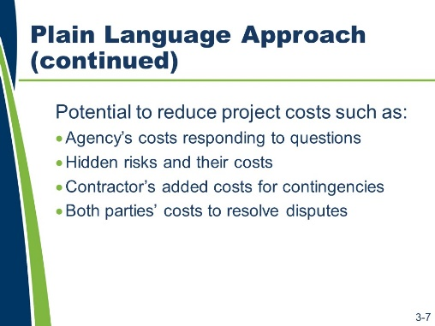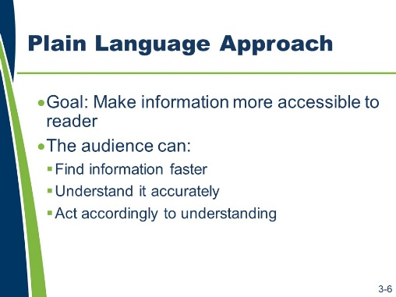
Plain Language Approach
The goal of the plain language approach is to make information more accessible to its primary audience (users).
What does “make information more accessible” mean? It means the audience is able to do the following.
- Find the relevant information faster
- Understand it accurately
- Act according to understanding
The plain language approach is a reliable approach for writing and maintaining specifications.
In the context of specifications, besides providing a more effective basis for communicating the project requirements, the benefit of the plain language approach is its great potential to reduce project costs, such as the following:
- Agency’s added costs to respond to questions about the intent of the specifications during both the bidding and construction phases.
- Hidden risks and their added costs that were not considered by either party.
- Contractor’s added costs to provide contingencies for unclear specifications.
- Both parties’ added costs to resolve disputes that are based on their different interpretations of the specifications.
What are other benefits of using a consistent writing style when writing specifications?

Slide 3-8
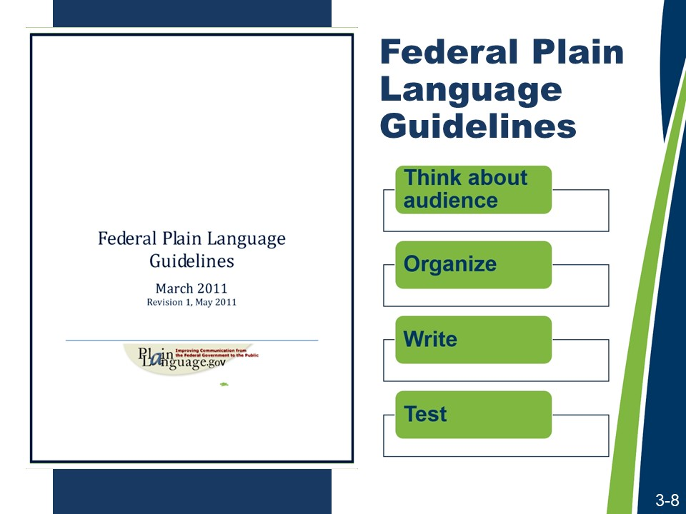
Federal Plain Language Guidelines
Because the writing style for one type of document may not be the same as the writing style for another type of document, the remainder of the course will focus on the principles of writing style as they apply to highway construction specifications.

The plain language approach is not something made up for this course. It relies on the Federal Plain Language Guidelines. These guidelines contain a four-step approach to writing in plain language.
- Step 1: Think about and empathize with your audience.
- Step 2: Organize.
- Step 3: Write your document.
- Step 4: Test.

Slide 3-9
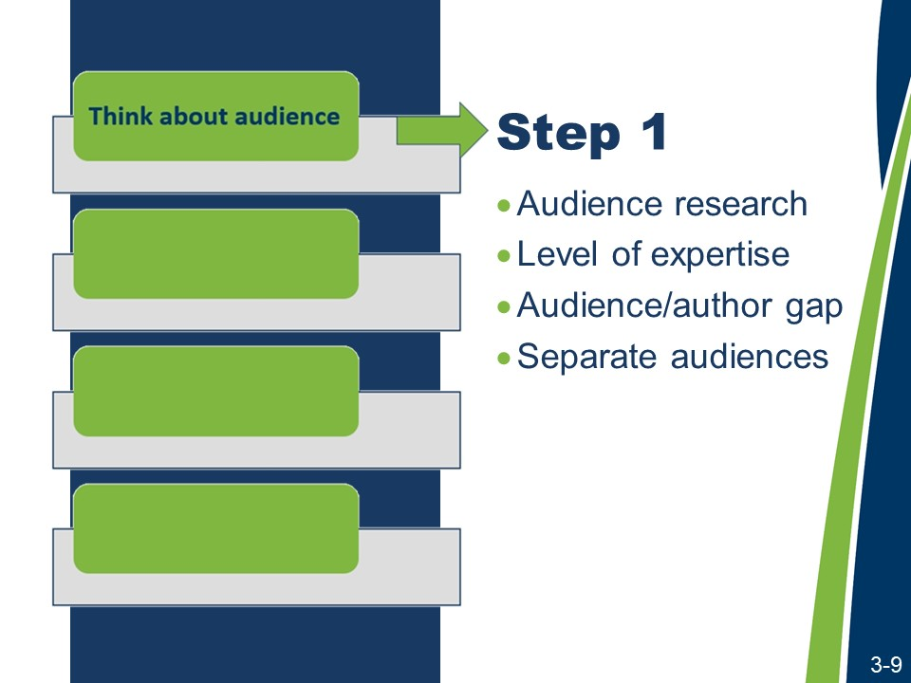
Federal Plain Language Guidelines (continued)
Step 1: Think about and empathize with your audience.
Audience research. Research the audience who will read and use the document. Get feedback from the audience whenever possible and then write with the entire audience in mind. Include both the parties with assigned actions or responsibilities and others using the document who are not specifically addressed.
Ways to conduct research include:
- Consulting relevant technical documents available from AASHTO, FHWA, and the industry.
- Interviewing experts within the agency.
- Talking with the agency and contractor personnel in the field that will have to interpret and execute the work required to comply with the specification.
- Referencing the AASHTO Guide Specification or other agencies’ specifications to see how these sources wrote specifications for the same kind of work. Compare and contrast these sources, developing an appreciation for the different approaches.
Level of expertise. What is the average reader’s level of expertise? Write to that average and not to technical or legal experts.
- Audience/author gap. Do not assume that the audience knows exactly what you know as the author. Plain language means presenting information in a manner that is well organized and logical for the audience. This is not just about short words, short sentences, and short paragraphs.
- Separate audiences. Address separate audiences separately. Consider that highway construction specifications address the obligations of the contractor and the agency.

Slide 3-10
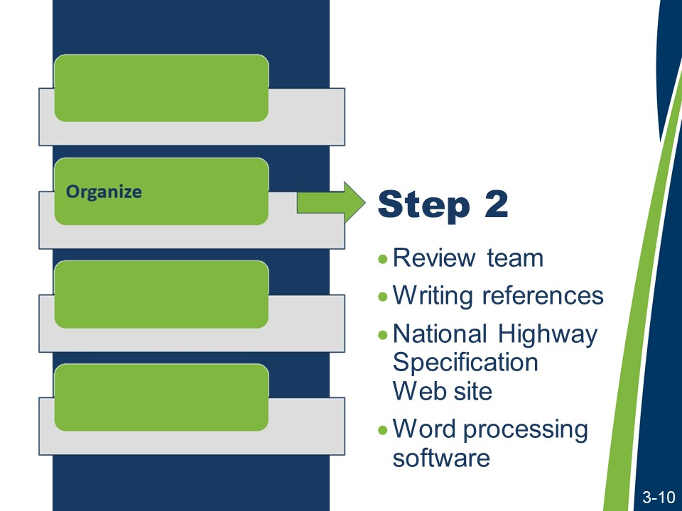
Federal Plain Language Guidelines (continued)
Step 2: Organize.
Review team. The specification writing process needs to be managed as any project. Team members need to know their responsibilities and how they will work together. Assign responsibilities with due dates.
Writing references. Because everyone’s writing skills are not equal, a style guide helps level the playing field. Writing references, such as style guides, provide the following.
- A standardized writing style for different types of provisions
- Guidance on how to consistently use terms and phrases
- Capitalization and abbreviation guidelines
- Punctuation and grammar rules
Word processing software. Word processing software is a resource for specification writers.

Slide 3-11
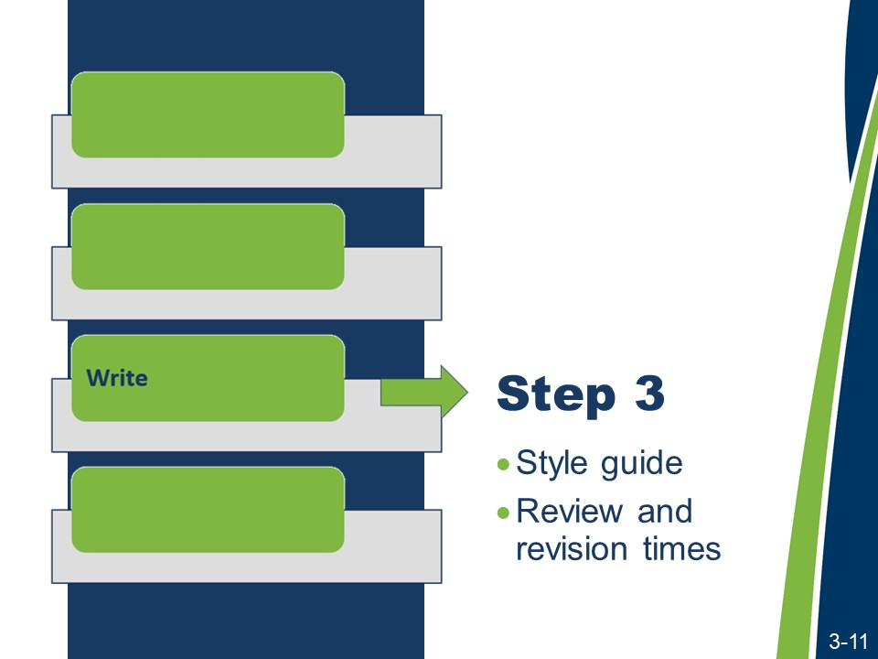
Federal Plain Language Guidelines (continued)
Step 3: Write your document.
Style guide. Use the style guide during the writing process.
The use of a style guide is as important to the “Write” step as it is to the “Organize” step. No specification writer is expected to memorize every detail of a style guide, but he or she should know where to find guidance on the relevant style topic. The course materials will address specific style guidance for writing with the appropriate voice and mood in Lesson 3.2 and for using the five Cs of specification writing in Lesson 3.3.
Review and revision times. Plan for the time needed to write, review, and revise the specifications. As Mario Puzo, the author of The Godfather, has written, “The secret to good writing is rewriting.”
Plan for the time needed to rewrite and revise drafts and for the time needed for an adequate peer review and commenting process. View specification writing as a collaborative process with peer reviewers being an integral part of the process.
For big efforts, consider developing a schedule with intermediate milestones to track progress. Schedule regular meetings to both ensure that progress is being made and adequate input is being received.

Slide 3-12
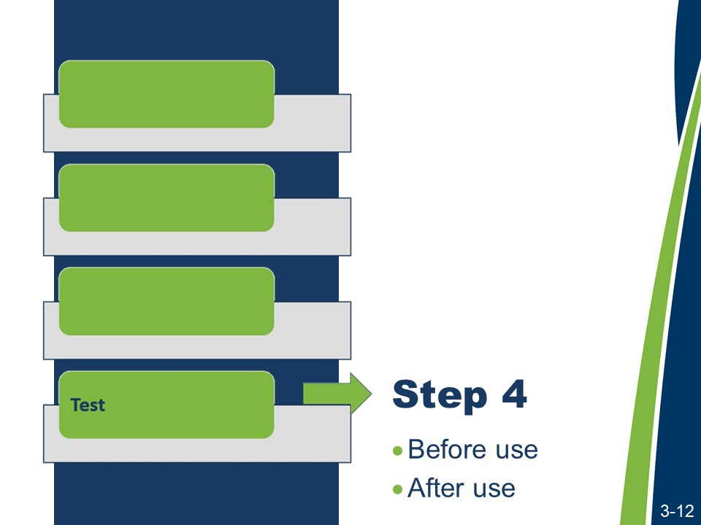
Federal Plain Language Guidelines (continued)
Step 4: Test.
The effectiveness of a specification can be evaluated.
Before use. Before the specifications become a part of a contract, their effectiveness can be evaluated through the internal Plans, Specifications, and Estimates (PS&E) review process.
For long-term maintenance of specifications, the FHWA Technical Advisory Development and Review of Specifications recommends that agencies establish and support a multi-disciplinary group with FHWA and agency representatives.
- Select group members to minimize organizational “mindset” and individual biases.
- Obtain feedback from the field personnel and industry representatives.
- Maintain a standing specification committee with the local contractors association.

Federal Plain Language Guidelines (continued)
After use. After the specifications are used, their effectiveness can be evaluated through review of the following.
- Bid tabulations for the item in question
- Field inspection report findings
- Industry comments
- Year-end summaries of change orders
- Requests for information
- Variance requests
- Time extensions
- Disputes and claims
By conducting careful reviews using reviewers from diverse backgrounds and by following up after the specification has been in use, the specification writer can validate the specification’s appropriateness and success at meeting the desired objectives, including achievement of the desired quality.

Slide 3-13

Specification Writer’s Checklist Activity
- Work with a partner.
- Review the “Writing Style and Plain Language” and “Review” sections in Appendix D: Specification Writer’s Checklist.
- Answer the questions.
- What questions do you have about the tasks?

- What tasks would you add to your checklist and why?

Slides 3-14 - 3-15
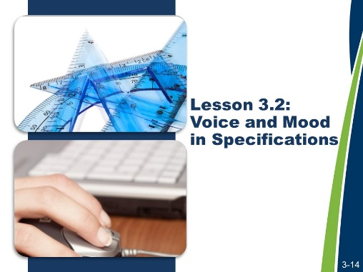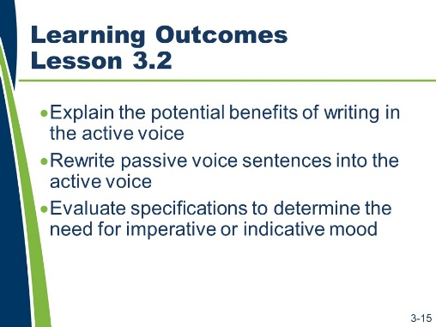

Lesson 3.2: Voice and Mood in Specifications
Lesson 3.2 addresses the mechanics of writing in the appropriate voice and mood.
Learning Outcomes
This lesson supports these learning outcomes.
- Explain the potential benefits of writing in the active voice.
- Rewrite passive voice sentences into the active voice.
- Evaluate specifications to determine the need for imperative or indicative mood.
Resources
- Agency’s specification manual(s).
- United States Department of Transportation, Federal Highway Administration. Development and Review of Specifications. Technical Advisory, OPI – HIAM-20. Washington, DC, March 24, 2010.

Slides 3-16 to 3-18
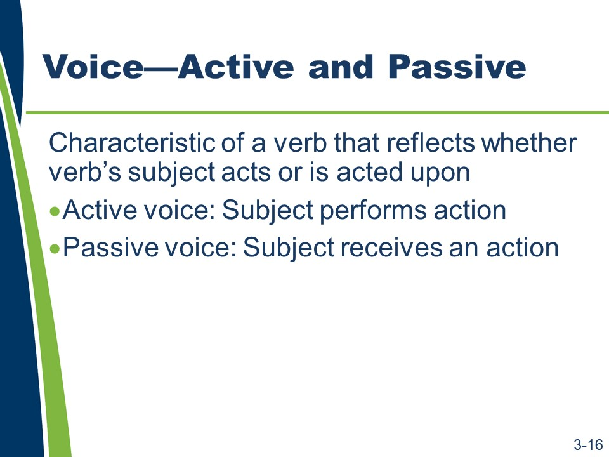
(Slides 3-17 and 3-18 are not shown because they contain answers to the activity.)
Voice
Too often, agencies write specifications using the passive voice. The best practice is to write specifications in the active voice. When specification writers write specifications in the active voice, that writing is less likely to be misinterpreted, and it uses substantially fewer words. The focus of this lesson is on learning how to write specifications in the active voice.
Voice is a characteristic of a verb that reflects whether its subject acts or is acted upon. In the passive voice, the subject receives an action. In the active voice, the subject performs an action.

Activity
- Identify the subject, verb, and object in the example sentences.

Examples of Active Voice
“The contractor shall place the concrete in continuous horizontal layers.”
Subject:
Verb:
Object:
“The contractor shall test the concrete cores for compressive strength.”
Subject:
Verb:
Object:

Examples of Passive Voice
“The concrete shall be placed in continuous horizontal layers.”
Subject:
Verb:
Object:
“The concrete cores shall be tested for compressive strength.”
Subject:
Verb:
Object:

Slides 3-19 and 3-20
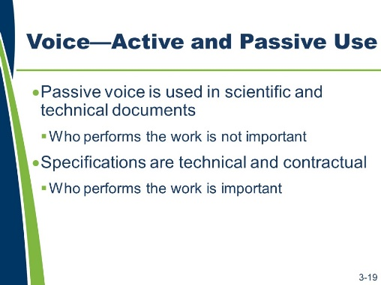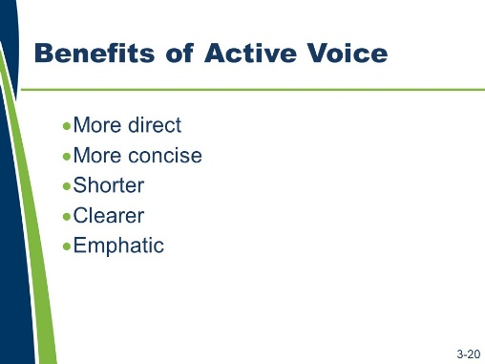
Voice—Active and Passive
The passive voice is used in scientific and technical writing. It is preferable in a strictly scientific or technical context because it provides objectivity; the results of a procedure or process will be the same regardless of who performs its steps. In the passive voice, who takes an action is not important.
Because specifications are technical in nature, agencies used the passive voice.
Highway construction specifications are both technical and contractual. On a highway construction project, who performs the steps of a given procedure or process is important.
Because the specifications are part of a contract, use the active voice instead of the passive voice to clearly convey who is responsible for taking an action.
Benefits of Active Voice
Active voice is more direct and more concise. Passive voice deemphasizes the actor (the performer of the verb’s action), uses more words (such as prepositional phrases), and is often vague or misleading.
Generally, the active voice uses fewer words than the passive voice. The active voice is clearer and more emphatic than the passive voice.

Slide 3-21
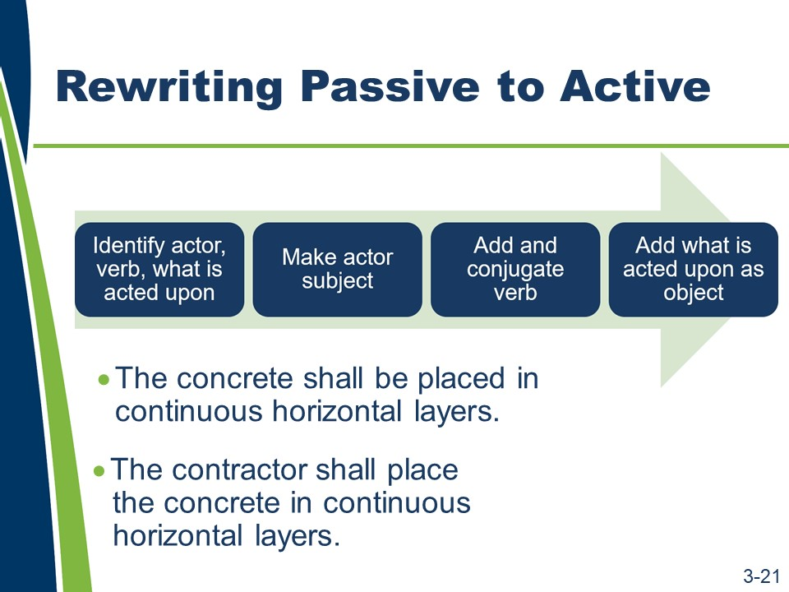
Rewriting from Passive to Active
There are several steps when rewriting from passive to active voice.
- Identify the actor, the verb, and what is acted upon.
- Make the actor the subject.
- Add and conjugate the verb.
- Add what is acted upon as the object and ensure that all other information is included without changing the meaning.

Slides 3-22 to 3-26
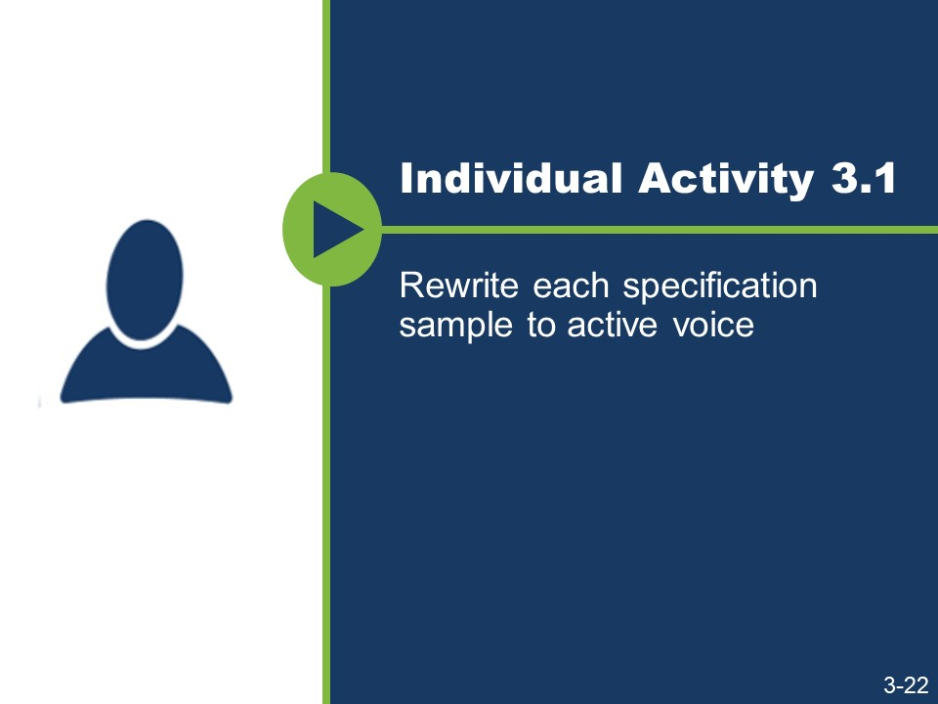
(Slides 3-23 to 3-26 are not shown because they contain answers to the activity.)
Activity
- Rewrite each specification sample to active voice.

Sample 1
“Materials shall be stored and handled to preserve its fitness for the work.”

Sample 2
“At least 30 days before the beginning of lime treatment, adequate quantities of soil and lime shall be supplied to the Materials Division for the determination of lime requirements.”

Sample 3
“Completed work shall be removed or uncovered by the contractor to allow inspection by the engineer.”

Sample 4
“The test cylinders and all associated equipment shall be provided by the contractor; the concrete will be sampled and tested by the engineer.”

Sample 5
“Any pile damaged by reason of internal defects or improper driving, or any pile driven out of its proper location or driven below the elevation fixed by the plans or the engineer, shall be corrected at no cost to the agency.”

Sample 6
“The submission of a bid shall be considered prima facie evidence that the bidder has made such examination and is satisfied as to the conditions to be encountered in performing the work and as to the requirements of the plans, specifications, supplemental specifications, special provisions, and contract.”

Slides 3-27 and 3-28
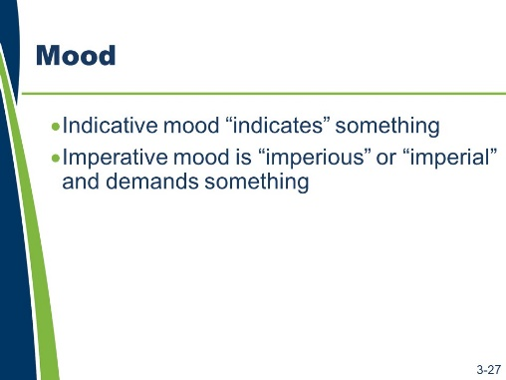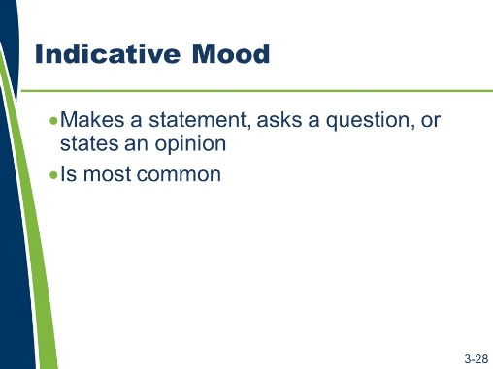
Mood
In addition to writing with the appropriate voice, specification writers must write using the appropriate mood. They should use the indicative or imperative mood when writing a specification.
- The indicative mood “indicates” something.
- The imperative mood is “imperious” or “imperial” and demands something.
Indicative Mood
The indicative mood:
- Makes a statement, asks a question, or states an opinion.
- Is the most common form and is used throughout specifications in different capacities.

Slides 3-29 and 3-30
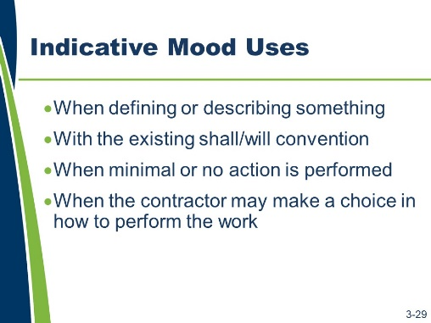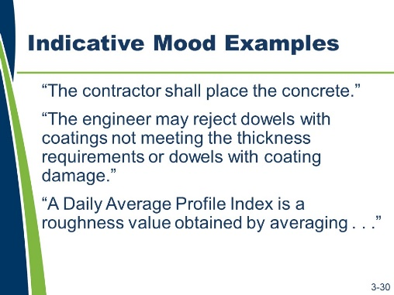
Indicative Mood (continued)
Use the indicative mood as follows:
- When defining or describing something.
- With the existing shall/will convention to distinguish between the contractor’s and the agency’s obligations.
- When minimal or no action is performed, such as to state an existing condition, to describe material characteristics, or to convey attributes of equipment.
- When the contractor may make a choice in how to perform the work.
Examples of the indicative mood are as follows:
- “The contractor shall place the concrete.”
- “The engineer may reject dowels with coatings not meeting the thickness requirements or dowels with coating damage.”
- “A Daily Average Profile Index is a roughness value obtained by averaging…”

Slides 3-31 and 3-32
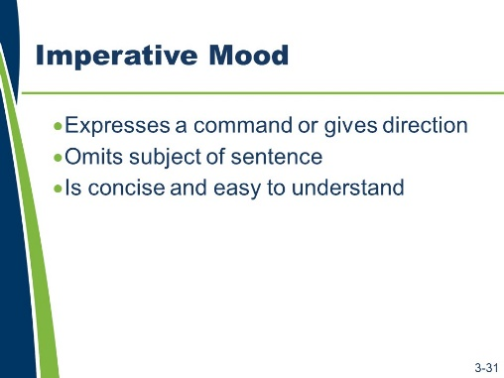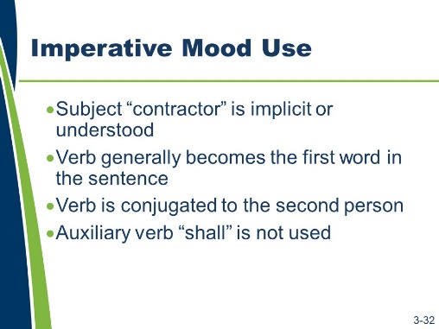
Imperative Mood
The imperative mood:
- Expresses a command or gives a direction to the reader.
- Omits the explicit subject of the sentence (in highway specifications, the contractor) and is written in the present tense.
- Is concise and easy to understand.
Use the imperative mood only in specifications when the contractor is being given direction.
When using the imperative mood, the following apply:
- The subject “contractor” is implicit or understood.
- The verb that clearly defines the action generally becomes the first word in the sentence.
- The verb is conjugated to the second person.
- The auxiliary verb “shall” is not used.

Slides 3-33 and 3-34
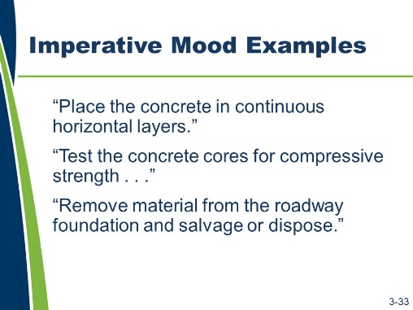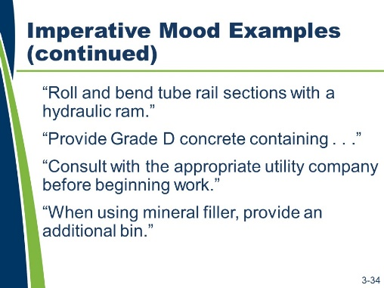
Imperative Mood (continued)
Examples of the imperative mood are as follows:
- “Place the concrete in continuous horizontal layers.”
- “Test the concrete cores for compressive strength . . .”
- “Remove material from the roadway foundation and salvage or dispose.”
- “Roll and bend tube rail sections with a hydraulic ram.”
- “Provide Grade D concrete containing . . .”
- “Consult with the appropriate utility company before beginning work.”
When using mineral filler, provide an additional bin.” What direction is given in the first sentence on slide 3-34?
Who is the subject of the first sentence on slide 3-34?
What verb tense is used in the first sentence of slide 3-34?

Slides 3-35 and 3-36
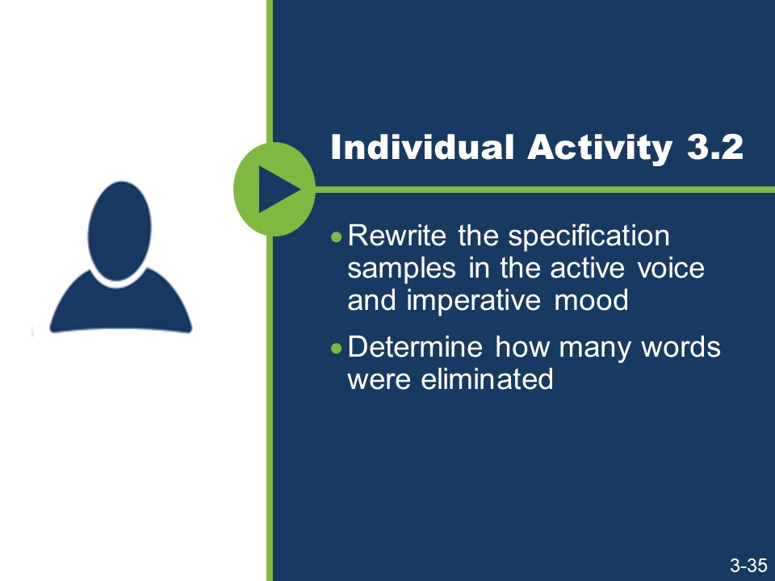
(Slide 3-36 is not shown because it contains answers to the activity.)
Activity
- Rewrite the specification samples in the active voice and imperative mood.
- Determine how many words were eliminated.

Sample 1
“The contractor shall assemble the truss sections and posts in the shop before galvanizing.”

How many words were eliminated by writing in the active voice and imperative mood?

Activity (continued)

Sample 2
“The engineer’s approval of facilities and services shall be obtained before installing on the project site.”
How many words were eliminated by writing in the active voice and imperative mood?

Sample 3
“A written record of each shop assembly set-up as requested by the engineer shall be provided.”
How many words were eliminated by writing in the active voice and imperative mood?

Slide 3-37
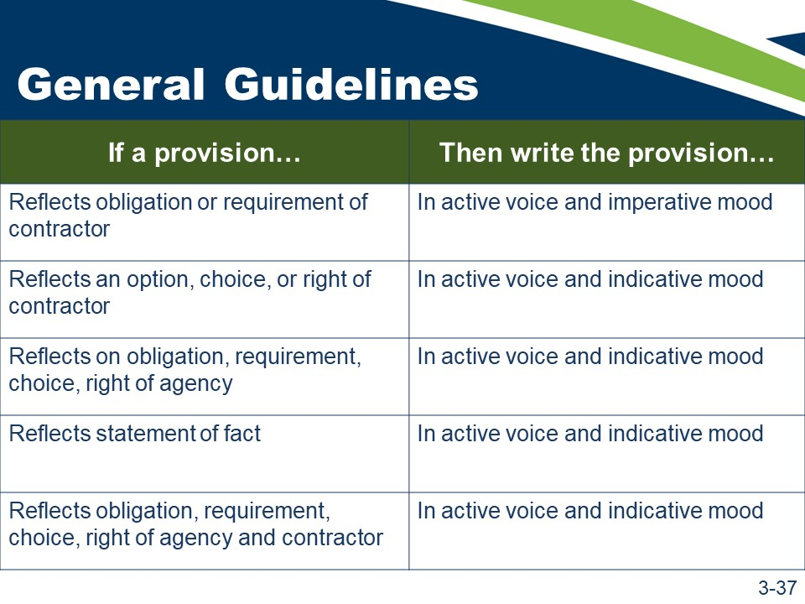
General Guidelines
There are some general guidelines to deciding which mood to use when writing a specification.
If a provision reflects an obligation or requirement of the contractor, write the provision in the active voice and imperative mood.
The following are examples:
- “Remove old concrete or stone masonry within the limits shown on the plans and without damaging the remaining structure.”
- “Store seed and inoculant in accordance with 106.6, ‘Storage of Materials,’ and under controlled conditions.”
If a provision represents an option or choice for, or a right of, the contractor, write the provision in the active voice and indicative mood.
The following are examples:
- “The contractor may perform shearing if the epoxy coating is not damaged and subject to permissible deformation.”
- “The contractor may use explosives to remove material not directly connected to the remaining structure as approved in writing by the engineer and in accordance with 107.11, ‘Use of Explosives.’”

General Guidelines (continued)
If a provision reflects an obligation or requirement of, an option or choice for, or a right of the agency or its representative(s), including the engineer, write the provision in the active voice and indicative mood.
The following are examples:
- “The engineer will take measurements to determine the limits of material classifications during excavation.”
- “The engineer may conduct testing to determine allowable use of a contractor- proposed water source.”
- “The agency reserves the right to sample, test, inspect, and accept or reject the material based on its own tests.”
If a provision reflects a simple statement of fact, write the provision in the active voice and indicative mood.
The following are examples:
- “The mineral filler will be finer than a #4 [4.75 mm] sieve and contain less than 25 percent of the material passing a #200 [75μm] sieve.”
- “The contract unit price for field office or field laboratory units of each type includes the cost of providing, placing, relocating, maintaining, and servicing the complete facility as required, including removal and relocation.”
If a provision reflects an obligation or requirement of, an option or choice for, or a right of both the agency and the contractor, write the provision in the active voice and indicative mood.
The following are examples:
- “The contractor and engineer may agree to change test procedures during the construction of the project.”
- “The contractor and engineer must both agree to a change of sampling location once production has begun.”

Slides 3-38 and 3-39
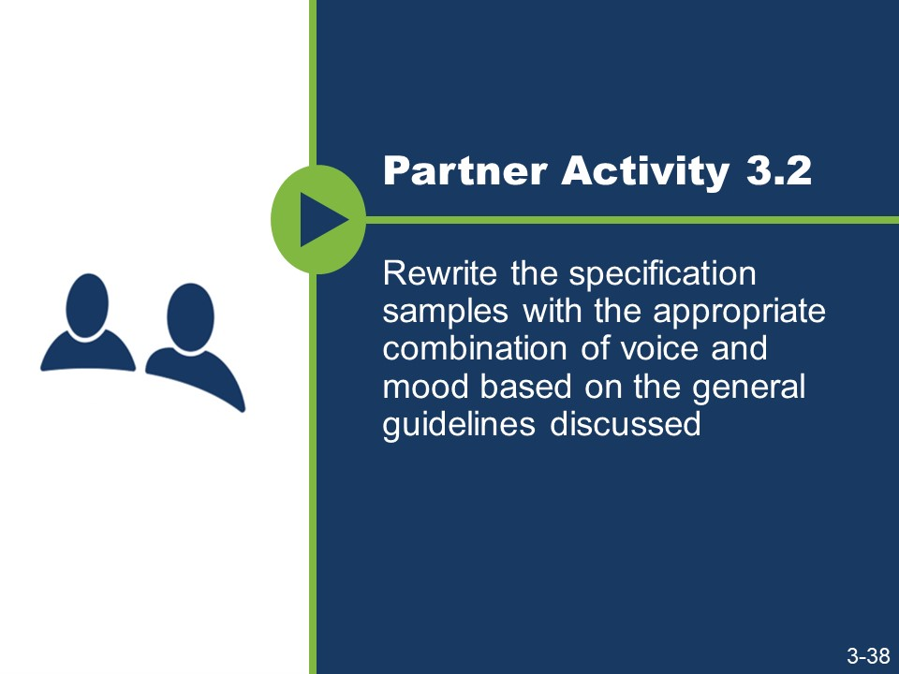
(Slide 3-39 is not shown because it contains answers to the activity.)
General Guidelines (continued) Activity
- Work with a partner.
- Rewrite the specification samples with the appropriate combination of voice and mood based on the general guidelines discussed.

Sample 1
“The fill shall be compacted in accordance with the quality compaction requirements in 205, ‘Excavation and Embankment.’”

Sample 2
“Preformed joint filler may be used to form vertical joints.”

Slide 3-40 to 3-42
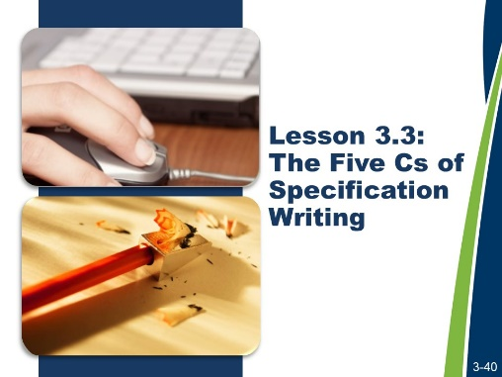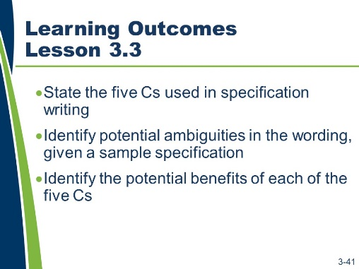
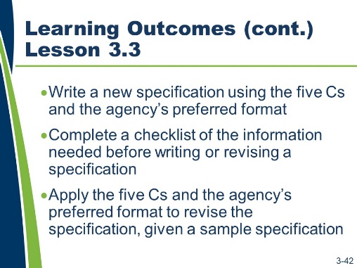

Lesson 3.3: The Five Cs of Specification Writing
Lesson 3.3 addresses the five Cs of specification writing. It also reviews the five Cs of specification writing and provides practice applying them when writing specifications.
Learning Outcomes
This lesson supports these learning outcomes.
- State the five Cs used in specification writing.
- Identify potential ambiguities in the wording, given a sample specification.
- Identify the potential benefits of each of the five Cs.
- Write a new specification using the five Cs and the agency’s preferred format.
- Complete a checklist of the information needed before writing or revising a specification.
- Apply the five Cs and the agency’s preferred format to revise the specification, given a sample specification.

Resources
- American Association of State Highway and Transportation Officials. Guide Specifications for Construction. Ninth Edition, 2008.
- The Construction Specifications Institute. The Project Resource Manual: CSI Manual of Practice. Fifth Edition. New York: McGraw-Hill, 2005.
- United States Department of Transportation, Federal Highway Administration. Development and Review of Specifications. Technical Advisory, OPI – HIAM-20. Washington, DC, March 24, 2010.

Slides 3-43 and 3-44
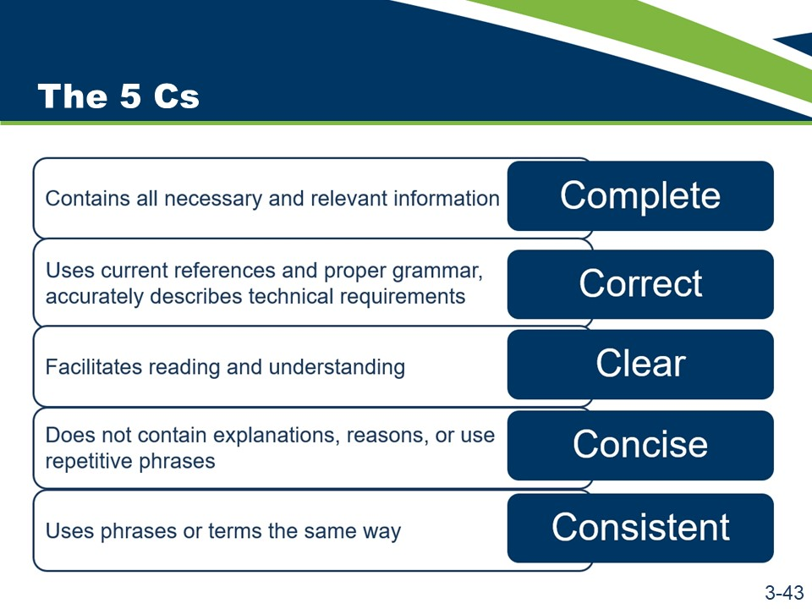
(Slide 3-44 is not shown because it contains answers to the activity.)
The Five Cs
A well-written specification uses the five Cs to ensure completeness, correctness, clarity, conciseness, and consistency. A contractor that complies with a specification written using the five Cs will deliver the project the agency needs.
The five Cs of specification writing are complete, correct, clear, concise, and consistent. These five terms summarize the attributes of a well-written specification.
The five Cs are important to specification writing because they are essential to fully communicating the author’s intent.
Definition | Term
Contains all necessary and relevant information | Complete
Uses current references and proper grammar; accurately describes technical requirements | Correct
Facilitates reading and understanding | Clear
Does not contain explanations, reasons, or use repetitive phrases | Concise
Uses phrases or terms the same way | Consistent

The first two Cs (complete and correct) create the requirements. The subsequent three Cs (clear, concise, and consistent) help ensure efficiency and proper interpretation.

Activity
- Match each of the five Cs (complete, correct, clear, concise, and consistent) with the description of its relationship to specification writing.

The Five Cs
Relationship to Specification Writing | Term
A specification should not use different terms and phrases to describe similar elements and concepts; doing so could lead to misinterpretation.
A specification should contain current references, accurate technical provisions, and proper grammar. Out-of-date references, inaccurate technical provisions, and improper grammar and syntax can affect interpretation.
A specification should contain all relevant information for performing the scope of work and should not be missing any information.
A specification should not be confusing or difficult to read. A specification’s audience should be able to find the information they are looking for, understand it, and act on that understanding.
A specification should not be long and full of explanatory language. It should also avoid the use of repetitive provisions.

Slide 3-45
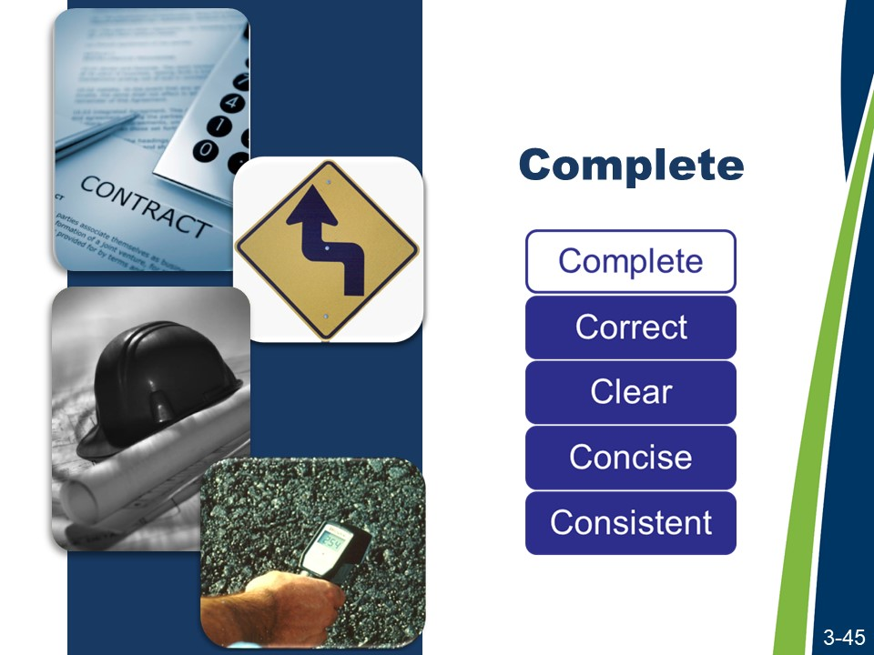
Complete
Each of the five Cs will be reviewed in a specific order, starting with complete.
A complete specification contains, along with the other contract documents, all of the information necessary for a bidder to prepare a responsive and responsible bid and the information necessary for the contractor to construct the project as the agency intends.
A complete specification assigns responsibility for all requirements and obligations. If a responsibility is not assigned, the specification misses its only opportunity to communicate the agency’s intent. If a dispute occurs, the intent may have to be determined by past experience, industry standard, or experts.

Activity
- Read the Specification Scenario.
- Answer the questions.

Specification Scenario
An agency’s specifications provided two different approaches for payment of curb and gutter. One approach provided payment for curb and gutter as a single pay item. The other approach provided separate pay items for curb and gutter.
The “Payment” section for the integrated curb and gutter pay item listed the bedding material as incidental to that pay item. The “Payment” section for the separate pay items did not explicitly list the bedding material as incidental. A contractor constructing a project where payment was provided for curb and gutter as two separate pay items asserted that the bedding material was not included in the unit price of either the curb or the gutter. The contractor argued that there was no relevant pay item for the bedding material when the curb and gutter were paid as separate items. The contractor demanded payment for the bedding material in addition to the reimbursement provided by the separate unit prices for the curb and the gutter. The agency refused to pay separately for the bedding, arguing that it was the intent of the contract, as demonstrated by the fact that the bedding material was listed as incidental to the combined curb and gutter item, that the cost of purchasing and installing the bedding was to be included in the separate pay items for curb and gutter. The agency also pointed to the general provisions, which stated that:
“Incidental Payment. Work required to safely and satisfactorily provide or accomplish a pay item or items but which is not directly measured and paid for, or for which the contract does not include a pay item, is an incidental obligation of the contractor. The agency does not directly pay for such work…”
The contractor filed a claim seeking reimbursement for the bedding material under the curb and under the gutter.
The claim is pursued in the courts and the judge ultimately rules that the contractor should be reimbursed for the cost of purchasing and installing the bedding material.

Activity (continued)
Based on the information provided, if you were asked to evaluate the contractor’s claim, how would you answer the contractor’s assertion that the contractor should be paid separately for bedding material?
How could this claim have been avoided?

Complete (continued)
A complete specification uses measurable or definable standards. There must be an objective means to determine if the work is acceptable. The contractor must be able to bid and perform the scope of work as represented in the bid documents and contract.
The contract should speak for itself; therefore, use discretionary phrases sparingly (e.g., “as directed by the engineer,” “at the discretion of the engineer,” “to the satisfaction of the engineer,” and “in the opinion of the engineer”). The need for any additional input or direction calls into question the completeness of the specification. In addition, one may then question whether additional compensation or time would be necessary to fulfill the intent of the specification.
A complete specification includes Federal requirements. The local FHWA Resource Center can provide guidance on Federal requirements.

A complete specification, if it does not contain everything necessary to tell the contractor what is required, includes appropriate references to allow the contractor to locate the necessary requirements or information. This includes information or requirements that may not be part of the specifications themselves. Examples might include geotechnical reports, ASTM testing requirements, and other similar documents or resources.

Slide 3-46
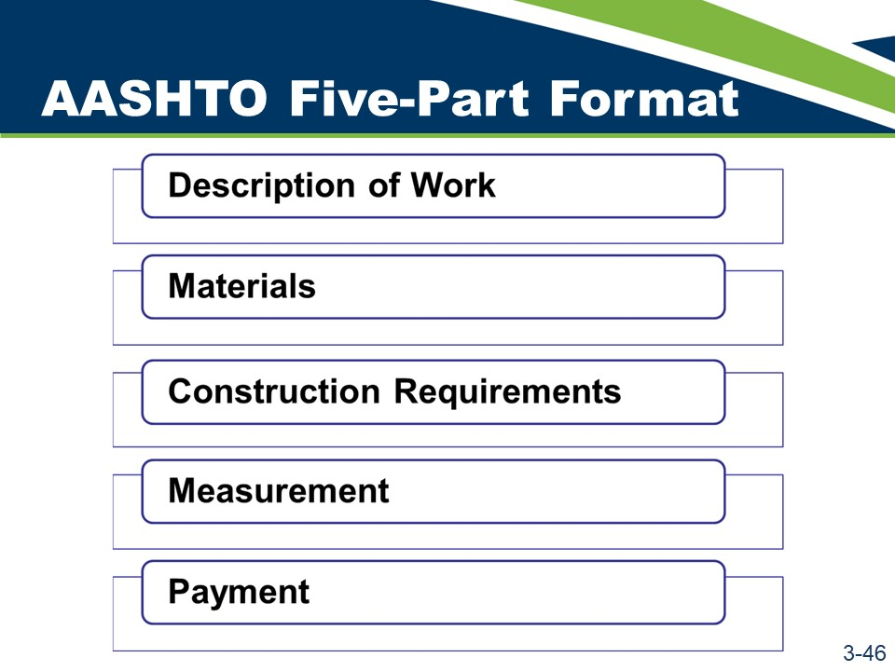
Complete (continued)
Specification writers should use the AASHTO five-part format as a guide when drafting complete specifications.
As previously discussed, the AASHTO five-part format is divided into five sections.
- Description of Work
- Materials
- Construction Requirements
- Measurement
- Payment
This format serves as a checklist, ensuring that all essential information is included in the specification.

Slide 3-47
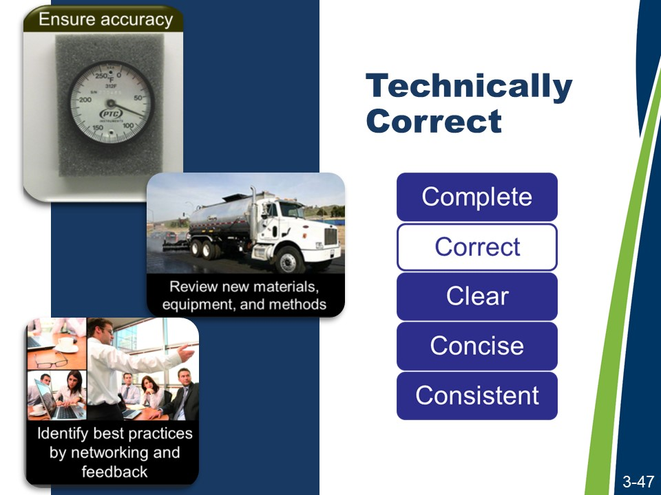
Technically Correct
The second of the five Cs is correct. Correct specifications are both technically and grammatically correct.
To be technically correct, a specification writer must ensure specifications are accurate and factual. Writers should do the following:
- Research the topic area thoroughly and consult subject matter experts as necessary.
- Evaluate new materials and equipment. Ensure that the materials and equipment specified are those currently used and are not outdated or unavailable. Technological advances in materials and equipment might merit a specification rewrite.
- Review new methods. The specification you are writing may use outdated methods or may present a good opportunity to create an end-result specification.
- Identify best practices. Network with your counterparts in other agencies. Find out what does and does not work well for them. Research documents on best practices through the Transportation Research Board’s National Cooperative Highway Research Program and the National Highway Specification Web site.
- Get feedback from the field. Consider obtaining input and feedback from field engineers and inspectors.
- Get feedback from the construction industry. The industry can be a great resource for critiquing the content and style of the specifications. Feedback can be obtained formally through a joint committee, or informally through other means. Create a dialogue when not involved in a dispute over the intent of a specification, as it can be significantly more productive than attempting to create a dialogue while embroiled in a dispute.

Technically Correct (continued)
- Use data sources that are reliable and current. Careless statements or statements based on unreliable data are frequently the cause of contract administration problems and contractor claims. Ensure referenced standards are current.
- For example, consider a specification that states, “Before applying the coating, prepare the concrete surface according to the coating manufacturer’s recommended standard” or, “Before applying the finish coat, prepare the surface according to XYZ Official Standards.” The manufacturer’s, national, or industry standard is now part of the contract.

Slides 3-48 and 3-49
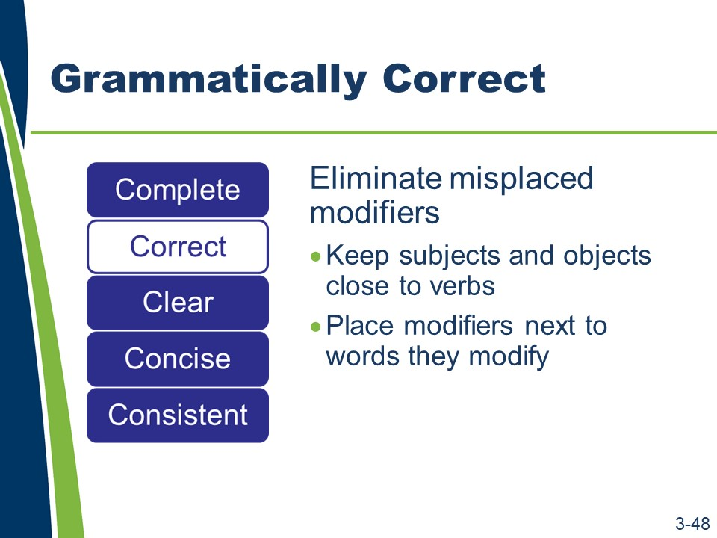
(Slide 3-49 is not shown because it contains answers to the activity.)
Grammatically Correct
In addition to being technically correct, a specification must also be grammatically correct.
To ensure grammatical correctness, a specification writer:
- Eliminates dangling or misplaced modifiers.
- Keeps subjects and objects close to their verbs.
- Places modifiers next to the words they modify.
Activity
- Read the sentence.
- Answer the questions.
“Obtain authorization from the engineer in writing.”
- Is this sentence written correctly?
- How can the specification be rewritten to address the deficiency?
Slides 3-50 and 3-51
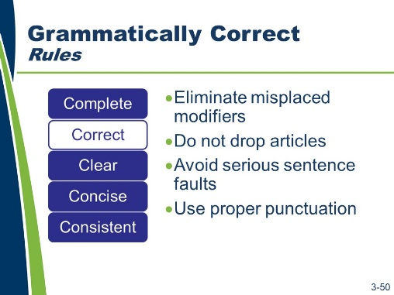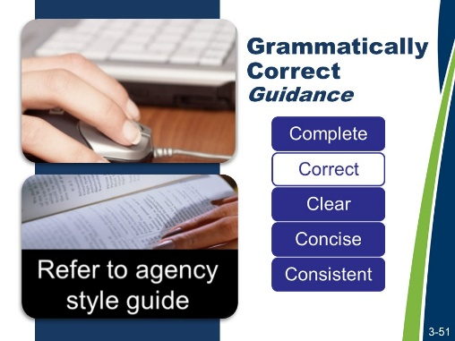
Grammatically Correct (continued)
- Do not drop articles. Articles signal nouns and specify their application. Dropping articles (i.e., a, an, the) can change meaning or create ambiguity.
Incorrect: “Provide concrete surface free of dirt.”
Correct: “Provide a concrete surface free of dirt.”
- Avoid serious sentence faults. Poor construction, including run-on sentences, sentence fragments, and incomplete sentences, interferes with readability and comprehension.
- Use proper punctuation. Punctuation can significantly affect a sentence’s meaning.
A specification writer does the following.
- Checks spelling and grammar. Uses computer programs to assist you but do not rely solely on these programs. Is familiar with general and construction-specific style and usage guides.
- Refers to his or her agency’s style guidance first. Agency style guides, however, do not address all, or even most, situations. When the agency style guide does not provide guidance, then the best examples of style guides include the Chicago Manual of Style, The Blue Book of Grammar and Punctuation, and Garner’s Modern American Usage. For legal terms, which should be used sparingly, use Black’s Law Dictionary. There are very few grammar issues that are not fully addressed by these standards.

Slides 3-52 and 3-53
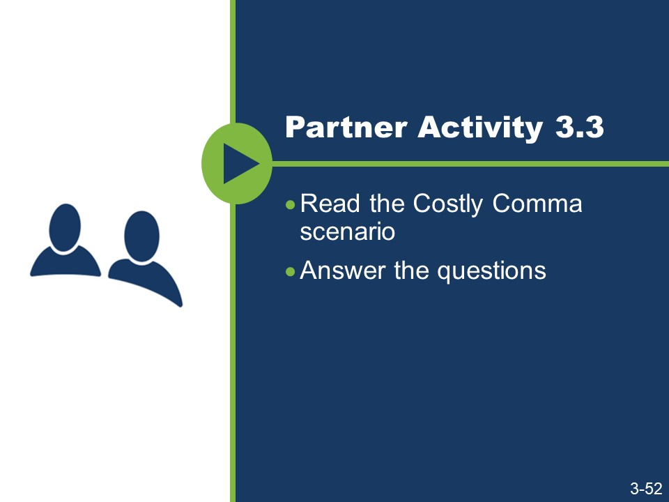
(Slide 3-53 is not shown because it contains answers to the activity.)
Grammatically Correct (continued) Activity
- Work with a partner.
- Read the Costly Comma scenario and excerpt.
- Answer the questions.

The Costly Comma
Scenario
Company A leased right-of-way from Company B. After three years, Company B decided to exercise its option to terminate by notifying Company A in writing of its intent to terminate at the end of the next year. As the contract’s termination would result in the loss of almost $1 million for Company A, Company A pursued the matter in court.
Excerpt
“This agreement shall be effective from the date it is made and shall continue in force for a period of five (5) years from the date it is made, and thereafter for successive five (5) year terms, unless and until terminated by one year prior notice in writing by either party.”
Was Company A correct in believing that Company B violated the terms of the lease? Why or why not?

Slide 3-54
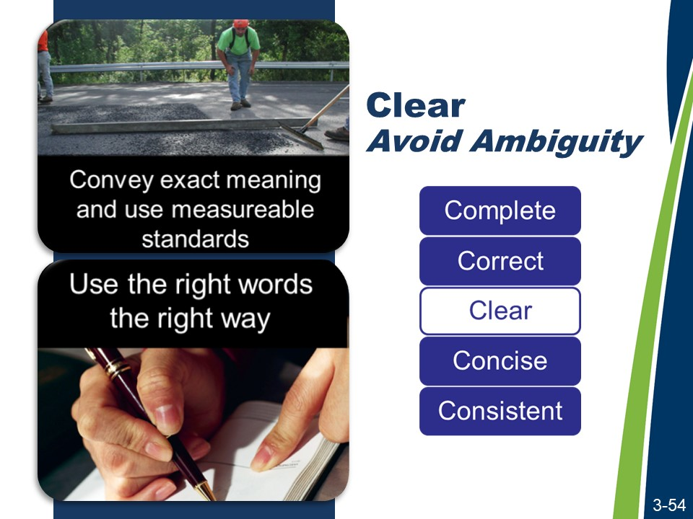
Clear
The third C is clear. Clear specifications avoid ambiguities. An ambiguity exists when a specification has more than one reasonable interpretation.
For example, a specification states, “Remove 4 in. to sound concrete.” The ambiguity is whether this specification requires the contractor to remove a minimum of 4 in. or until sound concrete in reached, whichever is greater, or until sound concrete is reached but no more than 4 in.
A specification writer can avoid ambiguities by using words that convey his or her meaning exactly and by using measurable standards where practical. For example, a specification states, “The surface shall have a smoothness tolerance of +/- ½ in. when measured using a 10 ft. straightedge.”
Is this provision ambiguous?
Why do you think it is or is not ambiguous?

A specification writer can avoid ambiguities by selecting words that say what he or she means.

Slide 3-55
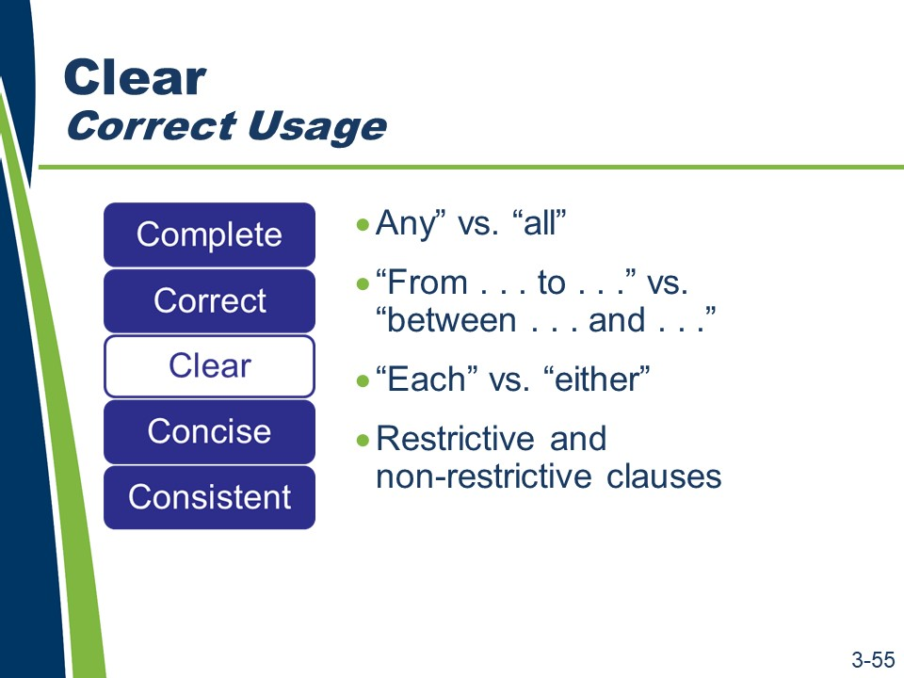
Clear (continued)
- Use “any” versus “all” correctly.
“Any” is a limited number selected at the discretion of the reader. The word “any” has a vague meaning. The words “all” or “every” are not vague. “All” is the entire amount. If applicable, use a qualifier to obtain the clearest meaning and provide the reader with a measurable standard.
- Use “from…to…” versus “between…and…” correctly. “From” and “to” imply an inclusive range; the two end points are included in the range. “Between” and “and” imply an exclusive range; the two end points are excluded from the range.
- Use “each” versus “either correctly. Use “each” in cases where “either” or “both” leads to confusion or ambiguity.
- Use restrictive and non-restrictive clauses properly (i.e., “that” versus “which”). If one can drop the clause and sustain the point of the sentence, use “which.” If one cannot drop the clause and sustain the point, use “that.” A “which” clause goes inside commas, a “that” clause does not.

Because “which” is appropriate in the situation where the clause can be dropped and still sustain the point, it is not widely used in specification writing.
Specifications should not contain unnecessary clauses. Consequently, when the word “which” is used in a specification, it is often used in error.

Slide 3-56
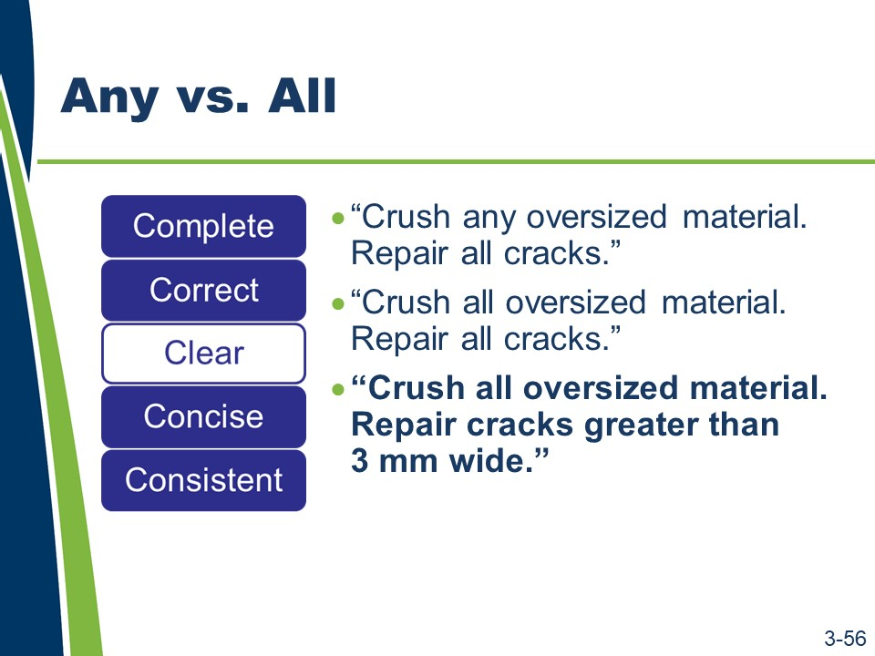
Activity

- Read the sample sentences from a specification.
- Answer the questions.

Sample 1
“Crush any oversize material. Repair all cracks.” “Crush all oversized material. Repair all cracks.”
  - How does each of these statements create very different results from similar information?
  - Is the requirement “repair all cracks” a measurable standard?

Slides 3-57 and 3-58
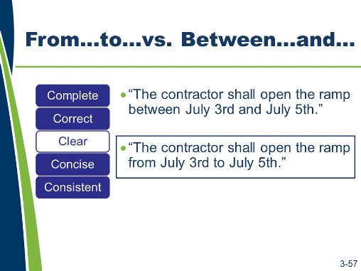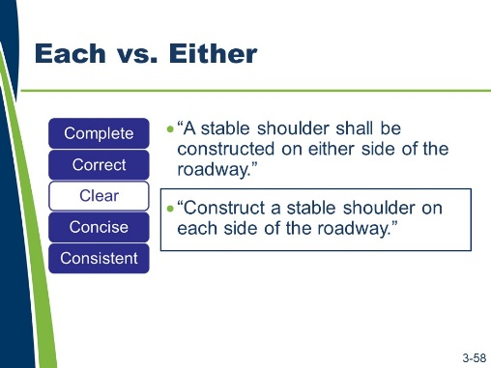
Activity (continued)

Sample 2
“The contractor shall open the ramp between July 3rd and July 5th.” “The contractor shall open the ramp from July 3rd to July 5th.”
- If the agency requires the ramp to be open on July 3rd, 4th, and 5th, which of these specifications is correct? Why?

Sample 3
“A stable shoulder shall be constructed on either side of the roadway.” “Construct a stable shoulder on each side of the roadway.”
1. Which of these two sentences is clearer?

Slides 3-59 and 3-60
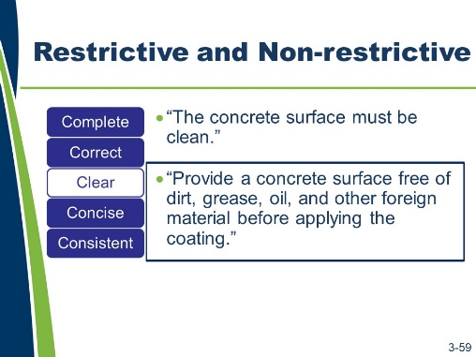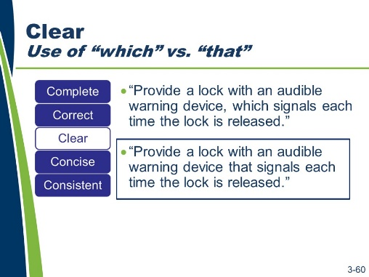
Activity (continued)

Sample 4
“The concrete surface must be clean.”
“Provide a concrete surface free of dirt, grease, oil, and other foreign material before applying the coating.”
1. Which is the better specification and why?

Sample 5
“Provide a lock with an audible warning device, which signals each time the lock is released.”
- Is “which” used correctly here?
- Why do you think it is or is not used correctly?

Slide 3-61
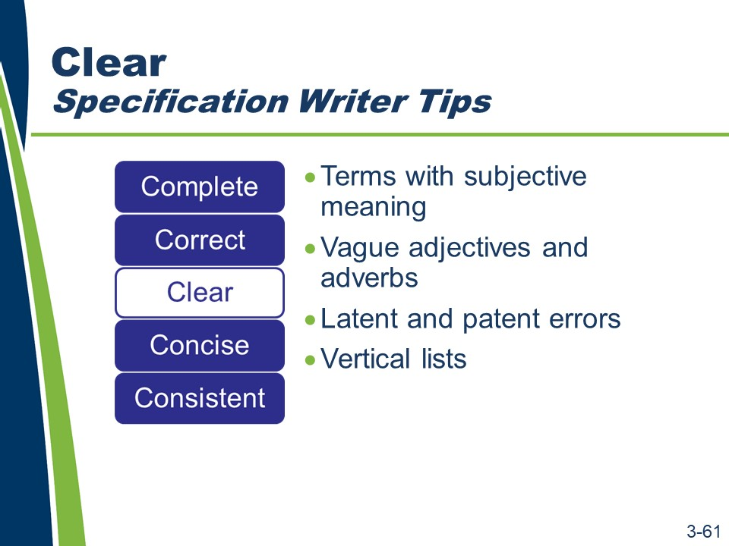
Clear (continued)

A specification writer can avoid ambiguities and write more clearly by doing the following:
- Avoid terms that have an undefined or subjective meaning (e.g., “etc.,” “as per,” “in a workmanlike manner,” “shall function as intended”).
- Avoid the use of vague adjectives and adverbs with multiple meanings. Avoid using adjectives and adverbs whose meaning can vary with the reader. This includes common construction words with multiple meanings. Choose words that have restrictive interpretations.
- Recognize the difference between latent (hidden) and patent (obvious) errors.
  - A patent error is one that is so obvious that the contractor has an obligation to notify the agency and seek clarification during the bidding process.
  - All other errors are latent, meaning they are hidden. A contractor is not responsible for a latent error.
  - The general rule is that errors will be considered latent unless proven to be patent.
  - Another general rule is that latent errors are ruled against the drafter. This means that the party writing a contract has the responsibility to write it clearly and without error.
If the drafter wanted the contractor to do something differently from what the contractor reasonably assumed was required, then the drafter should have written the latently erroneous provision more clearly and without error.
The rules for determining whether an error is patent or latent apply to all defects, inaccuracies, inconsistencies, ambiguities, omissions, conflicts, and all other shortcomings in the contract documents.

Clear (continued)
- The contractor’s responsibility for detecting deficiencies in the contract documents is typically addressed in Section 102 of the general provisions.
- Use vertical lists. Lists aid the audience in finding and understanding the content of a specification.
  - Introduce lists with lead-in sentences that establish whether one, more than one, or all of the listed items apply. Refer to the FHWA Technical Advisory Development and Review of Specifications for more details on introducing lists.
  - Based on the rule of intentional exclusion, if a specification writer leaves an item off a list, it will be interpreted as excluded. The agency would bear any cost implications of the interpretation based on the deficient list. Using the introductory phrase, “but not limited to,” does not make the list complete. The phrase may even draw attention to the deficient list.

Slide 3-62

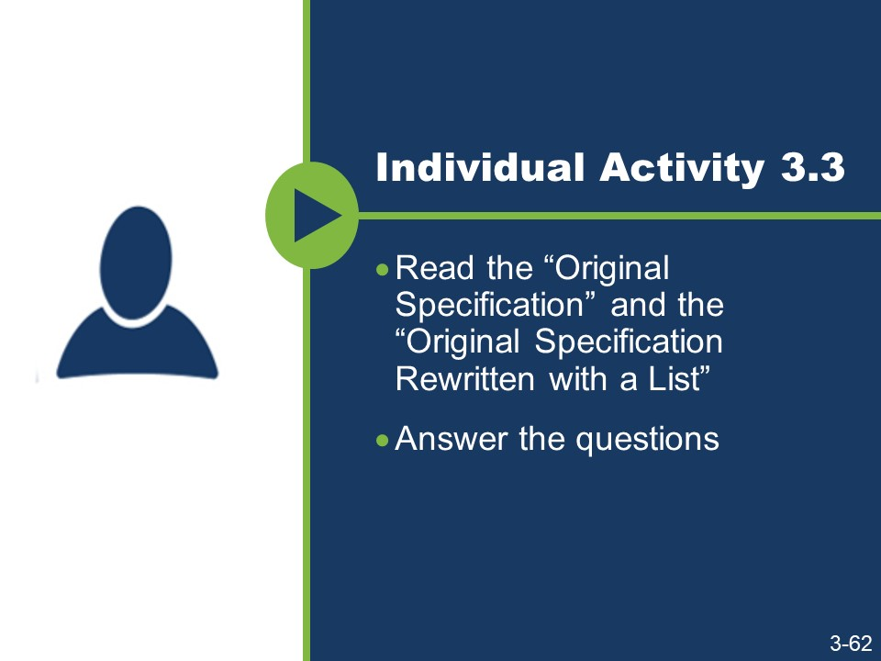
Activity

- Read the Original Specification and the Original Specification Rewritten with a List.
- Answer the questions.
- How did the list provide clarity?
- Does using the list change any of the other five Cs?

Activity (continued)

Original Specification
103.7 Final Clean Up. Before final acceptance of the work, the contractor shall remove all falsework, unused materials, erosion control devices, rubbish, and temporary bridges, approaches and buildings, unless otherwise provided in the contract or ordered by the engineer. The contractor shall remove from the right-of- way all machinery, equipment, temporary traffic control devices, and surplus material and leave all areas occupied by the contractor in conjunction with the contract in a neat and presentable condition satisfactory to the engineer. The contractor shall replace or repair all damaged fences. The contractor shall restore in an acceptable manner all property, including property outside of the project limits, which may have been used or damaged during the prosecution of the work. The contractor shall provide the agency a written release from any offsite property owner stating that the restoration has been accepted and the contractor has been released of responsibility. Paved roadbeds shall be cleaned within five working days prior to opening the pavement surface to traffic. Cleaning of roadbeds in residential and urban areas shall be performed in a manner that will not cause airborne dust.
Unless otherwise provided, full compensation for removal and disposal of materials for final clean-up will be considered as included in other items of work and no separate payment will be made.
(This specification uses 216 words.)

Activity (continued)

Original Specification Rewritten with a List
The agency will not grant final acceptance of the work until the following final clean-up operations are complete:
- Remove all falsework, unused materials, erosion control devices, rubbish, and temporary bridges, approaches, and buildings, unless the contract requires or the engineer directs otherwise.
- Remove from the right-of-way all machinery, equipment, temporary traffic control devices, and surplus material.
- Leave all areas occupied by the contractor in conjunction with the contract in a neat and presentable condition satisfactory to the engineer.
- Replace or repair all damaged fences.
- Restore in an acceptable manner all property, including property outside of the project limits that may have been used or damaged during the prosecution of the work.
- Provide the agency a written release from any offsite property owner stating that the property owner has accepted the restoration and released the contractor from responsibility.
- Clean paved roadbeds within five working days before opening the pavement surface to traffic.
- Clean roadbeds in residential and urban areas in a manner that will not cause airborne dust.
Unless otherwise provided, the agency will consider the cost of removing and disposing of materials for final clean-up to be included in the contract unit prices of other items of work.
(This specification rewritten with a list uses 206 words.)

Slide 3-63
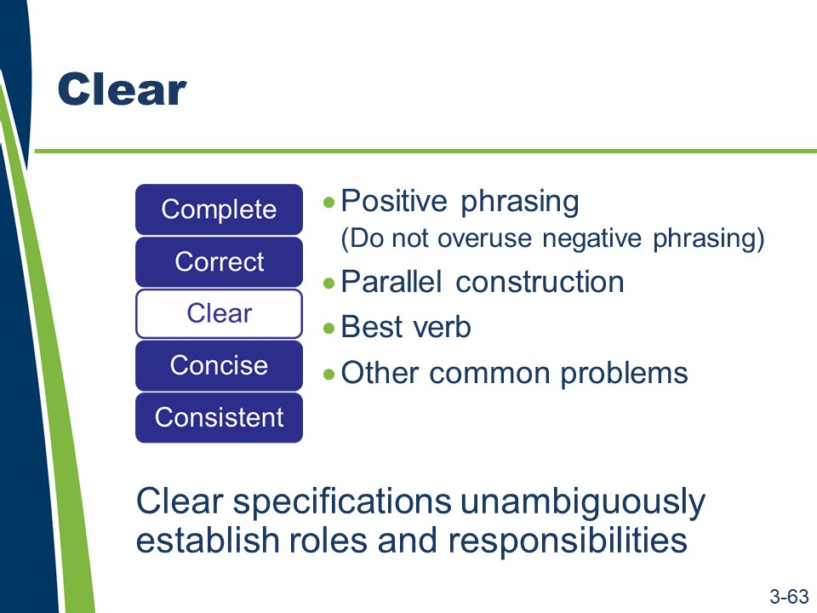
Clear (continued)

Clear specifications use positive phrasing and make definite assertions. People prefer to be told what to do instead of what they cannot do; however, sometimes it is more forceful to state what not to do, e.g., “Do not allow traffic on the base course.”
  - Reserve negative phrasing for when it is necessary to draw attention to a particular detail; its overuse can diminish that effect.

Clear specifications use parallel construction. Parallel construction is defined as similarity of grammatical form between two or more coordinated elements. It is required whenever elements are connected by coordinating or correlative conjunctions, elements are compared or contrasted, and when items are arranged in a list or outline.
Clear specifications use the best verb to represent the intent. A verb is a word or phrase expressing an action or a condition (state of being or description) of a subject. Clear specifications generally do the following.
- Use strong verbs.
- Use active voice.
- Use imperative mood (if appropriate).
- Avoid shifts in tense, voice, and mood within the same sentence.
- Vary verb tense to reflect the often complex data in a document. Typically, this appears in conditional statements or sequential direction.
- Revise when modifiers interrupt a verb phrase.
Incorrect – “Typically, agencies hold for prospective contractors pre-bid meetings.” Correct – “Typically, agencies hold pre-bid meetings for prospective contractors.”

Clear (continued)
Clear specifications avoid common problems that affect clarity. Avoid using expressions (such as “and/or”) that are grammatical short cuts and may confuse the reader. Select verbs with care, as some are used as both verbs and nouns (e.g., permit, backfill, splice, fill, mix, broom, surface). If there is a chance for confusion, select another verb.
Clear specifications unambiguously establish roles and responsibilities. This can be accomplished by using the appropriate combination of voice and mood.

Slides 3-64 to 3-67
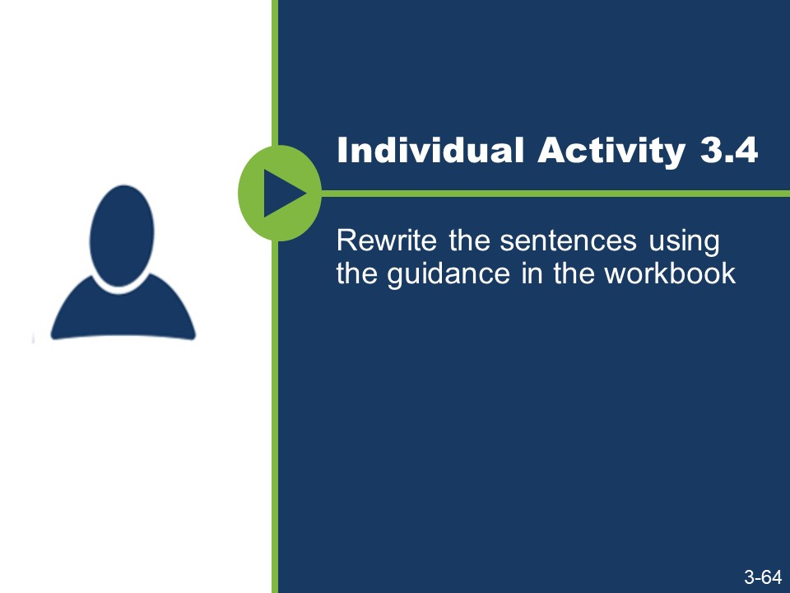
(Slides 3-65 to 3-67 are not shown because they contain answers to the activity.)

Activity

- Rewrite sentences #1 and #2 using positive phrasing.
- Rewrite sentence #3 using parallel construction.
- “Do not add water to the surface of the concrete to aid in finishing without the approval of the engineer.”
- “Do not bunch up the strokes in the cross-section of each layer.”

Activity (continued)
- “Submit the payment application for record keeping and to receive payment.”

Slides 3-68 to 3-70
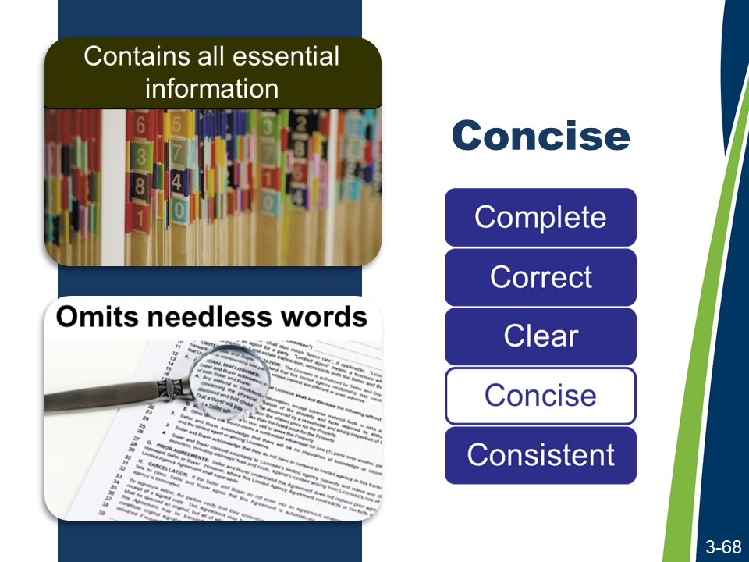
(Slides 3-69 and 3-70 are not shown because they contains answers to the activity.)
Concise
The fourth C is concise.
A concise specification contains all essential information and only essential information. Requirements and procedures nonessential to evaluating product quality or quantity serve no useful function and make it more difficult to enforce a specification in the field.
A concise specification omits words that do not add substantive meaning. Needless words include nonessential adjectives, adverbs, prepositional phrases, and modifiers. Where possible, choose a single word instead of a phrase.
Concise does not always mean shorter!

Activity
- Read the list of commonly used phrases.
- Consider what single word or short phrase should be used to replace each of these commonly used phrases.

Commonly Used Phrases
Common Use | Suggested
absolutely essential | essential
successfully complete | complete
a minimum of
not less than
enclosed herewith
at a later date
commence
heretofore
prior to
subsequent to
for the purpose of
through the use of
until such time as
in lieu of
utilize
in order to

Slide 3-71

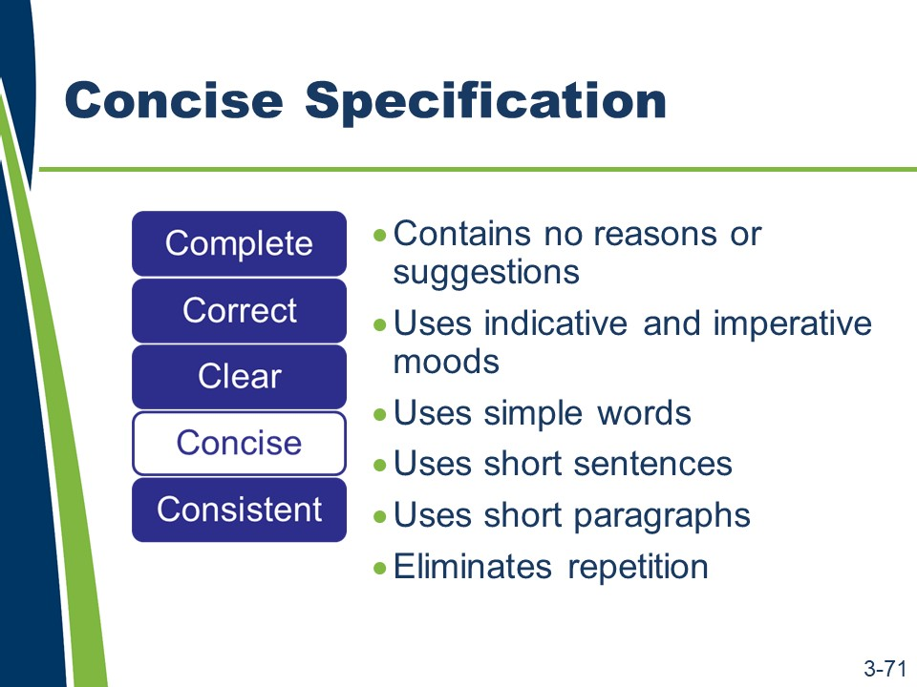
Concise (continued)

A concise specification uses the active voice instead of the passive voice. As explained in Lesson 3.2, the active voice is more direct and more concise. Traditionally, agencies have used the passive voice in specification writing. The passive voice de-emphasizes the actor (the performer of the verb’s action), uses more words (often prepositional phrases), and can be vague or misleading.
A concise specification does the following:
- Contains no reasons or suggestions, explanations, or justifications. These statements promote the wordiness of the specification, and the contractor may consider that such statements have a bearing on the requirement.
- Uses the indicative and imperative moods as appropriate.
- Uses simple words. Eliminate or replace adjectives, adverbs, and wordy phrases that do not add to the meaning of the specification. Write to express, not to impress. Choose the simplest words that accurately convey your point. Avoid slang, colloquialisms, and unnecessary legal and technical jargon.
- Uses short sentences. Short sentences that break up information into smaller, easier-to-process units are better for conveying complex information. When reviewing specifications, see if complex sentences can be broken down into lists or individual sentences. Use 1 point per sentence and, where possible, try to express that thought in 20 words or less.

Concise (continued)
- Uses short paragraphs. Limit paragraphs to a single issue or topic, expressed (where possible) in three or four sentences. This breaks up material into more readable and easily understood segments.
- Eliminates repetition. Avoid repeating the information within a specification, the plans, and the general provisions. Repetition increases the chance of conflicts within all contract documents. Common repetitions can collectively call into question whether that requirement must be repeated elsewhere to have authority, which can lead to disagreements or inconsistent enforcement. Know the general provisions and know how not to repeat them.

Slide 3-72
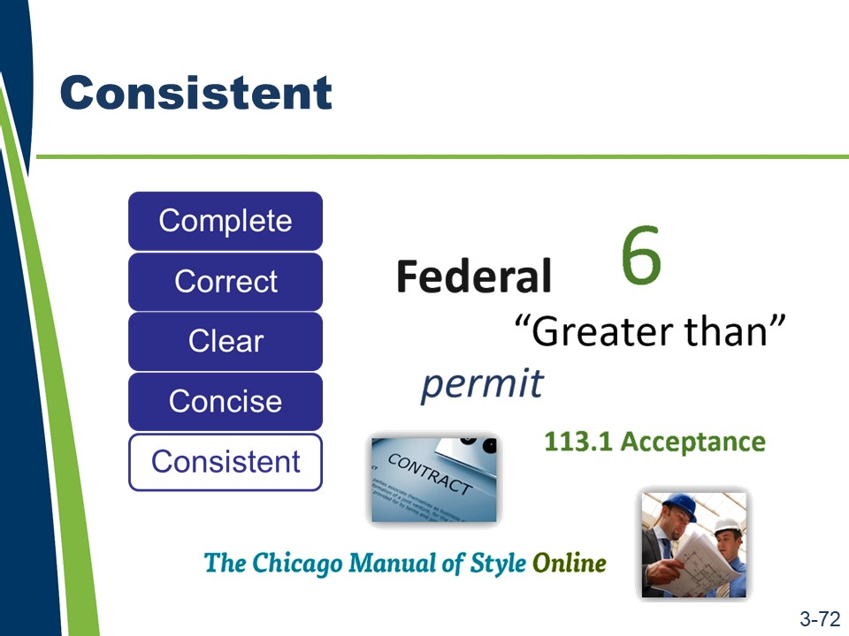
Consistent
The fifth C is consistent. Consistent specifications use common and defined terms consistently: phrases; abbreviations; acronyms; units of measure; and symbols.
Well-written specifications are consistent in:
- Use of numbers.
- Use of capitalization.
- Use of words in text and symbols in tables (e.g., “equal to or greater than” versus “≥”).
- Use of words as nouns or verbs.
- Use of format and organization.
- Reliance on the general provisions.
- Use of style guide and other specification writing guidance.

Slide 3-73

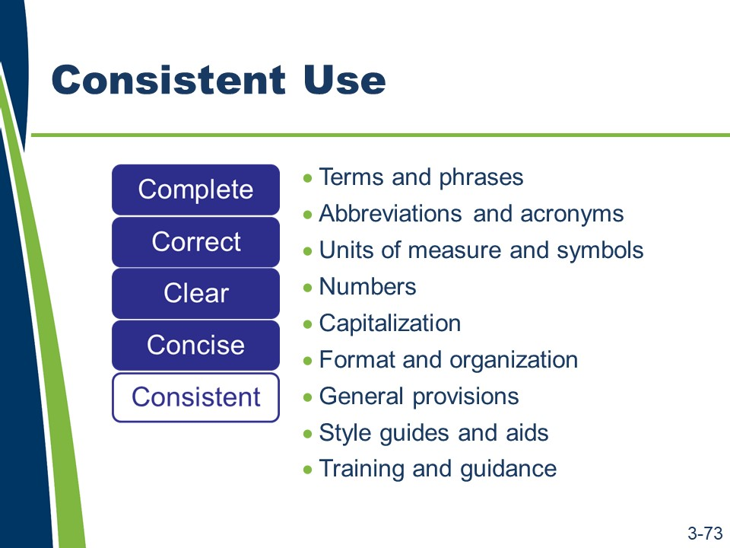
Consistent (continued)
More specifically, to ensure consistency, specification writers should use the following:
- Defined terms consistent with their definitions.
  - Define each term with an understanding of its usage throughout the contract documents.
  - If necessary, ensure that usage is correct and that alternate interpretations cannot contradict the intended meaning.
  - Avoid common construction words with multiple meanings as well as adjectives and adverbs whose meaning can vary with the reader.
- Phrases consistent with existing guidance.
- Abbreviations and acronyms consistent with existing guidance.
  - Define all acronyms. An acronym may have various meanings.
  - Define all abbreviations. Abbreviations include measurement unit symbols and other short forms that are crucial to understanding a specification’s intent.
  - If an abbreviation is not defined in the general provisions, spell it out at its first occurrence. Use abbreviations correctly.
  - Only use abbreviations when they will not confuse the reader and not lead to misinterpretation.
  - Always check the appropriate subsection in the general provisions of the agency’s standard specifications for accepted abbreviations.

Consistent (continued)
- Units of measure and symbols consistent with existing guidance.
  - Define all units of measure and symbols.
  - Use either the metric system or the customary (English) system for highway specifications. The rules for writing units of measure for these two systems vary significantly.
  - Use words in text and symbols in tables.
  - Consult the agency’s style guide for rules concerning the units of measure and symbols.
- Numbers expressed appropriately.
  - Always use numerals for dimensions, degrees of temperature, percent, and dollars and cents (e.g., 3 in. by 5 in., 50°C, 20 percent, $5.50).
  - Express clock times and dates in numerals (e.g., 2:10 p.m. on June 15 (omit “th”), 1992. Exceptions to this are the use of the words “noon” and “midnight.” For example, use noon rather than 12 noon, 12:00, or 12:00 p.m.).
  - Express decimals in numerals (e.g., 6.235). For quantities less than one, use a zero before the decimal point (e.g., 0.235).
  - Omit unneeded zeroes in time and money references (e.g., $200 not $200.00, and 9 p.m. not 9:00 p.m.).
- Capitalization minimized and consistently applied. For parties in the contract and defined terms, refer to the agency’s style guide, the general provisions, or the Chicago Manual of Style.
- Formatting and organization.
  - Use headings to break up information into logical, understandable pieces to assist the reader in locating information.
  - Use consistent headings (e.g., all paragraphs at the same level within a particular subpart should either use or not use headings).
  - Use headings with enough information to convey the main point of the paragraph without being so long as to overwhelm the material in the paragraph itself.
- General provisions review.

Consistent (continued)
- Style guide aids used to ensure consistency. As previously discussed, a style guide should be used when writing specifications. If the agency does not have a style guide, then the specification writer should consider developing one for the agency. A style guide provides the following:
  - Consistent language
  - Consistent word and number usage
  - Consistent format
  - Consistent organization
- Needed training and guidance.
Training can help ensure consistent specification writing practices, but guidance, training, and evaluation are necessary to ensure consistent enforcement. Without consistent enforcement, even a well-written specification becomes ineffective.

Slide 3-74
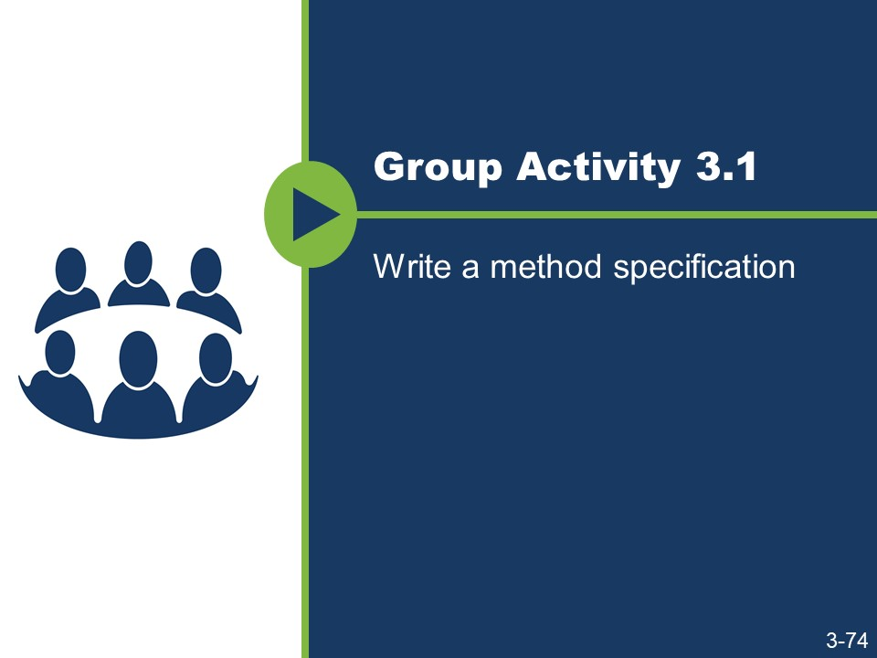
Writing a Method Specification
The Method Specification Template for a Concrete Sidewalk is based on the AASHTO five-part format outline created in Module 2. Sections of the template have been completed, including:
- Description of Work.
- Materials.
- Measurement.
- Payment.
The section numbers, material references, and other references are taken from the AASHTO Guide Specifications.
Activity
- Review the context and criteria.
- Using the template, write a method specification for constructing a concrete sidewalk.
- Apply the five Cs and the AASHTO five-part format when writing the method specification.
- Use Appendix D: Specification Writer’s Checklist as a resource.
- If style or format is not addressed in the course materials, follow the guidance provided by the agency’s style guide or other applicable standards.

Activity (continued)

Context
The agency intends to award a contract to provide for the reconstruction of eight blocks of a State Highway through an urban corridor and within a city’s limits. Included in the scope of this contract is the construction of a concrete sidewalk adjacent to new, concrete curb and gutter. The contract also includes the reconstruction of the adjacent State Highway asphalt pavement. The contractor is to construct the concrete sidewalk for the length of the project on both sides of the highway. The agency will require the contractor to comply with this specification when performing the sidewalk construction work. The plans show the location and dimensions of the sidewalk and a profile of the sidewalk and bedding course.

Criteria
The contractor will need an excavator, hand tools, and a hand-driven compactor to excavate for the bed course, compact the bed course, and set the forms. The contractor will also need to provide all necessary forms and hand tools for placing, consolidating, finishing, jointing, and texturing the concrete.
The materials needed to construct the sidewalk include bed course materials, concrete meeting the specified compressive strength, reinforcing steel, and joint filler similar to that specified in other subsections of the agency’s standard specifications.
- For the bed course, consider specifying a class of aggregate subbase that allows ease of placement and minimal compactive effort.
- For concrete, consider specifying a standard concrete mix that produces the minimum acceptable compressive strength considering the intended use of the sidewalk.
- For reinforcing steel, consider specifying a standard type used in the region or within the jurisdiction where the sidewalk is being placed.
- For the joint filler and curing agent, consider specifying types similar to those required by your agency for concrete pavements.
With regard to the administration of this work, the contractor should notify the engineer 24 hours before beginning the placement of concrete sidewalks. This will give the engineer an opportunity to inspect the bed course, reinforcing, and form work before the concrete pour.
The engineer should base his or her acceptance of the completed sidewalk on the construction of properly located sidewalks using the specified materials and methods in accordance with the plans and specifications. The engineer should not accept the concrete sidewalk if the material used was not as specified, if the contractor did not follow the specified methods, or if the joints or finish were not acceptable.
The engineer will separately measure and pay for completed and accepted sidewalk.

Activity (continued)

Method Specification Template for a Concrete Sidewalk 608 Concrete Sidewalk

Description of Work
This work consists of constructing a concrete sidewalk.

Materials
Provide material for constructing a concrete sidewalk as follows:
    - Bed course material in accordance with Subsection 703.12
    - Reinforcing steel in accordance with Subsection 711.01
    - Concrete, Class B, in accordance with Section 601 and Subsection 713.01(B)
    - Joint filler in accordance with Subsection 707.01(D)
    - Form release agent approved by the engineer
    - Curing compound in accordance with Subsection 713.02(C)

Construction Requirements
    - Equipment

Activity (continued)
    - Methods

Activity (continued)
    - Inspection and Acceptance

Measurement
The engineer will measure accepted sidewalk separately by the square foot (square meter) of concrete placed.

Payment
The agency will pay for accepted sidewalk in accordance with the contract pay items for sidewalk.

Slide 3-75
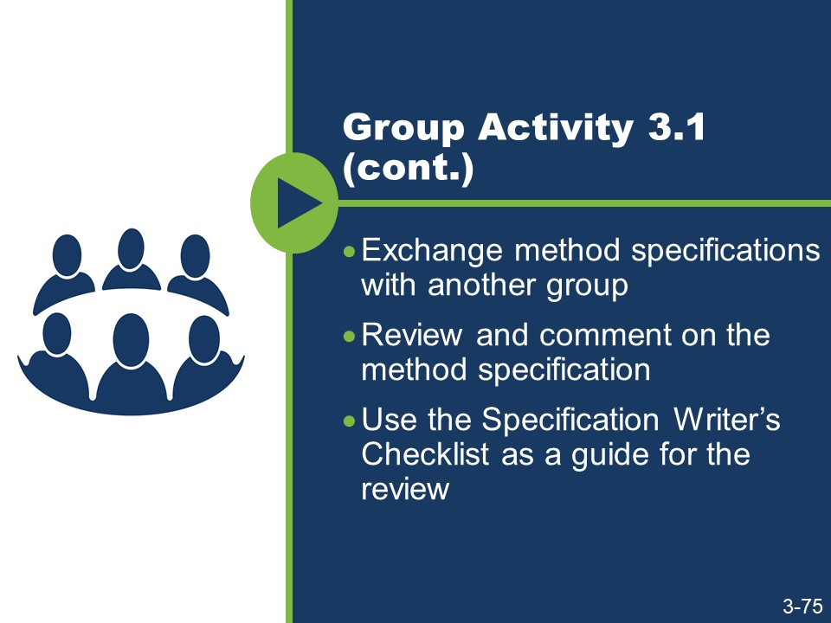

Activity (continued)

- Exchange your group’s method specification with another group.
- Review and comment on their method specification.
- Use the Appendix D: Specification Writer’s Checklist sections “Mood and Voice” and “The Five Cs of Specification Writing” as a guide for the review.

Slide 3-76
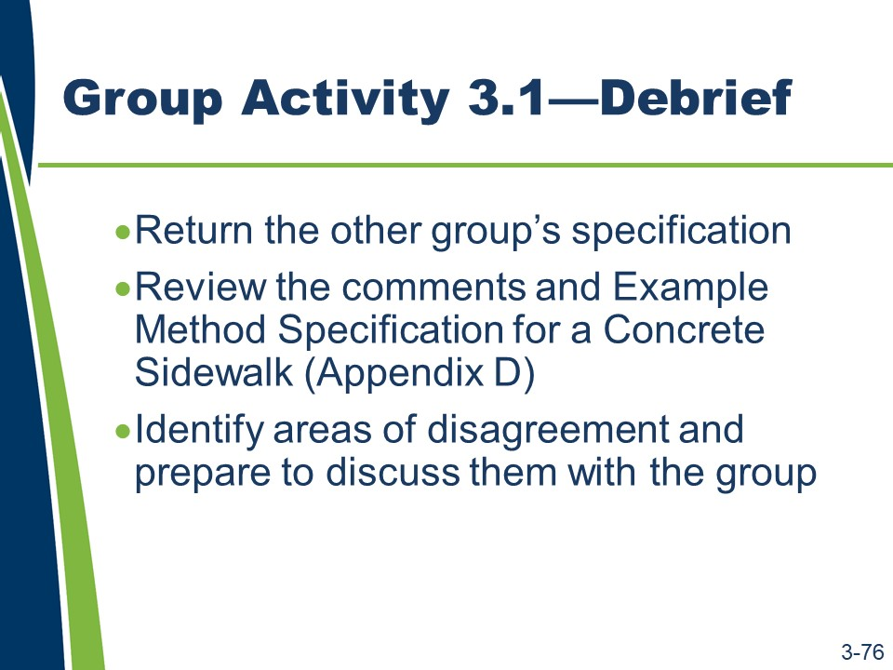
Activity (continued)
- Return the group’s specification.
- Review the comments and Appendix E: Example Method Specification for a Concrete Sidewalk.
- Identify areas of disagreement and be prepared to discuss them with the group.

Areas of disagreement:

It is unlikely that a new method specification can be written in one draft. Developing a writing process that works with individual experience and skill level and that reinforces the principles of writing specifications using the five Cs reduces the need for rewriting. The order in which the five Cs are applied affects the efficiency of the writing process. A specification, or part of a specification, should be complete and correct before continuing writing for clarity, conciseness, and consistency.

Slide 3-77
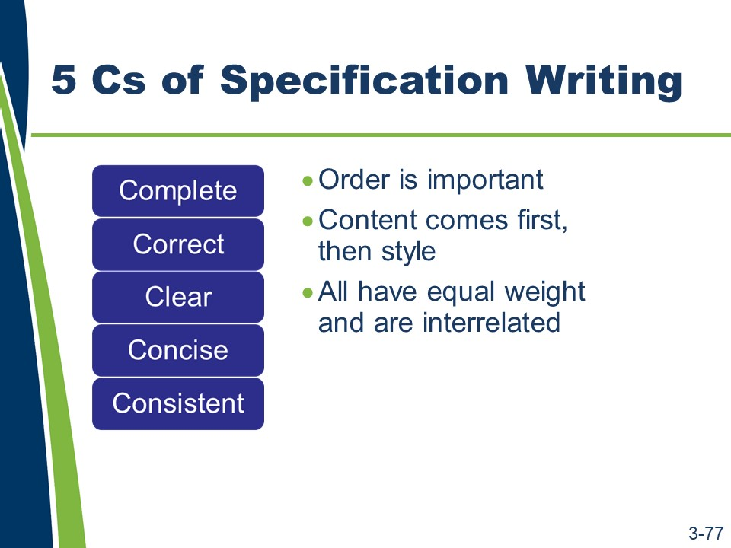
Five Cs of Specification Writing
Each of the five Cs is important on its own. To develop a specification that will perform well requires equal attention to all of the five Cs.
The order in which the five Cs are applied affects the efficiency of the writing process. A specification should be complete and correct before continuing writing for clarity, conciseness, and consistency.
Additionally, the five Cs are interrelated. Writing for one C often affects the other Cs.
- The order of the five Cs is complete, correct, clear, concise, and consistent. This order is important because it reflects that the content (complete and correct) must be developed before the style (concise, clear, and consistent).
- In other words, when content changes, the logic, organization, and the way the specification is written changes. Content should be finalized first. Then how to say it clearly, concisely, and consistently should be considered.
When a writing style changes, the content can remain static. Consider the passive- to-active voice rewritten samples. The writing style changed but it did not affect the content of the samples.
- The five Cs are highly interrelated.
  - Complete and Concise. Specification writers must assign responsibility for all requirements and obligations under the “complete” step. Specification writers should use the imperative and indicative moods with the active voice under the “concise” step. These topics are related because the use of the active voice with the imperative and indicative moods helps distinguish responsibilities of the contractor from responsibilities of the agency.

Five Cs of Specification Writing (continued)
  - Consistent and Clear. Specification writers should consistently use words as verbs or nouns under the consistent C. Specification writers should clearly represent the author’s intent in wording and usage of the specification language under the clear C. These topics are related because the consistent use of words as verbs or nouns helps clarify the author’s intent and reduce the possibility for misinterpretation.
  - Correct and Consistent. Specification writers should avoid conflicting requirements under the correct C. Specification writers should avoid repeating requirements and creating conflicts under the consistent C. These topics are related because repeated requirements create greater potential for conflicts due to the multiple locations of information needing revision when the content changes.

Slides 3-78 to 3-92
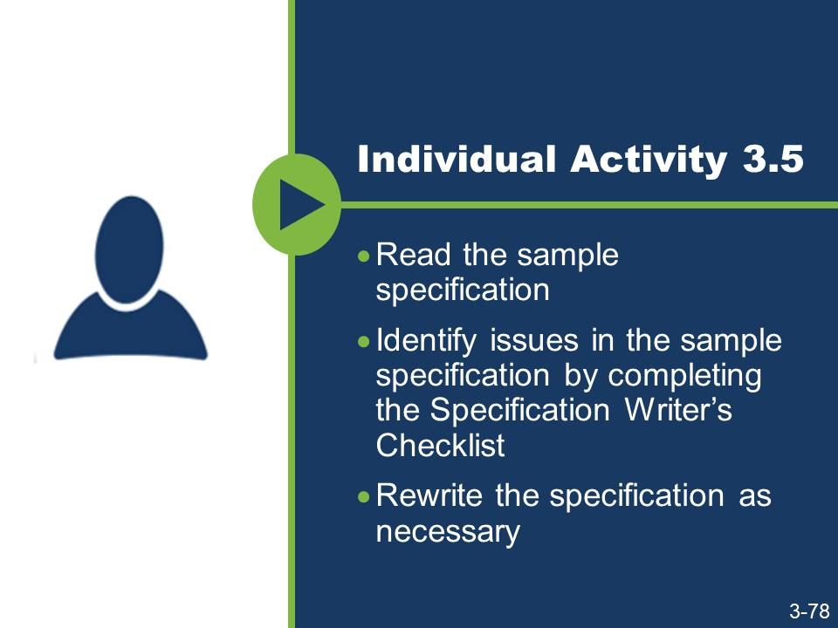
(Slides 3-79 to 3-92 are not shown because they contain answers to the activity.)
Activity
- Read the sample specification.
- Use Appendix D: Specification Writer’s Checklist sections “Mood and Voice” and “The Five Cs of Specification Writing” as a guide for the review.
- Rewrite the specification as necessary.
- If style or format is not addressed in the course materials, follow the guidance provided by the agency’s style guide or other applicable standards.
- If additional standards are needed to rewrite the specification, refer to the agency’s specification manual.

Activity (continued)

Sample Specification
“616.03 Construction Requirements. Excavation and backfill shall be according to the requirements of Section 801, “Traffic Control Plan.”
The agency will perform acceptance sampling and testing of the compacted backfill material in accordance with Subsection 208.03 at the frequencies established by the agency in Section 205, “Excavation and Embankment.”
Precast reinforced concrete box culvert units shall be bedded on a foundation of firm and stable material, accurately shaped to conform to their base.
When required by the plans, special bedding material shall be provided as required in Section 616.02. The special bedding material will be furnished at no cost to the agency.
Joints and joint materials shall comply with the requirements of Section 608. Lifting holes shall be filled with mortar or concrete and cured as directed.
When precast boxes are used to form multiple barrel structures, they shall be placed in conformance with the details shown on the plans. Material required between barrels shall be as shown on the plans. The material between barrels will be furnished at no cost to the agency.
Connections of precast boxes to cast-in-place boxes or to any required headwalls, wingwalls, riprap, or other structures shall comply with the details shown on the plans.
Headwalls, wingwalls, and footings shall be according to the details of the plans, except that the overall widths of the headwalls and footings shall be modified to fit the finished width of the various structures.
The number of drainage structures to be furnished will be listed on the plans or in the proposal. The contractor shall protect all drainage structures until the engineer has determined that all construction work has been completed.”

Activity (continued)
“616.03 Construction Requirements. Excavation and backfill shall be according to the requirements of Section 801, “Traffic Control Plan.””
- What issues did you identify?
- Which of the five Cs needs to be addressed?
The agency will perform acceptance sampling and testing of the compacted backfill material in accordance with Subsection 208.03 at the frequencies established by the agency in Section 205, “Excavation and Embankment.”
- What issues did you identify?
- Which of the five Cs needs to be addressed?

Activity (continued)
Precast reinforced concrete box culvert units shall be bedded on a foundation of firm and stable material, accurately shaped to conform to their base.
- What issues did you identify?
- Which of the five Cs needs to be addressed?
When required by the plans, special bedding material shall be provided as required in Section 616.02. The special bedding material will be furnished at no cost to the agency.
- What issues did you identify?
- Which of the five Cs needs to be addressed?

Activity (continued)
Joints and joint materials shall comply with the requirements of Section 608.
- What issues did you identify?
- Which of the five Cs needs to be addressed?
Lifting holes shall be filled with mortar or concrete and cured as directed.
- What issues did you identify?
- Which of the five Cs needs to be addressed?

Activity (continued)
When precast boxes are used to form multiple barrel structures, they shall be placed in conformance with the details shown on the plans. Material required between barrels shall be as shown on the plans. The material between barrels will be furnished at no cost to the agency.
- What issues did you identify?
- Which of the five Cs needs to be addressed?
Connections of precast boxes to cast-in-place boxes or to any required headwalls, wingwalls, riprap, or other structures shall comply with the details shown on the plans.
- What issues did you identify?
- Which of the five Cs needs to be addressed?

Activity (continued)
Headwalls, wingwalls, and footings shall be according to the details of the plans, except that the overall widths of the headwalls and footings shall be modified to fit the finished width of the various structures.
- What issues did you identify?
- Which of the five Cs needs to be addressed?
The number of drainage structures to be furnished will be listed on the plans or in the proposal. The contractor shall protect all drainage structures until the engineer has determined that all construction work has been completed.
- What issues did you identify?
- Which of the five Cs needs to be addressed?

Slide 3-93

Collaboration
A collaborative process exists when specification writers can rely on each other for useful feedback to improve the specification. In order for the collaborative process to be successful, specification writers need to be comfortable sharing their work with their peers, reviewing their peers’ work, and giving and receiving constructive feedback.
Establishing a collaborative process is an effective way to ensure quality, especially consistency.

The review process should be collaborative, not competitive. Feedback should address deficiencies objectively based on the agency’s style guides and policies, content covered in this course, and recognized standards. Use these resources to resolve disagreements with your peers.

Slide 3-94
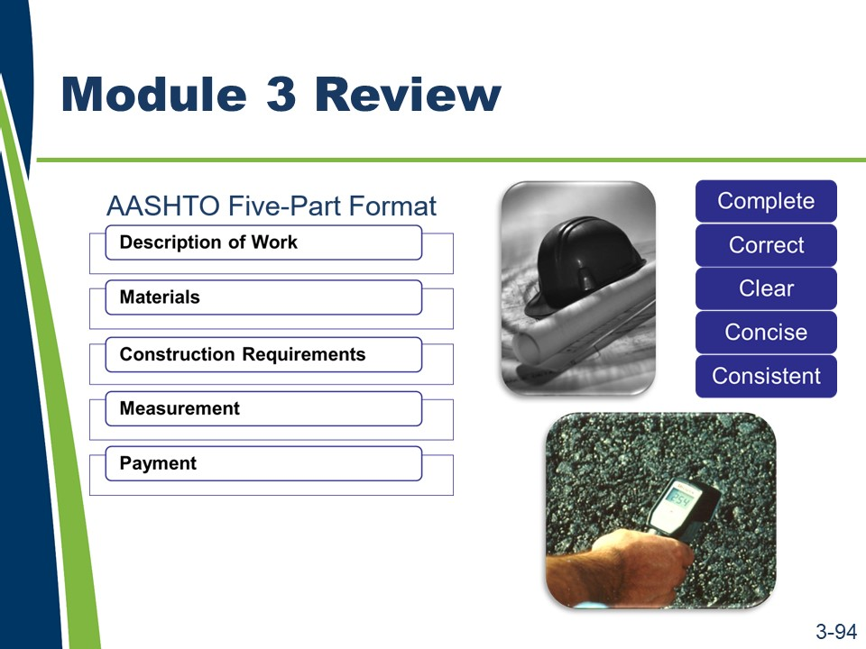
Module 3 Review
This concludes the content for Module 3.
In summary, the agency bears the risk that the contract documents will not properly communicate how the contractor must meet the agency’s expectations for a project. When the following exist in the contract documents, they cause disputes and impact the project: omissions (not complete), errors (not correct), ambiguities (not clear), unnecessary information (not concise), and inconsistencies (not consistent). Because the agency wrote the specifications, the agency is responsible if the specifications perform poorly.
Activity
- Work with a nearby partner.
- Review the key learning points and objectives from Module 3.
- Answer the questions.
- Think about and discuss a situation when a specification was misinterpreted. How can using a consistent writing style prevent this specification from being misinterpreted?

Module 3 Review (continued)
- When writing in the imperative mood, the actor is dropped. This course advocates the use of the imperative mood. Why is it acceptable to use the imperative mood, which drops the actor, but not to write in the passive voice?

- How can you use the Appendix D: Specification Writer’s Checklist as a resource when writing specifications?

Module 3 Review (continued)
The following are the key learning points in Lesson 3.1.
- The variety of writing styles used by individual specification writers requires a consistent writing style.
- The writing style used can have a major impact on the interpretation of specifications. Inconsistent writing can lead to inconsistent interpretation.
- To use the plain language approach when writing specifications, a writer must think about the audience, organize, write, and test.
- To implement a consistent writing style using the plain language approach, a writer needs proper guidance through a style guide or equivalent guidance document.
The following are the key learning points in Lesson 3.2.
- The active voice is preferred when writing specifications because it is more direct, more concise, more emphatic, and clearer than the passive voice.
- A change from the passive voice to the active voice requires the writer to confirm and emphasize the responsible party.
- The indicative and imperative moods are both used when writing specifications; generally, imperative mood for contractor responsibilities and indicative mood for everything else.
The following are the key learning points in Lesson 3.3.
- To write effective specifications, a writer must use the five Cs of specification writing: complete, correct, clear, concise, and consistent.
  - Complete. Complete provisions include all provisions necessary to perform the scope of work.
  - Correct. Correct provisions are technically and grammatically correct.
  - Clear. Clear provisions can be interpreted only one way.
  - Concise. Concise provisions are easy to navigate.
  - Consistent. Consistent provisions lead to consistent interpretations.

Module 3 Review (continued)
The following are the learning outcomes for Module 3.
- Explain how a consistent writing style can affect the interpretation of specifications.
- Explain the potential benefits of writing in the active voice.
- Rewrite passive voice sentences into the active voice.
- Evaluate specifications to determine the need for imperative or indicative mood.
- State the five Cs used in specification writing.
- Identify potential ambiguities in the wording, given a sample specification.
- Identify the potential benefits of each of the five Cs.
- Write a new specification using the five Cs and the agency’s preferred format.
- Complete a checklist of the information needed before writing or revising a specification.
- Apply the five Cs and the agency’s preferred format to revise the specification, given a specification.

This page is intentionally blank.

Module 4: Method or End-result Specifications

Slides 4-1 and 4-2
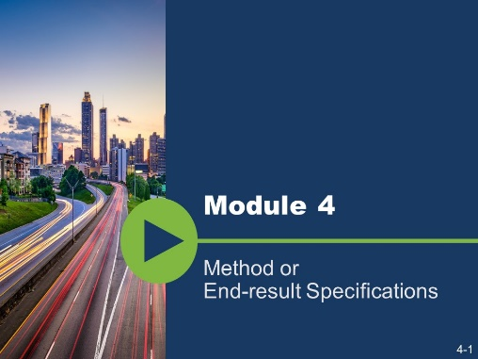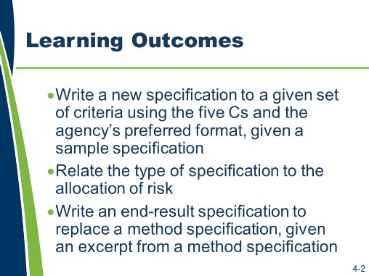
Module 4 addresses method and end-result specifications in greater detail, the topic of risk as it relates to the type of specifications, and the process of converting a method specification into an end-result specification.
Learning Outcomes
This module supports these learning outcomes.
- Write a new specification to a given set of criteria using the five Cs and the agency’s preferred format, given a sample specification.
- Relate the type of specification to the allocation of risk.
- Write an end-result specification to replace a method specification, given an excerpt from a method specification.
Resources
- American Association of State Highway and Transportation Officials. Guide Specifications for Construction. Ninth Edition, 2008.
- Federal Plain Language Guidelines, May 2011. http://www.plainlanguage.gov/.
- Agency’s specification manual(s).
- Oklahoma Department of Transportation, 2009 ODOT Standard Specifications, 2009.
- The Construction Specifications Institute. The Project Resource Manual: CSI Manual of Practice. Fifth Edition. New York: McGraw-Hill, 2005.
- Transportation Research Board of the National Academies. SHRP 2 Renewal Project R07. Performance Specifications for Rapid Highway Renewal, Implementation Guidelines Volume II, Developing and Drafting Effective Performance Specifications: A Guide for Specification Writers, 2013. Prepublication draft, not edited.

- Transportation Research Board of the National Academies. Transportation Research Circular E-C173: Glossary of Transportation Construction Quality Assurance Terms. Sixth Edition, 2013.
- United States Department of Transportation, Federal Highway Administration. Development and Review of Specifications. Technical Advisory, OPI – HIAM-20. Washington, DC, March 24, 2010.
- United States Department of Transportation, Federal Highway Administration, Federal Lands Highway. Specification Writers’ Guide for Federal Lands Highway. Publication No. FHWA-CFL/TD-08-001, May 2008.
- United States Department of Transportation, Federal Highway Administration, National Highway Institute. Transportation Construction Quality Assurance Course 134064A. Publication No. 08-067.
- Wyoming Department of Transportation. Standard Specifications for Road and Bridge Construction, 2010.

Slide 4-3
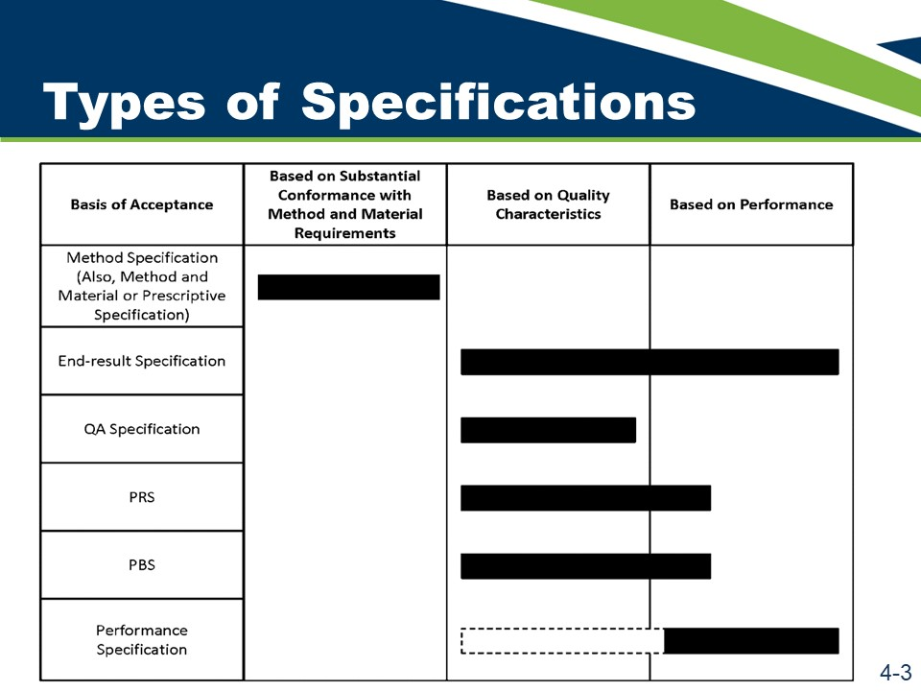
Types of Specifications
As discussed in Module 2, there are several types of specifications. Generally, the types are grouped under the categories of method specifications and end-result specifications. Under the category of end-result specifications, the types of specifications are divided according to several bases of acceptance. The bases range from quality characteristics to performance. The terms associated with a quality assurance plan were defined in Module 2. This section will focus on the definitions of the types of specifications shown in this table.

Slide 4-4
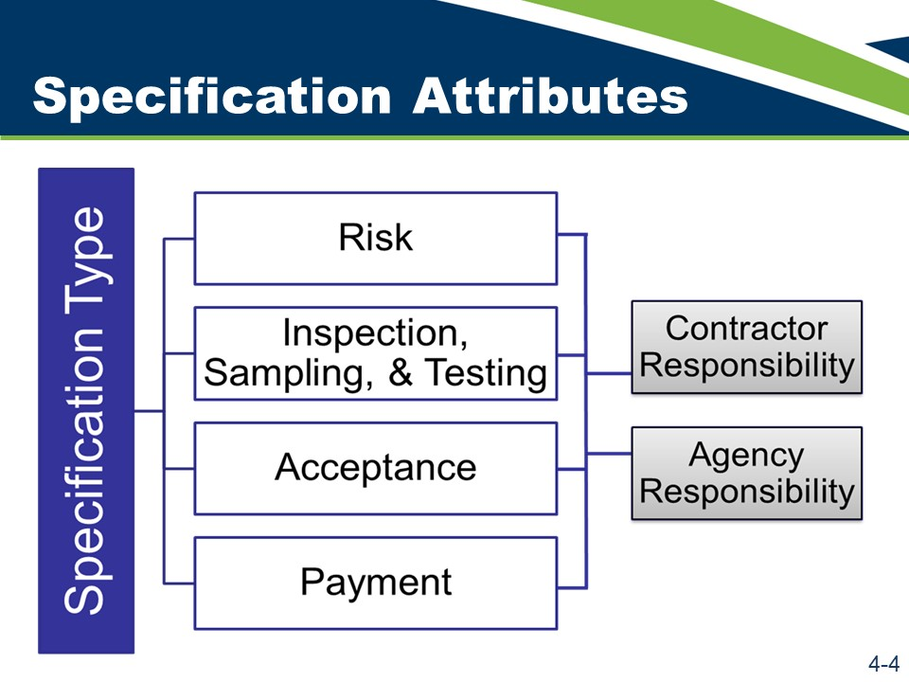
Types of Specifications (continued)

There are similar factors to consider across the five types of specifications. These attributes include the following.
- Risk
- Inspection, sampling, and testing
- Acceptance
- Payment
Contractor responsibility and agency responsibility should be considered within these attributes.
It is important not to combine method specifications with the other four types of specifications.
Under a method specification, the owner bears the risk of the specified method and materials producing a result of the desired quality; however, for the four other types of specifications, the contractor bears the risk of the method producing a quality product. If method specifications are combined with the other types of specifications, the allocation of risk becomes confused.
Activity
- Review the Matrix of Attributes starting on page 4-7 noting the rows for each specification type.
- Write notes for each section in the matrix as the instructor discusses each specification type.

Slides 4-5 to 4-7
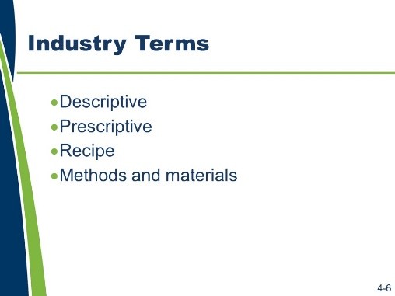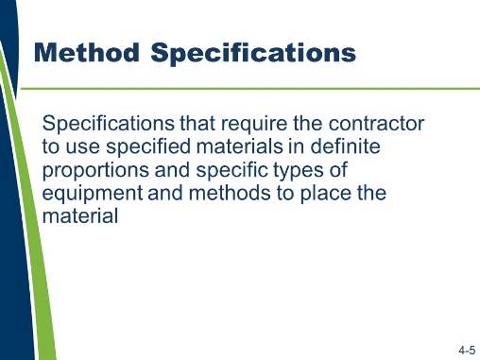
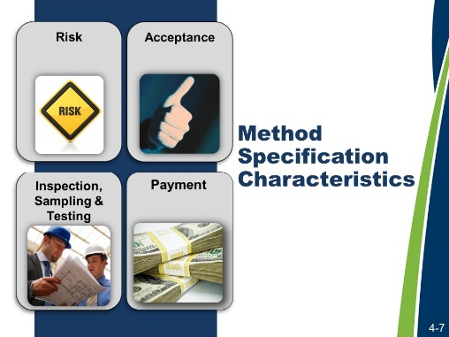
Method Specifications
Method specifications require the contractor to use specified materials in definite proportions and specific types of equipment and methods to place the material. Typically, method specifications are based on methods and materials that have historically produced satisfactory results. However, they do not allow for contractor innovation.
There are several interchangeable terms used in the industry in addition to the term method specifications. These items include:
- Descriptive.
- Prescriptive.
- Recipe.
- Methods and materials.
Slides 4-8 to 4-10 (Not shown because they contain answers to the activity.)
Matrix of Attributes: Method Specifications
Attribute | Notes
Risk
Contractor Responsibility
Agency Responsibility
Acceptance
Payment
Advantages
Disadvantages

Method Specifications (continued)
What are examples of a method specification in your standard specification book?
What are the clues that indicated this is a method specification?

Slides 4-11 and 4-12
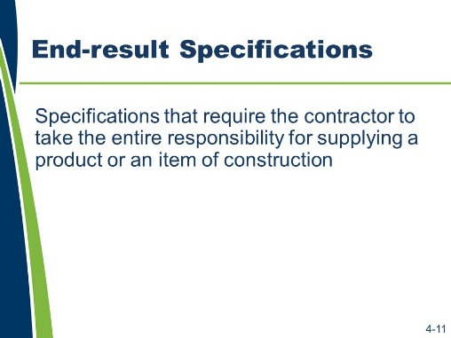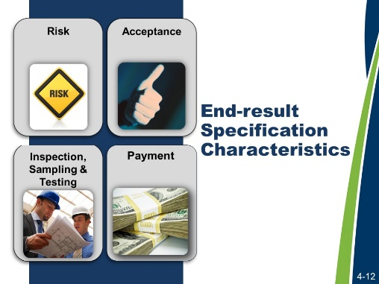
End-result Specifications
End-result specifications require the contractor to take the entire responsibility for supplying a product or component of the project. The transportation agency’s responsibility is to either accept or reject the final product or component or to apply a pay adjustment commensurate with the degree of compliance with the specifications.

Slides 4-13 and 4-14 (Not shown because they contain answers to the activity.)
Matrix of Attributes: End-result Specifications
Attribute | Notes
Risk
Contractor Responsibility
Agency Responsibility
Acceptance
Payment
Advantages
Disadvantages

End-result Specifications (continued)
What are examples of an end-result specification in your standard specification book?

What are the clues that indicated this is an end-result specification?
The advantages and disadvantages of the remaining types of specifications —quality assurance, performance-related, and performance-based —are similar to the advantages and disadvantages of end-result specifications.

Slides 4-15 and 4-16
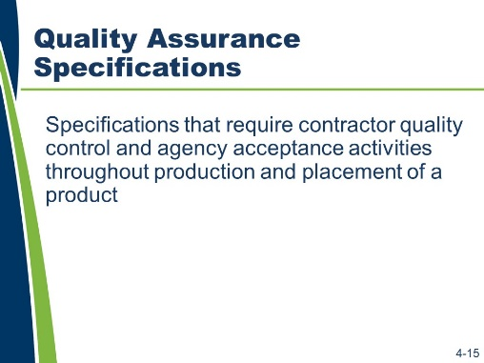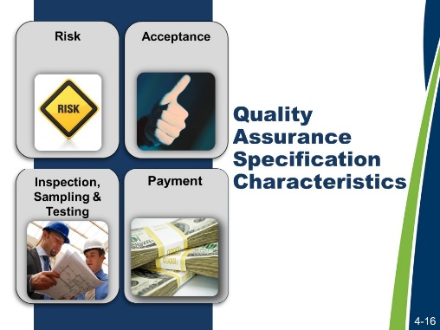
Quality Assurance Specifications
Quality assurance specifications require contractor quality control and agency acceptance activities throughout production and placement of a product. Final acceptance of the product is usually based on a statistical sampling of the measured quality level for key quality characteristics. These specifications recognize the inherent variability of materials.

Matrix of Attributes: Quality Assurance Specifications
Attribute | Notes
Risk
Contractor Responsibility
Agency Responsibility
Acceptance
Payment

Quality Assurance Specifications (continued)
What are examples of quality assurance specifications in your standard specification book?
What are the clues that indicated this is a quality assurance specification?

Slides 4-17 to 4-23
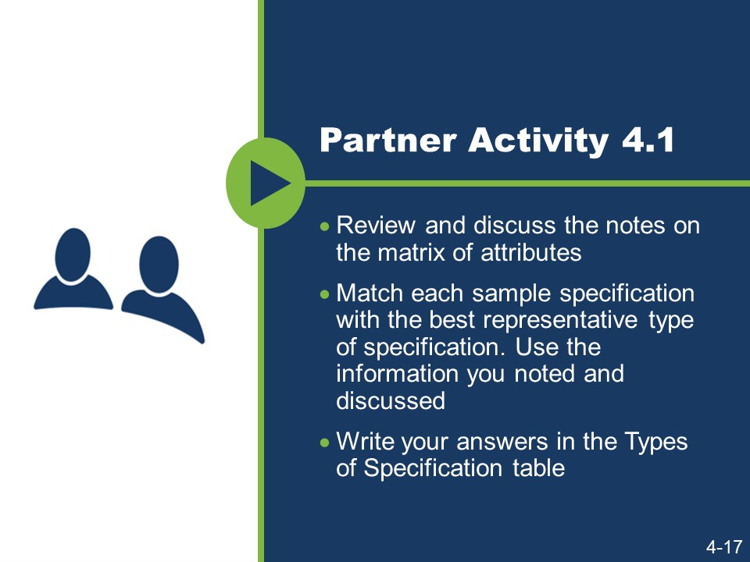
(Slides 4-18 to 4-23 are not shown because they contain answers
Activity
- The attributes of each type of specification aid in identifying the type of specification and distinguishing it from other types.
- Work with a partner.
- Review and discuss the notes on the matrix of attributes.
- Match each sample specification with the best representative type of specification. Use the information you noted and discussed.
- Write your answers in the Types of Specification table.

Activity (continued)
Types of Specifications
Sample Specification | Type of Specification
609.4.4 Finishing. When using forms, trowel exposed surfaces smooth and give a fine brush finish with brush strokes parallel to the curb line. After removing forms, fill surface blemishes that will be exposed with grout and finish.
When using the slip-form method, remove blemishes and give surfaces that will be exposed in the completed item a fine brush finish with brush strokes parallel to the line of the curb.
609.4.6 Surface Tolerance. Ensure that the finished top and face of the curb are true and straight and that the top surfaces are of uniform width and free from irregularities. Do not leave the finished surface with variation greater than 3/16 in. [5 mm] every 10 ft. [3 m] in any direction. Correct excess variation by removing and replacing the curb section.
605.03. Concrete Production. The contractor shall provide quality control measures for the production of concrete in accordance with Section 604. The engineer will not sample or test for quality control or assist in controlling the contractor's production operations. Continued production of concrete which does not meet specification with negative pay adjustment, in lieu of making adjustments to bring the work into conformance, will result in project shutdown until necessary adjustments are made.
401.16 Density. Acceptance will be based on lots and sublots in accordance with 401.07.
Density of the compacted dense graded mixture will be determined from cores except where:
- the total planned lay rate to be placed over a shoulder existing prior to the contract award is less than 385 lb./sq. yd. (210 kg/m2); or
- the 1st lift of material placed at less than 385 lb./sq. yd. (210 kg/m2) over a shoulder existing prior to the contract award.
Density of any random core location(s) in these areas will be assigned a value of 92.0 percent MSG and compaction shall be in accordance with 402.15.

Sample Specification | Type of Specification
716.03 General Requirements. The contractor shall submit a quality control plan, QCP, in accordance with ITM 803. The QCP shall be submitted to the engineer for review and acceptance, at least 15 days prior to the start of trenchless pipe installation operations.
5. Preparing Pavement Surface. Prepare the pavement surface to receive the chip seal. Clean pavements requiring treatment with a motorized power broom to remove loose material. Use a hand broom to clean cracks and other areas inaccessible by power broom. Use pick-up sweepers adjacent to lawns or roadways with curb and gutter.

Given the variety of types of specifications and the significant overlap between the types, it is often difficult to clearly identify one specification from another without looking at the entire specification section. Additionally, specification sections may have attributes of multiple types of specifications. For instance, even though a quality assurance specification also contains an equipment requirement, it does not mean that the specification becomes a method specification instead of a quality assurance specification. Most specifications in use today are hybrid specifications. Though this is not recommended as a best practice, it is the reality for most agencies.

Slides 4-24 and 4-25
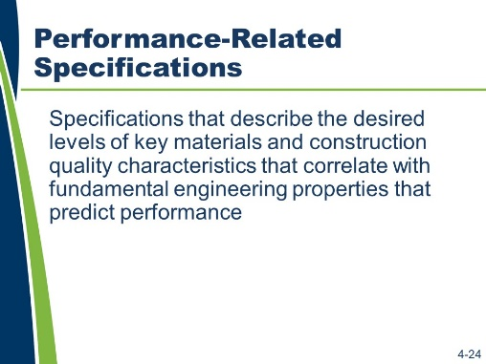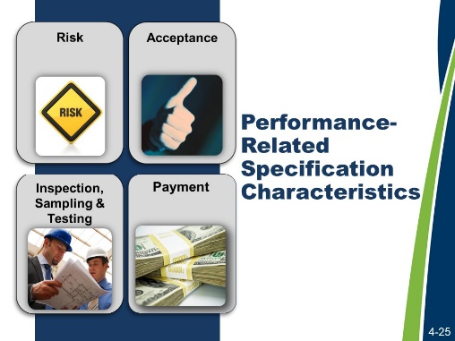
Performance-related Specifications
Performance-related specifications describe the desired levels of key materials and construction quality characteristics that correlate with fundamental engineering properties that predict performance. Performance-related specifications are like quality assurance specifications. They specify only the product quality characteristics measured at the time of construction and do not specify the desired long-term product performance. They differ from quality assurance specifications because performance- related specifications are based on mathematical models to quantify the relationship between key materials and construction quality characteristics and product performance.

Matrix of Attributes: Performance-related Specifications
Attribute | Notes
Risk
Contractor Responsibility
Agency Responsibility
Acceptance
Payment

Performance-related Specifications (continued)
For method, end-result, and quality assurance specifications, you were asked to find examples that show how they look and how they might differ from each other. If asked to find an example of a performance-related specification in your standard specifications or somewhere else, would you be able to distinguish between a quality assurance specification and this performance-related specification? Why or why not?

Slides 4-26 and 4-27
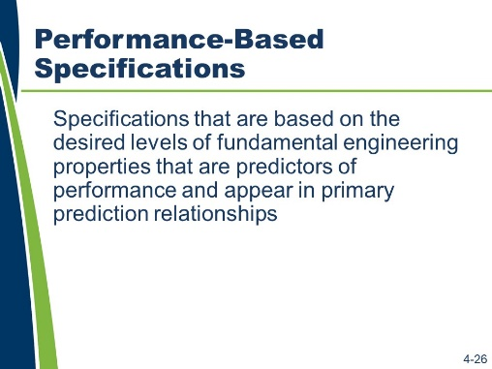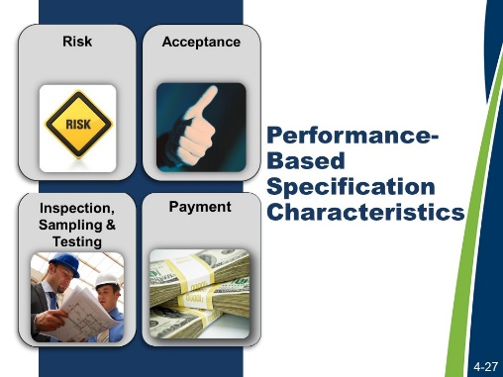
Performance-Based Specifications
Performance-based specifications are based on the desired levels of fundamental engineering properties (e.g., resilient modulus, creep properties, and fatigue properties). These properties are predictors of performance and appear in primary prediction relationships (e.g., models can be used to predict pavement stress, distress, or performance from combinations of predictors that represent traffic, environmental, roadbed, and structural conditions).

Matrix of Attributes: Performance-based Specifications
Attribute | Notes
Risk
Contractor Responsibility
Agency Responsibility
Acceptance
Payment

Performance-Based Specifications (continued)
For method, end-result, and quality assurance specifications, you were provided with examples to show how they look and how they might be different from each other. If asked to find an example of a performance-based specification in your standard specifications or somewhere else, would you be able to distinguish it from a quality assurance specification or a performance-related specification? Why or why not?

Slides 4-28 to 4-38
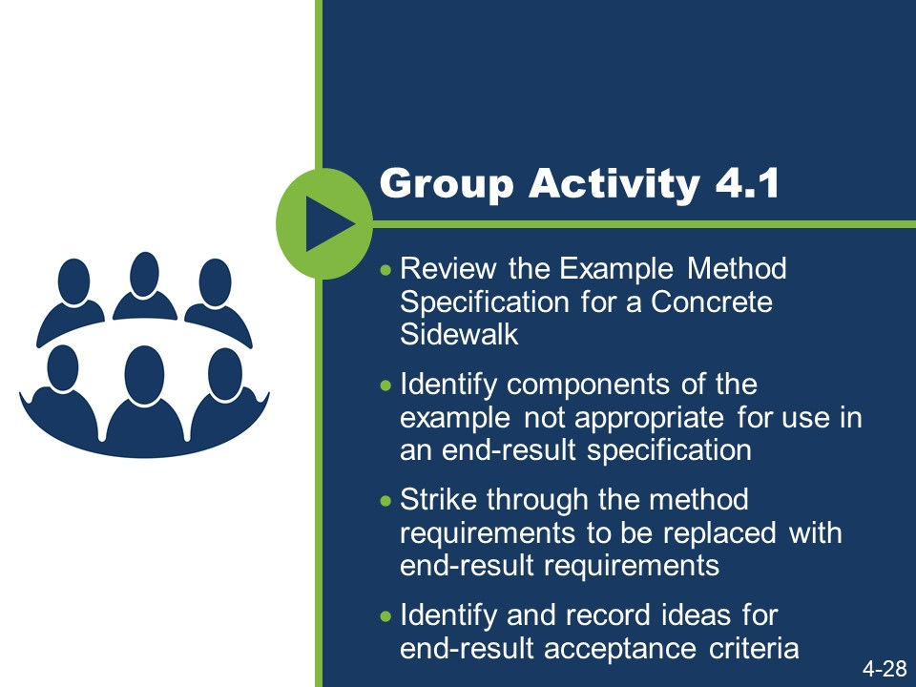
(Slides 4-29 to 4-38 are not show because they contain answers to activities.)
Convert a Method Specification to an End-result Specification Activity Part 1
In Module 3, we wrote a new method specification. During this activity, you will convert the method specification for a concrete sidewalk to an end-result specification.
- Work in a small group.
- Using the context, review the Example Method Specification for a Concrete Sidewalk.
- Identify the components of the example that are not appropriate for use in an end- result specification.
- Strike through the method requirements to be replaced with end-result requirements. There are two types of strikethroughs.
  - Requirements that you can delete because they are no longer needed.
  - Requirements that you can delete, but must replace with appropriate quality standards to ensure that the agency gets the concrete sidewalk it needs.
- As you strike through the requirements, identify and record ideas for end-result acceptance criteria that might be used to replace the deleted method specification requirements.

Activity Part 1 (continued)

Context
The agency intends to award a contract to provide for the reconstruction of eight blocks of a State Highway through an urban corridor and within a city’s limits. Included in the scope of this contract will be the construction of a concrete sidewalk adjacent to new, concrete curb and gutter to be reconstructed as part of the same contract. The contract will also include the reconstruction of the adjacent State Highway asphalt pavement.
The concrete sidewalk will be constructed for the length of the project on both sides of the highway. The contractor constructing the sidewalk will be required to comply with this specification when performing the sidewalk construction work. The location and dimensions of the sidewalk and a profile of the sidewalk and bedding course are shown in the plans for the project.
The end-result specification should provide pay adjustments related to the compressive strength of the concrete.

Activity Part 1 (continued)

Example Method Specification for a Concrete Sidewalk
(This specification was developed based on the AASHTO Guide Specifications. The section numbers and references are based on appropriate references from the AASHTO Guide Specification.)

Description of Work
This work consists of constructing a concrete sidewalk.
Ideas for end-result criteria:

Materials
Provide material for constructing a concrete sidewalk as follows:
    - Bed course material in accordance with Subsection 703.12
    - Reinforcing steel in accordance with Subsection 711.01
    - Concrete, Class B, in accordance with Section 601 and Subsection 713.01(B)
    - Joint filler in accordance with Subsection 707.01(D)
    - Form release agent approved by the engineer
    - Curing compound in accordance with Subsection 713.02(C)

Ideas for end-result criteria:

Activity Part 1 (continued)

Construction Requirements
Construct concrete sidewalk using the equipment and methods in accordance with the following requirements:
    - Equipment
  - Excavator and hand tools for excavation and placement of bed course material.
  - Hand-driven compactor for compaction.
  - Forms and hand tools for placing, consolidating, finishing, jointing, and texturing the concrete.

Ideas for end-result criteria:

Activity Part 1 (continued)
    - Methods
  - Excavating. Excavate to the depth and width necessary to allow for the proper depth of the bed course material and the installation and bracing of the forms. Replace soft and yielding material with the specified bed course material.
Place, shape, and compact the bed course material to the line and grade established by the plans.
  - Forms. Use full-depth forms that, when properly braced, are strong enough to resist the concrete pressure. Maintain horizontal and vertical alignment. Use clean forms and coat with a form-release agent.
  - Reinforcing Steel. Place reinforcing steel as specified in Subsection 809.
  - Placing Concrete. Moisten the foundation prior to placing concrete.
Proportion, mix, and place as specified in Subsection 601. Place uniformly in one course.
  - Finishing. Float and apply a light broomed finish. Edge all outside slab and all joint edges to a ¼ in. (6 mm) radius.
  - Joints. Fill expansion joints with the specified preformed expansion joint filler. Section the sidewalk using false joints at 5 ft. (1.5 m) intervals ⅛ in. (3 mm) wide and at least 1 in. (25 mm) deep using a jointing tool. Match curb or pavement joints.
  - Form full-depth construction joints around all appurtenances, such as manholes and utility poles. Install full-depth preformed expansion joint filler between concrete sidewalks and structures.
  - Curing. Cure concrete as specified in Subsection 808.03(I) for 72 hours. Do not allow pedestrian and vehicle traffic on the concrete for 7 days unless the surface is protected by planks, plywood, or a minimum 1 in. (25 mm) sand layer. Do not place protection directly on the concrete for a minimum 12 hours after application of the curing compound.

Ideas for end-result criteria:

Activity Part 1 (continued)
    - Inspection and Acceptance
  - Notify the engineer 24 hours before beginning the placement of concrete sidewalks.
  - The engineer will inspect the form work, bed course, and reinforcing steel installation before concrete is placed.

Ideas for end-result criteria:

Activity Part 1 (continued)

Measurement
The engineer will measure accepted sidewalk separately by the square foot (square meter) of concrete placed.
Ideas for end-result criteria:

Payment
The agency will pay for accepted sidewalk in accordance with the contract pay items for sidewalk.

Ideas for end-result criteria:

Slide 4-39
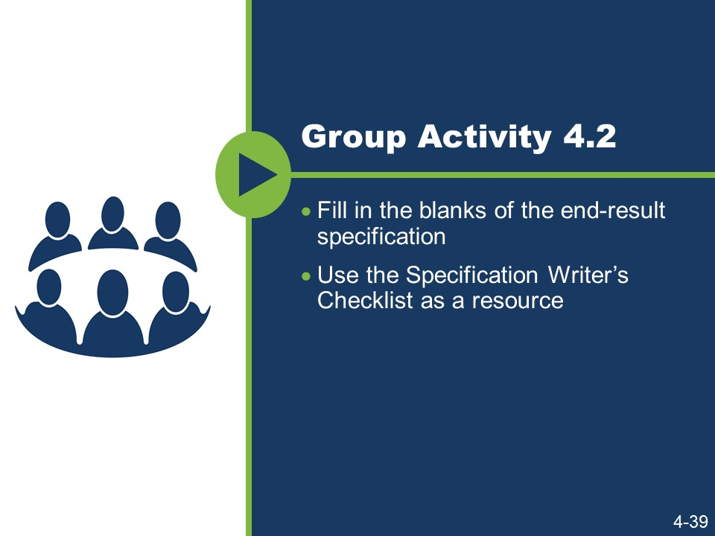
Activity Part 2
- Work in small groups.
- Consider the acceptance criteria discussed and provided in Appendix J and fill in the blanks of the end-result specification.
- Use Appendix D: Specification Writer’s Checklist as a resource.

Activity Part 2 (continued)

End-result Specification for a Concrete Sidewalk

Description of Work
This work consists of constructing a concrete sidewalk.

Materials
Provide material for constructing a concrete sidewalk as follows:
    - Reinforcing steel in accordance with Subsection 711.01
    - Concrete, Class B, in accordance with Section 601 and Subsection 713.01(B)
    - Joint filler in accordance with Subsection 707.01(D)

Construction Requirements
- General. Construct concrete sidewalk meeting the acceptance criteria below.
- Density of Bedding Course. (Identify appropriate density requirements.)
- Compressive Strength of Concrete. (Establish criteria for determining acceptance of concrete to be used for concrete sidewalk; use compressive strength.)

Activity Part 2 (continued)
- Joints. (Use criteria that define the agency’s expectations for joint placement and construction.)
- Roughness. (Use criteria for roughness meeting the ANSI standard for coefficient of friction as published by the National Bureau of Standards. Consider a slip resistance requirement as measured by a pendulum tester.)
- Sampling, Testing, and Acceptance. (Establish how either the contractor or the agency will sample and test for acceptance.)

Activity Part 2 (continued)

Measurement
The engineer will measure accepted sidewalk separately by the square foot (square meter) of concrete placed.

Payment

Slide 4-40

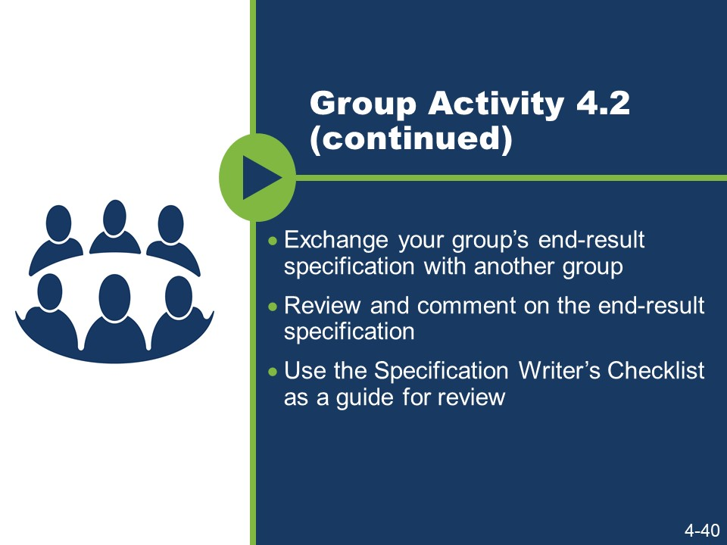
Activity Part 2 (continued)
- Exchange your group’s end-result specification with another group.
- Review and comment on their end-result specification.
- Use Appendix D: Specification Writer’s Checklist sections “Mood and Voice” and “The Five Cs of Specification Writing” as a guide for the review.

Slide 4-41
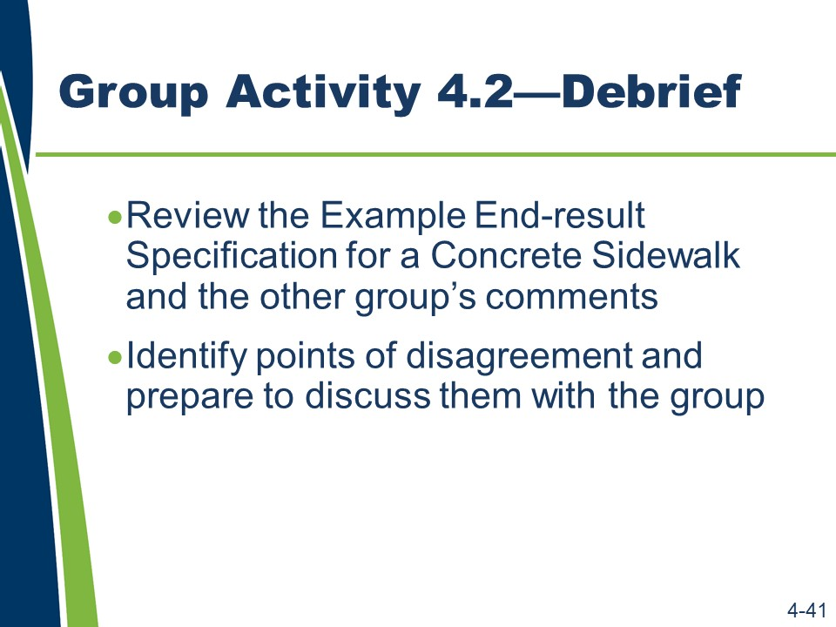
Activity Part 2 (continued)
- Return the group’s specification.
- Review the comments and Appendix K: Example Method Specification for a Concrete Sidewalk.
- Identify areas of disagreement and prepare to discuss these areas.

Areas of disagreement:

Slide 4-42
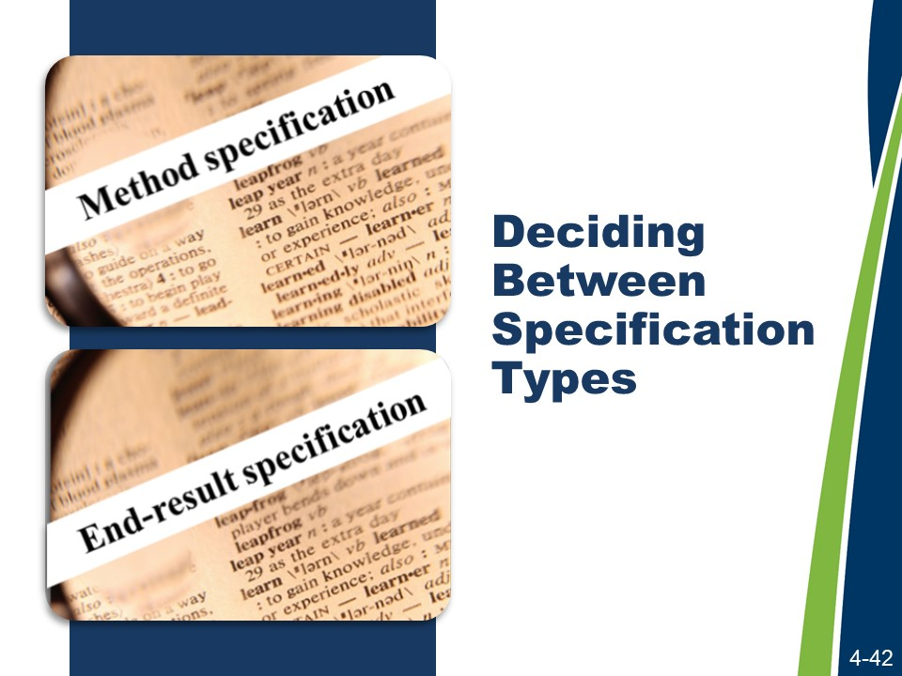
Deciding between Types
There are several factors to consider when choosing between method or end-result specifications.
According to the SHRP 2 Report, motivation for using end-result specifications will likely vary from agency to agency and from project to project. The literature and input from practitioners suggests that implementing end-result specifications has the potential to improve quality and long-term durability, encourage innovation, accelerate construction, and reduce an agency’s quality assurance burden during construction (particularly if the contractor has post-construction responsibilities).
The likelihood of realizing such benefits tends to correlate with project complexity. End- result specifications are typically most advantageous when the nature of the project provides numerous opportunities for the industry to innovate and influence performance outcomes. This is often the case on complex projects involving major reconstruction or new capacity, multi-phased work zone management, major or non-standard structures, and high traffic volumes requiring accelerated design and construction.
In contrast, non-complex projects involving minor resurfacing or restoration of the pavement surface, or use of standard structural components to match existing facilities, tend to be the least likely project types to benefit from using an end-result specification.
The criteria listed in Slide 4-43 are used to decide between the types of specifications.

Slide 4-43
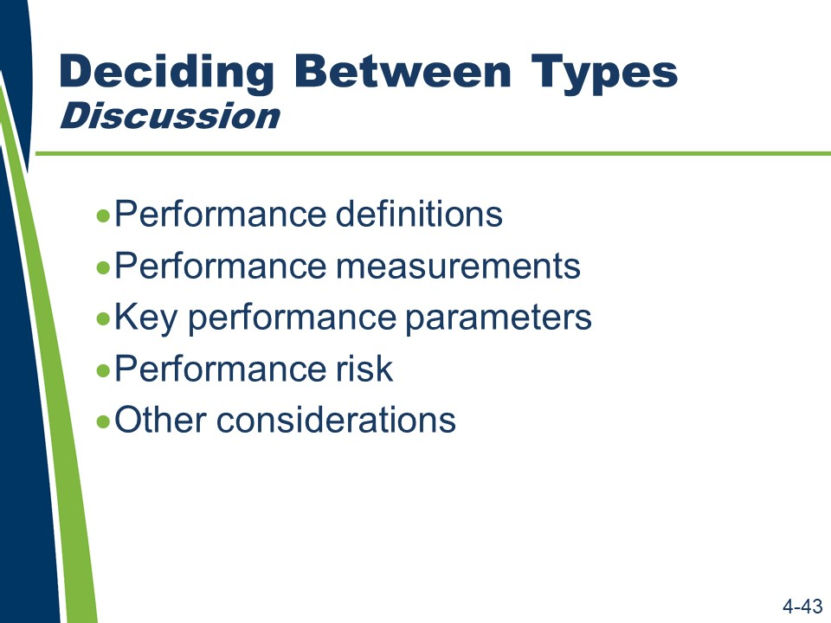
Activity
- Write M in the column if a method specification should have been used in the concrete sidewalk activity.
- Write an E in column if an end-result specification should have been used in the concrete sidewalk activity.
- Write the reason in the “Reason column.

Conditions for Deciding between Types
Item | Method Specifications | End-result Specifications | M/E | Reason
Performance Definitions | End product performance cannot be easily defined. | End product performance can be defined in terms of desired outcomes or user needs. | .
Performance Measurements | End product performance cannot be easily or economically measured and verified. | Key performance parameters can be measured and tested, and the test methods are rapid, reliable, and economical.
Key Performance Parameters | Key performance parameters cannot be identified. | Key performance parameters can be determined based on agency management system data and projected performance outcomes.
Performance Risk | The agency must retain performance risk because of permit requirements, maintenance considerations, the need to tie into existing or adjacent construction, or other external concerns. | Industry is willing to assume performance risk and sureties are willing to bond this risk.
Other Considerations | Removing and replacing defective work would be impractical. | Agency is willing to relinquish control over some aspects of the work.

Slide 4-44
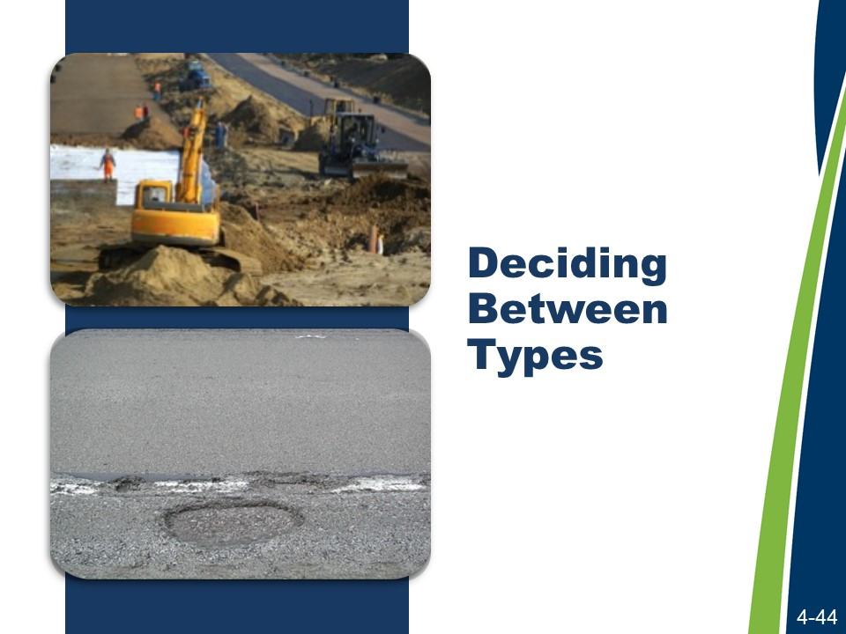
Deciding between Types (continued)
When writing a specification, as a best practice, be careful not to combine the different types of specifications for a requirement. For instance, do not tell the contractor how to install silt fence and then define the performance in terms of the fence not falling down under certain minimum conditions.
For example, in the concrete sidewalk example, do not specify the types of equipment and procedures to follow and then require that the contractor meet specific acceptance criteria with compensation based on test results for those criteria. There is potential to follow the method and not reach the end result. If the end result suffices to define the expected quality, that is all that is necessary.

Slide 4-45
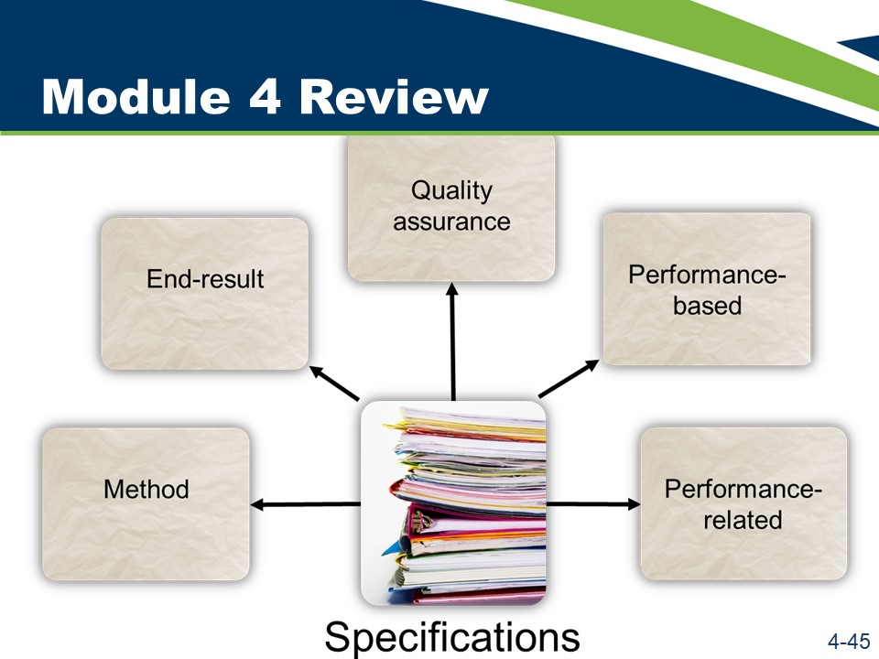
Module 4 Review
This concludes the content for Module 4.
Activity
- Work with a nearby partner.
- Review the key learning points and objectives from Module 4.
- Answer the questions.
    - Reflect on your experience revising the sidewalk specification from a method to an end-result specification. If your supervisor asked you to make a recommendation regarding the feasibility of converting a particular method specification to an end-result specification, list some of the factors you would consider in making your recommendation.

Module 4 Review (continued)
    - When defining and comparing method, end-result, quality assurance, performance-related, and performance-based specifications, the contractor’s risk increases with method specifications being the least risky and performance- based specifications being the most risky. What is the primary reason that the contractor’s risk increases?

Module 4 Review (continued)
The following are the key learning points in Module 4:

Method Specifications
- Achieve the desired outcome by specifying the method and materials to be used by the contractor to build the project.
- Rely upon agency inspection, sampling, and testing to verify that the contractor used the specified methods and provided the specified materials. The contractor’s risk is minimized because the ultimate quality and performance of the work is the agency’s responsibility as long as the contractor used the specified methods and provided the specified materials.
- Are used when it is difficult or impossible to specify practical approaches to sampling and testing quality characteristics or confirming performance.

End-result Specifications
- Achieve the desired outcome by specifying the end result (the agency’s specified outcome).
- Rely upon agency sampling and testing upon the completion of the contractor’s work to verify that the contractor provided the specified end result.
- Are riskier for the contractor because the contractor is responsible for the ultimate quality of the work.
- Are used when the end result can be confidently specified and verified.

Quality Assurance Specifications
- Achieve the desired outcome by specifying the quality characteristics the contractor must achieve.
- Rely upon agency sampling and testing as the work proceeds to verify that the contractor is performing and ultimately performs the work as specified.
- Are riskier for the contractor, though this is somewhat less than in the case of end- result specifications because the quality is measured as the work is performed instead of at the end.
- Are used when relevant quality characteristics can be identified and verified through sampling and testing.

Module 4 Review (continued)

Performance-Related Specifications
- Achieve the desired outcome by specifying the quality characteristics related analytically to fundamental engineering properties that the contractor must achieve. These fundamental engineering properties must themselves be related to performance.
- Rely upon agency sampling and testing as the work proceeds to verify that the contractor is performing and ultimately performs the work as specified.
- Are riskier for the contractor, though this is somewhat less than in the case of end- result specifications because the quality is measured as the work is performed.
- Are used when relevant quality characteristics can be related analytically to fundamental engineering properties and when these characteristics can also be verified through sampling and testing.

Performance-Based Specifications
- Achieve the desired outcome by specifying the fundamental engineering properties the contractor must achieve. These fundamental engineering properties are themselves related to performance.
- Rely upon agency sampling and testing as the work proceeds to verify that the contractor is performing and ultimately performs the work as specified.
- Maximize the contractor’s risk because achievement of the fundamental engineering properties is the contractor’s responsibility.
- Are used when fundamental engineering properties related directly to performance can be identified and verified through sampling and testing.
The following are the learning outcomes for Module 4:
- Write a new specification to a given set of criteria using the five Cs and the agency’s preferred format, given a sample specification.
- Relate the type of specification to the allocation of risk.
- Write an end-result specification to replace a method specification, given an excerpt from a method specification.

This page is intentionally blank.

Module 5: Conclusion and End-of-Course Activities

This page is intentionally blank.
Slide 5-1

Module 5 discusses some reference materials and tools for writing specifications.
Learning Outcomes
Module 5 supports all of the learning outcomes.
Resources
- Federal Plain Language Guidelines, May 2011. http://www.plainlanguage.gov/.
- The Construction Specifications Institute. The Project Resource Manual: CSI Manual of Practice. Fifth Edition. New York: McGraw-Hill, 2005.
- Transportation Research Board of the National Academies. Transportation Research Circular E-C173: Glossary of Transportation Construction Quality Assurance Terms. Sixth Edition, 2013.
- United States Department of Transportation, Federal Highway Administration. Development and Review of Specifications. Technical Advisory, OPI – HIAM-20. Washington, DC, March 24, 2010.
- Transportation Research Board of the National Academies. SHRP 2 Renewal Project R07. Performance Specifications for Rapid Highway Renewal, Implementation Guidelines Volume II, Developing and Drafting Effective Performance Specifications: A Guide for Specification Writers, 2013. Prepublication draft, not edited.

Slide 5-2
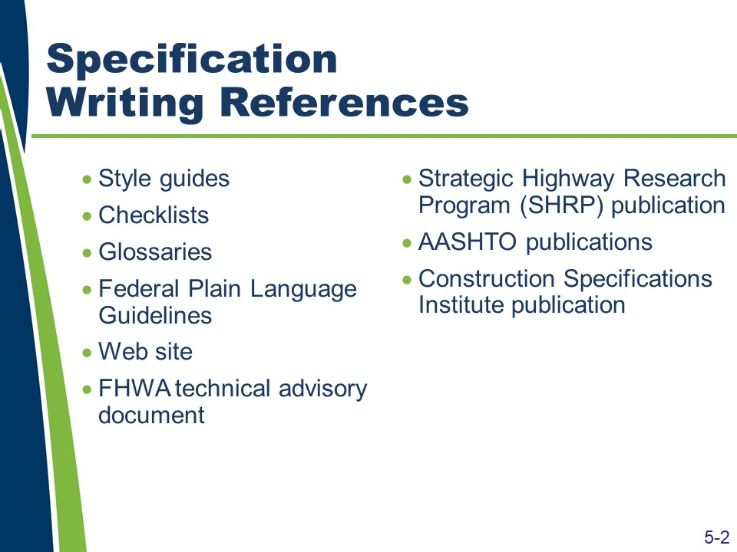
Specification Writing References
There are many specification writing references available. These include the following:
- Agency style, writing, or other specification development guidance. These documents are the primary source of guidance during the specification writing process.
- Specification Writer’s Checklist. The checklist provides a detailed and itemized list of many of the factors a specification writer should consider before, during, and after the writer has undertaken a specification writing task. The checklist begins with the initial assignment and follows the specification writing process through the writing and reviewing steps. Participants should use the checklist as a reminder for each new specification writing assignment. They should also add to the list additional items they believe would be useful reminders during the next specification writing assignment. They should treat the checklist as a living document.
- TRB EC 173 QA Glossary of Terms. This document includes terms and definitions related to the topic of quality assurance.
- Federal Plain Language Guidelines. These guidelines include general topics on how to make written documents more accessible to their audience. Because this document’s application is not specific to highway construction specifications, weigh each guideline against the agency’s style, writing, or other specification development guidance.
- National Highway Specifications Web Site. This Web site includes standard and supplemental specifications from all State transportation agencies. It can be used as a searchable library of potential model specifications. Always follow up with the agency’s Web site when choosing a model specification.
- FHWA Technical Advisory – Development and Review of Specifications. This technical advisory includes general guidance on how to develop and review specifications from FHWA’s perspective. Because this document’s primary audience is FHWA division office staff that review and approve specifications, weigh each guideline against the agency’s style, writing, or other specification development guidance.
- SHRP 2 Report. This report presents a flexible framework that specification writers may use to assess whether the use of specifications other than method specifications represents a viable option for a particular project or project element, and, if so, how performance specifications may then be developed and used to achieve project-specific goals and satisfy user needs.
- AASHTO Guide Specifications for Highway Construction. This guide includes a model for developing specifications, but the model needs adjustment for use in any given State.
- Construction Specifications Institute – Project Resource Manual. This manual includes a broad perspective on specification-related topics under various project delivery and contracting methods. While the general writing principles apply to highway construction specifications, weigh each guideline against the agency’s style, writing, or other specification development guidance.

Slide 5-3
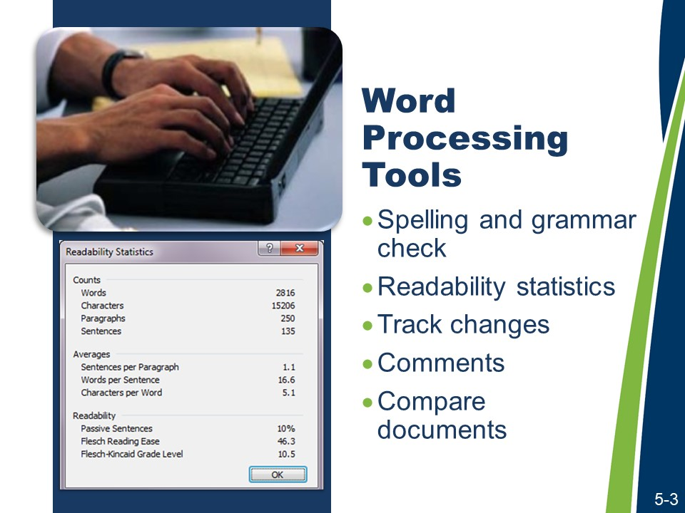
Word Processing Tools
In addition to multiple references, there are also word processing tools available to specification writers.
Word processing tools, like those available in Microsoft Word®, are a boon to specification writers. They allow one to do the following:
- Check spelling and grammar. Use these features but do not rely on them. Change the program’s grammar settings to recognize passive sentences.
- View readability statistics. Use file options and proofing functions in Microsoft Word® to show readability statistics. Keep averages (words per sentence, sentences per paragraph), percentage of passive voice, and readability scores low (except the Flesch Reading Ease score, which you want to keep high).
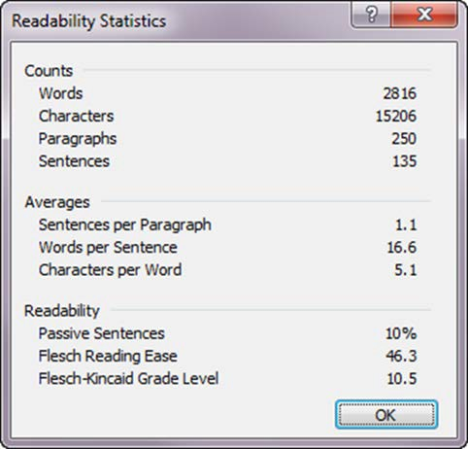
Additional information about readability and directions to use the Microsoft Word® tools can be found on the Microsoft® Web site at http://office.microsoft.com/.

Word Processing Tools (continued)
- Track changes. Enable Track Changes to facilitate the specification review process and collaboration with others.
- Comment on draft content. Track supporting information and decisions regarding the content and style of the specifications using the Comments feature.
- Compare document drafts. To compare two versions of the same document (or retroactively enable Track Changes), use the Compare Documents feature.

Slide 5-4

Learning Outcomes Review
The learning outcomes for this course include:
- Compare the functions of standard and supplemental specifications with the functions of special provisions.
- Explain how the “order of precedence” affects writing specifications and preparing plans.
- Explain the purposes of a specification.
- Describe the purpose of the general provisions.
- Explain how specifications are used to assign risk and affect the behavior of different parties, within a given scenario.
- Compare method and end-result specifications.
- Explain each element of the AASHTO five-part format.
- Explain how a consistent writing style can affect the interpretation of specifications.
- Explain the potential benefits of writing in the active voice.
- Rewrite passive voice sentences into the active voice.
- Evaluate specifications to determine the need for imperative or indicative mood.
- State the five Cs used in specification writing.
- Identify potential ambiguities in the wording, given a sample specification.
- Identify the potential benefits of each of the five Cs.
- Write a new specification using the five Cs and the agency’s preferred format.
- Complete a checklist of the information needed before writing or revising a specification.

Learning Outcomes Review (continued)
- Apply the five Cs and the agency’s preferred format to revise the specification, given a sample specification.
- Write a new specification to a given set of criteria using the five Cs and the agency’s preferred format, given a sample specification.
- Relate the type of specification to the allocation of risk.
- Write an end-result specification to replace a method specification, given an excerpt from a method specification.

Participant Appendices

This page is intentionally blank.

Appendix A: Spearin Doctrine Explanation
The Spearin Doctrine is derived from a decision made by the United States Supreme Court. The decision concerned the case of United States v. Spearin, 248 U.S. 132 (1918). The doctrine establishes that the contractor is not liable to the agency that prepared the plans and specifications for damages that result from deficiencies in those plans and specifications. Said another way, the agency implicitly warrants the accuracy and sufficiency of the contract documents, relieving the contractor of responsibility for defects in these documents.
In the Spearin case itself, the contractor, Spearin, was contracted to build a dry-dock at the Brooklyn Navy Yard by the United States Government. In order to build the dry-dock at the site selected by the agency, the contractor had to relocate a portion of a sewer that ran through the site. The agency provided the plans and specifications containing the requirements for the relocation of the section of the sewer. The contractor completed the relocation of the section of sewer in accordance with the plans and specifications, and the agency approved and accepted the work.
Nearly one year after the relocation of the sewer, a dam in a connecting sewer caused the relocated sewer to flood and burst, flooding the area excavated for the dry-dock.
This dam was not shown on the agency's plans and specifications. The Court held that the agency created an implied warranty that, if the contractor executed its work in accordance with the plans and specifications, the relocated sewer would be adequate. The Court further held that the general clauses requiring the contractor to examine the site and the plans and to maintain responsibility for the work until completion did not overcome or invalidate this implied warranty.
Other courts have further refined the Spearin doctrine to encompass two specific implied warranties. The first implied warranty is that the plans and specifications are accurate and the second is that they are suitable for their intended use. An agency breaches the first warranty when the plans contain errors or other deficiencies (for example, if there is a dam in the sewer that is not shown on the plans or described in the specifications). An agency breaches the second warranty when a contractor complies with the requirements of the plans and specifications, but fails to produce a finished project suitable for its intended purpose or satisfactory to the agency. An example might be a contractor who builds a bridge in strict accord with the plans and specifications, but the resulting bridge is found to be structurally unsound.
In both of the above-listed situations, a contractor may hold the agency liable for the added expense required to complete the project due to the inadequate plans and specifications. The contractor, however, must still show good faith. If the contractor has notice that the plans and specifications are defective, it must notify the agency promptly in order to preserve its cause of action. It should also be noted that courts have determined the Spearin doctrine to apply to private as well as public contracts.
Mitchell, Brendan P. "The Applicability of the Spearin Doctrine: Do Owners Warrant Plans and Specifications?". Find Law for Legal Professionals. 03, 2008. Accessed 07, 2013.

This page is intentionally blank.

Appendix B: Sample Style Guide Table of Contents
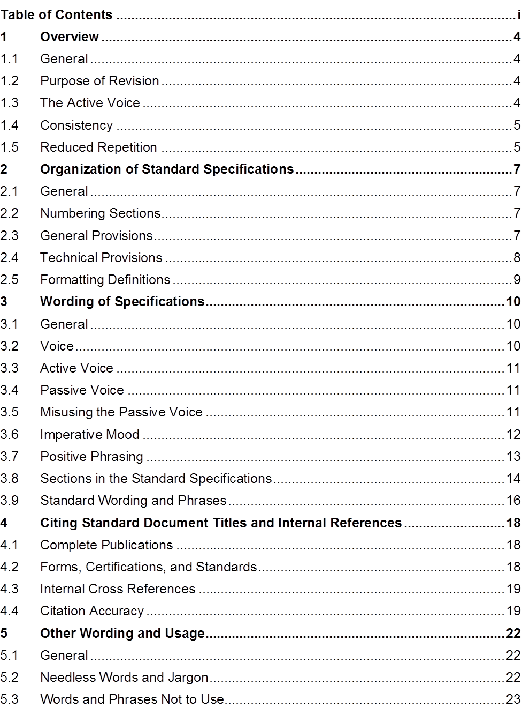

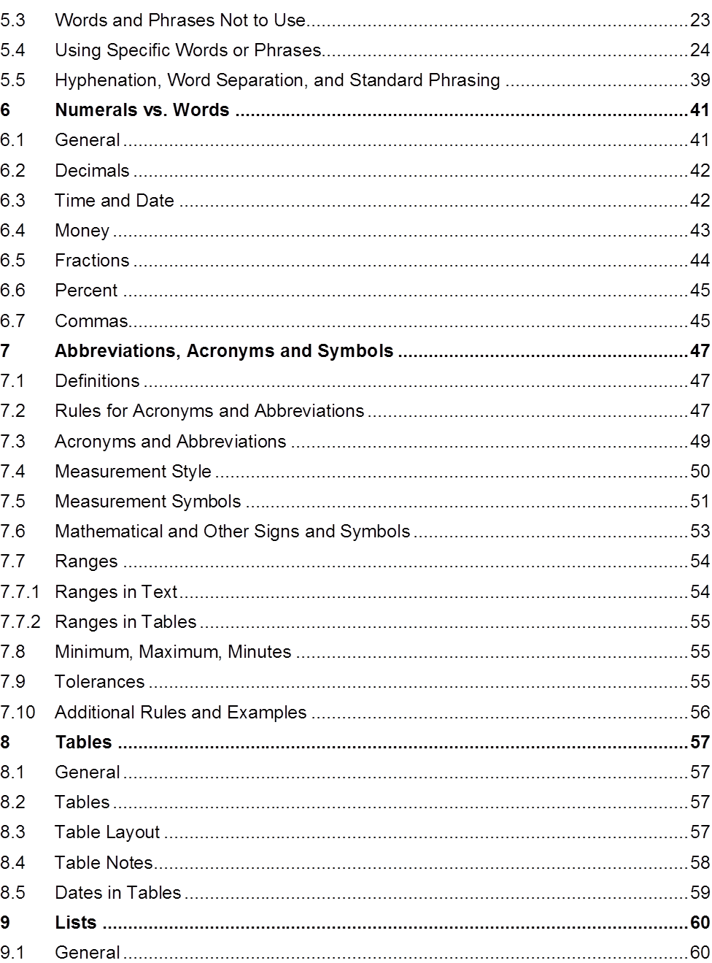

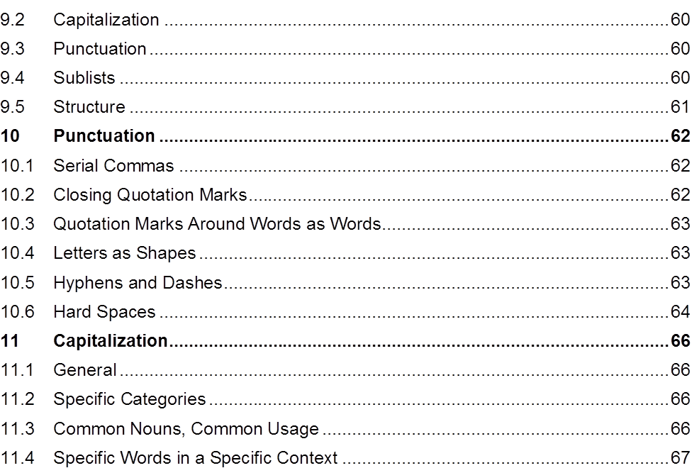

This page is intentionally blank.

Appendix C: Commonly Used Phrases
Common Use | Suggested
absolutely essential | essential
successfully complete | complete
a minimum of | at least
not less than | at least
enclosed herewith | enclosed
at a later date | later
commence | start, begin
heretofore | until now
prior to | before
subsequent to | after
for the purpose of | for, to
through the use of | using
until such time as | until
in lieu of | instead of
utilize | use
in order to | to

This page is intentionally blank.

Appendix D: Specification Writer’s Checklist
The checklist is a tool to aid when drafting specifications. It relates to drafting new or revising existing specifications for highway and bridge construction projects.
The Assignment
Status (√) | Task | Notes
 | I developed a schedule, and if appropriate, a budget for drafting or revising the specification.
 | I understand the purpose of the specification.
 | I know the technical and/or administrative requirements to be included in the specification.
 | I know which type of specification I am writing, method or end-result.
 | I know how the risks associated with the work specified are to be allocated to the agency or the contractor.
 | I know what contractor behaviors are to be encouraged or discouraged by the specification.

The Contract
Status (√) | Task | Notes
 | I know where the specification is to be inserted into the contract; as a standard specification, as a supplemental specification, as a special provision, or some other specification form.
 | I know whether the specification will be located in the general provisions or the technical specifications.

Writing Style and Plain Language
Status (√) | Task | Notes
 | I understand who the audience is for the specification I am writing; the contractor and/or the agency staff responsible for the project.
 | I performed the necessary research to ensure that I understand what the specification is to contain or address.
 | I reviewed the existing agency specifications related to the purpose or objective of the specification.
 | I reviewed the technical information related to the specification (agency, FHWA, and industry sources).

Status (√) | Task | Notes
 | I investigated best practices regarding the work associated with the specification.
 | I consulted with agency experts regarding the content of the specification.
 | I consulted with the appropriate agency construction personnel relevant to the specification.
 | I consulted, when appropriate, with representatives of the consulting and construction industry regarding the specification.
 | I reviewed similar specifications in the AASHTO Guide Specifications, the National Highway Specification Web site, and with FHWA.
 | I reviewed and considered the general provisions relevant to the specification.
 | I reviewed and considered the agency’s style guide or other relevant style guidance, and included these course materials.

Mood and Voice
Status (√) | Task | Notes
 | I wrote the specification in the active voice.
 | I wrote the specification in the imperative or indicative mood, as appropriate.

The Five Cs of Specification Writing
Complete
Status (√) | Task | Notes
 | I wrote the specification in the AASHTO five-part format.
 | If it is a method specification, I have adequately described the materials, equipment, and contractor work necessary to complete the work satisfactorily.
 | If it is an end-result specification, I have not specified the materials and the means and methods of construction.
 | If it is an end-result specification, I have identified measurable quality characteristics, specified a sampling and testing regime, and, if appropriate, determined pay-adjustment factors.

Correct
Status (√) | Task | Notes
 | I have carefully reviewed the specification to ensure that it is technically and grammatically correct.
 | With regard to questions of word usage, grammar, and clear punctuation, I consulted with the agency’s style guide, these course materials, or other referenced standards when appropriate.
 | I used the right words to convey the meaning I intended.
 | I used measurable standards.
 | I used “any” and “all” correctly.
 | I used “from,” “to,” and “between” correctly.
 | I used restrictive and non-restrictive clauses properly.

Status (√) | Task | Notes
 | I did not use undefined or subjective terms.
 | I did not use vague adjectives and adverbs.
 | I used vertical lists where appropriate.
 | I used positive phrasing where appropriate.
 | I used parallel sentence construction where appropriate.

Concise
Status (√) | Task | Notes
 | I included only essential information.
 | I omitted needless words and phrases.
 | I used the active voice and imperative mood, where appropriate.
 | I did not include reasons, suggestions, explanations, or justifications.
 | I used simple words (less than four syllables).
 | I used short sentences (less than 20 words).
 | I used short paragraphs (less than five sentences).
 | I did not repeat requirements already set forth in the general provisions or elsewhere in the specifications.

Consistent
Status (√) | Task | Notes
 | I used defined terms where appropriate.
 | I used abbreviations, acronyms, units of measure, and symbols as established in the general provisions or as appropriate.
 | I used words in text and the associated symbols in tables.
 | I expressed numbers consistent with the established agency style or industry standards, as appropriate.
 | I minimized the use of capitalization consistent with the agency’s established style guidance.
 | I used styles and formats consistent with the agency’s established guidance.

Review
Status (√) | Task | Notes
The specification has been reviewed by the following:
- My peers
 | - My supervisor
 | - The applicable technical committee
 | - Construction
 | - The industry
 | All comments from reviewers have been addressed.

Appendix E: Example Method Specification for a Concrete Sidewalk
(This specification was developed based on the AASHTO Guide Specifications. The section numbers and references are based on appropriate references from the AASHTO Guide Specification.)

Description of Work
This work consists of constructing a concrete sidewalk.

Materials
Provide material for constructing a concrete sidewalk as follows:
    - Bed course material in accordance with Subsection 703.12
    - Reinforcing steel in accordance with Subsection 711.01
    - Concrete, Class B, in accordance with Section 601 and Subsection 713.01(B)
    - Joint filler in accordance with Subsection 707.01(D)
    - Form release agent approved by the engineer
    - Curing compound in accordance with Subsection 713.02(C)

Construction Requirements
Construct concrete sidewalk using the equipment and methods in accordance with the following requirements:
    - Equipment
  - Excavator and hand tools for excavation and placement of bed course material.
  - Hand-driven compactor for compaction.
  - Forms and hand tools for placing, consolidating, finishing, jointing, and texturing the concrete.
    - Methods
  - Excavating. Excavate to the depth and width necessary to allow for the proper depth of the bed course material and the installation and bracing of the forms. Replace soft and yielding material with the specified bed course material.
Place, shape, and compact the bed course material to the line and grade established by the plans.

  - Forms. Use full-depth forms that, when properly braced, are strong enough to resist the concrete pressure. Maintain horizontal and vertical alignment. Use clean forms and coat with a form-release agent.
  - Reinforcing Steel. Place reinforcing steel as specified in Subsection 809.
  - Placing Concrete. Moisten the foundation prior to placing concrete.
Proportion, mix, and place as specified in Subsection 601. Place uniformly in one course.
  - Finishing. Float and apply a light broomed finish. Edge all outside slab and all joint edges to a ¼ in. (6 mm) radius.
  - Joints. Fill expansion joints with the specified preformed expansion joint filler. Section the sidewalk using false joints at 5 ft. (1.5 m) intervals ⅛ in. (3 mm) wide and at least 1 in. (25 mm) deep using a jointing tool. Match curb or pavement joints.
  - Form full-depth construction joints around all appurtenances, such as manholes and utility poles. Install full-depth preformed expansion joint filler between concrete sidewalks and structures.
  - Curing. Cure concrete as specified in Subsection 808.03(I) for 72 hours. Do not allow pedestrian and vehicle traffic on the concrete for 7 days unless the surface is protected by planks, plywood, or a minimum 1 in. (25 mm) sand layer. Do not place protection directly on the concrete for a minimum 12 hours after application of the curing compound.
    - Inspection and Acceptance
  - Notify the engineer 24 hours before beginning the placement of concrete sidewalks.
  - The engineer will inspect the form work, bed course, and reinforcing steel installation before concrete is placed.

Measurement
The engineer will measure accepted sidewalk separately by the square foot (square meter) of concrete placed.

Payment
The agency will pay for accepted sidewalk in accordance with the contract pay items for sidewalk.

Appendix F: Sample Rewritten
616.03 Construction Requirements. Perform excavation and backfill in accordance with Section 205, “Excavation and Embankment.” The agency will perform acceptance sampling and testing of the compacted backfill material in accordance with Subsection 208.03, “Acceptance,” at the frequencies established in Section 205, “Excavation and Embankment.”
Place precast reinforced concrete box culvert units on a foundation of firm and stable bedding material in accordance with Subsection 835.04, “Drainage Structure Bedding Material.” Accurately shape the foundation to conform to the base of the culvert.
The plans may require special bedding material.
Provide joints and joint materials in accordance with Section 608, “Structural Concrete Joints.”
Fill lifting holes with mortar or concrete, and cure in accordance with Subsection 620.03.D, “Curing Mortar and Concrete.”
If using precast boxes to form multiple barrel structures, place the boxes in accordance with the details shown on the plans. The plans will identify the material required between barrels.
Connect precast boxes to cast-in-place boxes or to any required headwalls, wingwalls, riprap, or other structures in accordance with the details shown on the plans.
Install headwalls, wingwalls, and footings in accordance with the details shown on the plans, except modify the overall widths of the headwalls and footings to fit the finished width of the various structures.
The plans will list the number of required drainage structures.

This page is intentionally blank.

Appendix G: Sample Method Specification
Section 613: Latex Emulsion Paint for Concrete

Description
This section describes the requirements for latex emulsion paint.

Materials
Provide latex emulsion paint in accordance with subsection 809.8.

Equipment—Vacant

Construction

Surface Preparation
- Give concrete surfaces a rubbed finish in accordance with Subsection 513.4.12, “Finishing Concrete Surfaces.”
- Clean surfaces before painting.
- Where applicable, protect concrete surfaces that have been or will be painted with latex from structural steel paint overspray.

Application
Allow the paste from surface preparation to set at least 24 hours. Saturate the surface with water and paint while damp but not showing free water. Do not mix sand with paint. Apply at least two coats at a rate of approximately 350 ft2/gal [9 m2/L] for the first coat and from 400 ft2/gal [10 m2/L] to 500 ft2/gal [12 m2/L] for the second. Apply additional coats as necessary for uniform coverage and appearance. Paint when the air temperature is at least 50oF [10oC] and only with rollers or brushes.

613.5 Measurement and Payment

613.5.1 General
- The engineer will measure Ltx Emulsion Paint (Conc) as a complete unit in place.
- The department will pay as follows:
  - Pay item is Ltx Emulsion Paint (Conc)
  - Pay unit is LS
  - Measure to the nearest LS
  - Pay to the Nearest LS
"Standard Specifications for Road and Bridge Construction". Cheyenne, Wyoming: State of Wyoming Department of Transportation. 2010.

This page is intentionally blank.

Appendix H: Sample End-result Specification
Section 615: Sanitary Sewer Pipe Conduits

Description
This work consists of constructing sanitary sewer pipe.

Materials
Provide materials in accordance with Section 726, “Drainage Conduits.” Mark the pipe with the appropriate specification number (e.g., AASHTO, ASTM, ANSI, NSF, and AWWA).
Provide pipe as follows:
- Concrete pipe with in-plant hydrostatic test of 10 psi [70kPa] in accordance with ANSI/ASTM C 497.
- Plastic pipe bearing the seal of the National Sanitation Foundation (NSF) with a Standard Dimension Ratio (SDR) no greater than 35.
- Cast-in-place reinforced concrete boxes for sanitary sewer installation.
Provide joints as follows:
- In accordance with Section 726, “Drainage Conduits,” except, make joints with a single natural rubber or neoprene gasket, or O-ring, in accordance with the manufacturer’s recommendations.
- Reinforced concrete pipe joints in accordance with ANSI/ASTM C 443, with a 1:1 cement mortar collar formed using a diaper.
- Vitrified clay pipe joints in accordance with ANSI/ASTM C 425.
Ensure Polyvinyl Chloride (PVC) pipe, fittings, and in-line tees dimensionally conform to ASTM D 3034, with an SDR of 35.

Equipment – Vacant

Construction Methods
- General
Construct sanitary sewer pipe conduits in accordance with Oklahoma State Department of Health (OSDH) Regulations, the manufacturer’s recommendations, ASTM, ANSI, AWWA, and the Public Utility for whom the work is to be performed by additional specifications.

During construction, maintain the sewerage operation of the system.
  - Setting Grade Lines
Use the grade line shown on the Plans, Supplemental Drawings, or established by the Resident engineer as the elevation of the invert or flowline of the sewer.
  - Accommodating Water Mains
Separate sanitary sewers and water mains vertically and horizontally in accordance with the OSDH regulations.
- Excavation
Excavate in accordance with Subsection 613.04.B., “Excavation.”
- Bedding
Place bedding in accordance with Subsection 613.04.C., “Bedding.”
- Laying Pipe
Lay pipe in accordance with Subsection of 613.04.G., “Laying Pipe.”
- Joining Pipe Conduit
Construct joints in accordance with the manufacturer’s recommendations. Before joining pipes, clean and dry the surfaces of the joint surface of the pipe. Keep trenches free of water until the joints become water tight.
- Backfilling
Backfill in accordance with Subsection 613.04.I., “Backfilling.”
- Field Testing
Provide written notification to the Resident Engineer 24 hours before testing.
Leakage tests may include water or low pressure air testing. Ensure outward or inward leakage, exfiltration or infiltration, does not exceed 200 gal per in [1,860 L per 100 mm] of pipe diameter per mile [kilometer] per day. Perform an exfiltration or infiltration test with a positive head of at least 2 ft [0.60 m].
Conduct deflection tests on flexible pipes at least 30 days after placing the final backfill. Ensure the pipe deflection does not exceed 5 percent. Perform the deflection test with a rigid ball or mandrel with a diameter equal to 95 percent of the inside diameter of the pipe. Do not use mechanical pulling devices, unless otherwise approved by the Resident Engineer.
As required by OSHA regulations, use explosion-proof devices to provide a mechanical method of exchanging the air within the sewer line.
- Acceptance
  - Leakage
  - 0 to 100 gal/m; accept with incentive
  - >100 to 200 gal/in; accept at 100 percent of unit price and no incentive
  - >gal/in; reject and require corrective action
  - Pipe Deflection
  - ≤5 percent; accept
  - >5 percent; reject and require corrective action

Method of Measurement
The Resident Engineer will measure the length of accepted Polyvinyl Chloride (PVC) Pipe and Sanitary Sewer Service Line along the pipe center and grade lines. The Resident Engineer will include the length of the riser pipe in the measurement for Sanitary Sewer Line.
The Resident Engineer will not include the following for measurement:
- The length of line within manholes and special structures.
- The length of vertical pipe or fittings required for drop manholes.

Basis of Payment
The Department will pay for each accepted pay item at the contract unit price per the specified pay unit as follows:
- For Polyvinyl Chloride (PVC) Pipe, the pay unit is Linear Foot (Meter).
- For Sanitary Sewer Service Connection, the pay unit is Each.
- For Sanitary Sewer Service Line, the pay unit is Linear Foot (Meter).
The Department will pay an incentive for the accepted length of pipe with a leakage test result of 0 to 100 gal/in in accordance with the specified incentive payment provision.
The Department will consider the cost of installing an in-line tee and bracing for riser pipe to be included in the contract unit price for Sanitary Sewer Service Line.
The Department will consider the cost of the line within manholes and special structures, the vertical pipe or fittings required for drop manholes, earth backfill, sheeting, shoring, and concrete cradles to be included in the contract unit price for the relevant pay item.
The Department will consider the cost of all fittings and adaptors to connect service to the existing line to be included in the contract unit price for Sanitary Sewer Service Line.
The Department will consider the cost of testing to be included in the contract unit price for the relevant pay item.
"2009 Standard Specifications for Highway Construction". Oklahoma City, Oklahoma: Oklahoma Department of Transportation. 2009.

This page is intentionally blank.

Appendix I: Sample Quality Assurance Specification
Section 113: Acceptance

113.1 Acceptance of Aggregate
The department will accept the gradation of crushed or screened aggregates used for pavements, bases, subbases, chip seals, and stockpiled materials with a gradation specification based on random samples taken at the direction of the engineer and a quality level analysis of test results. Quality level analysis is a method of analyzing aggregate gradation test results to determine compliance with the contract requirements. The quality level analysis will include an evaluation for outlier test results using the department’s computer software.
The engineer will determine the quality level, acceptance, and pay factor for each lot. Lot and sublot sizes are specified in the respective technical sections. The engineer will include partial lots with less than three samples with the previous lot for quality level analysis. All test results for a lot will be analyzed to determine the pay factor for the lot. The lowest pay factor computed for any one sieve will be used to adjust the pay for that lot. Acceptance procedures will not apply to sieve designations with requirements of 100
percent passing, 97 to 100 percent passing, and 95 to 100 percent passing. Only the PL (percent within lower limits) will be calculated for the sieve designations requiring 90 to 100 percent passing, and the PU (percent within upper limits) will be set at 100.
The maximum obtainable pay factor will be 1.05.
A lot containing material that does not meet the contract requirements will be:
- Accepted if the pay factor is at least 0.75 or
- Rejected if the material fails to obtain at least a 0.75 pay factor.
To avoid a pay factor less than 1.00, the contractor may remove defective material and replace it with new material, which the department will sample, test, and evaluate in accordance with this specification.
Without testing, the engineer may isolate and reject material that is obviously defective. Do not continue producing material that does not meet contract requirements. If two consecutive lots have a pay factor less than 1.00, change procedures to meet the requirements.

The engineer will compute the quality level analysis and pay factor as follows:
- Determine the arithmetic mean, 𝑥𝑥̅.
Where: ∑ = summation
x = individual test value
n = total number test values
𝑥𝑥̅ = ∑𝑥𝑥
𝑛𝑛
- Compute the sample standard deviation, s.

s =�[ 1 ] �𝑛𝑛 (𝑥𝑥𝑖𝑖−𝑥𝑥̅ )2
𝑛𝑛−1 𝑖𝑖=1
- Compute the upper quality index, Qu.
Q = 𝑺𝑺𝑳𝑳𝑼𝑼−𝑥𝑥̅
U
𝒔𝒔
Where: SLU = upper specification limit or target value of job mix plus allowable deviation.

target value

for QU = the single specification value with allowable deviations.

- Compute the lower quality index, QL
Q 𝑥𝑥̅−𝑺𝑺𝑳𝑳𝑳𝑳
L =
𝒔𝒔
Where: SLL = lower specification limit or target minus allowable deviation.
- Determine PU (the percent within the upper specification limit corresponding to a given QU) from Table 113.1-1, Quality Level Analysis by the Standard Deviation Method. If an SLU is not specified or if the upper specification limit for the sieve being evaluated is 100 percent, PU is 100.
- Determine PL (the percent within lower specification limit corresponding to a given QL) from Table 113.1-1, Quality Level Analysis by the Standard Deviation Method. If an SL is not specified, PL will be 100.
- Determine the quality level (the total percent within the specification limits).
quality level = (PU + PL) – 100

- Using the quality level from the preceding step, determine the pay factor from Table 113.1-2, Pay Factors. To obtain a given pay factor, meet or exceed the value in the table for the computed quality level. Pay factors greater than 1.0 do not apply when quality incentives are not included in the respective technical specifications for a pay item.
Testing frequency indicates the minimum number of tests required for the specified quantity of aggregate produced. For example, 1/1000 ton [1/1000 t] is equivalent to one test minimum required for each 1000 ton [1000 t] of aggregate produced.
TABLE 113.1-1
Quality Level Analysis by the Standard Deviation Method
Upper Quality Index QU or Lower Quality Index QL
PU or PL percent Within Limits for Positive Values Of QU or QL | n = 3 | n = 4 | n = 5 | N = 6 | n = 7
100 | 1.16 | 1.50 | 1.79 | 2.03 | 2.23
99 |  | 1.47 | 1.67 | 1.80 | 1.89
98 | 1.15 | 1.44 | 1.60 | 1.70 | 1.76
97 |  | 1.41 | 1.54 | 1.62 | 1.67
96 | 1.14 | 1.38 | 1.49 | 1.55 | 1.59
95 |  | 1.35 | 1.44 | 1.49 | 1.52
94 | 1.13 | 1.32 | 1.39 | 1.43 | 1.46

"Standard Specifications for Road and Bridge Construction". Cheyenne, Wyoming: State of Wyoming Department of Transportation. 2010.

This page is intentionally blank.
Appendix J: Example Method Specification for a Concrete Sidewalk (with strikethroughs of method requirements)

Description of Work
This work consists of constructing a concrete sidewalk.
Note to participant: The “Description of Work” part of the specification is the same regardless of whether the specification is a method specification or an end-result specification.

Materials
Provide material for constructing a concrete sidewalk as follows: 1. Bed course material in accordance with Subsection 703.12
- Reinforcing steel in accordance with Subsection 711.01
- Concrete, Class B, in accordance with Section 601 and Subsection 713.01(B)
- Joint filler in accordance with Subsection 707.01(D) 5. Form release agent approved by the engineer
6. Curing compound in accordance with Subsection 713.02(C)
Note to participant: Materials are specified in a method specification. In an end-result specification, materials may be specified, but the advantage of an end-result specification comes from allowing the contractor some flexibility and the ability to innovate.
The contractor may select materials or proportion materials to take advantage of local sources or contractor-owned sources.
The materials requirements should also allow the contractor flexibility in what methods or processes to use to meet the requirements. This flexibility may result in higher quality materials at equivalent cost or equal quality materials at lower cost.

The following is the reasoning behind deciding to strike through or not strike through each material requirement:
- The AASHTO Guide Specification, Subsection 703.12, provides several options with regard to bedding material. Because the density of the bedding material is to be measured, the suitability of the bedding material is verified through testing so that the material requirement can be deleted. Also, the contractor may be able to establish an adequate foundation for the sidewalk using the native or in situ soils.
- Separate sampling and testing for the reinforcing steel is not contemplated for this end-result specification. Consequently, it is appropriate to keep the reinforcing steel material requirements in place.
- The AASHTO Guide Specification provisions related to concrete already give the contractor substantial flexibility; however, the compressive strength of the concrete is also being tested. For this specification, the material requirements for concrete have been maintained. If the AASHTO Guide Specification requirements provided less flexibility, then the concrete material requirements might reasonably be revised or struck through.
- Separate sampling and testing for the joint filler is not being contemplated for this end-result specification. Consequently, it is appropriate to keep the joint filler material requirements in place.
- Depending on the methods or form materials used, the contractor may be able to complete the work satisfactorily without using a form release agent. This material requirement was struck through.
- There are several acceptable methods for curing concrete. Use of a curing compound is not required for each of these. This material requirement was deleted.

Construction Requirements
Construct concrete sidewalk using the equipment and methods in accordance with the following requirements:
    - Equipment
  - Excavator and hand tools for excavation and placement of bed course material.
  - Hand-driven compactor for compaction.
  - Forms and hand tools for placing, consolidating, finishing, jointing, and texturing the concrete.
Note to participant: It is generally inappropriate to specify equipment when writing an end-result specification. It is the contractor’s responsibility to select equipment that will result in the construction of a concrete sidewalk that meets the acceptance criteria set forth in the end-result specification.
    - Methods
  - Excavating. Excavate to the depth and width necessary to allow for the proper depth of the bed course material and the installation and bracing of the forms. Replace soft and yielding material with the specified bed course material.
Place, shape, and compact the bed course material to the line and grade established by the plans.
  - Forms. Use full-depth forms that, when properly braced, are strong enough to resist the concrete pressure. Maintain horizontal and vertical alignment. Use clean forms and coat with a form-release agent.
  - Reinforcing Steel. Place reinforcing steel as specified in Subsection 809.
  - Placing Concrete. Moisten the foundation prior to placing concrete.
Proportion, mix, and place as specified in Subsection 601. Place uniformly in one course.
  - Finishing. Float and apply a light broomed finish. Edge all outside slab and all joint edges to a ¼ in. (6 mm) radius.
  - Joints. Fill expansion joints with the specified preformed expansion joint filler. Section the sidewalk using false joints at 5 ft. (1.5 m) intervals ⅛ in. (3 mm) wide and at least 1 in. (25 mm) deep using a jointing tool. Match curb or pavement joints.
  - Form full-depth construction joints around all appurtenances, such as manholes and utility poles. Install full-depth preformed expansion joint filler between concrete sidewalks and structures.

  - Curing. Cure concrete as specified in Subsection 808.03(I) for 72 hours. Do not allow pedestrian and vehicle traffic on the concrete for 7 days unless the surface is protected by planks, plywood, or a minimum 1 in. (25 mm) sand layer. Do not place protection directly on the concrete for a minimum 12 hours after application of the curing compound.
    - Inspection and Acceptance
  - Notify the engineer 24 hours before beginning the placement of concrete sidewalks.
  - The engineer will inspect the form work, bed course, and reinforcing steel installation before concrete is placed.
Note to participant: In a method specification, the contractor is told how to build. Consequently, method specifications contain detailed instructions regarding construction. These detailed instructions are not appropriate for an end-result specification because the contractor is responsible for selecting mix designs, equipment, and construction processes that will result in the construction of a concrete sidewalk that meets the acceptance criteria.
Generally, when converting from a method specification to an end-result specification, the detailed construction requirements of the method specification are deleted and replaced with measurable acceptance criteria. In this example, where some portions of the former Construction Requirements were retained, the requirements only tell the contractor what to construct, not how to construct it. For this specification, additional measurable acceptance criteria might include ranges for density, compressive strength, and roughness.

Measurement
The engineer will measure accepted sidewalk separately by the square foot (square meter) of concrete placed.

Payment
The agency will pay for accepted sidewalk in accordance with the contract pay items for sidewalk.
Note to participant: The end-result specification to be developed for this activity will require that the engineer measure the area of accepted concrete sidewalk. It will also provide for a payment adjustment based on the compressive strength of the concrete.

Additional Technical Information Regarding Acceptance Criteria
    - Density.
Bed Course Density Requirements
Material | Target % Relative Compaction 1 | Allowable Range
In-Situ Material | 90 percent of Gmm | -2% to +5% of Gmm
Bed Course1 | 95 percent of Gmm | -3% to +1% of Gmm
1 The engineer should test the percent relative compaction of the bed course within 4 hours of notice provided by the contractor.
    - Compressive Strength.
Concrete Compressive Strength Requirements
Target Compressive Strength | Allowable Range
2500 psi | ±200 psi

    - Roughness. The roughness of a surface used the way a sidewalk is used can be measured using the ANSI standard for coefficient of friction as published by the National Bureau of Standards. The testing is performed using a pendulum tester.
Sidewalk Roughness Requirements
Roughness | Target Roughness | Allowable Range
Pendulum Test | 50 Reading | 40 to 64 Reading

    - Sampling, Testing, and Acceptance. Consider using the sampling and testing procedures for bed course density and concrete compressive strength provided in the agency’s specifications. The engineer should use the ANSI pendulum test for roughness.

    - Consider the following approach to adjusting payment for concrete compressive
Unit Price Pay Adjustments and Incentive Factors for Concrete Sidewalk
Contract Item | Range | Unit Price | Incentive Factor
Compressive Strength | ≥2300 psi to <2400 psi  ≥2400 psi to <2500 psi  ≥2500 psi to <2600 psi  ≥2600 psi to <2700 psi | 95%  98%  100%  100% | No Incentive No Incentive  +2%  +5%

Appendix K: Example End-result Specification for a Concrete Sidewalk

Description of Work
This work consists of constructing a concrete sidewalk.
Note to participant: The “Description of Work” section is the same regardless of the type of specification.

Materials
Provide material for constructing a concrete sidewalk as follows:
    - Reinforcing steel in accordance with Subsection 711.01
    - Concrete, Class B, in accordance with Section 601 and Subsection 713.01(B)
    - Joint filler in accordance with Subsection 707.01(D)
Note to participant: The “Materials” section can be the same regardless of the type of specification. However, end-result specifications can be developed to allow the contractor flexibility in what materials they choose, as long as the acceptance criteria are met. The typical method specification is more restrictive because the kinds of materials are prescribed; end-result specifications give the contractor more flexibility.

Construction Requirements
    - General. Construct concrete sidewalk meeting all of the acceptance criteria below.
    - Density. Construct the bed course to achieve the following density requirements:
Bed Course Density Requirements
Material | Target % Relative Compaction 1 | Allowable Range
In-Situ Material | 90% of Gmm | -2% to +5% of Gmm
Bed Course1 | 95% of Gmm | -3% to +1% of Gmm
1 The engineer should test the percent relative compaction of the bed course within 4 hours of notice provided by the contractor.

    - Compressive Strength. Construct a concrete sidewalk with concrete having a compressive strength within the allowable limits as specified below. The engineer will sample and test each day’s placement of concrete to determine the compressive strength.
Concrete Compressive Strength Requirements
Target Compressive Strength | Allowable Range
2500 psi | ±200 psi

    - Joints. Fill expansion joints with the specified preformed expansion joint filler. Section the sidewalk using false joints at 5 ft. (1.5 m) intervals ⅛ in. (3 mm) wide and at least 1 in. (25 mm). Match curb or pavement joints. Form full-depth construction joints around all appurtenances, such as manholes and utility poles. Install full-depth preformed expansion joint filler between concrete sidewalks and structures.
    - Roughness. Provide concrete sidewalk with roughness meeting the ANSI standard for coefficient of friction as published by the National Bureau of Standards. Meet the requirement for slip resistance as measured by a pendulum tester in accordance with the following:
Sidewalk Roughness Requirements
Roughness | Target Roughness | Allowable Range
Pendulum Test | 50 Reading | 40 to 64 Reading

    - Sampling, Testing, and Acceptance. The engineer will use the sampling and testing procedures for bed course density and concrete compressive strength in accordance with the requirements in these specifications. The engineer will use the ANSI pendulum test for roughness.
The engineer will accept concrete sidewalk meeting all acceptance criteria; however, the engineer may accept concrete sidewalk meeting the acceptance criteria in accordance with specified pay adjustments in the “Payment” section.

Measurement
The engineer will measure accepted sidewalk separately by the square foot (square meter) of concrete placed.

Payment
The agency will pay the unit price for acceptable concrete sidewalk placed. The agency will adjust the unit price of acceptable lots of concrete sidewalk based on the average test results for compressive strength of concrete.
The agency will pay for concrete sidewalk as follows:
Unit Price Pay Adjustments and Incentive Factors for Concrete Sidewalk
Contract Item | Range | Unit Price | Incentive Factor
Compressive Strength | ≥2300 psi to <2400 psi  ≥2400 psi to <2500 psi  ≥2500 psi to <2600 psi  ≥2600 psi to <2700 psi | 95%  98%  100%  100% | No Incentive No Incentive  +2%  +5%

This page is intentionally blank.

Appendix L: Answers to Activities
Module 2: Purpose of Specifications

Lesson 2.1: Specifications as a Contract Document
Activity: Review the sample specification and identify problems with the technical provision.

Sample 1
“This item consists of furnishing and installing an actuated controller and associated equipment according to these specifications and at the locations shown on the plans or as directed.”
Answer: There is no need to repeat the phrase “according to these specifications and at the locations shown on the plans or as directed.” The general provisions establish that all work is performed in accordance with the contract documents and as directed by the engineer.
“This item consists of furnishing and installing an actuated controller and associated equipment.”

Sample 2
“Before cleaning with pressurized water, remove all debris from bridge sidewalks, bridge decks, curb tops, beam flanges, gusset plates, abutment bridge seats, pier tops, truss joints, deck drain systems, and other locations where debris has accumulated and as directed by the engineer.”
Answer: If possible, the phrase “as directed by the engineer” should be removed.
“Before cleaning with pressurized water, remove all debris from bridge sidewalks, bridge decks, curb tops, beam flanges, gusset plates, abutment bridge seats, pier tops, truss joints, deck drain systems, and other locations where debris has accumulated.”

Lesson 2.1: Specifications as a Contract Document
Activity: Review the scenario with sample specifications and identify the potential risks.

Sample 1
“Remove and dispose of residue from the grooving operations as directed by the engineer to minimize dust and to prevent debris from entering drainage systems.”

Sample 2
“Using methods approved by the engineer, clean dirt and debris from the pavement surface and paved shoulders before placing HMA. Remove loose material from joints and cracks using compressed air. If the engineer determines the compressed air system will not remove deleterious material, remove loose material by a hand or mechanical method, as approved by the engineer. The agency will pay for removal of material by hand or mechanical methods in accordance with subsection 501.04.E.”

Sample 3
“The surface areas of asphalt and concrete pavement that are to receive markings shall be cleaned with a high pressure air blast to remove loose material prior to placement of the epoxy pavement marking. Should any pavement become dirty, from tracked mud or for other reasons, as determined by the engineer, it shall be cleaned prior to the placement of the epoxy pavement marking.”

Answer
Sample | Risk | Contractor | Agency
1 | - The risk of proper removal and disposal of the residue.  - The risk of violating an environmental regulation during debris disposal. | √  √
2 | - The risk of providing an acceptable method of cleaning and obtaining the engineer’s approval.  - The risk of whether or not the approved cleaning method cleans the surface acceptably.  - The risk of whether or not the compressed air method removes loose material from joints and cracks. | √  √ | √
3 | - The risk that the specified method for removing loose material from the pavement surface will not provide the desired results.  - The risk of having to perform additional removal of mud tracked onto the cleaned and prepared pavement surface if cleaned too far in advance of the pavement marking activity. | √ | √

Lesson 2.3: Formatting Specifications
Activity: Create a general outline for a new concrete sidewalk specification.

Context
The agency intends to award a contract to provide for the reconstruction of eight blocks of a State Highway through an urban corridor and within a city’s limits. Included in the scope of this contract will be the construction of a concrete sidewalk adjacent to new, concrete curb and gutter to be reconstructed as part of the same contract. The contract will also include the reconstruction of the adjacent State Highway asphalt pavement.
The concrete sidewalk will be constructed for the length of the project on both sides of the highway. The contractor constructing the sidewalk will be required to comply with this specification when performing the sidewalk construction work. The location and dimensions of the sidewalk and a profile of the sidewalk and bedding course are shown in the plans for the project.

Criteria
The equipment needed to construct a concrete sidewalk includes an excavator, hand tools, and a hand-driven compactor to excavate for and compact the bed course and set the forms. The contractor will also need to provide all necessary forms and hand tools for placing, consolidating, finishing, jointing, and texturing the concrete.
The material needed to construct the sidewalk includes bed course materials, concrete meeting the specified compressive strength, reinforcing steel, and joint filler similar to that specified in other subsections of the agency’s standard specifications.
- For the bed course, consider specifying a class of aggregate subbase that allows ease of placement and minimal compactive effort.
- For concrete, consider specifying a standard concrete mix that produces the minimum acceptable compressive strength considering the intended use of the sidewalk.
- For reinforcing steel, consider specifying a standard type used in the region or within the jurisdiction where the sidewalk is being placed.
- For the joint filler and curing agent, consider specifying types similar to those required by your agency for concrete pavements.

Answer

608 Concrete Sidewalk

Description of Work

Materials

Construction Requirements
- Equipment
- Methods
- Inspection and Acceptance

Measurement

Payment

Lesson 2.3: Formatting Specifications
Activity: Answer the review questions.
- Many agencies define change orders, contract modifications, or supplemental agreements (or other agency terms for contract revisions) as being part of the contract. If these documents were included in the agency’s order of precedence clause, where would they be placed in the pyramid?
Answer: Change orders, contract modifications, or supplemental agreements are specific to a project. In addition, they are intended to modify the contract. As such, they should be placed at the top of the pyramid.
- During discussion of the effect of specifications on a contractor’s behavior, it was observed that specifying erosion control or traffic maintenance as lump sum items encouraged desirable contractor behaviors, such as better planning to minimize lane closures. Using lump-sum items appeared to reduce the risk to the agency related to the cost of these items. However, one of the considerations related to specifying erosion control as a lump sum item, related to the contractor holding the environmental permit. What contractor behaviors would be a concern if erosion control was specified as a lump sum item, but the agency also held the environmental permit?
Answer: The contractor’s determination to minimize expenditures on erosion control might increase the agency’s risk of non-compliance with the environmental permit.
- There are many different organizational structures that might be used for highway construction specifications other than the AASHTO five-part format. For example, the Construction Specifications Institute publishes a specification format that is widely used in private industry. Benefits of using the AASHTO five- part format are that it serves as a reliable outline for technical specifications and a convenient reminder to specifications writers regarding the necessary content of highway specifications. What other benefits come from agencies using the AASHTO five-part format?
Answer: Because the AASHTO five-part format is widely used by agencies throughout the country, it is easier for contractors to pursue work outside of their State. This significantly increases the pool of potential bidders and increases competition. It also allows agencies to more easily share specifications, reducing the effort needed to develop new specifications and increasing the speed by which innovations may be spread across the country.

Module 3: Writing and Interpreting Specifications

Lesson 3.2: Voice and Mood in Specifications
Activity: Rewrite sentences from the passive to active voice.

Sample 1
“Materials shall be stored and handled to preserve their fitness for the work.”
Answer: “The contractor shall store and handle materials to preserve their fitness for the work.”

Sample 2
“At least 30 days before the beginning of lime treatment, adequate quantities of soil and lime shall be supplied to the Materials Division for the determination of lime requirements.”
Answer: At least 30 days before the beginning of lime treatment, the contractor shall supply adequate quantities of soil and lime to the Materials Division for the determination of lime requirements.”

Sample 3
“Completed work shall be removed or uncovered by the contractor to allow inspection by the engineer.”
Answer: “The contractor shall remove or uncover completed work to allow inspection by the engineer.”

Sample 4
“The test cylinders and all associated equipment shall be provided by the contractor; the concrete will be sampled and tested by the engineer.”
Answer: “The contractor shall provide the test cylinders and all associated equipment; the engineer will sample and test the concrete.”

Sample 5
“Any pile damaged by reason of internal defects or improper driving, or any pile driven out of its proper location or driven below the elevation fixed by the plans or the engineer, shall be corrected at no cost to the agency.”
Answer: The contractor shall correct any pile damaged by reason of internal defects or improper driving, or any pile driven out of its proper location or driven below the elevation fixed by the plans or the engineer at no cost to the agency.

Sample 6
“The submission of a bid shall be considered prima facie evidence that the bidder has made such examination and is satisfied as to the conditions to be encountered in performing the work and as to the requirements of the plans, specifications, supplemental specifications, special provisions, and contract.”
Answer: The agency will consider the submission of a bid as prima facie evidence that the bidder has made such examination and is satisfied as to the conditions to be encountered in performing the work and as to the requirements of the plans, specifications, supplemental specifications, special provisions, and contract.

Lesson 3.2: Voice and Mood in Specifications
Activity: Rewrite the specification samples in the active voice and imperative mood. Identify how many words were eliminated by writing in the active voice and imperative mood.

Sample 1
“The contractor shall assemble the truss sections and posts in the shop before galvanizing.”
Answer: “Assemble the truss sections and posts in the shop before galvanizing.”
Answer: 3 words are eliminated; from 14 words to 11; a 20 percent reduction

Sample 2
“The engineer’s approval of facilities and services shall be obtained by the contractor before installing on the project site.”
Answer: “Obtain the engineer’s approval of facilities and services before installing on the project site.”
Answer: 5 words are eliminated; from 19 words to 14; a 26 percent reduction

Sample 3
“A written record of each shop assembly set-up as requested by the engineer shall be provided.”
Answer: “Provide a written record of each shop assembly set-up as requested by the engineer.”
Answer: 2 words are eliminated; from 17 words to 15; a 12 percent reduction

Lesson 3.2: Voice and Mood in Specifications
Activity: Rewrite the specification samples with the appropriate combination of voice and mood.

Sample 1 – Active/Imperative
“The fill shall be compacted in accordance with the quality compaction requirements in 205, ‘Excavation and Embankment.’”
Answer: “Compact the fill in accordance with the quality compaction requirements in 205, ‘Excavation and Embankment.’”

Sample 2 – Active/Indicative
“Preformed joint filler may be used by the contractor to form vertical joints.”
Answer: “The contractor may use preformed joint filler to form vertical joints.”

Lesson 3.3: The Five Cs of Specification Writing
Activity: Match each of the five Cs with the description of its relationship to specification writing.
Answer
Relationship to Specification Writing | Term
A specification should not use different terms and phrases to describe similar elements and concepts; doing so could lead to misinterpretation. | Consistent
A specification should contain current references, accurate technical provisions, and proper grammar. Out-of-date references, inaccurate technical provisions, and improper grammar and syntax can affect interpretation. | Correct
A specification should contain all relevant information for performing the scope of work and should not be missing any information. | Complete
A specification should not be confusing or difficult to read. A specification’s audience should be able to find the information they are looking for, understand it, and act on that understanding. | Clear
A specification should not be long and full of explanatory language. It should also avoid the use of repetitive provisions. | Concise

Lesson 3.3: The Five Cs of Specification Writing
Activity: Rewrite sentences #1 and #2 using positive phrasing. Rewrite sentence #3 using parallel construction.
- “Do not add water to the surface of the concrete to aid in finishing without the approval of the engineer.”
Answer: “Obtain the approval of the engineer before adding water to the surface of the concrete to aid in finishing.”
- “Do not bunch up the strokes in the cross-section of each layer.”
Answer: “Uniformly distribute the strokes over the cross-section of each layer.”
- “Submit the payment application for record keeping and to receive payment.”
Answer: “Submit the payment application to provide a record and to receive payment.”

Module 4: Method or End-result Specifications Activity:
Answer
Matrix of Attributes: Method Specifications
Attribute | Notes
Risk | The risk of producing a result of the intended quality is minimized for the contractor and maximized for the agency because the contractor is not responsible for the ultimate quality or performance.
Contractor Responsibility | Perform the work using methods and materials specified by the agency.
Agency Responsibility | Inspect to ensure that work was performed using specified methods.  Sample and test to ensure that the specified materials were used.
Acceptance | There is substantial compliance.
Payment | Typically, payment is 100 percent based on substantial compliance.
Advantages | Method specifications are well established, easily understood, and applicable to a wide range of topic areas.  The agency can exert significant control over the work.  Requirements are based on methods and materials that have worked in the past, minimizing risk associated with newer or less proven methods or with varying contractor performance.

Attribute | Notes
Disadvantages | The contractor has little opportunity to deviate from the specification, and, if the specifications are met, is not responsible for performance deficiencies of the end product. Essentially, the agency retains performance risk.  Method specifications lack built-in incentives for contractors to provide enhanced performance (e.g., cost, time, and quality).  The prescribed procedures may prevent or discourage the contractor from using the most cost-effective or innovative procedures and equipment to perform the work.  Contractor payment is not tied to the performance or quality of the work.  Acceptance decisions based on test results of individual field samples can increase the potential for disputes.

Matrix of Attributes: End-result Specification
Attribute | Notes
Risk | The risk is moderate for the contractor because the contractor is responsible for quality but not for performance.  The risk is increased for the contractor because there is no intermediate inspection, sampling, and testing.
Contractor Responsibility | Perform the work using methods and materials chosen by the contractor to achieve the specified quality established by the agency.
Agency Responsibility | Inspect, sample, and test the final result to ensure that the contractor achieved the specified quality.
Acceptance | Inspection, sampling, and testing of the final result to ensure the final work was completed to the specified quality.
Payment | Payment is 100 percent, or payment is adjusted based on quality of final work.  Pay adjustments may be based on the level of compliance.
Advantages | End-result specifications promote contractor innovation. The contractor assumes more performance risk.  Contractors have the flexibility to select materials, techniques, and procedures to improve the quality or economy, or both, of the end product.  An end-result specification can provide a more rational mechanism for adjusting payment based on the quality or performance of the as-constructed facility.
Disadvantages | The agency can exert less control over the work.  Opportunities for smaller, local construction firms may be reduced.  It can be challenging to identify all of the parameters critical to performance and to establish related thresholds.  Roles and responsibilities of the contractor and agency can blur if not adequately defined in the specifications or contract documents.

Matrix of Attributes: Quality Assurance Specification
Attribute | Notes
Risk | The risk is moderate for the contractor because the contractor is responsible for quality, but not performance.  The risk is greater for contractors that lack experience with quality characteristic measurement criteria.
Contractor Responsibility | Perform the work using methods and materials chosen by the contractor to achieve the level of quality specified by the agency  The contractor provides quality control.
Agency Responsibility | Inspect, sample, and test the work as it is being performed to ensure that the contractor achieves the specified quality.
Acceptance | Verification that work as performed is completed to the specified quality based on statistical sampling of quality characteristics.
Payment | Payment is based on the degree of compliance with specified quality characteristics.

Matrix of Attributes: Performance-Related Specification
Attribute | Notes
Risk | The risk is moderate for the contractor because the contractor is responsible for quality, but not performance.  The risk is greater for contractors that lack experience with quality characteristic measurement criteria.
Contractor Responsibility | Perform the work using methods and materials chosen by the contractor to achieve the level of quality specified by the agency.  The contractor provides quality control.
Agency Responsibility | Inspect, sample, and test the work as it is being performed to ensure that the contractor achieves the specified quality.  Agency develops specifications reflecting the relationship between quantified quality characteristics and LCC from prediction models of long-term performance.
Acceptance | Verification that work as performed is completed to the specified quality based on statistical sampling of key quality characteristics that predict performance.
Payment | Payment is based on the degree of compliance with the specified quality characteristics.

Matrix of Attributes: Performance-Based Specification
Attribute | Notes
Risk | The contractor’s risk is maximized because the contractor is responsible to meet the specified fundamental engineering properties.
Contractor Responsibility | Perform the work using methods and materials chosen by the contractor to achieve the specified fundamental engineering properties.  The contractor provides quality control.
Agency Responsibility | Inspect, sample, and test the work as it is performed to ensure that the contractor achieves the specified fundamental engineering properties.  Agency develops specified properties based on enhanced prediction models of performance.
Acceptance | Inspection, sampling, and testing to ensure that the work as performed achieved the specified fundamental engineering properties.
Payment | Payment is based on degree of achievement of specified fundamental engineering properties.

Activity: Using the matrix of attributes, match each sample specification with the best representative type of specification.
Answer
Sample Specification | Type of Specification
609.4.4 Finishing. When using forms, trowel exposed surfaces smooth and give a fine brush finish with brush strokes parallel to the curb line. After removing forms, fill surface blemishes that will be exposed with grout and finish.  When using the slip-form method, remove blemishes and give surfaces that will be exposed in the completed item a fine brush finish with brush strokes parallel to the line of the curb. | Method specification
609.4.6 Surface Tolerance. Ensure that the finished top and face of the curb are true and straight and that the top surfaces are of uniform width and free from irregularities. Do not leave the finished surface with variation greater than 3/16 in. [5 mm] every 10 ft. [3 m] in any direction. Correct excess variation by removing and replacing the curb section. | End-result specification
605.03. Concrete Production. The contractor shall provide quality control measures for the production of concrete in accordance with section 604. The engineer will not sample or test for quality control or assist in controlling the contractor's production operations. Continued production of concrete which does not meet specification with negative pay adjustment, in lieu of making adjustments to bring the work into conformance, will result in project shutdown until necessary adjustments are made. | Quality assurance specification
401.16 Density. Acceptance will be based on lots and sublots in accordance with 401.07.  Density of the compacted dense graded mixture will be determined from cores except where:  - the total planned lay rate to be placed over a shoulder existing prior to the contract award is less than 385 lb./sq. yd. (210 kg/m2); or  - the 1st lift of material placed at less than 385 lb./sq. yd. (210 kg/m2) over a shoulder existing prior to the contract award.  Density of any random core location(s) in these areas will be assigned a value of 92.0 percent MSG and compaction shall be in accordance with 402.15. | End-result specification

Sample Specification | Type of Specification
716.03 General Requirements. The contractor shall submit a quality control plan, QCP, in accordance with ITM 803. The QCP shall be submitted to the engineer for review and acceptance, at least 15 days prior to the start of trenchless pipe installation operations. | Quality assurance specification
5. Preparing Pavement Surface. Prepare the pavement surface to receive the chip seal. Clean pavements requiring treatment with a motorized power broom to remove loose material. Use a hand broom to clean cracks and other areas inaccessible by power broom. Use pick-up sweepers adjacent to lawns or roadways with curb and gutter. | Method specification

Activity: Write M in the column if a method specification should have been used in the concrete sidewalk activity. Write an E in the column if an end-result specification should have been used in the concrete sidewalk activity.
Item | Method Specifications | End-result Specifications | M/E | Reason
Performance Definitions | End product performance cannot be easily defined. | End product performance can be defined in terms of desired outcomes or user needs. | E | Expectations regarding the performance of a concrete sidewalk are well known.
Performance Measurements | End product performance cannot be easily or economically measured and verified. | Key performance parameters can be measured and tested, and the test methods are rapid, reliable, and economical. | M | Agencies typically do not have the expertise or equipment necessary to perform the pendulum test for roughness.  Density may not be a sufficient measure of the acceptability of the bedding.  Concrete strength may not be a sufficient measure of the acceptability of concrete. In addition, concrete coring and testing can be expensive and time consuming and, thus, impractical for the purposes of measuring the acceptability of the concrete sidewalk.

Item | Method Specifications | End-result Specifications | M/E | Reason
Key Performance Parameters | Key performance parameters cannot be identified. | Key performance parameters can be determined based on agency management system data and projected performance outcomes. | E | Key performance parameters for a concrete sidewalk are well known.
Performance Risk | The agency must retain performance risk because of permit requirements, maintenance considerations, the need to tie into existing or adjacent construction, or other external concerns. | Industry is willing to assume performance risk and sureties are willing to bond this risk. | E | Risks associated with sidewalk performance are well known.
Other Considerations | Removing and replacing defective work would be impractical. | Agency is willing to relinquish control over some aspects of the work. | E | Removing or replacing defective work would not be difficult. Agencies should be willing to relinquish control.

Appendix M: Glossary of Terms
The purpose of the glossary is to provide the participants and the instructor with a single location for all specialized terms used in the course material.
AASHTO. American Association of State Highway and Transportation Officials.
Acceptance. All factors used by the agency (e.g., sampling, testing, and inspection) to evaluate the degree of compliance with contract requirements and to determine the corresponding value for a given product.
Active voice. The voice used to indicate that the grammatical subject of the verb is performing the action or causing the happening denoted by the verb; “The boy threw the ball,” uses the active voice. (Source: FreeDictionary.com)
Ambiguity. Uncertainty or inexactness of meaning in language. (Source: Oxford Dictionary.com)
Contract. Written agreement between the agency and the contractor detailing the obligations of each to perform the work. The contract includes the invitation for bids, addenda, proposal, contract form, contract bonds, standard specifications, supplemental specifications, special provisions, standard plans, notice to proceed, and change orders and supplemental agreements that are required to complete the work. (Source: AASHTO)
End-result specification. Specifications that require the contractor to take the entire responsibility for supplying a product or an item of construction. The transportation agency’s responsibility is to either accept or reject the final product or to apply a pay adjustment commensurate with the degree of compliance with the specifications. (Source: Transportation Circular E-C173, Federal Highway Administration)
Error or omissions. Missing or incorrect information in the contract documents.
Forms of specifications. Forms of specifications include standard specifications, supplemental specifications, and special provisions. (Source: AASHTO)
General provisions. Provisions that contain administrative content such as contract administrative obligations, legal responsibilities, general procedures, rights and protections, and technical topics such as scheduling and the measurement of quantities.
Imperative mood. A mood that expresses an intention to influence the listener's behavior. (Source: FreeDictionary.com)
Independent assurance (IA). 23 CFR 637 defines IA as “Activities that are an unbiased and independent evaluation of all the sampling and testing procedures used in the acceptance program.”

Indicative mood. A mood (grammatically unmarked) that represents the act or state as an objective fact.
Method specification. Specification that requires the contractor to use specified materials in definite proportions and specific types of equipment and methods to place the material. Each step is directed by a representative of the transportation industry. (Source: Transportation Circular E-C173, Federal Highway Administration)
Mood. In grammar, mood is a verb form that indicates the writer’s attitude toward what he or she is saying. There are three moods: indicative, imperative, and subjunctive.
Order of precedence. A sequential hierarchy of nominal importance of items. (Source: FreeDictionary.com)
Passive voice. The voice used to indicate that the grammatical subject of the verb is the recipient (not the source) of the action denoted by the verb. "The ball was thrown by the boy,” uses the passive voice. "The ball was thrown,” is an abbreviated passive. (Source: FreeDictionary.com)
Performance-based specification. Quality Assurance (QA) specifications that describe the desired levels of fundamental engineering properties (e.g., resilient modulus, creep properties, and fatigue properties) that are predictors of performance and appear in primary prediction relationships (e.g., models that can be used to predict pavement stress, distress, or performance from combinations of predictors that represent traffic, environmental, roadbed, and structural conditions). (Source: Transportation Circular E-C173, Federal Highway Administration)
Performance-related specification. QA specifications that describe the desired levels of key materials and construction quality characteristics that have been found to correlate with fundamental engineering properties that predict performance. These characteristics (e.g., air voids in asphalt concrete (AC) and compressive strength of PCC) are amenable to acceptance testing at the time of construction. (Source: Transportation Circular E-C173, Federal Highway Administration)
Performance specification. Specification that describes how the finished product should perform over time. (Source: Transportation Circular E-C173, Federal Highway Administration)
Performance warranty. Specifications that hold the contractor fully responsible for product performance during the warranty period. (Source: Transportation Circular E- C173, Federal Highway Administration)
Plan notes. A written note on a plan sheet.
Plans. Contract drawings showing location, type, dimensions, and details of specified work. (Source: AASHTO Guide Specs)
Quality assurance (QA). AASHTO defines QA as “(1) All those planned and systematic actions necessary to provide confidence that a product or facility will perform satisfactorily in service; or (2) making sure the quality of a product is what it should be.”
Quality assurance specification. Specifications that require contractor QC and agency acceptance activities throughout production and placement of a product. Final acceptance of the product is usually based on a statistical sampling of the measured quality level for key quality characteristics. (Source: Transportation Circular E-C173, Federal Highway Administration)
Quality control (QC). FHWA’s Transportation Construction Quality Assurance Reference Manual defines QC as “The system used by a contractor party to monitor, assess, and adjust their production or placement processes to ensure that the final product will meet the specified level of quality.”
Risk. Possibility of loss or injury. (Source: Merriam Webster online dictionary) (1) Also called statistical risk. The probability of suffering harm or loss. (2) Also called engineering risk. A function that represents the expected cost associated with a risk event. Engineering risk = (probability of event occurring) × (economic consequences of event).” (Source: TRB EC 173 Glossary of QA Terms)
Risk Allocation. The distribution of engineering risk among the various participants in a project. (Source: TRB EC 173 Glossary of QA Terms)
Special Provisions. Revisions to the standard and supplemental specifications applicable to an individual project. (Source: AASHTO)
Specifications. Compilation of provisions and requirements to perform prescribed work. Used in Lesson 2.2. (Source: 2008 AASHTO Guide Specifications for Highway Construction)
Standard specifications. Book of specifications approved for general application and repetitive use. (Source: AASHTO)
Subjunctive mood. A mood that represents an act or state (not as a fact but) as contingent or possible. (Source: FreeDictionary.com)
Supplemental specifications. Approved additions and revisions to the standard specifications.
Style. A way of using language. (Source: Oxford Dictionary.com)
Voice. Characteristic of a verb that reflects whether the verb’s subject acts or is acted upon.

