**Table of Contents**

Introduction and Course Description ii

Module 1: Introductions and Course Overview 1

Introductions and Course Overview 4

Module 2: Purpose of Specifications 1

Lesson 2.1: Specifications as a Contract Document 3

Lesson 2.2: Specification Types 57

Lesson 2.3: Formatting Specifications 63

Module 3: Writing and Interpreting Specifications 1

Lesson 3.1: Introduction to Writing Style and Plain Language 3

Lesson 3.2: Voice and Mood in Specifications 19

Lesson 3.3: The Five Cs of Specification Writing 43

Module 4: Method or End-result Specifications 1

Module 4: Method or End-result Specifications 3

Module 5: Conclusion and End-of-Course Activities 1

Participant Appendices 1

Appendix A: Spearin Doctrine Explanation 3

Appendix B: Sample Style Guide Table of Contents 5

Appendix C: Commonly Used Phrases 9

Appendix D: Specification Writer’s Checklist 11

Appendix E: Example Method Specification for a Concrete Sidewalk 21

Appendix F: Sample Rewritten 23

Appendix G: Sample Method Specification 25

Appendix H: Sample End-result Specification 27

Appendix I: Sample Quality Assurance Specification 31

Appendix J: Example Method Specification for a Concrete Sidewalk 35

Appendix K: Example End-result Specification for a Concrete Sidewalk 41

Appendix L: Answers to Activities 45

Appendix M: Glossary of Terms 67

Instructor Appendices 1

Appendix N: Agency Background Questionnaire 3

Appendix O: Instructor’s Course Customization Checklist 9

National Highway Institute (NHI) has been designated as an Accredited Provider by the International Association for Continuing Education and Training (IACET).

NHI is accredited by IACET to offer 1.2 CEUs for this program (NHI-134001 Principles and Applications of Highway Construction Specifications).

## Introduction and Course Description

This is the Instructor Guide for *NHI 134001 Principles and Applications of Highway Construction Specifications*.

NHI 134001 is a two-day training course designed to provide those who write and use construction specifications with the tools to recognize and apply the principles of correct, consistent, clear, complete, and concise highway construction specifications. The course reflects current best practices and requirements for writing highway construction specifications.

This course has been in existence since the early 1990s. It has been changed and improved significantly with each revision. In this most recent version, there are several notable changes, including the following:

* A complete rewrite of the course to incorporate student-centered content and interactivity.
* The elimination of the resource manual, which has now been incorporated into the instructor guide and participant workbook.
* The addition of significant content related to the assignment of risk.
* The development of a more robust link to a project’s quality assurance plan.
* A significant reduction in the time spent on the rules of grammar.
* A significant reduction in the time spent on the historical perspective regarding specifications.

In addition, the course was previously available in two-, three-, and four-day versions; it is now available only in a two-day version.

### Course Goal, Themes, and Outcomes

#### Course Goal

At the end of this course, participants will be able to recognize and apply the principles of writing correct, consistent, clear, complete, and concise highway construction specifications.

#### Course Themes

Throughout the course, the content and instruction emphasize how to write quality specifications. The intention is to guide participants toward writing specifications that are accurately interpreted, thus minimizing confusion and disputes.

This course contains other themes, including the effect of writing style upon the interpretation of specifications, the function of specifications as a contract document, and the assignment of risk to each party.

#### Course Outcomes

Upon completion of the course, participants will be able to do the following:

* Compare the functions of standard and supplemental specifications with the functions of special provisions.
* Explain how the “order of precedence” affects writing specifications and preparing plans.
* Explain the purposes of a specification.
* Describe the purpose of the general provisions.
* Explain how specifications are used to assign risk and affect the behavior of different parties, within a given scenario.
* Compare method and end-result specifications.
* Explain each element of the AASHTO five-part format.
* Explain how a consistent writing style can affect the interpretation of specifications.
* Explain the potential benefits of writing in the active voice.
* Rewrite passive voice sentences into the active voice.
* Evaluate specifications to determine the need for imperative or indicative mood.
* State the five Cs used in specification writing.
* Identify potential ambiguities in the wording, given a sample specification.
* Identify the potential benefits of each of the five Cs.
* Write a new specification using the five Cs and the agency’s preferred format.
* Complete a checklist of the information needed before writing or revising a specification.
* Apply the five Cs and the agency’s preferred format to revise the specification, given a sample specification.
* Write a new specification to a given set of criteria using the five Cs and the agency’s preferred format, given a sample specification.
* Relate the type of specification to the allocation of risk.
* Write an end-result specification to replace a method specification, given an excerpt from a method specification.

### Target Audience

This course is designed primarily for individuals who write, review, and implement an agency’s contract specifications. Participants might represent Federal, State, and local transportation agencies; other public agencies; contractors; and consultant firms.

Individuals who do not write specifications but may contribute to specification development, as well as those who use specifications, may also benefit from this course and the interaction with their classmates. Such participants might include personnel from environmental, materials, or construction sections or units; legal departments; work zone and safety professionals; contractor personnel; and any others involved with the design and construction of transportation facilities.

### Student Requirements

The agency should advise all participants to bring a copy of their standard specification book to class.

If participants plan to use an e-spec instead of a specification book, they should download it to a device before arriving because Internet access might not be available in the training room.

An expert in the agency’s specifications and specification writing practices should be present for the entire day for each day of class.

### Prerequisites

There are no prerequisites for this course; however, students should be able to read and write English. Proficiency in English grammar will greatly assist the student in successfully completing this course.

### Class Size

A minimum of 20 and a maximum of 30 participants is required and enforced for each course. NHI Training Program Manager (TPM) approval is required for any deviation.

### Course Duration

The duration of this course is two days (12 classroom contact hours and a 1-hour final exam). The course is scheduled to meet daily from 8:30 a.m. to 4:30 p.m., allowing two 15-minute breaks (one morning and one afternoon) and one 60-minute lunch hour. The instructor and agency may negotiate the class start and stop times before the class meets as long as the overall class time matches the 13-hour core length.

### Course Organization

A qualified instructor presents the course using the curriculum materials, which include a participant workbook, an instructor guide, and visual aids. The materials and subject matter are presented in a modularized format with specification excerpts, graphics, and visual aids embedded in the text.

The participant workbook includes a class schedule; introduction; table of contents; course goal and learning outcomes; course content; and appendices containing a glossary of terms, answers to activities, and lists of additional resources or references.

The instructor guide provides enough information for a knowledgeable subject matter expert to teach the course. It supplies a detailed and annotated outline for the course and offers interactive lesson plans for each module. The instructor guide also describes what the instructor must do to customize the course for the agency.

In addition, the instructor guide provides setup and debrief notes for the scenarios; instructor activities related to the visual aids; instructions on how to anticipate questions and manage group activities; visual cues for the activities; questions to prompt discussions; and time allotments for each module. In essence, the instructor guide complements the participant workbook, providing detailed procedures and tools for preparing and presenting the course.

Practice activities and simplified real-life scenarios are an integral part of the curriculum. Many of the scenarios are set up as group activities, focusing on the reinforcement of the learning outcomes.

During the course, the instructor gauges the extent to which the participants have learned information or skills based on the participants’ responses to group discussions and their performance on practical activities. The instructor may provide additional reinforcement of certain topics as needed.

At the conclusion of the course, the instructor administers a final exam to measure the extent of learning.

The presentation of the course is enhanced with visual aids appropriate to the content, including the use of a Microsoft PowerPoint® presentation, flip charts, or white board. All course materials comply with the layout and formatting, imaging, table, notes, and additional requirements of the Section 508 Amendment to the Rehabilitation Act of 1973.

The course consists of the following five modules:

* 1. Introductions and Course Overview
  2. Purpose of Specifications

Module 2 addresses the purpose of specifications and how specifications function as a contract document.

* 1. Writing and Interpreting Specifications

Module 3 addresses how to prepare for the writing process, how to affect the interpretation of specifications through writing style, and how to implement an appropriate writing style.

* 1. Method or End-result Specifications

Module 4 addresses the different types of specifications, comparisons of their advantages and disadvantages, and approaches to converting a method specification to an end-result specification.

* 1. Conclusion and End-of-Course Activities

The presentation of the three core modules (Modules 2, 3, and 4) introduces content from the general to the specific. For example, the course content addresses the topic of writing style before individual types of specifications because the writing style affects all types of specifications.

The lessons within each module also reflect the presentation of content from the general to the specific. For example, Lesson 3.1 addresses general writing style topics and the preparation process, Lesson 3.2 addresses the voice and mood of specifications, and Lesson 3.3 addresses the finer mechanics of writing specifications through the five Cs.

The instructor describes this presentation order in Module 1, Introductions and Course Overview, and as a transition between the core modules to highlight the interrelationship of the content topics.

### Overall Course Agenda

#### Day 1

|  |  |  |
| --- | --- | --- |
| **Time** | **Module Number and Lesson Title** | **Est. Time (Min.)** |
| 8:30 – 9:20  a.m. | Module 1: Introductions and Course Overview | 50 |
| 9:20 – 10:15  a.m. | Module 2: Lesson 2.1: Specifications as a Contract Document | 55 |
| 10:15 – 10:30  a.m. | Break | 15 |
| 10:30 – 11:36  a.m. | Module 2: Lesson 2.1: Specifications as a Contract Document | 66 |
| 11:36 – 11:42  a.m. | Module 2: Lesson 2.2: Specification Types | 6 |
| 11:42 a.m. –  12:13 p.m. | Module 2: Lesson 2.3: Formatting Specifications | 31 |
| 12:13 – 1:13  p.m. | Lunch | 60 |
| 1:13 – 1:46  p.m. | Module 3: Lesson 3.1: Introduction to Writing Style and Plain Language | 33 |
| 1:46 – 2:43  p.m. | Module 3: Lesson 3.2: Voice and Mood in Specifications | 57 |
| 2:43 – 2:58  p.m. | Break | 15 |
| 2:58 – 3:18  p.m. | Module 3: Lesson 3.2: Voice and Mood in Specifications | 20 |
| 3:18 – 4:30  p.m. | Module 3: Lesson 3.3: The Five Cs of Specification Writing | 72 |

#### Day 2

|  |  |  |
| --- | --- | --- |
| **Time** | **Module Number and Lesson Title** | **Est. Time (min)** |
| 8:30 – 10:30  a.m. | Module 3: Lesson 3.3: The Five Cs of Specification Writing | 120 |
| 10:30 – 10:45  a.m. | Break | 15 |
| 10:45 – 11:27  a.m. | Module 3: Lesson 3.3: The Five Cs of Specification Writing | 42 |
| 11:27 a.m. –  12:29 p.m. | Module 4: Method or End-result Specifications | 62 |
| 12:29 – 1:29  p.m. | Lunch | 60 |
| 1:29 – 2:57  p.m. | Module 4: Method or End-result Specifications | 88 |
| 2:57 – 3:12  p.m. | Break | 15 |
| 3:12 – 4:30  p.m. | Module 5: Conclusion and End-of-Course Activities (including exam and course evaluation) | 78 |

### Coordination of Course Scheduling and Registration

The following individuals work together to coordinate the delivery of this course:

* NHI Training Program Manager (TPM) and Course Scheduler
* Delivery contractor
* Course instructors
* Host Agency Training Coordinator

Typically, the agency provides Form FHWA-1530 with requested dates and training sites to the NHI Course Scheduler, who forwards this information to the delivery contractor. The contractor then contacts the agency to decide on a date for the course. The contractor then confirms the delivery date with the Host Agency Training Coordinator, the NHI Course Scheduler, and instructors.

After the date is confirmed, NHI’s Course Scheduler submits the FHWA-1530 with the agreed-upon date to the NHI TPM for approval. When the TPM approves the FHWA- 1530, the course session is formally scheduled. This authorizes the contractor to conduct the course. NHI emails confirmation (including the NHI session identification number) to the instructors. This process triggers a request for the Materials Manager to print and ship training materials and administrative supplies to the training site.

### Course Materials

NHI ships 30 copies of each participant workbook and the administrative package to the address specified by the agency on the course request form (FHWA-1530). The administrative package contains registration forms, name cards, course evaluations, pencils, and course certificates. The agency must notify the NHI Course Scheduler concerning any changes to the shipping address.

NHI produces and delivers course materials for 30 participants. The agency must obtain NHI Training Program Manager approval for additional participant materials.

Instructor guides, final exams, and answer keys are not shipped. Instructors are responsible for bringing these items to the session.

### Course Customization

The instructor works with the Host Agency Training Coordinator, or the person to whom the Training Coordinator delegates coordination responsibilities, to learn about relevant local policies or guidance. This enables the instructor to customize the course content to the local audience. Such customization is critical to the successful delivery of the course.

The instructor will send Appendix N: Agency Background Questionnaire (ABQ) to the Host Agency Training Coordinator. Through the ABQ, the agency can share details on the course sites, suggestions on travel arrangements, agency’s procedures and guidance for specifications, and a specification style guide (if one exists).

Upon the review of the responses to the ABQ, the instructor will contact the designee (as indicated by the ABQ) to discuss the responses and fill out the Instructor’s Course Customization Checklist (provided in the instructor guide). The instructor should remind the designee that participants should bring their standard specification book to class each day.

The Instructor’s Course Customization Checklist comprises a list of content items essential to the proper customization of the course content. These content items allow the instructor to address the differences between the most common or best practices reflected in the course content and the agency’s policies or guidance on writing specifications.

### Instructor Introduction

Although not required, it is recommended that the agency introduce the instructor at the start of the class. The agency should emphasize the importance of the course and underline the significance the agency places on the course material.

### Presentation Requirements

As the instructor, you must complete specific actions prior to, during, and after the training event.

#### Before the Training Event

As Soon As the Session Is Confirmed

1. Send the ABQ and request that the agency complete and return it.
2. Contact the agency to discuss the responses to the ABQ. Collect information regarding the agency’s specific policies and guidance for each item on the Instructor’s Course Customization Checklist. Remind the agency in the call to instruct participants to bring their standard specification book with them to class.
3. Schedule travel and accommodation arrangements based on the responses to the ABQ, but only after the date and location of the course have been confirmed.

Three Weeks Before Training

1. Confirm the training dates, location, and number of participants. Remember that the minimum number of participants is 20 and the maximum number is 30. If the class is not filling, the agency or coordinator can contact the NHI Course Scheduler for assistance in filling open seats.
2. Read and study the instructor guide and Microsoft PowerPoint® presentation. Review the participant workbook.
3. Refer to individual lesson plans for required resources and pre-session planning.
4. Work with the agency to ensure you have the following items:
   * A computer loaded with a Microsoft Windows® operating system capable of supporting Microsoft Office 2010® products.
   * Electronic remote device to advance slides for the Microsoft PowerPoint® presentation, if available.
   * LCD projector compatible with the available computer or the instructor’s laptop.
   * Cables to connect projector to computer, if necessary
   * Spare projector bulb
   * A printed copy of the agency’s standard specifications for the instructor’s use during class.
   * Projection screen
   * Microphone, if necessary
   * Power strip, if necessary
   * Extension cord, if necessary
   * Multiple flip charts with an adequate number of large markers of assorted colors. (Note to instructor: This course requires at least one flip chart per group for participant activities and at least one flip chart for the instructor’s use.)
   * Large black markers for student name tents (at least one marker for every two participants).
   * Masking tape (Note to instructor: Make certain that tape is allowed in the training room; otherwise ensure that the flip chart paper is the “sticky note” variety.)
   * Reminder to participants to bring their standard specification book The Day Before or Several Hours Before Training
5. Ensure you have the facilities and resources for a successful training event, as requested from the Host Agency Training Coordinator. (See item #4 in the *Three Weeks before Training* section above.)
6. Check the training facility to ensure that all the following materials have arrived:
   * Participant workbook, one copy for each participant
   * Participant registration forms, one for each participant
   * Course and instructor evaluation, one for each participant
   * NHI session roster
   * Certificates of attendance, one for each participant
   * Pencils, one for each participant
   * Make sure you have brought the following items with you:
     + Instructor guide, one copy for each instructor
     + Microsoft PowerPoint® presentation
     + Course exams and answer keys
     + NHI instructor number for each instructor
     + NHI session identification number
7. Familiarize yourself with housekeeping items, such as emergency procedures and exits, lunch recommendations, restroom and snack areas, quiet zones for telephone calls, and so forth.
8. Post the following information on flip chart paper or other means at the front of the room. Leave this information posted until all participants have completed their registration and course evaluation forms.
   * Course title
   * Course number
   * Session number
   * Instructor names and identification numbers
9. Ensure the room is arranged properly.
   * Classroom is a large conference room or similar room with sufficient tables and chairs for 30 participants.
   * Ceiling height is adequate to permit visual aids to be seen clearly from the back of the room.
   * Tables and chairs are arranged to enable groups of four to six individuals to work together.
   * Tables are separated to allow the instructor access to the students, as a high level of interaction is necessary for conveying the course material.
   * All students face the front of the room, but students should be able to move when working on group activities (such as to opposite sides of tables).
   * If the room does not feature a ceiling-mounted projector, a computer projection table and screen is aligned with the center of the room.
   * The room is in a quiet area, and its lighting system permits the lights to be dimmed easily.
   * The room is well ventilated and shielded from external noise to promote a comfortable learning environment.
   * A live Internet connection is available (where possible) and arrangements are made to enable the instructor to access the Internet either with his or her computer or by means of a computer provided by the host.
10. Test the equipment.
11. Ensure the following items are placed at each attendee’s seat:
    * One copy of the participant workbook
    * One tent card
    * One pencil
    * One black marker for every two participants (so they can write their names on the tent card)
    * One participant registration form

#### During the Training Event

1. Arrive early. Give yourself plenty of time to get organized.
2. Ask the participants to complete the participant registration form before the conclusion of the class. Participants will not receive credit for attending the course unless the registration form is completed and collected.
3. Always start on time, even if only one participant is in the room. Stay on track. Keep exercises within their time limits. End discussions when they cease to be productive. Lead participants away from digressions and tangents, and return to the lesson.
4. Mentor participants during the scenarios and writing activities, answering questions and offering guidance as appropriate. Ensure participants are on track as they work. Give constructive feedback as necessary.
5. At the beginning of each lesson, review that lesson’s learning outcomes. Make sure participants are fully aware of the topics to be addressed in the lesson. At the end of each lesson, review the outcomes and check for understanding.

#### At the Conclusion of the Training Event

1. Distribute and proctor the final exam. Grade the exams as participants turn them in.
2. As you distribute the final exams, also distribute the course evaluation forms.
3. Sign the certificates of attendance.
4. Provide the certificates of attendance **after** the participants have returned their participant registration and course evaluation forms.

#### After the Training Event

1. Ensure you have gathered the following materials:
   * All participant registration forms, with both participant and instructor sections completed
   * All sign-in sheets
   * All course and instructor evaluations
   * All completed final exams
   * Completed NHI session roster
   * Completed NHI session cover sheet
2. Remove all excess items from the training site, such as flip chart notes and blank copies of the exam.
3. Within ten days after the last day of the classroom session, fax or scan the session roster to NHI. Mail the cover sheet, original session roster, course evaluations, participant registration forms and graded final exams to the NHI Instructor Liaison/Adult Learning Specialist.

*Note to instructor:* The Instructor Liaison/Adult Learning Specialist will send copies of the evaluation forms to the contractor.

### Instructor-Led Training Content

It is important for you to present this course as directed in the instructor guide. “Hitting the mark” on the course goals and outcomes requires that all questions are

answered completely and correctly and that all activities are explored fully. Because this course is not completely lecture-based, the questions and activities must be completed and debriefed as directed so that the participants master the intended learning outcomes.

The strength of this course is that participants learn through discussion and practical experience. Applying prior knowledge, sharing practices within groups, and building knowledge through critical thinking are all ways that learners acquire knowledge.

Ensure you facilitate the activities and guide the conversation so that learners take away the ability to apply that knowledge in the field, internalize the best practices, and understand how one area directly affects another area. It is your job to synthesize content and ideas so that participants can have that “Aha!” moment.

It is up to you—with support and guidance from the instructor guide—to make this course relevant, exciting, and important.

* Remind participants that they have a participant workbook. Most slides are included in the workbook to allow participants to follow along with the slides being shown in class. Some slides were not included, such as the slides that contain answers to the activities.
* Provide as many State-specific example documents and regulations as possible. Prior to class, use the Instructor’s Course Customization Checklist to assist you in researching these State-specific items. Simply asking participants, “How do you do that in your State?” is not adequate for this class.
* Follow this instructor guide, as it includes ideas for tying together the course’s themes.

Thank you.

# Module 1: Introductions and Course Overview



Slide 1-1

(No specific timing. This is a pre-class event.)

*Note to instructor:* See Resources and Pre-Session Planning on the following page for additional details. The pre-session work takes up to an hour, so arrive at the site early to allow enough time to complete these activities.

### Key Message

*Display slide 1-1.*

Display this slide while participants are arriving in the classroom.

Informally greet each participant as he or she arrives. Make the participants feel welcome and at ease.

### Instruction

The following should happen as participants arrive:

* Ensure that they sign in on the NHI and agency (if applicable) sign-in sheets.
* Remind them that credit for the course is dependent upon (among other factors) signing in each morning and afternoon.
* Direct participants to write their names on the tent cards at their seats.
* Explain how to complete the necessary forms. Point out the course title, course number, session number, and instructor name and number posted at the front of the room.

### Interactivity

N/A

## Introductions and Course Overview

### Lesson Plan

#### Learning Outcomes

This lesson supports all of the learning outcomes.

#### Instructional Methodology

This module includes the methods of brief instruction and small group activity.

*Note to instructor:* This introductory module uses a small group activity to introduce participants to one another so that they can work together, either as partners or in small groups, throughout the rest of the session. It also introduces the general topic of specification writing by drawing on participants’ experience with well-written and poorly written specifications. This module also provides you with the opportunity to emphasize your background and expertise on the topic while remaining responsive and accessible to participants.

#### Time Allocation

50 minutes

#### Evaluation Plan

N/A

#### Resources

* Flip charts
* White board
* Tent cards
* Participant workbooks
* Required forms (e.g., registration forms and sign-in sheets)

#### Pre-Session Planning

* Review Appendix O: Instructor’s Course Customization Checklist for details specific to this module.
* Post the course title, course number, session number, and instructor name and number on the white board or flip chart at the front of the room.
* Prepare a flip chart marked “Parking Lot” and post in a conspicuous place.
* In preparation for the icebreaker activity, draw one large version of the shield (coat of arms shown below) on flip chart paper. Post it or tape it (if permitted) on a wall.
* Create five work areas in the room (one in each of the four corners, and another located mid-wall). Do not use the classroom tables and chairs. Place flip chart paper, markers, and masking tape (if permitted) at each work area.

### Graphic of a coat of arms. Divided into four numbered parts.Coat of Arms

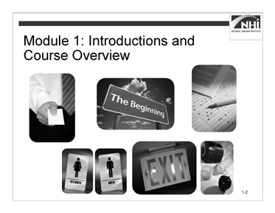

Slide 1-2

(Allow 45 minutes [10 minutes instruction, 35 minutes interactivity])

*Display slide 1-2.*

### Key Message

Welcome to *Principles and Applications of Highway Construction Specifications*. It is important that we begin promptly so that we can cover all of the materials over the next two days.

### Instruction

*Animate the slide.*

Invite the agency (or designee) to offer brief welcoming remarks.

Introduce yourself by stating your name, your title, your company, and your experience with writing highway construction specifications. State briefly why you are excited to be presenting this course.

*Animate the slide.*

Explain how to complete the necessary forms. Point out the course title, course number, session number, and the instructor name and number posted at the front of the room.

Note that the scannable forms must be properly completed or the NHI database will be inaccurate. Collect the registration forms by the end of the second day of class.

Review the rules for attendance (100% attendance required), sign-in sheets, breaks, IACET credits, final exam requirement (participants must pass with a 70% or better), course evaluation, and instructor evaluation. Pass around the sign-in sheet.

### Instruction (continued)

*Animate the slide.*

Review the housekeeping details such as location of restrooms, emergency exits, and possible locations for lunch.

Discuss the ground rules of the course. Ground rules include restricted use of cell phones, respect for others, participation from everyone, adherence to time allotment for breaks, and similar details.

Explain how you prefer to manage the classroom experience. For example, should participants ask questions at any time? Should participants raise their hands or simply call out a question?

Point out the parking lot flip chart. Explain that the parking lot is a place for unresolved ideas or questions to which you will return before class ends or on which you would follow up after class if necessary.

*Animate the slide.*

Explain the basic outline of the course and the use of course materials.

Explain the contents of the participant workbook, including the slides and appendices.

Explain the general-to-specific presentation order of the modules and lessons within the modules.

*Advance to the next slide.*

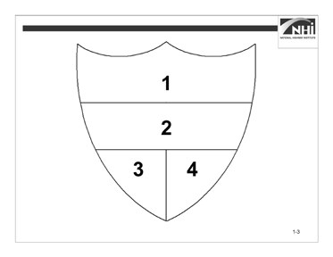

Slide 1-3

### Interactivity

(15 minutes activity, 20 minutes debrief)

*Note to instructor:* This is a small group activity. It is designed to introduce the participants to one another and to the course topic of writing specifications. Form small groups using your preferred method or based on where the participants are already seated.

Instruct participants to:

* Form small groups of no more than five.
* Select a spokesperson for the group.
* Introduce yourselves to each other.
* Move to one of the identified work areas around the room.
* Re-create the shield diagram (as large as possible) on a sheet of flip chart paper.
* Discuss the four items, achieve consensus, and record your responses in the corresponding panels (positions) on the shield as shown on the slide.
* Post the shield so that everyone in the room can view it.
* Complete this task in 15 minutes.

### Interactivity (continued) Shield Panels (positions)

1. Identify one critical skill in specification writing that all members of your team want to improve.

(Possible answers: Writing, grammar, knowledge of active voice, and others.)

1. Identify a common household chore and write a brief (must fit legibly within the space provided) portion of a specification for that chore.

(Potential answers: Brush teeth, take out trash, set the table.)

1. Draw a symbol or illustration of the greatest challenge faced in writing a specification.

(Potential answers: Working with someone else, accuracy, not enough time.)

1. Record the names and respective years of experience with specifications (either following specifications or writing specifications) for each member of the small group. Total and post the collective years of experience for the entire small group.

*When ready to debrief the activity, ask the following questions.*

*Note to instructor:* For panel two, ask each of the spokespersons to read the small group’s mini-specification. Guide the discussion toward constructive critiques, being sure to build enthusiasm for developing clear, effective specifications.

For panel five, ask each member of each group to introduce him- or herself and to present his or her individual years of experience. The spokesperson should also relate the aggregate number of years’ experience for the small group.

**Ask:** Who would like to share their shield by explaining each panel in the order 1, 2, 3, 4?

**Ask:** When you were listening to each group’s specification, what were you listening for? What was clear? What could be improved?

Thank each group for participating.

*Advance to the next slide.*

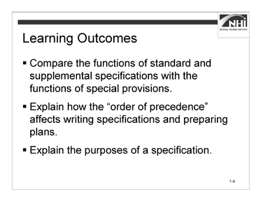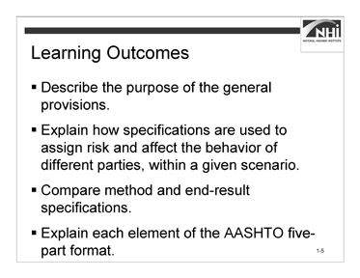

Slide 1-4 Slide 1-5

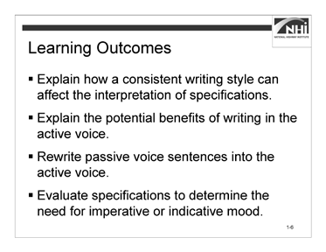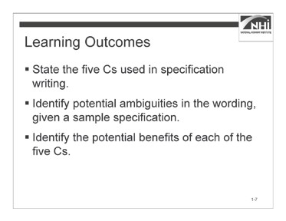

Slide 1-6 Slide 1-7

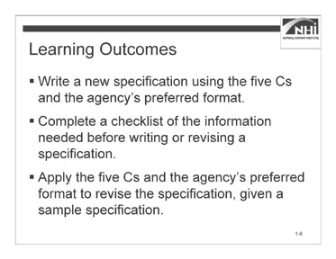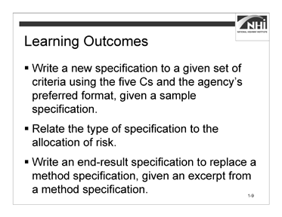

Slide 1-8 Slide 1-9

(Allow 5 minutes)

*Note to instructor:* As appropriate, relate the learning outcomes to the constructive critiques of the small groups’ mini-specifications.

### Key Message

Many factors affect how highway construction specifications are written and interpreted. By the end of this course, participants will be able to recognize and apply the principles of writing complete, correct, clear, concise, and consistent highway construction specifications.

### Instruction

Review the learning outcomes on the slides.

*Display slides 1-5 – 1-9 as you review the learning outcomes.*

# Module 2: Purpose of Specifications

## Lesson 2.1: Specifications as a Contract Document

### Lesson Plan

#### Learning Outcomes

This lesson supports these learning outcomes.

* Compare the functions of standard and supplemental specifications with the functions of special provisions.
* Explain how the “order of precedence” affects writing specifications and preparing plans.
* Explain the purposes of a specification.
* Describe the purpose of the general provisions.
* Explain how specifications are used to assign risk and affect the behavior of different parties, within a given scenario.

#### Instructional Methodology

This lesson includes the methods of brief instruction, group discussion, individual activity, and small group activity.

#### Time Allocation

121 minutes plus 15-minute break

#### Evaluation Plan

Participant learning is evaluated throughout the lesson by instructor-based questioning and assessment, discussion, activity-oriented engagement, and contributions. A final exam at the end of the course completes the evaluation.

#### Resources

* Flip chart paper and markers
* Agency’s specification manual(s)
* American Association of State Highway and Transportation Officials. *Guide Specifications for Highway Construction*. Ninth Edition, 2008.

Transportation Research Board of the National Academies. *Transportation Research Circular E-C173: Glossary of Transportation Construction Quality Assurance Terms*. Sixth Edition, 2013.

* United States Department of Transportation, Federal Highway Administration. *Development and Review of Specifications*. Technical Advisory, OPI – HIAM-20. Washington, DC, March 24, 2010.
* United States Department of Transportation, Federal Highway Administration, National Highway Institute. Transportation Construction Quality Assurance Course 134064A. Publication No. 08-067.
* United States Department of Transportation, Federal Highway Administration.

*Transportation Construction Quality Assurance Reference Manual*, 2012.

* United States National Archives and Records Administration. *Code of Federal Regulations*. 23 CFR 637: Construction Inspection and Approval, 2011.

#### Pre-Session Planning

Review Appendix O: Instructor’s Course Customization Checklist for details specific to this lesson.

Prior to class, download all online resources to your laptop. Some facilities do not provide Internet access or the Internet may not be available.

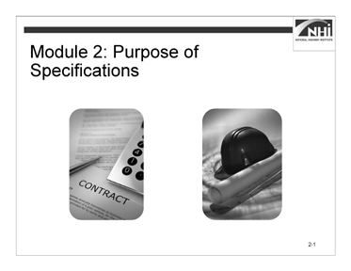

(Allow 1 minute)

Slide 2-1

### Key Message

*Display slide 2-1.*

Module 2 addresses the purpose of specifications through the following sections:

* Definitions of important terms
* Establishment of specifications as part of an agency’s contract
* Order of precedence of the many documents that make up the contract
* Purpose of specifications
* Content of specifications
* Types of specifications
* Format of specifications

### Instruction

N/A

### Interactivity

N/A

*Advance to the next slide.*

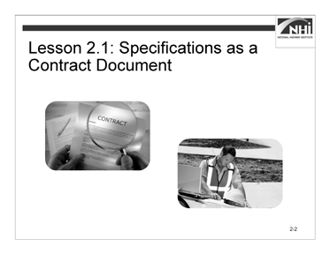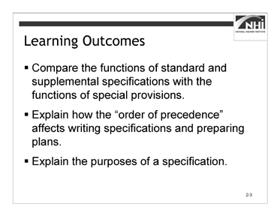

Slide 2-2 Slide 2-3

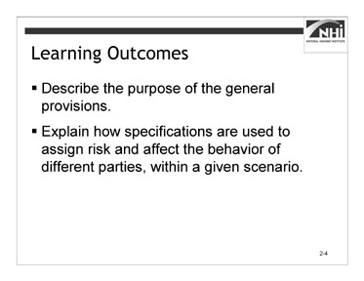

(Allow 1 minute)

Slide 2-4

### Key Message

Lesson 2.1 addresses the purposes of specifications.

### Instruction

*Display slides 2-3 and 2-4.*

Review the learning outcomes on the slides.

### Interactivity

N/A

*Advance to the next slide.*

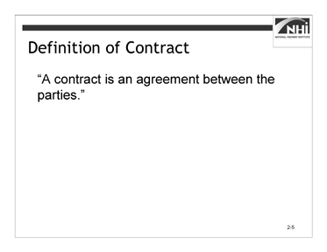

(Allow 30 minutes)

Slide 2-5

*Note to instructor:* The participants have been encouraged to bring their agency’s standard specifications. In case participants do not bring their specifications or the Internet is unavailable, develop an alternate way to present this information

The interactivity has three parts – a group discussion and two small group activities.

### Key Message

The foundation of highway construction is the contract. Specifications are a part of the contract.

### Instruction

The contract defines specifications and other related terms. It is important for specification writers to understand these definitions.

### Interactivity Part 1

(5 minutes activity, 5 minutes debrief)

*Note to instructor:* This is a group discussion. The purpose of this activity is to define the terms “contract” and “specification,” identify the parts of the contract, and establish specifications as one of those parts.

**Ask:** What is the basic definition of a contract?

*Animate the slide. (Note: the slide is not displayed in participant workbook to avoid showing the answer before participants discuss.)*

(Answer: A contract is an agreement between the parties.)

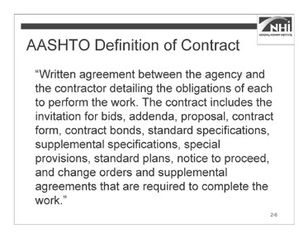

### Interactivity Part 1 (continued)

Slide 2-6

Discuss AASHTO definition and compare to the simpler definition on previous slide.

“Written agreement between the agency and the contractor detailing the obligations of each to perform the work. The contract includes the invitation for bids, addenda, proposal, contract form, contract bonds, standard specifications, supplemental specifications, special provisions, standard plans, notice to proceed, and change orders and supplemental agreements that are required to complete the work.”

AASHTO is the American Association of State Highway and Transportation Officials. AASHTO produces a document titled the *Guide Specifications for Highway Construction* as guidance for the development of highway contract specifications.

The *Guide Specifications for Highway Construction* is referenced throughout this course. The references are provided as examples, not the standard to be used.)

*Advance to the next slide.*

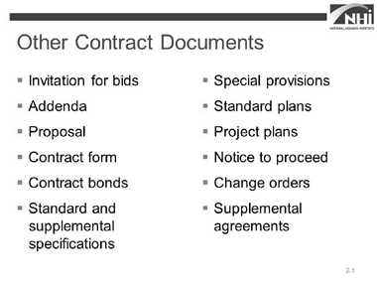

### Interactivity Part 1 (continued)

Slide 2-7

Direct participants to their agency’s standard specifications.

**Ask:** What documents are considered part of your agency’s contract?

*As participants answer, write their responses on the flip chart.*

*Display slide 2-7. (Note that the slide does not appear in participant workbook to avoid displaying answers before participants discuss.)*

(Answer: Answers will vary by agency, but may include the following:

* Invitation for bids
* Addenda
* Proposal
* Contract form
* Contract bonds
* Standard specifications
* Supplemental specifications
* Special provisions
* Standard plans
* Project plans
* Notice to proceed
* Change orders
* Supplemental agreements)

In some agencies, the names of the documents included in the contract are different from the ASSHTO list. Additionally, some agencies may or may not include each of the documents included by ASSHTO as part of their contract. They may also include other documents not listed. *Advance to the next slide.*

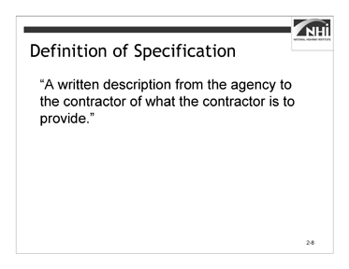

### Interactivity Part 1 (continued)

Slide 2-8

**Ask:** What is a typical definition of specification?

*Animate the slide. (Note that the slide does not appear in participant workbook to avoid displaying answers before participants discuss.)*

(Answer: “A written description from the agency to the contractor of what the contractor is to provide.”)

Direct participants to their agency’s standard specifications.

**Ask:** What is your agency’s definition of specification? (Answer: Answers will vary by agency.)

*Advance to the next slide.*

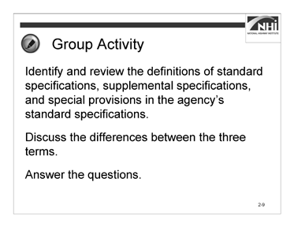

Slide 2-9

### Interactivity Part 2

(5 minutes activity, 5 minutes debrief)

*Note to instructor:* This is a small group activity. The purpose of this activity is for participants to define and develop an understanding of the differences between standard specifications, supplemental specifications, and special provisions.

Instruct participants to:

* Work in a small group.
* Identify and review the definitions of standard specifications, supplemental specifications, and special provisions in the agency’s standard specifications.
* Discuss the differences between the three terms.
* Answer the questions.
* Complete this task in 5 minutes.

*When ready to debrief the activity, advance to the next slide.*

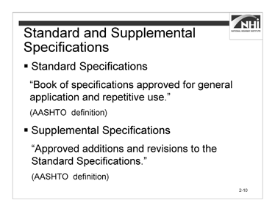

### Interactivity Part 2 (continued)

Slide 2-10

**Ask:** What is the definition of standard specifications?

*Animate the slide.*

(Answer: Answers will vary by agency. The AASHTO definition of standard specifications is shown as an example, not as a standard.

“Book of specifications approved for general application and repetitive use.”)

Note that Slides 2-10 and 2-11 are not in the PW because they contain the answers. Remind participants to record the answers to the questions in their PW wherever slides or answers are not provided.

**Ask:** What is the definition of supplemental specifications?

*Animate the slide.*

(Answer: Answers will vary by agency. The AASHTO definition of supplemental specifications is shown as an example, not as a standard.

“Approved additions and revisions to the Standard Specifications.”)

**Ask:** What is the difference between standard specifications and supplemental specifications?

(Answer: The supplemental specifications contain revisions to the standard specifications. When the standard specifications are revised and updated, the supplemental specifications are usually incorporated as standard specifications.)

*Advance to the next slide.*

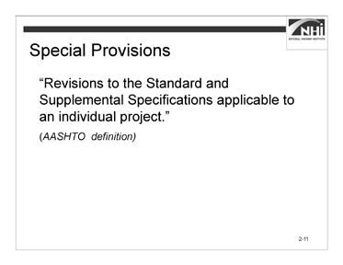

### Interactivity Part 2 (continued)

Slide 2-11

**Ask:** What is the definition of special provisions?

*Animate the slide.*

(Answer: Answers will vary by agency. The AASHTO definition of special provisions is shown as an example, not as a standard.

“Revisions to the Standard and Supplemental Specifications applicable to an individual project.”)

**Ask:** What is the difference between special provisions and standard and supplemental specifications?

(Answer: Special provisions apply to particular agency projects. Standard and supplemental specifications apply to all agency projects.)

*Advance to the next slide.*

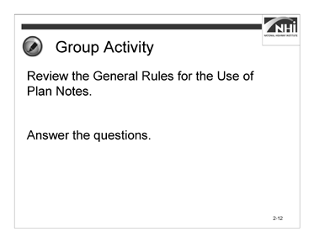

Slide 2-12

### Interactivity Part 3

(5 minutes activity, 5 minutes debrief)

*Note to instructor:* This is a small group activity. The purpose of the activity is to clarify when it is appropriate to use plan notes.

This topic has the potential to bring up disagreements. Consider using the parking lot if necessary.

Instruct participants to:

* Work in a small group.
* Review the General Rules for the Use of Plan Notes.
* Answer the questions.
* Complete this task in 5 minutes.

### Interactivity Part 3 (continued)

#### General Rules for the Use of Plan Notes

(Excerpted from the FHWA Technical Advisory)

* Do not include information in both the specifications and the plans.
* Use plan notes when necessary to communicate and clarify information on the plans where the information cannot be highlighted advantageously in a specification.
* If the instructions apply to only one particular item, plan notes may be appropriate.
* Permitting agencies may also require the inclusion of certain notes on the plans.
* Plan notes should not function as a specification, so they should not be used to revise the specifications. Revisions to the specifications should instead be handled through a supplemental specification or a special provision.
* Because plan notes are a way to circumvent the specification review and approval process, their overuse can have serious consequences.

**Ask:** Does your agency have a policy governing the use of plan notes? (Answer: Answers will vary by agency.)

**Ask:** Can you describe that policy? (Answer: Answers will vary by agency.)

**Ask:** How does your agency policy compare and contrast with the general rules? (Answer: Answers will vary by agency.)

Even though plan notes are in the plans and should not be used instead of specifications, when a plan note is appropriate, it should be written with the same care and using the same principles to be addressed in Module 3.

*Advance to the next slide.*

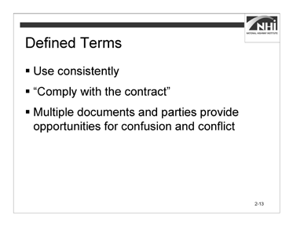

(Allow 2 minutes)

Slide 2-13

### Key Message

There are significant benefits to using defined terms and using them consistently.

### Instruction

Defined terms need to be used consistently. Understanding the contents of and definitions within the contract documents is necessary to writing specifications that are properly coordinated with the other contract documents. This consistent approach will help guide a specification user to the information he or she seeks.

Using defined terms can also allow specifications to be written more efficiently and concisely. For example, if the plans and specifications are both defined as being part of the contract, then it is no longer necessary to require the contractor to “comply with the requirements of the plans and specifications.” Instead, fewer words can be used by simply saying that the contractor is required to “comply with the contract.”

With the many contract documents that the agency must coordinate during the planning and design phases and that the contractor must navigate during the bidding and construction phases, there are many opportunities for confusion and potential conflict. The contract is written to address this potential for conflict.

### Interactivity

N/A

*Advance to the next slide.*



Slide 2-14

(Allow 10 minutes [5 minutes instruction, 5 minutes interactivity])

### Key Message

An order of precedence clause is one mechanism to ensure that conflicts between the various contract documents do not compromise the quality of the project. This clause is often found in the “Control of Work” section of the General Provisions.

### Instruction

There are many opportunities for confusion and potential conflict within the contract documents that the agency uses during the planning and design phases and the contractor navigates during the bidding and construction phases.

If not addressed, the potential conflicts can lead to disputes and claims; therefore, it is important to address these potential conflicts in the contract documents.

A tool that is used in the contract to address potential conflicts is an order of precedence clause. The order of precedence clause establishes a hierarchy of authority for the documents in the contract.

In general, the order of the precedence clause establishes a hierarchy of documents using the following guidelines:

* Project-specific information usually governs or takes precedence over the more generic information.
* Written specifications govern over drawings.

### Instruction (continued)

For example, if a requirement in the standard specifications conflicts with a requirement in the plans, the requirement in the plans would take precedence over the standard specifications because the plans are more specific to the project. However, standard specifications would take precedence over standard plans because written specifications typically govern over drawings.

*Advance to the next slide.*

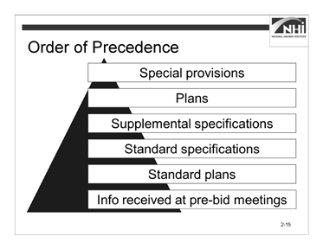

### Instruction (continued)

Slide 2-15

The hierarchy of documents in the order of precedence clause in the AASHTO Guide Specifications is as follows:

* Information received at the pre-bid meetings is at the bottom of the pyramid because all other items in the contract documents take precedence over it.
* The standard plans govern over the information received at the pre-bid meetings but not over the other contract documents.
* The standard specifications take precedence over the standard plans.
* The supplemental specifications prevail over the standard specifications.
* The plans outweigh the supplemental specifications.
* The special provisions govern over all the other contract documents.

### Interactivity

(5 minutes activity)

*Note to instructor:* This is an individual activity. The purpose of the activity is to provide an opportunity for participants to locate and identify the order of precedence clause in the agency’s standard specifications.

Refer to the Instructor’s Course Customization Checklist for the number and title of the section that contains the agency’s order of precedence clause.

**Ask:** Does anyone know where the agency’s order of precedence clause is located in the agency’s standard specifications?

(Answer: Answers will vary by agency.)

### Interactivity (continued)

Instruct participants to:

* Review the agency’s order of precedence clause.
* Complete the blank order of precedence pyramid.
* Complete this task in 3 minutes



**Ask:** What is your order of precedence? (Answer: Answers will vary by agency.)

*Advance to the next slide.*

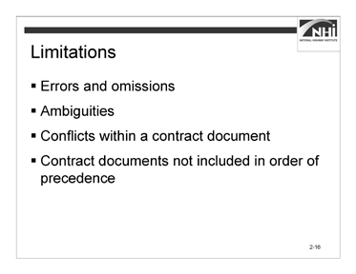

(Allow 8 minutes)

Slide 2-16

### Key Message

The order of precedence clause has its limitations.

### Instruction N/A Interactivity

*Note to Instructor:* This is a group discussion. The purpose of this activity is to discuss the several problems the order of precedence clause may not resolve.

*Animate the slide.*

* Errors and omissions

**Ask:** If the wrong special provision or detail sheet is included in the contract, will the order of precedence clause address this problem?

(Answer: Typically, no, because the order of precedence clause only addresses the situation where parts of the contract are in conflict, not the situation where the wrong provision was included.)

**Ask:** What if a plan sheet or special provision is missing from the contract?

(Answer: The order of precedence clause does not address situations where information is missing, only situations where different parts of the contract are in conflict.)

### Instruction (continued)

*Animate the slide.*

* Ambiguities

**Ask:** Does the order of precedence clause address ambiguities?

(Answer: Typically, no, because ambiguities exist when contract requirements have more than one reasonable interpretation, not situations where parts of the contract are in conflict. If the contractor’s or the agency’s interpretation is in conflict with another part of the contract, then that interpretation is not reasonable and no ambiguity actually exists. Contracts must be read as a whole. Ultimately, if the agency directs the contractor to perform the work according to the agency’s interpretation and the contractor can prove that his or her own interpretation was reasonable and reflected in the unit prices, the contractor would have a good case for a contract revision.)

*Animate the slide.*

* Conflicts within a contract document

**Ask:** Does the order of precedence clause address conflicts within a particular document (for example, within a special provision)?

(Answer: Typically, no. The order of precedence clause does not address conflicts within a provision, only between provisions or parts of the contract. There are several examples of possible conflicts within a contract document, including:

* Conflict between a material and a construction section
* Conflict between two plan sheets
* Conflict between the general provisions and technical provisions)

### Instruction (continued)

*Animate the slide.*

* Contract documents not included in the order of precedence

**Ask:** If a document is not listed (for example, if the contract form, addenda, contract bonds, or change orders are not listed), does the order of precedence clause address conflicts with these documents?

(Answer: Typically, if the document is not listed, the order of precedence clause does not address conflicts between the unlisted document and other documents, whether these other documents are listed or unlisted. Sometimes, limited direction can be provided by the general rules of contract interpretation. For example, there is a common rule that says that the specific will take precedence over the general.

Also, the order of precedence itself may provide some direction. For example, with regard to plans, the order of precedence may say that written dimensions take precedence over scaled dimensions in a set of plans.)

### Interactivity

N/A

*Advance to the next slide.*

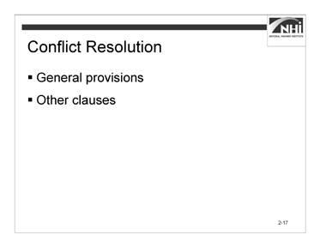

(Allow 3 minutes)

Slide 2-17

### Key Message

It is important to know the location of the clause, its purpose, and its application. Knowing where the clause exists and how to use it prevents the disputes and claims that it is designed to avoid. However, this clause should not be overused or used as a crutch.

### Instruction

N/A

### Interactivity

(3 minutes activity)

*Note to instructor:* This is a group discussion. The purpose of this activity is to consider methods for resolving conflicts with the specifications.

**Ask:** What mechanism do we have to rely on when a problem with the specifications cannot be resolved by the order of precedence clause?

*Animate the slide.*

(Answer: The general provisions provide procedures for addressing disputes and claims. In the case of differences of opinion about the order or precedence, use these procedures to resolve the conflict.

When a conflict cannot be resolved by the order of precedence clause, then the agency may look to other clauses in the contract. For example, some contracts contain a provision that requires the contractor to proceed with the more expensive option when a conflict exists. While such a provision is not recommended, it is an example of another way to deal with a conflict. Absent such language, conflicts are typically dealt with according to the rules of contract interpretation based on applicable legal precedent. For most agencies, the conflict will be resolved by change order, contract modification, or supplemental agreement.)

*Advance to the next slide.*

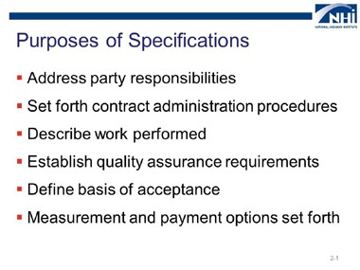

Slide 2-18

(Allow 3 minutes)

### Key Message

Specifications have five basic purposes.

### Instruction

N/A

### Interactivity

(3 minutes activity)

*Note to instructor:* This is a group discussion. The purpose of this activity is to consider the purposes of specifications.

**Ask:** What are the purposes of specifications?

*As participants answer, write their responses on the flip chart. When ready to debrief the activity, animate the slide.*

(Answer: The purposes of specifications are to:

* Address party responsibilities.
* Set forth contract administration procedures.
* Describe the work performed.
* Establish quality assurance requirements.
* Define the basis of acceptance.
* Measurement and payment options set forth.)

*Advance to the next slide.*

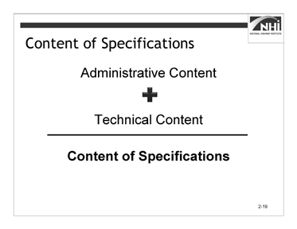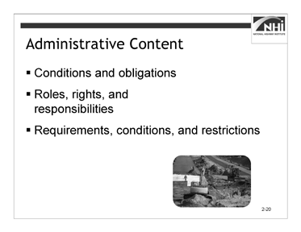

Slide 2-19 Slide 2-20

(Allow 4 minutes [2 minutes instruction, 2 minutes interactivity])

### Key Message

Specifications are composed of two kinds of content – administrative and technical.

### Instruction

*Display slide 2-20.*

Administrative content includes the following:

* The conditions and obligations that control the behaviors of the parties to the contract.
* The roles, rights, and responsibilities of the parties to the contract.
* The administrative requirements, conditions, and restrictions that affect how the work is performed and the contract is administered.

*Advance to the next slide.*

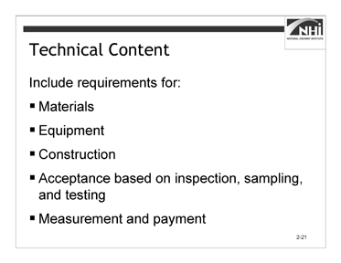

### Instruction (continued)

Slide 2-21

Technical content focuses on the technical elements of the work and defines the quality of the end product. That includes requirements for the following:

* Materials
* Equipment
* Construction
* Acceptance based on inspection, sampling, and testing
* Measurement and payment

### Interactivity

(2 minutes activity)

*Note to instructor:* This is a group discussion. The purpose of this activity is to establish examples of administrative and technical content.

**Ask:** What are examples of administrative content in the agency’s standard specifications?

(Answer: Participant answers will vary. Some examples are notification requirements, submittal requirements, and insurance requirements.)

**Ask:** What are examples of technical content in the agency’s standard specifications?

(Answer: Participant answers will vary. Some examples are concrete mix design parameters, construction requirements for milling pavement, and material requirements.)

*Advance to the next slide.*

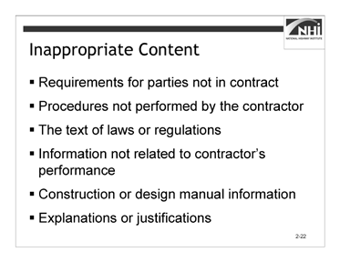

Slide 2-22

(Allow 5 minutes [2 minutes instruction, 3 minutes interactivity])

### Key Message

While administrative and technical content belong in specifications, other content is not appropriate for inclusion in a specification.

### Instruction

Content that should not be in a specification includes:

* Requirements applicable to parties that are not part of the contract.
* Testing, sampling, and inspection procedures not being performed by the contractor.
* The text of laws or regulations (unless the law or regulation requires that the text be included in the contract).
* Information that that does not relate to the contractor’s performance of the work.
* Information that should be included in a construction or design manual.
* Explanations or justifications of requirements.

*Advance to the next slide.*

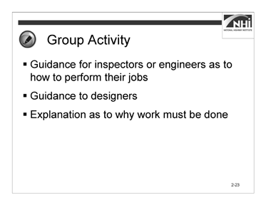

Slide 2-23

### Interactivity

(3 minutes activity)

*Note to instructor:* This is a group discussion. The purpose of this activity is to reinforce participants’ understanding of content that should not be included in a specification.

**Ask:** Does this content belong in a specification?

*Animate the slide.*

Guidance for inspectors or engineers as to how to perform their jobs (Answer: No.)

*Animate the slide.*

Guidance to designers (Answer: No.)

*Animate the slide.*

Explanation as to why work must be done (Answer: No.)

*Advance to the next slide.*

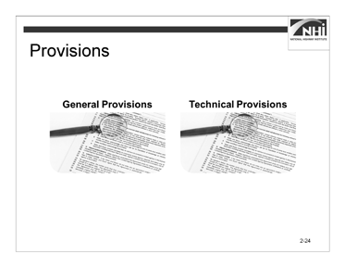

Slide 2-24

(Allow 5 minutes [2 minutes instruction, 3 minutes interactivity])

### Key Message

The general provisions consist primarily of administrative content. The technical provisions generally contain technical content.

General provisions reduce the need for repetition in the technical provisions.

### Instruction

The general provisions are typically found in Section 100. (Section 100 might also be known as Section 1, Division 1, Division 100, or Part 1.) The technical provisions are generally found in Sections 200 to 800. Agencies may use numbering systems different from the numbering systems presented here.

The general provisions are like umbrella provisions in that they apply to every type of work (each contract item). There is no need to refer to or repeat the requirements covered by the general provisions in the technical provisions, unless a general provision is being modified by a technical provision for use in a unique situation.

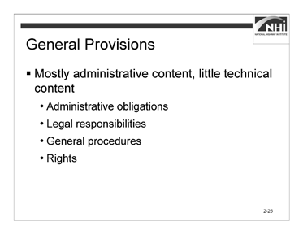

Slide 2-25

### Interactivity

(3 minutes activity)

*Note to instructor:* This is a group discussion. The purpose of this activity is for participants to identify examples of general provisions and technical provisions.

Create a flip chart with two columns, “general provisions” and “technical provisions.” As participants share answers, write them on the flip chart.

**Ask:** What types of provisions exist in the general and in the technical provisions?

*Display slide 2-25.*

(Answer: General provisions contain mostly administrative content and little technical content. General provisions contain content such as:

* Administrative obligations
* Legal responsibilities
* General procedures
* Rights)

*Advance to the next slide.*

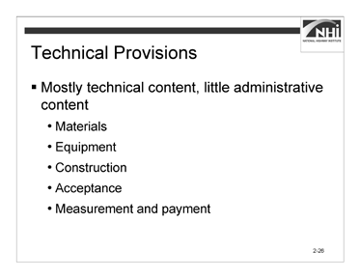

### Interactivity (continued)

Slide 2-26

(Answer: Technical provisions contain mostly technical content and little administrative content. Technical provisions contain content such as:

* Materials
* Equipment
* Construction
* Acceptance
* Measurement and payment)

*Advance to the next slide.*

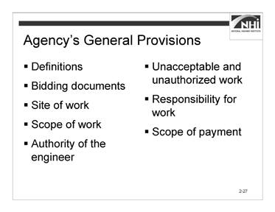

(Allow 14 minutes)

Slide 2-27

### Key Message

The agency’s general provisions typically provide seventy to one hundred pages of requirements; however, the following are particularly important to the writing of specifications:

* Details on definitions
* Bidding documents
* Site of work
* Scope of work
* Authority of the engineer
* Unacceptable and unauthorized work
* Responsibility for the work
* Scope of payment

*Advance to the next slide.*

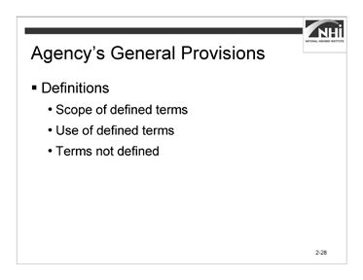

Slide 2-28

### Instruction

*Note to instructor:* Ensure you have reviewed and tabbed the agency’s general provisions sections.

Direct participants to locate the general provisions section of their agency’s specifications. Participants should take notes as needed.

* Definitions
* **Scope of defined terms.** These definitions affect how the terms are used not only in the standard specifications but also in all of the contract documents.
* **Use of defined terms.** It is important and contractually significant to consistently use and interpret defined terms. If these terms are not used consistently, then the value of the defined term itself is diminished. It can also result in the creation of conflicts and ambiguities.
* **Terms not defined.** For words not defined in this section, the commonly used definition applies. Defined terms that are specific to an item of work may be defined in their respective material or construction section.

*Advance to the next slide.*

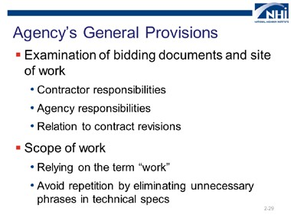

### Instruction (continued)

Slide 2-29

* Examination of the bidding documents and site of work
* **Contractor responsibilities.** This provision allocates risk by specifying the assumed completeness of the contractor’s knowledge of the bidding documents and the site of work.
* **Agency responsibilities.** This provision obligates the agency to provide bidding documents for a project that is buildable as represented. The accuracy of the bidding document and the contract equates to the agency’s responsibility for additional costs that result if the contract documents, when followed by the contractor, do not yield the intended product. This is referred to as the Spearin Doctrine.
* **Relation to contract revisions.** This provision addresses the contract parties’ knowledge of their respective obligations as represented in the bidding documents. It is one of the considerations when evaluating the need for a contract revision on the project.

Direct participants to Appendix A: Spearin Doctrine Explanation to review a brief explanation.

### Instruction (continued)

*Animate the slide.*

* Scope of work
* **Relying on the term “work**.” The term “work” is often defined as “all work.” The common agency definition of work includes everything associated with completing the task. Using the term “work” means that technical specifications do not have to state, for example, that the contractor must provide materials or mobilize equipment. These requirements are covered by using the term “work.”
* **Avoid repetition by eliminating unnecessary phrases in technical specs.** This section tells the contractor to perform the work in accordance with the contract. It is unnecessary to state elsewhere in the specifications that work must be performed “in accordance with the contract” because this section states, “All work must be performed in accordance with the contract.”

*Advance to the next slide.*

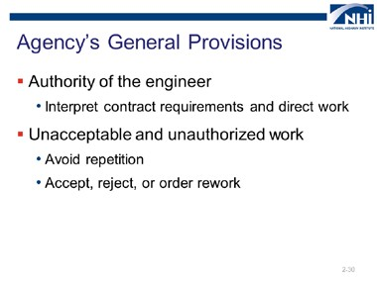

Slide 2-30

### Instruction (continued)

* Authority of the engineer
* **Interpret the contract documents and direct work**. The engineer has authority to interpret the contract documents and make acceptance decisions via this section. It is not necessary to repeat elsewhere in the specifications that work is to be performed “as directed by the engineer” or other similar statements because this authority is stated in the general provisions. Remembering this will help eliminate repetition in technical specifications.

*Animate the slide.*

* Unacceptable and unauthorized work
* **Avoid repetition.** Based on this section, it is not necessary to repeat that the agency will not pay for unacceptable (or “rejected”) or unauthorized work in the specific technical sections.
* **Accept, reject, or order rework.** The technical section only needs to state how the specific work will be identified as unacceptable or unauthorized and how the contractor is to correct or remove and replace that work.

*Advance to the next slide.*

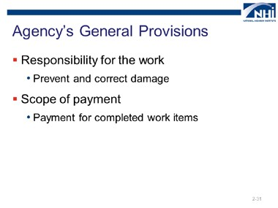

Slide 2-31

### Instruction (continued)

* Responsibility for the work
* **Prevent and correct damage.** This provision requires the contractor to prevent and correct any damage to the work prior to final acceptance by the agency. Avoid repetition by not repeating similar obligations in the technical provisions. Technical specifications that modify this requirement for “interim completion” or “opening to public traffic” can be used effectively.

*Animate the slide.*

* Scope of payment
* **Payment for completed work items.** It is unnecessary to repeat that the payment for each contract item at the unit price is full compensation for all costs necessary to perform the work represented by the contract item. This is covered in the scope of payment provision of the general provisions.

### Interactivity

N/A

*Advance to the next slide.*

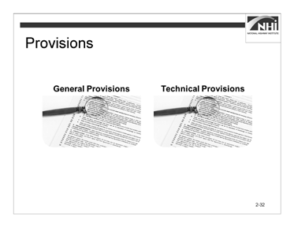

Slide 2-32

(Allow 10 minutes [2 minutes instruction, 8 minutes interactivity])

### Key Message

The general provisions are necessary to properly write technical provisions. The general provisions set the broad framework within which the technical provisions are interpreted.

### Instruction

What is stated in the general provisions does not need to be repeated in the technical provisions, because what is established in the general provisions applies to all technical provisions.

If a general provision requirement is repeated or improperly applied in the language of a technical provision, a number of problems may occur.

* Repetition may set a precedent that these general provisions need to be repeated in a technical provision for it to apply to that provision.
* Repetition provides an opportunity for the general provisions to be applied improperly; that is, the general provision is now in two locations and has to be maintained in two locations.

When preparing to write technical provisions, specification writers should review the general provisions carefully and use this knowledge to avoid repetition.

*Advance to the next slide.*

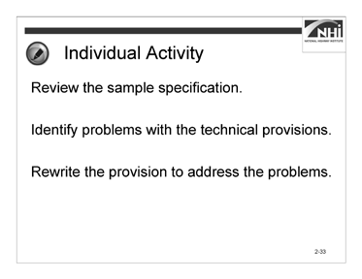

Slide 2-33

### Interactivity

(4 minutes activity, 4 minutes debrief)

*Note to instructor:* This is an individual activity. It provides an opportunity for the participants to review and rewrite the sample specifications.

Instruct participants to:

* Review the sample specification and identify problems with the technical provisions.
* Rewrite the provision to address the problems.
* Complete this task in 4 minutes.

*When ready to debrief the activity, advance to the next slide.*

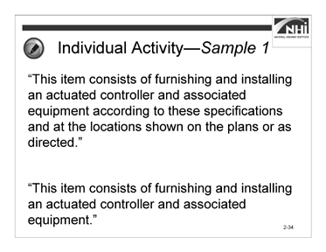

### Interactivity (continued)

Slide 2-34

#### Sample 1

“This item consists of furnishing and installing an actuated controller and associated equipment according to these specifications and at the locations shown on the plans or as directed.”

**Ask:** What problems did you identify and how did you rewrite the specification?

*Animate the slide.*

(Answer: There is no need to repeat the phrase “according to these specifications and at the locations shown on the plans or as directed.” The general provisions establish that all work is performed in accordance with the contract documents and as directed by the engineer.

“This item consists of furnishing and installing an actuated controller and associated equipment.”)

*Advance to the next slide.*

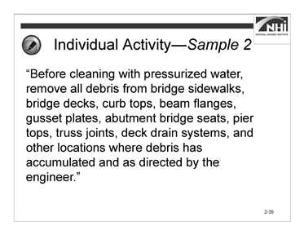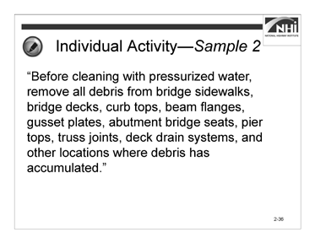

Slide 2-35 Slide 2-36

### Interactivity (continued)

#### Sample 2

“Before cleaning with pressurized water, remove all debris from bridge sidewalks, bridge decks, curb tops, beam flanges, gusset plates, abutment bridge seats, pier tops, truss joints, deck drain systems, and other locations where debris has accumulated and as directed by the engineer.”

**Ask:** What problems did you identify and how did you rewrite the specification?

*Display slide 2-36.*

(Answer: If possible, the phrase “as directed by the engineer” should be removed.

“Before cleaning with pressurized water, remove all debris from bridge sidewalks, bridge decks, curb tops, beam flanges, gusset plates, abutment bridge seats, pier tops, truss joints, deck drain systems, and other locations where debris has accumulated.”)

### Interactivity (continued)

**Ask:** Will the agency always be able to remove the phrase “as directed by the engineer”?

(Answer: No.)

**Ask:** If the phrase cannot be removed, then how does the contractor know at the time of generating his or her bid what the engineer’s direction is going to be with regard to the removal of the debris?

If the contractor does not know what the engineer will require, then how does the contractor factor the engineer’s requirements into its bid?

(Answer: The contractor will have to base the bid on experience or place an appropriate contingency in the bid. When evaluating the use of the phrase “as directed by the engineer,” the contractor’s challenge is often made more daunting by a common clause in agency contracts. This clause is often found in Section 102.05 and is often labeled, “Examination of Site of Work and proposal.”

An example of how the first paragraph of this clause has been written is:

“The submission of a bid will be considered conclusive evidence that the bidder has examined the site of the proposed work, the bid proposal and other documents referenced therein, and the plans before submitting a bid and is satisfied as to the conditions to be encountered in performing the work and the requirements specified in the proposal.”

This provision indicates that the contractor is satisfied as to the conditions to be encountered, even though the engineer may determine those conditions after award of the contract.)

*Advance to the next slide.*

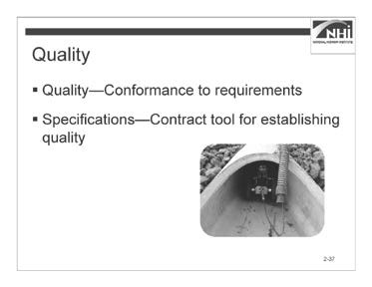

(Allow 2 minutes)

Slide 2-37

### Key Message

An important aspect of the administrative and technical content of specifications relates to quality and how it is to be assured. Quality is addressed in both the general and technical provisions of the agency’s specifications. Quality in highway construction is highly dependent on the strength and clarity of the specifications.

### Instruction

The Transportation Research Board defines quality as the degree to which a product or service:

* Is excellent
* Satisfies the needs of a specific customer
* Conforms with a given requirement

A simpler definition, presented in NHI’s Transportation Quality Assurance Course, is that quality is the “conformance to requirements.” Specifications are the contract tool used to establish the degree of conformity necessary for acceptance; therefore, specifications are the key tool for establishing quality.

Consider the systems that need to be in place to ensure that the contractor provides a project to the desired level of quality, that is, in conformance with the requirements.

*Advance to the next slide.*

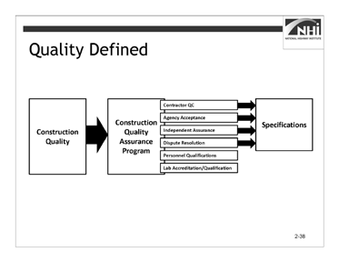

### Instruction (continued)

Slide 2-38

First, the quality of the construction is defined. Then, a quality assurance program is developed. By implementing the components of the quality assurance program, the contractor is guided toward the quality goals and it helps to ensure that the project is constructed to the defined quality.

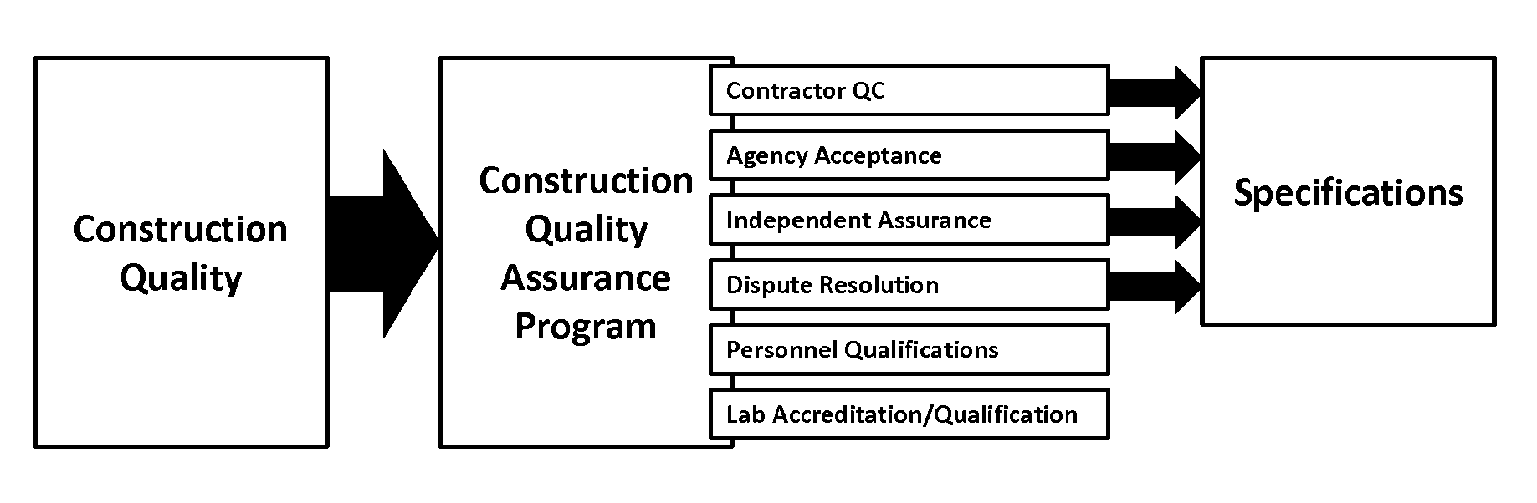

### Interactivity

N/A

*Advance to the next slide.*

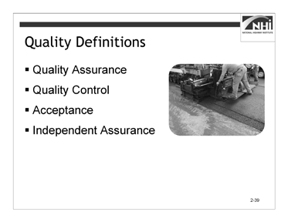

Slide 2-39

(Allow 5 minutes [2 minutes instruction, 3 minutes interactivity])

### Key Message

There are four key terms applicable to a discussion of quality.

### Instruction

**Quality Assurance.** AASHTO defines quality assurance (QA) as (1) all of those planned and systematic actions necessary to provide confidence that a product or facility will perform satisfactorily in service or (2) making sure the quality of a product is what it should be.

*Animate the slide.*

**Quality Control.** *FHWA’s Transportation Construction Quality Assurance Reference Manual* defines quality control (QC) as the system used by a contractor party to monitor, assess, and adjust their production or placement process to ensure that the final product will meet the specified level of quality.

*Animate the slide.*

**Acceptance.** NHI Course 134064A *Transportation Quality Assurance Publication No. 08-067* defines acceptance as all factors used by the agency (e.g., sampling, testing, and inspection) to evaluate the degree of compliance with contract requirements and to determine the corresponding value for a given product.

### Instruction (continued)

*Animate the slide.*

**Independent Assurance.** *23 CFR 637 Construction Inspection and Approval* defines independent assurance as activities that are an unbiased and an independent evaluation of all the sampling and testing procedures used in the acceptance program.

### Interactivity

(3 minutes activity)

*Note to instructor:* This is a group discussion. The purpose of the activity is for participants to consider the agency’s quality assurance program.

**Ask:** Does your agency have its own quality assurance program?

(Answer: Answers will vary by agency. The instructor should identify the terms and definitions used by the agency when the instructor completes the Instructor’s Course Customization Checklist.)

**Ask:** If you do, does your agency use the same terms as FHWA’s Quality Assurance program or different terms?

(Answer: Answer will vary by agency.)

**Ask:** If different from the FHWA’s terms, what terms does your agency use and how are they defined?

(Answer: Answer will vary by agency.)

Ultimately, this course is about writing specifications, not quality. NHI Course 134064A

*Transportation Quality Assurance* delivers a more complete exploration of quality. However, the risk that the specification will not yield a product of sufficient quality is an important consideration when drafting specifications. Risk is the next focus of this course.

*Advance to the next slide.*

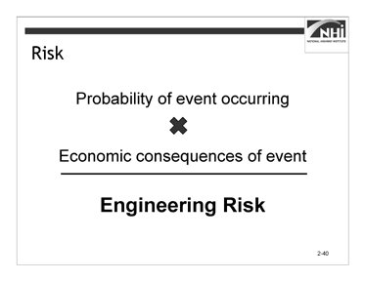

Slide 2-40

(Allow 15 minutes [3 minutes instruction, 12 minutes for interactivity])

### Key Message

Prudent risk sharing must be considered within the specifications. When writing specifications, specification writers should consider both implicit and explicit risk allocation.

### Instruction

Since the agency and the contractor are the only two parties to the contract, then all of the risks associated with the project are owned or shared by them in some way.

Specifications are the vehicle through which risks associated with the execution of the project are assigned to either the agency or the contractor.

Though risk can be explicitly assigned, it can also be implicit. For example, the risk associated with discovering a differing site condition is explicitly shifted to the agency when the agency’s contract contains a differing site conditions clause. If the contract is silent with regard to differing site conditions, however, the risk of discovery still exists, and that risk is borne by the agency or the contractor depending on the nature of the conditions that are encountered and applicable legal precedent.

Note that using the specifications to increase the contractor’s risk can result in higher costs to the agency. The contractor must address increased risk by increasing its contingency or by declining to bid on a risky project, thus reducing the field of bidders, reducing competition, and potentially resulting in higher prices for the work.

### Instruction (continued)

Being able to identify how risk is allocated in a specification requires an understanding of the following:

* What can go wrong on a project and why?
* What are the chances of something going wrong?
* What are the potential costs or other consequences of something going wrong?

**Ask:** How do you define risk?

(Answer: In general, risk is defined as the possibility of loss or injury. According to the FHWA, risk is defined as either statistical risk (the probability of suffering harm or loss) or engineering risk (a function that represents the expected cost associated with a risk event)).

**Ask:** What are some of the potential risks on a highway construction project?

(Answer: Cost overruns, damage to the work, differing site conditions, delays, natural disaster, storm water run-off violations, and worker accidents)

The perception of risk can also affect the behavior of the parties to the contract.

Specification writers should consider what behavior to encourage before beginning to write a specification.

For example, one agency was considering whether to reimburse erosion control as a lump sum. In this agency’s experience, when the agency paid for erosion control as a lump sum, as opposed to individual erosion control bid items or force account items, the contractor behaved in a more responsible manner when planning the work and kept the clearing and grubbing to a minimum; only exposing those areas being actively worked. This behavior happened especially if the contractor was also the responsible party for the environmental permit.

The agency had observed similar behavior when traffic control was paid as a lump sum. The contractor tended to apply additional effort in planning its and its subcontractors’ work based on traffic control and work zone needs to minimize their costs and take advantage of multiple work operations within the same work zone.

It is the agency’s observation that when erosion control and traffic control are performed using estimated quantities and unit prices, the contractor has no incentive to minimize the costs to the agency. Instead, the contractor may behave in a manner to maximize profit by maximizing quantities.

*Advance to the next slide.*

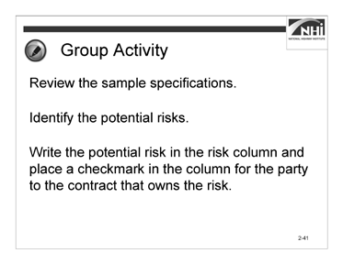

Slide 2-41

### Interactivity

(5 minutes activity, 7 minutes debrief)

*Note to instructor:* This is a small group activity. It provides an opportunity for participants to review sample scenarios to identify potential risks and the owners of these risks.

While participants are working in the small groups, draw a three-column list with the titles “Risk,” “Contractor,” and “Agency” on a white board or flip chart. Use the list to record participant answers as you debrief the activity. Allow enough room under the “Contractor” and “Agency” columns to also write how behavior is affected.

Instruct participants to:

* Work in a small group.
* Review the sample specifications.
* Identify the potential risks.
* Write the potential risk in the risk column and place a checkmark in the column for the party to the contract that owns the risk.
* Complete this task in 5 minutes.

*When ready to debrief the activity, advance to the next slide.*

### Interactivity (continued)

#### Sample 1

“Remove and dispose of residue from the grooving operations as directed by the engineer to minimize dust and to prevent debris from entering drainage systems.”

#### Sample 2

“Using methods approved by the engineer, clean dirt and debris from the pavement surface and paved shoulders before placing HMA. Remove loose material from joints and cracks using compressed air. If the engineer determines the compressed air system will not remove deleterious material, remove loose material by a hand or mechanical method, as approved by the engineer. The agency will pay for removal of material by hand or mechanical methods in accordance with subsection 501.04.E.”

#### Sample 3

“The surface areas of asphalt and concrete pavement that are to receive markings shall be cleaned with a high pressure air blast to remove loose material prior to placement of the epoxy pavement marking. Should any pavement become dirty, from tracked mud or for other reasons, as determined by the engineer, it shall be cleaned prior to the placement of the epoxy pavement marking.”

|  |  |  |  |
| --- | --- | --- | --- |
| **Sample** | **Risk**  **(There may be more than one risk for each sample.)** | **Contractor (√)** | **Agency (√)** |
| 1 |  |  |  |
| 2 |  |  |  |
| 3 |  |  |  |

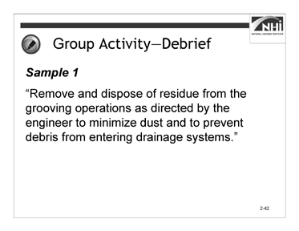

Slide 2-42

### Interactivity (continued)

#### Sample 1

**Ask:** What risks are associated with this sample?

(Answer: There are two risks associated with the sample.

* The risk of proper removal and disposal of the residue.
* The risk of violating an environmental regulation during debris disposal.)

**Ask**: Who owns the risk?

(Answer: The owner of the risk is as follows:

* The risk of proper removal and disposal of the residue is as follows: If the contractor performs this work as directed by the engineer and the work is not of the intended quality, the agency will likely bear the risk. If the contractor performs this work as directed by the engineer but a significant quantity of debris enters a drainage system, the contractor may bear the risk.
* Regarding the risk of violating an environmental regulation relating to debris disposal, the agency may bear the risk if its direction caused the violation.

The contractor may bear the risk if he or she knowingly performed the work in violation of the regulation or performed the work deficiently. The contractor is required elsewhere in the specifications to be aware of all local, State, and Federal laws and regulations and to perform the work in full compliance with those laws and regulations.)

*Advance to the next slide.*

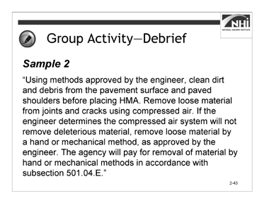

Slide 2-43

### Interactivity (continued)

#### Sample 2

**Ask:** What risks are associated with this sample?

(Answer: There are at least three risks associated with this sample.

* The risk of providing an acceptable method of cleaning and obtaining the engineer’s approval.
* The risk of whether or not the approved cleaning method cleans the surface acceptably.
* The risk of whether or not the compressed air method removes loose material from joints and cracks.)

**Ask**: Who owns the risk?

(Answer: The owner of the risk is as follows:

* The contractor bears the risk of providing an acceptable method of cleaning and obtaining the engineer’s approval.
* The contractor bears the risk of whether or not the approved cleaning method cleans the surface acceptably.
* The agency bears the risk of whether or not the compressed air method removes loose material from joints and cracks.)

*Advance to the next slide.*

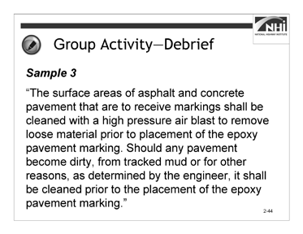

Slide 2-44

### Interactivity (continued)

#### Sample 3

**Ask:** What risks are associated with this sample?

(Answer: There are at least two risks associated with this sample.

* The risk that the specified method for removing loose material from the pavement surface will not provide the desired results.
* The risk of having to perform additional removal of mud tracked onto the cleaned and prepared pavement surface if cleaned too far in advance of the pavement marking activity.)

**Ask**: Who owns the risk?

(Answer: The owner of the risk is as follows:

* The agency bears the risk that the specified method for removing loose material from the pavement surface will not provide the desired results.
* The contractor bears the risk of having to perform additional removal of mud tracked onto the cleaned and prepared pavement surface if cleaned too far in advance of the pavement marking activity.)

*Advance to the next slide.*

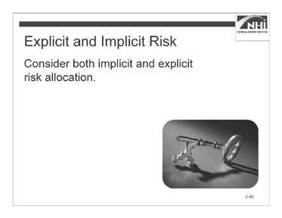

(Allow 3 minutes)

Slide 2-45

### Key Message

Both implicit and explicit risk allocation must be considered when writing specifications.

### Instruction

In order to discern the difference between implicit and explicit risk allocation, consider the samples from the previous activity.

* In Sample 1, the risk of the engineer’s direction is implicit. The engineer has the authority to give directions to the contractor; however, the agency may have to pay for those directions as changes to the scope of work or as corrective work if the direction does not produce a quality product.
* In Sample 2, the risk of the compressed air method is explicit, as the provisions define how the agency will pay for additional work if the compressed air method does not work. The risk the agency bears is explicit.
* In Sample 3, the risk of the compressed air method is implicit, since it is the specified method for removing loose material. If it does not accomplish this objective, then the direction to use another method would be a change for which the agency would be responsible. However, the risk that the surface might become dirty and need to be cleaned is explicitly assigned to the contractor. This risk is complicated by the fact that it is the engineer who determines when the pavement is sufficiently dirty to require cleaning before application of the epoxy pavement marking.

### Interactivity

N/A

## Lesson 2.2: Specification Types

### Lesson Plan

#### Learning Outcomes

This lesson supports this learning outcome.

* Compare method and end-result specifications.

#### Instructional Methodology

This lesson includes the method of brief instruction.

#### Time Allocation

6 minutes

#### Evaluation Plan

A final exam at the end of the course completes the evaluation.

#### Resources

* Flip chart paper and markers
* NHI course *Alternative Contracting* (Course Number 134058)
* Transportation Research Board of the National Academies. *Transportation Research Circular E-C173: Glossary of Transportation Construction Quality Assurance Terms*. Sixth Edition, 2013.
* United States Department of Transportation, Federal Highway Administration. *Development and Review of Specifications*. Technical Advisory, OPI – HIAM-20. Washington, DC, March 24, 2010.

#### Pre-Session Planning

N/A

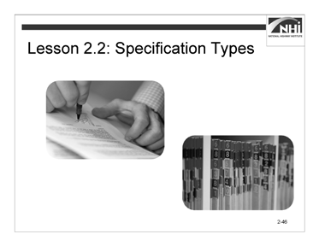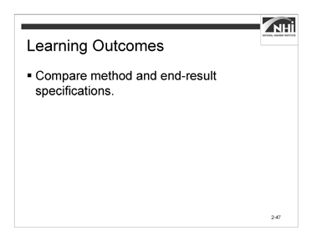

Slide 2-46 Slide 2-47

(Allow 1 minute)

### Key Message

*Display slide 2-46.*

Lesson 2.1 addressed the purpose of specifications, ending with a discussion of risk allocation. In Lesson 2.2, the discussion of risk allocation is expanded with the focus shifting from specific specification language to types of specifications

### Instruction

*Display slide 2-47.*

Review the learning outcome on the slide.

### Interactivity

N/A

*Advance to the next slide.*

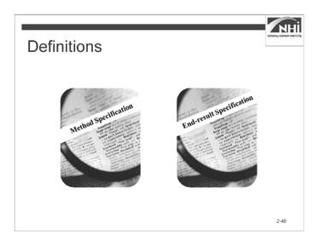

(Allow 5 minutes)

Slide 2-48

### Key Message

Method specifications and end-result specifications are distinct types of specifications and represent two different approaches to specifying. The Federal Highway Administration (FHWA) has approved definitions for method and end-result specifications.

### Instruction

As detailed in *Transportation Circular E-C173* in guidance from the Federal Highway Administration (FHWA), the definitions for method and end-result specifications include:

* **Method Specifications.** Specifications that require the contractor to use specified materials in definite proportions and specific types of equipment and methods to place the material. Typically, method specifications are based on materials and methods that have historically produced satisfactory results; however, they do not allow for contractor innovation. If the agency writes a method specification, the agency directs the method of construction.

In method specifications, the agency bears the risk of whether or not the method will perform as intended. The contractor only has to be capable of performing the work using the specified method.

* **End-result Specifications.** Specifications that describe how the finished product should perform over time.

In end-result specifications, the contractor bears more of the risk because the contractor must choose a method that will meet the acceptance criteria.

*Advance to the next slide.*

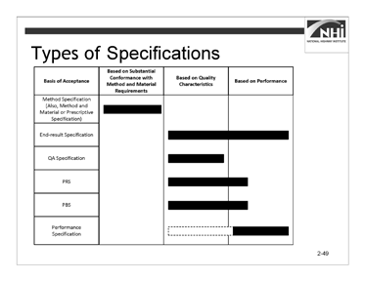

### Instruction (continued)

Slide 2-49

There are several approaches to specifying an end result.

* End-result
* Quality assurance
* Performance-related
* Performance-based

Module 4 will further define the types of specifications, compare method and end-result specifications in more detail, and include an activity converting a method specification to an end-result specification.

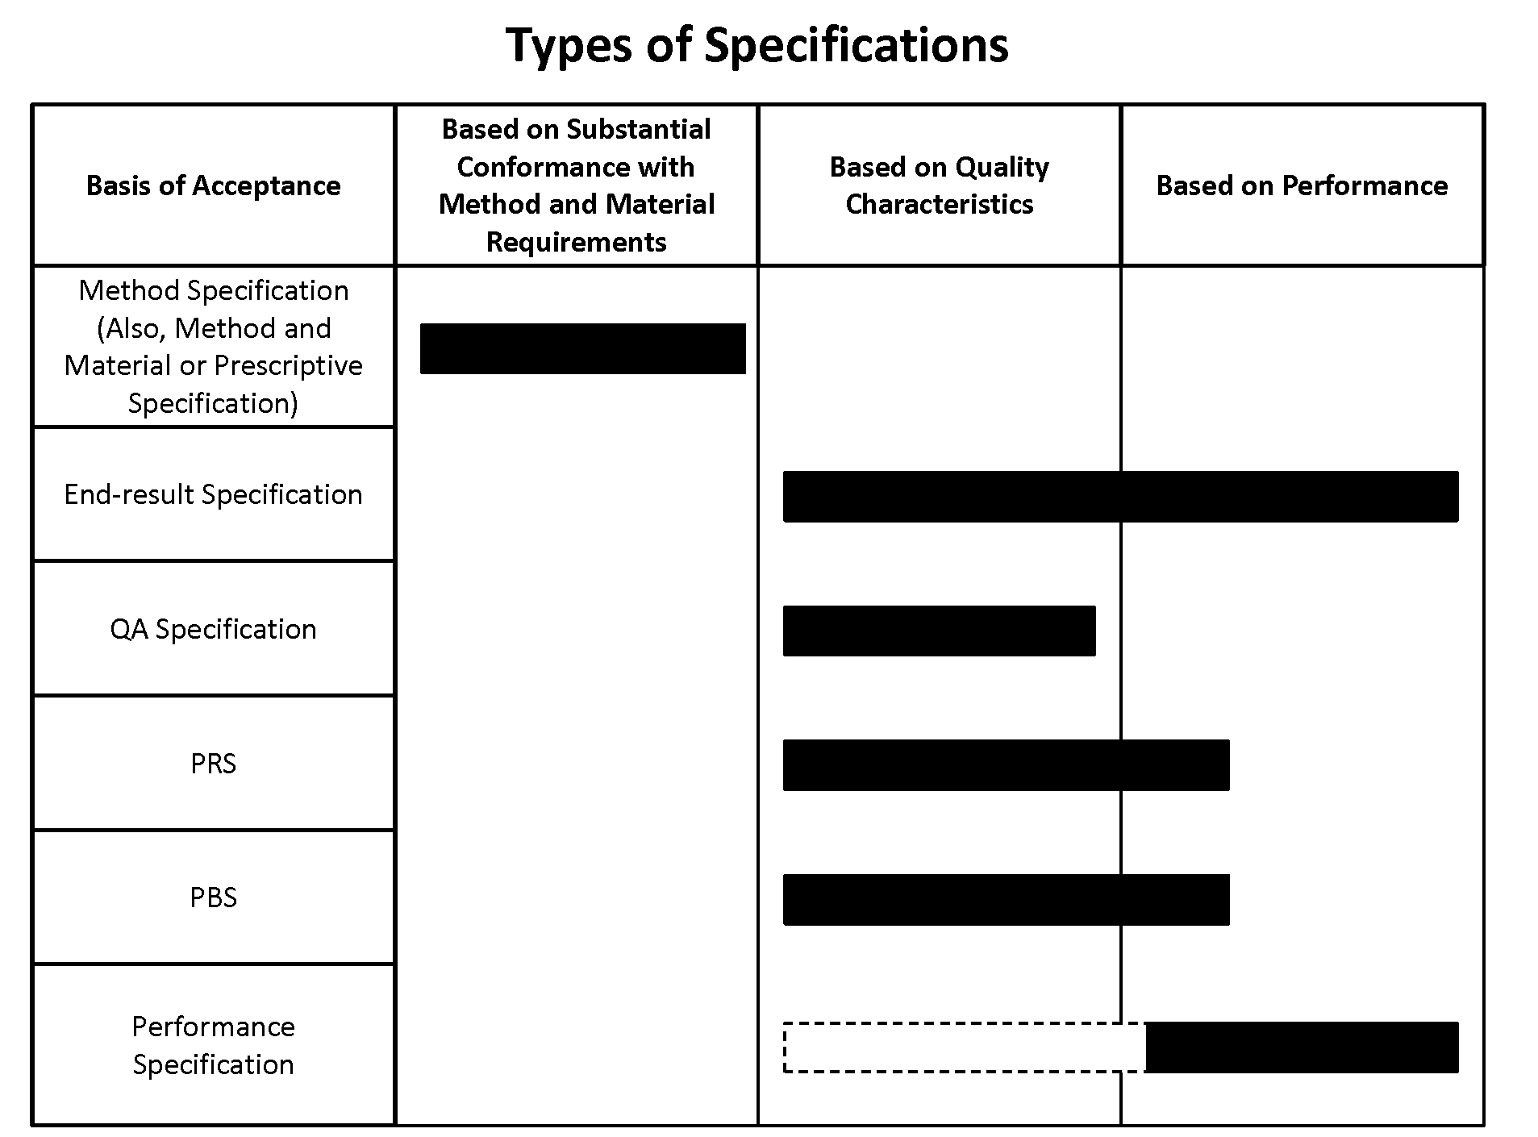

### Instruction (continued)

For further training opportunities on the topic of delivery methods and alternative contracting options, consider attending the NHI course *Alternative Contracting* (Course Number 134058).

### Interactivity

N/A

## Lesson 2.3: Formatting Specifications

### Lesson Plan

#### Learning Outcome

This lesson supports this learning outcome.

* Explain each element of the AASHTO five-part format.

#### Instructional Methodology

This lesson includes the methods of brief instruction, group discussion, individual activity, and small group activity.

#### Time Allocation

31 minutes plus 60-minute break

#### Evaluation Plan

Participant learning is evaluated throughout the lesson by instructor-based questioning and assessment, discussion, activity-oriented engagement, and contributions. A final exam at the end of the course completes the evaluation.

#### Resources

* American Association of State Highway and Transportation Officials. *Guide Specifications for Highway Construction*. Ninth Edition, 2008.
* Flip chart paper and markers
* United States Department of Transportation, Federal Highway Administration. *Development and Review of Specifications*. Technical Advisory, OPI – HIAM-20. Washington, DC, March 24, 2010.

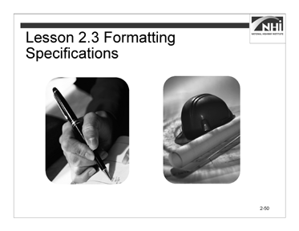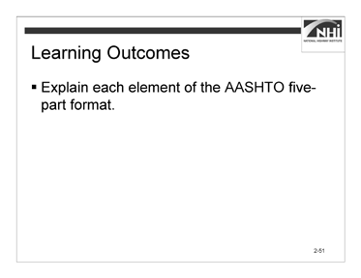

Slide 2-50 Slide 2-51

(Allow 1 minute)

### Key Message

*Display slide 2-50.*

Lesson 2.1 addressed the purpose of specifications, ending with a discussion of risk allocation. In Lesson 2.2, the discussion of risk allocation was expanded with the focus shifting from specific specification language to types of specifications. This lesson addresses the formatting of specifications.

### Instruction

*Display slide 2-51.*

Review the learning outcome on the slide.

### Interactivity

N/A

*Advance to the next slide.*

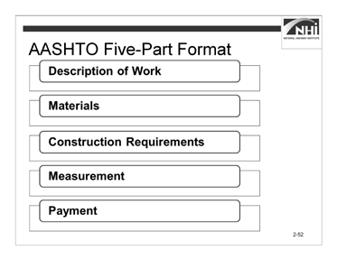

Slide 2-52

(Allow 25 minutes [5 minutes instruction, 20 minutes interactivity])

*Note to instructor:* The interactivity has two parts – an individual activity and a small group activity.

### Key Message

Agency specifications should be organized using the AASHTO five-part format. In addition to creating uniformity across the highway construction industry nationally, using the five-part format helps specification writers ensure that the specifications contain all the necessary components.

### Instruction

The AASHTO five-part format includes:

* Description of Work
* Materials
* Construction Requirements
* Measurement
* Payment

Each part has an important and unique function within the overall specification.

### Instruction (continued)

Some technical specification sections may not contain material requirements (e.g., clearing and grubbing). To maintain a consistent heading structure throughout the technical specifications, do not omit the “Materials” subsection heading. Label the subsection heading as vacant or blank.

Some older specifications may not follow the AASHTO five-part format and may not contain all necessary components; therefore, specification writers should avoid developing new specifications simply by “cutting and pasting” from older specifications. Instead, the specification writer should break down the older specification into its essential elements and then begin developing the new specification from these essential elements, organizing the completed specification into the AASHTO five-part format.

The following is a description of the contents of each part of the AASHTO five-part format.

**“Description of Work.”** This specification section is sometimes titled “Scope of Work” or “Work Included,” as often seen in architectural or building specifications. AASHTO has adopted the title “Description of Work” for highway specifications.

**“Materials.”** This part of a specification identifies the materials required to complete the work. This section of a specification stipulates detailed material requirements or provides cross-references to detailed material specifications in another division or book.

**“Construction Requirements.”** This part fully describes requirements to construct and accept the work. It also describes the measurable quality of the work.

**“Measurement.”** The “Measurement” part specifies what, when, and how to measure for payment.

**“Payment.”** The “Payment” part should define all of the pay items needed to complete the work.

This format serves as an organizational structure, an outline for the specification, and a checklist ensuring that all essential information is included in the specification.

*Advance to the next slide.*

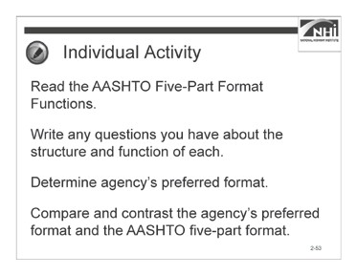

Slide 2-53

### Interactivity Part 1

(6 minutes activity, 4 minutes debrief)

*Note to instructor:* This is an individual activity. The purpose of this activity is for participants to develop an understanding of the structure and function of each part of the AASHTO five-part format.

Instruct participants to:

* Read the AASHTO Five-Part Format Functions.
* Write any questions you have about the structure and function of each part.
* Determine the agency’s preferred format found in the technical provisions in the agency’s standard specifications.
* Compare and contrast the agency’s preferred format and the AASHTO five-part format.
* Complete this task in 6 minutes.

### Interactivity Part 1 (continued)

#### AASHTO Five-Part Format Functions

|  |  |
| --- | --- |
| **Part Title** | **This part should…** |
| Description of Work | * Provide a short, concise statement of the work required. * Define the related plans or specifications that clarify the work. * State the relationships to other work items that are necessary to perform this work. * Avoid phrases such as “in accordance with these specifications and as shown on the plans or directed by the engineer.” This point is covered in the general provisions and should not be repeated. * Avoid including methods of construction, construction details, and procedures for measurement and payment. * Avoid duplicating or elaborating on information already on the plans. |
| Materials | * Cross-reference applicable agency standard material specifications. * Cross-reference applicable nationally recognized material specifications (e.g., AASHTO or American Society for Testing and Materials (ASTM)) if the agency’s specifications do not apply to or do not fully describe the required material. * Establish detailed specifications of the properties of each material and the methods of testing each material. This is critical if reference specifications are unavailable or if a given material is common to many work items located in the agency’s Materials division. |

|  |  |
| --- | --- |
| **Part Title** | **This part should…** |
| Construction Requirements | * Complement the plans. Information overlap or duplication may lead to a difference in instructions and disagreements as to which is the proper document to follow. * Identify and describe the equipment to be used to perform the work for method specifications. * Provide the detailed sequence of construction operations, or if using performance standards, describe the required end product. * Specify the type and frequency of tests required during construction and the final testing results necessary for acceptance. * Identify the minimum quality control activities if quality control testing and measurement are the responsibility of the contractor. * Specify the quality assurance methods that the agency will use. |
| Measurement | * Specify the components of the interim or completed work to measure for payment. * Include the units of measurement used for each bid item. * Specify exactly how to determine the quantity, including what measurement to take, and where or when to take the measurement. For example, measurements can be taken in place, before disturbing the material that is to be excavated, as originally provided, as finally provided, in the vehicles hauling the material, and others. Specify all modifying measurement factors (e.g., disturbed or undisturbed material, temperature, waste, and spillage). * Avoid specifying what work will be at the contractor’s expense. * The following is not recommended language: “Contractor shall perform corrective work at contractor’s expense.” This language is not recommended for two reasons. First, the general provisions already make clear the contractor’s obligation with regard to corrective work. Second, the specification should not be concerned with how the contractor pays for the corrective work. Rather, the specification should make clear that the corrective work is to be performed at “no additional cost to the agency.” |

|  |  |
| --- | --- |
| **Part Title** | **This part should…** |
| Payment | * Identify all work incidental to the payment. It should not repeat the full compensation language. For example, “This payment constitutes full compensation for all labor, materials, equipment, and other resources necessary to complete the work as required by the contract.” The general provisions already state that this is true of payment for all contract items. * Ensure that the bid item reflects a discrete unit of work that includes the labor, materials, equipment, and other costs related to the work. |

### Interactivity Part 1 (continued)

*When ready to debrief the activity, ask the following questions.*

**Ask:** Do you have any questions about the structure and function of each part? (Answer: Participant questions and answers will vary.)

**Ask:** If the agency’s preferred format differs from the AASHTO five-part format, how are the AASHTO five-part format functions addressed?

(Answer: Answers will vary by agency.)

*Advance to the next slide.*

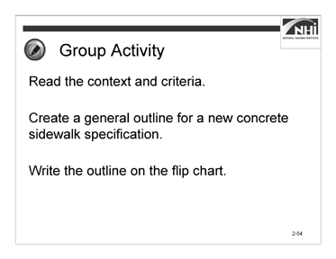

Slide 2-54

### Interactivity Part 2

(6 minutes activity, 4 minutes debrief)

*Note to instructor:* This is small group activity. The purpose of this activity is for participants to understand that the AASHTO five-part format can be used as an outline for a specification.

* Instruct participants to:
* Work in a small group.
* Read the context and criteria.
* Create a general outline for a new concrete sidewalk specification.
* Write the outline on the flip chart.
* Complete this task in 6 minutes.

### Interactivity Part 2 (continued)

#### Context

The agency intends to award a contract for the reconstruction of eight blocks of a State Highway through an urban corridor and within a city’s limits. Included in the scope of this contract will be the construction of a concrete sidewalk adjacent to new, concrete curb and gutter to be reconstructed as part of the same contract. The contract will also include the reconstruction of the adjacent State Highway asphalt pavement. The concrete sidewalk will be constructed for the length of the project on both sides of the highway. The contractor constructing the sidewalk will be required to comply with this specification when performing the sidewalk construction work. The location and dimensions of the sidewalk and a profile of the sidewalk and bedding course are shown in the plans for the project.

#### Criteria

The equipment needed to construct a concrete sidewalk includes an excavator, hand tools, and a hand-driven compactor to excavate for and compact the bed course and set the forms. The contractor will also need to provide all necessary forms and hand tools for placing, consolidating, finishing, jointing, and texturing the concrete.

The material needed to construct the sidewalk includes bed course materials, concrete meeting the specified compressive strength, reinforcing steel, and joint filler similar to that specified in other subsections of the agency’s standard specifications.

* For the bed course, consider specifying a class of aggregate subbase that allows ease of placement and minimal compactive effort.
* For concrete, consider specifying a standard concrete mix that produces the minimum acceptable compressive strength considering the intended use of the sidewalk.
* For reinforcing steel, consider specifying a standard type used in the region or within the jurisdiction where the sidewalk is being placed.
* For the joint filler and curing agent, consider specifying types similar to those required by your agency for concrete pavements.

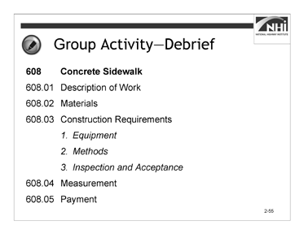

### Interactivity Part 2 (continued)

Slide 2-55

Call on a small group to present its general outline for a new concrete sidewalk specification.

**Ask:** Do you have any questions regarding the outline?

**Ask:** Do you have any suggestions regarding the outline?

*Display slide 2-55.*

Discuss similarities and differences between the outline shown on the slide and the small groups’ outlines.

#### 608 Concrete Sidewalk

#### Description of Work

#### Materials

#### Construction Requirements

* 1. Equipment
  2. Methods
  3. Inspection and Acceptance

#### Measurement

#### Payment

*Advance to the next slide.*

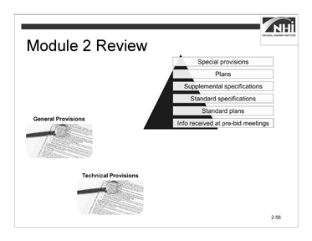

(Allow 5 minutes)

Slide 2-56

### Key Message

This concludes the content for Module 2.

### Instruction

N/A

### Interactivity

*Note to instructor:* This is a partner activity. The purpose of the activity is to review and connect the concepts and content of Module 2.

Instruct participants to:

* Work with a nearby partner.
* Review the key learning points and objectives from Module 2.
* Answer the questions.

### Interactivity (continued)

1. Many agencies define change orders, contract modifications, or supplemental agreements (or other agency terms for contract revisions) as being part of the contract. If these documents were included in the agency’s order of precedence clause, where would they be placed in the pyramid?

(Answer: Change orders, contract modifications, or supplemental agreements are specific to a project. In addition, they are intended to modify the contract. As such, they should be placed at the top of the pyramid.)

1. During discussion of the effect of specifications on a contractor’s behavior, it was observed that specifying erosion control or traffic maintenance as lump sum items encouraged desirable contractor behaviors, such as better planning to minimize lane closures. Using lump sum items appeared to reduce the risk to the agency related to the cost of these items. However, an important consideration, when contemplating making erosion control a lump sum item, is whether the contractor or the owner holds the environmental permit. What contractor behaviors would be a concern if erosion control was specified as a lump sum item, but the agency held the environmental permit?

(Answer: The contractor’s determination to minimize expenditures on erosion control might increase the agency’s risk of non-compliance with the environmental permit.)

### Interactivity (continued)

1. There are many different organizational structures that might be used for highway construction specifications other than the AASHTO five-part format. For example, the Construction Specifications Institute publishes a specification format that is widely used in private industry. Benefits of using the AASHTO five- part format are that it serves as a reliable outline for technical specifications and a convenient reminder to specification writers regarding the necessary content of highway specifications. What other benefits come from agencies using the AASHTO five-part format?

(Answer: Because the AASHTO five-part format is widely used by agencies throughout the country, it is easier for contractors to pursue work outside of their State. This significantly increases the pool of potential bidders and increases competition. It also allows agencies to more easily share specifications, reducing the effort needed to develop new specifications, and increasing the speed by which innovations may be spread across the country.)

### Interactivity (continued)

The following are the key learning points in Lesson 2.1:

* The definitions of contract and specifications
* The identification of the parts of the contract
* The definitions of important highway specification related terms
* The order of precedence
* The purpose of specifications
* The definition of general and technical provisions
* The definition of administrative and technical content
* Risk

The following is the key learning point in Lesson 2.2:

* The two main types of specifications (method and end-result)

The following are the key learning points in Lesson 2.3:

* The five-part format helps specification writers ensure that the specifications contain all the necessary components.

The following are the learning outcomes for Module 2:

* Compare the functions of standard and supplemental specifications with the functions of special provisions.
* Explain how the “order of precedence” affects writing specifications and preparing plans.
* Explain the purposes of a specification.
* Describe the purpose of the general provisions.
* Explain how specifications are used to assign risk and affect the behavior of different parties, within a given scenario.
* Compare method and end-result specifications.
* Explain each element of the AASHTO five-part format.

# Module 3: Writing and Interpreting Specifications

## Lesson 3.1: Introduction to Writing Style and Plain Language

### Lesson Plan

#### Learning Outcome

This lesson supports these learning outcomes.

* Explain how a consistent writing style can affect the interpretation of specifications.

#### Instructional Methodology

This lesson includes the methods of brief instruction, group discussion, and individual and group activities.

#### Time Allocation

33 minutes

#### Evaluation Plan

Participant learning is evaluated throughout the lesson by instructor-based questioning and assessment, discussion, activity-oriented engagement, and contributions. A final exam at the end of the course completes the evaluation.

#### Resources

* Federal Plain Language Guidelines, May 2011. [http://www.plainlanguage.gov/.](http://www.plainlanguage.gov/)
* Flip chart paper and markers
* Agency’s specification manual(s)
* United States Department of Transportation, Federal Highway Administration. *Development and Review of Specifications*. Technical Advisory, OPI – HIAM-20. Washington, DC, March 24, 2010.

#### Pre-Session Planning

* Review the Federal Plain Language Guidelines (May 2011 revision).
* Review the Federal Plain Language Act of 2010.
* Review agency’s style guide or other example style guides.
* Review Appendix O: Instructor’s Course Customization Checklist for details specific to this lesson.

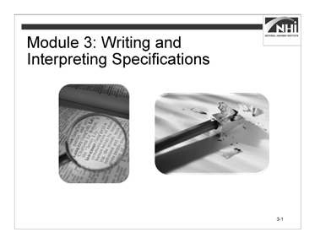

(Allow 1 minute)

Slide 3-1

### Key Message

*Display slide 3-1.*

Module 3 addresses writing and interpreting specifications.

### Instruction

N/A

### Interactivity

N/A

*Advance to the next slide.*

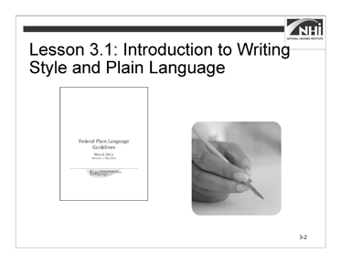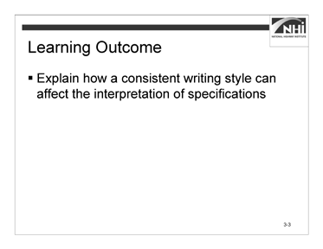

Slide 3-2 Slide 3-3

(Allow 5 minutes [1 minute instruction, 4 minutes interactivity])

### Key Message

Module 2 addressed the purpose of specifications. Lesson 3.1 explains the use of writing style and its effect on the audience’s interpretation. Resources available to specification writers to help them write better specifications will also be identified.

### Instruction

*Display slide 3-3.*

Review the learning outcome on the slide.

### Interactivity

(4 minutes activity)

*Note to instructor:* This is a group discussion. The purpose of the activity is to gain an understanding of the participants’ knowledge of writing styles and experience using a style guide.

Refer back to the variety of experience levels and job functions from the course introduction, and point out how that variety has potential to create inconsistencies in the writing style of the specifications.

### Interactivity (continued)

**Ask:** What training in specification writing have you had prior to this course? Consider on-the-job training, previous education, seminars, and other writing responsibilities.

(Answer: Participant answers will vary.)

**Ask:** What is your experience using a style guide? The experience can be in any capacity, including previous careers, as a student, and personal interests.

(Answer: Participant answers will vary.)

**Ask:** Is the style guide a useful tool? Why or why not? (Answer: Participant answers will vary.)

**Ask:** Considering the need to coordinate a consistent style with outside design consultants, what guidance exists for design consultants?

(Answer: Participant answers will vary.)

*Advance to the next slide.*

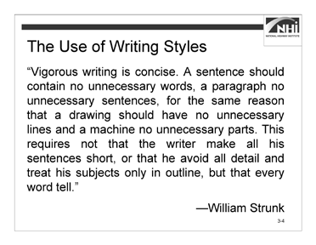

Slide 3-4

(Allow 5 minutes [4 minutes instruction, 1 minute interactivity])

### Key Message

Lesson 3.1 is a high-level view of what specification writers need to know to improve their writing skills.

Direct the participants to consider the following quote with the analogy it presents between writing and design.

Vigorous writing is concise. A sentence should contain no unnecessary words, a paragraph no unnecessary sentences, for the same reason that a drawing should have no unnecessary lines and a machine no unnecessary parts. This requires not that the writer make all of his sentences short, or that he avoid all detail, and treat his subjects only in outline, but that every word tell.

—William Strunk

*Advance to the next slide.*

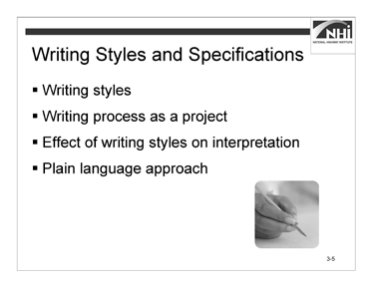

Slide 3-5

### Instruction

Use of a specific writing style affects the development and use of specifications.

* **Writing styles.** Writers have control over styles and the writer should play an active role in selecting and using the appropriate style.

Writing is a skill. Hone it!

* **Writing process as a project.** The writing process requires careful preparation and appropriate resources; specification writers need to spend time planning to write well.
* **Effect of writing style on interpretation.** The interpretation of specifications is directly correlated to the way they are written. The chance of them being interpreted differently increases when specifications are written in various ways,
* **Plain language approach.** Writing in plain language allows the audience to clearly understand the information.

*Advance to the next slide.*

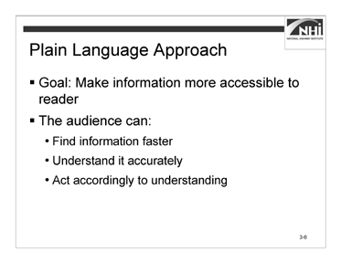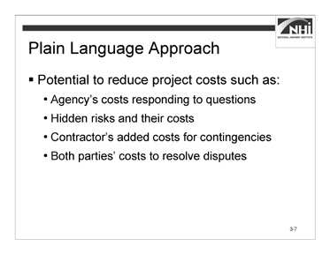

Slide 3-6 Slide 3-7

### Instruction (continued)

The goal of the plain language approach is to make information more accessible to its primary audience (users).

What does “make information more accessible” mean? It means the audience is able to do the following:

* Find the relevant information faster
* Understand it accurately
* Act according to understanding

The plain language approach is a reliable approach for writing and maintaining specifications.

*Display slide 3-7.*

In the context of specifications, besides providing a more effective basis for communicating the project requirements, the benefit of the plain language approach is its great potential to reduce project costs, such as the following:

* Agency’s added costs to respond to questions about the intent of the specifications during both the bidding and construction phases.
* Hidden risks and their added costs that were not considered by either party.
* Contractor’s added costs to provide contingencies for unclear specifications.
* Both parties’ added costs to resolve disputes that are based on their different interpretations of the specifications.

### Interactivity

(1 minute activity)

*Note to instructor:* This is a group discussion. The purpose of the activity is to generate interest in the topic and to drive the discussion toward listing benefits of using a consistent writing style.

**Ask:** What are other benefits of using a consistent writing style when writing specifications?

(Possible answers: Reduce time of internal review processes, reduce disagreements between agency personnel, and provide guidance to design consultants.)

*Advance to the next slide.*

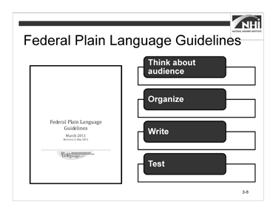

Slide 3-8

(Allow 22 minutes [12 minutes instruction, 10 minutes interactivity])

### Key Message

Because the writing style for one type of document may not be the same as the writing style for another type of document, the remainder of the course will focus on the principles of writing style as they apply to highway construction specifications.

### Instruction

*Note to instructor:* Mention the Federal Plain Language Act of 2010 and the Federal Plain Language Guidelines. Be prepared to discuss the Act and the Guidelines in general and as they apply to specification writing. This can help establish some authority for the subject matter. The course material follows the four-step approach, which has been adapted to the context of highway construction specifications.

The plain language approach is not something made up for this course. It relies on the Federal Plain Language Guidelines. These guidelines contain a four-step approach to writing in plain language.

Step 1: Think about and empathize with your audience Step 2: Organize

Step 3: Write your document Step 4: Test

*Advance to next slide.*

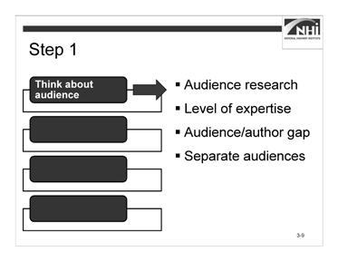

### Instruction (continued)

Slide 3-9

Step 1: Think about and empathize with your audience.

* **Audience research.** Research the audience who will read and use the document. Get feedback from the audience whenever possible and then write with the entire audience in mind. Include both the parties with assigned actions or responsibilities and others using the document who are not specifically addressed.

Ways to conduct research include:

* Consulting relevant technical documents available from AASHTO, FHWA, and the industry.
* Interviewing experts within the agency.
* Talking with the agency and contractor personnel in the field that will have to interpret and execute the work required to comply with the specification.
* Referencing the AASHTO Guide Specifications or other agencies’ specifications to see how these sources wrote specifications for the same kind of work. Compare and contrast these sources, developing an appreciation for the different approaches.
* **Level of expertise.** What is the average reader’s level of expertise? Write to that average and not to technical or legal experts.
* **Audience/author gap.** Do not assume that the audience knows exactly what you know as the author. Plain language means presenting information in a manner that is well organized and logical for the audience. This is not just about short words, short sentences, and short paragraphs.
* **Separate audiences.** Address separate audiences separately. Consider that highway construction specifications address the obligations of the contractor and the agency.

*Advance to the next slide*

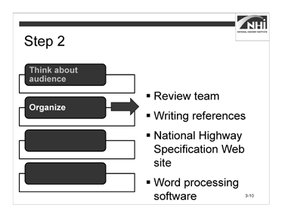

Slide 3-10

### Instruction (continued)

Step 2: Organize.

* **Review team.** The specification writing process needs to be managed as any project. Team members need to know their responsibilities and how they will work together. Assign responsibilities with due dates.
* **Writing references.** Because everyone’s writing skills are not equal, a style guide helps level the playing field. Writing references, such as style guides, provide the following:
* A standardized writing style for different types of provisions
* Guidance on how to consistently use terms and phrases
* Capitalization and abbreviation guidelines
* Punctuation and grammar rules

Direct participants to Appendix B: Sample Style Guide Table of Contents in the workbook to review the table of contents from a sample style guide. Discuss the contents and organization. If the agency has a style guide, discuss the contents and organization of the agency’s style guide.

*Note to instructor:* Inform participants of the location of their agency’s style guide. If the agency does not have a style guide, place example style guides at the back of the room for participants to review.

### Instruction (continued)

* **National Highway Specification Web site.** The National Highway Specification Web site, found at [http://www.specs.fhwa.dot.gov/,](http://www.specs.fhwa.dot.gov/) provides a searchable database of most states’ standard and supplemental specifications. While this Web site is a great starting point when researching model specifications, specification writers should check the model State’s Web site to ensure they have the latest version.
* **Word processing software.** Word processing software is a resource for specification writers.

Offer a brief explanation of word processing software. A more detailed review is included later in Lessons 3.2 and 3.3.

*Advance to the next slide.*

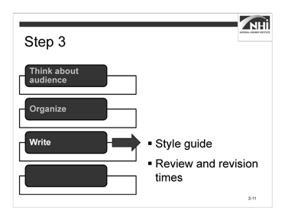

Slide 3-11

### Instruction (continued)

Step 3: Write your document.

* **Style guide.** Use the style guide during the writing process.

The use of a style guide is as important to the “Write” step as it is to the “Organize” step. No specification writer is expected to memorize every detail of a style guide, but he or she should know where to find guidance on the relevant style topic. The course materials will address specific style guidance for writing with the appropriate voice and mood in Lesson 3.2 and using the five Cs of specification writing in Lesson 3.3.

* **Review and revision times.** Plan for the time needed to write, review, and revise the specifications. As Mario Puzo, the author of *The Godfather*, has written, “The secret to good writing is rewriting.”

Plan for the time needed to rewrite and revise drafts and for the time needed for an adequate peer review and commenting process. View specification writing as a collaborative process with peer reviewers being an integral part of the process.

For big efforts, consider developing a schedule with intermediate milestones to track progress. Schedule regular meetings to both ensure that progress is being made and adequate input is being received.

*Advance to the next slide.*

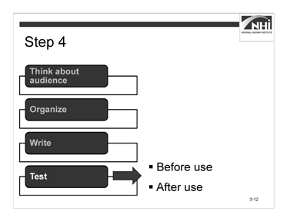

Slide 3-12

### Instruction (continued)

Step 4: Test.

The effectiveness of a specification can be evaluated.

* **Before use.** Before the specifications become a part of a contract, their effectiveness can be evaluated through the internal Plans, Specifications, and Estimates (PS&E) review process.

For long-term maintenance of specifications, the FHWA Technical Advisory *Development and Review of Specifications* recommends that agencies establish and support a multi-disciplinary group with FHWA and agency representatives.

* Select group members to minimize organizational “mindset” and individual biases.
* Obtain feedback from the field personnel and industry representatives.
* Maintain a standing specification committee with the local contractors association.

### Instruction (continued)

* **After use.** After the specifications are used, their effectiveness can be evaluated through review of the following:
* Bid tabulations for the item in question
* Field inspection report findings
* Industry comments
* Year-end summaries of change orders
* Requests for information
* Variance requests
* Time extensions
* Disputes and claims

By conducting careful reviews using reviewers from diverse backgrounds and by following up after the specification has been in use, the specification writer can validate the specification’s appropriateness and success at meeting the desired objectives, including achievement of the desired quality.

*Advance to the next slide.*

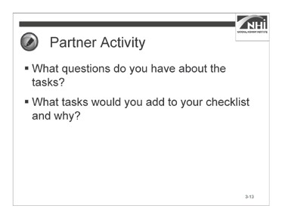

Slide 3-13

### Interactivity

(5 minutes activity, 5 minutes debrief)

*Note to instructor:* This is a partner activity. The activity provides participants the opportunity to review sections of Appendix D: Specification Writer’s Checklist, discuss challenges, and brainstorm additional checklist items.

Since this is the first time that the Specification Writer’s Checklist has been used in the course, take this opportunity to introduce the checklist and describe its purpose.

The Specification Writer’s Checklist is a compilation of best practices. The best practices are presented as tasks in the checklist. The objective is to provide specification writers with a convenient job aid to use as a guide each time the specification writer takes on a new assignment.

Instruct participants to:

* Work with a partner.
* Review the “Writing Style and Plain Language” and “Review” sections in Appendix D: Specification Writer’s Checklist.
* Answer the questions.
* Complete this task in 5 minutes.

**Ask:** What questions do you have about the tasks?

**Ask:** What tasks would you add to your checklist and why?

## Lesson 3.2: Voice and Mood in Specifications

### Lesson Plan

#### Learning Outcomes

This lesson supports these learning outcomes.

* Explain the potential benefits of writing in the active voice.
* Rewrite passive voice sentences into the active voice.
* Evaluate specifications to determine the need for imperative or indicative mood.

#### Instructional Methodology

This lesson includes the methods of brief instruction, group discussion, and individual and group activities.

#### Time Allocation

77 minutes plus 15-minute break

#### Evaluation Plan

Participant learning is evaluated throughout the lesson by instructor-based questioning and assessment, discussion, activity-oriented engagement, and contributions. A final exam at the end of the course completes the evaluation.

#### Resources

* Agency’s specification manual(s)
* United States Department of Transportation, *Federal Highway Administration. Development and Review of Specifications*. Technical Advisory, OPI – HIAM-20. Washington, DC, March 24, 2010.

#### Pre-Session Planning

Review Appendix O: Instructor’s Course Customization Checklist.

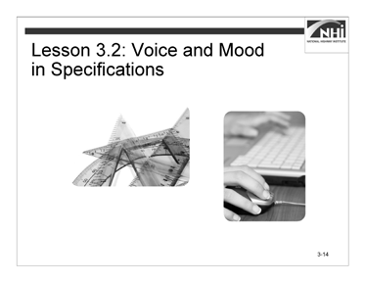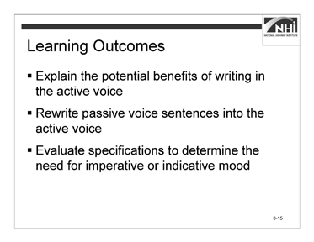

Slide 3-14 Slide 3-15

(Allow 2 minutes)

### Key Message

*Display slide 3-14.*

Lesson 3.1 addressed the topic of style, style guidance, and how to prepare for the specification writing process. Lesson 3.2 addresses the mechanics of writing in the appropriate voice and mood. Lesson 3.3 will address more specification writing principles as they are represented by the five Cs.

### Instruction

*Display slide 3-15.*

Review the learning outcomes on the slide.

### Interactivity

N/A

*Advance to the next slide.*

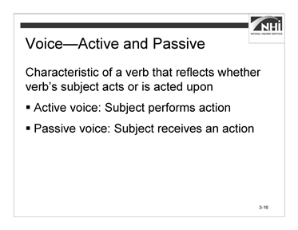

Slide 3-16

(Allow 30 minutes [5 minutes instruction, 25 minutes interactivity])

*Note to instructor:* This section is designed to be highly interactive; therefore, the interactivities are interspersed throughout the instruction. The interactivity has two parts – a group discussion and an individual activity.

### Key Message

Too often, agencies write specifications using the passive voice. The best practice is to write specifications in the active voice. When specification writers write specifications in the active voice, that writing is less likely to be misinterpreted, and it uses substantially fewer words. The focus of this lesson is on learning how to write specifications in the active voice.

### Instruction

Voice is a characteristic of a verb that reflects whether its subject acts or is acted upon. In the passive voice, the subject receives an action. In the active voice, the subject performs an action.

*Advance to the next slide.*

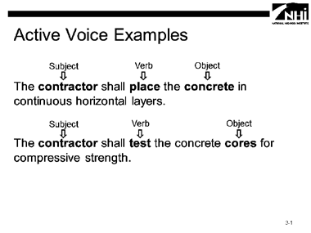

Slide 3-17

### Interactivity Part 1

(5 minutes activity)

*Note to instructor:* This is a group discussion. The purpose of this activity is to help participants’ understand verb placement relative to the subject of the sentence when using the active voice.

**Ask:** What are the subject, verb, and object in the example sentences?

*Animate the slide to show the answer for each example sentence.*

(Answer: “The **contractor** shall **place** the **concrete** in continuous horizontal layers.”) (Answer: “The **contractor** shall **test** the concrete **cores** for compressive strength.”)

**Ask:** Who is performing the work? (Answer: The contractor.)

*Advance to the next slide.*

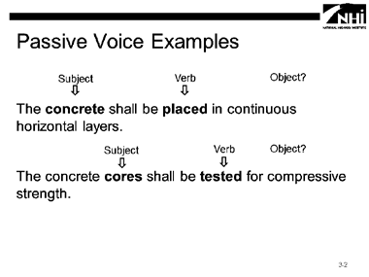

### Interactivity Part 1 (continued)

Slide 3-18

**Ask:** What are the subject, verb, and object in the example sentences?

*Animate the slide to show the answer for each example sentence.*

(Answer: “The **concrete** shall be **placed** in continuous horizontal layers.”) (Answer: “The concrete **cores** shall be **tested** for compressive strength.”)

**Ask:** Who is performing the work?

(Answer: In these passive voice examples, the subject does not perform the action. It is possible to write the specification without identifying the party responsible for performing the work.)

*Advance to the next slide.*

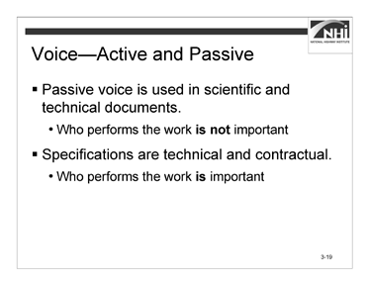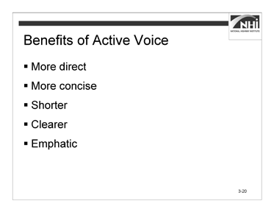

Slide 3-19 Slide 3-20

### Instruction (continued)

The passive voice is used in scientific and technical writing. It is preferable in a strictly scientific or technical context because it provides objectivity; the results of a procedure or process will be the same regardless of who performs its steps. In the passive voice, who takes an action is not important.

Because specifications are technical in nature, agencies used the passive voice.

Highway construction specifications are both technical and contractual. On a highway construction project, who performs the steps of a given procedure or process is important.

Because the specifications are part of a contract, use the active voice instead of the passive voice to clearly convey who is responsible for taking an action.

*Display slide 3-20.*

Active voice is more direct and more concise. Passive voice deemphasizes the actor (the performer of the verb’s action), uses more words (such as prepositional phrases), and is often vague or misleading.

Generally, the active voice uses fewer words than the passive voice. The active voice is clearer and more emphatic than the passive voice.

*Advance to the next slide.*

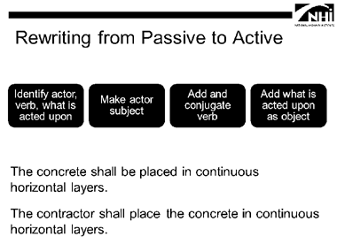

### Instruction (continued)

Slide 3-21

There are several steps when rewriting from passive to active voice.

* Identify the actor, the verb, and what is acted upon.
* Make the actor the subject.

*Animate the slide and discuss the changes shown in the second sentence.*

* Add and conjugate the verb.

*Animate the slide and discuss the changes shown in the second sentence.*

* Add what is acted upon as the object and ensure that all other information is included without changing the meaning.

*Animate the slide and discuss the changes shown in the second sentence. Advance to the next slide.*

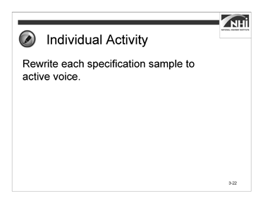

Slide 3-22

### Interactivity Part 2

(10 minutes activity, 10 minutes debrief)

*Note to instructor:* This is an individual activity. The activity provides an opportunity for each participant to rewrite sentences from the passive to active voice.

Instruct participants to:

* Rewrite each specification sample to active voice.
* Complete this task in 10 minutes.

*When ready to debrief the activity, advance to the next slide.*

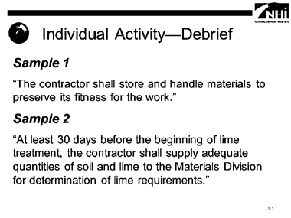

### Interactivity Part 2 (continued)

Slide 3-23

**Ask:** How did you rewrite the specification sample in the active voice?

*Animate the slide to show the answer for each specification sample.*

### Sample 1

“Materials shall be stored and handled to preserve its fitness for the work.”

(Answer: “The contractor shall store and handle materials to preserve its fitness for the work.”)

### Sample 2

“At least 30 days before the beginning of lime treatment, adequate quantities of soil and lime shall be supplied to the Materials Division for the determination of lime requirements.”

(Answer: “At least 30 days before the beginning of lime treatment, the contractor shall supply adequate quantities of soil and lime to the Materials Division for the determination of lime requirements.”)

*Advance to the next slide.*

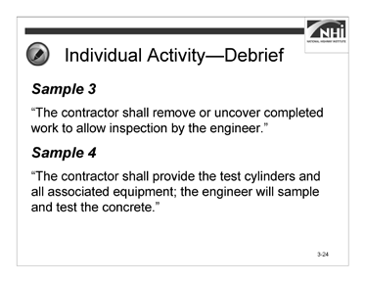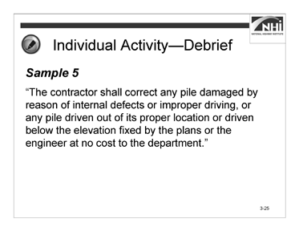

Slide 3-24 Slide 3-25

### Interactivity Part 2 (continued)

### Sample 3

“Completed work shall be removed or uncovered by the contractor to allow inspection by the engineer.”

(Answer: “The contractor shall remove or uncover completed work to allow inspection by the engineer.”)

### Sample 4

“The test cylinders and all associated equipment shall be provided by the contractor; the concrete will be sampled and tested by the engineer.”

(Answer: “The contractor shall provide the test cylinders and all associated equipment; the engineer will sample and test the concrete.”)

*Display slide 3-25.*

### Sample 5

“Any pile damaged by reason of internal defects or improper driving, or any pile driven out of its proper location or driven below the elevation fixed by the plans or the engineer, shall be corrected at no cost to the agency.”

(Answer: “The contractor shall correct any pile damaged by reason of internal defects or improper driving, or any pile driven out of its proper location or driven below the elevation fixed by the plans or the engineer at no cost to the agency.”)

*Advance to the next slide.*

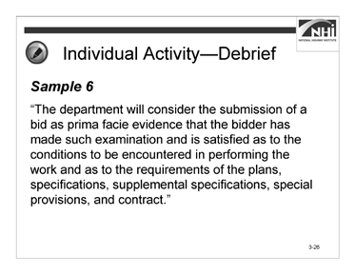

Slide 3-26

### Interactivity Part 2 (continued) Sample 6

“The submission of a bid shall be considered prima facie evidence that the bidder has made such examination and is satisfied as to the conditions to be encountered in performing the work and as to the requirements of the plans, specifications, supplemental specifications, special provisions, and contract.”

(Answer: “The agency will consider the submission of a bid as prima facie evidence that the bidder has made such examination and is satisfied as to the conditions to be encountered in performing the work and as to the requirements of the plans, specifications, supplemental specifications, special provisions, and contract.”)

*Advance to the next slide.*

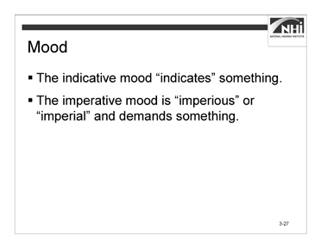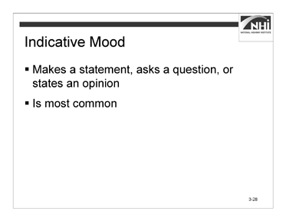

Slide 3-27 Slide 3-28

(Allow 25 minutes [10 minutes instruction, 15 minutes interactivity])

### Key Message

In addition to writing with the appropriate voice, specification writers must write using the appropriate mood. They should use the indicative or imperative mood when writing a specification.

* The indicative mood “indicates” something.
* The imperative mood is “imperious” or “imperial” and demands something.

### Instruction

*Display slide 3-28.*

#### Indicative Mood

The indicative mood:

* Makes a statement, asks a question, or states an opinion.
* Is the most common form and is used throughout specifications in different capacities.

*Advance to next slide.*

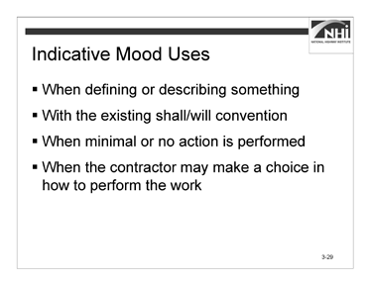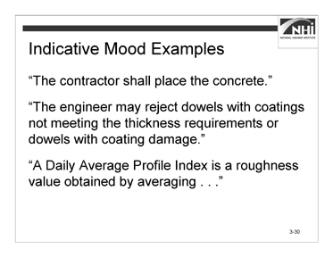

Slide 3-29 Slide 3-30

### Instruction (continued)

Use the indicative mood as follows:

* When defining or describing something.
* With the existing shall/will convention to distinguish between the contractor’s and the agency’s obligations.
* When minimal or no action is performed, such as to state an existing condition, to describe material characteristics, or to convey attributes of equipment.
* When the contractor may make a choice in how to perform the work.

*Display slide 3-30.*

Examples of the indicative mood are as follows:

* “The contractor shall place the concrete.”
* “The engineer may reject dowels with coatings not meeting the thickness requirements or dowels with coating damage.”
* “A Daily Average Profile Index is a roughness value obtained by averaging . . .”

*Advance to next slide.*

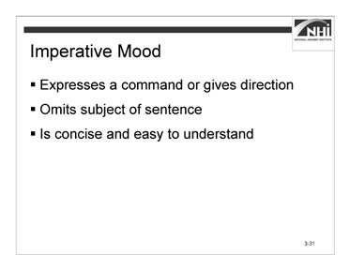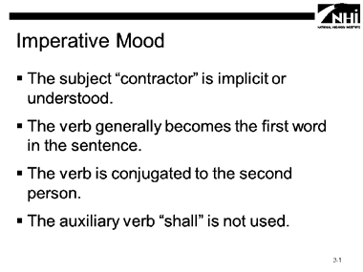

Slide 3-31 Slide 3-32

### Instruction (continued)

#### Imperative Mood

The imperative mood:

* Expresses a command or gives a direction to the reader.
* Omits the explicit subject of the sentence (in highway specifications, the contractor) and is written in the present tense.
* Is concise and easy to understand.

Use the imperative mood only in specifications when the contractor is being given direction.

*Display slide 3-32.*

When using the imperative mood, the following apply:

* The subject “contractor” is implicit or understood.
* The verb that clearly defines the action generally becomes the first word in the sentence.
* The verb is conjugated to the second person.
* The auxiliary verb “shall” is not used.

*Advance to next slide.*

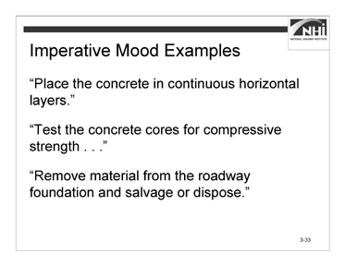

### Instruction (continued)

Slide 3-33

Examples of the imperative mood are as follows:

* “Place the concrete in continuous horizontal layers.”
* “Test the concrete cores for compressive strength . . .”
* “Remove material from the roadway foundation and salvage or dispose.”

*Advance to next slide.*

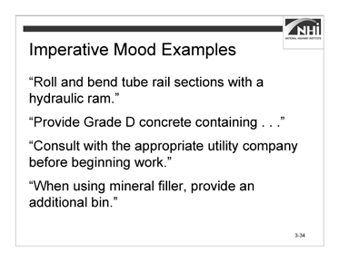

### Instruction (continued)

Slide 3-34

* “Roll and bend tube rail sections with a hydraulic ram.”
* “Provide Grade D concrete containing . . .”
* “Consult with the appropriate utility company before beginning work.”
* “When using mineral filler, provide an additional bin.”

**Ask:** What direction is given in the first sentence? (Answer: Roll and bend)

**Ask:** Who is the subject? (Answer: You.)

**Ask:** What verb tense is used? (Answer: Present tense)

*Advance to next slide.*

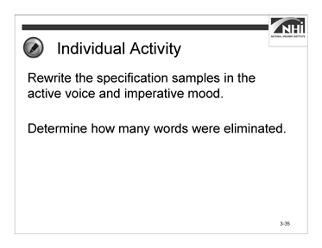

Slide 3-35

### Interactivity

(9 minutes activity, 6 minutes debrief)

*Note to instructor:* This is an individual activity. The activity provides an opportunity for each participant to rewrite sample provisions in the active voice and imperative mood. Technical requirements may vary from State to State. Encourage participants to focus on the rewrite.

Instruct participants to:

* Rewrite the specification samples in the active voice and imperative mood.
* Determine how many words were eliminated.
* Complete this task in 9 minutes.

*When ready to debrief the activity, advance to the next slide.*

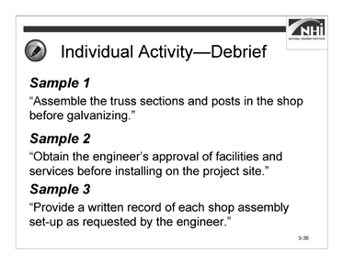

### Interactivity (continued)

Slide 3-36

*For each sample, ask the following questions.*

**Ask:** How did you rewrite the sample?

*Animate the slide to show the answer for each sample.*

**Ask:** How many words were eliminated by writing in the active voice and imperative mood?

#### Sample 1

“The contractor shall assemble the truss sections and posts in the shop before galvanizing.”

(Answer: “Assemble the truss sections and posts in the shop before galvanizing.”) (Answer: 3 words are eliminated; from 14 words to 11; a 20% reduction)

#### Sample 2

“The engineer’s approval of facilities and services shall be obtained before installing on the project site.”

(Answer: “Obtain the engineer’s approval of facilities and services before installing on the project site.”)

(Answer: 5 words are eliminated; from 19 words to 14; a 26% reduction)

### Interactivity (continued)

#### Sample 3

“A written record of each shop assembly set-up as requested by the engineer shall be provided.”

(Answer: “Provide a written record of each shop assembly set-up as requested by the engineer.”)

(Answer: 2 words are eliminated; from 17 words to 15; a 12% reduction)

### NOTE: An improved version that accounts for clarity as well as active voice and imperative voice might read, “Provide a written record of each shop assembly.”

**Ask:** What direction has your agency given in terms of writing in the active voice and using the indicative or imperative moods when writing specifications?

(Answer: The use of mood in specification writing varies from one agency to another. In some agencies, there is no guidance or standard regarding the voice or mood of the specification. Some agencies have established the active voice and imperative mood as the standard for all specifications. Other agencies have established the active voice and imperative mood as the standard for technical specifications but require the use of the active voice and indicative mood for the general provisions.)

*Advance to next slide.*

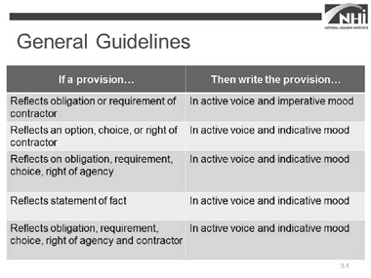

Slide 3-37

(Allow 20 minutes [10 minutes instruction, 10 minutes interactivity])

### Key Message

There are some general guidelines to deciding which mood to use when writing a specification.

### Instruction

* If a provision reflects an obligation or requirement of the contractor, write the provision in the active voice and imperative mood.

The following are examples:

* “Remove old concrete or stone masonry within the limits shown on the plans and without damaging the remaining structure.”
* “Store seed and inoculant in accordance with 106.6, ‘Storage of Materials,’ and under controlled conditions.”
* If a provision represents an option or choice for, or a right of, the contractor, write the provision in the active voice and indicative mood.

The following are examples:

* “The contractor may perform shearing if the epoxy coating is not damaged.”
* “The contractor may use explosives to remove material not directly connected to the remaining structure as approved in writing by the engineer and in accordance with 107.11, ‘Use of Explosives.’”

### Instruction (continued)

* If a provision reflects an obligation or requirement of, an option or choice for, or a right of the agency or its representative(s), including the engineer, write the provision in the active voice and indicative mood.

The following are examples:

* “The engineer will take measurements to determine the limits of material classifications during excavation.”
* “The engineer may conduct testing to determine allowable use of a contractor-proposed water source.”
* “The agency reserves the right to sample, test, inspect, and accept or reject the material based on its own tests.”
* If a provision reflects a simple statement of fact, write the provision in the active voice and indicative mood.

The following are examples:

* “The mineral filler will be finer than a #4 [4.75 mm] sieve and contain less than 25% of the material passing a #200 [75μm] sieve.”
* “The contract unit price for field office or field laboratory units of each type includes the cost of providing, placing, relocating, maintaining, and servicing the complete facility as required, including removal and relocation.”
* If a provision reflects an obligation or requirement of, an option or choice for, or a right of both the agency and the contractor, write the provision in the active voice and indicative mood.

The following are examples:

* “The contractor and engineer may agree to change test procedures during the construction of the project.”
* “The contractor and engineer must both agree to a change of sampling location once production has begun.”

*Advance to the next slide.*

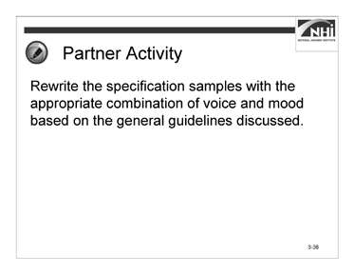

Slide 3-38

### Interactivity

(5 minutes activity, 5 minutes debrief)

*Note to instructor:* This is a partner activity. The activity provides an opportunity for each participant to rewrite sample provisions using the appropriate voice and mood based on the general guidelines discussed.

Instruct participants to:

* Work with a partner.
* Rewrite the specification samples with the appropriate combination of voice and mood based on the general guidelines discussed.
* Complete this task in 5 minutes.

*When ready to debrief the activity, advance to the next slide.*

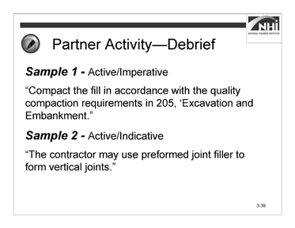

### Interactivity (continued)

Slide 3-39

**Ask:** How did you rewrite the sample?

*Animate the slide to show the answer for each specification sample.*

#### Sample 1

“The fill shall be compacted in accordance with the quality compaction requirements in 205, ‘Excavation and Embankment.’”

(Answer: “Compact the fill in accordance with the quality compaction requirements in 205, ‘Excavation and Embankment.’”)

#### Sample 2

“Preformed joint filler may be used to form vertical joints.”

(Answer: “The contractor may use preformed joint filler to form vertical joints.”)

## Lesson 3.3: The Five Cs of Specification Writing

### Lesson Plan

#### Learning Outcomes

This lesson supports these learning outcomes.

* State the five Cs used in specification writing.
* Identify potential ambiguities in the wording, given a sample specification.
* Identify the potential benefits of each of the five Cs.
* Write a new specification using the five Cs and the agency’s preferred format.
* Complete a checklist of the information needed before writing or revising a specification.
* Apply the five Cs and the agency’s preferred format to revise the specification, given a sample specification.

#### Instructional Methodology

This lesson includes the methods of brief instruction, group discussion, and individual and small group activities.

#### Time Allocation

72 minutes on Day 1

162 minutes on Day 2 plus 15-minute break

#### Evaluation Plan

Participant learning is evaluated throughout the lesson by instructor-based questioning and assessment, discussion, activity-oriented engagement, and contributions. A final exam at the end of the course completes the evaluation.

#### Resources

* American Association of State Highway and Transportation Officials. *Guide Specifications for Highway Construction*. Ninth Edition, 2008.
* Flip chart paper and markers
* United States Department of Transportation, Federal Highway Administration. *Development and Review of Specifications*. Technical Advisory, OPI – HIAM-20. Washington, DC, March 24, 2010.

#### Pre-Session Planning

Review Appendix O: Instructor’s Course Customization Checklist for details specific to this module.

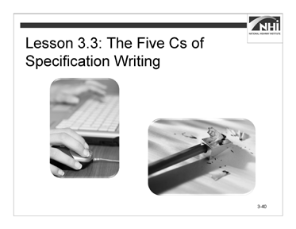

(Allow 1 minute)

Slide 3-40

### Key Message

*Display slide 3-40.*

Lesson 3.2 addressed the mechanics of writing in the appropriate voice and mood. Lesson 3.3 addresses the five Cs of specification writing.

### Instruction

N/A

### Interactivity

N/A

*Advance to the next slide.*

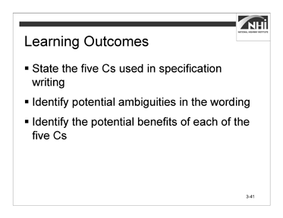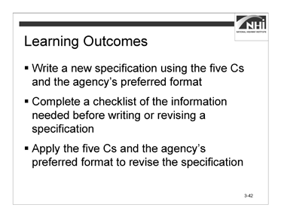

Slide 3-41 Slide 3-42

(Allow 1 minute)

### Key Message

This lesson will review the five Cs of specification writing and provide practice applying them when writing specifications.

### Instruction

*Display slide 3-42.*

Review the learning outcomes on the slide.

### Interactivity

N/A

*Advance to the next slide.*

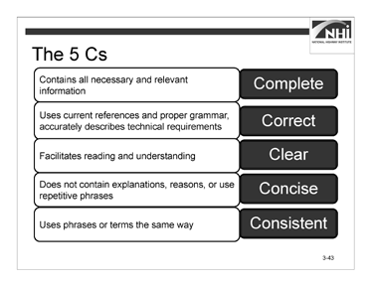

Slide 3-43

(Allow 10 minutes [2 minutes instruction, 8 minutes interactivity])

### Key Message

A well-written specification uses the five Cs to ensure completeness, correctness, clarity, conciseness, and consistency. A contractor that complies with a specification written using the five Cs will deliver the project the agency needs.

### Instruction

The five Cs of specification writing are complete, correct, clear, concise, and consistent. These five terms summarize the attributes of a well-written specification.

The five Cs are important to specification writing because they are essential to fully communicating the author’s intent.

### Instruction (continued)

#### The Five Cs

|  |  |
| --- | --- |
| **Definition** | **Term** |
| Contains all necessary and relevant information | Complete |
| Uses current references and proper grammar; accurately describes technical requirements | Correct |
| Facilitates reading and understanding | Clear |
| Does not contain explanations, reasons, or use repetitive phrases | Concise |
| Uses phrases or terms the same way | Consistent |

The first two Cs (complete and correct) create the requirements. The subsequent three Cs (clear, concise, and consistent) help ensure efficiency and proper interpretation.

### Interactivity

(3 minutes activity, 5 minutes debrief)

*Note to instructor:* This is an individual activity. The purpose of the activity is to reinforce participants’ understanding of the definitions of each of the five Cs as related to specification writing.

Instruct participants to:

* Match each of the five Cs (complete, correct, clear, concise, and consistent) with the description of its relationship to specification writing.
* Complete this task in 3 minutes.

*When ready to debrief the activity, advance to the next slide.*

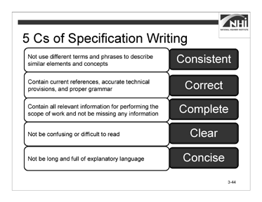

### Interactivity (continued)

Slide 3-44

**Ask:** Which term matches the description of its relationship to specification writing?

*Animate the slide to show the answer for each description.*

#### The Five Cs

|  |  |
| --- | --- |
| **Relationship to Specification Writing** | **Term** |
| A specification should not use different terms and phrases to describe similar elements and concepts; doing so could lead to misinterpretation. | Consistent |
| A specification should contain current references, accurate technical provisions, and proper grammar. Out-of-date references, inaccurate technical provisions, and improper grammar and syntax can affect interpretation. | Correct |
| A specification should contain all relevant information for performing the scope of work and should not be missing any information. | Complete |
| A specification should not be confusing or difficult to read. A specification’s audience should be able to find the information they are looking for, understand it, and act on that understanding. | Clear |
| A specification should not be long and full of explanatory language. It should also avoid the use of repetitive provisions. | Concise |

*Advance to the next slide.*

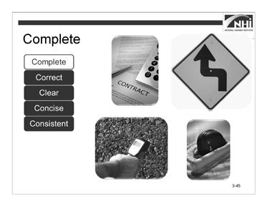

Slide 3-45

(Allow 10 minutes [5 minutes instruction, 5 minutes interactivity])

*Note to instructor:* This section is designed to be highly interactive; therefore, the interactivity is interspersed throughout the instruction.

### Key Message

*Note to instructor:* Throughout the discussion of each of the five Cs, provide enough information to ensure participants have a basic understanding of the term. Where appropriate, illustrate using brief personal examples of positive or negative outcomes due to a well-written or poorly written specification based on the appropriate C. Watch your time because there is a lot to be covered in a relatively short period.

Each of the five Cs will be reviewed in a specific order, starting with complete.

### Instruction

*Animate the slide.*

A complete specification contains, along with the other contract documents, all of the information necessary for a bidder to prepare a responsive and responsible bid and the information necessary for the contractor to construct the project as the agency intends.

*Animate the slide.*

A complete specification assigns responsibility for all requirements and obligations. If a responsibility is not assigned, the specification misses its only opportunity to communicate the agency’s intent. If a dispute occurs, the intent may have to be determined by past experience, industry standard, or experts.

### Interactivity

(5 minutes)

*Note to instructor:* This is an individual activity. The purpose of the activity is to explain what happens if a specification is incomplete.

Instruct participants to:

* Read the Specification Scenario.
* Answer the questions.
* Complete this task in 3 minutes.

#### Specification Scenario

An agency’s specifications provided two different approaches for payment of curb and gutter. One approach provided payment for curb and gutter as a single pay item. The other approach provided separate pay items for curb and gutter.

The “Payment” section for the integrated curb and gutter pay item listed the bedding material as incidental to that pay item. The “Payment” section for the separate pay items did not explicitly list the bedding material as incidental. A contractor constructing a project where payment was provided for curb and gutter as two separate pay items asserted that the bedding material was not included in the unit price of either the curb or the gutter. The contractor argued that there was no relevant pay item for the bedding material when the curb and gutter were paid as separate items. The contractor demanded payment for the bedding material in addition to the reimbursement provided by the separate unit prices for the curb and the gutter. The agency refused to pay separately for the bedding, arguing that it was the intent of the contract, as demonstrated by the fact that the bedding material was listed as incidental to the combined curb and gutter item, that the cost of purchasing and installing the bedding was to be included in the separate pay items for curb and gutter. The agency also pointed to the general provisions, which stated that:

**“Incidental Payment.** Work required to safely and satisfactorily provide or accomplish a pay item or items but which is not directly measured and paid for, or for which the contract does not include a pay item, is an incidental obligation of the contractor. The agency does not directly pay for such work . . .”

The contractor filed a claim seeking reimbursement for the bedding material under the curb and under the gutter.

The claim is pursued in the courts and the judge ultimately rules that the contractor should be reimbursed for the cost of purchasing and installing the bedding material.

### Interactivity (continued)

**Ask:** Based on the information provided, if you were asked to evaluate the contractor’s claim, how would you answer the contractor’s assertion that the contractor should be paid separately for bedding material?

(Possible answers: The contractor is correct and should be paid for the bedding material. The reasoning is that the specifications are not complete in that they do not make it clear, as they did for the integrated curb and gutter item, that payment for the bedding material is also incidental to the payment for curb and gutter work when these components are paid for separately.

The second answer is that the contractor is not correct because the contract makes clear that work that is not separately measured and paid for or for which the contract does not include a pay item is paid as incidental work.)

**Ask:** How could this claim have been avoided?

(Answer: This claim could have been avoided by ensuring that the specification was complete and described all the work that was included in the unit prices for the separate curb and gutter items, including the incidental bedding material.)

### Instruction (continued)

*Animate the slide.*

A complete specification uses measurable or definable standards. There must be an objective means to determine if the work is acceptable. The contractor must be able to bid and perform the scope of work as represented in the bid documents and contract.

The contract should speak for itself; therefore, use discretionary phrases sparingly (e.g., “as directed by the engineer,” “at the discretion of the engineer,” “to the satisfaction of the engineer,” and “in the opinion of the engineer”). The need for any additional input or direction calls into question the completeness of the specification. In addition, one may then question whether additional compensation or time would be necessary to fulfill the intent of the specification.

*Animate the slide.*

A complete specification includes Federal requirements. The local FHWA Resource Center can provide guidance on Federal requirements.

A complete specification, if it does not contain everything necessary to tell the contractor what is required, includes appropriate references to allow the contractor to locate the necessary requirements or information. This includes information or requirements that may not be part of the specifications themselves. Examples might include geotechnical reports, ASTM testing requirements, and other similar documents or resources.

*Advance to the next slide.*

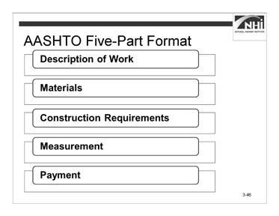

### Instruction (continued)

Slide 3-46

Specification writers should use the AASHTO five-part format as a guide when drafting complete specifications.

As previously discussed, the AASHTO five-part format is divided into five sections.

* Description of Work
* Materials
* Construction Requirements
* Measurement
* Payment

This format serves as a checklist, ensuring that all essential information is included in the specification.

*Advance to the next slide.*

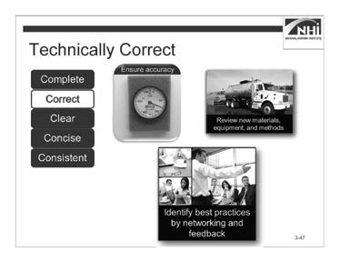

(Allow 5 minutes)

Slide 3-47

### Key Message

The second of the five Cs is correct. Correct specifications are both technically and grammatically correct.

### Instruction

*Animate the slide.*

To be technically correct, a specification writer must ensure specifications are accurate and factual. Writers should do the following:

* Research the topic area thoroughly and consult subject matter experts as necessary.

*Animate the slide.*

* Evaluate new materials and equipment. Ensure that the materials and equipment specified are those currently used and are not outdated or unavailable. Technological advances in materials and equipment might merit a specification rewrite.
* Review new methods. The specification you are writing may use outdated methods or may present a good opportunity to create an end-result specification.

*Animate the slide.*

* Identify best practices. Network with your counterparts in other agencies. Find out what does and does not work well for them. Research documents on best practices through the Transportation Research Board’s National Cooperative Highway Research Program and the National Highway Specification Web site.

### Instruction (continued)

* Get feedback from the field. Consider obtaining input and feedback from field engineers and inspectors.
* Get feedback from the construction industry. The industry can be a great resource for critiquing the content and style of the specifications. Feedback can be obtained formally through a joint committee, or informally through other means. Create a dialogue when not involved in a dispute over the intent of a specification, as it can be significantly more productive than attempting to create a dialogue while embroiled in a dispute.
* Use data sources that are reliable and current. Careless statements or statements based on unreliable data are frequently the cause of contract administration problems and contractor claims. Ensure referenced standards are current.

For example, consider a specification that states, “Before applying the coating, prepare the concrete surface according to the coating manufacturer’s recommended standard” or, “Before applying the finish coat, prepare the surface according to XYZ Official Standards.” The manufacturer’s, national, or industry standard is now part of the contract.

### Interactivity

N/A

*Advance to the next slide.*

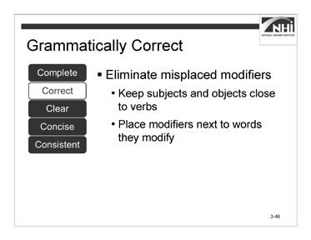

Slide 3-48

(Allow 20 minutes [8 minutes instruction, 12 minutes interactivity])

*Note to instructor:* This section is designed to be highly interactive; therefore, the interactivities are interspersed throughout the instruction. The interactivity has two parts – a group discussion and a partner activity.

### Key Message

In addition to being technically correct, a specification must also be grammatically correct.

### Instruction

To ensure grammatical correctness, a specification writer should:

* Eliminate dangling or misplaced modifiers.
* Keep subjects and objects close to their verbs.
* Place modifiers next to the words they modify.

*Advance to the next slide.*

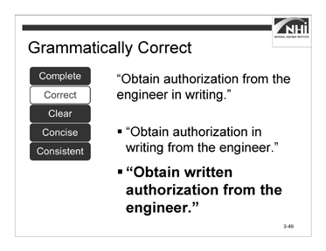

Slide 3-49

### Interactivity Part 1

(2 minutes activity)

*Note to instructor:* This is a group discussion. The purpose of the activity is to provide participants an opportunity to identify and correct grammatical errors in a specification.

Instruct participants to:

* Read the sentence.
* Answer the questions.

“Obtain authorization from the engineer in writing.”

**Ask:** Is this sentence grammatically correct?

(Answer: No. The modifier “in writing” is misplaced. It does not modify the “engineer,” it modifies “authorization.”)

**Ask:** How can the specification be rewritten to address the deficiency?

*Animate the slide.*

(Possible answers: “Obtain authorization in writing from the engineer.” While “in writing” now modifies “authorization,” it does so awkwardly and with more words than are necessary.

“Obtain written authorization from the engineer.” This is the best choice because it clearly requires the authorization to be in writing but does so with fewer words.)

*Advance to the next slide.*

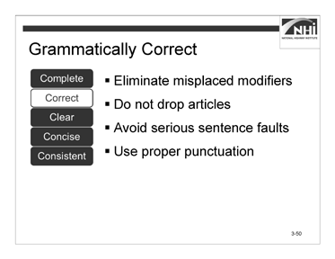

### Instruction Part 1 (continued)

Slide 3-50

* Do not drop articles. Articles signal nouns and specify their application. Dropping articles (i.e., a, an, the) can change meaning or create ambiguity.

Incorrect: “Provide concrete surface free of dirt.” Correct: “Provide a concrete surface free of dirt.”

*Animate the slide.*

* Avoid serious sentence faults. Poor construction, including run-on sentences, sentence fragments, and incomplete sentences, interferes with readability and comprehension.

*Animate the slide.*

* Use proper punctuation. Punctuation can significantly affect a sentence’s meaning.

*Advance to the next slide.*

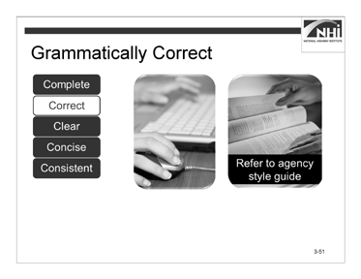

Slide 3-51

### Instruction (continued)

A specification writer does the following:

* Checks spelling and grammar. Use computer programs to assist you but do not rely solely on these programs. Familiarize yourself with general and construction-specific style and usage guides.
* Refers to his or her agency’s style guidance first. Agency style guides, however, do not address all, or even most, situations. When the agency style guide does not provide guidance, then the best examples of style guides include the *Chicago Manual of Style*, *The Blue Book of Grammar and Punctuation*, and *Garner’s Modern American Usage*. For legal terms, which should be used sparingly, use *Black’s Law Dictionary.* There are very few grammar issues that are not fully addressed by these standards.

*Advance to the next slide.*

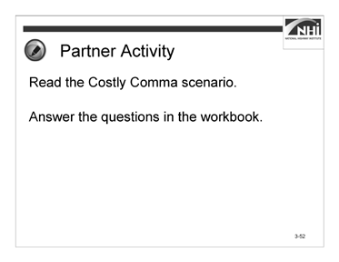

Slide 3-52

### Interactivity Part 2

(5 minutes activity, 5 minutes debrief)

*Note to instructor:* This is a partner activity. The purpose of the activity is to highlight the importance of using punctuation correctly to accurately convey meaning.

The activity is derived from a standard lease for the use of utility poles, negotiated between Rogers Communications of Toronto (Company A) and a telephone company, Bell Aliant (Company B). Rogers took Bell Aliant to court over the cancellation of the contract. The cancellation was worth $1 million Canadian ($888,000 US) to Rogers.

Instruct participants to:

* Work with a partner.
* Read the Costly Comma scenario and excerpt.
* Answer the question.
* Complete this task in 5 minutes.

*When ready to debrief, advance to the next slide.*

### Interactivity Part 2 (continued)

#### The Costly Comma

### Scenario

Company A leased right-of-way from Company B. After three years, Company B decided to exercise its option to terminate by notifying Company A in writing of its intent to terminate at the end of the next year. As the contract’s termination would result in the loss of almost $1 million for Company A, Company A pursued the matter in court.

### Excerpt

“This agreement shall be effective from the date it is made and shall continue in force for a period of five (5) years from the date it is made, and thereafter for successive five

(5) year terms, unless and until terminated by one year prior notice in writing by either party.”

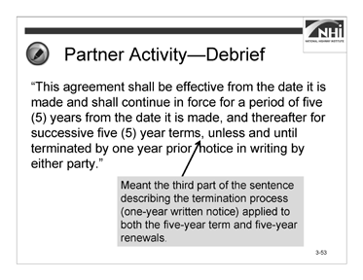

### Interactivity Part 2 (continued)

Slide 3-53

**Ask:** Was Company A correct in believing that Company B violated the terms of the lease? Why or why not?

*Animate the slide.*

(Answer: No, Company B did not violate the terms of the lease. An industry regulator found that the second comma meant that the third part of the sentence describing the termination process (one-year written notice) applied to both the five-year term and five-year renewals.)

The “Costly Comma” scenario was adapted from Austen, Ian. “The Comma That Costs 1 Million Dollars (Canadian).” The New York Times, October 25, 2006. Accessed August 27, 2013. [http://www.nytimes.com/2006/10/25/business/worldbusiness/25comma.html.](http://www.nytimes.com/2006/10/25/business/worldbusiness/25comma.html)

*Advance to the next slide.*

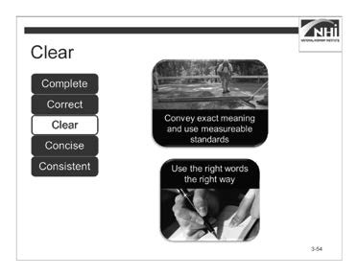

Slide 3-54

(Allow 25 minutes [5 minutes instruction, 20 minutes interactivity])

*Note to instructor:* This section is designed to be highly interactive; therefore, the interactivities are interspersed throughout the instruction. The interactivity has three parts – a group discussion and two individual activities.

### Key Message

The third C is clear. Clear specifications avoid ambiguities. An ambiguity exists when a specification has more than one reasonable interpretation.

For example, a specification states, “Remove 4 in. to sound concrete.” The ambiguity is whether this specification requires the contractor to remove a minimum of 4 in. or until sound concrete in reached, whichever is greater, or until sound concrete is reached but no more than 4 in.

### Instruction

*Animate the slide.*

A specification writer can avoid ambiguities by using words that convey his or her meaning exactly and by using measurable standards where practical. For example, a specification states, “The surface shall have a smoothness tolerance of +/- ½ in. when measured using a 10 ft. straightedge.”

**Ask:** Is this provision ambiguous? Why do you think it is or is not ambiguous?

(Answer: It may be ambiguous because, taken as a whole, the tolerance is a total of 1 in. If the positive side of the tolerance represents the distance between the surface and the straightedge, then the significance of the negative side of the tolerance is not obvious. It may be reasonable for the contractor to assume that +/- ½ in. is the same as a 1 in. difference between the surface and the bottom of the straightedge.)

*Animate the slide.*

A specification writer can avoid ambiguities by selecting words that say what he or she means.

*Advance to the next slide.*

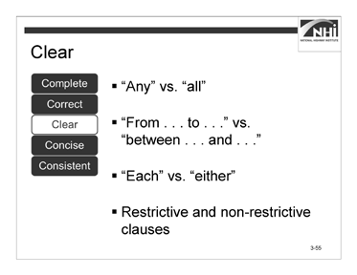

Slide 3-55

### Instruction (continued)

* Use “any” versus “all” correctly.

“Any” is a limited number selected at the discretion of the reader. The word “any” has a vague meaning. The words “all” or “every” are not vague. “All” is the entire amount. If applicable, use a qualifier to obtain the clearest meaning and provide the reader with a measurable standard.

*Animate the slide.*

* Use “from . . . to . . .” versus “between . . . and . . .” correctly. “From” and “to” imply an inclusive range; the two end points are included in the range. “Between” and “and” imply an exclusive range; the two end points are excluded from the range.

*Animate the slide.*

* Use “each” versus “either” correctly. Use “each” in cases where “either” or “both’ leads to confusion or ambiguity.

*Animate the slide.*

* Use restrictive and non-restrictive clauses properly (i.e., “that” versus “which”). If one can drop the clause and sustain the point of the sentence, use “which.” If one cannot drop the clause and sustain the point, use “that.” A “which” clause goes inside commas, a “that” clause does not.
* Because “which” is appropriate in the situation where the clause can be dropped and still sustain the point, it is not widely used in specification writing. Specifications should not contain unnecessary clauses. Consequently, when the word “which” is used in a specification, it is often used in error.

*Advance to the next slide.*

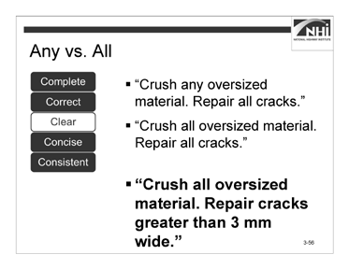

Slide 3-56

### Interactivity Part 1

(5 minutes activity)

*Note to instructor:* This is a group discussion. The purpose of the activity is for participants to identify the use of words that result in clear specifications.

Instruct participants to:

* Read the sample sentences from a specification. “Crush any oversized material. Repair all cracks.” “Crush all oversized material. Repair all cracks.”

**Ask:** How does each of these specifications create very different results from similar information?

(Answer: In the first sentence, the contractor is compliant with the requirement if they crushed a single piece of oversized material. In the second sentence, the contractor must crush all oversized material to be compliant.)

**Ask:** Is the requirement “repair all cracks” a measurable standard?

*Animate the slide.*

(Answer: No. It does not specify the minimum size of the crack to be repaired. If you use a measureable standard, “all” is no longer necessary.

“Crush all oversized material. Repair cracks greater than 3 mm wide.”)

*Advance to the next slide.*

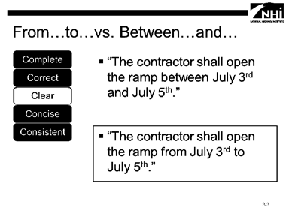

### Interactivity Part 1 (continued)

Slide 3-57

Instruct participants to:

* Read the sample sentences from a specification.

“The contractor shall open the ramp between July 3rd and July 5th.” “The contractor shall open the ramp from July 3rd to July 5th.”

**Ask:** If the agency requires the ramp to be open on July 3rd, 4th, and 5th, which of these specifications is correct? Why?

*Animate the slide.*

(Answer: The use of “from . . .to . . .” is clearer because it indicates that the ramp is to be open on July 3rd and July 5th.

“The contractor shall open the ramp from July 3rd to July 5th.”)

*Advance to the next slide.*

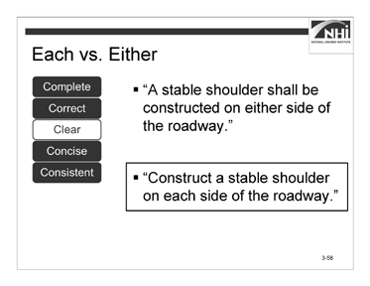

### Interactivity Part 1 (continued)

Slide 3-58

Instruct participants to:

* Read the sample sentences from a specification.

“A stable shoulder shall be constructed on either side of the roadway.” “Construct a stable shoulder on each side of the roadway.”

**Ask:** Which of these two sentences is clearer?

*Animate the slide.*

(Answer: “Either” implies a choice; therefore, “each” is accurate. This sentence should be rewritten in the active voice and imperative mood.

“Construct a stable shoulder on each side of the roadway.”)

*Advance to the next slide.*

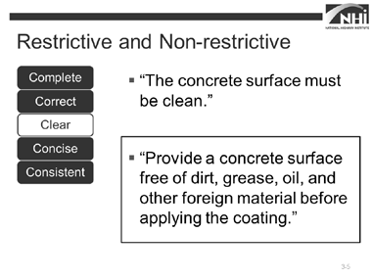

### Interactivity Part 1 (continued)

Slide 3-59

Instruct participants to:

* Read the sample sentences from a specification. “The concrete surface must be clean.”

“Provide a concrete surface free of dirt, grease, oil, and other foreign material before applying the coating.”

**Ask:** Which is the better specification and why?

*Animate the slide.*

(Answer: The last sentence is more restrictive and is the better specification.

“Provide a concrete surface free of dirt, grease, oil, and other foreign material before applying the coating.”)

*Advance to the next slide.*

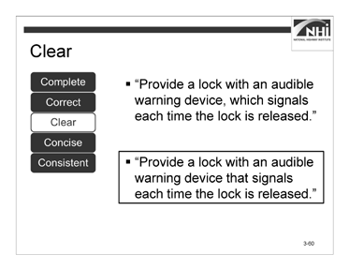

### Interactivity Part 1 (continued)

Slide 3-60

Instruct participants to:

* Read the sample sentence from a specification.

“Provide a lock with an audible warning device, which signals each time the lock is released.”

**Ask:** Is “which” used correctly here? Why do you think it is or is not used correctly?

*Animate the slide.*

(Answer: No. If the clause beginning with “which” is removed from the sentence, the sentence does not completely convey the intended requirement. “Which,” in this case, should be replaced with “that.”

“Provide a lock with an audible warning device that signals each time the lock is released.”)

*Advance to the next slide.*

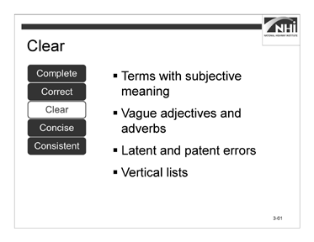

### Instruction (continued)

Slide 3-61

A specification writer can avoid ambiguities and write more clearly by doing the following:

*Animate the slide.*

* Avoid terms that have an undefined or subjective meaning (e.g., “etc.,” “as per,” “in a workmanlike manner,” “shall function as intended”).

*Animate the slide.*

* Avoid the use of vague adjectives and adverbs with multiple meanings. Avoid using adjectives and adverbs whose meaning can vary with the reader. This includes common construction words with multiple meanings. Choose words that have restrictive interpretations.

*Animate the slide.*

* Recognize the difference between latent (hidden) and patent (obvious) errors.
* A patent error is one that is so obvious that the contractor has an obligation to notify the agency and seek clarification during the bidding process.
* All other errors are latent, meaning they are hidden. A contractor is not responsible for a latent error.
* The general rule is that errors will be considered latent unless proven to be patent.

### Instruction (continued)

* Another general rule is that latent errors are ruled against the drafter. This means that the party writing a contract has the responsibility to write it clearly and without error.

If the drafter wanted the contractor to do something different from what the contractor reasonably assumed was required, then the drafter should have written the latently erroneous provision more clearly and without error.

* The rules for determining whether an error is patent or latent apply to all defects, inaccuracies, inconsistencies, ambiguities, omissions, conflicts, and all other shortcomings in the contract documents.
* The contractor’s responsibility for detecting deficiencies in the contract documents is typically addressed in Section 102 of the general provisions.

*Animate the slide.*

* Use vertical lists. Lists aid the audience in finding and understanding the content of a specification.
* Introduce lists with lead-in sentences that establish whether one, more than one, or all of the listed items apply. Refer to the FHWA Technical Advisory *Development and Review of Specifications* for more details on introducing lists.
* Based on the rule of intentional exclusion, if a specification writer leaves an item off a list, it will be interpreted as excluded. The agency would bear any cost implications of the interpretation based on the deficient list. Using the introductory phrase, “but not limited to,” does not make the list complete.

The phrase may even draw attention to the deficient list.

*Advance to the next slide.*

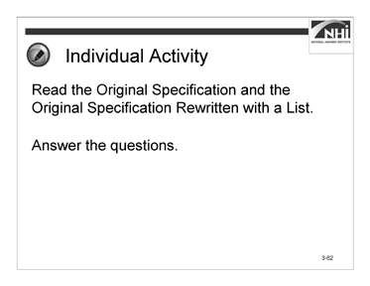

Slide 3-62

### Interactivity Part 2

(4 minutes activity, 4 minutes debrief)

*Note to instructor:* This is an individual activity. The purpose of the activity is to provide participants the opportunity to understand how drafting a specification with a list can make for a clearer and more concise specification.

Instruct participants to:

* Read the Original Specification and the Original Specification Rewritten with a List.
* Answer the questions.
* Complete this task in 4 minutes.

**Ask:** How did the list provide clarity?

(Answer: A list makes the specification easier to read.)

**Ask:** Does using the list change any of the other five Cs?

(Answer: Using a list may result in a more concise specification. Though not a huge difference, it is a reduction in the number of words of almost 5%.)

*Advance to the next slide.*

### Interactivity Part 2 (continued)

#### Original Specification

**103.07 Final Clean Up**. Before final acceptance of the work, the contractor shall remove all falsework, unused materials, erosion control devices, rubbish, and temporary bridges, approaches and buildings, unless otherwise provided in the contract or ordered by the engineer. The contractor shall remove from the right-of- way all machinery, equipment, temporary traffic control devices, and surplus material and leave all areas occupied by the contractor in conjunction with the contract in a neat and presentable condition satisfactory to the engineer. The contractor shall replace or repair all damaged fences. The contractor shall restore in an acceptable manner all property, including property outside of the project limits, which may have been used or damaged during the prosecution of the work. The contractor shall provide the agency a written release from any offsite property owner stating that the restoration has been accepted and the contractor has been released of responsibility. Paved roadbeds shall be cleaned within five working days prior to opening the pavement surface to traffic. Cleaning of roadbeds in residential and urban areas shall be performed in a manner that will not cause airborne dust.

Unless otherwise provided, full compensation for removal and disposal of materials for final clean-up will be considered as included in other items of work and no separate payment will be made.

(This specification uses 216 words.)

### Interactivity Part 2 (continued)

#### Original Specification Rewritten with a List

The agency will not grant final acceptance of the work until the following final clean-up operations are complete:

* Remove all falsework, unused materials, erosion control devices, rubbish, and temporary bridges, approaches, and buildings, unless the contract requires or the engineer directs otherwise.
* Remove from the right-of-way all machinery, equipment, temporary traffic control devices, and surplus material.
* Leave all areas occupied by the contractor in conjunction with the contract in a neat and presentable condition satisfactory to the engineer.
* Replace or repair all damaged fences.
* Restore in an acceptable manner all property, including property outside of the project limits that may have been used or damaged during the prosecution of the work.
* Provide the agency a written release from any offsite property owner stating that the property owner has accepted the restoration and released the contractor from responsibility.
* Clean paved roadbeds within five working days before opening the pavement surface to traffic.
* Clean roadbeds in residential and urban areas in a manner that will not cause airborne dust.

Unless otherwise provided, the agency will consider the cost of removing and disposing of materials for final clean-up to be included in the contract unit prices of other items of work.

(This specification rewritten with a list uses 206 words.)

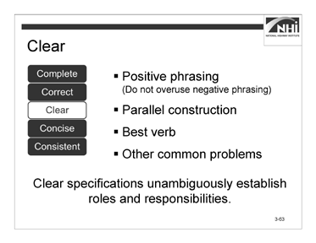

### Instruction (continued)

Slide 3-63

Clear specifications use positive phrasing and make definite assertions. People prefer to be told what to do instead of what they cannot do; however, sometimes it is more forceful to state what not to do, e.g., “Do not allow traffic on the base course.” Reserve negative phrasing for when it is necessary to draw attention to a particular detail; its overuse can diminish that effect.

*Animate the slide.*

Clear specifications use parallel construction. Parallel construction is defined as similarity of grammatical form between two or more coordinated elements. It is required whenever elements are connected by coordinating or correlative conjunctions, when elements are compared or contrasted, and when items are arranged in a list or outline.

*Animate the slide.*

Clear specifications use the best verb to represent the intent. A verb is a word or phrase expressing an action or a condition (state of being or description) of a subject. Clear specifications generally do the following:

* Use strong verbs
* Use active voice
* Use imperative mood (if appropriate)
* Avoid shifts in tense, voice, and mood within the same sentence

### Instruction (continued)

* Vary verb tense to reflect the often complex data in a document. Typically, this appears in conditional statements or sequential direction.
* Revise when modifiers interrupt a verb phrase.

Incorrect – “Typically, agencies hold for prospective contractors pre-bid meetings.” Correct – “Typically, agencies hold pre-bid meetings for prospective contractors.”

*Animate the slide.*

Clear specifications avoid common problems that affect clarity. Avoid using expressions (such as “and/or”) that are grammatical short cuts and may confuse the reader. Select verbs with care, as some are used as both verbs and nouns (e.g., permit, backfill, splice, fill, mix, broom, surface). If there is a chance for confusion, select another verb.

*Animate the slide.*

Clear specifications unambiguously establish roles and responsibilities. This can be accomplished by using the appropriate combination of voice and mood.

*Advance to the next slide.*

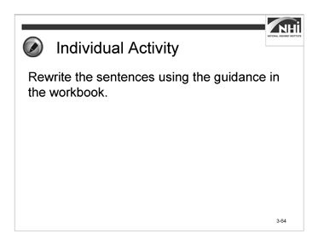

Slide 3-64

### Interactivity Part 3

(4 minutes activity, 3 minutes debrief)

*Note to instructor:* This is an individual activity. The purpose of the activity is to provide an opportunity for participants to rewrite sentences using positive phrasing.

Instruct participants to:

* Rewrite sentences #1 and #2 using positive phrasing.
* Rewrite sentence #3 using parallel construction.
* Complete this task in 4 minutes.

*When ready to debrief, advance to the next slide.*

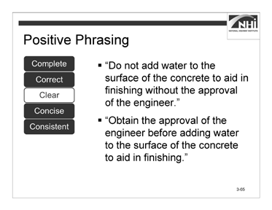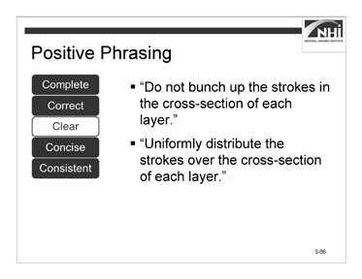

Slide 3-65 Slide 3-66

### Interactivity Part 3 (continued)

**Ask:** How did you rewrite the sentence using positive phrasing?

*Animate the slide.*

“Do not add water to the surface of the concrete to aid in finishing without the approval of the engineer.”

(Answer: “Obtain the approval of the engineer before adding water to the surface of the concrete to aid in finishing.”)

*Display slide 3-66.*

**Ask:** How did you rewrite the sentence using positive phrasing?

*Animate the slide.*

“Do not bunch up the strokes in the cross-section of each layer.”

(Answer: “Uniformly distribute the strokes over the cross-section of each layer.”)

*Advance to the next slide.*

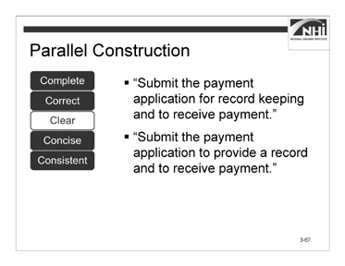

### Interactivity Part 3 (continued)

Slide 3-67

**Ask:** How did you rewrite the sentence using parallel construction?

*Animate the slide.*

“Submit the payment application for record keeping and to receive payment.”

(Answer: “Submit the payment application to provide a record and to receive payment.”)

*Advance to the next slide.*

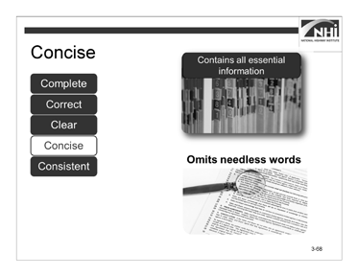

Slide 3-68

(Allow 10 minutes [3 minutes instruction, 7 minutes interactivity])

*Note to instructor:* This section is designed to be highly interactive; therefore, the interactivities are interspersed throughout the instruction.

### Key Message

The fourth C is concise.

### Instruction

*Animate the slide.*

A concise specification contains all essential information and only essential information. Requirements and procedures nonessential to evaluating product quality or quantity serve no useful function and make it more difficult to enforce a specification in the field.

*Animate the slide.*

A concise specification omits words that do not add substantive meaning. Needless words include nonessential adjectives, adverbs, prepositional phrases, and modifiers. Where possible, choose a single word instead of a phrase.

*Advance to the next slide.*

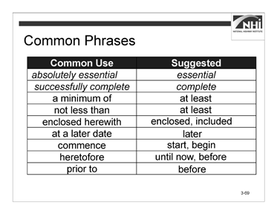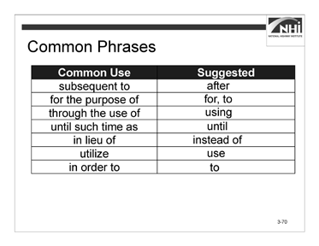

Slide 3-69 Slide 3-70

### Interactivity

(7 minutes activity)

*Note to instructor:* This is a group discussion. The purpose of the activity is to help participants recognize commonly used wordy phrases and identify appropriate replacements.

The first two answers are given as examples. The table is split after “prior to” into a second slide.

There may be more than one correct answer based on the context in which the participants consider the commonly used phrase.

Instruct participants to:

* Read the list of commonly used phrases.
* Consider what single word or short phrase should be used to replace each of these commonly used phrases.

**Ask:** What suggestions do you have for the commonly used phrase?

*Note to instructor:* After one participant has answered, animate the slide to show the suggested replacement. Proceed through each phrase until the chart is completed.

Direct participants to Appendix C: Commonly Used Phrases in the workbook.

*Advance to the next slide.*

### Interactivity (continued)

#### Commonly Used Phrases

|  |  |
| --- | --- |
| **Common Use** | **Suggested** |
| *absolutely essential* | *essential* |
| *successfully complete* | *complete* |
| a minimum of |  |
| not less than |  |
| enclosed herewith |  |
| at a later date |  |
| commence |  |
| heretofore |  |
| prior to |  |
| subsequent to |  |
| for the purpose of |  |
| through the use of |  |
| until such time as |  |
| in lieu of |  |
| utilize |  |
| in order to |  |

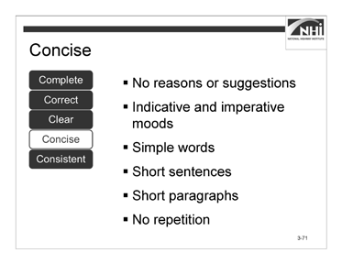

### Instruction (continued)

Slide 3-71

A concise specification uses the active voice instead of the passive voice. As explained in Lesson 3.2, the active voice is more direct and more concise. Traditionally, agencies have used the passive voice in specification writing. The passive voice de-emphasizes the actor (the performer of the verb’s action), uses more words (often prepositional phrases), and can be vague or misleading.

*Animate the slide.*

A concise specification does the following:

* Contains no reasons or suggestions, explanations, or justifications. These statements promote the wordiness of the specification, and the contractor may consider that such statements have a bearing on the requirement.

*Animate the slide.*

* Uses the indicative and imperative moods as appropriate.

*Animate the slide.*

* Uses simple words. Eliminate or replace adjectives, adverbs, and wordy phrases that do not add to the meaning of the specification. Write to express, not to impress. Choose the simplest words that accurately convey your point. Avoid slang, colloquialisms, and unnecessary legal and technical jargon.

### Instruction (continued)

*Animate the slide.*

* Uses short sentences. Short sentences that break up information into smaller, easier-to-process units are better for conveying complex information. When reviewing specifications, see if complex sentences can be broken down into lists or individual sentences. Use one point per sentence and, where possible, try to express that thought in 20 words or less.

*Animate the slide.*

* Uses short paragraphs. Limit paragraphs to a single issue or topic, expressed (where possible) in three or four sentences. This breaks up material into more readable and easily understood segments.

*Animate the slide.*

* Eliminates repetition. Avoid repeating the information within a specification, the plans, and the general provisions. Repetition increases the chance of conflicts within all contract documents. Common repetitions can collectively call into question whether that requirement must be repeated elsewhere to have authority, which can lead to disagreements or inconsistent enforcement. Know the general provisions and know how not to repeat them.

*Advance to the next slide.*

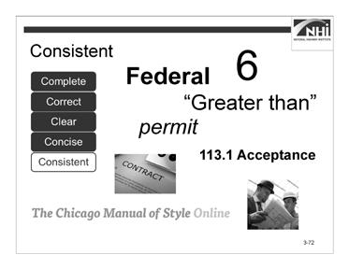

(Allow 10 minutes)

Slide 3-72

### Key Message

The fifth C is consistent. Consistent specifications use common and defined terms consistently: phrases; abbreviations; acronyms; units of measure; and symbols.

### Instruction

Well-written specifications are consistent in:

* Use of numbers.
* Use of capitalization.
* Use of words in text and symbols in tables (e.g., “equal to or greater than” versus “≥”).
* Use of words as nouns or verbs.
* Use of format and organization.
* Reliance on the general provisions.
* Use of style guide and other specification writing guidance.

*Advance to next slide.*

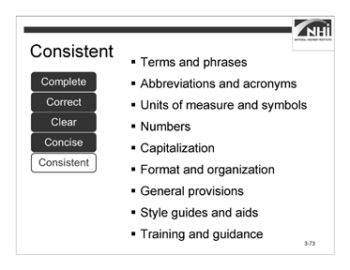

### Instruction (continued)

Slide 3-73

More specifically, to ensure consistency, specification writers should use the following:

*Animate the slide.*

* Defined terms consistent with their definitions.
* Define each term with an understanding of its usage throughout the contract documents.
* If necessary, ensure that usage is correct and that alternate interpretations cannot contradict the intended meaning.
* Avoid common construction words with multiple meanings as well as adjectives and adverbs whose meaning can vary with the reader.
* Phrases consistent with existing guidance.

*Note to instructor:* Every state is different. Participants should refer to the agency’s style guide for guidance on usage and phrasing. Two examples of phrasing choices include the use of “approve” versus “accept” and “as shown on the plans” versus “as required in the plans.”

### Instruction (continued)

*Animate the slide.*

**Ask:** What does the acronym APA represent?

(Answer: The acronym APA has multiple meanings including:

* Engineered Wood Association; which changed its name from the American Plywood Association
* American Planning Association
* American Psychological Association
* American Poolplayers Association
* American Psychiatric Association
* American Payroll Association)
* Abbreviations and acronyms consistent with existing guidance.
* Define all acronyms. An acronym may have various meanings.
* Define all abbreviations. Abbreviations include measurement unit symbols and other short forms that are crucial to understanding a specification’s intent.
* If an abbreviation is not defined in the general provisions, spell it out at its first occurrence. Use abbreviations correctly.
* Only use abbreviations when they will not confuse the reader and not lead to misinterpretation.
* Always check the appropriate subsection in the general provisions of the agency’s standard specifications for accepted abbreviations.

### Instruction (continued)

*Animate the slide.*

* Units of measure and symbols consistent with existing guidance.
* Define all units of measure and symbols.
* Use either the metric system or the customary (English) system for highway specifications. The rules for writing units of measure for these two systems vary significantly.
* Use words in text and symbols in tables.
* Consult the agency’s style guide for rules concerning the units of measure and symbols.

*Animate the slide.*

* Numbers expressed appropriately.
* Always use numerals for dimensions, degrees of temperature, percent, and dollars and cents (e.g., 3 in. by 5 in., 50°C, 20%, $5.50).
* Express clock times and dates in numerals (e.g., 2:10 p.m. on June 15 (omit “th”), 1992. Exceptions to this are the use of the words “noon” and “midnight.” For example, use noon rather than 12 noon, 12:00, or 12:00 p.m.).
* Express decimals in numerals (e.g., 6.235). For quantities less than one, use a zero before the decimal point (e.g., 0.235).
* Omit unneeded zeroes in time and money references (e.g., $200 not

$200.00, and 9 p.m. not 9:00 p.m.).

*Animate the slide.*

* Capitalization minimized and consistently applied. For parties in the contract and defined terms, refer to the agency’s style guide, the general provisions, or the *Chicago Manual of Style*.

*Animate the slide.*

* Formatting and organization.
* Use headings to break up information into logical, understandable pieces to assist the reader in locating information.
* Use consistent headings (e.g., all paragraphs at the same level within a particular subpart should either use or not use headings).
* Use headings with enough information to convey the main point of the paragraph without being so long as to overwhelm the material in the paragraph itself.

### Instruction (continued)

*Animate the slide.*

* General provisions review.

*Note to instructor:* Explain that Lesson 2.1 provided a review of the most significant general provision topics. Participants should spend time outside of class becoming conversant with all the general provision topics and how they affect specification writing.

*Animate the slide.*

* Style guide aids used to ensure consistency. As previously discussed, a style guide should be used when writing specifications. If the agency does not have a style guide, then the specification writer should consider developing one for the agency. A style guide provides the following:
* Consistent language
* Consistent word and number usage
* Consistent format
* Consistent organization

*Animate the slide.*

* Needed training and guidance. Training can help ensure consistent specification writing practices, but guidance, training, and evaluation are necessary to ensure consistent enforcement. Without consistent enforcement, even a well-written specification becomes ineffective.

### Interactivity

N/A

*Advance to the next slide.*

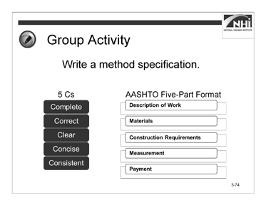

(Allow 65 minutes)

Slide 3-74

### Key Message

An important part of this course is to provide you with an opportunity to develop and write a method specification. Earlier in this lesson, the five Cs were discussed at length. This material is applied in the specification writing activities.

### Instruction

N/A

### Interactivity

(50 minutes activity, 15 minutes debrief)

*Note to instructor:* This is a small group activity. It provides an opportunity for the participants to practice applying the five Cs to write a specification.

Direct participants to the Method Specification Template for a Concrete Sidewalk.

The Method Specification Template for a Concrete Sidewalk is based on the AASHTO five-part format outline created in Module 2. Sections of the template have been completed, including:

* Description of Work
* Materials
* Measurement
* Payment

The section numbers, material references, and other references are taken from the AASHTO Guide Specifications.

The method specification developed will serve as the starting point for the Module 4 small group activity converting a method specification to an end-result specification.

Instruct participants to:

* Work in a small group.
* Review the context and criteria.
* Using the template, write a method specification for constructing a concrete sidewalk.
* Apply the five Cs and the AASHTO five-part format when writing the method specification.
* Use Appendix D: Specification Writer’s Checklist as a resource.
* If style or format is not addressed in the course materials, follow the guidance provided by the agency’s style guide or other applicable standards.
* Complete this task in 30 minutes.

*When ready to continue the activity, advance to the next slide.*

### Interactivity (continued)

#### Context

The agency intends to award a contract to provide for the reconstruction of eight blocks of a state highway through an urban corridor and within a city’s limits. Included in the scope of this contract is the construction of a concrete sidewalk adjacent to new, concrete curb and gutter. The contract also includes the reconstruction of the adjacent state highway asphalt pavement. The contractor is to construct the concrete sidewalk for the length of the project on both sides of the highway. The agency will require the contractor to comply with this specification when performing the sidewalk construction work. The plans show the location and dimensions of the sidewalk and a profile of the sidewalk and bedding course.

#### Criteria

The contractor will need an excavator, hand tools, and a hand-driven compactor to excavate for the bed course, compact the bed course, and set the forms. The contractor will also need to provide all necessary forms and hand tools for placing, consolidating, finishing, jointing, and texturing the concrete.

The materials needed to construct the sidewalk include bed course materials, concrete meeting the specified compressive strength, reinforcing steel, and joint filler similar to that specified in other subsections of the agency’s standard specifications.

* For the bed course, consider specifying a class of aggregate subbase that allows ease of placement and minimal compactive effort.
* For concrete, consider specifying a standard concrete mix that produces the minimum acceptable compressive strength considering the intended use of the sidewalk.
* For reinforcing steel, consider specifying a standard type used in the region or within the jurisdiction where the sidewalk is being placed.
* For the joint filler and curing agent, consider specifying types similar to those required by your agency for concrete pavements.

With regard to the administration of this work, the contractor should notify the engineer 24 hours before beginning the placement of concrete sidewalks. This will give the engineer an opportunity to inspect the bed course, reinforcing, and form work before the concrete pour.

The engineer should base his or her acceptance of the completed sidewalk on the construction of properly located sidewalks using the specified materials and methods in accordance with the plans and specifications. The engineer should not accept the concrete sidewalk if the material used was not as specified, if the contractor did not follow the specified methods, or if the joints or finish were not acceptable.

The engineer will separately measure and pay for completed and accepted sidewalk.

### Interactivity (continued)

#### Method Specification Template for a Concrete Sidewalk 608 Concrete Sidewalk

#### Description of Work

This work consists of constructing a concrete sidewalk.

#### Materials

Provide material for constructing a concrete sidewalk as follows:

* + 1. Bed course material in accordance with Subsection 703.12
    2. Reinforcing steel in accordance with Subsection 711.01
    3. Concrete, Class B, in accordance with Section 601 and Subsection 713.01(B)
    4. Joint filler in accordance with Subsection 707.01(D)
    5. Form release agent approved by the engineer
    6. Curing compound in accordance with Subsection 713.02(C)

#### Construction Requirements

* + 1. Equipment

*Note to instructor*: Participants complete this section.

* + 1. Methods

*Note to instructor*: Participants complete this section.

* + 1. Inspection and Acceptance

*Note to instructor*: Participants complete this section.

#### Measurement

The engineer will measure accepted sidewalk separately by the square foot (square meter) of concrete placed.

#### Payment

The agency will pay for accepted sidewalk in accordance with the contract pay items for sidewalk.

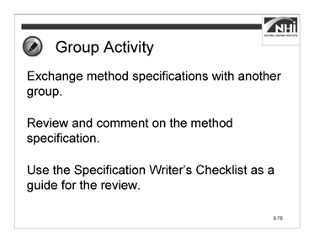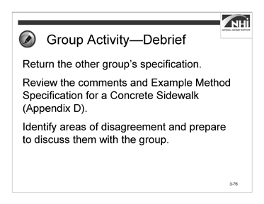

Slide 3-75 Slide 3-76

### Interactivity (continued)

Instruct participants to:

* Exchange your group’s method specification with another group.
* Review and comment on their method specification.
* Use the Appendix D: Specification Writer’s Checklist sections “Mood and Voice” and “The Five Cs of Specification Writing” as a guide for the review.
* Complete this task in 10 minutes.

*When ready to continue the activity, display slide 3-76.*

Instruct participants to:

* Return the group’s specification.
* Review the comments and Appendix E: Example Method Specification for a Concrete Sidewalk.
* Identify areas of disagreement and prepare to discuss these areas.
* Complete this task in 10 minutes.

### Interactivity (continued)

*When ready to debrief, ask the following questions.*

**Ask:** What are your areas of disagreement?

(Answer: Participant questions and answers will vary. As participants share the areas of disagreement, guide the discussion to reach a resolution. Refer to course materials previously covered when necessary.)

**Ask:** How can reviewing each other’s specifications result in better-written specifications?

(Answer: It is unlikely that a new method specification can be written in one draft. Reviewing and rewriting specifications is an essential part of the specification writing process. When creating a schedule, include time for reviewing and rewriting the specification.)

*Advance to the next slide.*

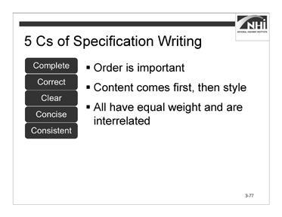

Slide 3-77

(Allow 70 minutes [5 minutes instruction, 65 minutes interactivity])

### Key Message

Each of the five Cs is important on its own. To develop a specification that will perform well requires equal attention to all of the five Cs.

The order in which the five Cs are applied affects the efficiency of the writing process. A specification should be complete and correct before continuing writing for clarity, conciseness, and consistency.

Additionally, the five Cs are interrelated. Writing for one C often affects the other Cs.

### Instruction

*Animate the slide.*

* The order of the five Cs is complete, correct, clear, concise, and consistent. This order is important because it reflects that the content (complete and correct) must be developed before the style (concise, clear, and consistent).

*Animate the slide.*

* In other words, when content changes, the logic, organization, and the way the specification is written changes. Content should be finalized first. Then how to say it clearly, concisely, and consistently should be considered.

When a writing style changes, the content can remain static. Consider the passive- to-active voice rewritten samples. The writing style changed but it did not affect the content of the samples.

### Instruction (continued)

*Animate the slide.*

* The five Cs are highly interrelated.
* Complete and Concise. Specification writers must assign responsibility for all requirements and obligations under the complete C. Specification writers should use the imperative and indicative moods with the active voice under the concise C. These topics are related because the use of the active voice with the imperative and indicative moods helps distinguish responsibilities of the contractor from responsibilities of the agency.
* Consistent and Clear. Specification writers should consistently use words as verbs or nouns under the consistent C. Specification writers should clearly represent the author’s intent in wording and usage of the specification language under the clear C. These topics are related because the consistent use of words as verbs or nouns helps clarify the author’s intent and reduce the possibility for misinterpretation.
* Correct and Consistent. Specification writers should avoid conflicting requirements under the correct C. Specification writers should avoid repeating requirements and creating conflicts under the consistent C. These topics are related because repeated requirements create a greater potential for conflicts due to the multiple locations of information needing revision when the content changes.

*Advance to the next slide.*

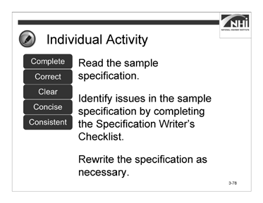

Slide 3-78

### Interactivity

(40 minutes activity, 25 minutes debrief)

*Note to instructor:* This is an individual activity. The purpose of the activity is to implement the 5Cs by rewriting a specification.

Instruct participants to:

* Read the sample specification.
* Use Appendix D: Specification Writer’s Checklist sections “Mood and Voice” and “The Five Cs of Specification Writing” as a guide for the review.
* Rewrite the specification as necessary.
* If style or format is not addressed in the course materials, follow the guidance provided by the agency’s style guide or other applicable standards.
* If additional standards are needed to rewrite the specification, refer to the agency’s specification manual.
* Complete this task in 40 minutes.

*When ready to debrief, advance to the next slide.*

### Interactivity (continued)

#### Sample Specification

“616.03 Construction Requirements. Excavation and backfill shall be according to the requirements of Section 801, “Traffic Control Plan.”

The agency will perform acceptance sampling and testing of the compacted backfill material in accordance with Subsection 208.03 at the frequencies established by the agency in Section 205, “Excavation and Embankment.”

Precast reinforced concrete box culvert units shall be bedded on a foundation of firm and stable material, accurately shaped to conform to their base.

When required by the plans, special bedding material shall be provided as required in Section 616.02. The special bedding material will be furnished at no cost to the agency.

Joints and joint materials shall comply with the requirements of Section 608. Lifting holes shall be filled with mortar or concrete and cured as directed.

When precast boxes are used to form multiple barrel structures, they shall be placed in conformance with the details shown on the plans. Material required between barrels shall be as shown on the plans. The material between barrels will be furnished at no cost to the agency.

Connections of precast boxes to cast-in-place boxes or to any required headwalls, wingwalls, riprap, or other structures shall comply with the details shown on the plans.

Headwalls, wingwalls, and footings shall be according to the details of the plans, except that the overall widths of the headwalls and footings shall be modified to fit the finished width of the various structures.

The number of drainage structures to be furnished will be listed on the plans or in the proposal. The contractor shall protect all drainage structures until the engineer has determined that all construction work has been completed.”

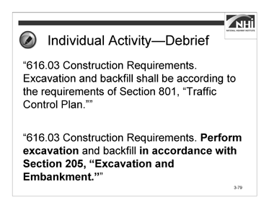

### Interactivity (continued)

Slide 3-79

#### Annotated Sample for Instructor Use

*Note to instructor:* The bolded items throughout indicate some of the more important changes to the revised specification.

**Ask:** What issues did you identify?

(Answer: “616.03 Construction Requirements. **Excavation and backfill shall be according to the requirements of Section 801, “Traffic Control Plan.”**”

This is not the correct section reference.

This sentence is written in the passive voice.)

**Ask:** Which of the five Cs need to be addressed? (Answer: Complete, correct, and concise.)

**Ask:** How should this sentence be rewritten?

*Animate the slide.*

(Answer: “616.03 Construction Requirements. **Excavate** and backfill **in accordance with Section 205, “Excavation and Embankment.”**”)

*Advance to the next slide.*

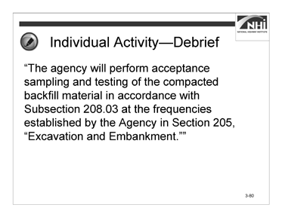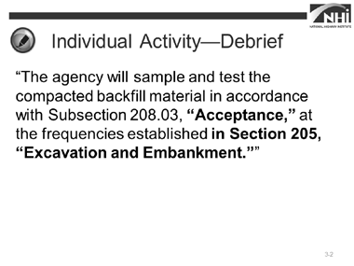

Slide 3-80 Slide 3-81

### Interactivity (continued)

**Ask:** What issues did you identify?

(Answer: “The agency will perform acceptance sampling and testing of the compacted backfill material in accordance with Subsection 208.03 at the frequencies **established by the agency in Section 205, “Excavation and Embankment.”**”

The word “agency” is not capitalized consistently.

The second “by the agency” is redundant and can be deleted. The reference to Subsection 208.03 is incomplete.)

**Ask:** Which of the five Cs need to be addressed? (Answer: Complete, consistent and concise.)

**Ask:** How should this sentence be rewritten?

*Display slide 3-81.*

(Answer: “The agency will sample and test the compacted backfill material in accordance with Subsection 208.03, **“Acceptance,”** at the frequencies established **in Section 205, “Excavation and Embankment.”**”)

*Advance to the next slide.*

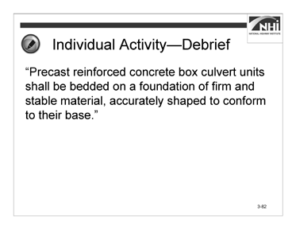

### Interactivity (continued)

Slide 3-82

**Ask:** What issues did you identify?

(Answer: “Precast reinforced concrete box culvert units **shall be bedded** on a foundation of firm and stable material, accurately shaped to conform to **their** base.”

There is no direction or standard provided as to what would constitute adequate bedding. At best, there is the potential for ambiguity, since the contractor and the agency might have different standards with regard to adequate bedding.

Sometimes completeness and conciseness can seem to be in competition. The original specification is shorter and, thus, perhaps assumed to be more concise. However, it is incomplete. This further illustrates the need to first ensure that the specification is complete. Then the specification writer can address making the specification concise.

This sentence is written in the passive voice.)

**Ask:** Which of the five Cs need to be addressed? (Answer: Complete and concise.)

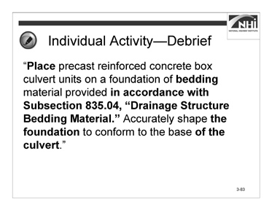

### Interactivity (continued)

Slide 3-83

**Ask:** How should this sentence be rewritten?

*Display slide 3-83.*

(Answer: “**Place** precast reinforced concrete box culvert units on a foundation of **bedding** material provided **in accordance with Subsection 835.04, “Drainage Structure Bedding Material.”** Accurately shape **the foundation** to conform to the base **of the culvert**.”)

*Advance to the next slide.*

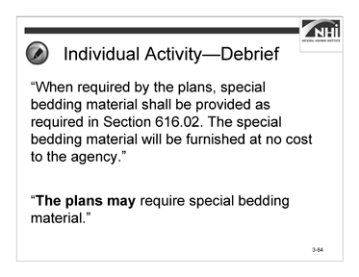

### Interactivity (continued)

Slide 3-84

**Ask:** What issues did you identify?

(Answer: “When required by the plans, special bedding material **shall be provided** as required in **Section 616.02. The special bedding material will be furnished at no cost to the agency.**”

Special bedding material requirements are specified in Section 616.02. There is no need to repeat this requirement. In addition, the measurement and payment provisions should make clear what is and is not included in the unit price. There is no need to repeat the requirement.

This sentence is written in the passive voice. The specification relies on “shall” versus “will” to show contractor responsibility.

There is no need to reference the material requirement because all material requirements are set forth in the material requirement section.

It is both unnecessary and wrong to say that the bedding material “will be furnished at no cost to the agency.” The cost of the special bedding material should be included in the existing unit price for the relevant contract item and will be furnished at no additional cost to the agency. Both of these requirements are already established in the general provisions.)

### Interactivity (continued)

**Ask:** Which of the five Cs need to be addressed? (Answer: Complete and concise.)

**Ask:** How should this sentence be rewritten?

*Animate the slide.*

(Answer: “**The plans may** require special bedding material.”)

*Advance to the next slide.*

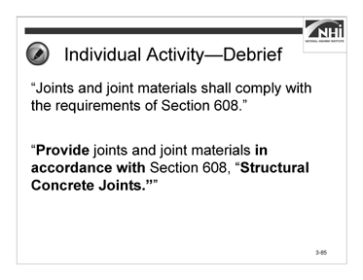

### Interactivity (continued)

Slide 3-85

**Ask:** What issues did you identify?

(Answer: “Joints and joint materials shall comply with the requirements of **Section 608**.”

References to specific sections should usually include the name of the section. This can help in situations where the section number is referenced in error. In this instance, the title of the reference is used for other references, as well.

It is important to consider if the reference is sufficiently precise for the audience to find the information. Include a reference to the joint and joint material subsection in Section 608, if necessary. Add the title of the referenced section.

This sentence is written in the passive voice.)

**Ask:** Which of the five Cs need to be addressed? (Answer: Complete, concise, and consistent.)

**Ask:** How should this sentence be rewritten?

*Animate the slide.*

(Answer: “**Provide** joints and joint materials **in accordance with** Section 608, “**Structural Concrete Joints.”**”)

*Advance to the next slide.*

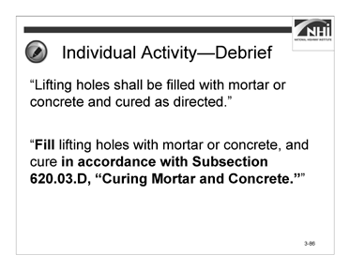

### Interactivity (continued)

Slide 3-86

**Ask:** What issues did you identify?

(Answer: “Lifting holes **shall be filled** with mortar or concrete and cured **as directed.**”

The overused discretionary phrase “as directed” should be deleted. This sentence is written in the passive voice.

The standard for curing should be identified. If a standard is needed to govern the filling of the lifting hole, this should be provided, as well.)

**Ask:** Which of the five Cs need to be addressed? (Answer: Complete, clear, and concise.)

**Ask:** How should this sentence be rewritten?

*Animate the slide.*

(Answer: “**Fill** lifting holes with mortar or concrete, and cure **in accordance with Subsection 620.03.D, “Curing Mortar and Concrete.”**”)

*Advance to the next slide.*

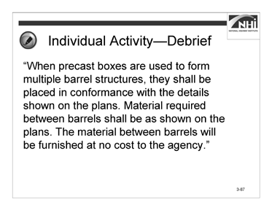

### Interactivity (continued)

Slide 3-87

**Ask:** What issues did you identify?

### (Answer: “When precast boxes are used to form multiple barrel structures, they shall be placed in conformance with the details shown on the plans. Material required between barrels shall be as shown on the plans. The material between barrels will be furnished at no cost to the agency.”

With regard to the second sentence, it is not clear what is required, what is shown on the plans, the type of material, or the method of installation.

The second sentence relies on “shall” versus “will,” but “shall” versus “will” does not work because this is a contractor responsibility, and “will” implies agency responsibility.

The third sentence is unnecessary because the requirement is addressed in the general provisions.

For consistency, the phrase “in compliance with” should be replaced with “in accordance with.”

Articles have been dropped.

The sentences are written in the passive voice.)

**Ask:** Which of the five Cs need to be addressed?

(Answer: Complete, correct, clear, concise, and consistent.)

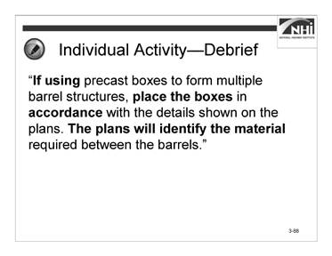

### Interactivity (continued)

Slide 3-88

**Ask:** How should this sentence be rewritten?

*Display slide 3-88.*

(Answer: “**If using** precast boxes to form multiple barrel structures, **place the boxes** in **accordance** with the details shown on the plans. **The plans will identify the material** required between the barrels.”)

*Advance to the next slide.*

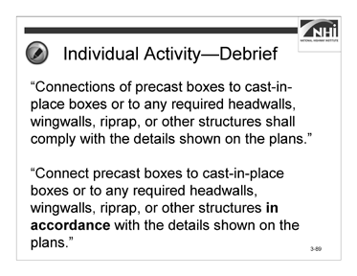

### Interactivity (continued)

Slide 3-89

**Ask:** What issues did you identify?

### (Answer: “Connections of precast boxes to cast-in-place boxes or to any required headwalls, wingwalls, riprap, or other structures shall comply with the details shown on the plans.”

For consistency, the phrase “comply with” should be replaced with “in accordance with.”

The sentence is written in the passive voice.)

**Ask:** Which of the five Cs need to be addressed? (Answer: Complete, concise and consistent.)

**Ask:** How should this sentence be rewritten?

*Animate the slide.*

(Answer: “Connect precast boxes to cast-in-place boxes or to any required headwalls, wingwalls, riprap, or other structures **in accordance** with the details shown on the plans.”)

*Advance to the next slide.*

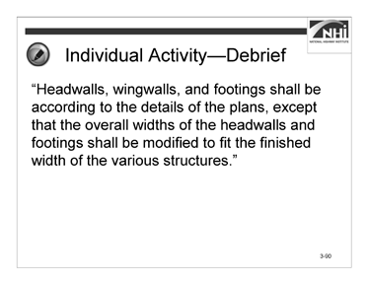

### Interactivity (continued)

Slide 3-90

**Ask:** What issues did you identify?

### (Answer: “Headwalls, wingwalls, and footings shall be according to the details of the plans, except that the overall widths of the headwalls and footings shall be modified to fit the finished width of the various structures.”

Make clear that the connection requirement is static and the width of the two must be modified to meet field conditions. This may be an appropriate place for a discretionary phrase. There is ambiguity as to what the finished width of the structure would be.

For consistency, the phrase “according to” should be replace with “in accordance with.”

This sentence is written in the passive voice.)

**Ask:** Which of the five Cs needs to be addressed? (Answer: Complete, clear, concise, and consistent.)

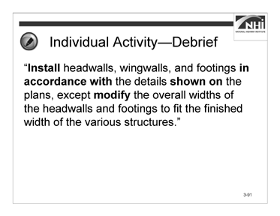

### Interactivity (continued)

Slide 3-91

**Ask:** How should this sentence be rewritten?

*Display slide 3-91.*

(Answer: “**Install** headwalls, wingwalls, and footings **in accordance with** the details **shown on** the plans, except **modify** the overall widths of the headwalls and footings to fit the finished width of the various structures.”)

*Advance to the next slide.*

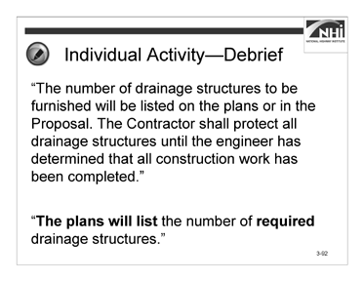

### Interactivity (continued)

Slide 3-92

**Ask:** What issues did you identify?

(Answer: “The number of drainage structures to be furnished will be listed on the **plans or in the proposal. The contractor shall protect all drainage structures until the engineer has determined that all construction work has been completed.**”

There is a potential ambiguity in that it is difficult for the contractor’s and the agency’s on-site representatives to understand where the necessary information is located.

Regarding the second sentence, this concern should already be reliably addressed by the protection of work and acceptance clauses in the general provisions.)

**Ask:** Which of the five Cs needs to be addressed? (Answer: Clear and concise.)

**Ask:** How should this sentence be rewritten?

*Animate the slide.*

(Answer: “**The plans will list** the number of **required** drainage structures.”)

Direct participants to Appendix F: Sample Rewritten to view the complete sample rewritten.

*Advance to the next slide.*



(Allow 2 minutes)

Slide 3-93

### Key Message

As demonstrated in the previous activities, a collaborative process is essential when writing specifications.

### Instruction

A collaborative process exists when specification writers can rely on each other for useful feedback to improve the specification. Establishing a collaborative process is an effective way to ensure quality, especially consistency.

In order for the collaborative process to be successful, specification writers need to be comfortable sharing their work with their peers, reviewing their peers’ work, and giving and receiving constructive feedback.

The review process should be collaborative, not competitive. Feedback should address deficiencies objectively based on the agency’s style guides and policies, content covered in this course, and recognized standards. Use these resources to resolve disagreements with your peers.

### Interactivity

N/A

*Advance to the next slide.*

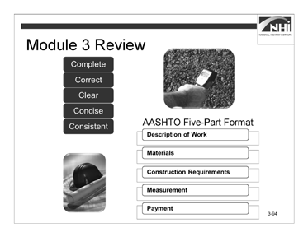

(Allow 5 minutes)

Slide 3-94

### Key Message

This concludes the content for Module 3.

In summary, the agency bears the risk that the contract documents will not properly communicate how the contractor must meet the agency’s expectations for a project. When the following exist in the contract documents, they cause disputes and impact the project: omissions (not complete), errors (not correct), ambiguities (not clear), unnecessary information (not concise), and inconsistencies (not consistent). Because the agency wrote the specifications, the agency is responsible if the specifications perform poorly.

### Instruction

N/A

### Interactivity

*Note to instructor:* This is a partner activity. The purpose of the activity is to review and connect the concepts and content of Module 3.

### Interactivity (continued)

Instruct participants to:

* Work with a nearby partner.
* Review the key learning points and objectives from Module 3.
* Answer the questions.
  + 1. Think about and discuss a situation when a specification was misinterpreted. How can using a consistent writing style prevent this specification from being misinterpreted?

(Answer: Participant answers will vary.)

* + 1. When writing in the imperative mood, the actor is dropped. This course advocates the use of the imperative mood. Why is it acceptable to use the imperative mood, which drops the actor, but not to write in the passive voice?

(Answer: In the passive voice, the actor is unknown or can only be discerned based on the context of the specification. The imperative mood is used only when the specification includes a requirement pertaining to the contractor. As a result, the actor is always known in a specification written in the imperative mood.

* + 1. How can you use the Appendix D: Specification Writer’s Checklist as a resource when writing specifications?

(Answer: Participant answers will vary.)

### Interactivity (continued)

The following are the key learning points in Lesson 3.1:

* The variety of writing styles used by individual specification writers requires a consistent writing style.
* The writing style used can have a major impact on the interpretation of specifications. Inconsistent writing can lead to inconsistent interpretation.
* To use the plain language approach when writing specifications, a writer must think about the audience, organize, write, and test.
* To implement a consistent writing style using the plain language approach, a writer needs proper guidance through a style guide or equivalent guidance document.

The following are the key learning points in Lesson 3.2:

* The active voice is preferred when writing specifications because it is more direct, more concise, more emphatic, and clearer than the passive voice.
* A change from the passive voice to the active voice requires the writer to confirm and emphasize the responsible party.
* The indicative and imperative moods are both used when writing specifications; generally, imperative mood for contractor responsibilities and indicative mood for everything else.

The following are the key learning points in Lesson 3.3:

* To write effective specifications, a writer must use the five Cs of specification writing: complete, correct, clear, concise, and consistent.
* Complete. Complete provisions include all provisions necessary to perform the scope of work.
* Correct. Correct provisions are technically and grammatically correct.
* Clear. Clear provisions can be interpreted only one way.
* Concise. Concise provisions are easy to navigate.
* Consistent. Consistent provisions lead to consistent interpretations.

### Interactivity (continued)

The following are the learning outcomes for Module 3:

* Explain how a consistent writing style can affect the interpretation of specifications.
* Explain the potential benefits of writing in the active voice.
* Rewrite passive voice sentences into the active voice.
* Evaluate specifications to determine the need for imperative or indicative mood.
* State the five Cs used in specification writing.
* Identify potential ambiguities in the wording, given a sample specification.
* Identify the potential benefits of each of the five Cs.
* Write a new specification using the five Cs and the agency’s preferred format.
* Complete a checklist of the information needed before writing or revising a specification.
* Apply the five Cs and the agency’s preferred format to revise the specification, given a sample specification.

# Module 4: Method or End-result Specifications

## Module 4: Method or End-result Specifications

### Lesson Plan

#### Learning Outcomes

This module supports these learning outcomes.

* Write a new specification to a given set of criteria using the five Cs and the agency’s preferred format, given a sample specification.
* Relate the type of specification to the allocation of risk.
* Write an end-result specification to replace a method specification, given an excerpt from a method specification.

#### Instructional Methodology

This module includes the methods of brief instruction, group discussion, partner activity, and small group activity.

#### Time Allocation

150 minutes plus a 15-minute break and 60-minute break

#### Evaluation Plan

Participant learning is evaluated throughout the lesson by instructor-based questioning and assessment, discussion, activity-oriented engagement, and contributions. A final exam at the end of the course completes the evaluation.

#### Resources

* American Association of State Highway and Transportation Officials. *Guide Specifications for Highway Construction*. Ninth Edition, 2008.
* Federal Plain Language Guidelines, May 2011. [http://www.plainlanguage.gov/.](http://www.plainlanguage.gov/)
* Agency’s specification manual(s)
* Oklahoma Department of Transportation, *2009 ODOT Standard Specifications*, 2009.
* Transportation Research Board of the National Academies. SHRP 2 Renewal Project R07. *Performance Specifications for Rapid Highway Renewal, Implementation Guidelines Volume II, Developing and Drafting Effective Performance Specifications: A Guide for Specification Writers*, 2013. Prepublication draft, not edited.
* Transportation Research Board of the National Academies. *Transportation Research Circular E-C173: Glossary of Transportation Construction Quality Assurance Terms*. Sixth Edition, 2013.
* United States Department of Transportation, Federal Highway Administration. *Development and Review of Specifications*. Technical Advisory, OPI – HIAM-20. Washington, DC, March 24, 2010.
* United States Department of Transportation, Federal Highway Administration, Federal Lands Highway. *Specification Writers’ Guide for Federal Lands Highway*. Publication No. FHWA-CFL/TD-08-001, May 2008.
* United States Department of Transportation, Federal Highway Administration, National Highway Institute. Transportation Construction Quality Assurance Course 134064A. Publication No. 08-067.
* Wyoming Department of Transportation. *Standard Specifications for Road and Bridge Construction*, 2010.

#### Pre-Session Planning

Review Appendix O: Instructor’s Course Customization Checklist for details specific to this module.

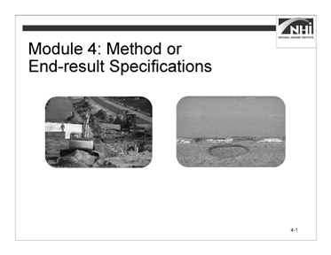

Slide 4-1

(Allow 1 minute)

### Key Message

*Display slide 4-1.*

Module 4 addresses method and end-result specifications in greater detail, the topic of risk as it relates to the type of specifications, and the process of converting a method specification to an end-result specification.

### Instruction

N/A

### Interactivity

N/A

*Advance to the next slide.*

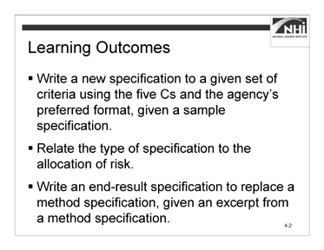

(Allow 1 minute)

Slide 4-2

### Key Message

This module will compare method and end-result specifications and provide practice converting method to end-result specifications.

### Instruction

Review the learning outcomes on the slide.

### Interactivity

N/A

*Advance to the next slide.*

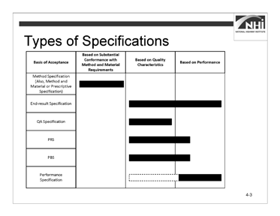

Slide 4-3

(Allow 5 minutes [4 minutes instruction, 1 minute interactivity])

*Note to instructor:* Discussions in the course will be limited to the top five types of specifications. Performance specifications are mentioned here only to illustrate the difference between a true performance specification and the types discussed in this course. In addition, the intent is to show why it would be inappropriate to call any of the five specifications “performance specifications.”

### Key Message

As discussed in Module 2, there are several types of specifications. Generally, the types are grouped under the categories of method specifications and end-result specifications. Under the category of end-result specifications, the types of specifications are divided according to several bases of acceptance. The bases range from quality characteristics to performance. The terms associated with a quality assurance plan were defined in Module 2. This section will focus on the definitions of the types of specifications shown in this table.

#### Graphic of a four column, six row table. Column headings, left to right: Basis of Acceptance, Based on Substantial Conformance with Method and Material Requirements, Based on Quality Characteristics, Based on Performance. Row headings, top to bottom (under Basis of Acceptance): Method Specification (Also, Method and Material or Prescriptive Specification), End-result Specification, QA Specification, PRS, PBS, Performance Specification. Some of the rows have filled in box, relating to the text. Types of Specifications

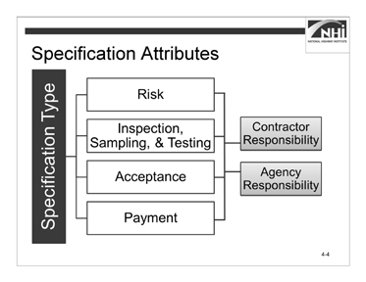

Slide 4-4

### Instruction

*Display slide 4-4.*

There are similar factors to consider across the five types of specifications. These attributes include the following:

* Risk
* Inspection, sampling, and testing
* Acceptance
* Payment

Contractor responsibility and agency responsibility should be considered within these attributes.

It is important not to combine method specifications with the other four types of specifications.

Under a method specification, the agency bears the risk of the specified method and materials producing a result of the desired quality; however, for the four other types of specifications, the contractor bears the risk of the method producing a quality product. If method specifications are combined with the other types of specifications, the allocation of risk becomes confused.

### Interactivity

(1 minute activity)

*Note to instructor:* This is an individual activity. The purpose of this activity is for participants to complete the Matrix of Attributes table in the workbook as each type of specification is discussed.

Instruct participants to:

* Review the Matrix of Attributes noting the rows for each specification type.
* Write notes for each section in the matrix as the instructor discusses each specification type.

*Advance to the next slide.*

#### Matrix of Attributes

*(This table is located in the Participant Workbook.)*

Method Specification

|  |  |
| --- | --- |
| **Attribute** | **Notes** |
| **Risk** |  |
| **Contractor Responsibility** |  |
| **Agency Responsibility** |  |
| **Acceptance** |  |
| **Payment** |  |
| **Advantages** |  |
| **Disadvantages** |  |

### Interactivity (continued)

End-result Specification

|  |  |
| --- | --- |
| **Attribute** | **Notes** |
| **Risk** |  |
| **Contractor Responsibility** |  |
| **Agency Responsibility** |  |
| **Acceptance** |  |
| **Payment** |  |
| **Advantages** |  |
| **Disadvantages** |  |

Quality Assurance Specification

|  |  |
| --- | --- |
| **Attribute** | **Notes** |
| **Risk** |  |
| **Contractor Responsibility** |  |
| **Agency Responsibility** |  |
| **Acceptance** |  |
| **Payment** |  |

### Interactivity (continued)

Performance-related Specification

|  |  |
| --- | --- |
| **Attribute** | **Notes** |
| **Risk** |  |
| **Contractor Responsibility** |  |
| **Agency Responsibility** |  |
| **Acceptance** |  |
| **Payment** |  |

Performance-based Specification

|  |  |
| --- | --- |
| **Attribute** | **Notes** |
| **Risk** |  |
| **Contractor Responsibility** |  |
| **Agency Responsibility** |  |
| **Acceptance** |  |
| **Payment** |  |

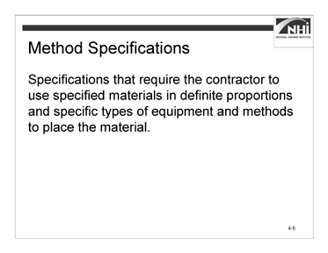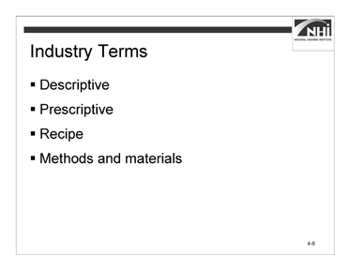

Slide 4-5 Slide 4-6

(Allow 13 minutes [8 minutes instruction, 5 minutes interactivity])

### Key Message

Method specifications require the contractor to use specified materials in definite proportions and specific types of equipment and methods to place the material. Typically, method specifications are based on methods and materials that have historically produced satisfactory results. However, they do not allow for contractor innovation.

### Instruction

*Display slide 4-6.*

There are several interchangeable terms used in the industry in addition to the term method specifications. These items include:

* Descriptive
* Prescriptive
* Recipe
* Methods and materials

For this class, method specification is the term used.

*Advance to the next slide.*

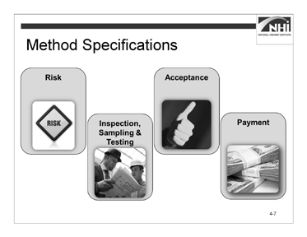

### Instruction (continued)

Slide 4-7

There are several characteristics of method specifications.

*Animate the slide.*

Method specifications place the most control, responsibility, and risk in the hands of the agency. They provide a “cookbook” with specific “recipes” for the contractor to follow.

The risk of producing a result of the intended quality is minimized for the contractor and maximized for the agency because the contractor is not responsible for the ultimate quality or performance. The contractor is responsible only for executing the work as specified using the specified materials.

*Animate the slide.*

Method specifications rely on agency inspection, sampling, and testing.

### Instruction (continued)

*Animate the slide.*

Method specifications base acceptance on “reasonable conformance” or “substantial compliance.” While these terms may seem somewhat subjective, remember that a method specification provides specific material and equipment requirements. It also describes specific methods or procedures to follow to perform the work. Consequently, the determination of reasonable conformance or substantial compliance is founded on a substantial number of objective criteria, such as the use of specified materials, equipment, and procedures.

This is not to say there is no subjectivity, just that there are many objective measures of compliance.

If test results are used as a component of the acceptance determination, usually only individual or representative field samples are taken. These individual results may fail to recognize the inherent variability in the material itself, potentially leading to disputes between the contractor and agency over acceptance decisions.

*Animate the slide.*

Method specifications typically pay 100% across a range of quality.

*Advance to the next slide.*

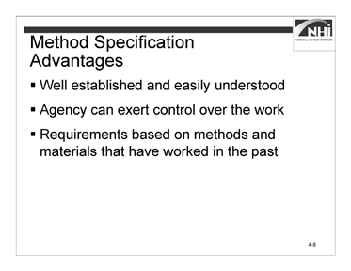

### Instruction (continued)

Slide 4-8

There are advantages and disadvantages to each type of specification. In general, when discussing the advantages and disadvantages of the specification types, where these specifications differ is in how they define what the contractor must deliver and how much latitude they extend to contractors to meet project requirements.

The advantages of method specifications include:

* Method specifications are well established, easily understood, and applicable to a wide range of topic areas.
* The agency can exert significant control over the work.
* Requirements are based on methods and materials that have worked in the past, minimizing risk associated with newer or less proven methods or with varying contractor performance

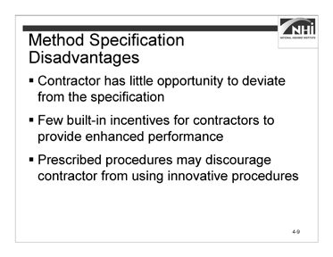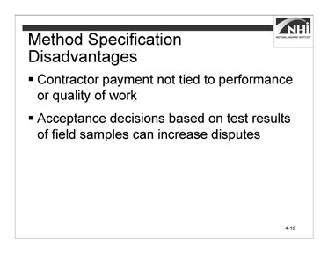

Slide 4-9 Slide 4-10

### Instruction (continued)

The disadvantages of method specifications include:

* The contractor has little opportunity to deviate from the specification, and, if the specifications are met, is not responsible for performance deficiencies of the end product. Essentially, the agency retains performance risk.
* Method specifications lack built-in incentives for contractors to provide enhanced performance (e.g., cost, time, and quality).
* The prescribed procedures may prevent or discourage the contractor from using the most cost-effective or innovative procedures and equipment to perform the work.

*Display slide 4-10.*

* Contractor payment is not tied to the performance or quality of the work.
* Acceptance decisions based on test results of individual field samples can increase the potential for disputes.

*Advance to the next slide.*

### Interactivity

(5 minutes activity)

*Note to instructor:* This is a group discussion. The purpose of this activity is for participants to identify an example of a method specification.

Refer to the agency’s standard specification book to confirm participant answers. If participants are unable to give examples, use the examples you identified in the pre- session planning. If the agency does not have a standard specification book, use the sample found in Appendix G: Sample Method Specification.

**Ask:** What are examples of a method specification in your standard specification book?

(Answer: The answer is dependent upon which specification the participant selects as an example. The instructor will have to read the example and then quickly determine if the participant has correctly identified a method specification. The instructor should have a suitable example prepared prior to the start of the class.)

**Ask:** What are the clues that indicated this is a method specification?

(Answer: The answer is dependent upon the chosen specification. In general, the chosen specification should specify materials, equipment, and the method of construction, not quality characteristics.)

*Advance to the next slide.*

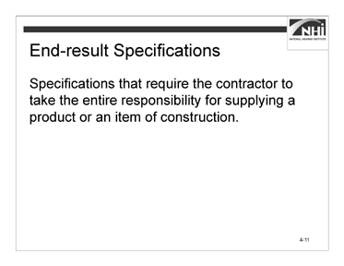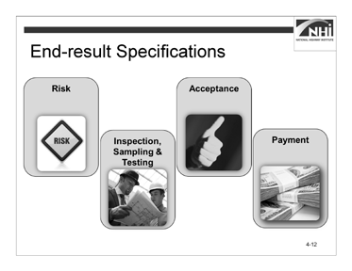

Slide 4-11 Slide 4-12

(Allow 12 minutes [7 minutes instruction, 5 minutes interactivity])

### Key Message

End-result specifications require the contractor to take the entire responsibility for supplying a product or component of the project. The transportation agency’s responsibility is to either accept or reject the final product or component or to apply a pay adjustment commensurate with the degree of compliance with the specifications.

### Instruction

*Display slide 4-12.*

There are several characteristics of end-result specifications.

*Animate the slide.*

End-result specifications assign the contractor complete responsibility and latitude in determining the procedures and equipment used to produce the product. True end- result specifications place no or minimal restrictions on the materials to be used or on the methods of incorporating them into the completed product. The risk is moderate for the contractor because the contractor is responsible for quality but not for performance. The risk increases further for the contractor because there is no intermediate inspection, sampling, and testing. The risk to the agency is reduced because the contractor has the risk that the chosen materials or methods will not result in a product that achieves the desired quality. The agency still has the risk that its acceptance criteria will result in the construction of a project with the desired performance.

*Animate the slide.*

Quality control sampling, testing, and inspection are the responsibility of the contractor or producer.

### Instruction (continued)

*Animate the slide.*

End-result specifications base acceptance on sampling and testing of the final in-place product. They stress sampling and testing, as opposed to inspection, as the primary approach to determining agency acceptance.

*Animate the slide.*

End-result specifications may include a price adjustment based upon the degree of compliance with the specification criteria.

### Interactivity

(5 minutes activity)

*Note to instructor:* This is a group discussion. The purpose of this activity is for participants to identify an example of an end-result specification.

Refer to the agency’s standard specification book to confirm participant answers. If participants are unable to give examples, use the examples you identified in the pre- session planning. If the agency does not have a standard specification book, use the sample found in Appendix H: Sample End-result Specification.

**Ask:** What are examples of an end-result specification in your standard specification book?

(Answer: The answer is dependent upon which specification the participant selects as an example. The instructor will have to read the example and then quickly determine if the participant has correctly identified an end-result specification. The instructor should have a suitable example prepared prior to the start of the class.)

**Ask:** What are the clues that indicated this is an end-result specification?

(Answer: The answer is dependent upon the chosen specification. In general, the chosen specification should not specify the use of materials, equipment, or methods. Instead, the specification should establish criteria for acceptance measured when the work is completed.)

*Advance to the next slide.*

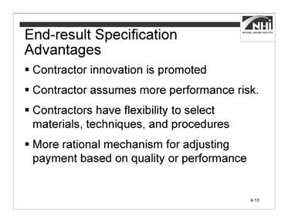

### Instruction (continued)

Slide 4-13

The advantages of end-result specifications include:

* End-result specifications promote contractor innovation.
* The contractor assumes more performance risk.
* Contractors have the flexibility to select materials, techniques, and procedures to improve the quality or economy, or both, of the end product.
* An end-result specification can provide a more rational mechanism for adjusting payment based on the quality or performance of the as-constructed facility.

*Advance to the next slide.*

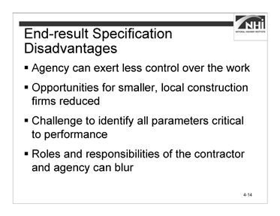

### Instruction (continued)

Slide 4-14

The disadvantages of end-result specifications include:

* The agency can exert less control over the work.
* Opportunities for smaller, local construction firms may be reduced.
* It can be challenging to identify all of the parameters critical to performance and to establish related thresholds.
* Roles and responsibilities of the contractor and agency can blur if not adequately defined in the specifications or contract documents.

The advantages and disadvantages of end-result specifications generally apply to the quality assurance, performance-related, and performance-based specifications.

Consequently, the advantages and disadvantages of these three types of specifications will not be addressed when we introduce these types of specifications later in this section.

*Advance to the next slide.*

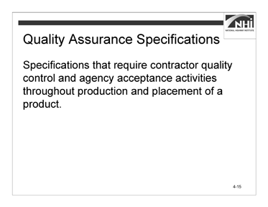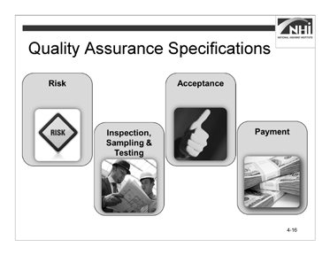

Slide 4-15 Slide 4-16

(Allow 10 minutes [5 minutes instruction, 5 minutes interactivity])

### Key Message

Quality assurance specifications require contractor quality control and agency acceptance activities throughout production and placement of a product. Final acceptance of the product is usually based on a statistical sampling of the measured quality level for key quality characteristics. These specifications recognize the inherent variability of materials.

### Instruction

*Display slide 4-16.*

There are several characteristics of quality assurance specifications.

*Animate the slide.*

The risk is moderate for the contractor because the contractor is responsible for quality but not for performance. Some contractors may view quality assurance specifications as riskier, at least until the contractor has implemented the necessary management systems and training to ensure that the staff can develop and implement the right methods and quality control practices to ensure that the contractor achieves the specified quality characteristics.

The risk to the agency is reduced because the contractor has the risk that the chosen materials or methods will not result in a product that achieves the desired quality. The agency still has the risk that its acceptance criteria will not result in the construction of a project with the desired performance.

### Instruction (continued)

*Animate the slide.*

Quality assurance specifications assign quality control sampling, testing, and inspection to the contractor and include acceptance sampling, testing, and inspection by the agency.

*Animate the slide.*

They identify the specific quality characteristics that are measured for acceptance.

*Animate the slide.*

Quality assurance specifications provide price adjustments related to the quality level of the product. Payment increases for superior quality work, typically 101-105%. Some agencies may pay as much as 110-115%. Payment is reduced for lesser quality work, typically 50-99%.

### Interactivity

(5 minutes activity)

*Note to instructor:* This is a group discussion. The purpose of this activity is for participants to identify an example of a quality assurance specification.

Refer to the agency’s standard specification book to confirm participant answers. If participants are unable to give examples, use the examples you identified in the pre- session planning. If the agency does not have a standard specification book, use the sample found in Appendix I: Sample Quality Assurance Specification.

### Interactivity (continued)

**Ask:** What are examples of quality assurance specifications in your standard specification book?

(Answer: The answer is dependent upon which specification the participant selects as an example. The instructor will have to read the example and then quickly determine if the participant has correctly identified a quality assurance specification. The instructor should have a suitable example prepared prior to the start of the class.)

**Ask:** What are the clues that indicated this is a quality assurance specification?

(Answer: The answer is dependent upon the chosen specification. In general, the chosen specification should specify quality criteria that are evaluated throughout the performance of the work.)

*Advance to the next slide.*

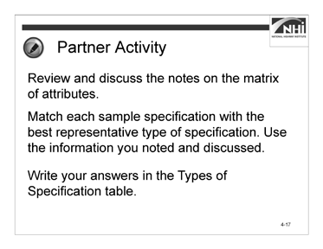

Slide 4-17

(Allow 20 minutes [2 minutes instruction, 18 minutes interactivity])

### Key Message

The attributes of each type of specification aid in identifying the type of specification and distinguishing it from other types.

### Instruction

N/A

### Interactivity

(8 minutes activity, 10 minutes debrief)

*Note to instructor:* This is a partner activity. The activity provides an opportunity for the participants to review and use the matrix of attributes to determine a specification’s type.

Instruct participants to:

* Work with a partner.
* Review and discuss the notes on the matrix of attributes.
* Match each sample specification with the best representative type of specification. Use the information you noted and discussed.
* Write your answers in the Types of Specification table.
* Complete this task in 8 minutes.

*When ready to debrief, advance to the next slide.*

### Interactivity (continued)

#### Types of Specifications

|  |  |
| --- | --- |
| **Sample Specification** | **Type of Specification** |
| **609.4.4 Finishing.** When using forms, trowel exposed surfaces smooth and give a fine brush finish with brush strokes parallel to the curb line. After removing forms, fill surface blemishes that will be exposed with grout and finish.  When using the slip-form method, remove blemishes and give surfaces that will be exposed in the completed item a fine brush finish with brush strokes parallel to the line of the curb. |  |
| **609.4.6 Surface Tolerance.** Ensure that the finished top and face of the curb are true and straight and that the top surfaces are of uniform width and free from irregularities. Do not leave the finished surface with variation greater than 3/16 in. [5 mm] every 10 ft. [3 m] in any direction. Correct excess variation by removing and replacing the curb section. |  |
| **605.03. Concrete Production.** The contractor shall provide quality control measures for the production of concrete in accordance with Section 604. The engineer will not sample or test for quality control or assist in controlling the contractor's production operations. Continued production of concrete which does not meet specification with negative pay adjustment, in lieu of making adjustments to bring the work into conformance, will result in project shutdown until necessary adjustments are made. |  |
| **401.16 Density.** Acceptance will be based on lots and sublots in accordance with 401.07.  Density of the compacted dense graded mixture will be determined from cores except where:   1. the total planned lay rate to be placed over a shoulder existing prior to the contract award is less than 385 lb./sq. yd. (210 kg/m2); or 2. the 1st lift of material placed at less than 385 lb./sq. yd. (210 kg/m2) over a shoulder existing prior to the contract award.   Density of any random core location(s) in these areas will be assigned a value of 92.0% MSG and compaction shall be in accordance with 402.15. |  |

|  |  |
| --- | --- |
| **Sample Specification** | **Type of Specification** |
| **716.03 General Requirements.** The contractor shall submit a quality control plan, QCP, in accordance with ITM 803. The QCP shall be submitted to the engineer for review and acceptance, at least 15 days prior to the start of trenchless pipe installation operations**.** |  |
| **5. Preparing Pavement Surface.** Prepare the pavement surface to receive the chip seal. Clean pavements requiring treatment with a motorized power broom to remove loose material. Use a hand broom to clean cracks and other areas inaccessible by power broom. Use pick-up sweepers adjacent to lawns or roadways with curb and gutter. |  |

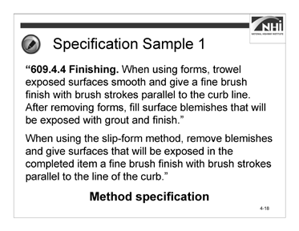

### Interactivity (continued)

Slide 4-18

Given the variety of types of specifications and the significant overlap between the types, it is often difficult to clearly identify one specification type from another without looking at the entire specification section. Additionally, specification sections may have attributes of multiple types of specifications. For instance, even though a quality assurance specification also contains an equipment requirement, it does not mean that the specification becomes a method specification instead of a quality assurance specification. Most specifications in use today are hybrid specifications.

#### Specification Sample 1

“**609.4.4 Finishing.** When using forms, trowel exposed surfaces smooth and give a fine brush finish with brush strokes parallel to the curb line. After removing forms, fill surface blemishes that will be exposed with grout and finish.

When using the slip-form method, remove blemishes and give surfaces that will be exposed in the completed item a fine brush finish with brush strokes parallel to the line of the curb.”

**Ask:** Who will share their answer for the first sample specification?

*Animate the slide.*

(Answer: Method specification)

*Advance to the next slide.*

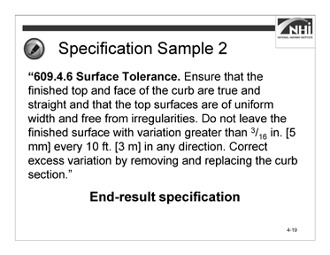

### Interactivity (continued)

Slide 4-19

#### Specification Sample 2

“**609.4.6 Surface Tolerance.** Ensure that the finished top and face of the curb are true and straight and that the top surfaces are of uniform width and free from irregularities. Do not leave the finished surface with variation greater than 3/16 in. [5 mm] every 10 ft. [3 m.] in any direction. Correct excess variation by removing and replacing the curb section.”

**Ask:** Who will share their answer for the second sample specification?

*Animate the slide.*

(Answer: End-result specification)

*Advance to the next slide.*

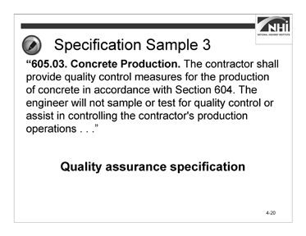

### Interactivity (continued)

Slide 4-20

#### Specification Sample 3

“**605.03. Concrete Production.** The contractor shall provide quality control measures for the production of concrete in accordance with Section 604. The engineer will not sample or test for quality control or assist in controlling the contractor's production operations. Continued production of concrete which does not meet specification with negative pay adjustment, in lieu of making adjustments to bring the work into conformance, will result in project shutdown until necessary adjustments are made.”

**Ask:** Who will share their answer for the third sample specification?

*Animate the slide.*

(Answer: Quality assurance specification.)

*Advance to the next slide.*

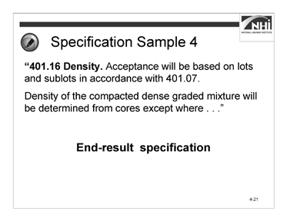

### Interactivity (continued)

Slide 4-21

#### Specification Sample 4

“**401.16 Density.** Acceptance will be based on lots and sublots in accordance with 401.07.

Density of the compacted dense graded mixture will be determined from cores except where:

1. the total planned lay rate to be placed over a shoulder existing prior to the contract award is less than 385 lb./sq. yd. (210 kg/m2); or
2. the 1st lift of material placed at less than 385 lb./sq. yd. (210 kg/m2) over a shoulder existing prior to the contract award.

Density of any random core location(s) in these areas will be assigned a value of 92.0% MSG and compaction shall be in accordance with 402.15.”

**Ask:** Who will share their answer for the fourth sample specification?

*Animate the slide.*

(Answer: End-result specification)

*Advance to the next slide.*

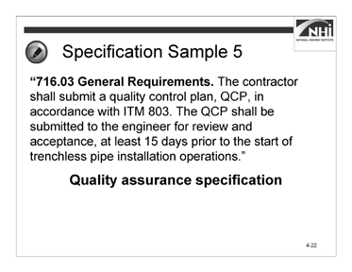

### Interactivity (continued)

Slide 4-22

#### Specification Sample 5

“**716.03 General Requirements.** The contractor shall submit a quality control plan, QCP, in accordance with ITM 803. The QCP shall be submitted to the engineer for review and acceptance, at least 15 days prior to the start of trenchless pipe installation operations.”

**Ask:** Who will share their answer for the fifth sample specification?

*Animate the slide.*

(Answer: Quality assurance specification. A quality control plan (QCP) requirement that is typically an attribute of a quality assurance specification. This specification sample could also be an end-result specification as nothing prevents an end-result specification from having a QCP requirement.)

*Advance to the next slide.*

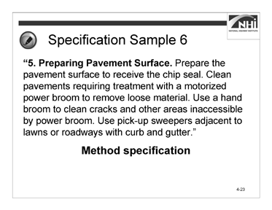

### Interactivity (continued)

Slide 4-23

#### Specification Sample 6

“**5. Preparing Pavement Surface.** Prepare the pavement surface to receive the chip seal. Clean pavements requiring treatment with a motorized power broom to remove loose material. Use a hand broom to clean cracks and other areas inaccessible by power broom. Use pick-up sweepers adjacent to lawns or roadways with curb and gutter.”

**Ask:** Who will share their answer for the sixth sample specification?

*Animate the slide.*

(Answer: Method specification. This specification sample prescribes equipment and methods for performing the work.)

*Advance to the next slide.*

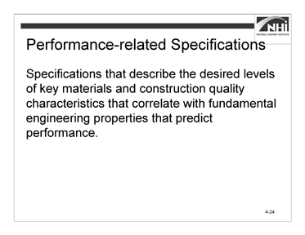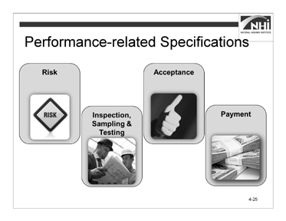

Slide 4-24 Slide 4-25

(Allow 7 minutes [4 minutes instruction, 3 minutes interactivity])

### Key Message

Performance-related specifications describe the desired levels of key materials and construction quality characteristics that correlate with fundamental engineering properties that predict performance. Performance-related specifications are like quality assurance specifications. They specify only the product quality characteristics measured at the time of construction and do not specify the desired long-term product performance. They differ from quality assurance specifications because performance- related specifications are based on mathematical models to quantify the relationship between key materials and construction quality characteristics and product performance.

### Instruction

*Display slide 4-25.*

There are several characteristics of performance-related specifications.

*Animate the slide.*

The risk is moderate for the contractor because the contractor is responsible for quality but not for performance. Some contractors may view performance-related specifications as riskier, at least until the contractor has implemented the necessary management systems and training to ensure that its staff can develop and implement the right methods and quality control practices to ensure that the contractor achieves the specified quality characteristics. The risk to the agency is reduced because the contractor has the risk that the chosen materials or methods will not result in a product that achieves the desired quality. The agency, however, still has the risk that its acceptance criteria will not result in the construction of a project with the desired performance although this risk has been reduced because the acceptance criteria have been related to actual performance.

### Instruction (continued)

*Animate the slide.*

These characteristics, such as air voids in asphalt concrete and compressive strength of pre-cast concrete, are amenable to acceptance testing at the time of construction.

*Animate the slide.*

Performance-related specifications base acceptance on key quality characteristics found to correlate with fundamental engineering properties that predict performance.

*Animate the slide.*

They allow for price adjustments related to the expected life-cycle cost (LCC) of the constructed transportation facility.

### Interactivity

(3 minutes activity)

*Note to instructor:* This is a group discussion. The purpose of the activity is to understand the potential difficulty distinguishing a performance-related specification from a quality assurance specification.

**Ask:** For method, end-result, and quality assurance specifications, you were asked to find examples that show how they look and how they might differ from each other. If asked to find an example of a performance-related specification in your standard specifications or somewhere else, would you be able to distinguish between a quality assurance specification and this performance-related specification? If not, why not?

### Interactivity (continued)

(Answer: You cannot because performance-related specifications and quality assurance specifications both base acceptance on quality characteristics. The difference between a quality assurance specification and a performance-related specification is in how the quality characteristic is determined. Essentially, the chosen quality characteristic is analytically correlated to a fundamental engineering property, which is itself correlated to performance. In essence, the quality characteristic is an indicator of performance. In a quality assurance specification, this connection between the quality characteristic and performance has not been established analytically. The difference between a quality assurance specification and a performance-related specification can be recognized if the quality characteristics used to determine each is known. Generally, that cannot be determined by reviewing the specification.)

*Advance to the next slide.*

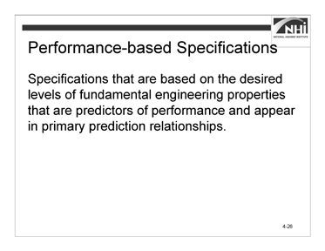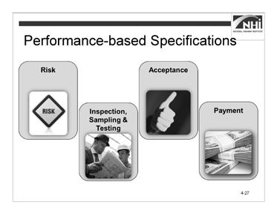

Slide 4-26 Slide 4-27

(Allow 7 minutes [4 minutes instruction, 3 minutes interactivity])

### Key Message

Performance-based specifications are based on the desired levels of fundamental engineering properties (e.g., resilient modulus, creep properties, and fatigue properties). These properties are predictors of performance and appear in primary prediction relationships (e.g., models can be used to predict pavement stress, distress, or performance from combinations of predictors that represent traffic, environmental, roadbed, and structural conditions).

### Instruction

*Display slide 4-27.*

There are several characteristics of performance-based specifications.

*Animate the slide.*

The contractor’s risk is higher than the other types of specifications discussed because the contractor is responsible for meeting the specified fundamental engineering properties. The risk to the agency is reduced, because the contractor has the risk that the chosen materials or methods will not result in a product that achieves the desired quality. Though the agency still has some risk that its acceptance criteria will not result in the construction of a project with the desired performance, this risk is reduced to a minimum because acceptance is based on the actual fundamental engineering properties that affect performance.

### Instruction (continued)

*Animate the slide.*

Quality control sampling, testing, and inspection are the responsibility of the contractor or producer. Performance-based specifications base acceptance on sampling and testing of the in-place product. They stress sampling and testing, as opposed to inspection, as the primary approach to determine agency acceptance.

*Animate the slide.*

Performance-based specifications base acceptance on measurement of the performance-predicting fundamental engineering properties of the finished product. Acceptance limits are established using a statistically valid basis.

*Animate the slide.*

Performance-based specifications allow for price adjustments based on the expected life-cycle cost of the constructed transportation facility.

Performance-based specifications use mathematical models to quantify the relationship between the fundamental engineering properties measured and product performance. Complete performance-based specifications do not yet exist. Many agencies use this type of specification as developed by SHRP for the Superpave Performance Graded Asphalt Binder (PGAB) specifications. All of a product’s constituent materials and their related fundamental engineering properties must be included in order to have complete models to predict performance of that product. Other performance-based test methods have not been fully developed.

### Interactivity

(3 minutes)

*Note to instructor:* This is a group discussion. The purpose of the activity is to understand why potential difficulty exists in distinguishing a performance-based specification from a performance-related or a quality assurance specification.

**Ask:** For method, end-result, and quality assurance specifications, you were provided with examples to show how they look and how they might be different from each other. If asked to find an example of a performance-based specification in your standard specifications or somewhere else, would you be able to distinguish it from a quality assurance specification or a performance-related specification? Why or why not?

### Interactivity (continued)

(Answer: You cannot tell the difference between quality assurance and performance- based specifications, and performance-related and performance-based specifications because all three base acceptance on quality characteristics. The difference between the three types of specifications is as follows:

* + The quality assurance specification bases acceptance on a quality characteristic that may not necessarily be related to performance.
  + A performance-related specification bases acceptance on a quality characteristic that is analytically correlated to a fundamental engineering property, which is itself correlated to performance.
  + A performance-based specification bases acceptance on a quality characteristic that is an actual fundamental engineering property related to performance.)

*Advance to the next slide.*

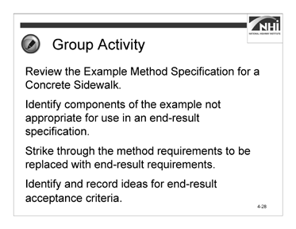

(Allow 60 minutes)

Slide 4-28

*Note to instructor:* The interactivity has two parts – each part is a small group activity.

### Key Message

In Module 3, we wrote a new method specification. During the activity, you will convert the method specification for a concrete sidewalk to an end-result specification.

### Instruction

N/A

### Interactivity Part 1

(10 minutes activity, 10 minutes debrief)

*Note to instructor:* This is a small group activity. It provides an opportunity for the participants to review an example method specification and identify the parts of the example method specification that are inappropriate for an end-result specification. Additionally, participants will brainstorm ideas for end-result acceptance criteria and replace method requirements with end-result requirements.

Instruct participants to:

* Work in a small group.
* Using the context, review the Example Method Specification for a Concrete Sidewalk.
* Identify the components of the example that are not appropriate for use in an end- result specification.
* Strike through the method requirements to be replaced with end-result requirements. There are two types of strikethroughs.
* Requirements that you can delete because they are no longer needed.
* Requirements that you can delete, but must replace with appropriate quality standards to ensure that the agency gets the concrete sidewalk it needs.
* As you strike through the requirements, identify and record ideas for end-result acceptance criteria that might be used to replace the deleted method specification requirements.
* Complete this task in 10 minutes.

### Interactivity Part 1 (continued)

#### Context

The agency intends to award a contract to provide for the reconstruction of eight blocks of a state highway through an urban corridor and within a city’s limits. Included in the scope of this contract will be the construction of a concrete sidewalk adjacent to new, concrete curb and gutter to be reconstructed as part of the same contract. The contract will also include the reconstruction of the adjacent state highway asphalt pavement. The concrete sidewalk will be constructed for the length of the project on both sides of the highway. The contractor constructing the sidewalk will be required to comply with this specification when performing the sidewalk construction work. The location and dimensions of the sidewalk and a profile of the sidewalk and bedding course are shown in the plans for the project.

The end-result specification should provide pay adjustments related to the compressive strength of the concrete.

### Interactivity Part 1 (continued)

#### Example Method Specification for a Concrete Sidewalk

(This specification was developed based on the AASHTO Guide Specifications. The section numbers and references are based on appropriate references from the AASHTO Guide Specification.)

#### Description of Work

This work consists of constructing a concrete sidewalk.

#### Materials

Provide material for constructing a concrete sidewalk as follows:

* + 1. Bed course material in accordance with Subsection 703.12
    2. Reinforcing steel in accordance with Subsection 711.01
    3. Concrete, Class B, in accordance with Section 601 and Subsection 713.01(B)
    4. Joint filler in accordance with Subsection 707.01(D)
    5. Form release agent approved by the engineer
    6. Curing compound in accordance with Subsection 713.02(C)

#### Construction Requirements

Construct concrete sidewalk using the equipment and methods in accordance with the following requirements:

* + 1. Equipment
       - Excavator and hand tools for excavation and placement of bed course material.
       - Hand-driven compactor for compaction.
       - Forms and hand tools for placing, consolidating, finishing, jointing, and texturing the concrete.
    2. Methods
       - *Excavating.* Excavate to the depth and width necessary to allow for the proper depth of the bed course material and the installation and bracing of the forms. Replace soft and yielding material with the specified bed course material.

Place, shape, and compact the bed course material to the line and grade established by the plans.

### Interactivity Part 1 (continued)

* + - * *Forms.* Use full-depth forms that, when properly braced, are strong enough to resist the concrete pressure. Maintain horizontal and vertical alignment. Use clean forms and coat with a form-release agent.
      * *Reinforcing Steel*. Place reinforcing steel as specified in Subsection 809.
      * *Placing Concrete.* Moisten the foundation prior to placing concrete.

Proportion, mix, and place as specified in Subsection 601. Place uniformly in one course.

* + - * *Finishing.* Float and apply a light broomed finish. Edge all outside slab and all joint edges to a ¼ in. (6 mm) radius.
      * *Joints.* Fill expansion joints with the specified preformed expansion joint filler. Section the sidewalk using false joints at 5 ft. (1.5 m) intervals ⅛ in. (3 mm) wide and at least 1 in. (25 mm) deep using a jointing tool. Match curb or pavement joints.
      * Form full-depth construction joints around all appurtenances, such as manholes and utility poles. Install full-depth preformed expansion joint filler between concrete sidewalks and structures.
      * *Curing.* Cure concrete as specified in Subsection 808.03(I) for 72 hours. Do not allow pedestrian and vehicle traffic on the concrete for 7 days unless the surface is protected by planks, plywood, or a minimum 1 in. (25 mm) sand layer. Do not place protection directly on the concrete for a minimum 12 hours after application of the curing compound.
    1. Inspection and Acceptance
       - Notify the engineer 24 hours before beginning the placement of concrete sidewalks.
       - The engineer will inspect the form work, bed course, and reinforcing steel installation before concrete is placed.

#### Measurement

The engineer will measure accepted sidewalk separately by the square foot (square meter) of concrete placed.

#### Payment

The agency will pay for accepted sidewalk in accordance with the contract pay items for sidewalk.

### Interactivity Part 1 (continued)

*Note to instructor:* When appropriate, reinforce the previous discussion regarding the fact that there are two types of strikethroughs – strikethroughs to eliminate provisions that are no longer needed and strikethroughs used to remove requirements that are not appropriate for inclusion in an end-result specification, but which must be replaced by appropriate quality standards.

As you move through each section, ask participants to share a few ideas for end-result acceptance criteria. For example, if a specific concrete mix is not specified and the methods for placing and curing the concrete are eliminated, then acceptance criteria for the concrete have to be developed to replace the concrete requirements deleted from the method specification.

Other possible answers with regard to end-result acceptance criteria may come up during this part of the activity. As long as these criteria represent a quality or performance characteristic of the end product, these are possible answers.

*When ready to debrief, advance to the next slide.*

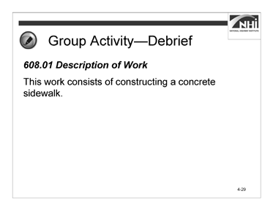

### Interactivity Part 1 (continued)

Slide 4-29

**Ask:** What method requirements did you strike through Section 608.01?

*Animate the slide.*

(Answer: There are no strikethroughs in this section. The “Description of Work” part of the specification is the same regardless of whether the specification is a method specification or an end-result specification.)

*Advance to the next slide.*

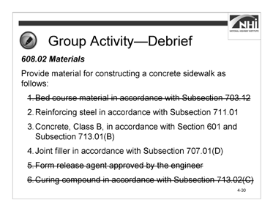

### Interactivity Part 1 (continued)

Slide 4-30

**Ask:** What method requirements did you strike through in Section 608.02?

*Animate the slide.*

(Answer: ***608.02 Materials***

Provide material for constructing a concrete sidewalk as follows: ~~1. Bed course material in accordance with Subsection 703.12~~

* + - 1. Reinforcing steel in accordance with Subsection 711.01
      2. Concrete, Class B, in accordance with Section 601 and Subsection 713.01(B)
      3. Joint filler in accordance with Subsection 707.01(D) ~~5. Form release agent approved by the engineer~~

~~6. Curing compound in accordance with Subsection 713.02(C)~~

Materials are specified in a method specification. In an end-result specification, materials may be specified, but the advantage of an end-result specification comes from allowing the contractor some flexibility and the ability to innovate.

The contractor may select materials or proportion materials to take advantage of local sources or contractor-owned sources.

The materials requirements should also allow the contractor flexibility in what methods or processes to use to meet the requirements. This flexibility may result in higher quality materials at equivalent cost or equal quality materials at lower cost.

The following is the reasoning behind deciding to strike through or not strike through each material requirement:

* The AASHTO Guide Specifications, Subsection 703.12, provides several options with regard to bedding material. Because the density of the bedding material is to be measured, the suitability of the bedding material is verified through testing so that the material requirement can be deleted. Also, the contractor may be able to establish an adequate foundation for the sidewalk using the native or in situ soils.

*Note to instructor:* Measuring density may not be sufficient to establish the acceptability of the bedding material for the sidewalk. If this concern is raised during discussions, acknowledge this fact and ask the participants to consider other quality standards that might be used for bedding material. In the interest of time, ask participants to assume for the purposes of this activity that density alone will be used as the basis for acceptance of the bedding material in the end-result specification.

This may be an appropriate place to remind participants that it may not always be possible to use an end-result specification.

* Separate sampling and testing for the reinforcing steel is not contemplated for this end-result specification. Consequently, it is appropriate to keep the reinforcing steel material requirements in place.
* The AASHTO Guide Specifications provisions related to concrete already give the contractor substantial flexibility; however, the compressive strength of the concrete is also being tested. For this specification, the material requirements for concrete have been maintained. If the AASHTO Guide Specifications requirements provided less flexibility, then the concrete material requirements might reasonably be revised or struck through.
* Separate sampling and testing for the joint filler is not being contemplated for this end-result specification. Consequently, it is appropriate to keep the joint filler material requirements in place.
* Depending on the methods or form materials used, the contractor may be able to complete the work satisfactorily without using a form release agent. This material requirement was struck through.
* There are several acceptable methods for curing concrete. Use of a curing compound is not required for each of these. This material requirement was deleted.

*Note to instructor:* The use of a curing compound may have benefits beyond providing adequate concrete strength. If this concern is raised during discussions, acknowledge this fact and ask the participants to consider quality standards that might be used to alleviate the need to specify a curing compound. In the interest of time, ask participants to assume for the purposes of this activity that the adequacy of curing can be determined based on testing the strength of the concrete. This may be an appropriate place to remind participants that it may not always be possible to use an end-result specification.)

*Advance to the next slide.*

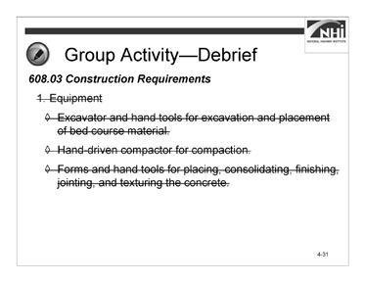

### Interactivity Part 1 (continued)

Slide 4-31

**Ask:** What method requirements did you strike through in Section 608.03,

1. Equipment?

*Animate the slide.*

(Answer: ***608.03 Construction Requirements***

Construct concrete sidewalk using ~~the equipment and~~ methods in accordance with the following requirements:

* 1. ~~Equipment~~
     + ~~Excavator and hand tools for excavation and placement of bed course material.~~
     + ~~Hand-driven compactor for compaction.~~
     + ~~Forms and hand tools for placing, consolidating, finishing, jointing, and texturing the concrete.~~

It is generally inappropriate to specify equipment when writing an end-result specification. It is the contractor’s responsibility to select equipment that will result in the construction of a concrete sidewalk that meets the acceptance criteria set forth in the end-result specification.)

*Advance to the next slide.*

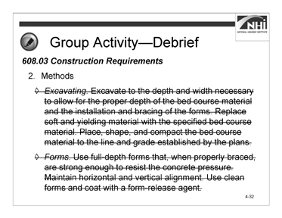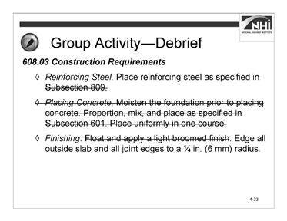

Slide 4-32 Slide 4-33

### Interactivity Part 1 (continued)

**Ask:** What method requirements did you strike through in Section 608.03,

* 1. Methods?

*Animate the slide.*

(Answer:

1. Methods
   * *~~Excavating.~~* ~~Excavate to the depth and width necessary to allow for the proper depth of the bed course material and the installation and bracing of the forms. Replace soft and yielding material with the specified bed course material. Place, shape, and compact the bed course material to the line and grade established by the plans.~~
   * *~~Forms.~~* ~~Use full-depth forms that, when properly braced, are strong enough to resist the concrete pressure. Maintain horizontal and vertical alignment. Use clean forms and coat with a form-release agent.~~

*Display slide 4-33.*

* + *~~Reinforcing Steel~~*~~. Place reinforcing steel as specified in Subsection 809.~~
  + *~~Placing Concrete.~~* ~~Moisten the foundation prior to placing concrete.~~

~~Proportion, mix, and place as specified in Subsection 601. Place uniformly in one course.~~

* + *Finishing.* ~~Float and apply a light broomed finish.~~ Edge all outside slab and all joint edges to a ¼ in. (6 mm) radius.

*Advance to the next slide*

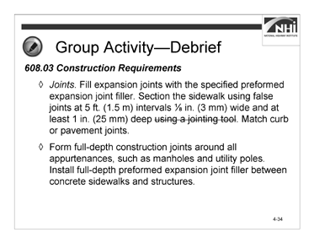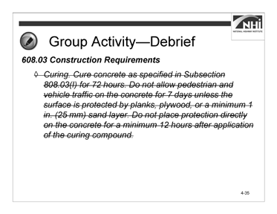

Slide 4-34 Slide 4-35

### Interactivity Part 1 (continued)

* + *Joints.* Fill expansion joints with the specified preformed expansion joint filler. Section the sidewalk using false joints at 5 ft. (1.5 m) intervals ⅛ in. (3 mm) wide and at least 1 in. (25 mm) deep ~~using a jointing tool.~~ Match curb or pavement joints.
  + Form full-depth construction joints around all appurtenances, such as manholes and utility poles. Install full-depth preformed expansion joint filler between concrete sidewalks and structures.

*Display slide 4-35.*

* + *~~Curing.~~* ~~Cure concrete as specified in Subsection 808.03(I) for 72 hours.~~

~~Do not allow pedestrian and vehicle traffic on the concrete for 7 days unless the surface is protected by planks, plywood, or a minimum 1 in. (25 mm) sand layer. Do not place protection directly on the concrete for a minimum 12 hours after application of the curing compound.~~)

*Advance to the next slide.*

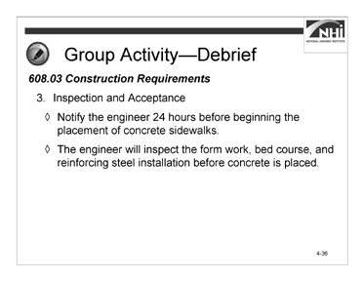

### Interactivity Part 1 (continued)

Slide 4-36

**Ask:** What method requirements did you strike through in Section 608.03,

1. Inspection and Acceptance?

*Animate the slide.*

(Answer: There are no strikethroughs in this section.

1. Inspection and Acceptance
   * Notify the engineer 24 hours before beginning the placement of concrete sidewalks.
   * The engineer will inspect the form work, bed course, and reinforcing steel installation before concrete is placed.

In a method specification, the contractor is told how to build. Consequently, method specifications contain detailed instructions regarding construction. These detailed instructions are not appropriate for an end-result specification because the contractor is responsible for selecting mix designs, equipment, and construction processes that will result in the construction of a concrete sidewalk that meets the acceptance criteria.

Generally, when converting from a method specification to an end-result specification, the detailed construction requirements of the method specification are deleted and replaced with measurable acceptance criteria. In this example, where some portions of the former Construction Requirements were retained, the requirements only tell the contractor what to construct, not how to construct it. For this specification, additional measurable acceptance criteria might include ranges for density, compressive strength, and roughness.)

*Advance to the next slide.*

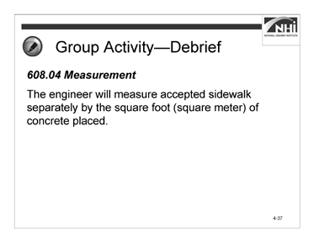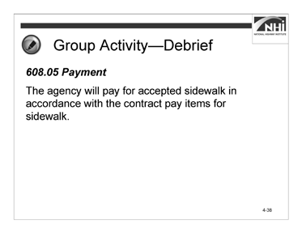

Slide 4-37 Slide 4-38

### Interactivity Part 1 (continued)

**Ask:** What method requirements did you strike through in Section 608.04?

*Animate the slide.*

(Answer: There are no strikethroughs in this section.

#### Measurement

The engineer will measure accepted sidewalk separately by the square foot (square meter) of concrete placed.)

*Display slide 4-38.*

**Ask:** What method requirements did you strike through in Section 608.05?

*Animate the slide.*

(Answer: There are no strikethroughs in this section.

#### Payment

The agency will pay for accepted sidewalk in accordance with the contract pay items for sidewalk.

The end-result specification to be developed for the activity will require that the engineer measure the area of accepted concrete sidewalk. It will also provide for a payment adjustment based on the compressive strength of the concrete.)

*Advance to the next slide.*

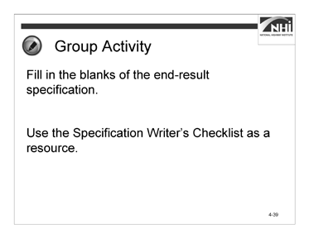

Slide 4-39

### Interactivity Part 2

(30 minutes activity, 10 minutes debrief)

*Note to instructor:* This is a small group activity. The purpose of this activity is for participants to practice rewriting a method specification as an end-result specification.

Instruct participants to:

* Work in small groups.
* Consider the acceptance criteria discussed and provided in Appendix J: Example Method Specification for a Concrete Sidewalk (with strikethroughs of method requirements) and fill in the blanks of the end-result specification.
* Use Appendix D: Specification Writer’s Checklist as a resource.
* Complete this task in 15 minutes.

*When ready to continue the activity, advance to the next slide.*

### Interactivity Part 2 (continued)

#### End-result Specification for a Concrete Sidewalk

#### Description of Work

This work consists of constructing a concrete sidewalk.

#### Materials

Provide material for constructing a concrete sidewalk as follows:

* + 1. Reinforcing steel in accordance with Subsection 711.01
    2. Concrete, Class B, in accordance with Section 601 and Subsection 713.01(B)
    3. Joint filler in accordance with Subsection 707.01(D)

#### Construction Requirements

1. General. Construct concrete sidewalk meeting the acceptance criteria below.
2. Density of Bedding Course. (Identify appropriate density requirements.)
3. Compressive Strength of Concrete. (Establish criteria for determining acceptance of concrete to be used for concrete sidewalk; use compressive strength.)
4. Joints. (Use criteria that define the agency’s expectations for joint placement and construction.)
5. Roughness. (Use criteria for roughness meeting the ANSI standard for coefficient of friction as published by the National Bureau of Standards. Consider a slip resistance requirement as measured by a pendulum tester.)
6. Sampling, Testing, and Acceptance. (Establish how either the contractor or the agency will sample and test for acceptance.)

#### Measurement

The engineer will measure accepted sidewalk separately by the square foot (square meter) of concrete placed.

#### Payment

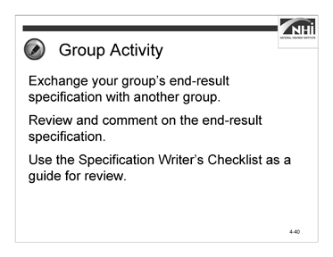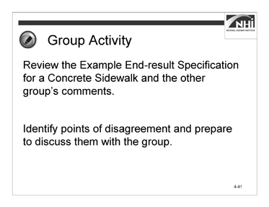

Slide 4-40 Slide 4-41

### Interactivity Part 2 (continued)

Instruct participants to:

* Exchange your group’s end-result specification with another group.
* Review and comment on their end-result specification.
* Use the Appendix D: Specification Writer’s Checklist sections “Mood and Voice” and “The Five Cs of Specification Writing” as a guide for the review.
* Complete this task in 10 minutes.

*When ready to continue the activity, display slide 4-41.*

Instruct participants to:

* Return the group’s specification.
* Review the comments and Appendix K: Example Method Specification for a Concrete Sidewalk.
* Identify areas of disagreement and prepare to discuss these areas.
* Complete this task in 10 minutes.

### Interactivity Part 2 (continued)

*Note to instructor:* In addition to addressing any questions the participants have regarding the differences between the specifications, use the debrief as an opportunity to highlight the difficulties the groups may have had identifying quality attributes that were measurable. Some method specifications cannot be converted to end-result specifications. The reason for this is that the relevant quality standards do not exist or cannot be easily measured.

It is also important to highlight the value of the other group’s review and the importance of collaboration successfully. The drafting of a comprehensive end-result specification requires a deep understanding of the reasons for the specified equipment, materials, and construction methods in the method specification. It is unlikely that any one person will possess all of the required knowledge necessary to draft a complete end-result specification. This activity reinforces the importance of using a collaborative approach to the drafting of specifications. A collaborative approach is particularly important when drafting end-result specifications.

*When ready to debrief the activity, ask the following question.*

**Ask:** What are your areas of disagreement?

(Answer: Participant questions and answers will vary. As participants share the areas of disagreement, guide the discussion to reach a resolution. Refer to course materials previously covered when necessary.)

*Advance to the next slide.*

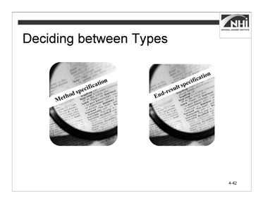

Slide 4-42

(Allow 9 minutes [3 minutes instruction, 6 minutes interactivity])

### Key Message

There are several factor to consider when choosing between method or end-result specifications.

### Instruction

According to the SHRP 2 Report, motivation for using end-result specifications will likely vary from agency to agency and from project to project. The literature and input from practitioners suggests that implementing end-result specifications has the potential to improve quality and long-term durability, encourage innovation, accelerate construction, and reduce an agency’s quality assurance burden during construction.

The likelihood of realizing such benefits tends to correlate with project complexity. End- result specifications are typically most advantageous when the nature of the project provides numerous opportunities for the industry to innovate and influence performance outcomes. This is often the case on complex projects involving major reconstruction multi-phased work zone management, major or non-standard structures, and high traffic volumes requiring accelerated design and construction.

In contrast, non-complex projects involving minor resurfacing or restoration of the pavement surface, or use of standard structural components to match existing facilities, tend to be the least likely project types to benefit from using an end-result specification.

*Advance to the next slide.*

The criteria listed in Slide 4-43 are used to decide between the types of specifications.

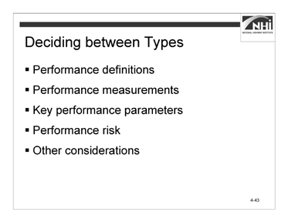

Slide 4-43

### Interactivity

(6 minutes activity)

*Note to instructor:* This is a group discussion. The purpose of this activity is for participants to develop a better understanding of the factors affecting the decisions to use a method or end-result specification by determining whether a concrete sidewalk can be specified using an end-result specification.

Instruct participants to:

* Write M in the column if a method specification should have been used in the concrete sidewalk activity.
* Write an E in the column if an end-result specification should have been used in the concrete sidewalk activity.
* Write the reason in the “Reason column.

*As you review each of the conditions for deciding between types of specifications, ask the following questions.*

**Ask:** Based on the information provided here and considering the concrete sidewalk activity, which type of specification should be used?

**Ask:** Why would you use this specification?

(Answer: Participant answers will vary. There may be more than one correct answer. Potential answers are provided in the table.)

*When finished debriefing, advance to the next slide.*

#### Conditions for Deciding between Types

|  |  |  |  |  |
| --- | --- | --- | --- | --- |
| **Item** | **Method Specifications** | **End-result Specifications** | **M/E** | **Reason** |
| Performance Definitions | End product performance cannot be easily defined. | End product performance can be defined in terms of desired outcomes or user needs. | E | Expectations regarding the performance of a concrete sidewalk are well known. |
| Performance Measurements | End product performance cannot be easily or economically measured and verified. | Key performance parameters can be measured and tested, and the test methods are rapid, reliable, and economical. | M | Agencies typically do not have the expertise or equipment necessary to perform the pendulum test for roughness.  Density may not be a sufficient measure of the acceptability of the bedding.  Concrete strength may not be a sufficient measure of the acceptability of concrete. In addition, concrete coring and testing can be expensive and time consuming and, thus, impractical for the purposes of measuring the acceptability of the concrete sidewalk. |

|  |  |  |  |  |
| --- | --- | --- | --- | --- |
| **Item** | **Method Specifications** | **End-result Specifications** | **M/E** | **Reason** |
| Key Performance Parameters | Key performance parameters cannot be identified. | Key performance parameters can be determined based on agency management system data and projected performance outcomes. | E | Key performance parameters for a concrete sidewalk are well known. |
| Performance Risk | The agency must retain performance risk because of permit requirements, maintenance considerations, the need to tie into existing or adjacent construction, or other external concerns. | Industry is willing to assume performance risk and sureties are willing to bond this risk. | E | Risks associated with sidewalk performance are well known. |
| Other Considerations | Removing and replacing defective work would be impractical. | Agency is willing to relinquish control over some aspects of the work. | E | Removing or replacing defective work would not be difficult. Agencies should be willing to relinquish control. |

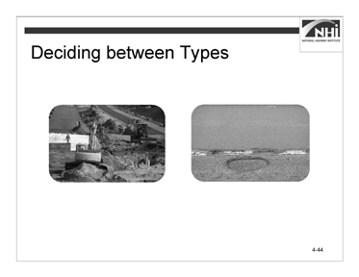

Slide 4-44

### Interactivity (continued)

During the activity, you did the following:

* Reviewed the example method specification and identified the parts of the example method specification that are inappropriate for an end-result specification.
* Identified end-result specification acceptance criteria.
* Replaced method requirements with end-result requirements.
* Worked collaboratively with a small group.

When writing a specification, as a best practice, be careful not to combine the different types of specifications for a requirement. For instance, do not tell the contractor how to install silt fence and then define the performance in terms of the fence not falling down under certain minimum conditions.

For example, in the concrete sidewalk example, do not specify the types of equipment and procedures to follow and then require that the contractor meet specific acceptance criteria with compensation based on test results for those criteria. There is potential to follow the method and not reach the end result. If the end result suffices to define the expected quality, that is all that is necessary.

*Advance to the next slide.*

Let participants know that the answers to activities are provided in Appendix L.

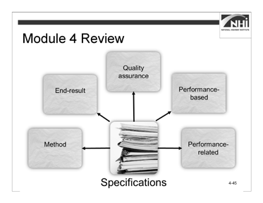

(Allow 5 minutes)

Slide 4-45

### Key Message

This concludes the content for Module 4.

### Instruction

N/A

### Interactivity

*Note to instructor:* This is a partner activity. The purpose of the activity is to review and connect the concepts and content of Module 4.

Instruct participants to:

* Work with a nearby partner.
* Review the key learning points and objectives from Module 4.
* Answer the questions.
  + 1. Reflect on your experience revising the sidewalk specification from a method to an end-result specification. If your supervisor asked you to make a recommendation regarding the feasibility of converting a particular method specification to an end-result specification, list some of the factors you would consider in making your recommendation.

(Answer: Answers may vary. The primary task is to verify that the end result can be specified. In order for the end result to be “specifiable,” the following must be true:

* + - * The characteristics of an acceptable product must be known.
      * These characteristics have to be measurable, testable, or observable.
      * Measuring or testing the characteristics has to be practical. This means that they have to be affordable, yield a result in a reasonable amount of time, and the skills and equipment needed to measure and test have to be available.)
    1. When defining and comparing method, end-result, quality assurance, performance-related, and performance-based specifications, the contractor’s risk increases with method specifications being the least risky and performance- based specifications being the most risky. What is the primary reason that the contractor’s risk increases?

(Answer: Contractor risk increases because the contractor takes on increasing responsibility for the ultimate satisfactory performance of the product. For a method specification, the contractor has little risk as long as the contractor uses the specified materials, equipment, and method of construction. At the other end of the spectrum, for performance-based specifications the contractor must select materials, equipment, and methods of construction that result in a product with the fundamental engineering characteristics associated with successful performance.)

### Interactivity (continued)

The following are the key learning points in Module 4:

#### Method Specifications

* Achieve the desired outcome by specifying the method and materials to be used by the contractor to build the project.
* Rely upon agency inspection, sampling, and testing to verify that the contractor used the specified methods and provided the specified materials. The contractor’s risk is minimized because the ultimate quality and performance of the work is the agency’s responsibility as long as the contractor used the specified methods and provided the specified materials.
* Are used when it is difficult or impossible to specify practical approaches to sampling and testing quality characteristics or confirming performance.
* Write a new specification to a given set of criteria using the five Cs and the agency’s preferred format, given a sample specification.
* Relate the type of specification to the allocation of risk.
* Write an end-result specification to replace a method specification, given an excerpt from a method specification.

#### End-result Specifications

* Achieve the desired outcome by specifying the end result (the agency’s specified outcome).
* Rely upon agency sampling and testing upon the completion of the contractor’s work to verify that the contractor provided the specified end result.
* Are riskier for the contractor because the contractor is responsible for the ultimate quality of the work.
* Are used when the end result can be confidently specified and verified.

#### Quality Assurance Specifications

* Achieve the desired outcome by specifying the quality characteristics the contractor must achieve.
* Rely upon agency sampling and testing as the work proceeds to verify that the contractor is performing and ultimately performs the work as specified.
* Are riskier for the contractor, though this is somewhat less than in the case of end- result specifications because the quality is measured as the work is performed instead of at the end.
* Are used when relevant quality characteristics can be identified and verified through sampling and testing.

#### Performance-related Specifications

* Achieve the desired outcome by specifying the quality characteristics related analytically to fundamental engineering properties that the contractor must achieve. These fundamental engineering properties must themselves be related to performance.
* Rely upon agency sampling and testing as the work proceeds to verify that the contractor is performing and ultimately performs the work as specified.
* Are riskier for the contractor, though this is somewhat less than in the case of end- result specifications because the quality is measured as the work is performed.
* Are used when relevant quality characteristics can be related analytically to fundamental engineering properties and when these characteristics can also be verified through sampling and testing.

#### Performance-based Specifications

* Achieve the desired outcome by specifying the fundamental engineering properties the contractor must achieve. These fundamental engineering properties are themselves related to performance.
* Rely upon agency sampling and testing as the work proceeds to verify that the contractor is performing and ultimately performs the work as specified.
* Maximize the contractor’s risk because achievement of the fundamental engineering properties is the contractor’s responsibility.
* Are used when fundamental engineering properties related directly to performance can be identified and verified through sampling and testing.

The following are the learning outcomes for Module 4:

* Write a new specification to a given set of criteria using the five Cs and the agency’s preferred format, given a sample specification.
* Relate the type of specification to the allocation of risk.
* Write an end-result specification to replace a method specification, given an excerpt from a method specification

# Module 5: Conclusion and End-of-Course Activities

### Lesson Plan

#### Learning Outcomes

This lesson supports all of the learning outcomes.

#### Instructional Methodology

This module includes brief instruction and group discussion.

#### Time Allocation

78 minutes

#### Evaluation Plan

Participant learning is evaluated throughout the lesson by instructor-based questioning and assessment, discussion, and contributions. A final exam completes the evaluation.

#### Resources

* One final exam for each participant
* One pencil for each participant
* One course evaluation for each participant
* One certificate for each participant
* Federal Plain Language Guidelines, May 2011. [http://www.plainlanguage.gov/.](http://www.plainlanguage.gov/)
* Transportation Research Board of the National Academies. Transportation Research Circular E-C173: Glossary of Transportation Construction Quality Assurance Terms. Sixth Edition, 2013.
* United States Department of Transportation, Federal Highway Administration. *Development and Review of Specifications*. Technical Advisory, OPI – HIAM-20. Washington, DC, March 24, 2010.
* Transportation Research Board of the National Academies. SHRP 2 Renewal Project R07. Performance Specifications for Rapid Highway Renewal, Implementation Guidelines Volume II, Developing and Drafting Effective Performance Specifications: A Guide for Specification Writers, 2013. Prepublication draft, not edited.

#### Pre-Session Planning

* Review parking lot flip chart and small groups’ coats-of-arms to identify topics that were, and that were not, addressed.

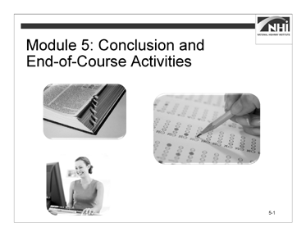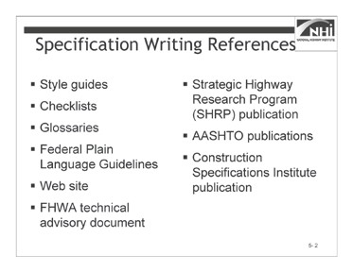

Slide 5-1 Slide 5-2

(Allow 3 minutes)

### Key Message

*Display slide 5-1.*

Before we wrap up the course and take the final exam, let us talk about some reference materials and tools for writing specifications.

### Instruction

*Display slide 5-2.*

*Animate the slide to display each bullet.*

There are many specification writing references available. These include the following:

* **Agency style, writing, or other specification development guidance.** These documents are the primary source of guidance during the specification writing process.
* **Specification Writer’s Checklist.** The checklist provides a detailed and itemized list of many of the factors a specification writer should consider before, during, and after the writer has undertaken a specification writing task. The checklist begins with the initial assignment and follows the specification writing process through the writing and reviewing steps. Participants should use the checklist as a reminder for each new specification writing assignment. They should also add to the list additional items they believe would be useful reminders during the next specification writing assignment. They should treat the checklist as a living document.
* **TRB EC 173 QA Glossary of Terms.** This document includes terms and definitions related to the topic of quality assurance.
* **Federal Plain Language Guidelines.** These guidelines include general topics on how to make written documents more accessible to their audience. Because this document’s application is not specific to highway construction specifications, weigh each guideline against the agency’s style, writing, or other specification development guidance.
* **National Highway Specifications Web site.** This Web site includes standard and supplemental specifications from all State transportation agencies. It can be used as a searchable library of potential model specifications. Always follow up with the agency’s Web site when choosing a model specification.
* **FHWA Technical Advisory – Development and Review of Specifications.** This technical advisory includes general guidance on how to develop and review specifications from FHWA’s perspective. Because this document’s primary audience is FHWA division office staff that review and approve specifications, weigh each guideline against the agency’s style, writing, or other specification development guidance.
* **SHRP 2 Report.** This report presents a flexible framework that specification writers may use to assess whether the use of specifications other than method specifications represents a viable option for a particular project or project element, and, if so, how performance specifications may then be developed and used to achieve project-specific goals and satisfy user needs.
* **AASHTO Guide Specifications for Highway Construction.** This guide includes a model for developing specifications, but the model needs adjustment for use in any given state.
* **Construction Specifications Institute – Project Resource Manual.** This manual includes a broad perspective on specification-related topics under various project delivery and contracting methods. While the general writing principles apply to highway construction specifications, weigh each guideline against the agency’s style, writing, or other specification development guidance.

### Interactivity

N/A

*Advance to the next slide.*

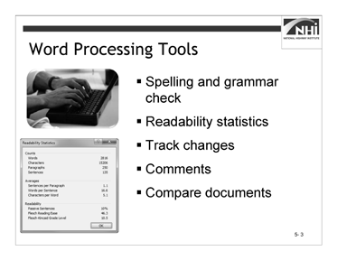

(Allow 2 minutes)

Slide 5-3

### Key Message

In addition to multiple references, there are also word processing tools available to specification writers.

### Instruction

Word processing tools, like those available in Microsoft Word®, are a boon to specification writers. They allow one to do the following:

* **Check spelling and grammar.** Use these features but do not rely on them. Change the program’s grammar settings to recognize passive sentences.

*Animate the slide to display the readability statistic graphic.*

*Direct participants to the readability statistic graphic in the workbook.*

* **View readability statistics.** Use file options and proofing functions in Microsoft Word® to show readability statistics. Keep averages (words per sentence, sentences per paragraph), percentage of passive voice, and readability scores low (except the Flesch Reading Ease score, which you want to keep high).

Additional information about readability and directions to use the Microsoft Word® tools can be found on the Microsoft® Web site at [http://office.microsoft.com/.](http://office.microsoft.com/)

* **Track changes.** Enable Track Changes to facilitate the specification review process and collaboration with others.
* **Comment on draft content.** Track supporting information and decisions regarding the content and style of the specifications using the Comments feature.
* **Compare document drafts.** To compare two versions of the same document (or retroactively enable Track Changes), use the Compare Documents feature.

### Interactivity

N/A

*Advance to the next slide.*



Slide 5-4

(Allow 8 minutes [1 minute instruction, 7 minutes interactivity])

### Key Message

The learning outcomes for this course begin with a verb—that is, they are actions a specification writer can perform.

### Instruction

N/A

### Interactivity

(7 minutes activity)

*Note to instructor:* This is a group discussion. The purpose of the activity is for participants to review and discussion questions they have about the course content.

Instruct participants to:

* Review the learning outcomes.
* Identify any questions they have about the learning outcomes and course material.

**Ask:** What questions do you have regarding the content related to any of the learning outcomes?

(Answer: Participant answers will vary.)

**Ask:** What other questions do you have regarding the course material? (Answer: Participant answers will vary.)

### Interactivity (continued)

*Note to instructor:* Go to the parking lot flip chart. Review the items on the parking lot. If there are any unaddressed items, confirm that someone will follow up on any remaining issues.

*Advance to the next slide.*

The learning outcomes for this course include:

* Compare the functions of standard and supplemental specifications with the functions of special provisions.
* Explain how the “order of precedence” affects writing specifications and preparing plans.
* Explain the purposes of a specification.
* Describe the purpose of the general provisions.
* Explain how specifications are used to assign risk and affect the behavior of different parties, within a given scenario.
* Compare method and end-result specifications.
* Explain each element of the AASHTO five-part format.
* Explain how a consistent writing style can affect the interpretation of specifications.
* Explain the potential benefits of writing in the active voice.
* Rewrite passive voice sentences into the active voice.
* Evaluate specifications to determine the need for imperative or indicative mood.
* State the five Cs used in specification writing.
* Identify potential ambiguities in the wording, given a sample specification.
* Identify the potential benefits of each of the five Cs.
* Write a new specification using the five Cs and the agency’s preferred format.
* Complete a checklist of the information needed before writing or revising a specification.
* Apply the five Cs and the agency’s preferred format to revise the specification, given a sample specification.
* Write a new specification to a given set of criteria using the five Cs and the agency’s preferred format, given a sample specification.
* Relate the type of specification to the allocation of risk.
* Write an end-result specification to replace a method specification, given an excerpt from a method specification.

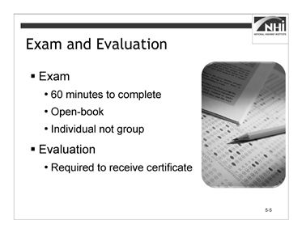

(Allow 65 minutes)

Slide 5-5

### Key Message

Now it is time to evaluate your learning and the course materials.

### Instruction

* Distribute one copy of the exam to each participant. Alternate version 1 and version 2 of the final exam when distributing.
* Distribute the course and instructor evaluation.
* Remind the participants about the course number, session number, instructor number, and anything else they need to put on the evaluations.

Tell the participants they have 60 minutes to complete the final exam. When they have concluded the final exam, they must also complete and return the course evaluation.

Remind them that this is an open-book exam. It must be taken independently; this is not a group activity. In order to receive continuing education credits (CEUs), they must score at least 70%.

Participants must turn in a completed course evaluation to receive a certificate of completion.

Thank them for attending and for participating in the course.

### Interactivity

N/A

# Participant Appendices

## Appendix A: Spearin Doctrine Explanation

The Spearin Doctrine is derived from a decision made by the United States Supreme Court. The decision concerned the case of United States v. Spearin, 248 U.S. 132 (1918). The doctrine establishes that the contractor is not liable to the agency that prepared the plans and specifications for damages that result from deficiencies in those plans and specifications. Said another way, the agency implicitly warrants the accuracy and sufficiency of the contract documents, relieving the contractor of responsibility for defects in these documents.

In the Spearin case itself, the contractor, Spearin, was contracted to build a dry-dock at the Brooklyn Navy Yard by the United States Government. In order to build the dry-dock at the site selected by the agency, the contractor had to relocate a portion of a sewer that ran through the site. The agency provided the plans and specifications containing the requirements for the relocation of the section of the sewer. The contractor completed the relocation of the section of sewer in accordance with the plans and specifications, and the agency approved and accepted the work.

Nearly one year after the relocation of the sewer, a dam in a connecting sewer caused the relocated sewer to flood and burst, flooding the area excavated for the dry-dock.

This dam was not shown on the agency's plans and specifications. The Court held that the agency created an implied warranty that, if the contractor executed its work in accordance with the plans and specifications, the relocated sewer would be adequate. The Court further held that the general clauses requiring the contractor to examine the site and the plans and to maintain responsibility for the work until completion did not overcome or invalidate this implied warranty.

Other courts have further refined the Spearin doctrine to encompass two specific implied warranties. The first implied warranty is that the plans and specifications are accurate and the second is that they are suitable for their intended use. An agency breaches the first warranty when the plans contain errors or other deficiencies (for example, if there is a dam in the sewer that is not shown on the plans or described in the specifications). An agency breaches the second warranty when a contractor complies with the requirements of the plans and specifications, but fails to produce a finished project suitable for its intended purpose or satisfactory to the agency. An example might be a contractor who builds a bridge in strict accord with the plans and specifications, but the resulting bridge is found to be structurally unsound.

In both of the above-listed situations, a contractor may hold the agency liable for the added expense required to complete the project due to the inadequate plans and specifications. The contractor, however, must still show good faith. If the contractor has notice that the plans and specifications are defective, it must notify the agency promptly in order to preserve its cause of action. It should also be noted that courts have determined the Spearin doctrine to apply to private as well as public contracts.

Mitchell, Brendan P. "The Applicability of the Spearin Doctrine: Do Owners Warrant Plans and Specifications?". Find Law for Legal Professionals. 03, 2008. Accessed 07, 2013.

## Appendix B: Sample Style Guide Table of Contents

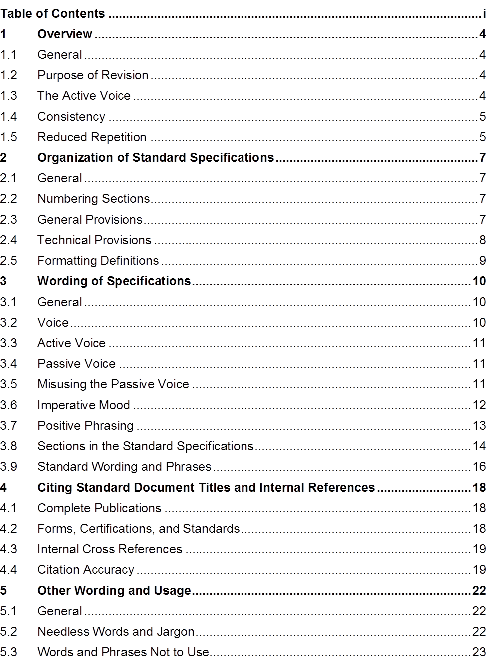

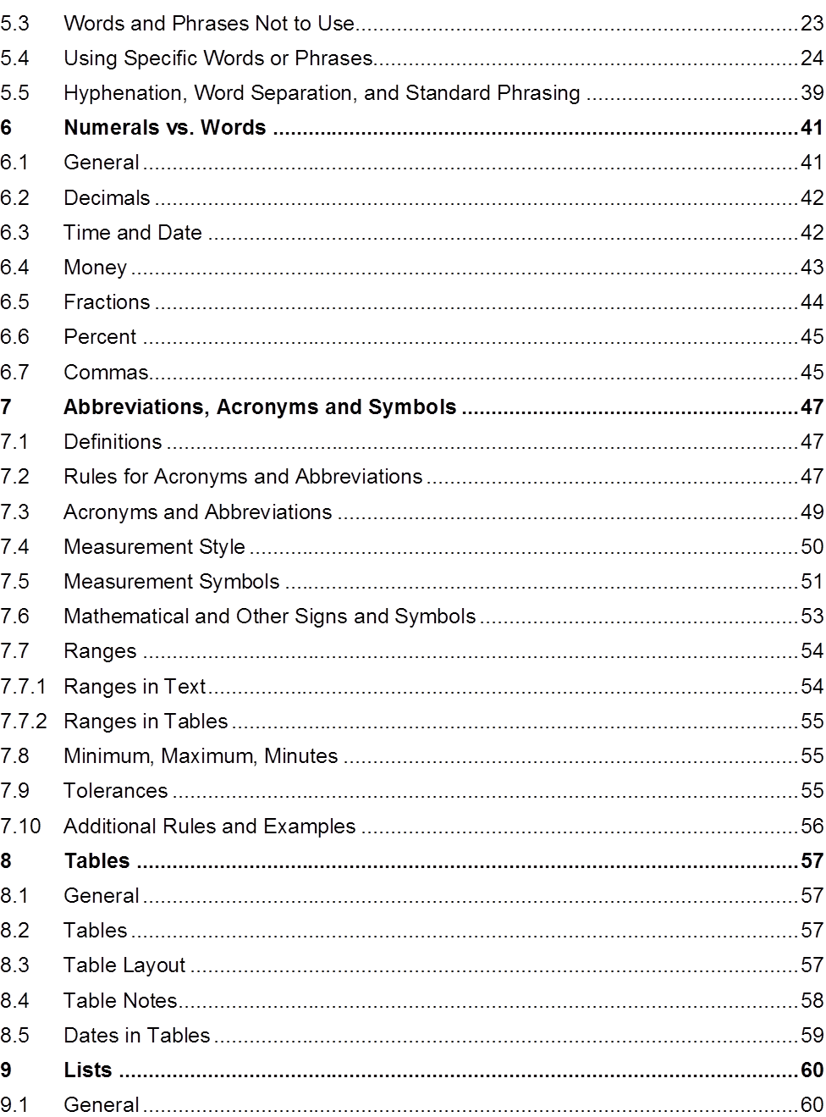

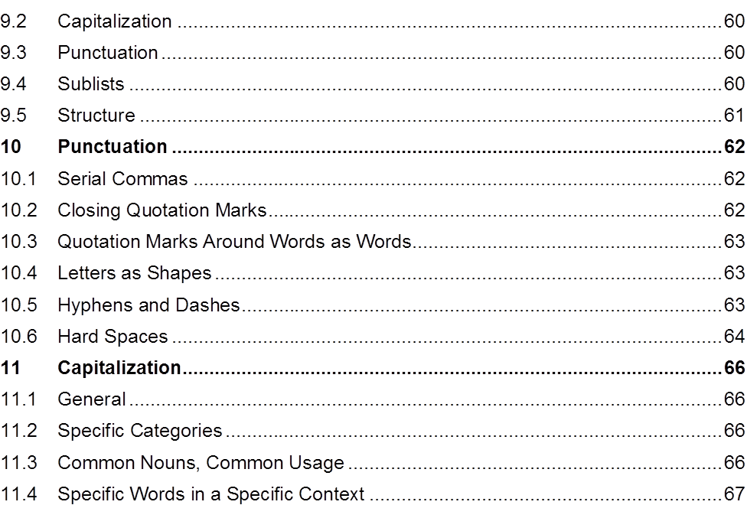

## Appendix C: Commonly Used Phrases

|  |  |
| --- | --- |
| **Common Use** | **Suggested** |
| *absolutely essential* | *essential* |
| *successfully complete* | *complete* |
| a minimum of | at least |
| not less than | at least |
| enclosed herewith | enclosed |
| at a later date | later |
| commence | start, begin |
| heretofore | until now |
| prior to | before |
| subsequent to | after |
| for the purpose of | for, to |
| through the use of | using |
| until such time as | until |
| in lieu of | instead of |
| utilize | use |
| in order to | to |

## Appendix D: Specification Writer’s Checklist

The checklist is a tool to aid when drafting specifications. It relates to drafting new or revising existing specifications for highway and bridge construction projects.

#### The Assignment

|  |  |  |
| --- | --- | --- |
| **Status (√)** | **Task** | **Notes** |
|  | I developed a schedule, and if appropriate, a budget for drafting or revising the specification. |  |
|  | I understand the purpose of the specification. |  |
|  | I know the technical and/or administrative requirements to be included in the specification. |  |
|  | I know which type of specification I am writing, method or end-result. |  |
|  | I know how the risks associated with the work specified are to be allocated to the agency or the contractor. |  |
|  | I know what contractor behaviors are to be encouraged or discouraged by the specification. |  |

#### The Contract

|  |  |  |
| --- | --- | --- |
| **Status (√)** | **Task** | **Notes** |
|  | I know where the specification is to be inserted into the contract; as a standard specification, as a supplemental specification, as a special provision, or some other specification form. |  |
|  | I know whether the specification will be located in the general provisions or the technical specifications. |  |

#### Writing Style and Plain Language

|  |  |  |
| --- | --- | --- |
| **Status (√)** | **Task** | **Notes** |
|  | I understand who the audience is for the specification I am writing; the contractor and/or the agency staff responsible for the project. |  |
|  | I performed the necessary research to ensure that I understand what the specification is to contain or address. |  |
|  | I reviewed the existing agency specifications related to the purpose or objective of the specification. |  |
|  | I reviewed the technical information related to the specification (agency, FHWA, and industry sources). |  |

|  |  |  |
| --- | --- | --- |
| **Status (√)** | **Task** | **Notes** |
|  | I investigated best practices regarding the work associated with the specification. |  |
|  | I consulted with agency experts regarding the content of the specification. |  |
|  | I consulted with the appropriate agency construction personnel relevant to the specification. |  |
|  | I consulted, when appropriate, with representatives of the consulting and construction industry regarding the specification. |  |
|  | I reviewed similar specifications in the AASHTO Guide Specifications, the National Highway Specification Web site, and with FHWA. |  |
|  | I reviewed and considered the general provisions relevant to the specification. |  |
|  | I reviewed and considered the agency’s style guide or other relevant style guidance, and included these course materials. |  |

#### Mood and Voice

|  |  |  |
| --- | --- | --- |
| **Status (√)** | **Task** | **Notes** |
|  | I wrote the specification in the active voice. |  |
|  | I wrote the specification in the imperative or indicative mood, as appropriate. |  |

#### The Five Cs of Specification Writing

Complete

|  |  |  |
| --- | --- | --- |
| **Status (√)** | **Task** | **Notes** |
|  | I wrote the specification in the AASHTO five-part format. |  |
|  | If it is a method specification, I have adequately described the materials, equipment, and contractor work necessary to complete the work satisfactorily. |  |
|  | If it is an end-result specification, I have not specified the materials and the means and methods of construction. |  |
|  | If it is an end-result specification, I have identified measurable quality characteristics, specified a sampling and testing regime, and, if appropriate, determined pay-adjustment factors. |  |

Correct

|  |  |  |
| --- | --- | --- |
| **Status (√)** | **Task** | **Notes** |
|  | I have carefully reviewed the specification to ensure that it is technically and grammatically correct. |  |
|  | With regard to questions of word usage, grammar, and clear punctuation, I consulted with the agency’s style guide, these course materials, or other referenced standards when appropriate. |  |
|  | I used the right words to convey the meaning I intended. |  |
|  | I used measurable standards. |  |
|  | I used “any” and “all” correctly. |  |
|  | I used “from,” “to,” and “between” correctly. |  |
|  | I used restrictive and non-restrictive clauses properly. |  |

|  |  |  |
| --- | --- | --- |
| **Status (√)** | **Task** | **Notes** |
|  | I did not use undefined or subjective terms. |  |
|  | I did not use vague adjectives and adverbs. |  |
|  | I used vertical lists where appropriate. |  |
|  | I used positive phrasing where appropriate. |  |
|  | I used parallel sentence construction where appropriate. |  |

Concise

|  |  |  |
| --- | --- | --- |
| **Status (√)** | **Task** | **Notes** |
|  | I included only essential information. |  |
|  | I omitted needless words and phrases. |  |
|  | I used the active voice and imperative mood, where appropriate. |  |
|  | I did not include reasons, suggestions, explanations, or justifications. |  |
|  | I used simple words (less than four syllables). |  |
|  | I used short sentences (less than 20 words). |  |
|  | I used short paragraphs (less than five sentences). |  |
|  | I did not repeat requirements already set forth in the general provisions or elsewhere in the specifications. |  |

Consistent

|  |  |  |
| --- | --- | --- |
| **Status (√)** | **Task** | **Notes** |
|  | I used defined terms where appropriate. |  |
|  | I used abbreviations, acronyms, units of measure, and symbols as established in the general provisions or as appropriate. |  |
|  | I used words in text and the associated symbols in tables. |  |
|  | I expressed numbers consistent with the established agency style or industry standards, as appropriate. |  |
|  | I minimized the use of capitalization consistent with the agency’s established style guidance. |  |
|  | I used styles and formats consistent with the agency’s established guidance. |  |

#### Review

|  |  |  |
| --- | --- | --- |
| **Status (√)** | **Task** | **Notes** |
|  | The specification has been reviewed by the following:   * My peers |  |
|  | * My supervisor |  |
|  | * The applicable technical committee |  |
|  | * Construction |  |
|  | * The industry |  |
|  | All comments from reviewers have been addressed. |  |

## Appendix E: Example Method Specification for a Concrete Sidewalk

(This specification was developed based on the AASHTO Guide Specifications. The section numbers and references are based on appropriate references from the AASHTO Guide Specification.)

#### Description of Work

This work consists of constructing a concrete sidewalk.

#### Materials

Provide material for constructing a concrete sidewalk as follows:

* + 1. Bed course material in accordance with Subsection 703.12
    2. Reinforcing steel in accordance with Subsection 711.01
    3. Concrete, Class B, in accordance with Section 601 and Subsection 713.01(B)
    4. Joint filler in accordance with Subsection 707.01(D)
    5. Form release agent approved by the engineer
    6. Curing compound in accordance with Subsection 713.02(C)

#### Construction Requirements

Construct concrete sidewalk using the equipment and methods in accordance with the following requirements:

* + 1. Equipment
       - Excavator and hand tools for excavation and placement of bed course material.
       - Hand-driven compactor for compaction.
       - Forms and hand tools for placing, consolidating, finishing, jointing, and texturing the concrete.
    2. Methods
       - *Excavating.* Excavate to the depth and width necessary to allow for the proper depth of the bed course material and the installation and bracing of the forms. Replace soft and yielding material with the specified bed course material.

Place, shape, and compact the bed course material to the line and grade established by the plans.

* + - * *Forms.* Use full-depth forms that, when properly braced, are strong enough to resist the concrete pressure. Maintain horizontal and vertical alignment. Use clean forms and coat with a form-release agent.
      * *Reinforcing Steel*. Place reinforcing steel as specified in Subsection 809.
      * *Placing Concrete.* Moisten the foundation prior to placing concrete.

Proportion, mix, and place as specified in Subsection 601. Place uniformly in one course.

* + - * *Finishing.* Float and apply a light broomed finish. Edge all outside slab and all joint edges to a ¼ in. (6 mm) radius.
      * *Joints.* Fill expansion joints with the specified preformed expansion joint filler. Section the sidewalk using false joints at 5 ft. (1.5 m) intervals ⅛ in. (3 mm) wide and at least 1 in. (25 mm) deep using a jointing tool. Match curb or pavement joints.
      * Form full-depth construction joints around all appurtenances, such as manholes and utility poles. Install full-depth preformed expansion joint filler between concrete sidewalks and structures.
      * *Curing.* Cure concrete as specified in Subsection 808.03(I) for 72 hours. Do not allow pedestrian and vehicle traffic on the concrete for 7 days unless the surface is protected by planks, plywood, or a minimum 1 in. (25 mm) sand layer. Do not place protection directly on the concrete for a minimum 12 hours after application of the curing compound.
    1. Inspection and Acceptance
       - Notify the engineer 24 hours before beginning the placement of concrete sidewalks.
       - The engineer will inspect the form work, bed course, and reinforcing steel installation before concrete is placed.

#### Measurement

The engineer will measure accepted sidewalk separately by the square foot (square meter) of concrete placed.

#### Payment

The agency will pay for accepted sidewalk in accordance with the contract pay items for sidewalk.

## Appendix F: Sample Rewritten

**616.03 Construction Requirements**. Perform excavation and backfill in accordance with Section 205, “Excavation and Embankment.” The agency will perform acceptance sampling and testing of the compacted backfill material in accordance with Subsection 208.03, “Acceptance,” at the frequencies established in Section 205, “Excavation and Embankment.”

Place precast reinforced concrete box culvert units on a foundation of firm and stable bedding material in accordance with Subsection 835.04, “Drainage Structure Bedding Material.” Accurately shape the foundation to conform to the base of the culvert.

The plans may require special bedding material.

Provide joints and joint materials in accordance with Section 608, “Structural Concrete Joints.”

Fill lifting holes with mortar or concrete, and cure in accordance with Subsection 620.03.D, “Curing Mortar and Concrete.”

If using precast boxes to form multiple barrel structures, place the boxes in accordance with the details shown on the plans. The plans will identify the material required between barrels.

Connect precast boxes to cast-in-place boxes or to any required headwalls, wingwalls, riprap, or other structures in accordance with the details shown on the plans.

Install headwalls, wingwalls, and footings in accordance with the details shown on the plans, except modify the overall widths of the headwalls and footings to fit the finished width of the various structures.

The plans will list the number of required drainage structures.

## Appendix G: Sample Method Specification

### Section 613: Latex Emulsion Paint for Concrete

#### Description

This section describes the requirements for latex emulsion paint.

#### Materials

Provide latex emulsion paint in accordance with subsection 809.8.

#### Equipment—Vacant

#### Construction

#### Surface Preparation

* Give concrete surfaces a rubbed finish in accordance with Subsection 513.4.12, “Finishing Concrete Surfaces.”
* Clean surfaces before painting.
* Where applicable, protect concrete surfaces that have been or will be painted with latex from structural steel paint overspray.

#### Application

Allow the paste from surface preparation to set at least 24 hours. Saturate the surface with water and paint while damp but not showing free water. Do not mix sand with paint. Apply at least two coats at a rate of approximately 350 ft2/gal [9 m2/L] for the first coat and from 400 ft2/gal [10 m2/L] to 500 ft2/gal [12 m2/L] for the second. Apply additional coats as necessary for uniform coverage and appearance. Paint when the air temperature is at least 50oF [10oC] and only with rollers or brushes.

#### 613.5 Measurement and Payment

#### 613.5.1 General

* The engineer will measure Ltx Emulsion Paint (Conc) as a complete unit in place.
* The department will pay as follows:
* Pay item is Ltx Emulsion Paint (Conc)
* Pay unit is LS
* Measure to the nearest LS
* Pay to the Nearest LS

"Standard Specifications for Road and Bridge Construction". Cheyenne, Wyoming: State of Wyoming Department of Transportation. 2010.

## Appendix H: Sample End-result Specification

### Section 615: Sanitary Sewer Pipe Conduits

#### Description

This work consists of constructing sanitary sewer pipe.

#### Materials

Provide materials in accordance with Section 726, “Drainage Conduits.” Mark the pipe with the appropriate specification number (e.g., AASHTO, ASTM, ANSI, NSF, and AWWA).

Provide pipe as follows:

* Concrete pipe with in-plant hydrostatic test of 10 psi [70kPa] in accordance with ANSI/ASTM C 497.
* Plastic pipe bearing the seal of the National Sanitation Foundation (NSF) with a Standard Dimension Ratio (SDR) no greater than 35.
* Cast-in-place reinforced concrete boxes for sanitary sewer installation.

Provide joints as follows:

* In accordance with Section 726, “Drainage Conduits,” except, make joints with a single natural rubber or neoprene gasket, or O-ring, in accordance with the manufacturer’s recommendations.
* Reinforced concrete pipe joints in accordance with ANSI/ASTM C 443, with a 1:1 cement mortar collar formed using a diaper.
* Vitrified clay pipe joints in accordance with ANSI/ASTM C 425.

Ensure Polyvinyl Chloride (PVC) pipe, fittings, and in-line tees dimensionally conform to ASTM D 3034, with an SDR of 35.

#### Equipment – Vacant

#### Construction Methods

### General

Construct sanitary sewer pipe conduits in accordance with Oklahoma State Department of Health (OSDH) Regulations, the manufacturer’s recommendations, ASTM, ANSI, AWWA, and the Public Utility for whom the work is to be performed by additional specifications.

During construction, maintain the sewerage operation of the system.

* 1. Setting Grade Lines

Use the grade line shown on the Plans, Supplemental Drawings, or established by the Resident engineer as the elevation of the invert or flowline of the sewer.

* 1. Accommodating Water Mains

Separate sanitary sewers and water mains vertically and horizontally in accordance with the OSDH regulations.

### Excavation

Excavate in accordance with Subsection 613.04.B., “Excavation.”

### Bedding

Place bedding in accordance with Subsection 613.04.C., “Bedding.”

### Laying Pipe

Lay pipe in accordance with Subsection of 613.04.G., “Laying Pipe.”

### Joining Pipe Conduit

Construct joints in accordance with the manufacturer’s recommendations. Before joining pipes, clean and dry the surfaces of the joint surface of the pipe. Keep trenches free of water until the joints become water tight.

### Backfilling

Backfill in accordance with Subsection 613.04.I., “Backfilling.”

### Field Testing

Provide written notification to the Resident Engineer 24 hours before testing.

Leakage tests may include water or low pressure air testing. Ensure outward or inward leakage, exfiltration or infiltration, does not exceed 200 gal per in [1,860 L per 100 mm] of pipe diameter per mile [kilometer] per day. Perform an exfiltration or infiltration test with a positive head of at least 2 ft [0.60 m].

Conduct deflection tests on flexible pipes at least 30 days after placing the final backfill. Ensure the pipe deflection does not exceed 5 percent. Perform the deflection test with a rigid ball or mandrel with a diameter equal to 95 percent of the inside diameter of the

pipe. Do not use mechanical pulling devices, unless otherwise approved by the Resident Engineer.

As required by OSHA regulations, use explosion-proof devices to provide a mechanical method of exchanging the air within the sewer line.

### Acceptance

* 1. Leakage
     + 0 to 100 gal/m; accept with incentive
     + >100 to 200 gal/in; accept at 100% of unit price and no incentive
     + >gal/in; reject and require corrective action
  2. Pipe Deflection
     + ≤5%; accept
     + >5%; reject and require corrective action

#### Method of Measurement

The Resident Engineer will measure the length of accepted Polyvinyl Chloride (PVC) Pipe and Sanitary Sewer Service Line along the pipe center and grade lines. The Resident Engineer will include the length of the riser pipe in the measurement for Sanitary Sewer Line.

The Resident Engineer will not include the following for measurement:

* The length of line within manholes and special structures.
* The length of vertical pipe or fittings required for drop manholes.

#### Basis of Payment

The Department will pay for each accepted pay item at the contract unit price per the specified pay unit as follows:

* For Polyvinyl Chloride (PVC) Pipe, the pay unit is Linear Foot (Meter).
* For Sanitary Sewer Service Connection, the pay unit is Each.
* For Sanitary Sewer Service Line, the pay unit is Linear Foot (Meter).

The Department will pay an incentive for the accepted length of pipe with a leakage test result of 0 to 100 gal/in in accordance with the specified incentive payment provision.

The Department will consider the cost of installing an in-line tee and bracing for riser pipe to be included in the contract unit price for Sanitary Sewer Service Line.

The Department will consider the cost of the line within manholes and special structures, the vertical pipe or fittings required for drop manholes, earth backfill, sheeting, shoring, and concrete cradles to be included in the contract unit price for the relevant pay item.

The Department will consider the cost of all fittings and adaptors to connect service to the existing line to be included in the contract unit price for Sanitary Sewer Service Line.

The Department will consider the cost of testing to be included in the contract unit price for the relevant pay item.

"2009 Standard Specifications for Highway Construction". Oklahoma City, Oklahoma: Oklahoma Department of Transportation. 2009.

## Appendix I: Sample Quality Assurance Specification

### Section 113: Acceptance

#### 113.1 Acceptance of Aggregate

The department will accept the gradation of crushed or screened aggregates used for pavements, bases, subbases, chip seals, and stockpiled materials with a gradation specification based on random samples taken at the direction of the engineer and a quality level analysis of test results. Quality level analysis is a method of analyzing aggregate gradation test results to determine compliance with the contract requirements. The quality level analysis will include an evaluation for outlier test results using the department’s computer software.

The engineer will determine the quality level, acceptance, and pay factor for each lot. Lot and sublot sizes are specified in the respective technical sections. The engineer will include partial lots with less than three samples with the previous lot for quality level analysis. All test results for a lot will be analyzed to determine the pay factor for the lot. The lowest pay factor computed for any one sieve will be used to adjust the pay for that lot. Acceptance procedures will not apply to sieve designations with requirements of 100

percent passing, 97 to 100 percent passing, and 95 to 100 percent passing. Only the P**L** (percent within lower limits) will be calculated for the sieve designations requiring 90 to 100 percent passing, and the P**U** (percent within upper limits) will be set at 100.

The maximum obtainable pay factor will be 1.05.

A lot containing material that does not meet the contract requirements will be:

* Accepted if the pay factor is at least 0.75 or
* Rejected if the material fails to obtain at least a 0.75 pay factor.

To avoid a pay factor less than 1.00, the contractor may remove defective material and replace it with new material, which the department will sample, test, and evaluate in accordance with this specification.

Without testing, the engineer may isolate and reject material that is obviously defective. Do not continue producing material that does not meet contract requirements. If two consecutive lots have a pay factor less than 1.00, change procedures to meet the requirements.

The engineer will compute the quality level analysis and pay factor as follows:

1. Determine the arithmetic mean, 𝑥𝑥̅.

Where: ∑ = summation

*x* = individual test value

*n* = total number test values

𝑥𝑥̅ = ∑𝑥𝑥

𝑛𝑛

1. Compute the sample standard deviation, *s*.

*s =*�[ 1 ] �𝑛𝑛 (𝑥𝑥𝑖𝑖−𝑥𝑥̅ )2

𝑛𝑛−1 𝑖𝑖=1

3. 3. Compute the upper quality index, *Qu.*

Q = 𝑺𝑺𝑳𝑳𝑼𝑼−𝑥𝑥̅

*U*

𝒔𝒔

Where: *SLU* = upper specification limit or target value

of job mix plus allowable deviation.

target value

for Q*U* = the single specification value with allowable deviations.

1. 4. Compute the lower quality index, *QL*

Q 𝑥𝑥̅−𝑺𝑺𝑳𝑳𝑳𝑳

*L =*

𝒔𝒔

Where: *SLL* = lower specification limit or target minus allowable deviation.

1. Determine PU (the percent within the upper specification limit corresponding to a given QU) from Table 113.1-1, Quality Level Analysis by the Standard Deviation Method. If an SLU is not specified or if the upper specification limit for the sieve being evaluated is 100 percent, PU is 100.
2. Determine PL (the percent within lower specification limit corresponding to a given QL) from Table 113.1-1, Quality Level Analysis by the Standard Deviation Method. If an SL is not specified, PL will be 100.
3. Determine the quality level (the total percent within the specification limits).

quality level = (*PU* + *PL*) – 100

1. Using the quality level from the preceding step, determine the pay factor from Table 113.1-2, Pay Factors. To obtain a given pay factor, meet or exceed the value in the table for the computed quality level. Pay factors greater than 1.0 do not apply when quality incentives are not included in the respective technical specifications for a pay item.

Testing frequency indicates the minimum number of tests required for the specified quantity of aggregate produced. For example, 1/1000 ton [1/1000 t] is equivalent to one test minimum required for each 1000 ton [1000 t] of aggregate produced.

### TABLE 113.1-1

### Quality Level Analysis by the Standard Deviation Method

### Upper Quality Index QU or Lower Quality Index QL

|  |  |  |  |  |  |
| --- | --- | --- | --- | --- | --- |
| **PU or PL percent Within Limits for Positive Values Of QU or QL** | **n = 3** | **n = 4** | **n = 5** | **N = 6** | **n = 7** |
| 100 | 1.16 | 1.50 | 1.79 | 2.03 | 2.23 |
| 99 |  | 1.47 | 1.67 | 1.80 | 1.89 |
| 98 | 1.15 | 1.44 | 1.60 | 1.70 | 1.76 |
| 97 |  | 1.41 | 1.54 | 1.62 | 1.67 |
| 96 | 1.14 | 1.38 | 1.49 | 1.55 | 1.59 |
| 95 |  | 1.35 | 1.44 | 1.49 | 1.52 |
| 94 | 1.13 | 1.32 | 1.39 | 1.43 | 1.46 |

"Standard Specifications for Road and Bridge Construction". Cheyenne, Wyoming: State of Wyoming Department of Transportation. 2010.

**Appendix J: Example Method Specification for a Concrete Sidewalk (with strikethroughs of method requirements)**

#### Description of Work

This work consists of constructing a concrete sidewalk.

*Note to participant:* The “Description of Work” part of the specification is the same regardless of whether the specification is a method specification or an end-result specification.

#### Materials

Provide material for constructing a concrete sidewalk as follows: ~~1. Bed course material in accordance with Subsection 703.12~~

1. Reinforcing steel in accordance with Subsection 711.01
2. Concrete, Class B, in accordance with Section 601 and Subsection 713.01(B)
3. Joint filler in accordance with Subsection 707.01(D) ~~5. Form release agent approved by the engineer~~

~~6. Curing compound in accordance with Subsection 713.02(C)~~

*Note to participant:* Materials are specified in a method specification. In an end-result specification, materials may be specified, but the advantage of an end-result specification comes from allowing the contractor some flexibility and the ability to innovate.

The contractor may select materials or proportion materials to take advantage of local sources or contractor-owned sources.

The materials requirements should also allow the contractor flexibility in what methods or processes to use to meet the requirements. This flexibility may result in higher quality materials at equivalent cost or equal quality materials at lower cost.

The following is the reasoning behind deciding to strike through or not strike through each material requirement:

* The AASHTO Guide Specification, Subsection 703.12, provides several options with regard to bedding material. Because the density of the bedding material is to be measured, the suitability of the bedding material is verified through testing so that the material requirement can be deleted. Also, the contractor may be able to establish an adequate foundation for the sidewalk using the native or in situ soils.
* Separate sampling and testing for the reinforcing steel is not contemplated for this end-result specification. Consequently, it is appropriate to keep the reinforcing steel material requirements in place.
* The AASHTO Guide Specification provisions related to concrete already give the contractor substantial flexibility; however, the compressive strength of the concrete is also being tested. For this specification, the material requirements for concrete have been maintained. If the AASHTO Guide Specification requirements provided less flexibility, then the concrete material requirements might reasonably be revised or struck through.
* Separate sampling and testing for the joint filler is not being contemplated for this end-result specification. Consequently, it is appropriate to keep the joint filler material requirements in place.
* Depending on the methods or form materials used, the contractor may be able to complete the work satisfactorily without using a form release agent. This material requirement was struck through.
* There are several acceptable methods for curing concrete. Use of a curing compound is not required for each of these. This material requirement was deleted.

#### Construction Requirements

Construct concrete sidewalk using ~~the equipment~~ and methods in accordance with the following requirements:

* + 1. ~~Equipment~~
       - ~~Excavator and hand tools for excavation and placement of bed course material.~~
       - ~~Hand-driven compactor for compaction.~~
       - ~~Forms and hand tools for placing, consolidating, finishing, jointing, and texturing the concrete.~~

*Note to participant:* It is generally inappropriate to specify equipment when writing an end-result specification. It is the contractor’s responsibility to select equipment that will result in the construction of a concrete sidewalk that meets the acceptance criteria set forth in the end-result specification.

* + 1. Methods
       - *~~Excavating.~~* ~~Excavate to the depth and width necessary to allow for the proper depth of the bed course material and the installation and bracing of the forms. Replace soft and yielding material with the specified bed course material.~~

~~Place, shape, and compact the bed course material to the line and grade established by the plans.~~

* + - * *~~Forms.~~* ~~Use full-depth forms that, when properly braced, are strong enough to resist the concrete pressure. Maintain horizontal and vertical alignment. Use clean forms and coat with a form-release agent.~~
      * *~~Reinforcing Steel~~*~~. Place reinforcing steel as specified in Subsection 809.~~
      * *~~Placing Concrete.~~* ~~Moisten the foundation prior to placing concrete.~~

~~Proportion, mix, and place as specified in Subsection 601. Place uniformly in one course.~~

* + - * *Finishing.* ~~Float and apply a light broomed finish.~~ Edge all outside slab and all joint edges to a ¼ in. (6 mm) radius.
      * *Joints.* Fill expansion joints with the specified preformed expansion joint filler. Section the sidewalk using false joints at 5 ft. (1.5 m) intervals ⅛ in. (3 mm) wide and at least 1 in. (25 mm) deep ~~using a jointing tool.~~ Match curb or pavement joints.
      * Form full-depth construction joints around all appurtenances, such as manholes and utility poles. Install full-depth preformed expansion joint filler between concrete sidewalks and structures.
      * *~~Curing.~~* ~~Cure concrete as specified in Subsection 808.03(I) for 72 hours. Do not allow pedestrian and vehicle traffic on the concrete for 7 days unless the surface is protected by planks, plywood, or a minimum 1 in. (25 mm) sand layer. Do not place protection directly on the concrete for a minimum 12 hours after application of the curing compound.~~
    1. Inspection and Acceptance
       - Notify the engineer 24 hours before beginning the placement of concrete sidewalks.
       - The engineer will inspect the form work, bed course, and reinforcing steel installation before concrete is placed.

*Note to participant:* In a method specification, the contractor is told how to build. Consequently, method specifications contain detailed instructions regarding construction. These detailed instructions are not appropriate for an end-result specification because the contractor is responsible for selecting mix designs, equipment, and construction processes that will result in the construction of a concrete sidewalk that meets the acceptance criteria.

Generally, when converting from a method specification to an end-result specification, the detailed construction requirements of the method specification are deleted and replaced with measurable acceptance criteria. In this example, where some portions of the former Construction Requirements were retained, the requirements only tell the contractor what to construct, not how to construct it. For this specification, additional measurable acceptance criteria might include ranges for density, compressive strength, and roughness.

#### Measurement

The engineer will measure accepted sidewalk separately by the square foot (square meter) of concrete placed.

#### Payment

The agency will pay for accepted sidewalk in accordance with the contract pay items for sidewalk.

*Note to participant:* The end-result specification to be developed for this activity will require that the engineer measure the area of accepted concrete sidewalk. It will also provide for a payment adjustment based on the compressive strength of the concrete.

### Additional Technical Information Regarding Acceptance Criteria

* + 1. Density.

### Bed Course Density Requirements

|  |  |  |
| --- | --- | --- |
| **Material** | **Target % Relative Compaction 1** | **Allowable Range** |
| In-Situ Material | 90% of Gmm | -2% to +5% of Gmm |
| Bed Course1 | 95% of Gmm | -3% to +1% of Gmm |

1 The engineer should test the percent relative compaction of the bed course within 4 hours of notice provided by the contractor.

* + 1. Compressive Strength.

### Concrete Compressive Strength Requirements

|  |  |
| --- | --- |
| **Target Compressive Strength** | **Allowable Range** |
| 2500 psi | ±200 psi |

* + 1. Roughness. The roughness of a surface used the way a sidewalk is used can be measured using the ANSI standard for coefficient of friction as published by the National Bureau of Standards. The testing is performed using a pendulum tester.

### Sidewalk Roughness Requirements

|  |  |  |
| --- | --- | --- |
| **Roughness** | **Target Roughness** | **Allowable Range** |
| Pendulum Test | 50 Reading | 40 to 64 Reading |

* + 1. Sampling, Testing, and Acceptance. Consider using the sampling and testing procedures for bed course density and concrete compressive strength provided in the agency’s specifications. The engineer should use the ANSI pendulum test for roughness.
    2. Consider the following approach to adjusting payment for concrete compressive

### Unit Price Pay Adjustments and Incentive Factors for Concrete Sidewalk

|  |  |  |  |
| --- | --- | --- | --- |
| **Contract Item** | **Range** | **Unit Price** | **Incentive Factor** |
| Compressive Strength | ≥2300 psi to <2400 psi  ≥2400 psi to <2500 psi  ≥2500 psi to <2600 psi  ≥2600 psi to <2700 psi | 95%  98%  100%  100% | No Incentive No Incentive  +2%  +5% |

## Appendix K: Example End-result Specification for a Concrete Sidewalk

#### Description of Work

This work consists of constructing a concrete sidewalk.

*Note to participant:* The “Description of Work” section is the same regardless of the type of specification.

#### Materials

Provide material for constructing a concrete sidewalk as follows:

* + 1. Reinforcing steel in accordance with Subsection 711.01
    2. Concrete, Class B, in accordance with Section 601 and Subsection 713.01(B)
    3. Joint filler in accordance with Subsection 707.01(D)

*Note to participant:* The “Materials” section can be the same regardless of the type of specification. However, end-result specifications can be developed to allow the contractor flexibility in what materials they choose, as long as the acceptance criteria are met. The typical method specification is more restrictive because the kinds of materials are prescribed; end-result specifications give the contractor more flexibility.

#### Construction Requirements

* + 1. General. Construct concrete sidewalk meeting all of the acceptance criteria below.
    2. Density. Construct the bed course to achieve the following density requirements:

### Bed Course Density Requirements

|  |  |  |
| --- | --- | --- |
| **Material** | **Target % Relative Compaction 1** | **Allowable Range** |
| In-Situ Material | 90% of Gmm | -2% to +5% of Gmm |
| Bed Course1 | 95% of Gmm | -3% to +1% of Gmm |

1 The engineer should test the percent relative compaction of the bed course within 4 hours of notice provided by the contractor.

* + 1. Compressive Strength. Construct a concrete sidewalk with concrete having a compressive strength within the allowable limits as specified below. The engineer will sample and test each day’s placement of concrete to determine the compressive strength.

### Concrete Compressive Strength Requirements

|  |  |
| --- | --- |
| **Target Compressive Strength** | **Allowable Range** |
| 2500 psi | ±200 psi |

* + 1. Joints. Fill expansion joints with the specified preformed expansion joint filler. Section the sidewalk using false joints at 5 ft. (1.5 m) intervals ⅛ in. (3 mm) wide and at least 1 in. (25 mm). Match curb or pavement joints. Form full-depth construction joints around all appurtenances, such as manholes and utility poles. Install full-depth preformed expansion joint filler between concrete sidewalks and structures.
    2. Roughness. Provide concrete sidewalk with roughness meeting the ANSI standard for coefficient of friction as published by the National Bureau of Standards. Meet the requirement for slip resistance as measured by a pendulum tester in accordance with the following:

### Sidewalk Roughness Requirements

|  |  |  |
| --- | --- | --- |
| **Roughness** | **Target Roughness** | **Allowable Range** |
| Pendulum Test | 50 Reading | 40 to 64 Reading |

* + 1. Sampling, Testing, and Acceptance. The engineer will use the sampling and testing procedures for bed course density and concrete compressive strength in accordance with the requirements in these specifications. The engineer will use the ANSI pendulum test for roughness.

The engineer will accept concrete sidewalk meeting all acceptance criteria; however, the engineer may accept concrete sidewalk meeting the acceptance criteria in accordance with specified pay adjustments in the “Payment” section.

#### Measurement

The engineer will measure accepted sidewalk separately by the square foot (square meter) of concrete placed.

#### Payment

The agency will pay the unit price for acceptable concrete sidewalk placed. The agency will adjust the unit price of acceptable lots of concrete sidewalk based on the average test results for compressive strength of concrete.

The agency will pay for concrete sidewalk as follows:

### Unit Price Pay Adjustments and Incentive Factors for Concrete Sidewalk

|  |  |  |  |
| --- | --- | --- | --- |
| **Contract Item** | **Range** | **Unit Price** | **Incentive Factor** |
| Compressive Strength | ≥2300 psi to <2400 psi  ≥2400 psi to <2500 psi  ≥2500 psi to <2600 psi  ≥2600 psi to <2700 psi | 95%  98%  100%  100% | No Incentive No Incentive  +2%  +5% |

## Appendix L: Answers to Activities

### Module 2: Purpose of Specifications

#### Lesson 2.1: Specifications as a Contract Document

**Activity:** Review the sample specification and identify problems with the technical provision.

#### Sample 1

“This item consists of furnishing and installing an actuated controller and associated equipment according to these specifications and at the locations shown on the plans or as directed.”

**Answer:** There is no need to repeat the phrase “according to these specifications and at the locations shown on the plans or as directed.” The general provisions establish that all work is performed in accordance with the contract documents and as directed by the engineer.

“This item consists of furnishing and installing an actuated controller and associated equipment.”

#### Sample 2

“Before cleaning with pressurized water, remove all debris from bridge sidewalks, bridge decks, curb tops, beam flanges, gusset plates, abutment bridge seats, pier tops, truss joints, deck drain systems, and other locations where debris has accumulated and as directed by the engineer.”

**Answer:** If possible, the phrase “as directed by the engineer” should be removed.

“Before cleaning with pressurized water, remove all debris from bridge sidewalks, bridge decks, curb tops, beam flanges, gusset plates, abutment bridge seats, pier tops, truss joints, deck drain systems, and other locations where debris has accumulated.”

#### Lesson 2.1: Specifications as a Contract Document

**Activity:** Review the scenario with sample specifications and identify the potential risks.

#### Sample 1

“Remove and dispose of residue from the grooving operations as directed by the engineer to minimize dust and to prevent debris from entering drainage systems.”

#### Sample 2

“Using methods approved by the engineer, clean dirt and debris from the pavement surface and paved shoulders before placing HMA. Remove loose material from joints and cracks using compressed air. If the engineer determines the compressed air system will not remove deleterious material, remove loose material by a hand or mechanical method, as approved by the engineer. The agency will pay for removal of material by hand or mechanical methods in accordance with subsection 501.04.E.”

#### Sample 3

“The surface areas of asphalt and concrete pavement that are to receive markings shall be cleaned with a high pressure air blast to remove loose material prior to placement of the epoxy pavement marking. Should any pavement become dirty, from tracked mud or for other reasons, as determined by the engineer, it shall be cleaned prior to the placement of the epoxy pavement marking.”

### Answer

|  |  |  |  |
| --- | --- | --- | --- |
| **Sample** | **Risk** | **Contractor** | **Agency** |
| 1 | * The risk of proper removal and disposal of the residue. * The risk of violating an environmental regulation during debris disposal. |    |  |
| 2 | * The risk of providing an acceptable method of cleaning and obtaining the engineer’s approval. * The risk of whether or not the approved cleaning method cleans the surface acceptably. * The risk of whether or not the compressed air method removes loose material from joints and cracks. |    |  |
| 3 | * The risk that the specified method for removing loose material from the pavement surface will not provide the desired results. * The risk of having to perform additional removal of mud tracked onto the cleaned and prepared pavement surface if cleaned too far in advance of the pavement marking activity. |  |  |

#### Lesson 2.3: Formatting Specifications

**Activity:** Create a general outline for a new concrete sidewalk specification.

#### Context

The agency intends to award a contract to provide for the reconstruction of eight blocks of a state highway through an urban corridor and within a city’s limits. Included in the scope of this contract will be the construction of a concrete sidewalk adjacent to new, concrete curb and gutter to be reconstructed as part of the same contract. The contract will also include the reconstruction of the adjacent state highway asphalt pavement. The concrete sidewalk will be constructed for the length of the project on both sides of the highway. The contractor constructing the sidewalk will be required to comply with this specification when performing the sidewalk construction work. The location and dimensions of the sidewalk and a profile of the sidewalk and bedding course are shown in the plans for the project.

#### Criteria

The equipment needed to construct a concrete sidewalk includes an excavator, hand tools, and a hand-driven compactor to excavate for and compact the bed course and set the forms. The contractor will also need to provide all necessary forms and hand tools for placing, consolidating, finishing, jointing, and texturing the concrete.

The material needed to construct the sidewalk includes bed course materials, concrete meeting the specified compressive strength, reinforcing steel, and joint filler similar to that specified in other subsections of the agency’s standard specifications.

* For the bed course, consider specifying a class of aggregate subbase that allows ease of placement and minimal compactive effort.
* For concrete, consider specifying a standard concrete mix that produces the minimum acceptable compressive strength considering the intended use of the sidewalk.
* For reinforcing steel, consider specifying a standard type used in the region or within the jurisdiction where the sidewalk is being placed.
* For the joint filler and curing agent, consider specifying types similar to those required by your agency for concrete pavements.

### Answer

#### 608 Concrete Sidewalk

#### Description of Work

#### Materials

#### Construction Requirements

1. Equipment
2. Methods
3. Inspection and Acceptance

#### Measurement

#### Payment

#### Lesson 2.3: Formatting Specifications

**Activity:** Answer the review questions.

1. Many agencies define change orders, contract modifications, or supplemental agreements (or other agency terms for contract revisions) as being part of the contract. If these documents were included in the agency’s order-of-precedence clause, where would they be placed in the pyramid?

**Answer:** Change orders, contract modifications, or supplemental agreements are specific to a project. In addition, they are intended to modify the contract. As such, they should be placed at the top of the pyramid.

1. During discussion of the effect of specifications on a contractor’s behavior, it was observed that specifying erosion control or traffic maintenance as lump sum items encouraged desirable contractor behaviors, such as better planning to minimize lane closures. Using lump-sum items appeared to reduce the risk to the agency related to the cost of these items. However, one of the considerations related to specifying erosion control as a lump sum item, related to the contractor holding the environmental permit. What contractor behaviors would be a concern if erosion control was specified as a lump sum item, but the agency also held the environmental permit?

**Answer:** The contractor’s determination to minimize expenditures on erosion control might increase the agency’s risk of non-compliance with the environmental permit.

1. There are many different organizational structures that might be used for highway construction specifications other than the AASHTO five-part format. For example, the Construction Specifications Institute publishes a specification format that is widely used in private industry. Benefits of using the AASHTO five- part format are that it serves as a reliable outline for technical specifications and a convenient reminder to specifications writers regarding the necessary content of highway specifications. What other benefits come from agencies using the AASHTO five-part format?

**Answer:** Because the AASHTO five-part format is widely used by agencies throughout the country, it is easier for contractors to pursue work outside of their State. This significantly increases the pool of potential bidders and increases competition. It also allows agencies to more easily share specifications, reducing the effort needed to develop new specifications and increasing the speed by which innovations may be spread across the country.

### Module 3: Writing and Interpreting Specifications

#### Lesson 3.2: Voice and Mood in Specifications

**Activity:** Rewrite sentences from the passive to active voice.

#### Sample 1

“Materials shall be stored and handled to preserve their fitness for the work.”

**Answer:** “The contractor shall store and handle materials to preserve their fitness for the work.”

#### Sample 2

“At least 30 days before the beginning of lime treatment, adequate quantities of soil and lime shall be supplied to the Materials Division for the determination of lime requirements.”

**Answer:** At least 30 days before the beginning of lime treatment, the contractor shall supply adequate quantities of soil and lime to the Materials Division for the determination of lime requirements.”

#### Sample 3

“Completed work shall be removed or uncovered by the contractor to allow inspection by the engineer.”

**Answer:** “The contractor shall remove or uncover completed work to allow inspection by the engineer.”

#### Sample 4

“The test cylinders and all associated equipment shall be provided by the contractor; the concrete will be sampled and tested by the engineer.”

**Answer:** “The contractor shall provide the test cylinders and all associated equipment; the engineer will sample and test the concrete.”

#### Sample 5

“Any pile damaged by reason of internal defects or improper driving, or any pile driven out of its proper location or driven below the elevation fixed by the plans or the engineer, shall be corrected at no cost to the agency.”

**Answer:** The contractor shall correct any pile damaged by reason of internal defects or improper driving, or any pile driven out of its proper location or driven below the elevation fixed by the plans or the engineer at no cost to the agency.

#### Sample 6

“The submission of a bid shall be considered prima facie evidence that the bidder has made such examination and is satisfied as to the conditions to be encountered in performing the work and as to the requirements of the plans, specifications, supplemental specifications, special provisions, and contract.”

**Answer:** The agency will consider the submission of a bid as prima facie evidence that the bidder has made such examination and is satisfied as to the conditions to be encountered in performing the work and as to the requirements of the plans, specifications, supplemental specifications, special provisions, and contract.

#### Lesson 3.2: Voice and Mood in Specifications

**Activity:** Rewrite the specification samples in the active voice and imperative mood. Identify how many words were eliminated by writing in the active voice and imperative mood.

#### Sample 1

“The contractor shall assemble the truss sections and posts in the shop before galvanizing.”

**Answer:** “Assemble the truss sections and posts in the shop before galvanizing.”

**Answer:** 3 words are eliminated; from 14 words to 11; a 20% reduction

#### Sample 2

“The engineer’s approval of facilities and services shall be obtained by the contractor before installing on the project site.”

**Answer:** “Obtain the engineer’s approval of facilities and services before installing on the project site.”

**Answer:** 5 words are eliminated; from 19 words to 14; a 26% reduction

#### Sample 3

“A written record of each shop assembly set-up as requested by the engineer shall be provided.”

**Answer:** “Provide a written record of each shop assembly set-up as requested by the engineer.”

**Answer:** 2 words are eliminated; from 17 words to 15; a 12% reduction

#### Lesson 3.2: Voice and Mood in Specifications

**Activity:** Rewrite the specification samples with the appropriate combination of voice and mood.

#### Sample 1 – Active/Imperative

“The fill shall be compacted in accordance with the quality compaction requirements in 205, ‘Excavation and Embankment.’”

**Answer:** “Compact the fill in accordance with the quality compaction requirements in 205, ‘Excavation and Embankment.’”

#### Sample 2 – Active/Indicative

“Preformed joint filler may be used by the contractor to form vertical joints.”

**Answer:** “The contractor may use preformed joint filler to form vertical joints.”

#### Lesson 3.3: The Five Cs of Specification Writing

**Activity:** Match each of the five Cs with the description of its relationship to specification writing.

### Answer

|  |  |
| --- | --- |
| **Relationship to Specification Writing** | **Term** |
| A specification should not use different terms and phrases to describe similar elements and concepts; doing so could lead to misinterpretation. | Consistent |
| A specification should contain current references, accurate technical provisions, and proper grammar. Out-of-date references, inaccurate technical provisions, and improper grammar and syntax can affect interpretation. | Correct |
| A specification should contain all relevant information for performing the scope of work and should not be missing any information. | Complete |
| A specification should not be confusing or difficult to read. A specification’s audience should be able to find the information they are looking for, understand it, and act on that understanding. | Clear |
| A specification should not be long and full of explanatory language. It should also avoid the use of repetitive provisions. | Concise |

#### Lesson 3.3: The Five Cs of Specification Writing

**Activity:** Rewrite sentences #1 and #2 using positive phrasing. Rewrite sentence #3 using parallel construction.

1. “Do not add water to the surface of the concrete to aid in finishing without the approval of the engineer.”

**Answer:** “Obtain the approval of the engineer before adding water to the surface of the concrete to aid in finishing.”

1. “Do not bunch up the strokes in the cross-section of each layer.”

**Answer:** “Uniformly distribute the strokes over the cross-section of each layer.”

1. “Submit the payment application for record keeping and to receive payment.”

**Answer:** “Submit the payment application to provide a record and to receive payment.”

**Module 4: Method or End-result Specifications Activity:** Matrix of Attributes

### Answer

Method Specifications

|  |  |
| --- | --- |
| **Attribute** | **Notes** |
| **Risk** | The risk of producing a result of the intended quality is minimized for the contractor and maximized for the agency because the contractor is not responsible for the ultimate quality or performance. |
| **Contractor Responsibility** | Perform the work using methods and materials specified by the agency. |
| **Agency Responsibility** | Inspect to ensure that work was performed using specified methods.  Sample and test to ensure that the specified materials were used. |
| **Acceptance** | There is substantial compliance. |
| **Payment** | Typically, payment is 100% based on substantial compliance. |
| **Advantages** | Method specifications are well established, easily understood, and applicable to a wide range of topic areas.  The agency can exert significant control over the work.  Requirements are based on methods and materials that have worked in the past, minimizing risk associated with newer or less proven methods or with varying contractor performance. |

|  |  |
| --- | --- |
| **Attribute** | **Notes** |
| **Disadvantages** | The contractor has little opportunity to deviate from the specification, and, if the specifications are met, is not responsible for performance deficiencies of the end product. Essentially, the agency retains performance risk.  Method specifications lack built-in incentives for contractors to provide enhanced performance (e.g., cost, time, and quality).  The prescribed procedures may prevent or discourage the contractor from using the most cost-effective or innovative procedures and equipment to perform the work.  Contractor payment is not tied to the performance or quality of the work.  Acceptance decisions based on test results of individual field samples can increase the potential for disputes. |

End-result Specification

|  |  |
| --- | --- |
| **Attribute** | **Notes** |
| **Risk** | The risk is moderate for the contractor because the contractor is responsible for quality but not for performance.  The risk is increased for the contractor because there is no intermediate inspection, sampling, and testing. |
| **Contractor Responsibility** | Perform the work using methods and materials chosen by the contractor to achieve the specified quality established by the agency. |
| **Agency Responsibility** | Inspect, sample, and test the final result to ensure that the contractor achieved the specified quality. |
| **Acceptance** | Inspection, sampling, and testing of the final result to ensure the final work was completed to the specified quality. |
| **Payment** | Payment is 100%, or payment is adjusted based on quality of final work.  Pay adjustments may be based on the level of compliance. |
| **Advantages** | End-result specifications promote contractor innovation. The contractor assumes more performance risk.  Contractors have the flexibility to select materials, techniques, and procedures to improve the quality or economy, or both, of the end product.  An end-result specification can provide a more rational mechanism for adjusting payment based on the quality or performance of the as-constructed facility. |
| **Disadvantages** | The agency can exert less control over the work.  Opportunities for smaller, local construction firms may be reduced.  It can be challenging to identify all of the parameters critical to performance and to establish related thresholds.  Roles and responsibilities of the contractor and agency can blur if not adequately defined in the specifications or contract documents. |

Quality Assurance Specification

|  |  |
| --- | --- |
| **Attribute** | **Notes** |
| **Risk** | The risk is moderate for the contractor because the contractor is responsible for quality, but not performance.  The risk is greater for contractors that lack experience with quality characteristic measurement criteria. |
| **Contractor Responsibility** | Perform the work using methods and materials chosen by the contractor to achieve the level of quality specified by the agency  The contractor provides quality control. |
| **Agency Responsibility** | Inspect, sample, and test the work as it is being performed to ensure that the contractor achieves the specified quality. |
| **Acceptance** | Verification that work as performed is completed to the specified quality based on statistical sampling of quality characteristics. |
| **Payment** | Payment is based on the degree of compliance with specified quality characteristics. |

Performance-related Specification

|  |  |
| --- | --- |
| **Attribute** | **Notes** |
| **Risk** | The risk is moderate for the contractor because the contractor is responsible for quality, but not performance.  The risk is greater for contractors that lack experience with quality characteristic measurement criteria. |
| **Contractor Responsibility** | Perform the work using methods and materials chosen by the contractor to achieve the level of quality specified by the agency.  The contractor provides quality control. |
| **Agency Responsibility** | Inspect, sample, and test the work as it is being performed to ensure that the contractor achieves the specified quality.  Agency develops specifications reflecting the relationship between quantified quality characteristics and LCC from prediction models of long-term performance. |
| **Acceptance** | Verification that work as performed is completed to the specified quality based on statistical sampling of key quality characteristics that predict performance. |
| **Payment** | Payment is based on the degree of compliance with the specified quality characteristics. |

Performance-based Specification

|  |  |
| --- | --- |
| **Attribute** | **Notes** |
| **Risk** | The contractor’s risk is maximized because the contractor is responsible to meet the specified fundamental engineering properties. |
| **Contractor Responsibility** | Perform the work using methods and materials chosen by the contractor to achieve the specified fundamental engineering properties.  The contractor provides quality control. |
| **Agency Responsibility** | Inspect, sample, and test the work as it is performed to ensure that the contractor achieves the specified fundamental engineering properties.  Agency develops specified properties based on enhanced prediction models of performance. |
| **Acceptance** | Inspection, sampling, and testing to ensure that the work as performed achieved the specified fundamental engineering properties. |
| **Payment** | Payment is based on degree of achievement of specified fundamental engineering properties. |

**Activity:** Using the matrix of attributes, match each sample specification with the best representative type of specification.

### Answer

|  |  |
| --- | --- |
| **Sample Specification** | **Type of Specification** |
| **609.4.4 Finishing.** When using forms, trowel exposed surfaces smooth and give a fine brush finish with brush strokes parallel to the curb line. After removing forms, fill surface blemishes that will be exposed with grout and finish.  When using the slip-form method, remove blemishes and give surfaces that will be exposed in the completed item a fine brush finish with brush strokes parallel to the line of the curb. | Method specification |
| **609.4.6 Surface Tolerance.** Ensure that the finished top and face of the curb are true and straight and that the top surfaces are of uniform width and free from irregularities. Do not leave the finished surface with variation greater than 3/16 in. [5 mm] every 10 ft. [3 m] in any direction. Correct excess variation by removing and replacing the curb section. | End-result specification |
| **605.03. Concrete Production.** The contractor shall provide quality control measures for the production of concrete in accordance with section 604. The engineer will not sample or test for quality control or assist in controlling the contractor's production operations. Continued production of concrete which does not meet specification with negative pay adjustment, in lieu of making adjustments to bring the work into conformance, will result in project shutdown until necessary adjustments are made. | Quality assurance specification |
| **401.16 Density.** Acceptance will be based on lots and sublots in accordance with 401.07.  Density of the compacted dense graded mixture will be determined from cores except where:   1. the total planned lay rate to be placed over a shoulder existing prior to the contract award is less than 385 lb./sq. yd. (210 kg/m2); or 2. the 1st lift of material placed at less than 385 lb./sq. yd. (210 kg/m2) over a shoulder existing prior to the contract award.   Density of any random core location(s) in these areas will be assigned a value of 92.0% MSG and compaction shall be in accordance with 402.15. | End-result specification |

|  |  |
| --- | --- |
| **Sample Specification** | **Type of Specification** |
| **716.03 General Requirements.** The contractor shall submit a Quality Control Plan, QCP, in accordance with ITM 803. The QCP shall be submitted to the engineer for review and acceptance, at least 15 days prior to the start of trenchless pipe installation operations**.** | Quality assurance specification |
| **5. Preparing Pavement Surface.** Prepare the pavement surface to receive the chip seal. Clean pavements requiring treatment with a motorized power broom to remove loose material. Use a hand broom to clean cracks and other areas inaccessible by power broom. Use pick-up sweepers adjacent to lawns or roadways with curb and gutter. | Method specification |

**Activity:** Write M in the column if a method specification should have been used in the concrete sidewalk activity. Write an E in the column if an end-result specification should have been used in the concrete sidewalk activity.

|  |  |  |  |  |
| --- | --- | --- | --- | --- |
| **Item** | **Method Specifications** | **End-result Specifications** | **M/E** | **Reason** |
| Performance Definitions | End product performance cannot be easily defined. | End product performance can be defined in terms of desired outcomes or user needs. | E | Expectations regarding the performance of a concrete sidewalk are well known. |
| Performance Measurements | End product performance cannot be easily or economically measured and verified. | Key performance parameters can be measured and tested, and the test methods are rapid, reliable, and economical. | M | Agencies typically do not have the expertise or equipment necessary to perform the pendulum test for roughness.  Density may not be a sufficient measure of the acceptability of the bedding.  Concrete strength may not be a sufficient measure of the acceptability of concrete. In addition, concrete coring and testing can be expensive and time consuming and, thus, impractical for the purposes of measuring the acceptability of the concrete sidewalk. |

|  |  |  |  |  |
| --- | --- | --- | --- | --- |
| **Item** | **Method Specifications** | **End-result Specifications** | **M/E** | **Reason** |
| Key Performance Parameters | Key performance parameters cannot be identified. | Key performance parameters can be determined based on agency management system data and projected performance outcomes. | E | Key performance parameters for a concrete sidewalk are well known. |
| Performance Risk | The agency must retain performance risk because of permit requirements, maintenance considerations, the need to tie into existing or adjacent construction, or other external concerns. | Industry is willing to assume performance risk and sureties are willing to bond this risk. | E | Risks associated with sidewalk performance are well known. |
| Other Considerations | Removing and replacing defective work would be impractical. | Agency is willing to relinquish control over some aspects of the work. | E | Removing or replacing defective work would not be difficult. Agencies should be willing to relinquish control. |

## Appendix M: Glossary of Terms

The purpose of the glossary is to provide the participants and the instructor with a single location for all specialized terms used in the course material.

**AASHTO.** American Association of State Highway and Transportation Officials.

**Acceptance.** All factors used by the agency (e.g., sampling, testing, and inspection) to evaluate the degree of compliance with contract requirements and to determine the corresponding value for a given product.

**Active voice.** The voice used to indicate that the grammatical subject of the verb is performing the action or causing the happening denoted by the verb; “The boy threw the ball,” uses the active voice. (Source: FreeDictionary.com)

**Ambiguity.** Uncertainty or inexactness of meaning in language. (Source: Oxford Dictionary.com)

**Contract.** Written agreement between the agency and the contractor detailing the obligations of each to perform the work. The contract includes the invitation for bids, addenda, proposal, contract form, contract bonds, standard specifications, supplemental specifications, special provisions, standard plans, notice to proceed, and change orders and supplemental agreements that are required to complete the work. (Source: AASHTO)

**End-result specification.** Specifications that require the contractor to take the entire responsibility for supplying a product or an item of construction. The transportation agency’s responsibility is to either accept or reject the final product or to apply a pay adjustment commensurate with the degree of compliance with the specifications. (Source: *Transportation Circular E-C173*, Federal Highway Administration)

**Error or omissions.** Missing or incorrect information in the contract documents.

**Forms of specifications.** Forms of specifications include standard specifications, supplemental specifications, and special provisions. (Source: AASHTO)

**General provisions.** Provisions that contain administrative content such as contract administrative obligations, legal responsibilities, general procedures, rights and protections, and technical topics such as scheduling and the measurement of quantities.

**Imperative mood.** A mood that expresses an intention to influence the listener's behavior. (Source: FreeDictionary.com)

**Independent assurance (IA).** 23 CFR 637 defines IA as “Activities that are an unbiased and independent evaluation of all the sampling and testing procedures used in the acceptance program.”

**Indicative mood.** A mood (grammatically unmarked) that represents the act or state as an objective fact.

**Method specification.** Specification that requires the contractor to use specified materials in definite proportions and specific types of equipment and methods to place the material. Each step is directed by a representative of the transportation industry. (Source: *Transportation Circular E-C173*, Federal Highway Administration)

**Mood.** In grammar, mood is a verb form that indicates the writer’s attitude toward what he or she is saying. There are three moods: indicative, imperative, and subjunctive.

**Order of precedence.** A sequential hierarchy of nominal importance of items. (Source: FreeDictionary.com)

**Passive voice**. The voice used to indicate that the grammatical subject of the verb is the recipient (not the source) of the action denoted by the verb. "The ball was thrown by the boy,” uses the passive voice. "The ball was thrown,” is an abbreviated passive. (Source: FreeDictionary.com)

**Performance-based specification.** Quality Assurance (QA) specifications that describe the desired levels of fundamental engineering properties (e.g., resilient modulus, creep properties, and fatigue properties) that are predictors of performance and appear in primary prediction relationships (e.g., models that can be used to predict pavement stress, distress, or performance from combinations of predictors that represent traffic, environmental, roadbed, and structural conditions). (Source: *Transportation Circular E-C173*, Federal Highway Administration)

**Performance-related specification.** QA specifications that describe the desired levels of key materials and construction quality characteristics that have been found to correlate with fundamental engineering properties that predict performance. These characteristics (e.g., air voids in asphalt concrete (AC) and compressive strength of PCC) are amenable to acceptance testing at the time of construction. (Source: *Transportation Circular E-C173*, Federal Highway Administration)

**Performance specification.** Specification that describes how the finished product should perform over time. (Source: *Transportation Circular E-C173*, Federal Highway Administration)

**Performance warranty.** Specifications that hold the contractor fully responsible for product performance during the warranty period. (Source: *Transportation Circular E- C173*, Federal Highway Administration)

**Plan notes.** A written note on a plan sheet.

**Plans**. Contract drawings showing location, type, dimensions, and details of specified work. (Source: AASHTO Guide Specs)

**Quality assurance (QA).** AASHTO defines QA as “(1) All those planned and systematic actions necessary to provide confidence that a product or facility will perform satisfactorily in service; or (2) making sure the quality of a product is what it should be.”

**Quality assurance specification.** Specifications that require contractor QC and agency acceptance activities throughout production and placement of a product. Final acceptance of the product is usually based on a statistical sampling of the measured quality level for key quality characteristics. (Source: *Transportation Circular E-C173*, Federal Highway Administration)

**Quality control (QC).** FHWA’s *Transportation Construction Quality Assurance Reference Manual* defines QC as “The system used by a contractor party to monitor, assess, and adjust their production or placement processes to ensure that the final product will meet the specified level of quality.”

**Risk.** Possibility of loss or injury. (Source: Merriam Webster online dictionary) (1) Also called statistical risk. The probability of suffering harm or loss. (2) Also called engineering risk. A function that represents the expected cost associated with a risk event. Engineering risk = (probability of event occurring) × (economic consequences of event).” (Source: TRB EC 173 Glossary of QA Terms)

**Risk Allocation.** The distribution of engineering risk among the various participants in a project. (Source: TRB EC 173 Glossary of QA Terms)

**Special Provisions.** Revisions to the standard and supplemental specifications applicable to an individual project. (Source: AASHTO)

**Specifications.** Compilation of provisions and requirements to perform prescribed work. Used in Lesson 2.2. (Source: *2008 AASHTO Guide Specifications for Highway Construction*)

**Standard specifications.** Book of specifications approved for general application and repetitive use. (Source: AASHTO)

**Subjunctive mood.** A mood that represents an act or state (not as a fact but) as contingent or possible. (Source: FreeDictionary.com)

**Supplemental specifications.** Approved additions and revisions to the standard specifications.

**Style.** A way of using language. (Source: Oxford Dictionary.com)

**Voice.** Characteristic of a verb that reflects whether the verb’s subject acts or is acted upon.

# Instructor Appendices

## Appendix N: Agency Background Questionnaire

The purpose of the questionnaire is to assist in the scheduling and preparation of the course. Please respond to all questions. Some information may affect how instructors present the material, while other information is requested to comply with NHI requirements. Thank you.

#### Training Needs

What is the agency’s primary reason for requesting this course?

Was the course specifically requested by someone in the agency? If so, please provide name and contact information.

When was the last time the agency rewrote its standard specifications?

Has the agency made the transition to active voice?

Is imperative mood used for contractor requirements? Is it used in the technical provisions only, or also in the general provisions?

#### Participant Demographics

Who will be attending the course (e.g., representatives from construction, maintenance, design, the field, the office, etc.)?

Will an attendee list be made available for the instructors to review before the course? If so, please provide as soon as possible.

Do any of the attendees have special needs that the instructors need to be aware of?

#### Agency Policies and Guidance for Specification Writing

What guidance does the agency provide its specification writers?

Does the agency have a style guide to assist specification writers? Where is it located?

What is the agency’s policy regarding the use of plan notes?

How are plan notes intended to be interpreted within the context of the order of precedence clause?

Are the units of measure in metric or customary (English), or both?

Are the standard and supplemental specifications available on the web, CD-ROM, or book-form only? If on the web, where are they located? If available on CD-ROM or book-form, please mail a copy to the instructor’s work address.

Does the agency have a quality assurance program? If so, please provide a link or a file containing the program.

Who develops the amendments to the standards specifications?

Does the agency have a specification-writing committee?

Does the agency have specific guidance on the use of method and end-result specifications?

#### Training Facility and Agency Details

Where will the course be held? Please provide the address of and directions to the training facility, as well as the necessary contact information if different than what was already provided.

Does the training facility have its own presentation equipment (particularly an LCD projector)? Please review the Presentation Requirements provided for additional classroom requirements. If it is a problem to provide any of the classroom requirements, please indicate so that other arrangements can be made.

NHI offers CEUs to qualified participants, and a Participant Registration form is required for all participants, regardless of wanting the CEUs. Does the agency have any additional requirements, such as mandatory post testing of participants? Please identify additional needs and coordinate with the Lead Instructor.

Please confirm that participants have been advised to bring a copy of the agency’s standard specifications with them to class.

Is there other information that you feel might be helpful to the instructors?

## Appendix O: Instructor’s Course Customization Checklist

The purpose of the checklist is to assist in the customization of the course material to cater to the specifics of the agency. Many of the answers will be provided in the responses to the Agency’s Background Questionnaire, but other details will need to come from a conversation with an agency representative who is familiar with the agency’s policies and guidance on specifications.

#### Training Needs

|  |  |  |
| --- | --- | --- |
| **Customization Topic** | **Details** | **Status (√)** |
| Refer to responses on the Agency’s Background Questionnaire. |  |  |

#### Module 1: Introductions and Course Overview

|  |  |  |
| --- | --- | --- |
| **Customization Topic** | **Details** | **Status (√)** |
| Locate and download an electronic version of the agency’s standard specifications from the agency’s Web site. Download files for instruction; either on the presentation work station or a portable USB drive. |  |  |
| Locate and bookmark the agency’s general provisions section. |  |  |

#### Lesson 2.1: Specifications as a Contract Document

|  |  |  |
| --- | --- | --- |
| **Customization Topic** | **Details** | **Status (√)** |
| Locate and download an electronic version of the agency’s standard specifications from the agency’s Web site. Download files for instruction; either on the presentation work station or a portable USB drive. |  |  |
| Locate and bookmark the agency’s definition of a contract. |  |  |

|  |  |  |
| --- | --- | --- |
| **Customization Topic** | **Details** | **Status (√)** |
| Locate and bookmark the agency’s definitions for the terms “specifications,” “standard specifications,” “supplemental specifications,” “and “special provisions.” |  |  |
| Locate the agency’s policy on the use of plan notes. Determine the agency’s policy on the use of plan notes, their representation in the order of precedence clause, and how they need to be coordinated with the other contract documents. |  |  |
| Locate and bookmark the agency’s order of precedence clause. |  |  |
| Locate and bookmark the agency’s general provisions section. |  |  |
| Locate the following: |  |  |
| Definitions | Section |  |
| Examination of the Bidding Documents and Site of Work | Section |  |
| Scope of Work | Section |  |
| Authority of the Engineer | Section |  |
| Unacceptable and Unauthorized Work | Section |  |
| Responsibility for the Work | Section |  |
| Scope of Payment | Section |  |
| Locate and obtain the definitions of the terms relative to the agency’s Quality Assurance Program. |  |  |

#### Lesson 2.3: Formatting Specifications

|  |  |  |
| --- | --- | --- |
| **Customization Topic** | **Details** | **Status (√)** |
| Identify the agency’s section format and any other organization and formatting guidance.  Compare it to the AASHTO five-part format. |  |  |

#### Lesson 3.1: Introduction to Writing Style and Plain Language

|  |  |  |
| --- | --- | --- |
| **Customization Topic** | **Details** | **Status (√)** |
| Determine if the agency provides style guidance (a style guide or equivalent). What about specification writing guidance for design consultants? |  |  |
| If it does, locate and bookmark the agency’s style guidance. |  |  |
| If it does not, bring sample style guides to share with participants as examples. |  |  |

#### Lesson 3.2: Voice and Mood in Specifications

|  |  |  |
| --- | --- | --- |
| **Customization Topic** | **Details** | **Status (√)** |
| Identify the agency’s guidance regarding voice and mood. |  |  |

#### Lesson 3.3: The Five Cs of Specification Writing

|  |  |  |
| --- | --- | --- |
| **Customization Topic** | **Details** | **Status (√)** |
| Identify the agency’s guidance regarding the use of new materials, equipment, and methods. |  |  |
| Identify the agency’s approach to obtaining feedback from the field and the construction industry. |  |  |
| Identify word and phrase choice and usage. |  |  |
| Identify ranges. |  |  |
| Identify words and phrases to avoid. |  |  |

|  |  |  |
| --- | --- | --- |
| **Customization Topic** | **Details** | **Status (√)** |
| Understand the use of vertical lists and introductory language. |  |  |
| Identify words and phrases to omit. |  |  |
| Identify common examples of repetition. |  |  |
| Identify maximum words per sentence. |  |  |
| Identify maximum sentences per paragraph. |  |  |
| Determine the use of defined terms. |  |  |
| Determine the use of abbreviations. |  |  |
| Determine the use of measurement units and symbols. |  |  |
| Determine the expression of numbers. |  |  |
| Determine capitalization guidelines. |  |  |
| Determine the preferred font, format, and organization. |  |  |

#### Module 4: Method or End-Result Specifications

|  |  |  |
| --- | --- | --- |
| **Customization Topic** | **Details** | **Status (√)** |
| Using the agency’s standard specification book, identify 1 or 2 examples of the following types of specifications:  Method End-result  Quality assurance |  |  |
| Determine the agency’s policy regarding the use of method and end-result specifications. |  |  |