PART 4

STANDARD MODIFICATIONS
Alaska Seal on Title Sheet Only.
AND
SPECIAL PROVISIONS

To the STATE OF ALASKA
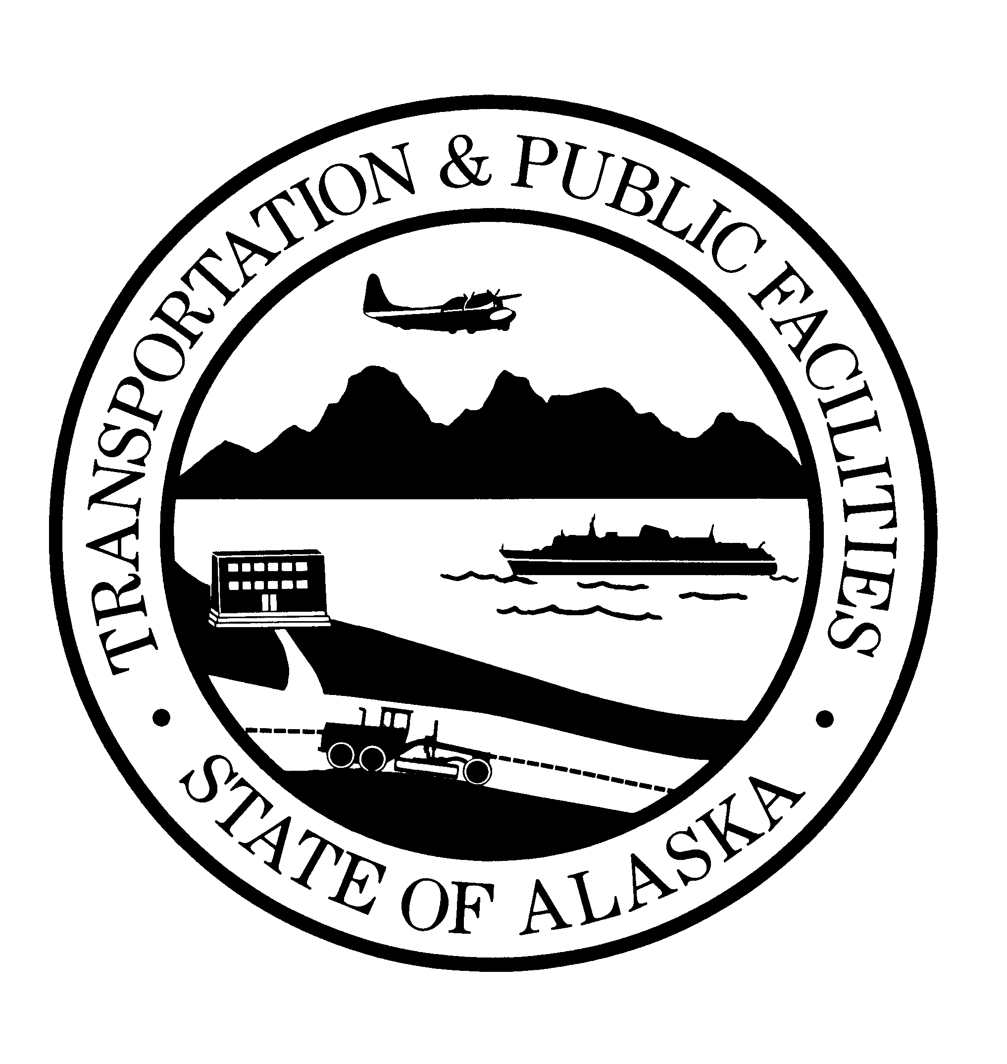

STANDARD
SPECIFICATIONS
FOR
HIGHWAY CONSTRUCTION

2020
Professional Seal is not required on the highway specification Title sheet.

EDITION

