CENTRAL REGION ALL-PROVISION—QUICK REFERENCE GUIDE (QRG)
(Delete QRG from final Project Provisions)

Use aides for the Central Region All-Provision (C100-700) document.

Guide Documents

Additional information is available in the Project Provisions and Style Guides.

• Network Drive "hyd" on 'Aviation Ave File Server (hyperion)',
..\..\..\..\..\Users\005_CHS_Specification_Provision_Guides
• DOT&PF FTP site:
https://dot.alaska.gov/creg/design/highways/specifications-users/005_CHS_Specification_Provision_Guides/

Current Provisions

Review the update notifications and confirm the latest provisions are used.

• Network Drive "hyd" on 'Aviation Ave File Server (hyperion)":
..\..\..\..\..\Users\003_CHS_Arc_Update_Notice\2020_Arc_Update_Notice
• DOT&PF FTP Site:
https://dot.alaska.gov/creg/design/highways/specifications-users/003_CHS_Arc_Update_Notice/2020_Arc_Update_Notice/

Table of Contents and Navigation Pane

Inform the Specification Engineer of problems using the automated table of contents.

Show/Hide: to see formatting symbols and fields, select - Home/Paragraph Group/¶ (show/hide symbol)

• Turn on the Show/Hide formatting and field aide to avoid deleting established fields.

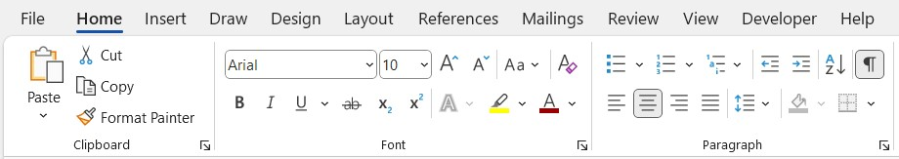
1. Navigate the document using the Navigation Pane.

• Select: View/Show/Navigation Pane (brings up the Nav Pane)
• Select: Click the Section Number and Title to go to each Section
• Delete a Section Number and Title in the document to remove it from the Navigation Pane

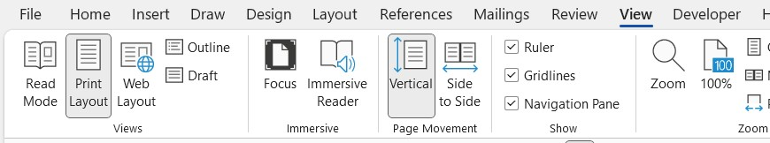
2. Navigate the document using the Table of Contents.

• Place arrow over Section number and title
• Press Control and Click: Section Number and Title to go to each Section
• Delete a Section Number and Title in the document to remove it from the Table of Content
• Update TOC (Follow link to update TOC)

3. Restore the Table of Contents.

a. If you delete a line of the table of contents - Update TOC and the line will come back.
b. If you delete the table of Contents, you can put it back.

Option 1

Before editing your project master specification add a custom table of contents to the table of contents gallery.
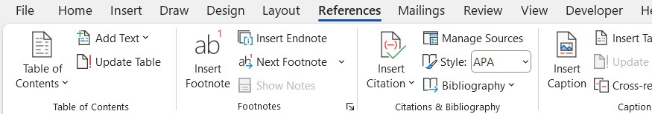
• Highlight the complete TOC including the title (TABLE OF CONTENTS) and column headings (Section & Page) through the body of the TOC. Do not highlight the Section Break
• Select: Reference/Table of Contents/Down Arrow/Save Selection to Table of Contents Gallery
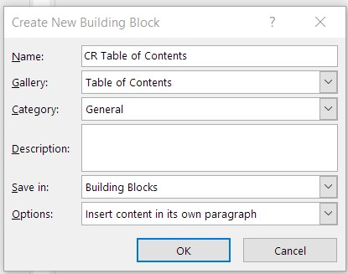
• Type in the Name "CR Table of Contents" or similar, click ok

To verify you have created a new table of contents follow the steps above and after the down arrow, you should see under "General" the new table of contents. Once established this table will be available in your future documents.

Replace the lost/deleted TOC.

• Position the cursor in the location of the lost/deleted TOC and then select - Reference/Table of Contents/Down Arrow/General CR Table of Contents

This will put the TOC back into the document. If you had removed and or added Sections from the document, and you had updated the TOC, the replacement TOC will include the deletions and or additions.
Option 2 (copy and paste the TOC from C100-700 to your project master specification)

• Save a new Master Doc from the DOT&PF network or DOT&PF ftp site
• Highlight the complete TOC including the title (TABLE OF CONTENTS) and column headings (Section & Page) through the body of the TOC. Do not highlight the Section Break
• Position the cursor in the location of the lost/deleted TOC and then Paste

Be sure to copy all of the TOC otherwise you will paste in formatted text without the fields.

Be sure you are placing the cursor where the TOC was before being deleted and that there is a section break (follow the link to add a Section) before the TOC and after the TOC.

If the TOC links change color and an underline appears after replacing the TOC right click anywhere in the TOC, select Update field, select update entire field, select Ok, the color will return to black and the underline will be gone.

Common Tasks (other than typical editing, copy/paste etc.)

Creating project specifications from C100-700 requires adding and deleting section breaks, deleting text boxes, deleting Sections, adding Sections, or otherwise modifying the provisions.

1. Section Breaks

Use Next Page section breaks. Do NOT use continuous section breaks (see below to remove).

Next Page Break.

Add:

• Place the cursor immediately before a preceding section break or before the title of the following Section
• Select Page Layout/Page Setup/Breaks down arrow/Section Breaks/Next Page
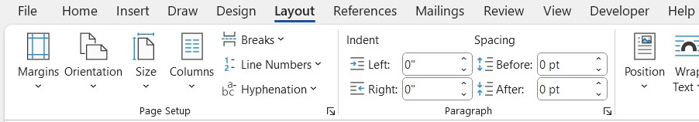
Remove:

• Highlight the Next Page, page break
• Press the delete key

Continuous Break—Removal

If a Continuous Section Break is present in your project specifications, remove it.

Option 1. Efficient/Effective Removal of Continuous Section Break.

• Add a Next Page section break before and after the Continuous section break
• Remove the Continuous section break
• Remove the additional Next Page section breaks

Option 2. Chasing the Continuous Section Break.

Highlighting and deleting a Continuous section break in one Section causes the Continuous section break, to move to the preceding Section. This will continue until you have found all Continuous section breaks. This is time consuming with the potential to leave the Continuous break in the document, when you believed you removed it, and causing unexpected issues at time of publication.

2. Remove a Text Box. (Blue box including instructions and recommendations)

• Place the mouse arrow over the perimeter of the box (a four-way arrow appears)
• Left click the perimeter of the box (perimeter is highlighted by corner dots & squares between)
• Press the delete key

3. Remove a Section.

Remove the navigation pane Section number and title, the body Section number, title and content through the end of Section Next Page section break (other Sections will remain intact).

Option 1. Body Content.

• Highlight Section number, title and body through the end of Section Next Page section break
• Press the delete key
• Update TOC. (Follow link to update TOC)

Option 2. Navigation Pane.

• Highlight the Section number and title
• Press the delete key
• Update TOC. (Follow link to update TOC)

4. Add a New Section

a. Insert Section Break

Next Page

• Place the cursor immediately before a preceding section break or before the title of the following Section
• Select Page Layout/Page Setup/Breaks down arrow/Section Breaks/Next Page
b. Update Header & Footer
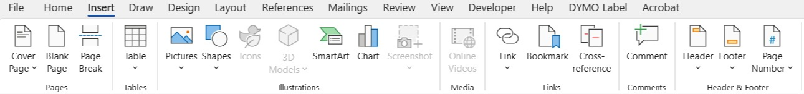
(1) Header – One and Two Page Headers

• Select Insert/Header & Footer/Header down arrow/Edit Header
• The QRG, SNtB, Title, TOC, Division 100-700 Sections and Addendums are separate from each other, not linked
• Division 100-700 Sections and Addendums Title page-last Appendix _: the first page of each Division/Section and each addendum is linked across the section page breaks; the second page each Division/Section and addendum is not linked across the section page breaks
• New second page headers and new addendums are not linked and require the addition of the section number and addendum letter between the Sections and between the Addendums

(2) Footers

• Select Insert/Header & Footer/Footer down arrow/Edit Footer
• The QRG, SNtB, Title, TOC, Division 100-700 Sections and Addendums are separate from each other, not linked
• Division 100-700 Sections and Addendums: first and second pages are linked between the divisions and sections and between the addendums
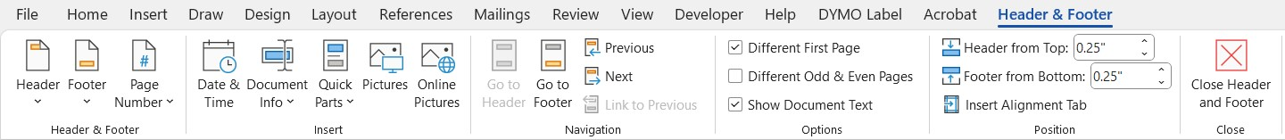
c. Insert Body Text

• Enter the new Section text (body text) above the new section break

d. Insert Section Number and Title. (centered, bold, and uppercase)

• Enter "Section ###;" Enter one soft returns (Shift + Enter); Enter "Title"

e. Assign Style to Section Number and Title

• Place the cursor in the Section title and select: Home/Styles/CR NAV SEC HD L2 Ctr 10pt (Section number and title will be added to the Navigation Pane)
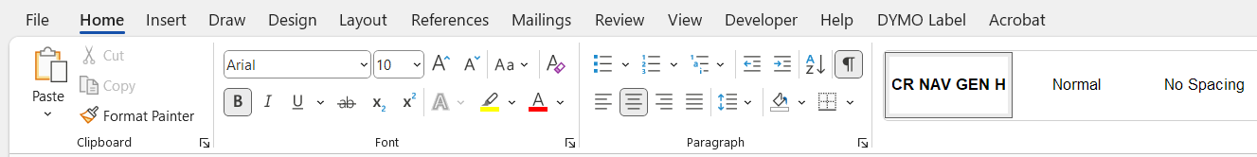
f. Place the TC fields after the title similar to other Sections

• Copy the TC field from a previous Section and paste after the new Section title
• Place the cursor in the field and edit the title (use sentence case) to match the new Section title keeping the quotes ("), and the switches (\f) as they were pasted in
• Update TOC. (Follow link to update TOC)
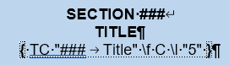
If the division field has been removed or provisions in a new division have been added follow a similar processs to adding the Section TC fields for the Division fields.

5. Footer Project Name and Project Number

Option 1

• Replace "Name" with the project name
• Add after "Project No.:" the Federal and or State (AKSAS/CFHWY) numbers
• Copy Project Name "XXX" and Project No.: ###. Paste over "Name" and insert "Project No.:"

Option 2

• Select Home/Editing/Find. (Opens the Navigation Pane)
• Select the search box down arrow/Advance Find

Name, Project No.:

• Select Replace and fill in. Find What: with "Name" and Replace With: with "Project Name." Select the options as provided at the bottom of the window. "Project No.:" similar to "Name"
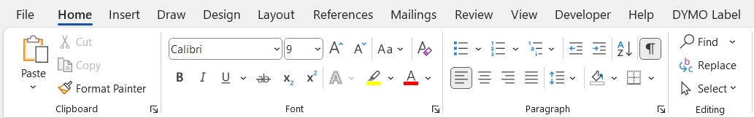
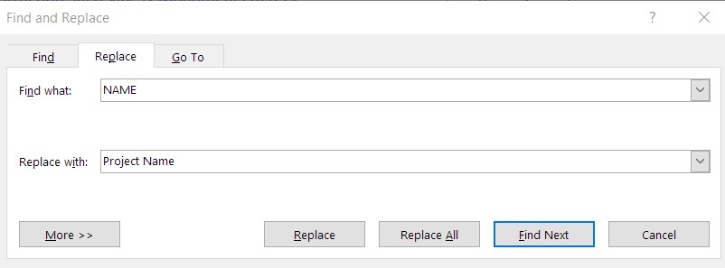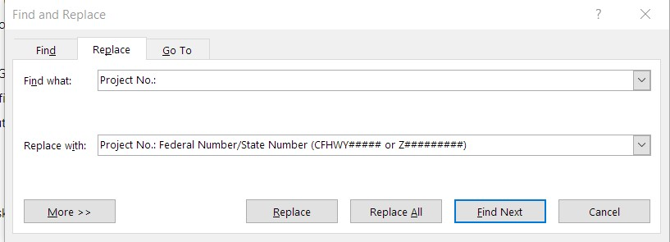

6. Update TOC (Update the TOC after any heading change, etc.)

• Left click in the TOC
• Right click and select: Update Field/Update entire table
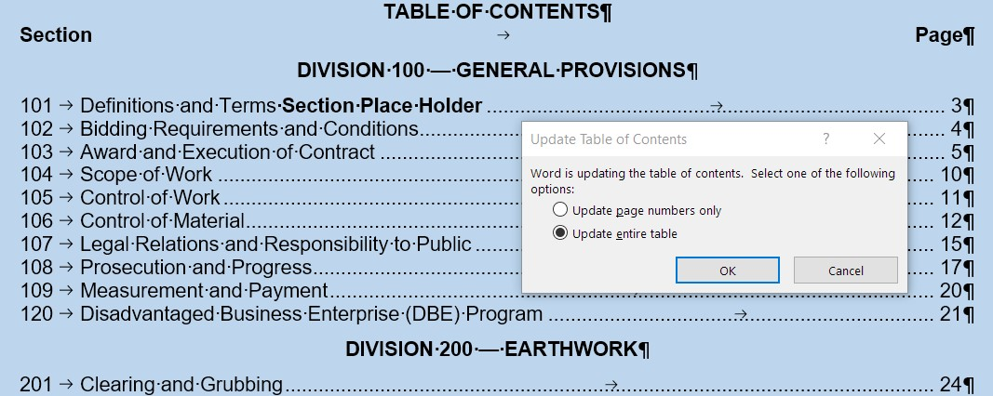
Content

1. Project Provisions – Guide

3.0 Process

3.1 General (Refer to Appendix A for further clarification)

Start with the All-Provision file 000_C100-700-yy.mmdd-0_SSHCyy. The All-Provision file is a compilations of the Provisions edited for use on Federal funded projects (any funding) and State only funded projects. The edited all-provision file becomes the Project Provisions.

Keep the Provisions that relate to the project design (Provision's in each Section associated with the Pay Items in the "Estimate of Quantities" (EQ) and "Engineers Estimate" (EE)) delete the other Provisions. Tailor the Project Provisions to meet project requirements. Match the completeness of the Project Provisions to the project Phase as discussed in "3.10 Reviews."

2. Comment/Instruction Boxes (blue text box)

When the comment/instruction has not been resolved, leave the box in place. When you remove the box, without a resolution, the reviewer does not know if you believe the issue is resolved, or you intend to provide resolution in the future. Leaving the box also works as a reminder of issues to be resolved. If you removed the box without resolving the issue, it is difficult to identify the issue for future resolution.

3. Blank Space Infill

Fill in the blank spaces with information specific to each project. When the condition does not apply, fill the blank space with "NA"; do not leave the space blank. A blank space appears to the reviewer, and ultimately to the Contractor, that information is missing, and the spec is incomplete.

4. Project Specific Edits – Identifying

Identify edits to provisions as indicated in the Project Provisions – Guide, Appendix F – Project Specific Edits – Identifying, is a good quick reference.

Warranties

1. Any Federal funding - Warranties require Federal Highway Administration (FHWA) Division Administrators' approval.

a. Alaska Department of Transportation and Public Facilities (Alaska DOT&PF) Standard Specifications for Highway Construction (SSHC) are FHWA approved.

b. Special Provisions incorporating the SSHC warranty content are FHWA approved.

c. Central Region (CR) special provisions, including project specific special provisions, may include warranties that fulfill, Warranties 3. Central Region Warranty Provision Requirements.

2. State of Alaska (SOA) funding only – Warranty requirements are similar to Warranties 3. Central Region Warranty Provision Requirements, except the FHWA Division Administrators' approval is not required.

3. Central Region Warranty Provision Requirements - CR special provision warranties, including project specific warranties, require approval by both:

a. The CR DOT&PF Highway Department Design Group Chief.

b. The FHWA Division Administrator (not required for SOA only funding).
Requirements

a. Specific construction product or feature under the Contractor's control.

b. Reasonable

• Period - Industry standard, except 1-2 years typical and 5 years' maximum
• Performance - Industry standard

c. Enforceable

• Clear, specific requirements
• Maintenance and Operations does not follow up on design project warranties
• Construction enforces the project requirements through Final Acceptance, 105-1.16
• There is no enforcement after Final Acceptance unless arranged during design

d. Defensible – Highway Design Group Chief must be able to defend the warranty

• Routine maintenance is not permitted, is therefore not defensible
• Industry standard is defensible
• Value to the Federal government is defensible

e. Submit the warranty and subsequent revisions to the Design Group Chief and if approved

f. Submit the warranty and subsequent revisions to the FHWA Division Administrator

4. Federal Highway Administration Regulations and Guidance Documents – Warranty Excerpts

Specific information is available from the included web site.

Federal Highway Administration

Code of Federal Regulations

https://www.fhwa.dot.gov/construction/cqit/warranty.cfm

Title 23 – Highways

Laws

23 USC 116 Maintenance

Regulations

635.413 Guaranty and warranty clauses

The STD may include warranty provisions in National Highway System (NHS) construction contracts in accordance with the following:

(a) Warranty provisions shall be for a specific construction product or feature. Items of maintenance not eligible for Federal participation shall not be covered.

(b) All warranty requirements and subsequent revisions shall be submitted to the Division Administrator for advance approval.

(c) No warranty requirement shall be approved which, in the judgment of the Division Administrator, may place an undue obligation on the contractor for items over which the contractor has no control.
See actual document for further information including design-build project warranty requirements.

Policy

Contract Administration Core Curriculum Manual

FHWA policy – Section III.B.8.c.iv.b)5) Warranty

The length of a warranty is dependent on the surety industry's willingness to underwrite the warranty. In general, warranties tend to be restricted to a maximum of five years due to bonding and/or surety limitations.

C100-700-QRG-25.0101

