Highway Design Project Closeout Document Instructional Guide

Instructions and Tips for going Digital

Purpose: This document is intended to guide staff on creating a searchable and bookmarked Project Closeout Document file.

Example: Final Project Closeout Document examples can be found here: <https://dot.alaska.gov/creg/design/highways/Submittals/Project_Closeout/>

Make documents pdf searchable:

Steps in “document” form:

* Open document (word, excel, emails, etc)
* File → Print → Under printer, select “Microsoft Print to PDF” → print
* Doing this NOW will eliminate an extra step when optimizing during Step 15

If the following is used to print to PDF, you will get a pop-up when optimizing during Step 15 that requires more work

* Acrobat tab → Create PDF (DO NOT USE)

Steps when “pdf” form:

* Open pdf in Abobe
* Click Scan & OCR (icon on right hand side of screen)
* Click Recognize Text → In This File → Recognize Text
* Print → Under printer, select Microsoft Print to PDF → print

OR

* Print → Under printer, select Adobe PDF → print

*These steps can be done at any time during the project phase. It’s recommended you do this whenever you’re storing a document in your project files – this will reduce your closeout efforts at the end of the project.*

Closeout Steps:

1. On your desktop, organize all projects pdfs in a separate file, in the same structure in which they will appear in the closeout- use Highway Design File Template provided. This keeps the W drive documents preserved in case something is deleted.

Use the recommended structure for Highway Design (*CR_Project_Closeout_Guide.docx*, Appendix A, Project Files Index)

1. Create dividers for each section

Refer to *CR_Project_Closeout_Guide.docx*, Appendix A for divider formats

1. Change all documents and dividers into searchable pdf formats BEFORE proceeding to next step, if not already done. You’ll be thankful.

Click Scan & OCR → Recognize Text → In This File → Settings → Change Output to “Searchable Image (Exact) → OK → Recognize Text

NOTE: If text is not recognized (i.e. scanned forms with handwriting), print to adobe pdf, run Scan & OCR again (above steps), save. Check doc for searchability.

1. Insert cover and divider pdfs into their respective section folder
2. Once all the covers, dividers, and pdfs organized on desktop, choose an option:

* OPTION 1 – Combine files within Acrobat

Open Acrobat DC → Create PDF on the Home tab → Multiple Files → Next → Add Files → Choose files one at a time OR drag and drop from File Manager (easier) → Combine

This is where step 1 and 2 really come in handy. Combine Files for each folder (i.e. Reports, Design Reviews, etc), as you go along. Items can be moved up or down, and they will appear in the same order that you arrange them in, so ensure you set your dividers up properly in between each file, you will save time in the end. Many “Binder” files will be created. Save to desktop or desired location.

* OPTION 2 - Combine files from your desktop

Open desktop folder → Shift-click to select all folders → Right click → Combine Files in Acrobat → Combine

This option will scramble all documents and make organizing tough. Not a good option.

NOTE: If step 3 was skipped, be prepared to wait during step 6.

1. Combine all Binder files created in Step 5 and save the pdf as:

<IRIS Program #> <Project Title> Archive.pdf

(Example: *CFHWY00381 AMATS Airport Heights Debarr to Glenn Hwy PP Archive.pdf*).

* 1. Create a copy of the new pdf to ensure a good starting point, should there be a critical error when performing later steps.

NOTE: Adobe can crash multiple times when performing closeout so it’s good practice to have a copy.

1. Open combined copy of project and create the bookmarks.

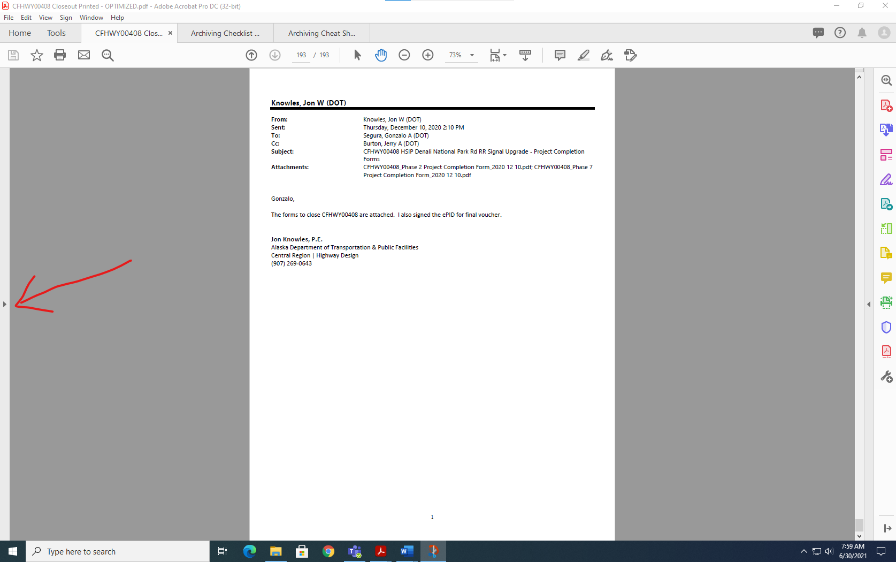Select arrow on far left (see Image 1) to show hidden bookmark tools

Image 1: Where to find hidden bookmark tools

Click the bookmark icon (See Image 2)

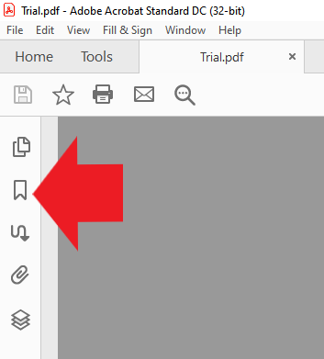

Image 2

1. Click New bookmark icon (Image 2 icon with a plus sign in the lower right corner) → Type name for bookmark → Enter → Scroll to page of bookmark (zoom out to 75.5% to see page) OR you can edit existing bookmarks → Set Destination → Move to desired location

To nest bookmarks: Click on bookmark name to be nested → drag to location

NOTES: Bookmarks can also be made during STEP 5 when combining files.

Delete bookmarks for all documents (this will not delete the document itself)

1. When bookmark is made for each cover (i.e. Reports) and divider (i.e. Reports: DSR), and document bookmarks are deleted, bookmarks should look similar to Image 3.

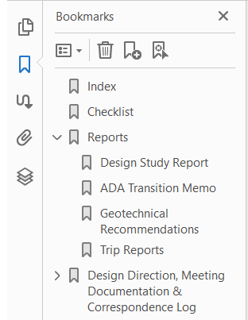

Image 3

1. If any documents, dividers, etc are missing or you forgot to add them, they can be added using the “Organize Pages”
2. Before proceeding to the next step, make sure the following is done:

* Saved the pdf
* Created a saved copy of the pdf (suggest saving a backup after major editing)
* Ensure all documents are right side up. If not, it create hardships and be more time consuming go fix later
* Blank pages are removed

To fix a documents orientation: Click “Organize Pages” on the toolbar on the right side of the screen. Use the slider at the bottom to make the thumbnail images larger or smaller. Scroll through and ensure everything is oriented correctly, if not, hover over the page, and select one of the rotate icons until it is correct.

1. Reduce file size.

This step can be skipped IF it was done prior to Step 1. Otherwise, it will take 30 minutes to an hour or longer to complete, depending on the number of pages. DO NOT use your computer during this time.

Scan and OCR → Recognize Text → In This File → Settings → Select “Searchable Image (Exact) for output → OK → Recognize Text

Toolbar should look like Image 4



Image 4

1. Recognize Text (this is an optional step and recommend skipping):

Scan and OCR → Recognize Text → Correct Recognized Text → Accept or type corrected word. This is a very long and tedious process.

This step will allow you to fix what the computer misunderstood. It is recommended to do this before Step 1. NOTE: If it highlights something such as a dotted line, or an arrow, press backspace and leave the field blank.

1. Optimize PDF

Tools tab → Under “Protect & Standardize” → Optimize PDF → Advanced Optimization (the feature is only available in Adobe Acobat Pro DC)

Note: This is a critical step as this drastically reduces the PDF file size.

1. Set parameters to match Image 5 → OK → save document

This step may take a while so don’t panic is the bar doesn’t move.

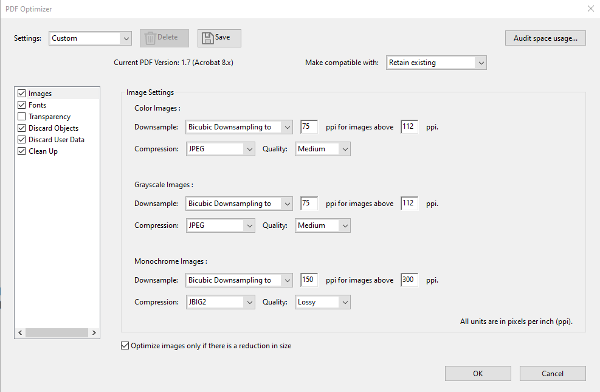

Image 5

Note: Once you’ve set the parameters as shown in Image 5, you can save these settings using the Save button next to the Settings dropdown.

If Image 6 appears during optimization, please follow the steps at the beginning of this guide for the affected pages.

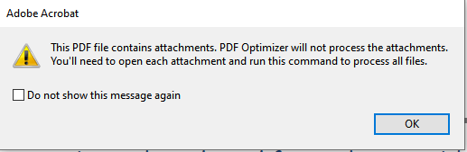

Image 6

1. The document should be searchable, and you should be able to flip through relatively easy. If not, there are a few different approaches to fixing it. If you have any questions, feel free to ask Deidre Peterson.
2. Follow SECTION 3. DIGITAL DOCUMENTATION of the *CR_Project_Closeout_Guide.docx* to complete the closeout process.