GUIDELINES
(do not print this page)

ALASKA DEPARTMENT OF TRANSPORTATION & PUBLIC FACILITIES
CENTRAL REGION
ADA TRANSITION MEMO TEMPLATE
This memo has been created to fulfill requirements by FHWA and 28 CFR 35 to track and report pedestrian facility upgrades, through Design and Construction, to the Civil Rights Office (CRO).

A few helpful guidelines when using the ADA Transition Memo Template:

During Design:
- This template has been broadly written to encompass all pedestrian facilities upgrades. For projects that have a limited scope, clarify the types of facilities investigated (e.g. Pavement Preservation project only looked at curb ramps).
- The memo, signed by the DOT&PF Design Project Manager, shall be included as an appendix in the Design Study Report (DSR). A copy of the memo and the ADA Inventory Spreadsheet shall be sent to the CRO at that time. This information will be provided in both PDF and electronic (.xls) versions.
- If it is determined that upgrading a facility to ADA compliance cannot be done after approval of the DSR, a Design Study Report Revision Memo must be completed to document the technical infeasibility. This must be signed by the Regional Preconstruction Engineer and amended to the DSR. Submit this document to the CRO.
- A copy of the signed memo, along with all revisions, shall be provided to the DOT&PF Construction Project Manager as part of the Transfer to Construction Memo. Provide them with an electronic version as well.
During Construction:
- The DOT&PF Construction Project Manager shall sign the memo at the completion of the construction project certifying that the constructed pedestrian facilities meet ADA minimum standards. The memo shall be resubmitted to the CRO at that time.
- The far right column of the table is provided as a place for construction notes for each facility identified. Use this space to indicate any unique conditions (e.g. reconstructed ramp length of 15.0’, resulting ramp slope >8.33%). If it is determined that a proposed upgrade cannot be constructed to meet minimum standards, document that as well.

MEMORANDUM State of Alaska
Department of Transportation & Public Facilities
Design and Engineering Services – Central Region
Highway Design

TO: | Dennis Good | DATE: | XXXX
 | Civil Rights Office Manager
THRU: | NAME | TELEPHONE NO: | 269-XXXX
 | Highway Design Group Chief
FROM: | NAME | PROJECT NAME: | {Name}
 | TITLE | Project No.: | XXXXXXXXX
 |  | SUBJECT: | ADA Transition Memo: Record of Design and Construction

This memorandum has been created to identify existing pedestrian facilities within the project limits that do not meet the current minimum standards set forth by the Americans with Disabilities Act (ADA) and document the upgrade to compliance, or technical infeasibility, through construction as part of the Civil Rights Office (CRO) ADA Transition Plan.

The pedestrian facilities identified on the following pages have been determined to be out of compliance during the design phase of the project and are recommended to be replaced during construction.

The Design Project Manager’s signature below indicates that the pedestrian facilities will be included in a construction project resulting from this design effort.

Any facilities that are determined to be unable to be brought into compliance due to technical infeasibility during final design will be documented by a supplemental amendment to the Design Study Report with an explanation of the constraints that prohibited ADA compliance.

The Construction Project Manager’s signature below, completed prior to Construction Project Closeout, indicates that the identified facilities have been replaced with ones that meet current ADA standards.

Design Project Manager Date |  | Construction Project Manager Date

Attachments: [PROJEC NUMBER] ADA Inventory Spreadsheet (hardcopy and electronic)

cc: Project Manager, P.E., Project Manager, Highway Design
Jim Amundsen, P.E., Chief, Highway Design
Construction Project Manager, P.E., Project Manager, Construction
Tom Dougherty, P.E., Regional Construction Engineer, Construction
David Lee, Central Region Construction Office Engineer, Construction

Construction Project Name and Number: ______________________________________________________________________________
(Complete this only if information does not match the design project information)

Legend:
RAB – Roundabout * Number corresponds with the attached [PROJECT NUMBER] ADA Inventory Spreadsheet.

Number* | Facility Type | Cross Street | Location | Curb Ramp Type | Description of Non-Compliance | Photo | Construction Notes (Indicate year of construction if it varied)
1 | Curb Ramp | Old Seward Hwy | NE Quad; S Ramp | Perpendicular | Landing slope > 2% | 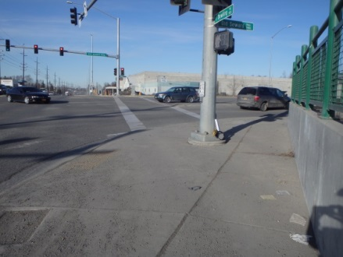
3 | Curb Ramp | Victory Christian Driveway Entrance | NW Quad | Parallel | Landing slope > 2% | 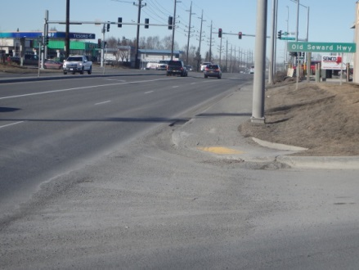
6 | Curb Ramp | Alaska Professional Auto Driveway Entrance | NE Quad | Parallel | Landing slope > 2%  Note: Dumpster should be moved | 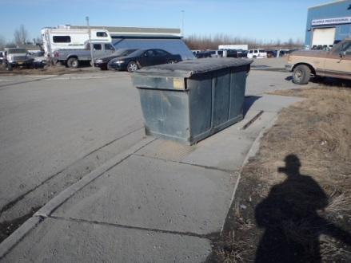
7 | Curb Ramp | West RAB; North Access | NW Quad; South Curb Ramp | Perpendicular | Landing slope > 2% | 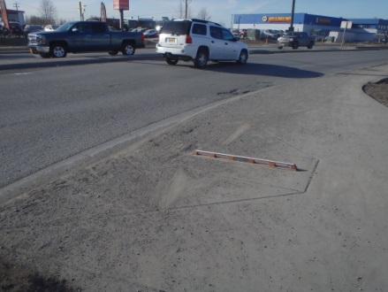
8 | Curb Ramp | West RAB; North Access | NW Quad; North Curb Ramp | Perpendicular | Cracks > 1/4” drop  Landing length  < 36”  Note: Type II Traffic Jbox is located in landing | 