Traffic Safety
- What does the Traffic Safety Section do? Besides collecting & analyzing crash data, what else is the Traffic Safety section responsible for?
[SCOTT - TRAFFIC SAFETY] is the planning and operations half. Technical experts and troubleshooters. In 15+ areas of expertise –
- crash data; signing; striping/rumble strips; signals ; lighting ; guardrail; work zones ; speed limits; RR Xings; school zones; capacity; access management, permits, TIA’s; Legal questions, cases; System Management - Ops Center, Field Ops; Responses, Awareness – Public and officials; Incident response

Monitor the Region between projects. Help M&O keep things moving safely. Traffic control device compliance and crash reduction over time.
Create projects. Fund $50 million per year in work. Review all projects.
Answer emergencies from the Commissioner, Director, Chiefs, and all functional groups.
ROW, Planning, PIO’s and M&O are also doing traffic safety work.

[LEISHA - TRAFFIC DESIGN] Technical experts on the hardware. They design what we plan and operate. They are the nuts and bolts and wiring and power for all things traffic and safety. The review submittals. They make sure it all is detailed correctly.
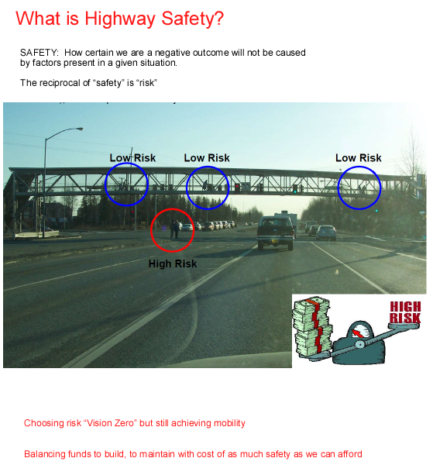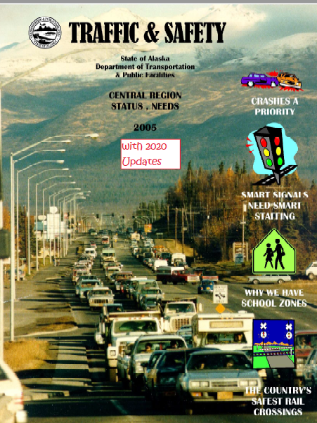Pinnacle: "2020_Updates_DiscoverTraffic”

- Why is a Traffic Safety engineer’s work important? What are the benefits from quality Traffic Safety engineer work?
[SCOTT] Vision Zero. All of us save lives in our work. It’s the PE Code. Do what you can within 1R, 3R, 4R formulas. Don’t leave it to other projects and sections. Traffic Engineers ensure consistency and the safest infrastructure we can build. We pick the outcomes. We create the solutions. We guide the consultant and in-house teams. We guide planners and surveyors in land use. The results keep all modes moving and prevent deaths and injuries as tracked on long term charts. If we did not do this, crashes would get worse and roads would come to as stop in places.

[LEISHA] Traffic geometry = Design geometry.

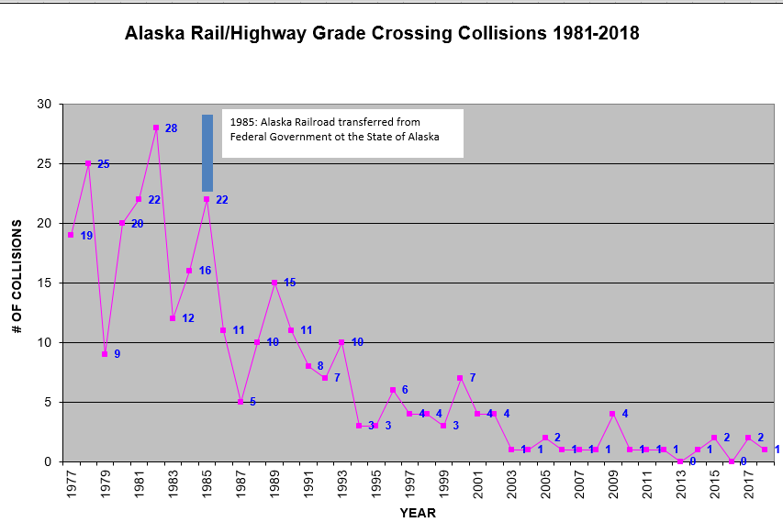
RR Xings – L Huling
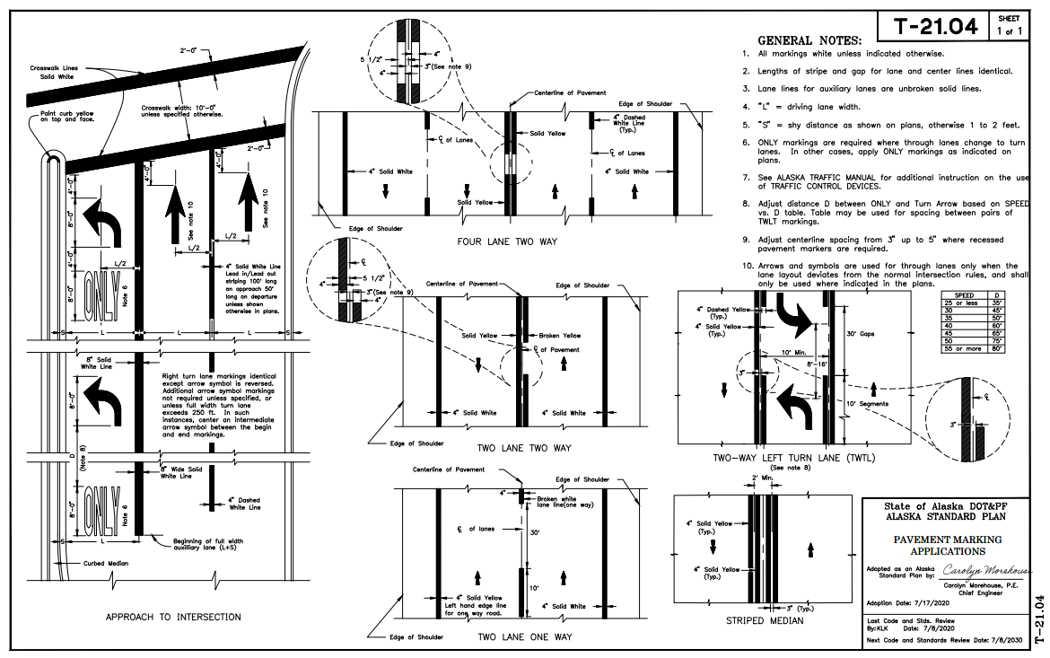

- How does traffic safety implement new safety features on our roadways?
[SCOTT] HSIP Screening = Inventory/Assess/Upgrade. Worst first.
Done for Moose, Peds, Bikes, Safety Corridors, Unsignalized Intersections, and future signals ranking.
Predict and prevent from what we know. Similar sites, segments.
HSM and AASHTOware not calibrated for AK. Better results with local judgment.
Nominate HSIP projects based on crash data matched to solutions.
HSIP creations go straight to Design.
Also work memo solutions for M&O.
Scope and review studies for ROW, Developers, Planning, Research, HQ, and other agencies. Write regional, statewide standards for 1R, 3R, HSIP, the Traffic Manual. Pitfalls in each method.

Nominations – O LeCroy

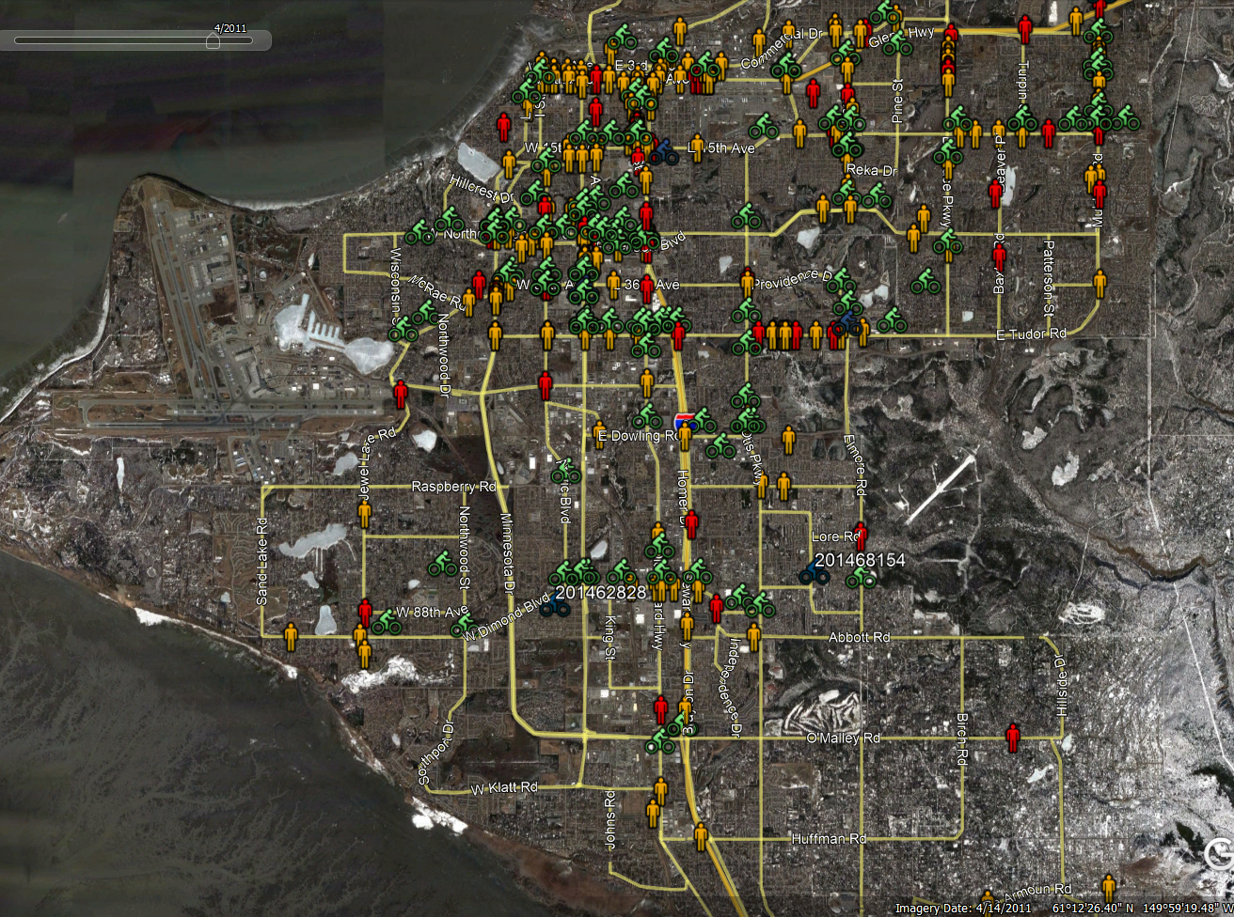
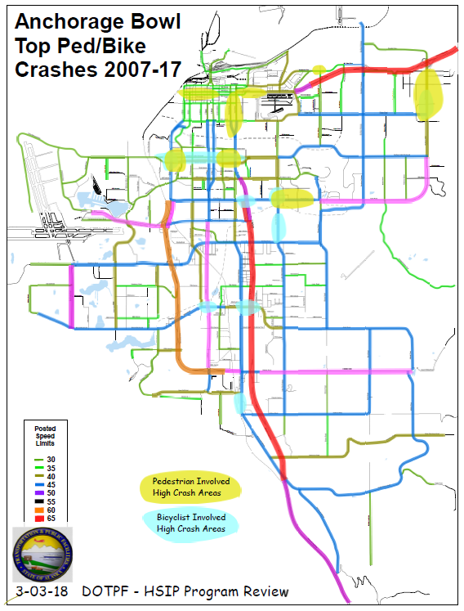
Crash Mapping – S Riopelle

- How do they figure out the timing on signal systems so that traffic flows better in one direction during high traffic times?
[SCOTT] We and MOA proportion time to demand and ITE formulas. With ITS funding, Val and Curtis program for time of day changes. “Green” time is proportioned to demand. Sensors to extend for variations in arrivals. Signal start times offset so they turn green in sequence. Favors peak commute flow direction while others stop for red. Computer models allow simulation before putting into practice.

[LEISHA] Safety’s concepts only work if her squad can get the hardware to fit and has the ROW and budget to upgrade...?

- When and how should the Traffic Safety Section be involved in a project being designed & delivered by another section (AVD/PD&E/HYD)?
[SCOTT} Know your history, Come see Traffic for history. Look for it during Planning and Scoping. Problems take more than 5 years to show themselves or to solve. Don’t get caught in a public meeting not knowing. Match design to problems we have on record through calls and legislative requests since the last project. During PIH and PSE we review for consistency checks. Our history files are your starting point. Same with Planning, M&O, and ROW – we are all working in between your projects.

[LEISHA] Traffic Design checks all the hardware for consistency during Design and Construction. They write all the hard work - the details and specs.

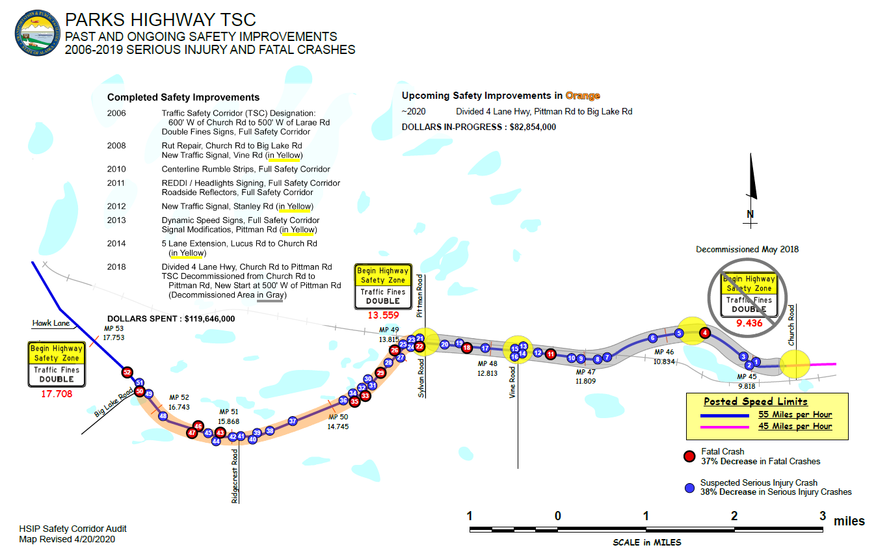
Crash / project mapping – S Riopelle

- If I have ______, ________, or ________ on my project, I should contact the Traffic Safety section immediately.
[SCOTT] Per our mission, if you have a history of deaths or major injuries on your project, you should contact the Traffic and Safety Section immediately. We can help you determine if your scope can mitigate that history, what is on file besides the project itself, or if other parallel efforts are an option.

[LEISHA} With the right geometry and hardware – we'll keep people moving at the same time.

- Have Studies and efforts been conducted by CR DOT to implement Pedestrian Lead Time intervals at crosswalks in areas of high volume pedestrian and vehicle traffic? If so, which would have priority, public safety or throughput capacity? Several cities much larger that Anchorage achieved zero-pedestrian traffic deaths in 2019 through engineering design. What takeaways has Alaska DOT gained from those examples, and what is DOT doing now to capture that same success?
[SCOTT] No. But “Every Day Counts” per FHWA. This is our #1 HSIP crash problem. We are asking other states how they use Flashing Yellow Arrow and whether we can write a new policy this winter to address Leading Pedestrian Intervals ahead of motorist turns. We are doing this through HQ. One year’s success in other cities does not equal long term sustained results. Anchorage’s signals are run by MOA and require a joint review. What we see is that most pedestrian crashes are not happening during the leading crosswalk interval. The solution does not match the problem.
We are seeing most pedestrian deaths are this time of year, at night, without snow. Rain and darkness and poor visibility. DOTPF CR has seven (7) dedicated pedestrian projects in Design now. Initiated before Alaska (Anchorage) rose to double digit deaths. Five corridor projects will double the light levels in the top areas of concern – with no increase in M&O costs. Tudor. Muldoon, Midtown and Gambell Streets. Two of the largest intersections will be “downsized” but still serve trucks – Dimond and C, Tudor and C. All areas are sites of past deaths. Starts in Traffic Safety, delivers in Traffic Design, and goes to Construction over the next 2 years to reverse current trends.
[LEISHA] Status of traffic designs for pedestrians – very tight fit...new inventions for lighting.
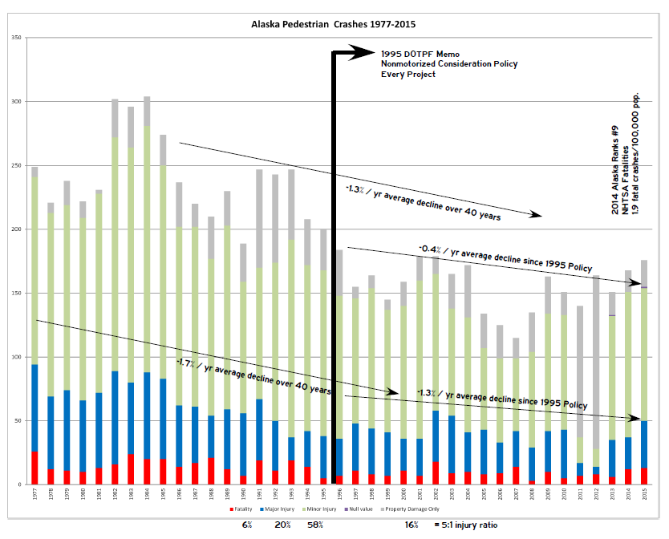

Data-driven Executive POLICY matters
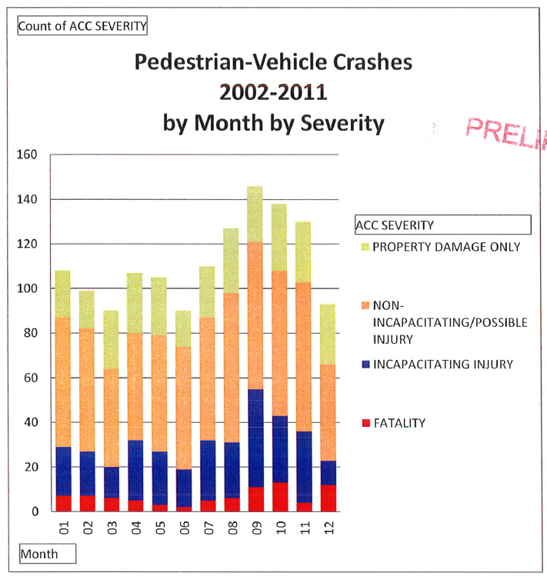Visibility Matters
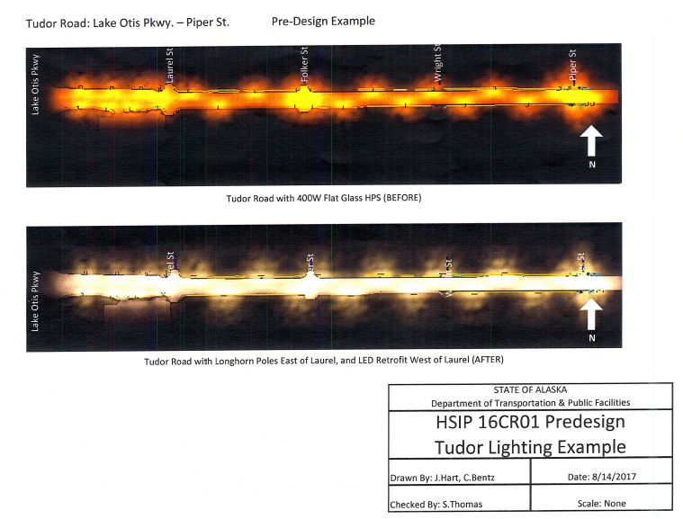

- How does each section support the overall DOT&PF Vision (“Moving beyond Alaska’s challenges while meeting Alaskans’ distinct transportation needs through trust, teamwork, and results”)?

[SCOTT] We keep roads open, as safe as speeds allow. Roads closed or all 20 MPH, we fail.
The mission is to keep people moving through infrastructure. Through lanes and traffic devices.
We manage risk proportional to speed. We eliminate crashes through infrastructure suited to speed needed. Keeping people moving, and alive, is how they make a living – it's the economy.
Engineering alone is not enough. Trust and teamwork, results come down to public acceptance from the user, the public. We partner with police, public relations, and emergency services. Trust is earned by coordinating, all of us on the same page, different strategies, same goal. Listen to the public – they're onto something if there’s a problem – but the solution may be something other than they are thinking such as a sign alone. 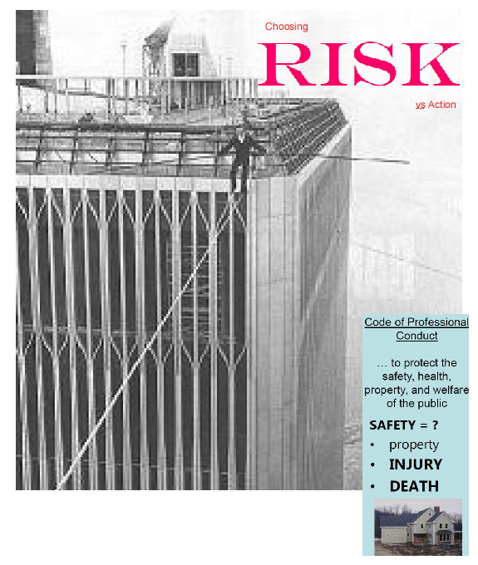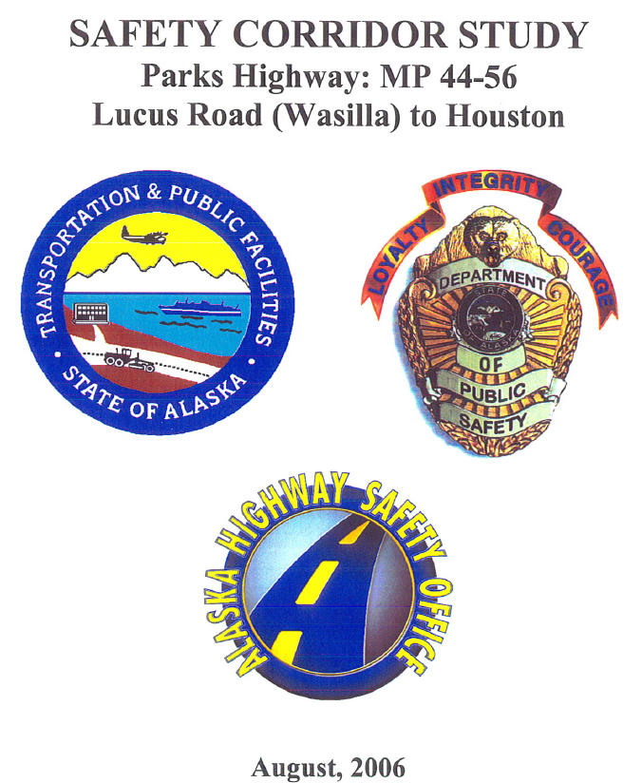
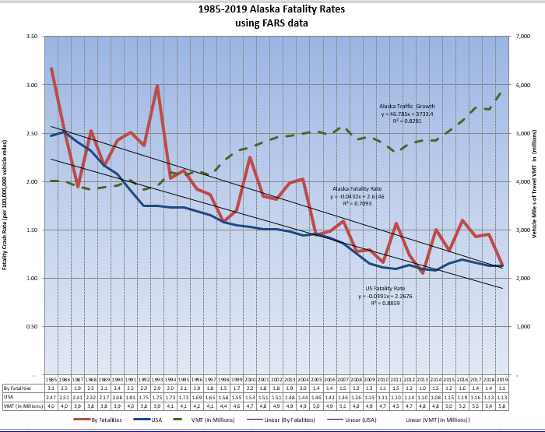

- What are some of the greatest challenges for each department?

[SCOTT] Staffing and budget to provide services. Achieved as of 2020. These are your next greatest problems –

- Public Service. Our mission as owner/caretakers not just project teams. How to measure and manage our mission beyond capital program delivery of $$ alone.
- GIS. The future passing us by without dedicated Regional GIS even with great personal efforts in squads. How to manage our assets, including traffic control.
- Big Data. 5G. Old DOTPF methods of in-house crash and vehicle data are going to be replaced by Big Data. They need ROW to expand. How do we work together to know our system and asset performance real-time, and use new data sources before we are obsolete?

- How does each section work with DOT projects? (e.g. traffic safety provides the most up to date safety regulation and data for that area)

[SCOTT]
Before project PLANNING = Inventory/Assess/Upgrade = System Management.
During project = ADVISE
Scope. History. Problem I.D. Solution matching.
Reviews. Consistency checks. Standards. Troubleshooting.
Overview. Advise. Complex unforeseen problems. Not easy to see our time in your budget.
Goals, rankings, screening, standards, methods.
Helping you deliver a quality project, not the project itself.
QA/QC role, but not as a normal budget and timeline item.
After built = OPERATIONS

[LEISHA] Traffic Design delivers the complex details. They provides piece of the plans or specs.
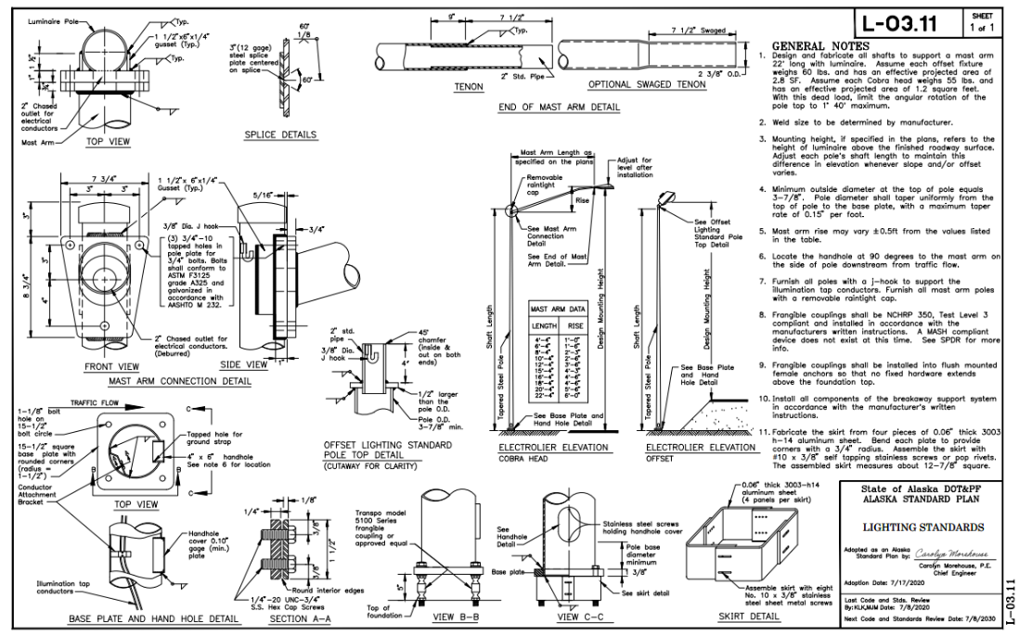
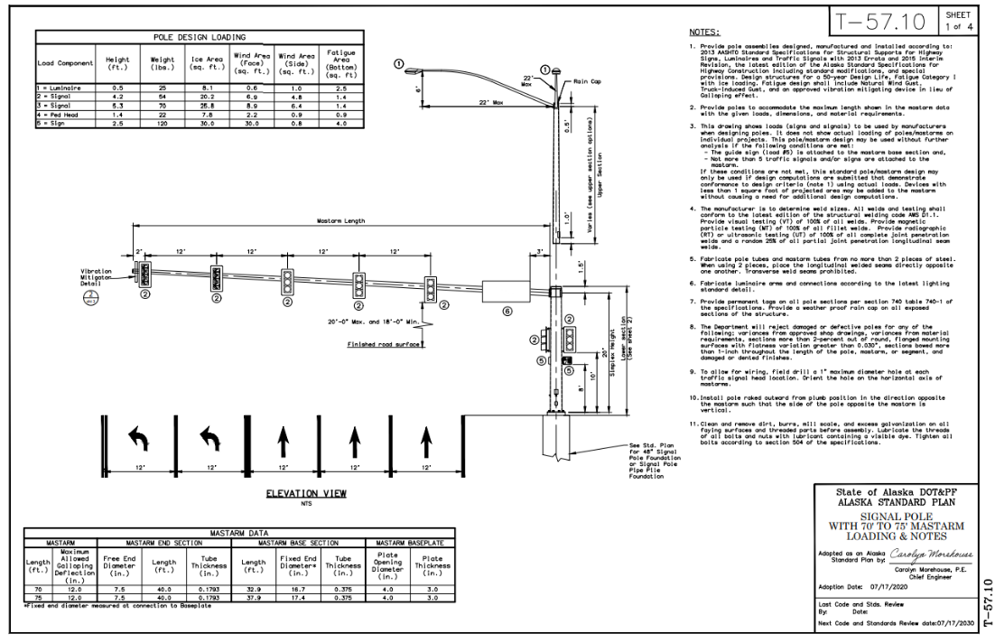

- Is Traffic Safety the experts/decision makers in regards to Controlled Access? Can you explain the process of determining/changing the C/A lines? What is being controlled? Just driveways and roads? Pedestrians? Can utility companies still access their facilities within in a C/A? Can a city bus let passengers cross a C/A?
[SCOTT] Experts, advisers – yes. One of several.
Decision makers = ROW and Chiefs. All sections review plats for consistent answers.
All of us should be studying access management and road function. Apply to 1R, 3R, and 4R, and platting and TIA’s.
Contributed to 2020 MatSu Subdivision Construction Manual and Driveway Code.
Wrote 2020 Parks Hwy Agreement with MatSu for Interstate access plan to Cantwell. Surveying with good engineering principles. Documents are online.
With C/A - NHS Interstate and expressways can be designed by you to work.
Without C/A any designs will erode in function, contrary to the DOTPF Mission.
Median C/A controls left turns only. Simpler to apply. (C St. Glenn, Parks).
Roadside C/A control all access. (Glenn, Parks, Seward).
No - Pedestrians, bus stops not allowed on C/A unless we provide a break or a path. Don’t mix high speed and low speed users. ROW has a huge resource on ROW history on this.
Yes – Utilities can access their facilities if no alternative is available.
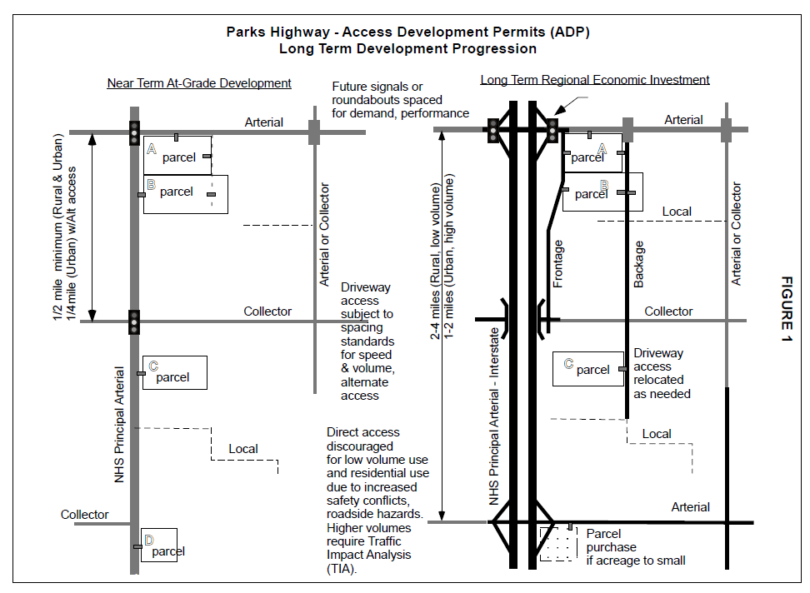
MSB Parks Hwy Access Development Plan (ADP) 2020 – ROW Online at TGIS pending
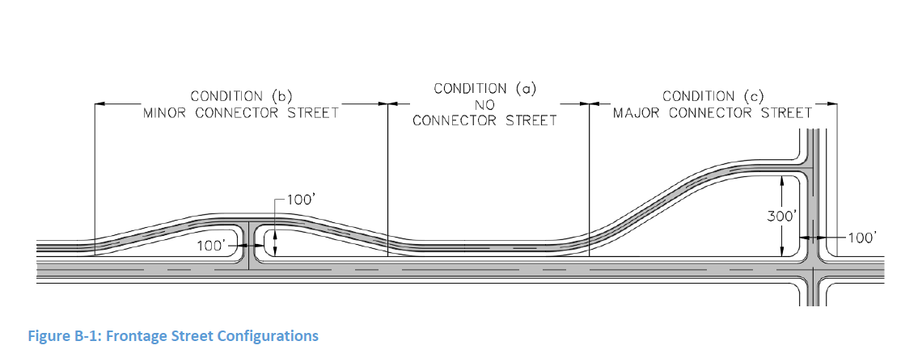
MSB Subdivision Construction Manual, Driveway Codes 2020

