**New Bidtab IV Account Inside DOT**

Internal users contact the OIT Help Desk ([oitsupport@alaska.gov](mailto:oitsupport@alaska.gov)), and request an rdp connection, or ask another user inside DOT for an rdp icon for Bidtab IV.

**New Bidtab IV Account Outside DOT**

External users require an SOA account with a DOT sponsor and VPN access to use Bidtab IV. DOT Project Manager, provide the OIT Help Desk ([oitsupport@alaska.gov](mailto:oitsupport@alaska.gov)) with the following:

1. Full Name (First Name, Middle Initial, Last Name)

2. Title

3. Telephone Number

4. E-mail Address

5. Fax Number (optional)

6. Sponsoring Division

7. DOT Sponsor

8. Company Name

The OIT Help Desk will create the SOA account and then provide you with a VPN request form. Return the form to the Help Desk.

Once the account is established, proceed to "New Bidtab Account Inside and Outside DOT" below.

[*The DOT Domain accounts are set to expire after one year. Contact your Project Manager and the OIT Help Desk to re-enable your account for another year*.]

**New Bidtab Account Inside and Outside DOT**

1. Open the Bidtab IV connection.

2. The opening screen in Bidtab IV is as shown below. If you do not see this screen, you have not reached Bidtab IV and you will need to work further with IT.

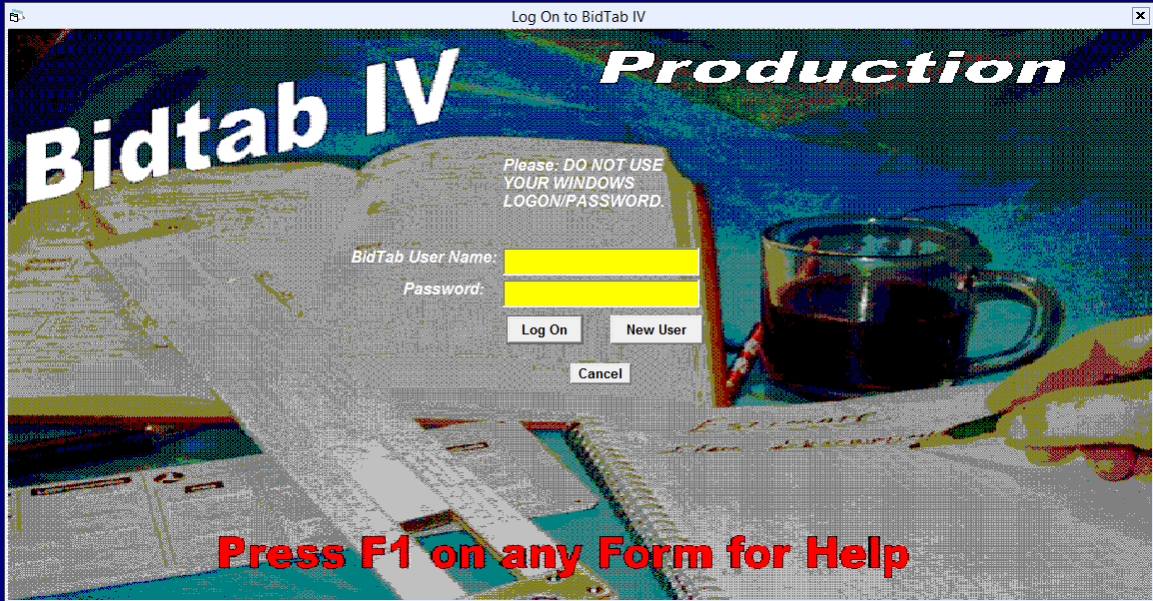

a. First time login to Bidtabs: enter the username and password you desire.

(1) User Name: Suggest you make the User Name the same as your computer log in ID, as in: first name initial, second name initial, last name. Annita A Bath (abath) or (aabath)

(2) Password: PW is at your discretion. You may want to make it simple. The first time you forget your password we (currently Fred Park, Virginia Groeschel, or Kevin Jackson) will reset it to "bidtab".

b. Select new user to create the account.

c. Answer the prompts and you are in. (Select the CR # and enter your email)

f. Each time you use Bidtab IV, after the first time you log in, answer yes at the Bidtab login

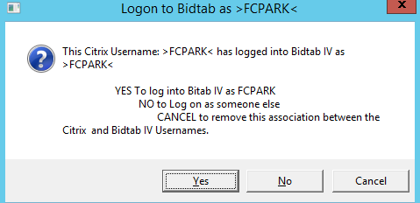

If you do not answer yes, you will need to reenter your password.

After the first time you login to Bidtab IV, request to be added to your cabinet/design group, contact:

• Fred Park, [fred.park@alaska.gov](mailto:fred.park@alaska.gov);

• Virginia Groeschel, [virginia.groeschel@alaska.gov](mailto:virginia.groeschel@alaska.gov)

• Kevin Jackson, [kevin.jackson@alaska.gov](mailto:kevin.jackson@alaska.gov).