Create the Engineers Estimate using the Highway Standard Contract Items, Central Region Supplement.

Highway Standard Contract Items, Central Region Supplement (HSCI-CRS)

The Highway Standard Contract Items are the pay items from the Standard Specifications for Highway Construction, 2004 Edition (Blue Book).

The Central Region Supplement includes the pay items from the "Standard Modifications," the "Statewide Special Provisions," and the "Central Region Special Provisions."

Instructions included here do not include directions for creating a cabinet or the initial estimate; review the instruction manuals for this information. The Estimate Engineer will assist with the basic use of Bidtab.

Create an estimate using the HSCI-CRS.

1. Create an Engineers Estimate.
2. Open the Engineers Estimate.
3. Select the tab "Standard Items," left click the tab (top left corner)
4. Select a Book.
a. left click the blue box next to the label "Book" (top left corner)
1) select the book, left click Highway Standard Contract Items

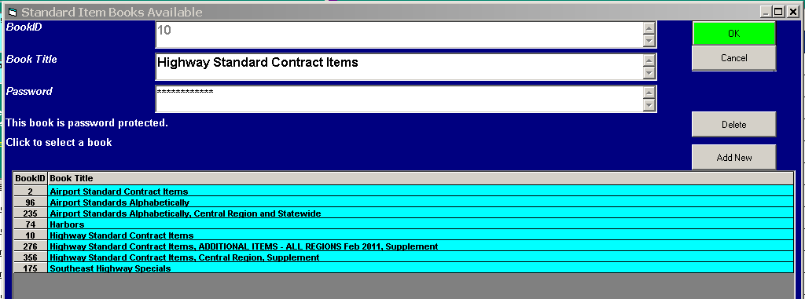

b. left click the green box "Add Supplement" next to the blue book box (top left corner)
c. select the supplement Highway Standard Contract Items, Central Region, Supplement
5. Select the Pay Items.
a. left click the left green box in the lower left side table of Pay Items and follow the prompts

When the supplement has been added the Pay Items will appear in the left side table of pay items in the color blue and the unit will include an "S." The "S" does not carry over into the estimate.

Follow the instructions 1 thru 5 for the most efficient use of the Highway Standard Contract Items, Central Region, Supplement
The following pictures illustrate options presented by Bidtab relative to selecting a Pay Item supplement:

This picture illustrates "Standard Items" from the Highway Standard Contract Items book, no supplement is added. Left side table.

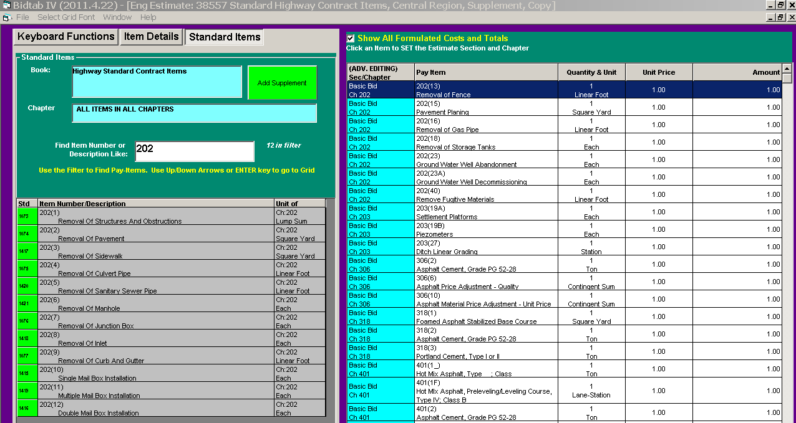

This picture illustrates "Standard Items" from the Highway Standard Contract Items book combined with the Pay Items from the Highway Standard Contract Items, Central Region, Supplement book. The supplemental Pay Items are colored blue and an "S" is added to the Unit for each Pay Item. Left side table.

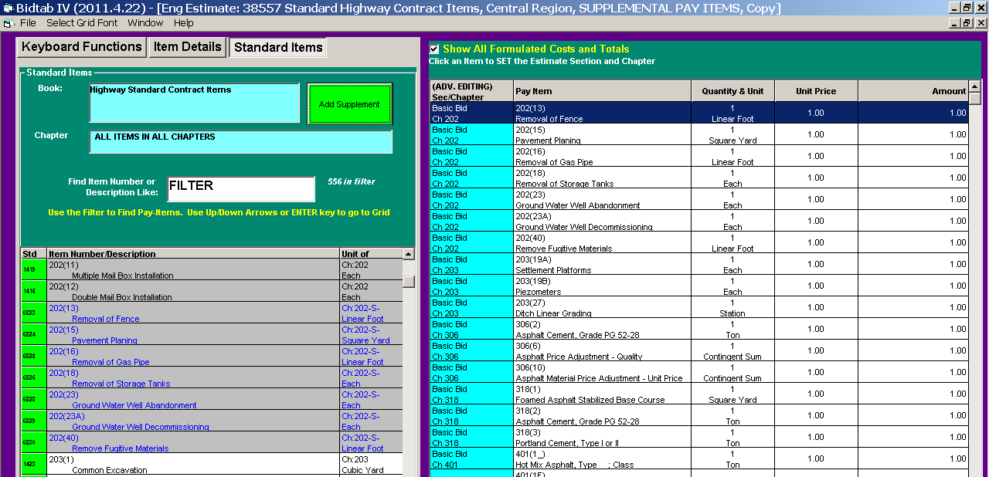
This picture illustrates "Pay Items" from the Highway Standard Contract Items, Central Region, Supplement book. The "Standard Items" from the Highway Standard Contract Items books are not included, only the supplemental Pay Items are included in the left side table. The Pay Items are no longer colored blue and the "S" is not included with the unit.

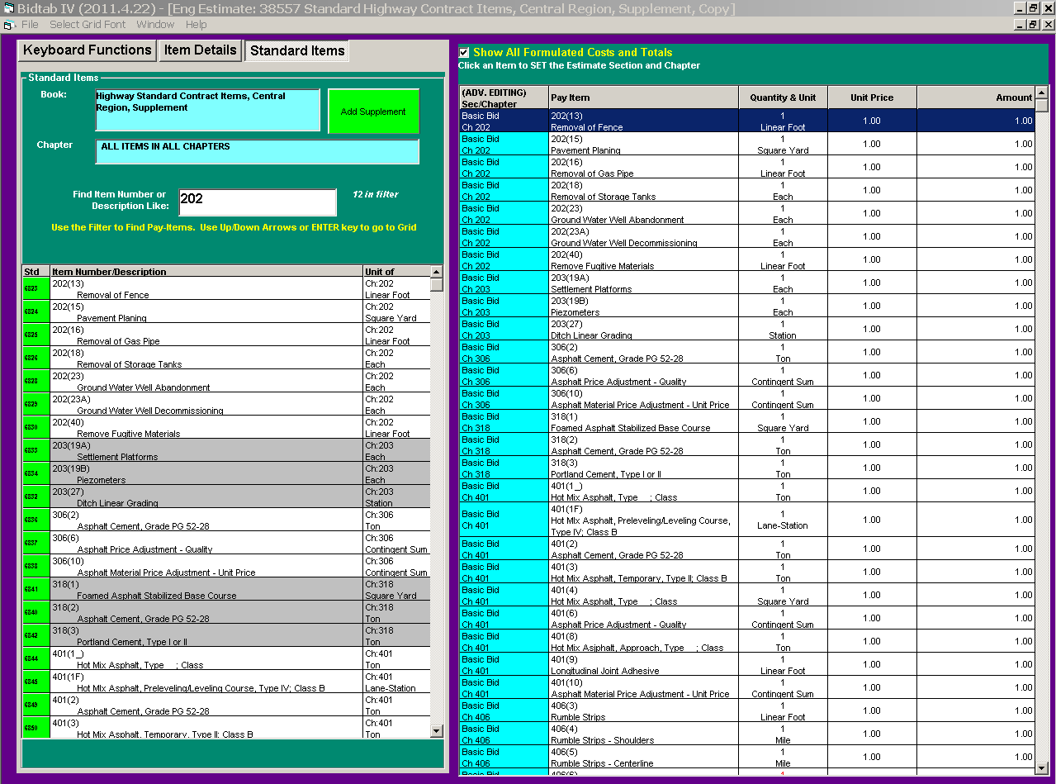
Additional notes:

1. When opening an estimate that inlcudes supplemental pay items Bidtab will prompt:

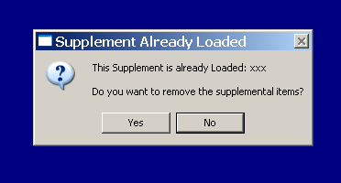

Selecting "No" removes the supplemental Pay Items from the left side table list of items. It does not remove the supplemental items from your estimate.

If you have created a copy of your estimate and you open the copy, the prompt will not appear.

2. If you click the "Add Supplement" box and then click a supplement that is already loaded Bidtab will prompt:

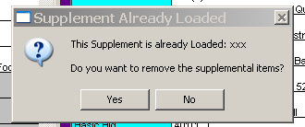

Selecting "yes" will remove the supplemental items from the left side table of items, not the Engineers Estimate.

3. Typically use the Highway Standard Contract Items book and add the supplement, Highway Standard Contract Items, Central Region, Supplement. As you change books Bidtab will prompt:

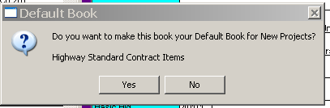

Answer yes for the typical application, no will only mean you will have to answer yes at another time.

4. A Pay Item from the SSHC replaced by a special provision Pay Item is not removed from the list of Highway Standard Contract Items. The Pay Item from the SSHC and the supplement will be sequential. Select the special provision Pay Item, the blue Pay Item.

5. Where a complete replacement special reuses pay items from the Highway Standard Contract Items there is not an added supplemental pay item. Use the Pay item from the Highway Standard Contract Items.

Attached documents include:
(lists of the Highway Standard Contract Items and the Central Region Supplement Pay Items)

1) Example estimate with only Highway Standard Contract Items (Pay Items)
2) Example estimate with only Highway Standard Contract Items, Central Region, Supplement (Pay Items)
3) Example estimate with Highway Standard Contract Items and Highway Standard Contract Items, Central Region, Supplement (Pay Items)

Example of attached: (partial estimate)

