From: fcp | To: CR Highway Design and Construction Engineers, file | Date: | 110118
Project No.: 2018 | Project: AASHTOware Project and Standard Specifications for Highway Construction
Subject: • Pay Item descriptions, AASHTOware Project (AWP) vs Standard Specifications for Highway Construction (SSHC)
• General Information, Internet Access, and References for AWP and BIDTAB IV
• ADOT&PF Network Estimate and FTP Estimate Folders
Pay Item descriptions and units of measure are required to match between all contract documents. When the name of the Pay Item or the unit of measure does not match between the Standard Specifications for Highway Construction and the estimate of quantities, the bid schedule, the plans or elsewhere, a special provision is required. However, in some instances, the standard pay items descriptions in AWP do not match the SSHC Pay Item descriptions. Typical differences in the item descriptions include:

• the word “existing” not included in the AWP item description
• “,” added or not included in the AWP item description
• “-“ added or not included in the AWP item description
• “___ inch/type/class” not at the end of the SSHC 2017 item description, is moved to the end of the AWP item description

The above noted differences between the AWP Pay Item descriptions and the SSHC Pay Item descriptions do not require a special provision or a change in the AWP Pay Item description, except where the meaning of the AWP description does not match the meaning of the SSHC description. Differences in the Pay Item description between the AWP Pay Items and the SSHC Pay Items that results in a meaning other than the SSHC Pay Item description meaning require a special provision for the AWP Pay Item. Pay Items descriptions and units are required to match between special provisions and all other contract documents.

Please inform the Central Region Specification & Estimate Engineer of pay items in the SSHC 2017 or the Central Region Special Provisions and not in AWP. Pay items deleted or retired from the SSHC 2017 or the Central Region Special Provisions will likely remain in AWP and retain the associated data. Please notify the Specification and Estimate engineer of errors and or conflicts.

General Information, Internet Access, and References for AWP and BIDTAB IV
Estimate - complete all estimates using AWP. Do not submit EXCEL spreadsheet estimates.
1. AASHTOware Project
a. Internet Access
AWP Login: in the Username field, type your State of Alaska Username (fmlast) and in the Password field, type your State of Alaska EMAIL password.
• Internal access http://dot.alaska.gov/awplogin
• External access https://awp.dot.alaska.gov
b. User Guides http://www.dot.alaska.gov/aashtoware/guides.shtml
c. Tentative Advertising Schedule http://dot.alaska.gov/procurement/awp/awp-tas.cfm
There is a new field in AWP for the Engineer’s Estimate amount. This is mainly used on projects that are not in MRS; however, there have been a few that did not transfer over. Please check that there is an EE range on the tentative advertising list. If there is not, login to AWP and enter in the EE amount. Follow the instructions in chapter 3 of the guide for information on updating this field and how to change/update the tentative advertising date.
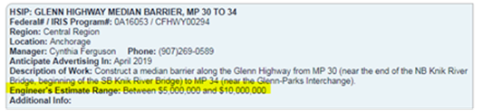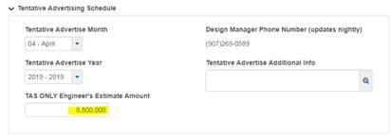
d. Updates and information http://www.dot.alaska.gov/aashtoware/
2. Alaska DOT&PF BidExpress https://www.bidx.com/ak/main
3. Alaska DOT&PF Procurement and Contracting http://dot.alaska.gov/procurement/
4. BIDTAB IV
If you do not have access to BIDTAB IV request access from the Specification and Estimate Engineer.
ADOT&PF Network Estimate and FTP Estimate Folders
ADOT Network (Internal)
ESTIMATES (..\..\..\ESTIMATES)
USERS (..\..\USERS)
Bid Results
Estimate_Update_Notification
Instructions

ADOT FTP (External)
http://www.dot.state.ak.us/creg/design/highways/ESTIMATE
ESTIMATE
Bid Results
Estimate_Update_Notificaiton
Instructions

Bid Results – Printed Bid Tabulations
• DOT&PF Personnel: Highway Design Layout Table
• Contractors: DOT&PF Plans Room - $50
If printed copies are not available, notify the Specification and Estimate Engineer

