**Central Region   
AASHTOWare Project (AWP)  
Preconstruction Supplement**



July 2018

# Central Region Supplement

**Contents**

Supplement 2

Consultants Inputting Funding Information in AWP 3

Adding Central Region Items 5

## Consultants Inputting Funding Information in AWP

Before consultants can input Funding information into AWP, they must be in the system and have a **Funding User** role assigned. See Chapter 13 of the AWP Guide for steps on how to add a new user.

To add a **Funding User** role:

1. Log into AWP.
2. Make sure you are in the ***Module Admin*** role.
3. Select **Users**.
4. Search for and select the username of the person. Check that the Regional Access is blank (null).

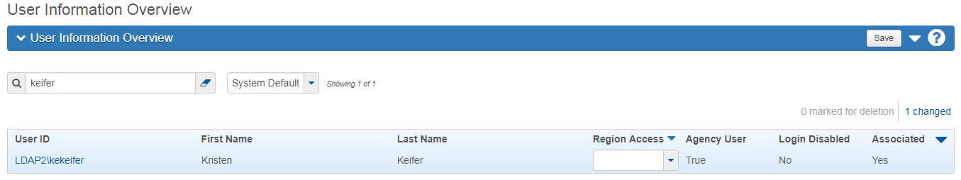

1. Click the **User** quick link.

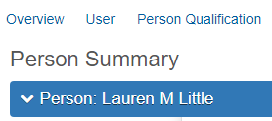

1. Select the **User Roles** tab.
2. Click the **<Select Roles>** button.

NOTE: Consultants are considered Agency Users, so the Agency User box should be checked for all DOT and consultants. Construction contractors are considered non-agency users.

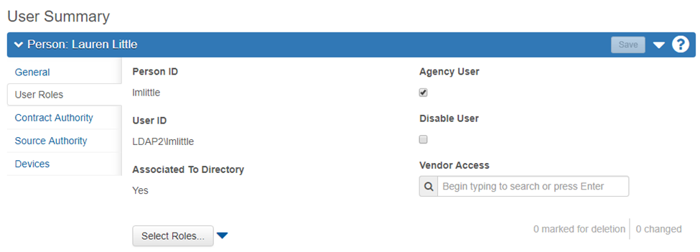

1. Select the **Funding User** role to add to the user. A green checkmark will appear next to the selected roles.
2. Click the **<Add to User>** button.
3. Click **<Save>**.

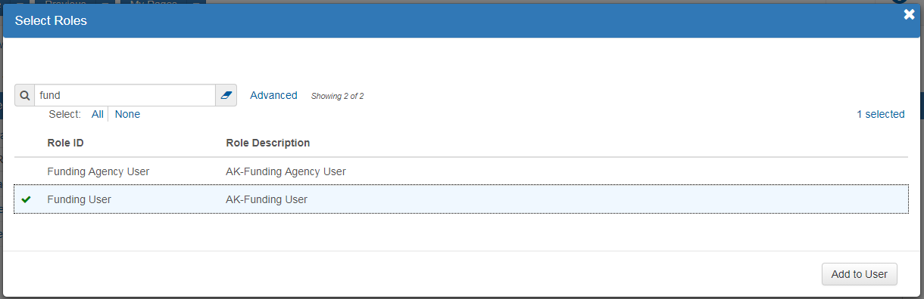

1. In the **Effective Date** field(s), click the calendar icon and select the correct date.
2. From the **Status** dropdown, select **Active**.
3. Click **<Save>**.

NOTE: If you are adding several roles to a user, you can enter the effective date and status for the first role and then range fill the rest if the same effective date and status apply.

## Adding Central Region Items

Central Region will have unique item numbers for all items on a project. Marine Facilities Public Facilities and AMHS see Chapter 13 of the AWP Guide for steps on how to add items.

The Designer, Project Engineer or Project Manager should send a request for a non-standard pay item.

Procedure for Establishing Non-Standard Items

1. Designer verifies that a non-standard item is required and that they cannot utilize an item that is already in AWP.
2. Designer emails all Central Region Module Admins (Ralph Kiehl, Kristen Keifer and Fred Park for Highway items and Ralph Kiehl, Kristen Keifer and Virginia Groeschel for Aviation items) requesting an item number with the following information:
   1. Specification Section
   2. Item Description
   3. Item Pay Unit
   4. Project to be used on
   5. Project Special if written
3. Module Admin will respond to you when the new item is created and which one to use (or discuss the possibility of using an already established item).

To create a new item for **Central Region** Aviation or Highway items:

1. Log into AWP.
2. Make sure you are in as the ***Items Admin*** role.
3. Select the **Items** link.
4. Expand the Item Overview component **action menu** and select **Add**.

NOTE: If adding a regional special item, look up the last regional special number used in the section to identify the next available regional special number.

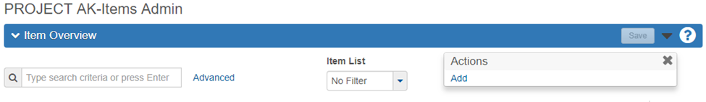

1. In the **Item ID** field, enter the appropriate item number using the number format provided below.
2. In the **Item Description** field, enter the item name/description using the description format provided below.

NOTE: For items that may appear multiple times in a bid schedule, there must be a unique item number. **The unique number will only use the last 4 digits.**

Indicates dimension, size, or type breakout for data mining, and used to create unique number

603.0001.0012

Spec book section

Designates Standard Item (0001-1999) or Regional Special Items (2000-8999)

1. Item number formats:
   1. For Highways, Marine Facilities, and Public Facilities included in the Highways item list, the number format is:

NOTE: Marine Facilities has MF followed by a sequential number in the middle sequence (i.e. 504.MF06.0000)

EXAMPLE :

Project #1 – Sesame Street Corridor Signal Improvements CFHWY00001

|  |  |  |
| --- | --- | --- |
| Item | Description | Supplemental Description |
| 660.0001.0001 | Traffic Signal System Complete, | Sesame Street & Easy Street |
| 660.0001.0002 | Traffic Signal System Complete, | Sesame Street & Main Street |
| 660.0001.0003 | Traffic Signal System Complete, | Sesame Street & First Ave |
| 660.0001.0004 | Traffic Signal System Complete, | Sesame Street & Second Ave |

Project #2 – Champs-Élysées Corridor Signalization CSHWY00002

|  |  |  |
| --- | --- | --- |
| Item | Description | Supplemental Description |
| 660.0001.0001 | Traffic Signal System Complete, | Champs-Élysées & Place de la Concorde |
| 660.0001.0002 | Traffic Signal System Complete, | Champs-Élysées & Place Charles de Gaulle |

Project #3 – Abbey Road Signalization CFHWY00003

|  |  |  |
| --- | --- | --- |
| Item | Description | Supplemental Description |
| 660.0001.0001 | Traffic Signal System Complete, | Abbey Road & Lennon Lane |
| 660.0001.0002 | Traffic Signal System Complete, | Abbey Road & McCartney Ave. |
| 660.0001.0003 | Traffic Signal System Complete, | Abbey Road & Harrison Highway |
| 660.0001.0004 | Traffic Signal System Complete, | Abbey Road & Starr Street |

NOTE: Additional consideration may be required for projects being combined for construction.

Indicates dimension, size, or type breakout for data mining, and used to create unique number

Spec section

Sequential number assigned (mostly increments of 10)

* 1. For Aviation and Public Facilities included in the Aviation item list the number format is:

D701.010.0012

1. See Chapter 13 of the AWP Guide for information on the other item fields: Supplemental Required checkbox, Furnished Material (on bid) box, Item List dropdown, OJT Item box, and Unit of Measure dropdown.
2. Click **<Save>**.

EXAMPLE :

Project #1 – London: Heathrow Runway Improvements CFAPT00010

|  |  |  |
| --- | --- | --- |
| Item | Description | Supplemental Description |
| F186.010.0010 | Access Controls for Vehicle Gate, | Gate A |
| F186.010.0020 | Access Controls for Vehicle Gate, | Gate B |
| F186.010.0030 | Access Controls for Vehicle Gate, | Gate C |
| F186.010.0040 | Access Controls for Vehicle Gate, | Gate D |

Project #2 – Chicago: O’Hare Safety Improvements CFAPT00011

|  |  |  |
| --- | --- | --- |
| Item | Description | Supplemental Description |
| F186.010.0010 | Access Controls for Vehicle Gate, | Gate A |
| F186.010.0020 | Access Controls for Vehicle Gate, | Gate B |

Project #3 – Paris: Charles de Gaulle Taxiway “R” Reconstruction CFAPT00012

|  |  |  |
| --- | --- | --- |
| Item | Description | Supplemental Description |
| F186.010.0010 | Access Controls for Vehicle Gate, | Gate A |
| F186.010.0020 | Access Controls for Vehicle Gate, | Gate B |
| F186.010.0030 | Access Controls for Vehicle Gate, | Gate C |
| F186.010.0040 | Access Controls for Vehicle Gate, | Gate D |

NOTE: Additional consideration may be required for projects being combined for construction.