Safe Routes to Schools Plan
For the
Bristol Bay Borough and Bristol Bay Borough School District

Section 1:
Introduction
In April 2008, a local third grade student named Isabel Babiak saw a need in our community for a path to the Bristol Bay School which offered increased pedestrian and traffic safety as well as an opportunity to help fight the obesity and diabetes epidemic. The trail Isabel proposed is an extension of an already established trail that local students, visiting sports teams, and summer visitors all use frequently throughout the year. The Sockeye Run Trail will provide a non-motorized route for children to bicycle and walk to school enhancing their safety and health. The trail will eventually help connect Naknek to other public lands or parks, engage youth in the outdoors, and promote a healthy lifestyle by encouraging youth and their parents to increase daily physical activity.
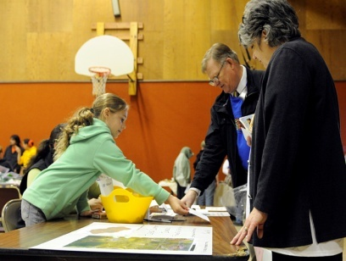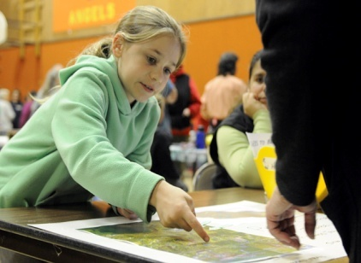
Isabel Babiak sharing her idea with community members.
Isabel presented her idea to the local assembly, school board, and community at large, receiving support from all three. In the interest of establishing this community driven request for a path to the school we held a Safe Routes to School (SRTS) Workshop and subsequently brought together a SRTS Team of community members to determine the next steps. We had a large turnout (over 40 people) for our small community and an amazing amount of support shown by all the offers to volunteer on various workgroups.
Utilizing the Safe Routes to School “5 Es” (Evaluation, Engineering, Education, Encouragement, and Enforcement), our plan looks at our community’s immediate needs that can be met within the first year, as well a some long term goals for our community in the next five years.
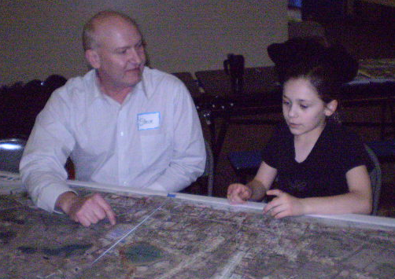
DOT/SRTS Representative Steve Soenksen discussing the SRTS Plan for our community with Isabel Babiak at the Community Workshop.

Section 2:
The Safe Routes to Schools Team
Primary Contacts
Yvonne Kopy
Planning specialist, Bristol Bay Borough
PO Box 189
Naknek, AK 99633
907-246-4224
Email: planning@thebourough.com

Jack Walsh
Superintendent, Bristol Bay School District
PO Box 169
Naknek, AK 99633
907-246-4225
Email: jwalsh@naknek.bbsd.schoolaccess.net

Marv Smith
Borough Manager, Bristol Bay Borough
PO Box 189
Naknek, AK 99633
907-246-4224
Email: manager@theborough.com

Lisa Babiak
Community Member
PO Box 516
Naknek, AK 99633
907-246-8022

Isabel Babiak
Student
907-246-8022

Andrea Hall
Student
907-246-6670

Gregory Harris
Student
907-246-6804

Promise Smith
Student
907-246-8859
Section 3:
The Public Input Process
Isabel Babiak initiated the interest in building a safe trail for our community back in April of 2008. She began by bringing a petition of support signed by over 70 of the local school children to the Planning and Zoning Commission and the local school board. She spoke to the Bristol Bay Borough Assembly and received a resolution of support for the project. A community driven fundraiser was held which rose over $2000 in seed money to get things started. Isabel then spoke to the State of Alaska Commissioners of Labor, Commerce, and the Department of Transportation to bring about awareness for her project when they came to town in July 2008. She requested and received letters of support from the Katmai National Park Superintendent, the local health clinic, and Parks and Recreation coordinator, as well as many community members. Isabel then applied for and was accepted into the National Park Service-River Trails and Conservation Assistance Program to help facilitate her efforts.
From all of this hard work many wonderful partnerships have surfaced in support of this young lady’s trail project.
- Conoco Phillips has invited Isabel to apply for funds to assist in her path.
- Alaska State Park has offered the use of artwork and technical assistance in developing interpretive displays along the trail
- Deborah Schildt is a freelance film producer who is interested in documenting this one young person’s initiative to make a difference in her community and how it can turn into something much larger.
- Eric Morey as a member of the American Society of Landscape Architects has offered his time and expertise to assist in put on paper the plans for the trail.
- Northland has offered free barge shipping from Seattle the playground and fitness equipment planned as part of the trail.
- Local construction companies have offered materials and equipment use to assist in trail construction.
- An engineering company Haas and Assoc. has offered some initial assistance in planning the trail.
- A local surveyor volunteered his time to survey the trail site.
The community hosted a 2-day workshop which included a walking audit of the area around the school and the proposed trail site. Publicity for the workshop included flyers, cable announcement, and Borough website announcement. Individual invitations were also sent out to all the stakeholders on the trail and a Friday afternoon assembly was held to increase awareness among the students. We had a diverse cross-section of our community attend. Interviews were held prior to the meeting with several key stakeholders (Borough Manager, Parks and Rec. manager, Health Commission President, Clinic manager) to make sure their input was noted. Lunch was also had with the elders to make sure they were included in the process since part of the trail is proposed to go by the Elder Home.
A student and parent survey was administered and will be addressed in the following section.
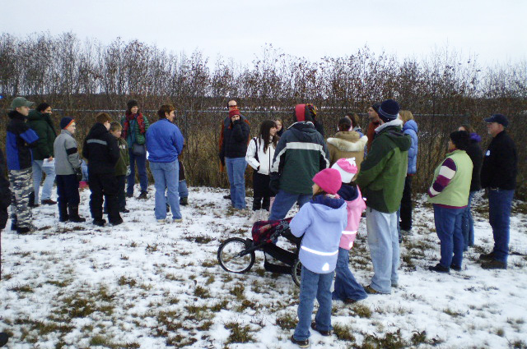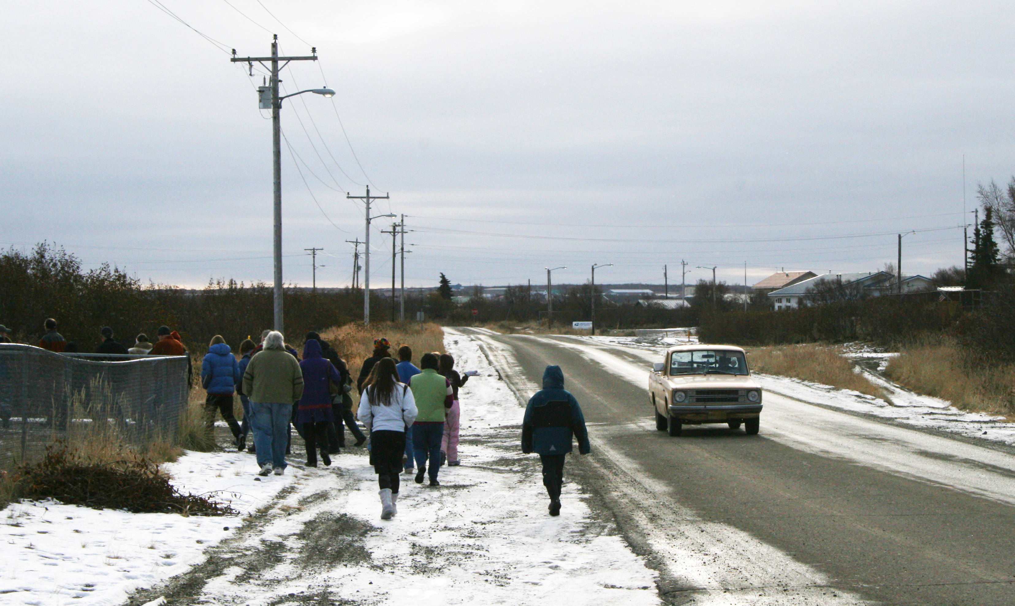
The Walking Audit of the trail was completed with great participation from the community.
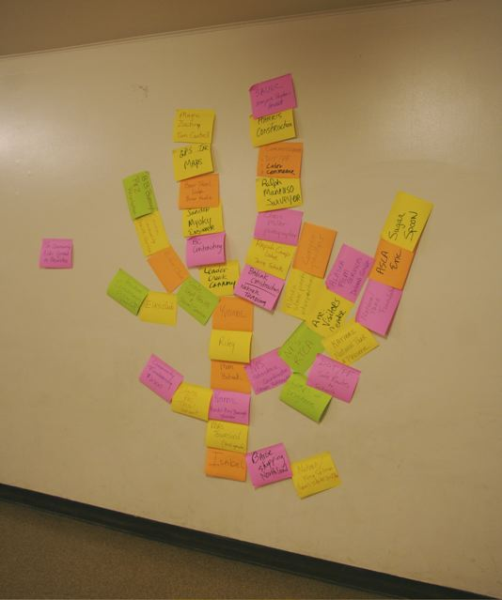 A “Tree of Partners” was formed to help visualize all the wonderful support already garnered for the trail project as a whole.
Section 4:
Current School Travel Environment
The results of a student and parent survey showed that generally most parents will not allow their children to walk or bike to school because of the amount of and speed of traffic on their route to school. However, all parents noted the health benefits of daily walking so with a safe route to school we may see an increase in this type of activity.

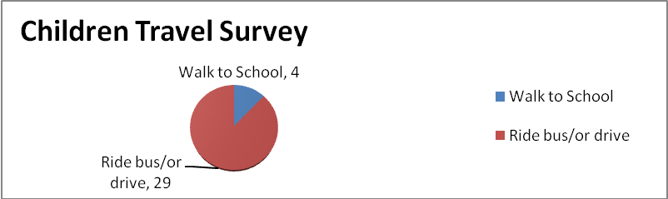

- Student travel modes- We currently have 6 students who fly across the river from South Naknek in a small Cessna airplane each day and are then bused from the air strip to the school. Some students bike (2) and walk (6) to school, but the majority are either brought to school by the school bus, family vehicle, or ATV.
- Distance from school- 35% of our children live within two miles of the school (51 of 145 students). The rest of children are spread out throughout the Bristol Bay area which serves the communities of Naknek, South Naknek (across the Naknek River), and King Salmon which is 15 miles from the school.
- School travel policies: The eligibility for riding a bus is living a distance of at least 1.5 miles from the school.
- List of perceived safety concerns: We currently have no sidewalks or barriers to protect our student pedestrians from motorized vehicles. Many of our community members utilize ATVs as their primary mode of transportation, however there is no distinction at this time between where pedestrians should walk and an ATV should drive, which makes for a very dangerous situation.
Section 5:
Hazards and Barriers to Active Transportation
- Missing or insufficient walkways- We currently have no sidewalks in Bristol Bay.
- No safe place to ride a bike-There is currently no safe place to ride a bike due to lack of any bike path, sidewalks, and shoulders of the busy roads shared with motorized ATVs.
- Crossing streets and intersections dangerous- We currently have no delineated crosswalks for our students around the school.
- Distance to school is too far-The majority of our students live outside the 2 mile radius of the school. The combination of distance and harsh weather conditions here in Alaska make it difficult for students to walk or bike to school from home.
- Bike parking at school is missing- We currently have no bicycle racks at school to offer for student use.
- Dangerous driving and speeding on streets-Between the lack of barriers to fast moving traffic and having to share the shoulder with reckless ATV drivers our pedestrians have a very difficult time staying safe.
- Drop-off and pick-up process creates congestion and unsafe behaviors- We currently have no specific direction for drop-off and pick-up which causes potential unsafe situations. The parking lot used for many of the students that drive to school has no barriers to direct traffic and over 150 feet of area the cars can drive onto the road from. You never know when or where a car will be coming out of the parking lot, which makes it difficult for children to be aware of which way to look for oncoming traffic.
Section 6:
Creating Solutions
We have come up with some strategies for addressing the aforementioned hazards and barriers to active transportation utilizing the SRTS 5 “E’s”
Evaluation
- Show of Hands Survey-Use a” Show of Hands Survey” three times a year to track 3rd through 5th grades mode of travel for 3 years to measure changes in travel habits/ measure mode shift. Supply data to the Alaska SRTS Program staff to record and track data in their state-wide database as well as keep our own records at the school district office.
- Student Travel Tally and Parent Surveys-Administer the Student Travel Tally and Parent Surveys to track travel habits and attitudes about student travel safety.
Engineering
- Sockeye Run Fitness Trail and Bike Path-Construct a gravel path trail from the corner of School Road and the Alaska Peninsula Highway to the driveway at the South School parking lot. The trail will provide opportunities for all community residents to engage in outside physical activities. To the extent possible, the trail will be designed for disabled access. As a part of this trail, a raised cross walk will be constructed from the new trail to the boardwalk on the south end of the school playground (See trail plan and side views and school site plan map for further details.
- Bike Racks- Place two bike racks at two locations at the school to encourage children and faculty to bike to school. (See school site plan map)
- School Site Improvements- Improve the parking lot adjacent to the school and across the street (in front of the pool). Possibly provide curbs, bumpers, and an improved traffic flow so that all traffic will be entering and exiting in a specified direction to improve pedestrian and traffic safety (See school site plan map).
- Additional Safe Routes to Schools Trail Opportunities-
  - Host Discussions with residents of South Naknek to determine feasibility and need for a trail from the village to the airstrip to assist children in getting to and from the school airplane charter safely.
  - Determine the route, rights-of-way requirements, and trail design standards for constructing trails from various residential areas throughout Naknek and the Borough to assist children in accessing school bus stops and bicycling and walking directly to school in the safest manner possible.
Education
- Bike Safety Rodeo-Hold a Bike Safety Rodeo in the Fall of 2009 at the school. The program would emphasize safety tips for maneuvering around other people, including emergency breaking, swerving, hand signals, etc.
- Pedestrian and Bicycle Class Curriculum-Incorporate pedestrian and bicycle safety classes into the physical education or health curriculum in grades 3 through 6 beginning in the Fall of 2009 and continuing until curriculum is delivered to all target grades.
Encouragement
- Walking Wednesdays-Establish “Walking Wednesday” program in which parents park and walk with, or drop-off, children to walk the rest of the way to school. A punch card would be given out to win prizes once completed. This would be a continuous program throughout the 2009-10 calendar school year. We used a Student Travel Tally and Parent Survey with results showing that most parents will not allow their children to walk or bike to school because of the amount of speed or traffic on their route to school. However, all parents noticed the health benefits of walking, so a park and walk may be a viable option for those students living outside the two mile radius of the school.
- Morning Mile- Start a “Morning Mile” program in which children and parents would be encouraged to walk or bicycle a mile each morning. A punch card would be used to record miles walked/biked and prizes would be given out to those completely filling in the card. This would be a continuous program throughout the 2009-10 calendar school year.
- Walking School Bus-Establish a walking school bus program with community members. This would be a continuous program throughout the 2009-10 calendar school year.
Enforcement
- Non-motorized Trail Zone Ordinance-A student-teacher council proposed ordinance will be written and submitted to the Borough Assembly for public review and approval to establish the proposed new trail as a non-motorized zone and to support legal enforcement of this ordinance.
- Established ATV Route to School and School Parking Area- An ATV route to school will be established, as well as an associated approved ATV parking area at the school.
- Signs-Signs will be installed to identify and delineate the non-motorized trail zone and the ATV-route and parking areas.
Section 7:
Mapping
See attached maps.

Section 8:
The Action Plan
Strategy Type (which of the 5 E’s) | Strategy Name | Strategy Detail | Time Frame | Responsible Party | Status | Possible Funding Source
Evaluation (1) | Show of Hands Survey | Use a “Show of Hands Survey” three times a year to track 3rd through 5th grades mode of travel for 3 years to measure change in travel habits/measure mode shift. . Supply data to the Alaska SRTS Program staff to record and track data in their state-wide database as well as keep our own records at the school district office. | Conduct annually for 3 Years | Bristol Bay School Distirct Jack Walsh, Superintendent; Trevor Townsend, Principal | To be completed beginning November 2009 | N/A
Evaluation (2) | Student Travel Tally | Student Travel Tally Surveys-Administer the Student Travel Tally and to track travel habits and attitudes about student travel safety. Supply data to the Alaska SRTS Program staff to record and track data in their state-wide database as well as keep our own records at the school district office. | Conduct annually for 3 years | Bristol Bay School Distirct Jack Walsh, Superintendent; Trevor Townsend, Principal | 1st Tally completed November 2008 | N/A
Evaluation (3) | Parent Survey | Administer the Parent Surveys annually to track travel habits and attitudes about student travel safety. Supply data to the Alaska SRTS Program staff to record and track data in their state-wide database as well as keep our own records at the school district office. | Conduct annually for 3 years | Bristol Bay School Distirct Jack Walsh, Superintendent; Trevor Townsend, Principal | 1st survey completed November 2008 | N/A
Engineering (1) | Sockeye Run Fitness Trail & Bike Path | Construct a gravel trail from the corner of School Road and the Alaska Peninsula Highway to the driveway at the South School parking lot. To the extent possible, the trail will be designed for disabled access. As part of this trail, a raised cross walk will be constructed from the new trail to the boardwalk on the south end of the school playground. (See trail plan and side views and school site plan map for further details.)  Action items include:  - complete trail management objectives;  - complete trail design drawings;  - conduct site engineering tests;  - complete trails design specifications and quantities;  - complete environmental compliance requirements;  - develop cost estimates;  - contract for construction;  - Community sustainable trail design training;  - construct. | 1. Completed  2. Completed  3. March 2009  4. March 2009  5. May 2009  6. May 2009  7. May 2009  8. Jun 2009  9. July 2009-July 2010 | 1. Lisa Holzapfel  2. Eric Morey  3. Haas Engineering  4. Eric Morey  5. Yvonne Kopy  6. SRTS Planning Group  7. Marv Smith  8.RTCA and Alaska Trails (Jillian Morrisey)  9. Marv Smith | 1. Completed  2. Completed  3. To be completed  4. To be completed  5. To be completed  6. To be completed  7. To be completed  8. To be completed  9. To be completed | 1. NPS-RTCA  2. Pro-Bono  3. Pro-Bono  4. Pro-Bono  5. Bristol Bay Borough  6. NPS-RTCA, Bristol Bay Borough, Pro-Bono  7. Bristol Bay Borough  8. SRTS
Engineering (2) | Bike Racks | Place 2 bike racks at 2 locations at the school to encourage children and faculty to bike to school. | Complete installation in 6 months | Bristol Bay School Distirct Jack Walsh, Superintendent; Trevor Townsend, Principal | To be completed | SRTS and Pro-bono labor
Engineering (3) | School Site Improvements (South School Parking Lot, Etc.) | Improve the parking lot adjacent to the school and across the street (in front of the pool). Possibly provide curbs, bumpers, and an improved traffic flow so that all traffic will be entering and exiting in a specified direction to improve pedestrian and traffic safety. Add up to two new crosswalks. | Initial design March 2009  Complete construction in 1 to 5 years | Design: Eric Morey  Construction: Bristol Bay School Distirct Jack Walsh, Superintendent; Trevor Townsend, Principal  and  Bristol Bay Borough, Marv Smith, Borough Manager | Design to be completed  Construction to be completed | SRTS and pro-bono design and survey work
Engineering (4) | Additional SRTS Trail Opportunities for South Naknek | Host discussions with residents of the village of South Naknek to determine the feasibility and need for a trail from the village to the airstrip to assist children in getting to and from the school airplane charter safely. | Make and implement decision in 1 to 5 years | Bristol Bay Borough  Yvonne Kopy,  Planning | To be completed | RTCA  Design-SRTS Planning funds
Engineering (5) | Greater SRTS Network | Determine the route, rights-of-way requirements, and trail design standards for constructing trails from various residential areas throughout Naknek and the Borough to assist children in accessing school bus stops and bicycling and walking directly to school in the safest manner possible. | Make and implement decision in 1 to 5 years | Bristol Bay Borough  Yvonne Kopy,  Planning | To be completed | -SRTS Planning funds
Education (1) | Bike Safety Rodeo | Hold a Bike Safety Rodeo in the Fall of 2009 at the school. The program would emphasize safety tips for maneuvering around other people, including emergency breaking, swerving, hand signals, etc. | Conduct annually beginning Fall 2009 | Bristol Bay Borough  Terri Stors, Parks and Recreation  Bristol Bay School Distirct Jack Walsh, Superintendent; Trevor Townsend, Principal | To be completed | REI  RTCA  STRS for cost of travel of instructors
Education (2) | Pedestrian and Bicycle Class Curriculum | Incorporate pedestrian and bicycle safety classes into the physical education or health curriculum in grades 3 through 6 beginning in the Fall of 2009 and continuing until curriculum is delivered to all target grades. | Complete curriculum in 1 year; Conduct annually | Bristol Bay School Distirct Jack Walsh, Superintendent; Trevor Townsend, Principal | To be completed | Bristol Bay School District
Encouragement (1) | Walking Wednesdays | Establish “Walking Wednesday” program in which parents park and walk with, or drop off, children to walk the rest of the way to school. A punch card would be given out to win prizes once completed. This would be a continuous program throughout the 2009-10 calendar school year. | Continuous, beginning in 2009/2010 school year | Bristol Bay School Distirct Jack Walsh, Superintendent; Trevor Townsend, Principal | To be completed | SRTS for punch cards, prizes
Encouragement (2) | Morning Mile | Start a “Morning Mile” program in which children and parents would be encouraged to walk or bicycle a mile each morning. A punch card would be used to record miles walked/biked and prizes would be given out to those completely filling in the card. This would be a continuous program throughout the 2009-10 calendar school year. | Continuous, beginning in 2009/2010 school year | Bristol Bay School Distirct Jack Walsh, Superintendent; Trevor Townsend, Principal | To be completed | SRTS for punch cards and prizes
Encouragement (3) | Walking School Bus | Establish a walking school bus program with community members. This would be a continuous program throughout the 2009-10 calendar school year. | Continuous, beginning in 2009/2010 school year | Bristol Bay School Distirct Jack Walsh, Superintendent; Trevor Townsend, Principal | To be completed | SRTS for promotional materials
Enforcement (1) | Nonmotorized Trail Zone Ordinance | A student-teacher council proposed ordinance will be written and submitted to the Borough Assembly for public review and approval to establish the proposed new trail as a non-motorized zone and to support legal enforcement of this ordinance. | Ordinance drafted and before Assembly within 6 months | Bristol Bay School Distirct Jack Walsh, Superintendent; Trevor Townsend, Principal | To be completed | Bristol Bay School District
Enforcement (2) | Established ATV Route to School and School Parking Area | An ATV- route to school will be established, as well as an associated approved ATV parking area at the school. | Completed within 6 months to a year | Bristol Bay School Distirct Jack Walsh, Superintendent; Trevor Townsend, Principal  School Safety Officer | To be completed | Bristol Bay Borough School District  And  Bristol Bay Borough
Enforcement (3) | Signs | Signs will be installed to identify and delineate the non-motorized trail zone and the ATV-route and parking area. | Completed within 6 months to a year | Bristol Bay Borough  Marv Smith, Borough Manager | To be completed | Signs: SRTS  Installation: Bristol Bay Borough School District  and  Bristol Bay Borough

Section 9
Plan Endorsements

See attached

Section 10:
Supporting Documents

See attached

