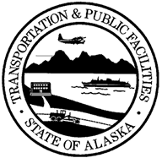 | STATE OF ALASKA  DEPARTMENT OF TRANSPORTATION  AND PUBLIC FACILITIES  NOTICE TO RELOCATION | project name: _________________________  state project #: _______________________  federal-aid project #: __________________  parcel #: ___________ unit #: __________

The first acquisition contact with the following property owner was made on ______________________, 2____ by ______________________________________________:

Name of property owner contacted _____________________________________________________________

Relocation is required Relocation is not required

Date ____________________, 2____ __________________________________________

Agent

