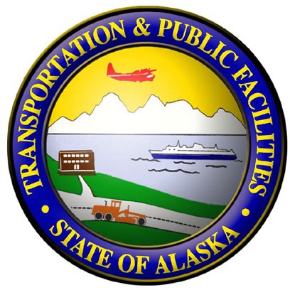
Comment Sheet

Airport Way West Bicycle and Pedestrian Path
Project # 0002449/NFHWY00447
Online Public Meeting

Thank you for taking time to be involved. We welcome your written comments and ideas.

Do you use this area (commuter, local resident, owner or employee of an area business, pedestrian/bicyclist)?

Please describe your safety concerns.

Which alternative do you approve? Why?

What do you like and/or dislike about the current design?

Do you support the project? Why or why not?

Do you have other comments?

*Before including your address, phone number, e-mail address, or other personal identifying information in your comment, be advised that your entire comment –including your personal identifying information –may be made publicly available at any time. While you can ask us in your comment to withhold from public review your personal identifying information, we cannot guarantee that we will be able to do so.

E-mail Address:

Name:

Mailing Address:
For further information, please contact David K. Fischer, P.E., Engineering Manager, at (907) 451-5357 or email:
david.fischer@alaska.govv.

Optional:

Please check all that apply:
Female |  | Male
White |  | Hispanic
AK Native |  | Asian
N. American |  | Pac. Islander
Black |  | Other

Please return comments by April 17, 2020.
The environmental review, consultation, and other actions required by applicable Federal environmental laws for this project are being, or have been, carried out by the Alaska DOT&PF pursuant to 23 U.S.C. 327 and a Memorandum of Understanding dated November 3, 2017 and executed by the FHWA and DOT&PF.

