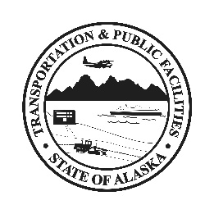
Welcome! Please read!
We ask for your help to keep our customers, visitors, and employees safe.
Here’s what you can do to help.
- Please keep six feet of space between you and others. This helps prevent the spread of germs.
- Please use the hand sanitizer provided and wash your hands frequently.
- Can you get this service online or over the phone? Please do not visit our office in person if you do not have to.
- Are you feeling sick? Please do not visit our office. Return home and call your health provider.

If you would like more information about COVID-19 and what you can do to slow the spread, visit coronavirus.alaska.gov. Thank you for your help!

